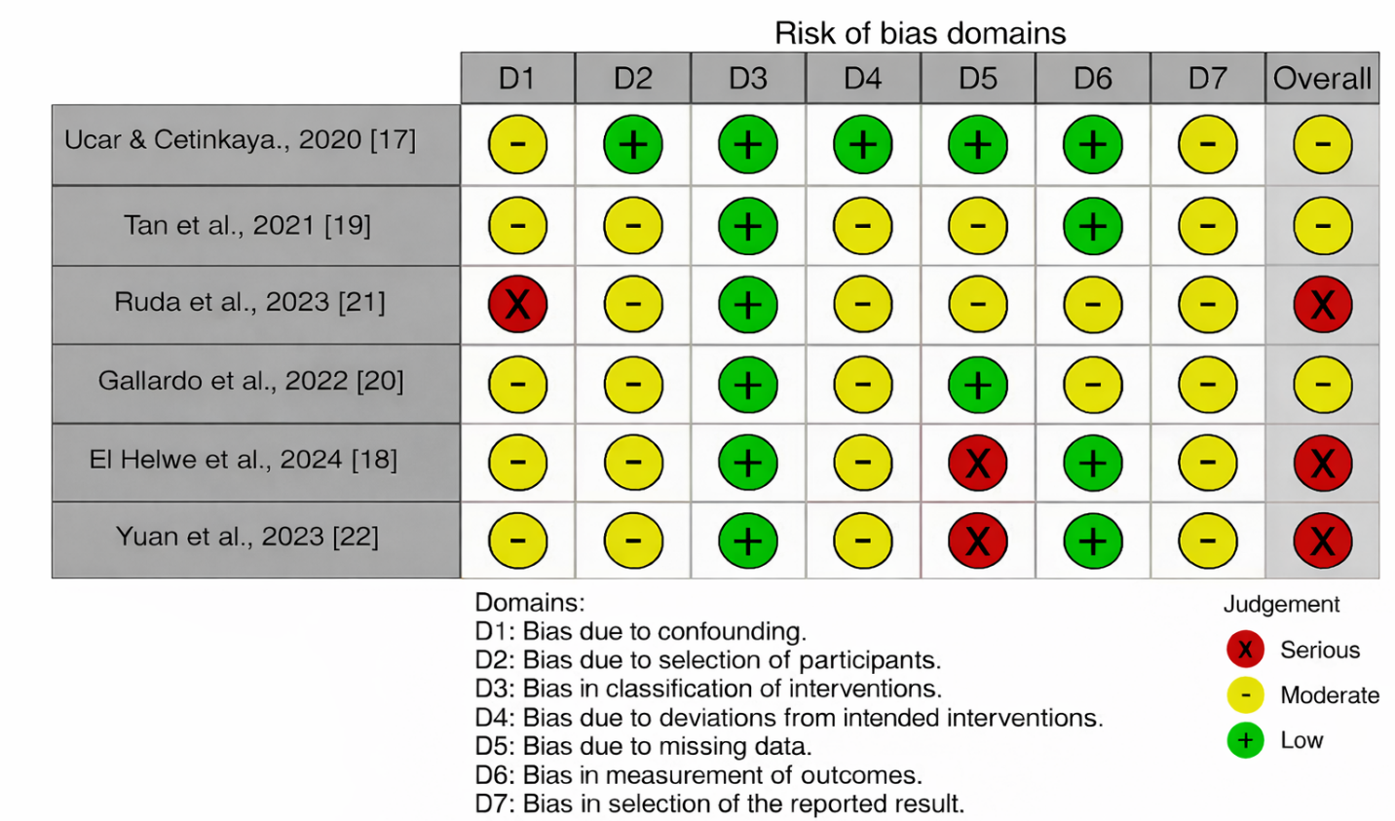

Supplementary figure 1. Cochrane Risk Of Bias In Non-randomized Studies - of Interventions (ROBINS-I).
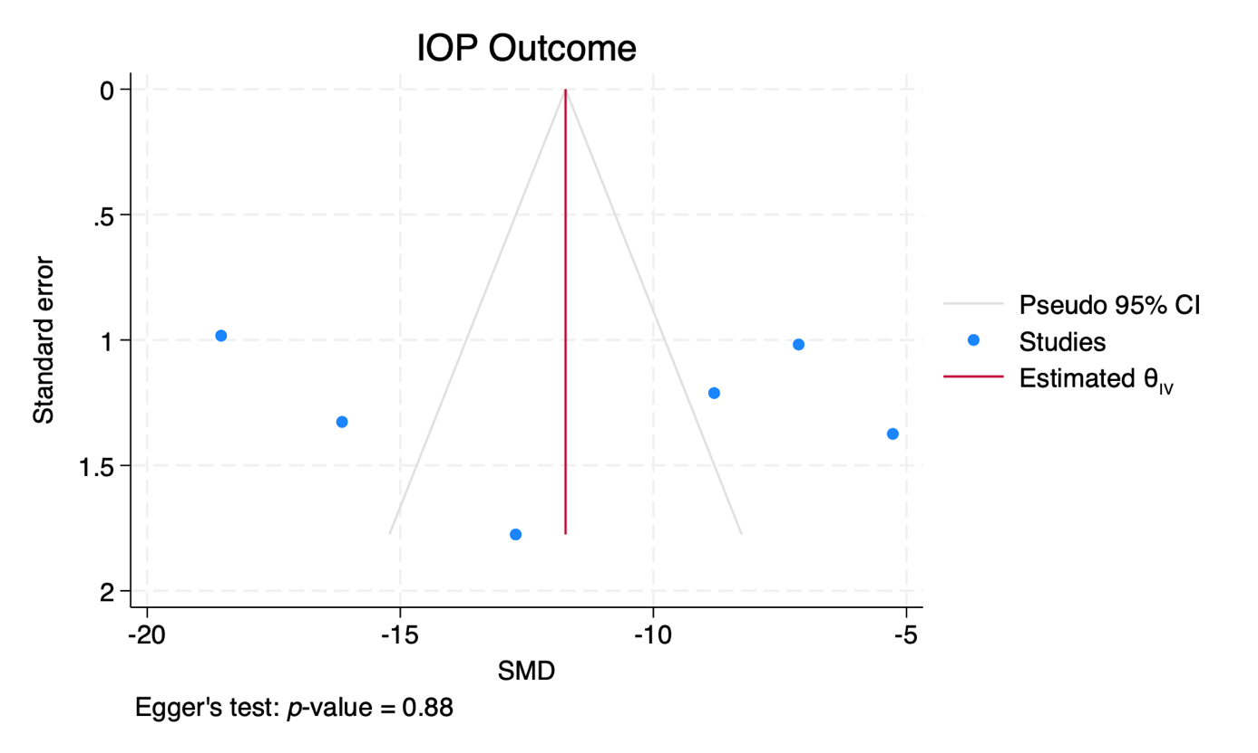
(a)
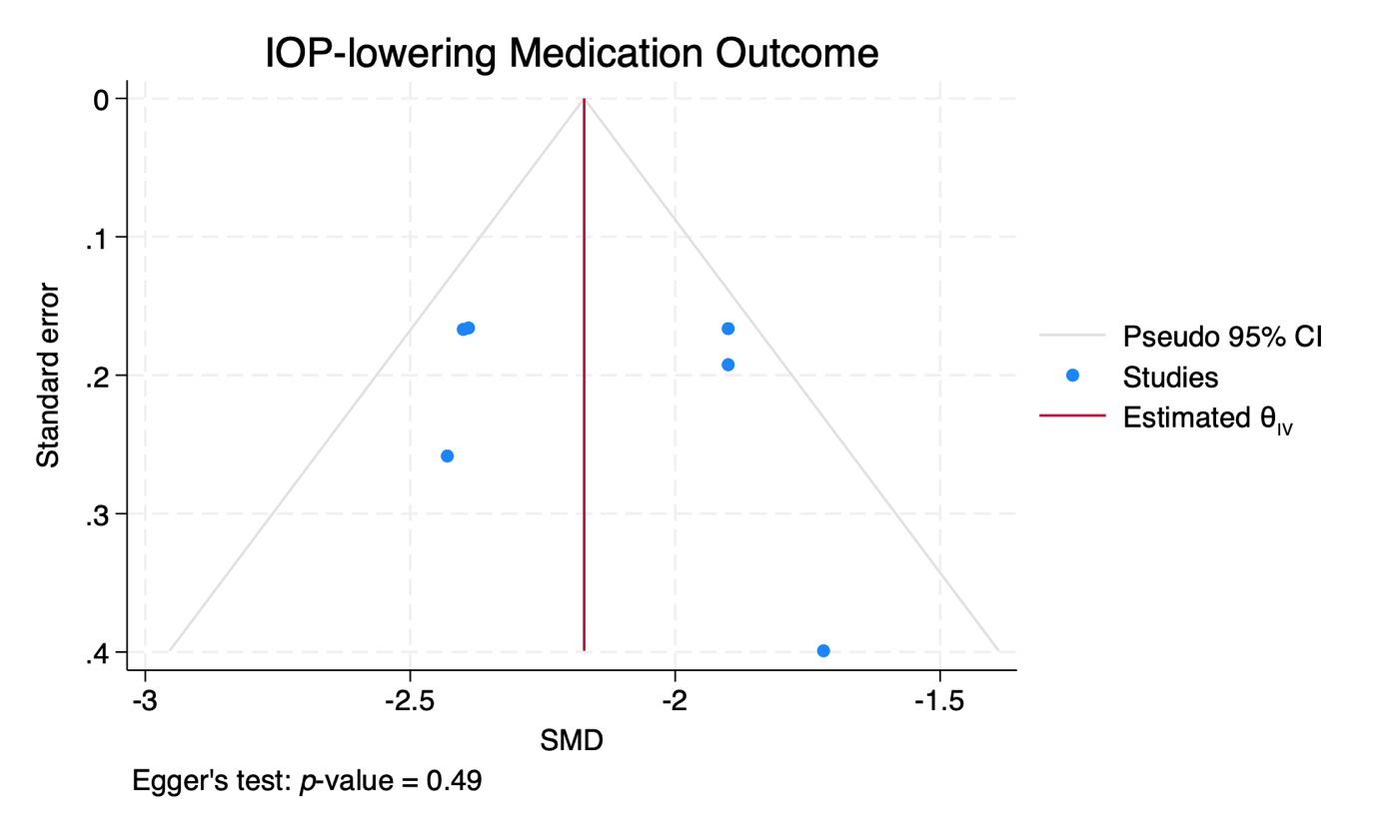
(b)

Supplementary figure 2. Funnel plots of (a) intraocular pressure (IOP) and (b) number of medications lowering IOP outcomes. SMD, standardized mean difference; CI, confidence interval.

References

- Ucar, F., & Cetinkaya, S. (2020). Xen implantation in patients with primary open-angle glaucoma: comparison of two different techniques. International ophthalmology, 40(10), 2487–2494. https://doi.org/10.1007/s10792-020-01427-z
- El Helwe, H., Ingram, Z., Neeson, C. E., Falah, H., Trzcinski, J., Lin, J. B., & Solá-Del Valle, D. A. (2024). Comparing Outcomes of 45 Xen Implantation Ab Interno With Closed Conjunctiva to Ab Externo With Open Conjunctiva Approaches. Journal of glaucoma, 33(2), 116–125. https://doi.org/10.1097/IJG.0000000000002320
- Tan, N. E., Tracer, N., Terraciano, A., Parikh, H. A., Panarelli, J. F., & Radcliffe, N. M. (2021). Comparison of Safety and Efficacy Between Ab Interno and Ab Externo Approaches to XEN Gel Stent Placement. Clinical ophthalmology (Auckland, N.Z.), 15, 299–305. https://doi.org/10.2147/OPTH.S292007
- Gallardo, M. J., Vincent, L. R., & Porter, M. (2022). Comparison of Clinical Outcomes Following Gel Stent Implantation via Ab-Externo and Ab-Interno Approaches in Patients with Refractory Glaucoma. Clinical ophthalmology (Auckland, N.Z.), 16, 2187–2197. https://doi.org/10.2147/OPTH.S354038
- Ruda, R. C., Yuan, L., Lai, G. M., Raiciulescu, S., & Kim, W. I. (2023). Clinical Outcomes of Ab Interno Placement versus Ab Externo Placement of XEN45 Gel Stents. Ophthalmology. Glaucoma, 6(1), 4–10. https://doi.org/10.1016/j.ogla.2022.07.002
- Yuan, L., Rana, H. S., Lee, I., Lai, G., Raiciulescu, S., & Kim, W. (2023). Short-Term Outcomes of Xen-45 Gel Stent Ab Interno Versus Ab Externo Transconjunctival Approaches. Journal of glaucoma, 32(7), e71–e79. https://doi.org/10.1097/IJG.0000000000002208

