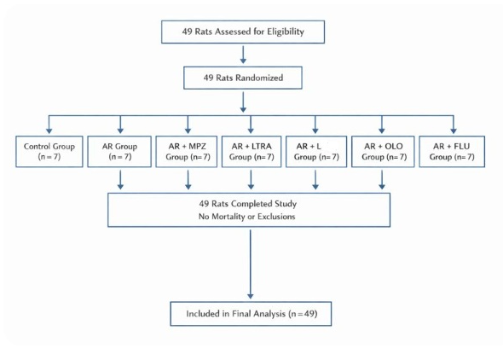
Supplementary Figure S1: CONSORT diagram of animal assignment

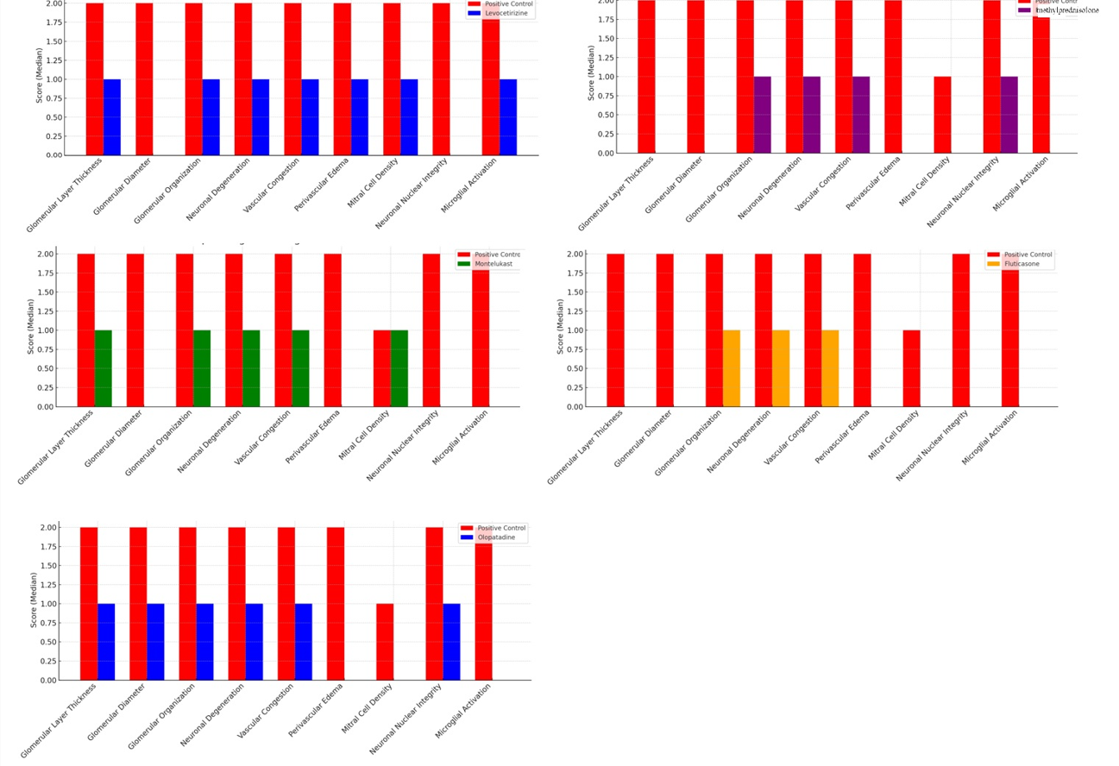

Supplementary Figure S2: Histopathological changes in the olfactory bulb following treatment in experimental allergic rhinitis

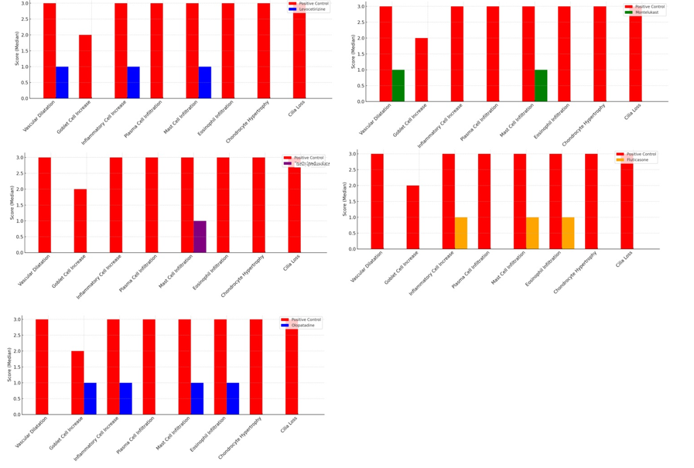
Supplementary Figure S3: Histopathological changes in the mucosal epitelhium following treatment in experimental allergic rhinitis
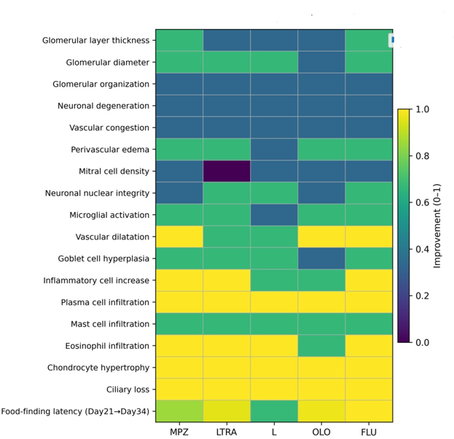
Supplementary Figure S4. Heatmap of normalized histopathological and functional improvement across treatment groups

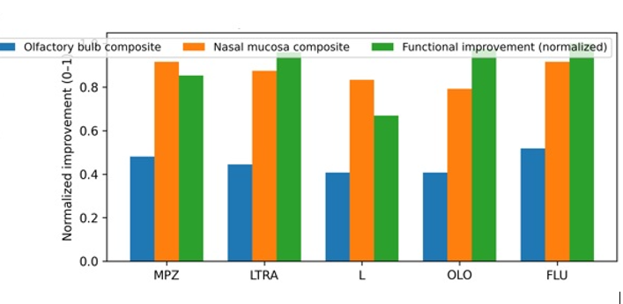
Supplementary Figure S5: Composite improvement scores for olfactory bulb, nasal mucosa, and olfactory function

Supplementary Table S1. Comparison of glomerular and nasal mucosal histopathology between the positive control and methylprednisolone-treated groups
Parameter, median (min -max) |  |  | p value
  AR group
  (n=7)
  AR + MPZ group (n=7)
Glomerular layer thickness† | 2.0 (1.0–3.0) | 0.0 (0.0–1.0) | 0.001
Glomerular diameter† | 2.0 (1.0–3.0) | 0.0 (0.0–1.0) | 0.001
Glomerular organization† | 2.0 (2.0–3.0) | 1.0 (0.0–1.0) | <0.001
Neuronal degeneration† | 2.0 (2.0–2.0) | 1.0 (0.0–2.0) | 0.004
Vascular congestion† | 2.0 (1.0–3.0) | 1.0 (0.0–1.0) | 0.002
Perivascular edema† | 2.0 (2.0–3.0) | 0.0 (0.0–1.0) | <0.001
Mitral cell density† | 1.0 (1.0–2.0) | 0.0 (0.0–1.0) | 0.002
Neuronal nuclear integrity† | 2.0 (1.0–2.0) | 1.0 (0.0–2.0) | 0.053
Microglial activation† | 2.0 (1.0–2.0) | 0.0 (0.0–1.0) | 0.002
Vascular dilatation* | 3.0 (1.0–3.0) | 0.0 (0.0–1.0) | 0.001
Goblet cell hyperplasia* | 2.0 (1.0–3.0) | 0.0 (0.0–1.0) | 0.001
Inflammatory cell increase* | 3.0 (2.0–3.0) | 0.0 (0.0–2.0) | 0.001
Plasma cell infiltration* | 3.0 (2.0–3.0) | 0.0 (0.0–0.2) | <0.001
Mast cell infiltration* | 3.0 (2.0–3.0) | 1.0 (0.0–1.0) | <0.001
Eosinophil infiltration* | 3.0 (1.0–3.0) | 0.0 (0.0–1.0) | 0.001
Chondrocyte hypertrophy* | 3.0 (1.0–3.0) | 0.0 (0.0–0.0) | <0.001
Ciliary loss* | 3.0 (1.0–3.0) | 0.0 (0.0–1.0) | 0.001
Min–max: Minimum–maximum; AR group: Positive control group; AR + MPZ group: systemic methylprednisolone-treated group, † glomerular histopathology findings; * nasal mucosal histopathology findings

Supplementary Table S2. Comparison of glomerular and nasal mucosal histopathology between the positive control and Leukotriene receptor antagonist treated groups
Parameter, median (min -max) |  |  | p value
  AR group
  (n=7)
  AR + LTRA group (n=7)
Glomerular layer thickness† | 2.0 (1.0–3.0) | 1.0 (0.0–2.0) | 0.007
Glomerular diameter† | 2.0 (1.0–3.0) | 0.0 (0.0–2.0) | 0.007
Glomerular organization† | 2.0 (2.0–3.0) | 1.0 (0.0–2.0) | 0.004
Neuronal degeneration† | 2.0 (2.0–2.0) | 1.0 (0.0–2.0) | 0.026
Vascular congestion† | 2.0 (1.0–3.0) | 1.0 (0.0–2.0) | 0.007
Perivascular edema† | 2.0 (2.0–3.0) | 0.0 (0.0–2.0) | 0.004
Mitral cell density† | 1.0 (1.0–2.0) | 1.0 (0.0–2.0) | 0.383
Neuronal nuclear integrity† | 2.0 (1.0–2.0) | 0.0 (0.0–1.0) | 0.007
Microglial activation† | 2.0 (1.0–2.0) | 0.0 (0.0–1.0) | 0.002
Vascular dilatation* | 3.0 (1.0–3.0) | 1.0 (0.0–2.0) | 0.011
Goblet cell hyperplasia* | 2.0 (1.0–3.0) | 0.0 (0.0–2.0) | 0.004
Inflammatory cell increase* | 3.0 (2.0–3.0) | 0.0 (0.0–2.0) | <0.001
Plasma cell infiltration* | 3.0 (2.0–3.0) | 0.0 (0.0–0.0) | <0.001
Mast cell infiltration* | 3.0 (2.0–3.0) | 1.0 (0.0–1.0) | <0.001
Eosinophil infiltration* | 3.0 (1.0–3.0) | 0.0 (0.0–2.0) | 0.001
Chondrocyte hypertrophy* | 3.0 (1.0–3.0) | 0.0 (0.0–1.0) | <0.001
Ciliary loss* | 3.0 (1.0–3.0) | 0.0 (0.0–1.0) | 0.001
Min–max: Minimum–maximum; AR group: Positive control group; AR + LTRA group: Leukotriene receptor antagonist treated group; † glomerular histopathology findings; * nasal mucosal histopathology findings

Supplementary Table S3. Comparison of glomerular and nasal mucosal histopathology between the positive control and levocetirizine groups
Parameter, median (min -max) |  |  | p value
  AR group
  (n=7)
  AR + L group (n=7)
Glomerular layer thickness† | 2.0 (1.0–3.0) | 1.0 (0.0–2.0) | 0.007
Glomerular diameter† | 2.0 (1.0–3.0) | 0.0 (0.0–1.0) | 0.001
Glomerular organization† | 2.0 (2.0–3.0) | 1.0 (0.0–2.0) | 0.008
Neuronal degeneration† | 2.0 (2.0–2.0) | 1.0 (0.0–1.0) | <0.001
Vascular congestion† | 2.0 (1.0–3.0) | 1.0 (0.0–2.0) | 0.008
Perivascular edema† | 2.0 (2.0–3.0) | 1.0 (0.0–2.0) | 0.003
Mitral cell density† | 1.0 (1.0–2.0) | 0.0 (0.0–1.0) | 0.026
Neuronal nuclear integrity† | 2.0 (1.0–2.0) | 0.0 (0.0–1.0) | 0.004
Microglial activation† | 2.0 (1.0–2.0) | 1.0 (0.0–1.0) | 0.011
Vascular dilatation* | 3.0 (1.0–3.0) | 1.0 (0.0–2.0) | 0.007
Goblet cell hyperplasia* | 2.0 (1.0–3.0) | 0.0 (0.0–1.0) | <0.001
Inflammatory cell increase* | 3.0 (2.0–3.0) | 1.0 (0.0–1.0) | <0.001
Plasma cell infiltration* | 3.0 (2.0–3.0) | 0.0 (0.0–1.0) | <0.001
Mast cell infiltration* | 3.0 (2.0–3.0) | 1.0 (0.0–1.0) | <0.001
Eosinophil infiltration* | 3.0 (1.0–3.0) | 0.0 (0.0–1.0) | 0.001
Chondrocyte hypertrophy* | 3.0 (1.0–3.0) | 0.0 (0.0–1.0) | <0.001
Ciliary loss* | 3.0 (1.0–3.0) | 0.0 (0.0–1.0) | 0.001
Min–max: Minimum–maximum; AR group: Positive control group; AR + L group: levocetirizine treated group; † glomerular histopathology findings; * nasal mucosal histopathology findings

Supplementary Table S4. Comparison of glomerular and nasal mucosal histopathology between the positive control and topical antihistamine treated groups
Parameter, median (min -max) |  |  | p value
  AR group
  (n=7)
  AR + OLO group (n=7)
Glomerular layer thickness† | 2.0 (1.0–3.0) | 1.0 (0.0–2.0) | 0.007
Glomerular diameter† | 2.0 (1.0–3.0) | 1.0 (0.0–2.0) | 0.011
Glomerular organization† | 2.0 (2.0–3.0) | 1.0 (0.0–2.0) | 0.053
Neuronal degeneration† | 2.0 (2.0–2.0) | 1.0 (0.0–2.0) | 0.004
Vascular congestion† | 2.0 (1.0–3.0) | 1.0 (1.0–2.0) | 0.011
Perivascular edema† | 2.0 (2.0–3.0) | 0.0 (0.0–2.0) | 0.017
Mitral cell density† | 1.0 (1.0–2.0) | 0.0 (0.0–1.0) | 0.011
Neuronal nuclear integrity† | 2.0 (1.0–2.0) | 1.0 (0.0–2.0) | 0.165
Microglial activation† | 2.0 (1.0–2.0) | 0.0 (0.0–1.0) | 0.002
Vascular dilatation* | 3.0 (1.0–3.0) | 0.0 (0.0–2.0) | 0.001
Goblet cell hyperplasia* | 2.0 (1.0–3.0) | 1.0 (0.0–1.0) | 0.001
Inflammatory cell increase* | 3.0 (2.0–3.0) | 1.0 (0.0–2.0) | 0.001
Plasma cell infiltration* | 3.0 (2.0–3.0) | 0.0 (0.0–0.2) | <0.001
Mast cell infiltration* | 3.0 (2.0–3.0) | 1.0 (0.0–2.0) | <0.001
Eosinophil infiltration* | 3.0 (1.0–3.0) | 1.0 (0.0–2.0) | 0.001
Chondrocyte hypertrophy* | 3.0 (1.0–3.0) | 0.0 (0.0–1.0) | <0.001
Ciliary loss* | 3.0 (1.0–3.0) | 0.0 (0.0–2.0) | 0.001
Min–max: Minimum–maximum; AR group: Positive control group; AR + OLO group: Topical antihistamine treated group; † glomerular histopathology findings; * nasal mucosal histopathology findings

Supplementary Table S5. Comparison of glomerular and nasal mucosal histopathology between the positive control and topical steroid treated groups
Parameter, median (min -max) |  |  | p value
  AR group
  (n=7)
  AR + FLU group (n=7)
Glomerular layer thickness† | 2.0 (1.0–3.0) | 0.0 (0.0–2.0) | 0.004
Glomerular diameter† | 2.0 (1.0–3.0) | 0.0 (0.0–2.0) | 0.007
Glomerular organization† | 2.0 (2.0–3.0) | 1.0 (0.0–3.0) | 0.053
Neuronal degeneration† | 2.0 (2.0–2.0) | 1.0 (0.0–2.0) | 0.073
Vascular congestion† | 2.0 (1.0–3.0) | 1.0 (1.0–3.0) | 0.128
Perivascular edema† | 2.0 (2.0–3.0) | 0.0 (0.0–3.0) | 0.017
Mitral cell density† | 1.0 (1.0–2.0) | 0.0 (0.0–0.0) | <0.001
Neuronal nuclear integrity† | 2.0 (1.0–2.0) | 0.0 (0.0–3.0) | 0.165
Microglial activation† | 2.0 (1.0–2.0) | 0.0 (0.0–1.0) | 0.001
Vascular dilatation* | 3.0 (1.0–3.0) | 0.0 (0.0–2.0) | 0.001
Goblet cell hyperplasia* | 2.0 (1.0–3.0) | 0.0 (0.0–2.0) | 0.001
Inflammatory cell increase* | 3.0 (2.0–3.0) | 1.0 (0.0–2.0) | 0.001
Plasma cell infiltration* | 3.0 (2.0–3.0) | 0.0 (0.0–0.2) | <0.001
Mast cell infiltration* | 3.0 (2.0–3.0) | 1.0 (0.0–2.0) | <0.001
Eosinophil infiltration* | 3.0 (1.0–3.0) | 1.0 (0.0–2.0) | 0.001
Chondrocyte hypertrophy* | 3.0 (1.0–3.0) | 0.0 (0.0–1.0) | <0.001
Ciliary loss* | 3.0 (1.0–3.0) | 0.0 (0.0–1.0) | 0.001
Min–max: Minimum–maximum; AR group: Positive control group; AR + FLU group: Topical steroid treated group; † glomerular histopathology findings; * nasal mucosal histopathology findings

Supplementary Table S6: Spearman correlation analysis between olfactory performance and histopathological parameters
Histopathological parameter | Day 1 (ρ) | p value | Day 21 (ρ) | p value | Day 28 (ρ) | p value | Day 34 (ρ) | p value
Glomerular layer thickness | −0.061 | 0.729 | −0.030 | 0.862 | 0.104 | 0.554 | −0.011 | 0.949
Glomerular diameter | 0.097 | 0.577 | 0.166 | 0.341 | 0.073 | 0.677 | −0.044 | 0.801
Glomerular organization | −0.120 | 0.493 | −0.060 | 0.733 | −0.069 | 0.695 | 0.102 | 0.562
Neuronal degeneration | −0.096 | 0.583 | 0.086 | 0.622 | −0.073 | 0.677 | 0.048 | 0.785
Vascular congestion | −0.234 | 0.175 | −0.002 | 0.990 | −0.165 | 0.342 | −0.286 | 0.096
Perivascular edema | −0.036 | 0.838 | −0.094 | 0.590 | −0.070 | 0.691 | 0.091 | 0.603
Mitral cell density | −0.079 | 0.653 | −0.087 | 0.621 | −0.026 | 0.883 | −0.042 | 0.809
Neuronal nuclear integrity | 0.088 | 0.615 | 0.275 | 0.110 | −0.072 | 0.679 | 0.088 | 0.615
Microglial activation | −0.137 | 0.432 | −0.131 | 0.453 | −0.173 | 0.321 | 0.075 | 0.671
Vascular dilatation | −0.105 | 0.549 | −0.081 | 0.644 | 0.279 | 0.105 | 0.145 | 0.407
Goblet cell hyperplasia | −0.048 | 0.784 | 0.182 | 0.296 | −0.385* | 0.023 | 0.025 | 0.884
Inflammatory cell infiltration | −0.359* | 0.034 | −0.245 | 0.156 | 0.104 | 0.553 | −0.012 | 0.944
Plasma cell infiltration | −0.218 | 0.208 | 0.060 | 0.732 | −0.115 | 0.510 | −0.180 | 0.301
Mast cell infiltration | −0.210 | 0.226 | 0.008 | 0.965 | 0.089 | 0.610 | 0.145 | 0.406
Eosinophil infiltration | −0.181 | 0.298 | 0.051 | 0.773 | 0.184 | 0.290 | 0.133 | 0.445
Chondrocyte hypertrophy | −0.105 | 0.548 | −0.121 | 0.488 | 0.008 | 0.963 | −0.178 | 0.307
Ciliary loss | −0.299 | 0.081 | −0.235 | 0.174 | 0.063 | 0.718 | −0.031 | 0.858
ρ, Spearman’s correlation coefficient
* p < 0.05 (two-tailed)

