Supplementary material
Fig. S1 HPLC chromatograms of Bu and Ap
(A) Negative control solution (260 nm). (B) Negative control solution (296 nm). (C) Bu/Ap mixed reference solution (260 nm). (D) Bu/Ap mixed reference solution (296 nm). (E) Blank liposome solution (260 nm). (F) Blank liposome solution (296 nm). (G) Drug-loaded liposome solution (260 nm). (H) Drug-loaded liposome solution (296 nm)

Fig. S2 Standard Curves of Bu and Ap

Table S1 The results of intraday precision of Bu and Ap
NO. | Bu |  |  | Ap
NO. | peak area | average | RSD% | peak area | average | RSD%
1 | 11636 | 11814 | 1.02 | 1812059 | 1816157 | 0.74
2 | 11986 | 11814 | 1.02 | 1805476 | 1816157 | 0.74
3 | 11797 | 11814 | 1.02 | 1805628 | 1816157 | 0.74
4 | 11802 | 11814 | 1.02 | 1837918 | 1816157 | 0.74
5 | 11905 | 11814 | 1.02 | 1827702 | 1816157 | 0.74
6 | 11759 | 11814 | 1.02 | 1808160 | 1816157 | 0.74

Table S2 The stability results of Bu and Ap
Time（h） | Bu |  |  | Ap
Time（h） | peak area | average | RSD% | peak area | average | RSD%
0 | 11665 | 11738 | 0.93 | 1801455 | 1826688 | 0.84
2 | 11652 | 11738 | 0.93 | 1816314 | 1826688 | 0.84
4 | 11691 | 11738 | 0.93 | 1839517 | 1826688 | 0.84
8 | 11697 | 11738 | 0.93 | 1841362 | 1826688 | 0.84
12 | 11782 | 11738 | 0.93 | 1826635 | 1826688 | 0.84
24 | 11939 | 11738 | 0.93 | 1834846 | 1826688 | 0.84

Table S3 The repeatability results of Bu and Ap
NO. | Bu |  |  |  | Ap
NO. | Peak area | Concentration (µg·mL⁻¹） | Average | RSD% | Peak area | Concentration (µg·mL⁻¹) | Average | RSD%
1 | 11492 | 2.992 | 3.032 | 1.11 | 1803105 | 1480 | 1499 | 0.66
2 | 11568 | 3.013 | 3.032 | 1.11 | 1834292 | 1506 | 1499 | 0.66
3 | 11696 | 3.047 | 3.032 | 1.11 | 1827405 | 1500 | 1499 | 0.66
4 | 11756 | 3.063 | 3.032 | 1.11 | 1833841 | 1506 | 1499 | 0.66
5 | 11793 | 3.073 | 3.032 | 1.11 | 1824719 | 1498 | 1499 | 0.66
6 | 11532 | 3.003 | 3.032 | 1.11 | 1832291 | 1504 | 1499 | 0.66

Table S4 The results of sample recovery of Bu and Ap
Drug | Sample content (μg) | Standard content (μg) | Measured content (μg) | Recovery (%) | Average recovery (%) | RSD (%) | Total  RSD (%)
Bu | 3.032 | 2.4 | 5.415 | 99.27 | 99.23 | 1.72 | 1.49
Bu | 3.032 | 2.4 | 5.372 | 97.50 | 99.23 | 1.72 | 1.49
Bu | 3.032 | 2.4 | 5.454 | 100.92 | 99.23 | 1.72 | 1.49
Bu | 3.032 | 3 | 6.018 | 99.53 | 99.07 | 1.22 | 1.49
Bu | 3.032 | 3 | 6.031 | 99.97 | 99.07 | 1.22 | 1.49
Bu | 3.032 | 3 | 5.963 | 97.70 | 99.07 | 1.22 | 1.49
Bu | 3.032 | 3.6 | 6.564 | 98.11 | 98.43 | 1.98 | 1.49
Bu | 3.032 | 3.6 | 6.511 | 96.65 | 98.43 | 1.98 | 1.49
Bu | 3.032 | 3.6 | 6.650 | 100.51 | 98.43 | 1.98 | 1.49
Ap | 1499 | 1200 | 2697.49 | 99.87 | 99.83 | 1.08 | 1.03
Ap | 1499 | 1200 | 2683.90 | 98.74 | 99.83 | 1.08 | 1.03
Ap | 1499 | 1200 | 2709.65 | 100.89 | 99.83 | 1.08 | 1.03
Ap | 1499 | 1500 | 2981.41 | 98.83 | 98.85 | 0.79 | 1.03
Ap | 1499 | 1500 | 2993.62 | 99.64 | 98.85 | 0.79 | 1.03
Ap | 1499 | 1500 | 2970.16 | 98.08 | 98.85 | 0.79 | 1.03
Ap | 1499 | 1800 | 3289.31 | 99.46 | 99.34 | 1.33 | 1.03
Ap | 1499 | 1800 | 3262.35 | 97.96 | 99.34 | 1.33 | 1.03
Ap | 1499 | 1800 | 3309.60 | 100.59 | 99.34 | 1.33 | 1.03

Fig. S3 Single-factor screening and response surface optimization of Bu&Ap-Lip preparation process. (A) The effect of different membrane material ratios on EEs of Bu and Ap. (B) The effect of different amounts of DSPE-PEG₂₀₀₀ on EEs of Bu and Ap. (C) The effect of different ratios of drug to lipid on EEs of Bu and Ap. (D) The effect of different rotary evaporation temperatures on EEs of Bu and Ap. (E) Effect of different hydration temperatures on EEs of Bu and Ap. (F) The effect of different hydration times on EEs of Bu and Ap. (G) The response surface and contour map of the fitting equation of the membrane material ratio, DSPE-PEG₂₀₀₀ addition amount and drug-lipid ratio in Bu&Ap-Lip on the comprehensive score (Y).

Table S5 Box-Behnken experimental design and results
No. | A | B | C | EE (%)
 |  |  |  | Bu | Ap | Synthesis(Y)
1 | 15:1 | 2 | 1:20 | 67.13 | 70.46 | 68.80
2 | 12.5:1 | 2 | 1:15 | 70.88 | 75.17 | 73.03
3 | 12.5:1 | 2 | 1:25 | 70.19 | 73.02 | 71.61
4 | 12.5:1 | 4 | 1:25 | 78.27 | 76.94 | 77.60
5 | 12.5:1 | 3 | 1:20 | 87.40 | 89.11 | 88.25
6 | 15:1 | 4 | 1:20 | 66.32 | 63.54 | 64.93
7 | 15:1 | 3 | 1:15 | 64.86 | 61.31 | 63.08
8 | 12.5:1 | 3 | 1:20 | 87.19 | 88.10 | 87.65
9 | 12.5:1 | 3 | 1:20 | 86.88 | 89.11 | 88.00
10 | 10:1 | 2 | 1:20 | 63.98 | 60.48 | 62.23
11 | 12.5:1 | 3 | 1:20 | 81.99 | 89.11 | 85.55
12 | 15:1 | 3 | 1:25 | 71.88 | 75.97 | 73.92
13 | 10:1 | 4 | 1:20 | 68.93 | 68.78 | 68.85
14 | 10:1 | 3 | 1:15 | 67.90 | 69.36 | 68.63
15 | 12.5:1 | 4 | 1:15 | 57.70 | 70.37 | 64.04
16 | 10:1 | 3 | 1:25 | 75.41 | 76.28 | 75.84
17 | 12.5:1 | 3 | 1:20 | 86.68 | 89.11 | 87.90

Table S6 Variance analysis results of the regression model
Source | Sum of  Squares | df | Mean Squares | F value | p- value  Prob>F | Significant
Model | 1422.23 | 9 | 158.03 | 42.49 | <0.0001 | Significant
A | 2.91 | 1 | 2.91 | 0.7818 | 0.4059
B | 0.0073 | 1 | 0.0073 | 0.0020 | 0.9659
C | 113.99 | 1 | 113.99 | 30.65 | 0.0009
AB | 27.53 | 1 | 27.53 | 7.40 | 0.0297
AC | 3.29 | 1 | 3.29 | 0.8834 | 0.3786
BC | 56.15 | 1 | 56.15 | 15.10 | 0.0060
A² | 531.24 | 1 | 531.24 | 142.83 | <0.0001
B² | 423.98 | 1 | 423.98 | 113.99 | <0.0001
C² | 144.92 | 1 | 144.92 | 38.97 | 0.0004
Residual | 26.03 | 7 | 3.72
Lack of Fit | 21.25 | 3 | 7.08 | 5.93 | 0.0592 | Not Significant
Pure Error | 4.78 | 4 | 1.20
Cor Total | 1448.26 | 16
R² | 0.9820
Adj R² | 0.9589
Pred R² | 0.7600

Table S7 Prediction and actual value of drug encapsulation efficiency results
 | A(mg) | B(mg) | C(mg) | EE（%）
 |  |  |  | Bu | Ap
predicted value | 12.45:1 | 3.06 | 1:21 | 87.99 | 87.99
actual value | 12.5:1 | 3.00 | 1:20 | 84.76 ± 2.51 | 85.43 ± 0.33

Fig. S4 The temperature-sensitive drug release characteristic of Ca-Lip. (A) The release rate of Ca-Lip at different temperatures. (B) The release rate of Ca-Lip at 45℃

Fig. S5 In vitro cytotoxicity of Bu-Lip, Ap-Lip and Bu&Ap-Lip on HCT116 cells.

Fig. S6 State diagram of Bu&Ap-Lip@IR820 Gel determined by the inversion method.
Fig. S7 Photothermal conversion characteristics of hydrogels with different IR820 concentrations. (A) Photothermal conversion curves of hydrogel preparations with different IR820 concentrations. (B) Photothermal stability curves of hydrogel preparations with different IR820 concentrations

Fig. S8 Bu&Ap-Lip@IR820 gel rheological reversibility testing at 37°C and 45°C

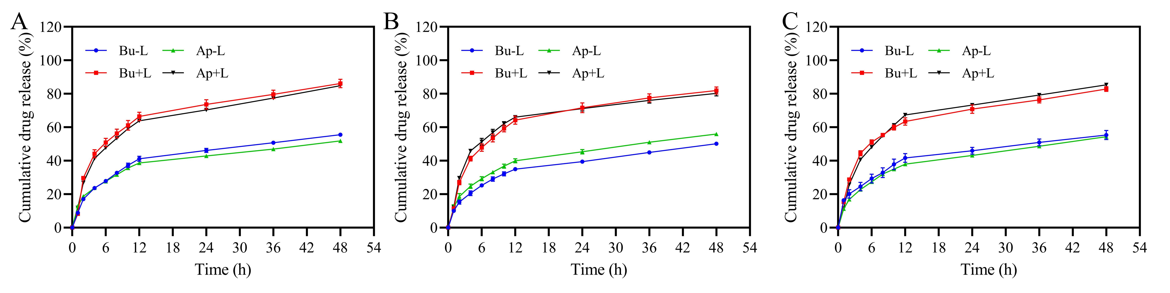
Fig. S9 In vitro release supplementary experiment (n=3)
(A) Bu = 1.125 mg·mL⁻¹, Ap = 0.375 mg·mL⁻¹. (B) Bu = 0.75 mg·mL⁻¹, Ap = 0.75 mg·mL⁻¹. (C) Bu = 0.375 mg·mL⁻¹, Ap = 1.125 mg·mL⁻¹.

Fig. S10 Apoptosis rate of HCT116 cells after treatment with different drugs. (n = 3, ***: p < 0.01)
Fig. S11 Quantitative analysis of antitumor mechanisms. (A) Accumulated optical density of Ki-67 immunohistochemistry. (B) Accumulated optical density of Cleaved Caspase-3 immunohistochemistry. (C) Accumulated optical density of MMP-2 immunohistochemistry. (D) Accumulated optical density of VEGF immunohistochemistry. (E) TUNEL apoptosis positive rate. (F) Immunofluorescence integral fluorescence value. (n=3, *: p < 0.05, **: p < 0.01)
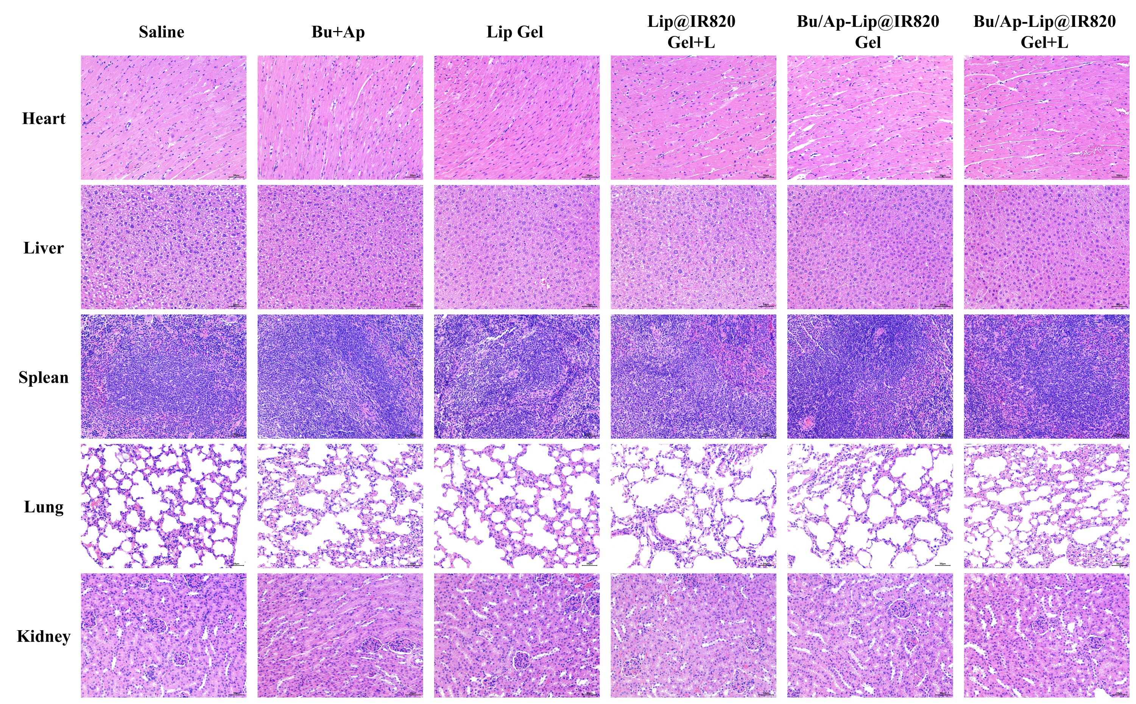
Fig. S12 HE staining of major organs treated with different drugs including heart, liver, spleen, lung and kidney (n=3). Scale bar: 50 μm.

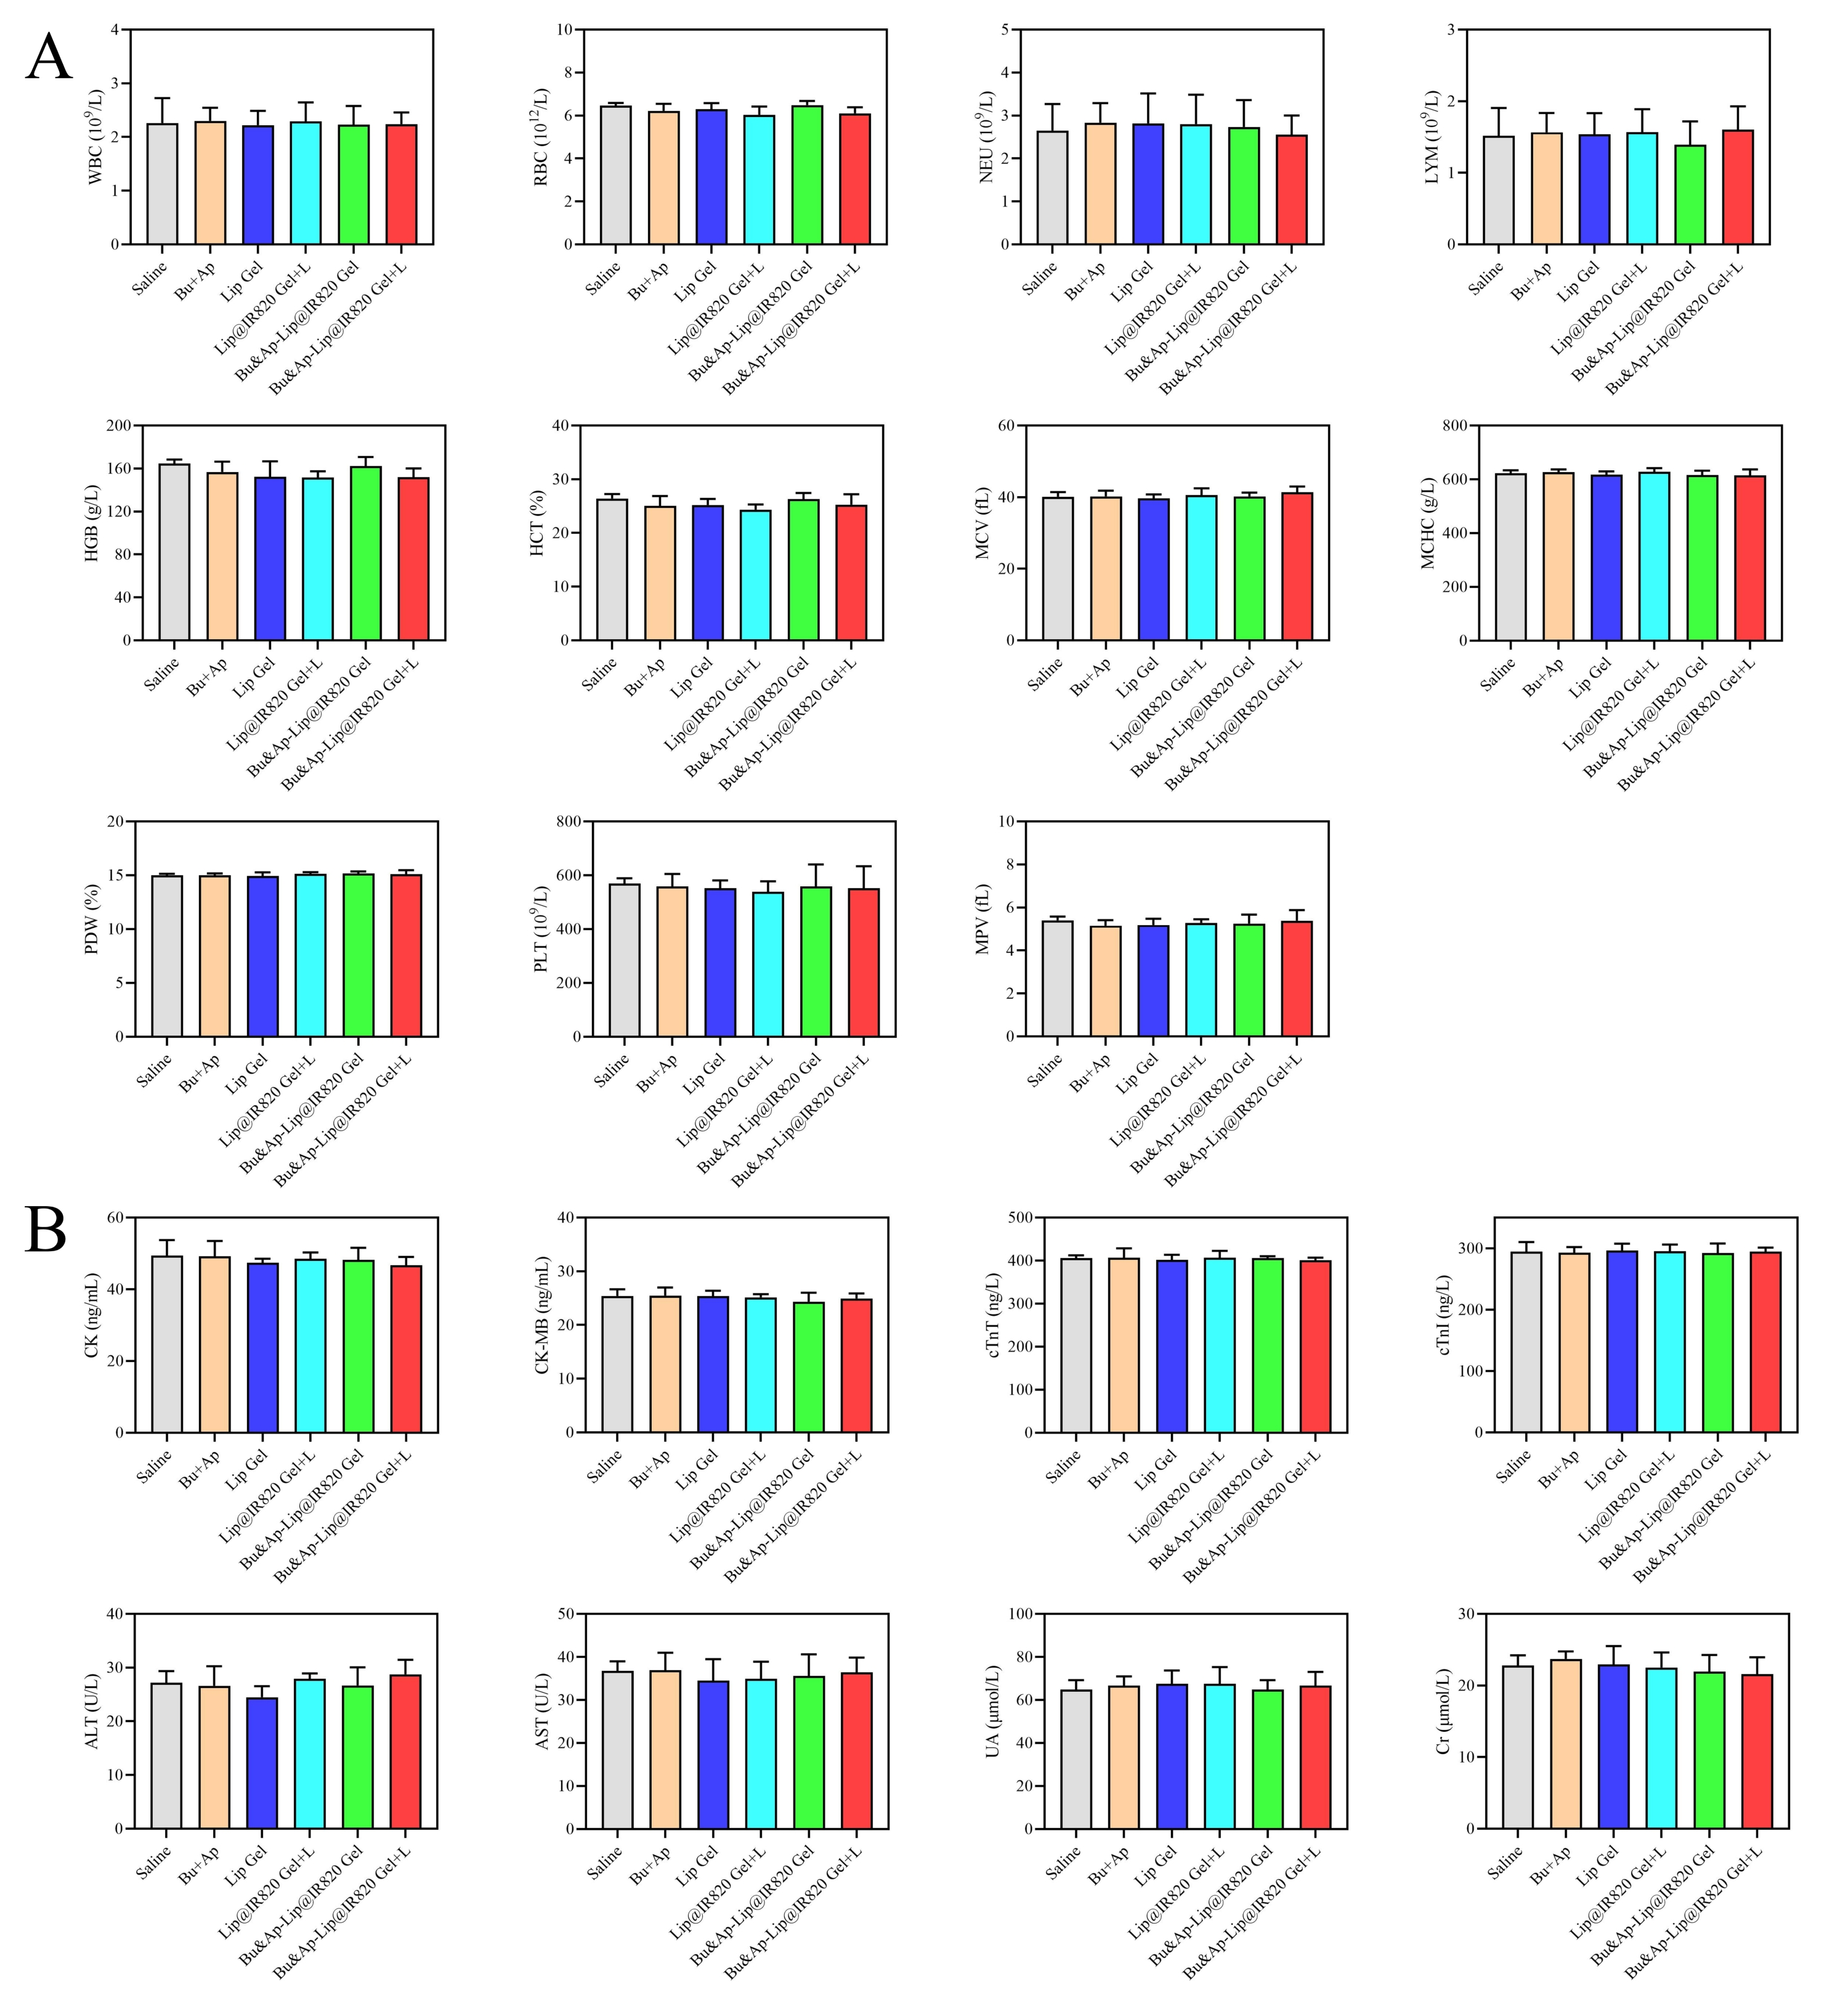
Fig. S13 Hydrogel biosafety results (n=6)
(A). Complete blood count results. (B). Serum biochemical indicators test results.
RBC: red blood cells, HGB: hemoglobin, HCT: hematocrit, MCV: mean corpuscular volume, MCHC: mean corpuscular hemoglobin concentration, WBC: white blood cell, NEU: neutrophil, LYM: lymphocyte, PDW: Platelet Distribution Width, PLT: platelet, MPV: mean platelet volume, CK: cardiac-related indicators creatine kinase, CK-MB: creatine kinase-MB, cTnT: cardiac troponin T, cTnI: cardiac troponin I, ALT: alanine aminotransferase, AST: aspartate aminotransferase, UA: uric acid, Cr: creatinine.

