Supplementary File
Table S1: The final pharmacophore models generated by the RLPG method and their ROC results with corresponding qualitative evaluations
Crystal Structure | Water at Active Site | Pharmacophore no. | Sensitivity | Specificity | ROC AUC | ROC Evaluation
3VW9 | With Water | 2 | 0.917 | 1.000 | 0.951 | Excellent
3VW9 | With Water | 6 | 0.917 | 0.727 | 0.917 | Excellent
3VW9 | With Water | 8 | 0.917 | 0.727 | 0.909 | Excellent
3VW9 | Without Water | 2 | 1.000 | 0.545 | 0.864 | Good
3VW9 | Without Water | 8 | 0.909 | 0.636 | 0.879 | Good
3VW9 | Without Water | 9 | 0.909 | 0.727 | 0.913 | Excellent
3W0T | With Water | 5 | 0.917 | 0.727 | 0.932 | Excellent
3W0T | With Water | 11 | 0.750 | 0.818 | 0.886 | Good
3W0T | Without Water | - | - | - | - | -
7WT2 | With Water | 1 | 0.917 | 0.778 | 0.856 | Good
7WT2 | Without Water | - | - | - | - | -

Table S2: The final pharmacophore models generated by the IG method and their ROC results with corresponding qualitative evaluations
Crystal Structure | Water at Active Site | Pharmacophore no. | Sensitivity | Specificity | ROC AUC | ROC Evaluation
3VW9 | With Water | 1 | 0.750 | 0.818 | 0.818 | Good
3VW9 | Without Water | 1 | 0.917 | 0.778 | 0.884 | Good
3VW9 | Without Water | 2 | 1.000 | 0.778 | 0.833 | Good
3VW9 | Without Water | 8 | 0.917 | 0.778 | 0.829 | Good
3W0T | With Water | 6 | 1.000 | 0.545 | 0.932 | Excellent
3W0T | With Water | 19 | 1.000 | 0.545 | 0.955 | Excellent
3W0T | Without Water | 3 | 1.000 | 0.455 | 0.864 | Good
3W0T | Without Water | 4 | 1.000 | 0.545 | 0.932 | Excellent
7WT2 | With Water | 39 | 0.833 | 0.778 | 0.926 | Excellent
7WT2 | Without Water | 3 | 0.667 | 0.909 | 0.889 | Good

Figure S1. Pharmacophore models generated using the RLPG method and their corresponding ROC curves based on the following GLO-I crystal structures: PDB IDs 3VW9, 3W0T, and 7WT2. Pharmacophore features are shown as follows: HBA (green), HBD (magenta), ZBF (light purple), AR (brown), HA (blue). The numbers denote the pharmacophore model identifiers used in this study.
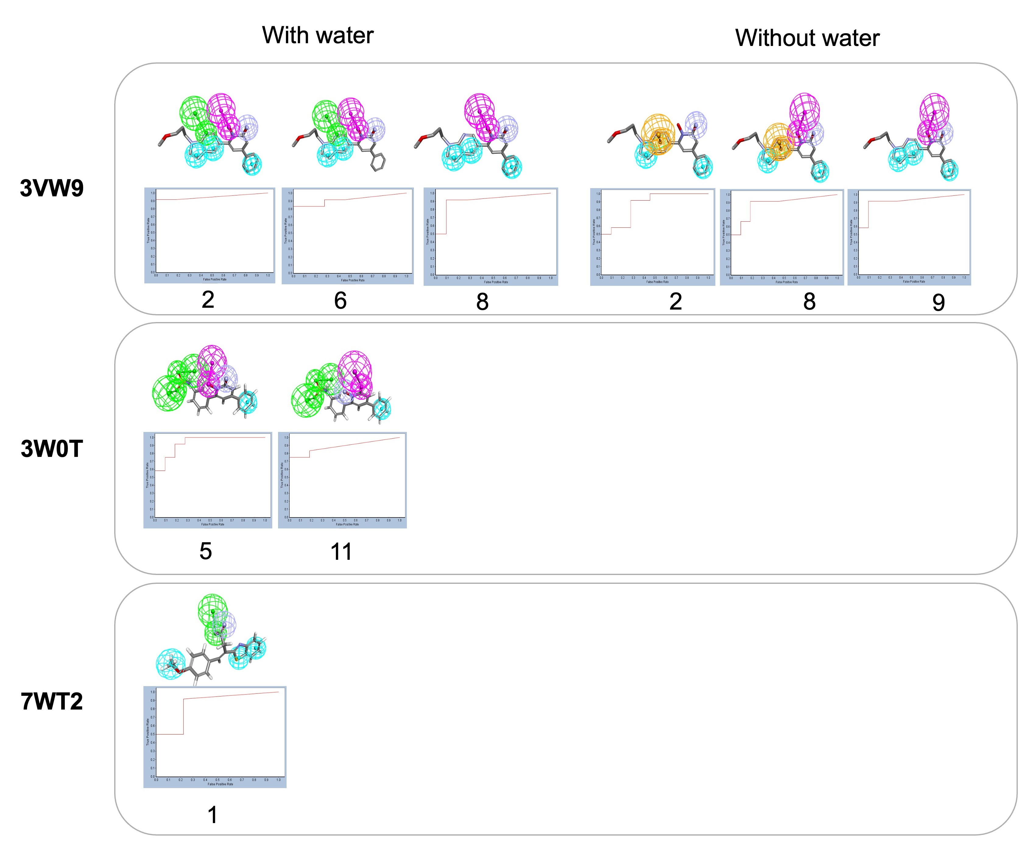
Figure S2. Pharmacophore models generated using the IG method and their corresponding ROC curves based on the following GLO-I crystal structures: PDB IDs 3VW9, 3W0T, and 7WT2. Pharmacophore features are shown as follows: HBA (green), HBD (magenta), ZBF (light purple), AR (brown), HA (blue). The numbers denote the pharmacophore model identifiers used in this study.
