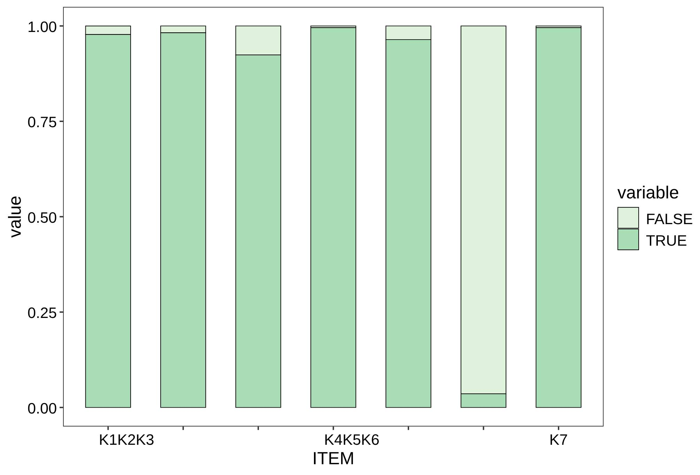
Supplementary Figure 1. Responses on the knowledge dimension

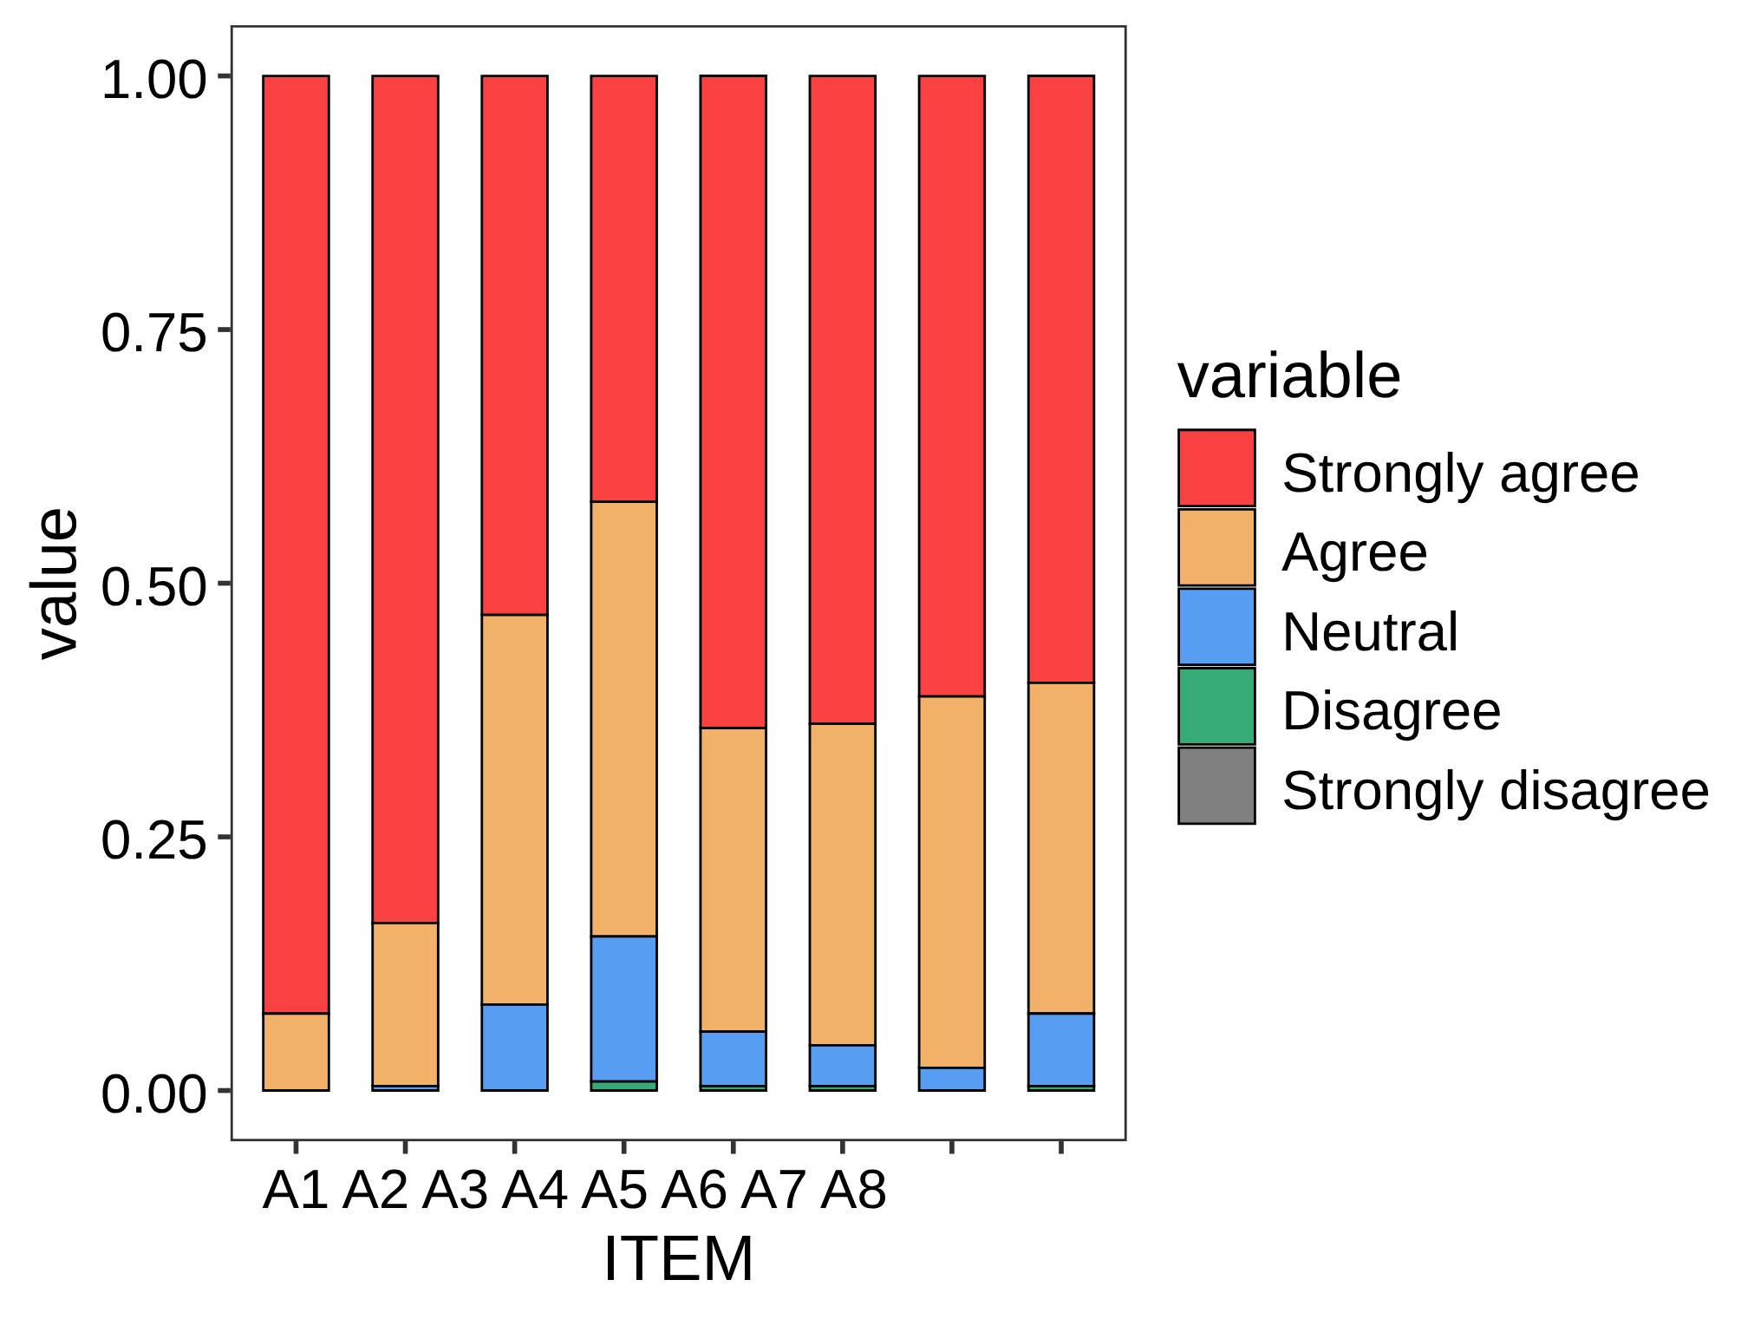
Supplementary Figure 2. Responses on the attitude dimension

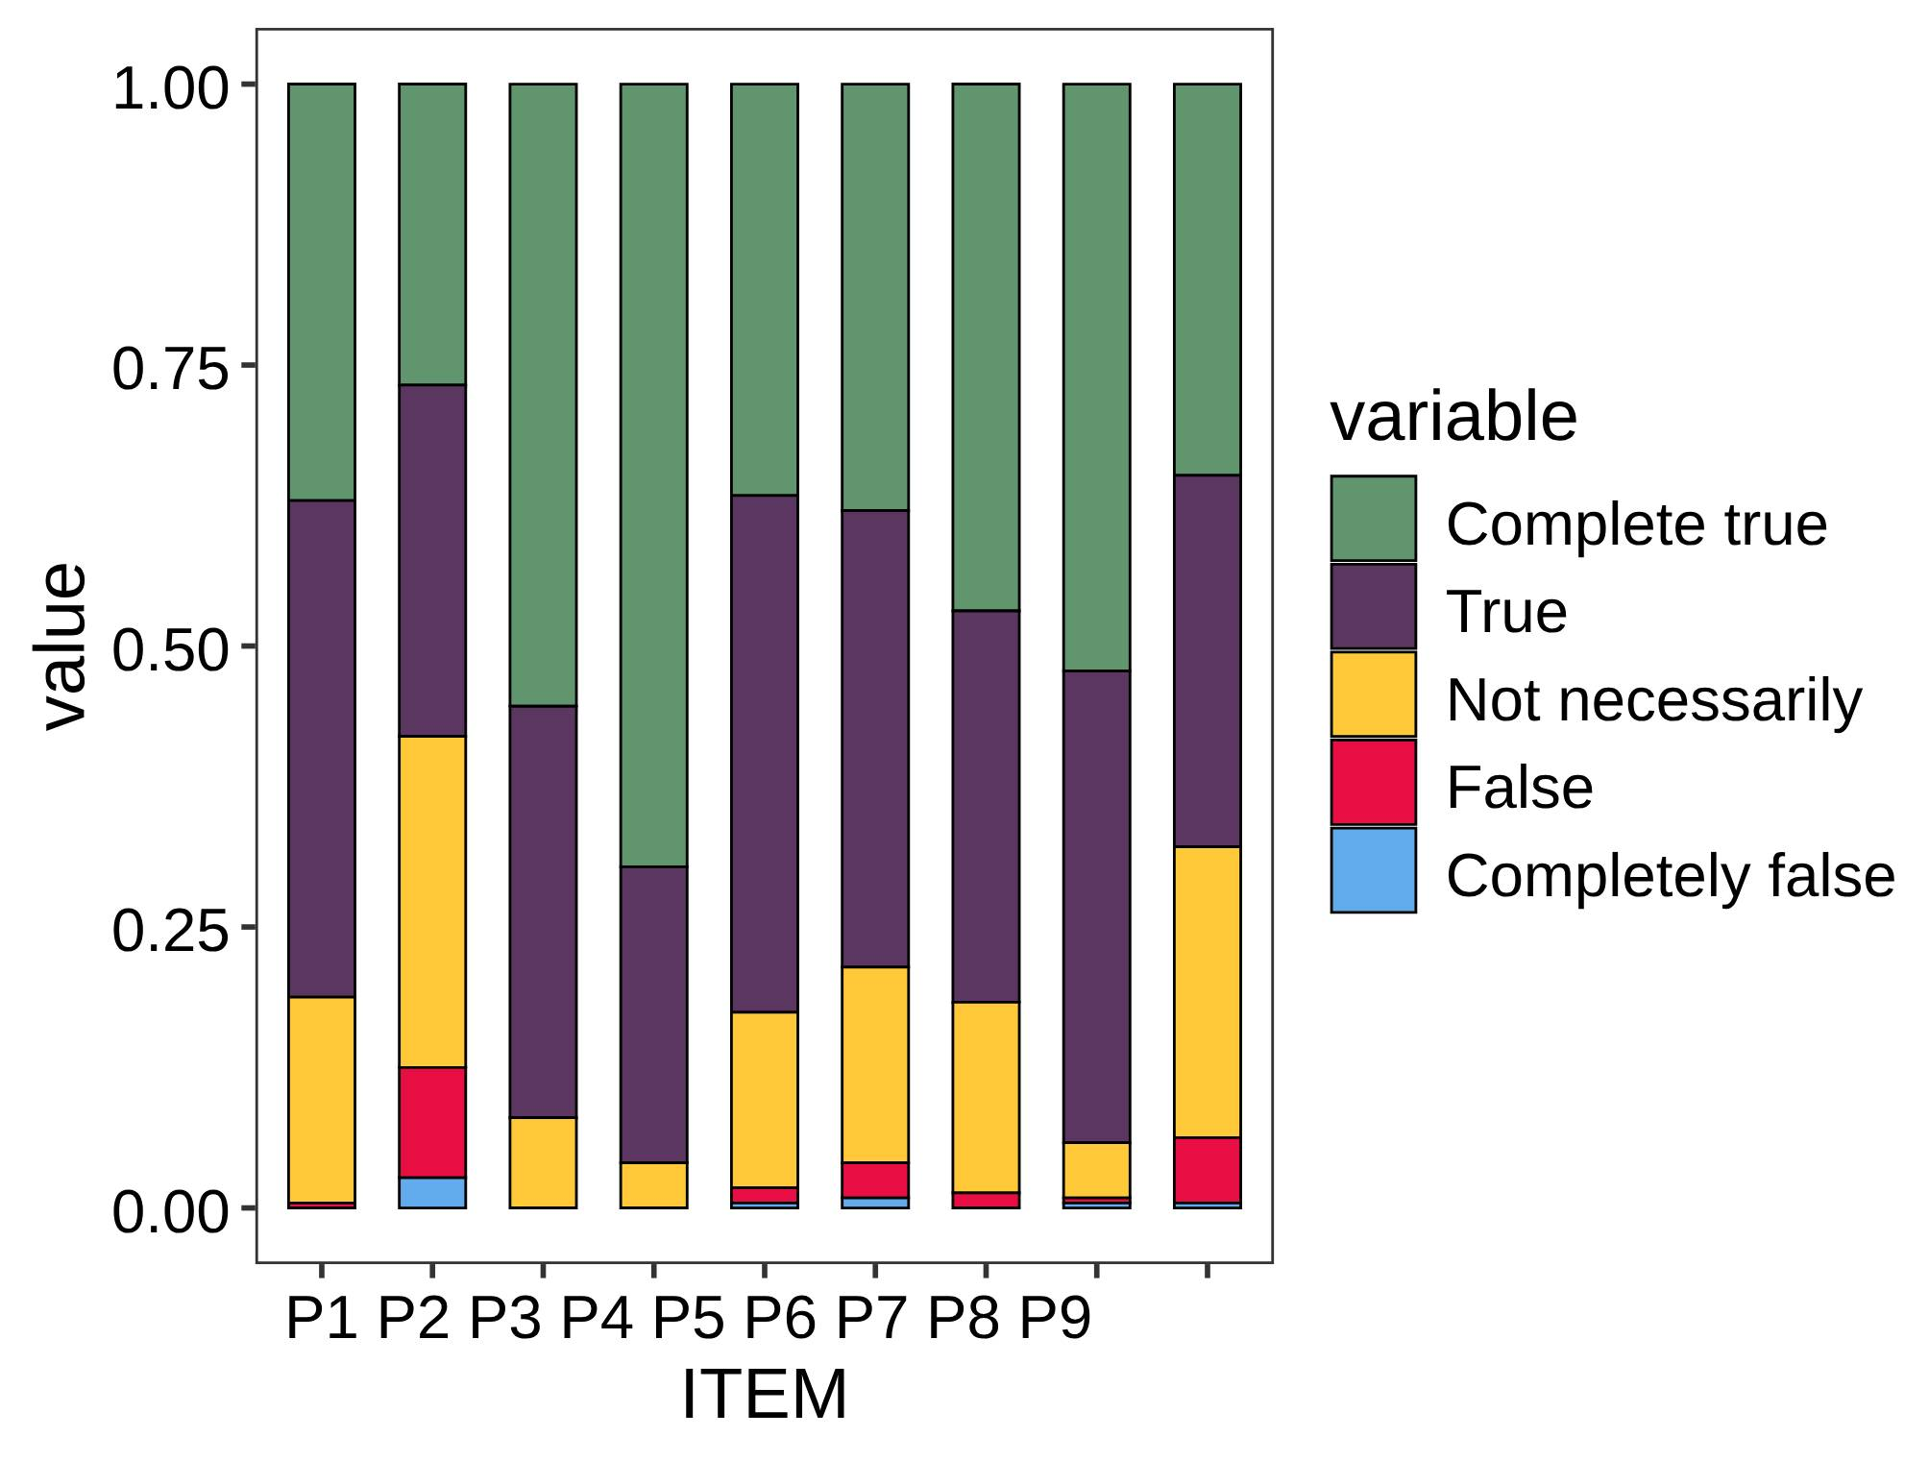
Supplementary Figure 3. Responses on the practice dimension

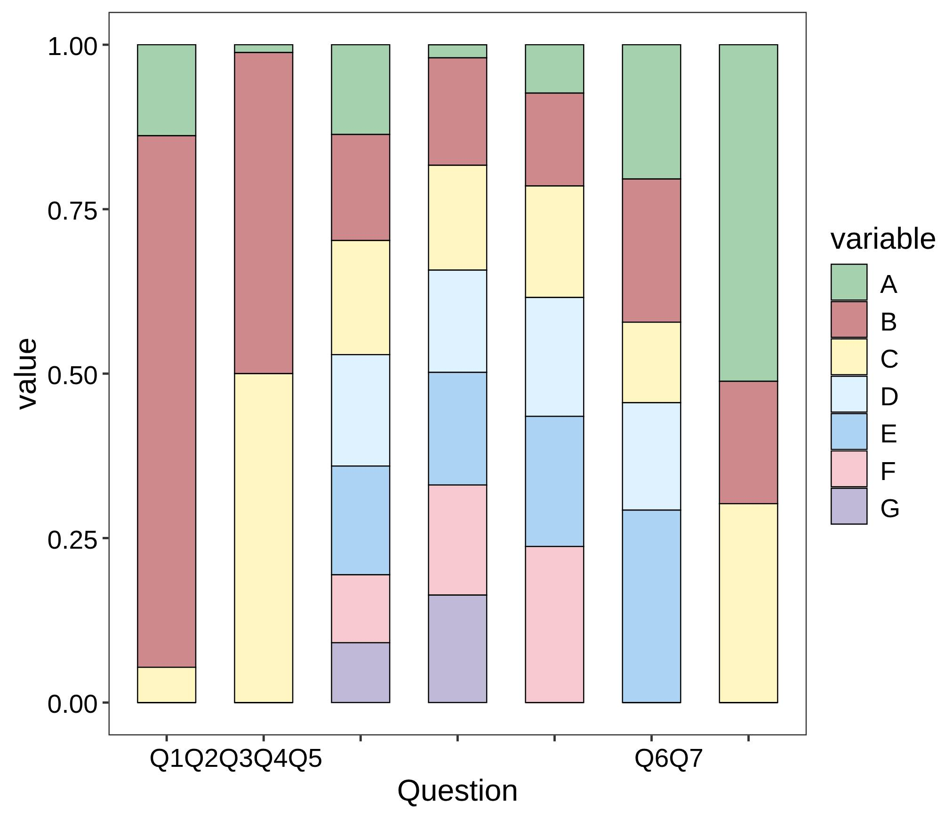
Supplementary Figure 4. Current bloodborne occupational exposure status
Supplementary table 1. Model fit indices for SEM
Indicators | Reference | Results
RMSEA | <0.08 Good | 0.051
SRMR | <0.08 Good | 0.023
TLI | >0.8 Good | 0.933
CFI | >0.8 Good | 0.990
RMSEA, root mean square error of approximation; SRMR, standardized root mean square residual; TLI, Tucker–Lewis index; CFI, comparative fit index.

Questionnaire Number:________________ （Please enable the comment view function to review the draft of the questionnaire）
Dear Sir/Madam,
Greetings！
We are researchers from the __________ Hospital, Department of __________, and we sincerely invite you to participate in our study titled "A Study on the Knowledge, Attitudes, and Practices of Acupuncture Physicians and Medical Students Regarding Bloodborne Occupational Exposure." The purpose of this study is to provide a scientifically sound tool to evaluate the knowledge, attitudes, and practices of acupuncture physicians and medical students concerning bloodborne occupational exposure. Additionally, it aims to survey the current status, analyze the factors affecting their knowledge-attitude-practice levels, and provide references for related training on bloodborne occupational exposure. Ultimately, we hope to improve the knowledge base of acupuncture physicians and medical students on bloodborne occupational exposure and enhance their current clinical practices related to such exposure.
We sincerely thank you for taking the time to complete this questionnaire. The process will take approximately 10 to 15 minutes. This research will not affect your rights or interests. The data collected will be encoded and securely stored, and only group data will be published. Your name and personal information will not be mentioned, and no related information will be disclosed to anyone without your permission. Please complete the questionnaire independently without referring to any related materials. We truly appreciate your support!

□I have read and agree that the collected data will be used for scientific research.
Informed Consent Signature:
Date of Participation： Year Month Day
Part 1 Basic Information
1. Your gender： | a、Male  b、Female
2. Your age： | _____years old
3. Place of residence： | a、Urban  b、Rural
4. Education level： | a、Technical school or below  b、Associate degree and bachelor’s degree  c、Master’s degree  d、PhD
5. Years of experience： | _____years
6. Professional title： | a、Junior  b. Intermediate  c. Associate Senior  d. Senior  e. None
7. Type of Hospital You Work In: | a. Primary Hospital  b. Secondary Hospital  c. Tertiary Hospital
8. Have you received any training related to bloodborne occupational exposure? | a. Yes  b. No
9. Your Professional Category: | a. Physician or Technician at this hospital  b. Nurse at this hospital  c. Student  d. Other

Part 2 Knowledge Related to Bloodborne Occupational Exposure
- Bloodborne occupational exposure refers to the exposure of healthcare or laboratory staff to infectious pathogens through contact with patients' blood or other body fluids. | a、True | b、False
- Hepatitis B virus (HBV), hepatitis C virus (HCV), and human immunodeficiency virus (HIV) can be transmitted to healthcare workers through bloodborne routes. | a、True | b、False
- The risk of infection after exposure for healthcare workers is primarily determined by three factors: (1) the prevalence of bloodborne pathogens in the population, (2) the likelihood of seroconversion after exposure, and (3) the frequency of exposure. | a、True | b、False
- The emergency management of bloodborne occupational exposure includes a series of measures such as local treatment, assessment of the exposure source, post-exposure management, and follow-up. | a、True | b、False
- The management of exposure varies depending on the type of virus involved and the vaccination status of the exposed individual. | a、True | b、False
- The management of exposure is the same regardless of the type of virus involved or the vaccination status of the exposed individual. | a、True | b、False
- Bloodborne occupational exposure can not only lead to infection but also cause psychological issues such as anxiety and fear, posing a serious threat to the physical and mental health of healthcare workers. | a、True | b、False

Part 3 Attitudes Towards Bloodborne Occupational Exposure
- You believe that preventive measures for bloodborne occupational exposure are necessary. (P) | a. Strongly agree | b. Agree | c. Neutral | d. Disagree | e. Strongly disagree
- You believe that following standard precautions can effectively reduce the risk of occupational exposure. (P) | a. Strongly agree | b. Agree | c. Neutral | d. Disagree | e. Strongly disagree
- You are concerned about the possibility of bloodborne occupational exposure in your work. (N) | a. Strongly agree | b. Agree | c. Neutral | d. Disagree | e. Strongly disagree
- You trust that the current post-exposure management and emergency response measures are effective. (P) | a. Strongly agree | b. Agree | c. Neutral | d. Disagree | e. Strongly disagree
- You are concerned that improper handling of occupational exposure may cause harm to patients or your own health. (N) | a. Strongly agree | b. Agree | c. Neutral | d. Disagree | e. Strongly disagree
- You believe that the hospital should provide more training on the prevention of bloodborne occupational exposure. (P) | a. Strongly agree | b. Agree | c. Neutral | d. Disagree | e. Strongly disagree
- You agree that occupational exposure risk assessment should be a routine part of your work. (P) | a. Strongly agree | b. Agree | c. Neutral | d. Disagree | e. Strongly disagree
- You believe that your colleagues will provide the necessary support and help in case of occupational exposure. (P) | a. Strongly agree | b. Agree | c. Neutral | d. Disagree | e. Strongly disagree

Part 4 Practices Regarding Bloodborne Occupational Exposure
1、You always wear appropriate personal protective equipment before performing procedures that may lead to bloodborne exposure. (P)
a. Completely true
b. True
c. Not necessarily
d. False
e. Completely false
2、You regularly participate in training on the prevention and control of bloodborne occupational exposure. (P)
a. Completely true
b. True
c. Not necessarily
d. False
e. Completely false
- After using sharp instruments (such as needles), you always follow the prescribed safety procedures for disposal. (P)
a. Completely true
b. True
c. Not necessarily
d. False
e. Completely false
4、You always disinfect your hands immediately after each contact with a patient's blood. (P)
a. Completely true
b. True
c. Not necessarily
d. False
e. Completely false
5、You are familiar with and can correctly execute emergency procedures after occupational exposure. (P)
a. Completely true
b. True
c. Not necessarily
d. False
e. Completely false
6、You regularly check and update your personal protective equipment to ensure its effectiveness. (P)
a. Completely true
b. True
c. Not necessarily
d. False
e. Completely false
- You proactively report all occupational exposure incidents, regardless of their severity. (P)
a. Completely true
b. True
c. Not necessarily
d. False
e. Completely false
- You provide your colleagues with information and support on preventing occupational exposure. (P)
a. Completely true
b. True
c. Not necessarily
d. False
e. Completely false
- You can accurately document all occupational exposure incidents and the actions taken. (P)
a. Completely true
b. True
c. Not necessarily
d. False
e. Completely false

Part 5 Current Status of Bloodborne Occupational Exposure Among Acupuncture Physicians and Medical Students
1、Have you experienced bloodborne occupational exposure in the past year?
a. Yes
b. No
c. Not sure
2、The site of your bloodborne occupational exposure was: (Multiple choice)
a. Hands
b. Eyes
c. Other
3、The source of your exposure was: (Multiple choice)
a. HBV
b. Treponema pallidum (Syphilis)
c. HCV
d. HIV
e. Co-infection
f. Unknown pathogen
g. No pathogen
4、The type of needle used during your bloodborne occupational exposure was: (Multiple choice)
a. Filiform needle
b. Intradermal needle
c. Dermal needle
d. Three-edged needle
e. Fire needle
f. Floating needle
g. Other types of needles
5、The stage at which you sustained the needle injury during bloodborne occupational exposure was: (Multiple choice)
a. During needle removal
b. During disposal of needle waste
c. Before needling
d. During needling
e. Accidental injury caused by others
f. Other stages
6、The location where your bloodborne occupational exposure occurred was: (Multiple choice)
a. Ward
b. Physiotherapy room
c. Treatment room
d. Outpatient clinic
e. Other locations
7、After experiencing bloodborne occupational exposure, your reporting situation was: (Single choice)
a. Reported immediately
b. Did not report due to unclear reporting procedure
c. Did not report because I believed it was unnecessary

