Supplementary Figure 1. A method flow diagram of MR analysis.
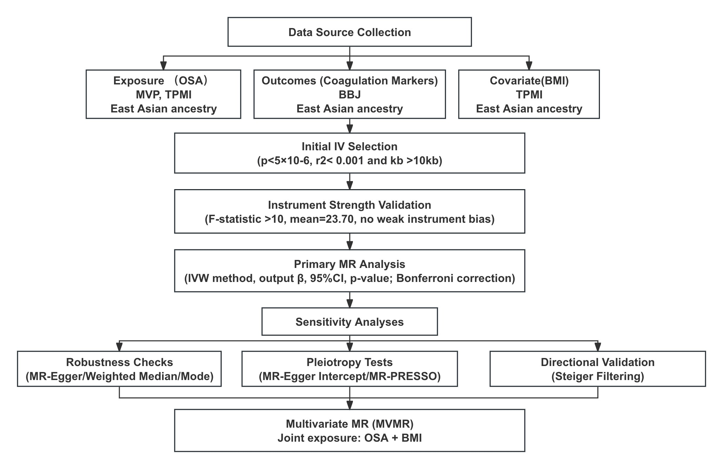
Abbreviations: SNPs, single-nucleotide polymorphism; MVP, Million Veteran Program; TPMI, Taiwan Precision Medicine Initiative.

Supplementary Table 1. GWAS Study Traits and Demographics.
ID | Trait | Sample size | Cohort | Ancestry
GCST90477484  TPMI:327.3  TPMI: BMI | Sleep apnea  Sleep apnea  Body mass index | 6,550  316,351  191,458 | Million Veteran Program  Taiwan Precision Medicine Initiative  Taiwan Precision Medicine Initiative | East Asian  East Asian  East Asian
bbj-a-7 | Activated partial thromboplastin time | 37,767 | BioBank Japan | East Asian
bbj-a-22 | Fibrinogen | 18,348 | BioBank Japan | East Asian
bbj-a-47 | Prothrombin time | 58,110 | BioBank Japan | East Asian
Abbreviations: GWAS Genome-wide association study, SNPs single-nucleotide polymorphisms.

Supplementary Table 2. Steiger filtering results of OSA on coagulation marker
GWAS | Exposure | Outcome | R²_exposure | R²_outcome | Correct_causal_direction
TPMI:327.3 | OSA | APTT | 1.51E-04 | 1.92E-05 | TRUE
 | OSA | Fibrinogen | 1.51E-04 | 1.30E-05 | TRUE
 | OSA | PT | 1.51E-04 | 1.12E-04 | TRUE
GCST90477484 | OSA | APTT | 1.44E-02 | 8.93E-05 | TRUE
 | OSA | Fibrinogen | 1.44E-02 | 3.06E-04 | TRUE
 | OSA | PT | 1.44E-02 | 1.09E-04 | TRUE
Abbreviations: OSA, Obstructive sleep apnea; GWAS, Genome-wide association study; APTT, Activated Partial Thromboplastin Time; Fib, Fibrinogen; PT, Prothrombin Time. R²_exposure and R²_outcome denote the variance explained by the instrumental SNPs in the exposure and the outcome, respectively.

