Samples were separated on a reversed-phase C18 column (ACQUITY UPLC®HSS T3 column, 150 mm × 2.1 mm, 1.8 µm, Waters, USA). The mobile phase consisted of acetonitrile and water in the ratio of 95:5 (v/v) with 0.1% formic acid. The flow rate was set as 0.3 mL/min, and the temperature was maintained at 25℃. In the QDa detector condition, the capillary and cone voltage were set as 2.4 kV and 40 V, respectively. The quantitation of samples was performed by single ion recording (SIR) of the transition of m/z 349 [M+Na]⁺ for AG and m/z 325 [M−H]⁻ for IS.
Supplementary Figure 1. The selected ion chromatograms for (A) AG and (B) IS in rat plasma.

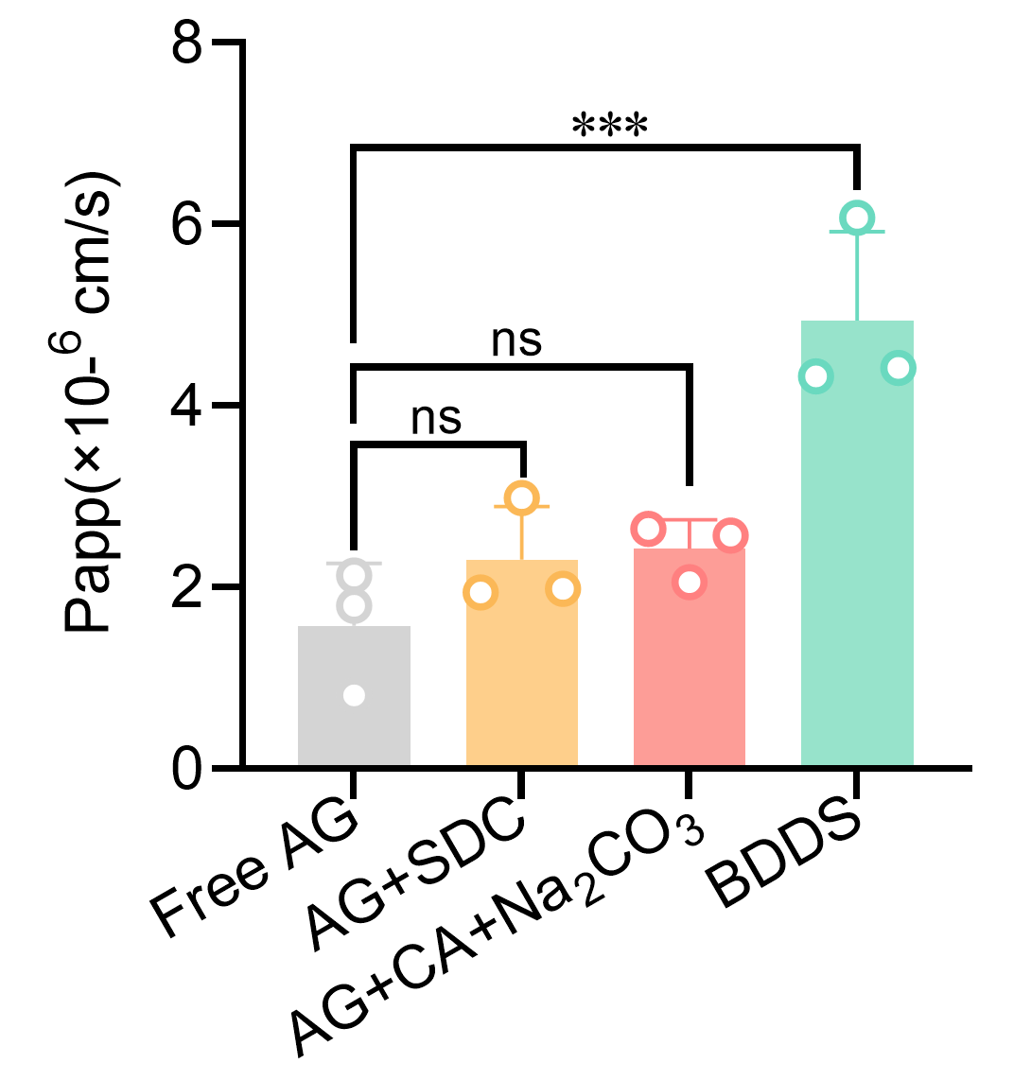
Supplementary Figure 2. Apparent permeability coefficient (Papp) determined by the parallel artificial membrane permeability assay (PAMPA). ^{ns} no significance; *** p < 0.001 versus the Free AG group.

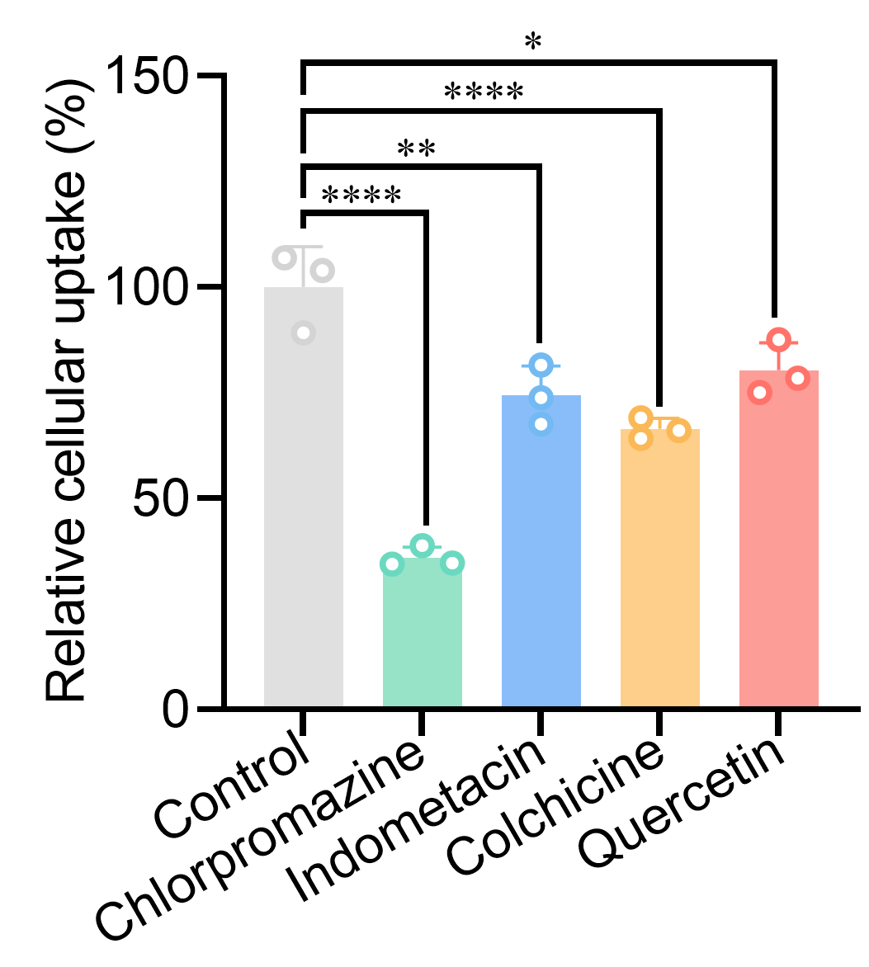
Supplementary Figure 3. Effects of endocytosis inhibitors on the internalization of BDDS in Caco-2 cells. * p < 0.05; ** p < 0.01; **** p < 0.0001 versus the control group.

