Supplementary Material

Supplementary table 1. List of All Included Variables with Their Respective Units
Categories | Clinical indicator | Unit
Demographic data | Age | year
 | Sex | /
 | Body Mass Index（BMI） | Kg/m2
 | Smoking history | /
 | Drinking alcohol history | /
Comorbidities | hypertension | Yes or not
 | diabetes | Yes or not
 | stroke | Yes or not
 | Number of atrial fibrillation ablations | Times
Complete Blood Count | White Blood Cell Count (WBC) | 10^9/L
 | Red Blood Cell Count (RBC) | 10^12/L
 | Platelet Count (PLT) | 10^9/L
 | Hemoglobin (Hb) | g/L
 | Neutrophil Percentage (Neut%) | %
Coagulation function | D-Dimer | ng/mL
Comprehensive Metabolic Panel | Aspartate Aminotransferase (AST) | U/L
 | Alanine Aminotransferase (ALT) | U/L
 | Gamma-Glutamyl Transferase (GGT) | U/L
 | Alkaline Phosphatase (ALP) | U/L
 | Direct Bilirubin (DBIL) | umol/L
 | Indirect Bilirubin (IBIL) | umol/L
 | Creatinine (Crea) | umol/L
 | Uric Acid (UA) | umol/L
 | Urea | mmol/L
 | Free Fatty Acids (FFA) | mmol/L
 | Total Protein (TP) | g/L
 | Albumin (ALB) | g/L
 | Globulin (GLO) | g/L
 | Cystatin C (Cys-C) | mg/L
Glucose level | Glycosylated Hemoglobin, Type A1C (HbA1c) | %
Lipid Profile | Total Cholesterol (TC) | mmol/L
 | Triglyceride (TG) | mmol/L
 | Low-Density Lipoprotein Cholesterol (LDL-C) | mmol/L
 | High-Density Lipoprotein Cholesterol (HDL-C) | mmol/L
 | Lipoprotein a (LPa) | mg/L
 | Apolipoprotein A1 (apoA1) | g/L
 | Apolipoprotein B, apoB) | g/L
Thyroid function | Thyroid-Stimulating Hormone (TSH) | mIU/L
 | Total Thyroxine (TT4) | nmol/L
 | Total Triiodothyronine (TT3) | nmol/L
Cardiac biomarkers | N-Terminal Pro-B-Type Natriuretic Peptide (NT-ProBNP) | ng/L
 | Creatine Kinase (CK) | IU/L
Echocardiogram | left Atrium (LA) | mm
 | Right Atrium (RA) | mm
 | Left Ventricular End-Diastolic Diameter (LVEDd) | mm
 | Left Ventricular Ejection Fraction (LVEF) | %

Supplementary Table 2. Comparison of train set and test set baseline information
Variables | Train set (n = 751) | Test set (n = 322) | P
Neut, % | 55.99 ± 8.71 | 56.03 ± 7.96 | 0.945
RBC, 10^12/L | 4.60 ± 0.53 | 4.63 ± 0.59 | 0.439
Age, year | 63.00 (55.00, 71.00) | 62.00 (54.00, 69.75) | 0.153
D-Dimer, ng/mL | 67.67 (37.50, 122.00) | 74.50 (39.25, 125.00) | 0.231
GGT, U/L | 24.00 (17.00, 38.00) | 22.00 (16.12, 32.45) | 0.054
AST, U/L | 19.10 (15.90, 23.60) | 19.30 (15.62, 23.90) | 0.791
HbA1c, % | 6.00 (5.70, 6.50) | 6.00 (5.70, 6.44) | 0.261
RA, mm | 36.00 (33.00, 41.00) | 36.00 (33.00, 39.00) | 0.789
TG, mmol/L | 1.09 (0.83, 1.56) | 1.15 (0.83, 1.57) | 0.183
LVEF, % | 61.90 (58.98, 63.37) | 61.68 (58.22, 63.83) | 0.599
Urea, mmol/L | 5.60 (4.70, 6.80) | 5.53 (4.50, 6.70) | 0.207
FFA, mmol/L | 0.41 (0.30, 0.54) | 0.41 (0.30, 0.54) | 0.845
GLO, g/L | 23.40 (20.90, 26.30) | 24.00 (21.10, 27.20) | 0.139
Crea, umol/L | 74.20 (64.00, 87.13) | 77.00 (66.00, 88.93) | 0.362
TT3, nmol/L | 1.62 (1.40, 1.82) | 1.64 (1.42, 1.83) | 0.512
TSH, mIU/L | 2.42 (1.55, 3.75) | 2.56 (1.72, 3.88) | 0.195
ApoB, g/L | 0.74 (0.59, 0.94) | 0.77 (0.62, 0.95) | 0.115
PLT, 10^9/L | 195.00 (164.50, 231.00) | 202.00 (166.00, 232.00) | 0.241
ApoA1, g/L | 1.12 (1.00, 1.27) | 1.14 (1.02, 1.29) | 0.210
ALT, U/L | 17.90 (13.34, 24.65) | 18.79 (13.40, 26.18) | 0.459
LVEDd, mm | 49.00 (47.00, 51.00) | 49.00 (47.00, 51.00) | 0.456
UA, umol/L | 328.00 (268.05, 395.00) | 329.13 (271.72, 399.48) | 0.875
TT4, nmol/L | 88.57 (78.22, 100.70) | 91.85 (80.52, 101.88) | 0.061
TP, g/L | 65.10 (62.05, 68.60) | 65.75 (62.30, 69.07) | 0.165
HDL-C, mmol/L | 1.01 (0.86, 1.18) | 1.02 (0.88, 1.19) | 0.428
Hb, g/L | 141.00 (130.00, 151.00) | 141.50 (128.00, 154.00) | 0.799
LPa, mg/L | 110.56 (56.67, 215.45) | 125.70 (60.97, 251.32) | 0.228
LDL-C, mmol/L | 2.24 (1.76, 2.77) | 2.34 (1.80, 2.84) | 0.161
Cys-C, mg/L | 0.98 (0.83, 1.16) | 0.96 (0.81, 1.12) | 0.121
NT-ProBNP, ng/L | 501.75 (155.70, 1040.00) | 442.57 (137.12, 1100.00) | 0.255
WBC, 10^12/L | 5.73 (4.81, 6.69) | 5.93 (5.00, 6.89) | 0.072
TC, mmol/L | 3.52 (2.93, 4.13) | 3.63 (3.02, 4.28) | 0.114
DBIL, umol/L | 4.59 (3.15, 6.21) | 4.18 (3.07, 6.00) | 0.132
ALP, U/L | 66.00 (55.70, 78.00) | 65.40 (53.25, 78.38) | 0.598
BMI, Kg/m2 | 25.78 (23.73, 28.07) | 25.52 (23.27, 28.01) | 0.389
CK, IU/L | 74.00 (54.00, 100.00) | 71.50 (54.50, 100.64) | 0.805
IBIL, umol/L | 9.86 (6.83, 13.96) | 9.77 (6.90, 12.87) | 0.511
LA, mm | 40.00 (35.00, 44.00) | 40.00 (35.00, 44.00) | 0.956
ALB, g/L | 41.50 (39.40, 44.20) | 41.60 (39.50, 43.80) | 0.922
Male, n(%) | 455 (60.59) | 193 (59.94) | 0.842
Smoke, n(%) | 165 (21.97) | 66 (20.50) | 0.590
Hypertension, n(%) | 332 (44.21) | 157 (48.76) | 0.170
Diabetes, n(%) | 114 (15.18) | 47 (14.60) | 0.806
Alcohol, n(%) | 131 (17.44) | 58 (18.01) | 0.823
Stroke, n(%) | 72 (9.59) | 28 (8.70) | 0.645
Secondary Catheter Ablation, n(%) | 245 (32.62) | 107 (33.23) | 0.846

Supplementary Table 3. Boruta Feature screening results
Variables | meanImp | medianImp | minImp | maxImp | normHits | decision
sex | 1.93261449 | 1.8724345 | 0.16460409 | 4.01706 | 0.05050505 | Rejected
age | 5.99972442 | 6.0694807 | 3.16261628 | 9.352741 | 0.97979798 | Confirmed
GGT | 1.28413045 | 1.4926195 | -1.36688658 | 3.942743 | 0.07070707 | Rejected
TG | 2.70419229 | 2.7936887 | -1.26936822 | 7.034789 | 0.57575758 | Tentative
LVEF | 4.73570849 | 4.6950982 | 1.30680015 | 7.724249 | 0.92929293 | Confirmed
Urea | 3.77231699 | 3.7875893 | 1.23087998 | 7.329077 | 0.81818182 | Confirmed
GLO | 3.17106883 | 3.158882 | 0.51857471 | 6.529087 | 0.70707071 | Confirmed
smoke | 2.95065316 | 2.8430508 | 0.09599515 | 6.327082 | 0.6969697 | Confirmed
Hb | 2.67567731 | 2.5760897 | -0.13880377 | 5.010477 | 0.62626263 | Tentative
LPa | -0.07549698 | -0.1710686 | -1.4317386 | 1.147517 | 0 | Rejected
Cys-C | 5.56286076 | 5.4342739 | 2.85712409 | 9.040796 | 0.96969697 | Confirmed
NT-ProBNP | 17.34343055 | 17.4454658 | 13.13147541 | 21.217733 | 1 | Confirmed
DBIL | 4.06054254 | 3.7794628 | 0.81608417 | 6.776269 | 0.81818182 | Confirmed
CK | 3.66678861 | 3.6448156 | 1.05405654 | 6.623658 | 0.81818182 | Confirmed

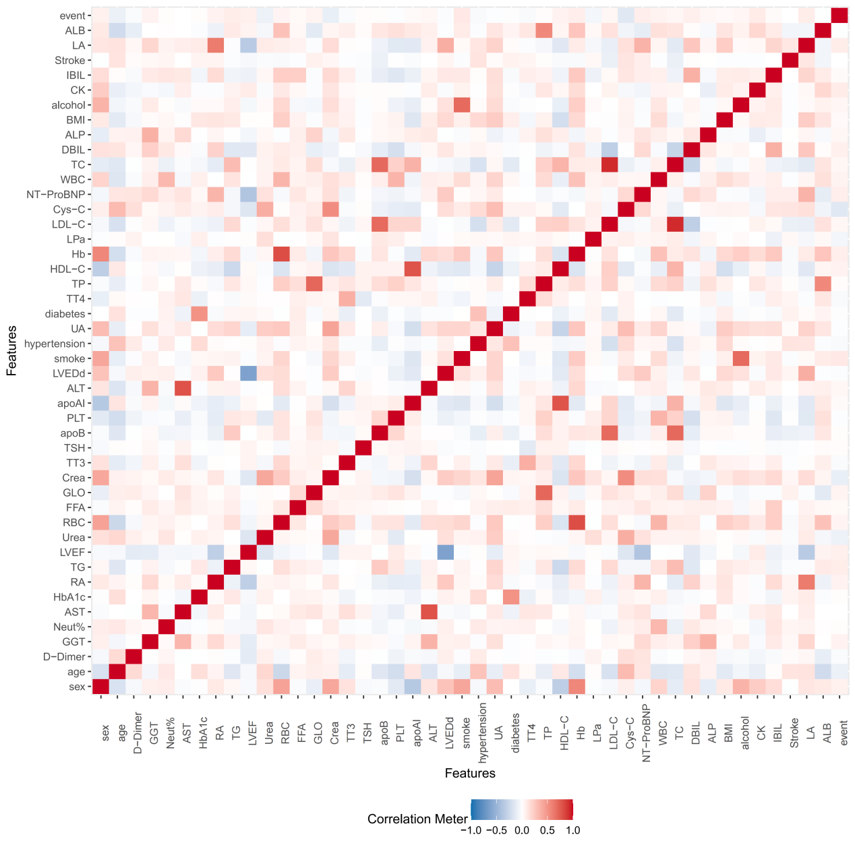
Supplement figure 1. Correlation Plot of Variables for the Entire Dataset

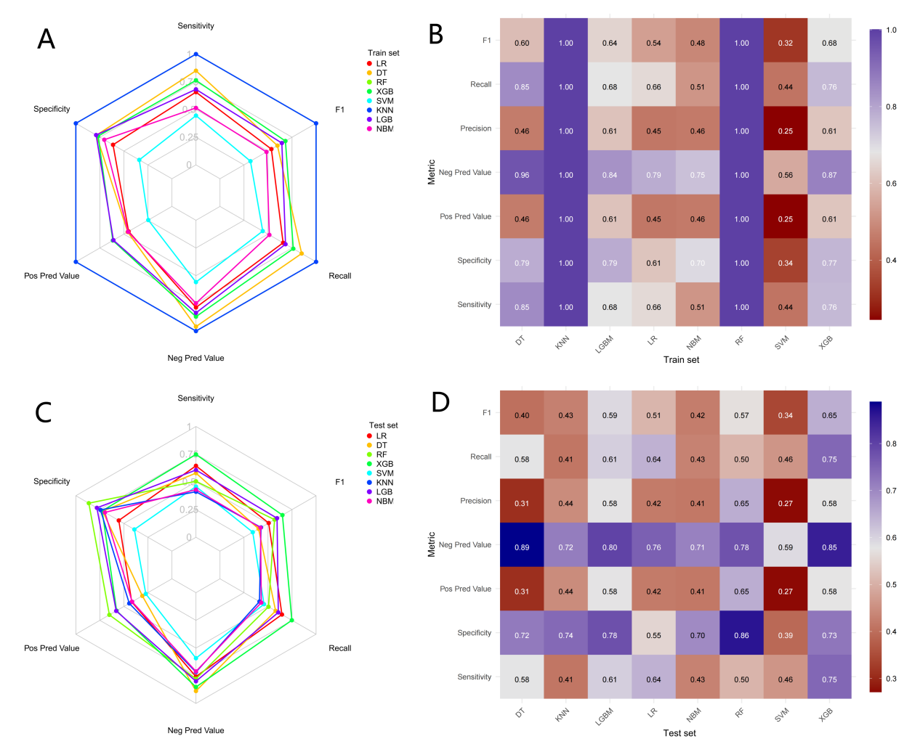
Supplementary Figure 2. Visual comparison of performance metrics for machine learning models.
(A, C) Radar plots showing six key performance metrics (F1, recall, precision, specificity, positive and negative predictive values) for each model in the training and test sets. (B, D) Corresponding heatmaps providing a color-coded summary of the same metrics. The XGBoost model demonstrated superior overall balance between sensitivity and specificity, particularly in the test set.

