Supplementary Material

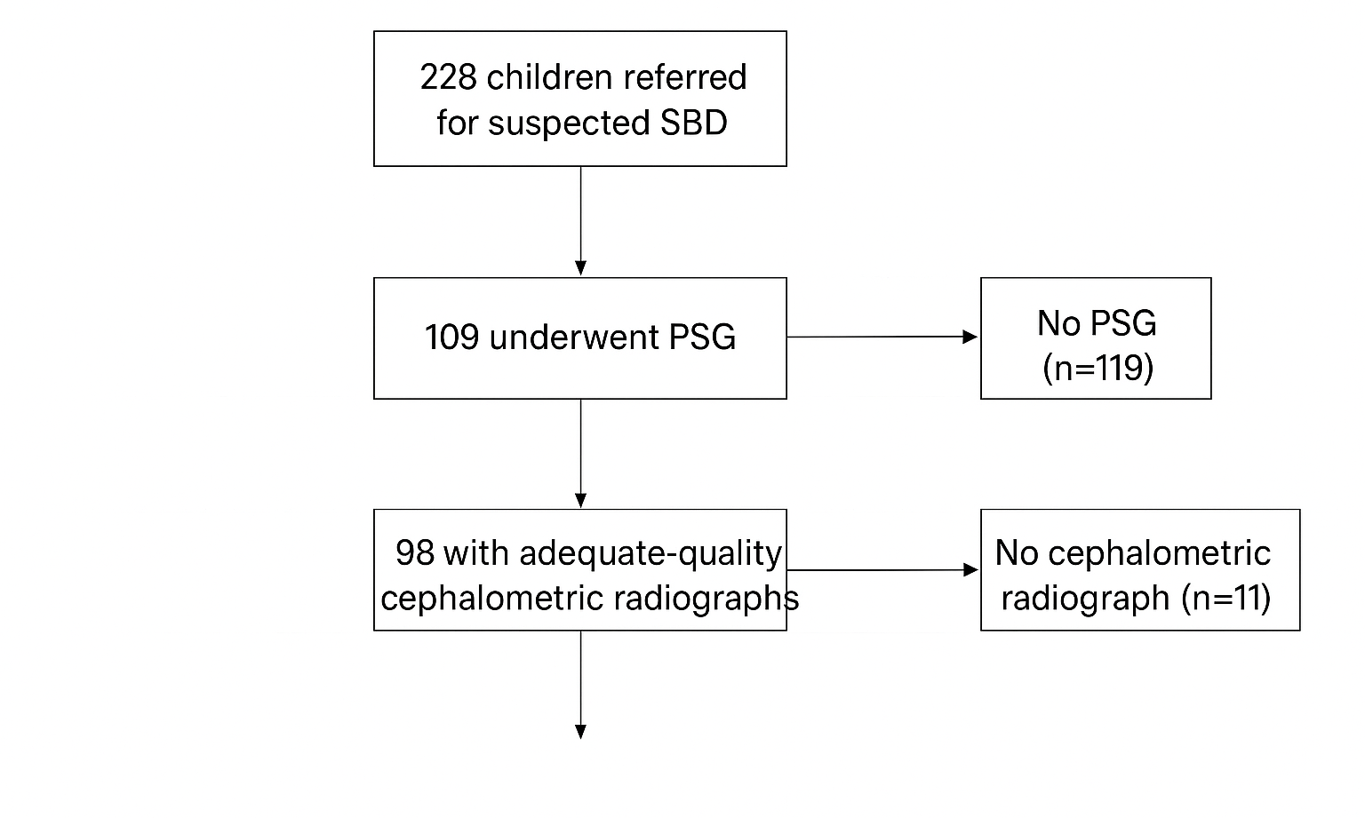

Supplementary Figure S1. Diagram of Participant Inclusion and Analytical Sample Selection

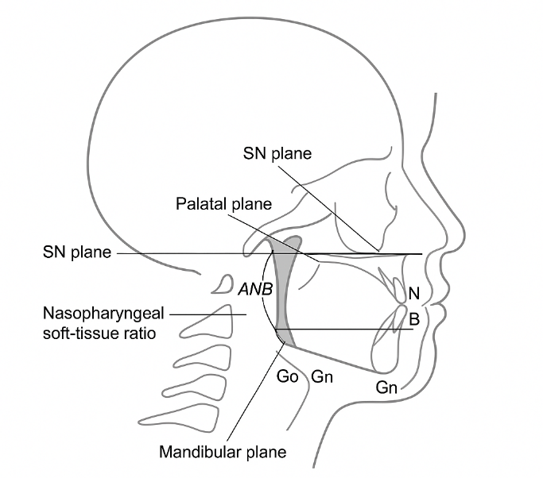

Supplementary Figure S2. Annotated Lateral Cephalogram Showing Cephalometric Landmarks, Reference Planes, ANB Angle, and Nasopharyngeal Soft-Tissue Ratio

Note: S = Sella; N = Nasion; A = A-point; B = B-point; PNS = Posterior nasal spine; Go = Gonion; Gn = Gnathion; SN plane = Sella–Nasion reference line; Palatal plane = ANS–PNS reference line (or N–PNS depending on your study convention); Mandibular plane = Gonion–Gnathion line.

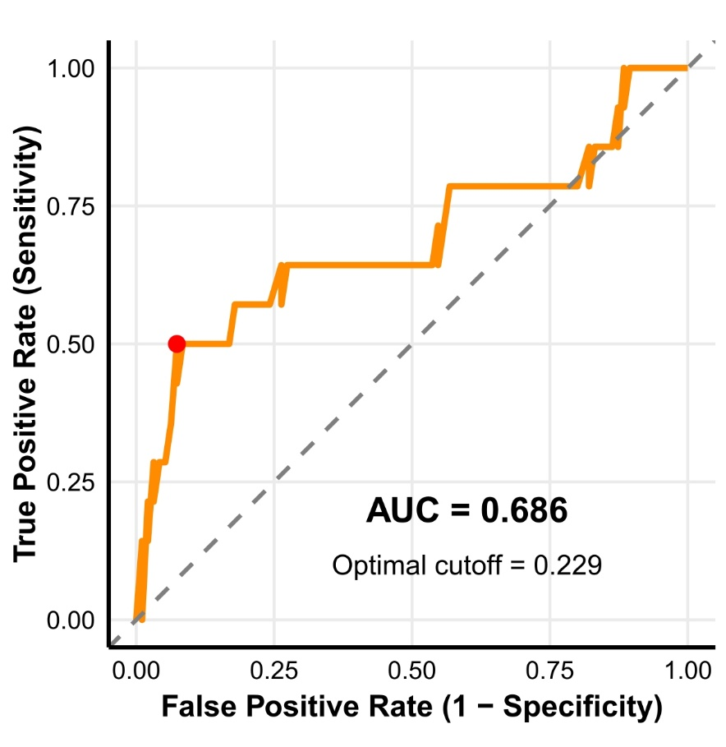

Supplementary Figure S3. Calibration Plot of the Predictive Model for Pediatric OSA
Notes: AUC – area under the curve

Supplementary Table S1: Consolidated participant accounting and data completeness
Study stage | Number | Notes / Reasons
Screened (referred for suspected SDB) | 256 | Referral log from June 2024 – Nov 2024
Excluded before enrolment | 28 | Prior adenotonsillectomy (n = 12); genetic / craniofacial syndrome (n = 4); declined consent (n = 9); other (n = 3)
Enrolled / consented | 228 | All underwent baseline clinical assessment
Lateral cephalogram performed | 104 | Radiographs obtained as part of clinical care
Cephalograms excluded for poor quality (motion / positioning) | 6 | Excluded after QC review
Cephalograms meeting inclusion criteria | 98 | Used in cephalometric analyses
Overnight PSG performed | 114 | All PSG scored per AASM pediatric rules
PSG excluded (technical failure / TST < 2 h) | 5 | Excluded from analytic dataset
PSG recordings included in analysis | 109 | Used for PSG-based analyses
Final analytic sample (cephalogram + PSG available) | 98 | Used in integrated models
Overall analytic denominator | 228 | For descriptive and demographic summaries

Supplementary Table S2: Comparison of Craniofacial Cephalometric Measurements and Soft Tissue Parameters Between Non-OSA and OSA Children
Parameter | Non-OSA Children (n = 119) | OSA Children (n = 122) | p-value
Skeletal Measurements
SNA (°) | 78.4 ± 3.2 | 78.1 ± 3.5 | 0.522
SNB (°) | 75.1 ± 3.1 | 74.3 ± 3.4 | 0.082
ANB (°) | 3.3 ± 1.0 | 3.9 ± 0.9 | <0.001
ANB classification (%)
- Class I | 98 (82.4%) | 99 (81.1%) | —
- Class II | 19 (16.0%) | 23 (18.9%) | —
- Class III | 2 (1.7%) | 0 | —
Soft Tissue Measurements
Soft palate length (mm) | 29.5 ± 3.2 | 30.2 ± 3.3 | 0.078
Adenoid–nasopharyngeal (A/N) ratio | 0.63 ± 0.08 | 0.68 ± 0.09 | <0.001
Airway space (mm) | 8.8 ± 2.4 | 8.1 ± 2.5 | 0.052
Tongue length (mm) | 56.3 ± 4.5 | 57.1 ± 4.7 | 0.192
Tissue Ratio | 0.64 ± 0.09 | 0.69 ± 0.11 | <0.001
Abbreviations: SNA: Sella-Nasion-A-point; SNB: Sella-Nasion-B-point; ANB: A-point-Nasion-B-point

Supplementary Table S3: Paediatric Obstructive Sleep Apnea Severity
Variable | Odds_ratio | CI_lower | CI_upper | p_value | prevalence_mod_severe | prevalence_normal_mild | n_mod_severe | n_normal_mild | variable_clean
Has_snoring | 3.207792208 | 0.394768404 | 26.06574 | 0.438069 | 92.85714 | 80.20833 | 14 | 96 | Snoring
Has_breathing_pauses | 1.105263158 | 0.28034846 | 4.357458 | 1 | 21.42857 | 19.79167 | 14 | 96 | Breathing Pauses
Has_inattention | 0.763636364 | 0.222386837 | 2.62219 | 0.89925 | 28.57143 | 34.375 | 14 | 96 | Inattention
Has_dark_circles | 0.396825397 | 0.123641945 | 1.2736 | 0.192586 | 35.71429 | 58.33333 | 14 | 96 | Dark Circles
Has_mouth_breathing_quiet | 0.627118644 | 0.203512952 | 1.932446 | 0.599184 | 50 | 61.45833 | 14 | 96 | Mouth Breathing

Supplementary Table S4: Key correlation analysis
AHI_BMI | 0.147004704
AHI_NasopharynxRatio | 0.103061328
AHI_ANB | 0.16468842
SaO2_AHI | -0.074997685
AHI_Age | -0.055793231
Abbreviaions: AHI: Apnea Hypopnea Index; BMI: Body Mass Index; ANB: A-point-Nasion-B-point; SaO2: Arterial Oxygen Saturation

Supplementary Table S5. TRIPOD Checklist
Item | Description | Location in Manuscript
1 | Identify study as prediction model development/validation. | Title page & Abstract
2 | Structured abstract summarizing objectives, design, participants, predictors, outcome, performance. | Abstract
3a | Medical context and rationale for model. | Introduction, paragraphs 1–3
3b | Specify objectives: model development and evaluation. | Introduction, final paragraph
4a | Study design, setting, timing. | Methods – Study Design and Patient Recruitment
4b | Eligibility and exclusion criteria. | Methods – Study Design
5a | Source of participants. | Methods – Study Design
6a | Define outcome (PSG-confirmed OSA; AHI>1). | Methods – Polysomnographic Assessment
7a | Define all predictors. | Methods – Cephalometric Radiography; Clinical Evaluation
8 | Sample size determination. | Methods – Study Design
9 | Handling of missing data. | Methods – Study Design
10a | Predictor handling. | Methods – Statistical Analysis
10b | Model-building procedures. | Methods – Statistical Analysis
10c | Validation method. | Methods – Statistical Analysis
10d | Performance measures. | Methods – Statistical Analysis
11 | Risk group creation. | Results – Phenotypic Risk Stratification
13a | Flow of participants. | Results – Demographic Characteristics; Suppl Table 1
13b | Distribution of predictors and outcome. | Results – Clinical & Cephalometric sections
14a | Number in each analysis. | Results – Throughout; Suppl Table 1
14b | Predictor–outcome associations. | Results – Clinical Predictors
15a | Full model description. | Results – Integrative Pattern Analysis
15b | Instructions to use model. | Decision-tree Results; Discussion
16 | Model performance. | Results – Figures 7–9
18 | Limitations. | Discussion – final paragraphs
19a | Interpretation and comparison. | Discussion – first half
19b | Model generalisability. | Discussion – last paragraphs
20 | Supplementary info. | Supplementary Material
21 | Funding. | Declarations – Funding
22 | Data & code availability. | Declarations – Data Availability
Notes: TRIPOD checklist adapted from Collins GS, Reitsma JB, Altman DG, Moons KG. Transparent reporting of a multivariable prediction model for individual prognosis or diagnosis (TRIPOD): the TRIPOD statement. BMJ. 2015;350(g7594). doi: 10.1136/bmj.g7594

Code

1. Software
• SPSS v27.0 – descriptive statistics and regression
• R v4.2.0 – ROC, PCA, decision-tree modelling
• Packages: rpart, pROC, ggplot2, stats
• Dolphin Imaging v11.9 – cephalometric measurement

2. Key R Code Excerpts
Logistic Regression:
model_logit <- glm(OSA ~ Snoring + MouthBreathing + LipClosure + BMI + ANB + TissueRatio,
data = dataset, family = binomial)
summary(model_logit)
ROC Curve & AUC:
library(pROC)
roc_obj <- roc(dataset$OSA, fitted(model_logit))
plot(roc_obj)
auc(roc_obj)
Decision Tree (CART):
library(rpart)
tree_model <- rpart(OSA ~ ANB + TissueRatio + BMI + Snoring,
data = dataset, method = "class")
plot(tree_model); text(tree_model)
Principal Component Analysis:
pca_res <- prcomp(dataset[,c("ANB","SNA","SNB","TissueRatio","BMI")], scale = TRUE)
summary(pca_res)

