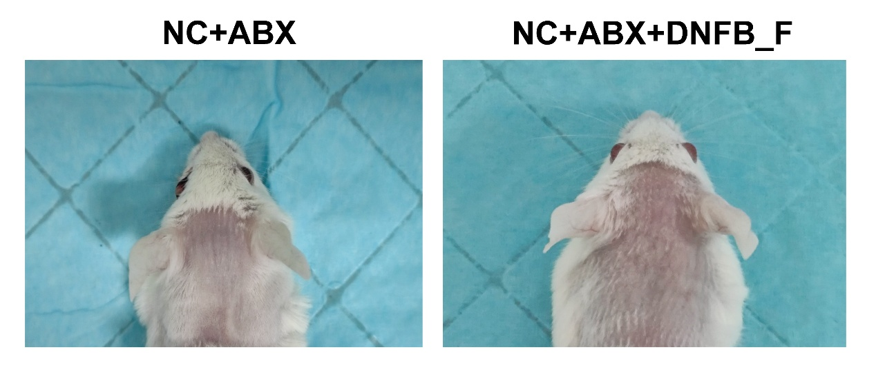
Supplementary Figure.S1 Fecal microbiota transplantation from mice with chronic itch has no effect on the skin of healthy mice.

