Supplementary Material

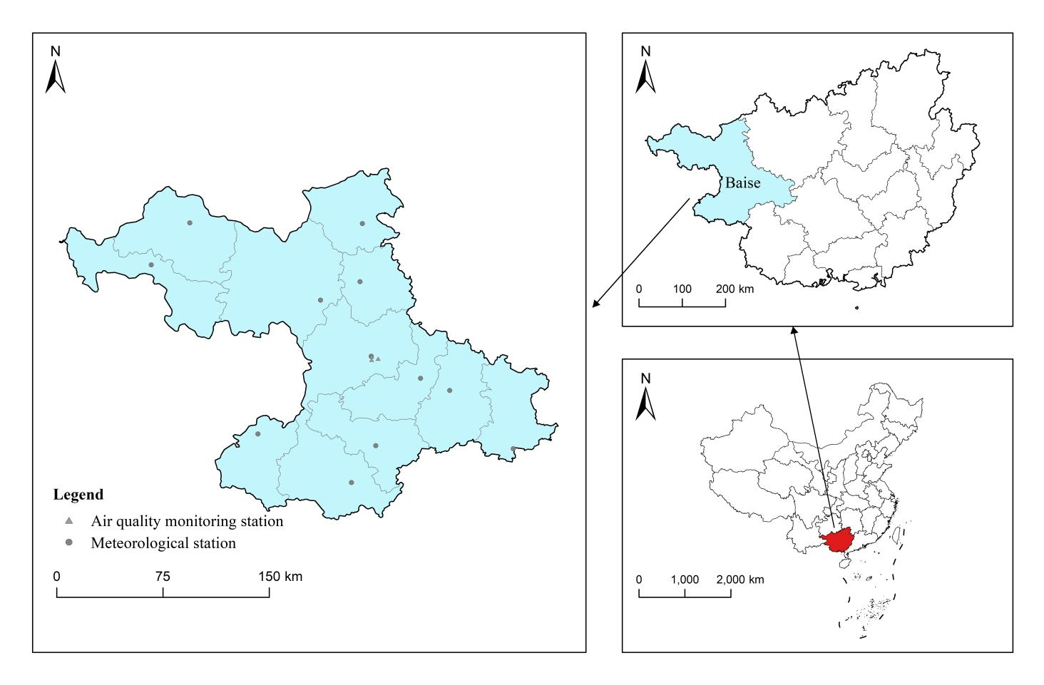
Figure S1 Locations of air pollutant monitoring stations and the meteorological station in Baise, Guangxi, China

Table S1 Relative risk (95% CI) of hypertension-related visits by sex at different lag days for each 10 µg/m³ increase in air pollutant concentration (each 100 μg/m³ increase in CO) in a single-pollutant model
Sex | Lag days | PM_{2.5} | PM₁₀ | NO₂ | CO
Male | lag0 | 1.008(0.997,1.019) | 1.009(1.001,1.016)* | 1.050(1.017,1.083)* | 1.014(1.001,1.026)*
 | lag1 | 1.002(0.997,1.007) | 1.002(0.999,1.006) | 1.017(1.003,1.032)* | 1.005(0.999,1.011)
 | lag2 | 1.002(0.996,1.008) | 1.001(0.997,1.006) | 1.008(0.990,1.027) | 1.002(0.995,1.009)
 | lag3 | 1.005(0.999,1.010) | 1.003(0.999,1.006) | 1.012(0.998,1.027) | 1.003(0.997,1.009)
 | lag4 | 1.008(1.003,1.013)* | 1.006(1.002,1.009)* | 1.021(1.006,1.035)* | 1.004(0.998,1.009)
 | lag5 | 1.008(1.002,1.014)* | 1.006(1.002,1.011)* | 1.024(1.005,1.043)* | 1.002(0.995,1.009)
 | lag6 | 1.003(0.998,1.008) | 1.003(0.999,1.007) | 1.013(0.998,1.027) | 0.994(0.988,1.000)
 | lag7 | 0.990(0.979,1.001) | 0.994(0.986,1.002) | 0.978(0.948,1.010) | 0.978(0.966,0.990)
 | lag01 | 1.010(0.997,1.022) | 1.011(1.002,1.020)* | 1.068(1.032,1.106)* | 1.019(1.005,1.033)*
 | lag02 | 1.012(0.999,1.025) | 1.012(1.003,1.021)* | 1.077(1.040,1.115)* | 1.021(1.007,1.036)*
 | lag03 | 1.017(1.004,1.031)* | 1.015(1.006,1.025)* | 1.090(1.051,1.131)* | 1.024(1.009,1.040)*
 | lag04 | 1.025(1.011,1.040)* | 1.021(1.011,1.031)* | 1.113(1.072,1.155)* | 1.028(1.012,1.044)*
 | lag05 | 1.033(1.017,1.049)* | 1.027(1.016,1.038)* | 1.139(1.094,1.186)* | 1.030(1.013,1.046)*
 | lag06 | 1.036(1.019,1.054)* | 1.031(1.018,1.043)* | 1.154(1.106,1.203)* | 1.023(1.006,1.041)*
 | lag07 | 1.026(1.009,1.043)* | 1.024(1.013,1.036)* | 1.129(1.088,1.171)* | 1.001(0.986,1.016)
Female | lag0 | 1.012(0.999,1.024) | 1.012(1.003,1.021)* | 1.062(1.025,1.100)* | 1.015(1.001,1.029)*
 | lag1 | 1.007(1.001,1.012)* | 1.005(1.001,1.009)* | 1.034(1.018,1.051)* | 1.010(1.003,1.016)*
 | lag2 | 1.003(0.996,1.010) | 1.002(0.997,1.007) | 1.018(0.997,1.039) | 1.006(0.998,1.013)
 | lag3 | 1.001(0.996,1.007) | 1.001(0.997,1.005) | 1.010(0.994,1.026) | 1.002(0.996,1.009)
 | lag4 | 1.001(0.995,1.006) | 1.001(0.997,1.005) | 1.006(0.990,1.022) | 1.000(0.994,1.006)
 | lag5 | 1.001(0.994,1.008) | 1.002(0.997,1.007) | 1.004(0.983,1.025) | 0.997(0.989,1.005)
 | lag6 | 1.001(0.995,1.007) | 1.001(0.998,1.005) | 1.001(0.984,1.017) | 0.995(0.988,1.001)
 | lag7 | 1.001(0.989,1.014) | 0.999(0.990,1.008) | 0.992(0.958,1.028) | 0.992(0.978,1.005)
 | lag01 | 1.019(1.005,1.033)* | 1.017(1.007,1.027)* | 1.098(1.057,1.141)* | 1.025(1.009,1.041)*
 | lag02 | 1.022(1.008,1.036)* | 1.019(1.009,1.029)* | 1.118(1.075,1.162)* | 1.030(1.014,1.047)*
 | lag03 | 1.023(1.008,1.039)* | 1.020(1.009,1.030)* | 1.129(1.083,1.176)* | 1.033(1.016,1.050)*
 | lag04 | 1.024(1.008,1.040)* | 1.021(1.010,1.032)* | 1.136(1.089,1.184)* | 1.033(1.015,1.050)*
 | lag05 | 1.025(1.007,1.043)* | 1.023(1.010,1.036)* | 1.140(1.090,1.193)* | 1.030(1.012,1.049)*
 | lag06 | 1.026(1.007,1.045)* | 1.024(1.011,1.038)* | 1.141(1.088,1.196)* | 1.025(1.005,1.044)*
 | lag07 | 1.027(1.008,1.047)* | 1.023(1.010,1.036)* | 1.132(1.087,1.180)* | 1.016(0.999,1.033)
Note: Bold indicates statistically significant results (*P < 0.05).

Table S2 Relative risk (95% CI) of hypertension-related visits stratified by age at different lag days for each 10 µg/m³ increase in air pollutant concentration (each 100 μg/m³ increase in CO) in a single-pollutant model
Age | Lag days | PM_{2.5} | PM₁₀ | NO₂ | CO
＜65 years old | lag0 | 1.007(0.996,1.019) | 1.008(1.001,1.016)* | 1.050(1.018,1.084)* | 1.013(1.001,1.026)*
 | lag1 | 1.005(0.999,1.010) | 1.004(1.001,1.007)* | 1.026(1.011,1.041)* | 1.008(1.002,1.014)*
 | lag2 | 1.004(0.998,1.011) | 1.002(0.998,1.007) | 1.014(0.995,1.034) | 1.005(0.998,1.012)
 | lag3 | 1.005(0.999,1.010) | 1.003(0.999,1.006) | 1.011(0.997,1.026) | 1.003(0.998,1.009)
 | lag4 | 1.005(1.001,1.010)* | 1.004(1.001,1.008)* | 1.012(0.997,1.027) | 1.001(0.996,1.007)
 | lag5 | 1.005(0.998,1.011) | 1.004(0.999,1.009) | 1.012(0.993,1.031) | 0.998(0.991,1.006)
 | lag6 | 1.002(0.997,1.007) | 1.002(0.999,1.006) | 1.008(0.993,1.023) | 0.994(0.988,1.000)
 | lag7 | 0.996(0.985,1.007) | 0.997(0.989,1.004) | 0.994(0.963,1.026) | 0.987(0.975,0.999)
 | lag01 | 1.012(0.999,1.025) | 1.012(1.003,1.021)* | 1.077(1.040,1.116)* | 1.021(1.007,1.036)*
 | lag02 | 1.017(1.004,1.030)* | 1.014(1.005,1.023)* | 1.093(1.055,1.132)* | 1.027(1.012,1.042)*
 | lag03 | 1.022(1.008,1.036)* | 1.017(1.008,1.027)* | 1.105(1.064,1.147)* | 1.030(1.015,1.046)*
 | lag04 | 1.027(1.012,1.042)* | 1.021(1.011,1.031)* | 1.118(1.077,1.162)* | 1.032(1.016,1.048)*
 | lag05 | 1.032(1.016,1.048)* | 1.026(1.014,1.037)* | 1.132(1.087,1.179)* | 1.030(1.013,1.047)*
 | lag06 | 1.034(1.016,1.051)* | 1.028(1.016,1.041)* | 1.141(1.093,1.191)* | 1.024(1.006,1.041)*
 | lag07 | 1.029(1.012,1.047)* | 1.025(1.013,1.036)* | 1.134(1.092,1.177)* | 1.010(0.995,1.026)
≥65 years old | lag0 | 1.012(0.999,1.024) | 1.012(1.004,1.021)* | 1.061(1.025,1.099)* | 1.016(1.002,1.029)*
 | lag1 | 1.004(0.998,1.009) | 1.003(0.999,1.007) | 1.024(1.008,1.041)* | 1.006(0.999,1.012)
 | lag2 | 1.001(0.994,1.008) | 1.000(0.996,1.005) | 1.011(0.991,1.032) | 1.002(0.995,1.010)
 | lag3 | 1.002(0.996,1.007) | 1.001(0.997,1.005) | 1.011(0.995,1.027) | 1.002(0.996,1.008)
 | lag4 | 1.004(0.998,1.009) | 1.003(0.999,1.007) | 1.016(0.999,1.033) | 1.003(0.996,1.009)
 | lag5 | 1.005(0.998,1.012) | 1.004(0.999,1.008) | 1.018(0.997,1.039) | 1.001(0.993,1.009)
 | lag6 | 1.002(0.997,1.008) | 1.003(0.999,1.007) | 1.006(0.990,1.023) | 0.995(0.988,1.001)
 | lag7 | 0.994(0.982,1.007) | 0.996(0.987,1.004) | 0.974(0.941,1.009) | 0.981(0.968,0.995)
 | lag01 | 1.015(1.002,1.029)* | 1.016(1.006,1.026)* | 1.087(1.046,1.129)* | 1.022(1.006,1.037)*
 | lag02 | 1.016(1.002,1.031)* | 1.016(1.007,1.026)* | 1.099(1.057,1.142)* | 1.024(1.008,1.040)*
 | lag03 | 1.018(1.003,1.034)* | 1.017(1.007,1.028)* | 1.111(1.067,1.158)* | 1.026(1.009,1.043)*
 | lag04 | 1.022(1.006,1.038)* | 1.020(1.009,1.031)* | 1.129(1.084,1.177)* | 1.029(1.012,1.046)*
 | lag05 | 1.027(1.009,1.045)* | 1.025(1.012,1.037)* | 1.149(1.099,1.202)* | 1.030(1.011,1.048)*
 | lag06 | 1.029(1.010,1.049)* | 1.027(1.014,1.041)* | 1.157(1.104,1.212)* | 1.024(1.005,1.044)*
 | lag07 | 1.023(1.005,1.042)* | 1.023(1.010,1.036)* | 1.127(1.082,1.174)* | 1.005(0.988,1.022)
Note: Bold indicates statistically significant results (*P < 0.05)

Table S3 Relative risk (95% CI) of hypertension-related visits stratified by season at different lag days for each 10 µg/m³ increase in air pollutant concentration (each 100 μg/m³ increase in CO) in a single-pollutant model
Season | Lag days | PM_{2.5} | PM₁₀ | NO₂ | CO
Cold | lag0 | 1.010(0.997,1.024) | 1.011(1.001,1.020)* | 1.062(1.024,1.101)* | 1.019(1.004,1.034)*
 | lag1 | 1.005(0.999,1.011) | 1.004(0.999,1.008) | 1.027(1.010,1.045)* | 1.009(1.002,1.016)*
 | lag2 | 1.004(0.997,1.011) | 1.002(0.997,1.008) | 1.015(0.993,1.037) | 1.005(0.996,1.014)
 | lag3 | 1.005(0.999,1.011) | 1.004(0.999,1.008) | 1.014(0.998,1.032) | 1.004(0.997,1.010)
 | lag4 | 1.006(1.001,1.012)* | 1.005(1.001,1.009)* | 1.019(1.002,1.036)* | 1.003(0.996,1.010)
 | lag5 | 1.005(0.998,1.013) | 1.006(1.001,1.011)* | 1.019(0.998,1.042) | 1.001(0.991,1.009)
 | lag6 | 1.001(0.995,1.007) | 1.002(0.998,1.006) | 1.008(0.991,1.026) | 0.994(0.987,1.001)
 | lag7 | 0.991(0.978,1.005) | 0.993(0.984,1.002) | 0.978(0.943,1.014) | 0.980(0.966,0.995)
 | lag01 | 1.016(1.001,1.031)* | 1.015(1.004,1.026)* | 1.091(1.048,1.136)* | 1.028(1.011,1.046)*
 | lag02 | 1.020(1.004,1.036)* | 1.018(1.007,1.029)* | 1.107(1.063,1.153)* | 1.033(1.016,1.051)*
 | lag03 | 1.025(1.008,1.042)* | 1.021(1.010,1.033)* | 1.123(1.075,1.172)* | 1.037(1.019,1.056)*
 | lag04 | 1.032(1.014,1.050)* | 1.027(1.014,1.039)* | 1.144(1.095,1.194)* | 1.040(1.022,1.059)*
 | lag05 | 1.037(1.017,1.057)* | 1.032(1.018,1.046)* | 1.166(1.113,1.221)* | 1.041(1.021,1.061)*
 | lag06 | 1.038(1.017,1.060)* | 1.034(1.019,1.050)* | 1.176(1.120,1.234)* | 1.034(1.013,1.056)*
 | lag07 | 1.029(1.008,1.051)* | 1.027(1.013,1.042)* | 1.150(1.101,1.200)* | 1.014(0.995,1.033)
Warm | lag0 | 1.010(0.991,1.029) | 1.008(0.995,1.021) | 1.023(0.965,1.085) | 1.004(0.986,1.023)
 | lag1 | 0.997(0.988,1.007) | 0.998(0.992,1.004) | 0.999(0.971,1.029) | 0.999(0.990,1.009)
 | lag2 | 0.993(0.982,1.004) | 0.994(0.987,1.001) | 0.988(0.956,1.022) | 0.998(0.987,1.008)
 | lag3 | 0.994(0.985,1.003) | 0.995(0.989,1.001) | 0.985(0.960,1.012) | 0.998(0.989,1.007)
 | lag4 | 0.998(0.989,1.006) | 0.998(0.993,1.004) | 0.988(0.962,1.015) | 0.999(0.991,1.009)
 | lag5 | 1.002(0.992,1.013) | 1.001(0.995,1.008) | 0.994(0.961,1.027) | 1.001(0.990,1.011)
 | lag6 | 1.005(0.996,1.014) | 1.003(0.997,1.009) | 0.999(0.972,1.027) | 0.999(0.990,1.009)
 | lag7 | 1.004(0.986,1.022) | 1.001(0.988,1.012) | 1.001(0.946,1.059) | 0.995(0.976,1.014)
 | lag01 | 1.007(0.984,1.031) | 1.006(0.990,1.022) | 1.023(0.953,1.098) | 1.004(0.981,1.027)
 | lag02 | 1.001(0.976,1.025) | 1.001(0.983,1.017) | 1.011(0.937,1.091) | 1.001(0.977,1.026)
 | lag03 | 0.994(0.968,1.021) | 0.995(0.977,1.014) | 0.996(0.918,1.081) | 0.999(0.974,1.026)
 | lag04 | 0.992(0.964,1.020) | 0.993(0.974,1.013) | 0.985(0.904,1.072) | 0.999(0.973,1.026)
 | lag05 | 0.994(0.964,1.024) | 0.994(0.974,1.016) | 0.978(0.892,1.073) | 0.999(0.972,1.028)
 | lag06 | 0.999(0.967,1.032) | 0.997(0.974,1.020) | 0.977(0.885,1.079) | 0.999(0.972,1.028)
 | lag07 | 1.002(0.968,1.037) | 0.997(0.973,1.022) | 0.978(0.886,1.079) | 0.994(0.969,1.020)
Note: Bold indicates statistically significant results (*P < 0.05).

Table S4 The RR (95% CI) of hospital admissions for hypertension associated with a 10μg/ m³ (and 100μg/m³ in CO) increment in ambient air pollutant concentrations in two-pollutant models.
Two-pollutants models | Lag 07 day | Two-pollutants models | Lag 07 day
PM_{2.5} | 1.027(1.011,1.043) | PM₁₀ | 1.024(1.013,1.035)
PM_{2.5}+SO₂ | 1.022(1.005,1.039) | PM₁₀+SO₂ | 1.020(1.009,1.032)
PM_{2.5}+CO | 1.022(1.002,1.042) | PM₁₀+CO | 1.023(1.010,1.037)
PM_{2.5}+O₃8h | 1.022(1.007,1.038) | PM₁₀+O₃8h | 1.020(1.009,1.031)
NO₂ | 1.130(1.092,1.170) | CO | 1.008(0.994,1.022)
NO₂+SO₂ | 1.126(1.084,1.171) | CO+PM_{2.5} | 0.997(0.980,1.014)
NO₂+CO | 1.145(1.099,1.193) | CO+PM₁₀ | 0.993(0.976,1.009)
NO₂+O₃8h | 1.097(1.061,1.134) | CO+SO₂ | 1.010(0.996,1.024)
 |  | CO+NO₂ | 0.989(0.974,1.005)
 |  | CO+O₃8h | 1.010(0.996,1.023  )

Table S5 Sensitivity analysis of time freedom degree change.
Variables | df
Variables | 6 | 7 | 8 | 9 | 10
PM_{2.5} | 1.027(1.011,1.043) | 1.027(1.011,1.043) | 1.027(1.011,1.043) | 1.027(1.011,1.043) | 1.027(1.011,1.043)
PM₁₀ | 1.024(1.013,1.035) | 1.024(1.013,1.035) | 1.024(1.013,1.035) | 1.024(1.013,1.035) | 1.024(1.013,1.035)
NO₂ | 1.130(1.092,1.170) | 1.130(1.092,1.170) | 1.130(1.092,1.170) | 1.130(1.092,1.170) | 1.130(1.092,1.170)
CO | 1.008(0.994,1.022) | 1.008(0.994,1.022) | 1.008(0.994,1.022) | 1.008(0.994,1.022) | 1.008(0.994,1.022)

