Appendix A: Covariate Adequacy Testing for Unanchored MAIC

Unanchored matching-adjusted indirect comparisons rely critically on the assumption that all prognostic factors and effect modifiers are measured and balanced between studies. To evaluate whether our selected nine baseline covariates meet this "no unmeasured confounding" requirement, we conducted the Yi-Jiang prognostic factor validation test [1]. The validation proceeded in five sequential steps:
1. Risk Score Derivation: A multivariable Cox proportional hazards model was fitted to the enlonstobart IPD using all nine covariates, generating individual risk scores that capture each patient's baseline prognostic profile.
2. Artificial Group Creation: Patients were initially stratified into quartiles based on risk scores, then allocated to "high-risk" (quartiles 1+3) versus "low-risk" (quartiles 2+4) artificial treatment groups to create meaningful prognostic separation.
3. Target Hazard Ratio Calibration: Through iterative patient reassignment between artificial groups, we calibrated the unadjusted hazard ratio to approximate the inverse of our primary MAIC findings (target HR = 1.9 for OS, corresponding to 1/0.53). This approach deviates slightly from the original methodology, which typically uses the unadjusted hazard ratio between the investigational drug and comparator as the target. However, given that the unadjusted survival differences between enlonstobart and camrelizumab were relatively small in the original trial data, we instead calibrated to the inverse of the strongest treatment effect observed in our MAIC analysis (HR = 0.53 for OS) to ensure sufficient signal strength for meaningful validation of covariate sufficiency. Testing against this more challenging target provides robust evidence of covariate adequacy, as successful validation under stricter criteria naturally supersedes adequacy under less demanding conditions.
4. Propensity Score Adjustment: A logistic regression model was fitted with artificial group membership as the outcome and the nine MAIC covariates as predictors. Inverse probability weighting was applied using the predicted propensity scores.
5. Adequacy Assessment: A weighted Cox regression tested whether covariate adjustment could eliminate the artificial treatment effect. Non-significance (p > 0.05) indicates that the selected covariates adequately capture prognostic heterogeneity.

Appendix B: Unanchored Simulated Treatment Comparison (STC)

After the unanchored MAIC of enlonstobart and camrelizumab in patients with recurrent or metastatic cervical cancer, we carried out a fully parametric simulated-treatment comparison implemented through single imputation (STC-SI) to evaluate the robustness of the MAIC findings [2]. The analysis involved a Gaussian-copula resampling step that retains higher-order covariate dependencies.

Generation of an imputed camrelizumab-like cohort
Let $X$ be the $\left(n_{\text{Enlon}}×p\right)$ matrix of binary baseline characteristics observed in the Enlonstobart individual-patient data (IPD). To generate a pseudo-IPD dataset that preserves the dependence structure among covariates observed in enlonstobart while matching the marginal prevalences reported for camrelizumab, we employed a two-stage approach. First, we fitted a Gaussian multivariate copula directly to the binary covariate matrix X using maximum likelihood estimation, which is the primary method of data reproduction. The Gaussian copula automatically captures the underlying dependence structure while appropriately handling discrete marginal distributions. From the fitted copula, we generated 54 synthetic covariate vectors that preserve the estimated correlation structure while allowing flexible marginal transformations. Second, we employed a fallback method using an enhanced multivariate normal approach when copula fitting encountered numerical difficulties. We computed the Spearman rank correlation matrix $\hat{Σ_{S}}$ of $X$, then ensured positive definiteness through eigenvalue decomposition and truncation:
$$\hat{Σ_{S}}=VΛV^{T}$$

where $V$ contains the eigenvectors and $Λ$ is the diagonal matrix of eigenvalues. To ensure positive definiteness, we constructed:
$${\hat{Σ}}_{S,\text{fixed}}=VΛ_{\text{fixed}}V^{T}$$
where $Λ_{\text{fixed}}=\max\left(Λ,εI\right)with ε={10}^{-8}$.
Both approaches preserve the monotonic rank-order relationships among covariates (ensuring correlation structure preservation) while achieving exact marginal prevalence matching through the probability integral transformation. The 54 synthetic patients constitute a single imputed dataset representing the camrelizumab population under the working assumption that baseline covariate correlations observed in enlonstobart also characterize the camrelizumab trial population.

Parametric modelling of survival for enlonstobart and camrelizumab
Progression-free survival (PFS) and overall survival (OS) in the enlonstobart IPD were each fitted with a Weibull accelerated-failure-time (AFT) model,
$$\log{T}=μ+x^{⊤}β+σW,$$where $W$ is a standard Gumbel variate. The AFT parameters were algebraically converted to the proportional-hazards (PH) representation
$$H_{Enlon}\left(t∣x\right)=t^{ρ}exp\left(γ_{0}+γ^{⊤}x\right),$$
$$ρ=1/σ,γ=-ρβ,γ_{0}=-ρμ,$$
with hazard $h\left(t ∣ x\right)=∂H/∂t$ and survivor function $S\left(t ∣ x\right)=\exp\left[-H\left(t ∣ x\right)\right]$. For Camrelizumab, digitized Kaplan–Meier points were smoothed with monotone splines and converted to cumulative hazards through $H_{\text{Cam}}\left(t\right)=-\ln{S_{\text{Cam}}}\left(t\right)$.

Point-wise cumulative-hazard averaging
The two cumulative-hazard curves overlap on the interval $\left[t_{min},t_{max}\right]$. We selected thirty equidistant grid points $t_{1},{…t}_{30}$ on that interval; a fixed dense grid, rather than the Camrelizumab event times, avoids overweighting early follow-up periods and ensures that information from the sparsely populated tail of the curve contributes proportionally. For every imputed patient $i\left(i=1,…,54\right)$ and time point $t_{j}$ we computed the ratio
$$R_{ij}=H_{\text{Enlon}}\left(t_{j} ∣ x_{i}\right)/H_{\text{Cam}}\left(t_{j}\right).$$Averaging over patients yields $\overline{R_{j}}=\left(1/54\right)\sum_{i}{R_{ij}}$; the study-level hazard ratio is the grand mean $\hat{\text{HR}}=\left(1/30\right)\sum_{j}{\overline{R_{j}}}$. Because the proportional-hazards assumption implies that $R_{ij}$ is constant in $t$, the average is unbiased for the true HR. Its standard error was estimated as the sample standard deviation of the thirty $\overline{R_{j}}$ divided by $\sqrt{30}$, and 95 % confidence intervals were formed with the normal approximation. The procedure rests on two assumptions: proportional hazards between treatments and sufficient accuracy of the imputed Camrelizumab covariate distribution.

Diagnostic assessment of the imputed cohort
Quality of the imputation was assessed by comparing (i) target versus generated marginal prevalences and (ii) preservation of pairwise correlations relative to the original enlonstobart IPD. Figure 2 displays bar plots of marginal means, absolute marginal errors, and heat maps of correlation matrices and their element-wise differences. We summarized performance by the mean and maximum marginal deviations and by the mean and maximum absolute correlation differences.

Results—Performance of the simulated cohort and hazard-ratio estimates
We generated a 54-patient pseudo-IPD for camrelizumab using nine baseline covariates also used in the unanchored MAIC analysis. The synthetic cohort achieved close alignment with the published trial baseline characteristics, as shown in Appendix Table 1. The absolute difference between target and achieved proportions was numerical small for all variables.

Appendix Table 1. Baseline Covariate Target vs. Achieved Proportions in Pseudo-IPD Generation for Camrelizumab Population
Covariate | Target | Achieved
ECOG PS (1 vs 0) | 0.667 | 0.667
Squamous cell carcinoma | 0.759 | 0.759
Previous radical surgery | 0.574 | 0.574
Previous radical concurrent chemoradiotherapy | 0.370 | 0.370
Previous radical treatment | 0.852 | 0.852
Prior systemic treatment lines ≥2 | 0.259 | 0.259
Previous targeted therapy | 0.389 | 0.389
Number of metastatic sites >1 | 0.519 | 0.519
Previous platinum chemotherapy | 1.000 | 1.000

The diagnostic assessment generated a mean marginal distribution error of approximately 0.0002 and maximum error of less than 0.0005. Inter-covariate correlation structure was preserved with reasonable but imperfect fidelity, showing a mean absolute difference of 0.125 (Appendix Fig. 1).

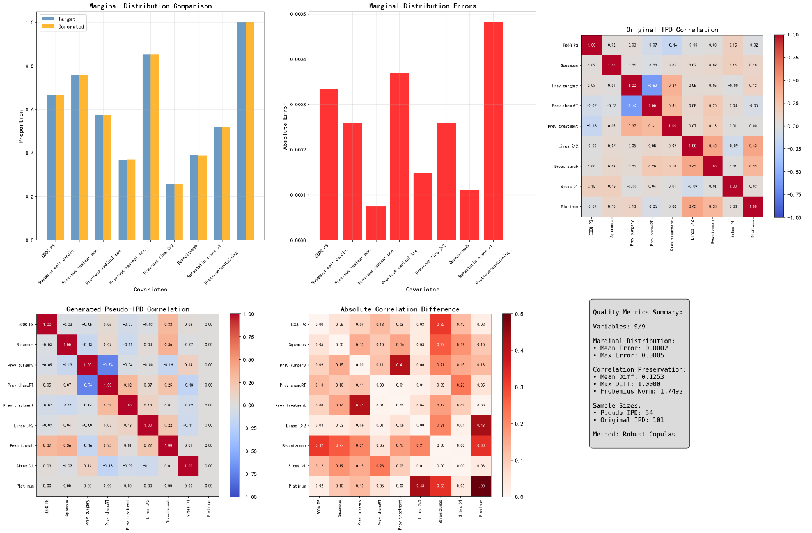
Appendix Figure 1. Diagnostic Assessment of Pseudo-IPD Generation Quality for Camrelizumab Population.
Top panels: Marginal distribution assessment showing (left) target versus achieved proportions for nine baseline covariates, (center) absolute errors between target and generated prevalences, and (right) original pairwise correlation structure in the enlonstobart IPD.
Bottom panels: Correlation structure preservation showing (left) generated pseudo-IPD correlation matrix, (center) absolute element-wise differences between original and generated correlations, and (right) summary quality metrics.
Abbreviations: ECOG PS = Eastern Cooperative Oncology Group Performance Status; IPD = individual patient data.

We fitted separate Weibull AFT models to the IPD (enlonstobart) and pseudo-IPD (camrelizumab) for both PFS and OS endpoints. The STC analysis using point-wise cumulative-hazard averaging under the Weibull-derived proportional hazards framework yielded hazard ratios favoring enlonstobart over camrelizumab. For PFS, the STC hazard ratio was 0.779 (95% CI: 0.705–0.861), indicating over 20% reduction in progression risk. For OS, the hazard ratio was 0.733 (95% CI: 0.680–0.789), corresponding to approximately 30% reduction in mortality risk.

Appendix References
- Yi, Y. & Jiang, Y. A process to validate prognostic factors for unanchored matching-adjusted indirect comparison of single-arm trials in oncology: A proof-of-concept study. J Comp Eff Res 14, e240235, doi:10.57264/cer-2024-0235 (2025).
- Zhang, L., Bujkiewicz, S. & Jackson, D. Four alternative methodologies for simulated treatment comparison: How could the use of simulation be re-invigorated? Research Synthesis Methods 15, 227-241, doi:10.1002/jrsm.1681 (2024).

