Supplementary Table 1. Threshold Effect Analysis of Composite Inflammatory Indices on AF Recurrence
Empty Cell | Adjusted HR (95% CI) | P value
Total | 1.19 (1.07 - 1.34) | 0.002
Fitting by 2-piecewise Cox proportional risk model
Inflection point | 524.75
SII<524.75 | 2.57 (1.24 - 5.33) | 0.011
SII≥524.75 | 1.08 (0.89 - 1.30) | 0.423
Likelihood ratio test |  | 0.036
Total | 1.05 (1.01 - 1.10) | 0.026
Fitting by 2-piecewise Cox proportional risk model
Inflection point | 2.63
NLR<2.63 | 1.60 (1.05 - 2.43) | 0.028
NLR≥2.63 | 1.01 (0.95 - 1.08) | 0.759
Likelihood ratio test |  | 0.015
Adjusted for sex, type of atrial fibrillation, heart failure, age, BMI, AF duration, CHA2DS2-VAS-C score, triglycerides, high-density lipoprotein cholesterol , LVEF, and LAD.

Supplementary Table 2. Diagnostic Performance of Composite Inflammatory Indices in Identifying AF Recurrence
Variables | AUC (95%CI) | Accuracy (95%CI) | Sensitivity (95%CI) | Specificity (95%CI) | PPV (95%CI) | NPV (95%CI) | Cut off
SII | 0.60 (0.55-0.64) | 0.57 (0.53-0.60) | 0.54 (0.50 - 0.58) | 0.64 (0.58 - 0.71) | 0.80 (0.75 - 0.84) | 0.35 (0.30 - 0.39) | 636.795
NLR | 0.62 (0.57-0.66) | 0.56 (0.52-0.59) | 0.51 (0.47 - 0.55) | 0.68 (0.62 - 0.75) | 0.81 (0.77 - 0.85) | 0.35 (0.30 - 0.39) | 2.032
NPR | 0.57 (0.52-0.61) | 0.57 (0.54-0.61) | 0.57 (0.53 - 0.61) | 0.58 (0.51 - 0.65) | 0.78 (0.74 - 0.82) | 0.34 (0.29 - 0.39) | 0.02
SIRI | 0.60 (0.55-0.64) | 0.51 (0.48-0.55) | 0.44 (0.40 - 0.48) | 0.71 (0.65 - 0.77) | 0.80 (0.75 - 0.84) | 0.33 (0.28 - 0.37) | 0.779
PIV | 0.61 (0.57-0.66) | 0.56 (0.52-0.59) | 0.50 (0.46 - 0.54) | 0.71 (0.65 - 0.78) | 0.82 (0.78 - 0.86) | 0.35 (0.31 - 0.40) | 150.759

AUC = area under the curve; NPV = negative predictive value; PPV = positive predictive value

A
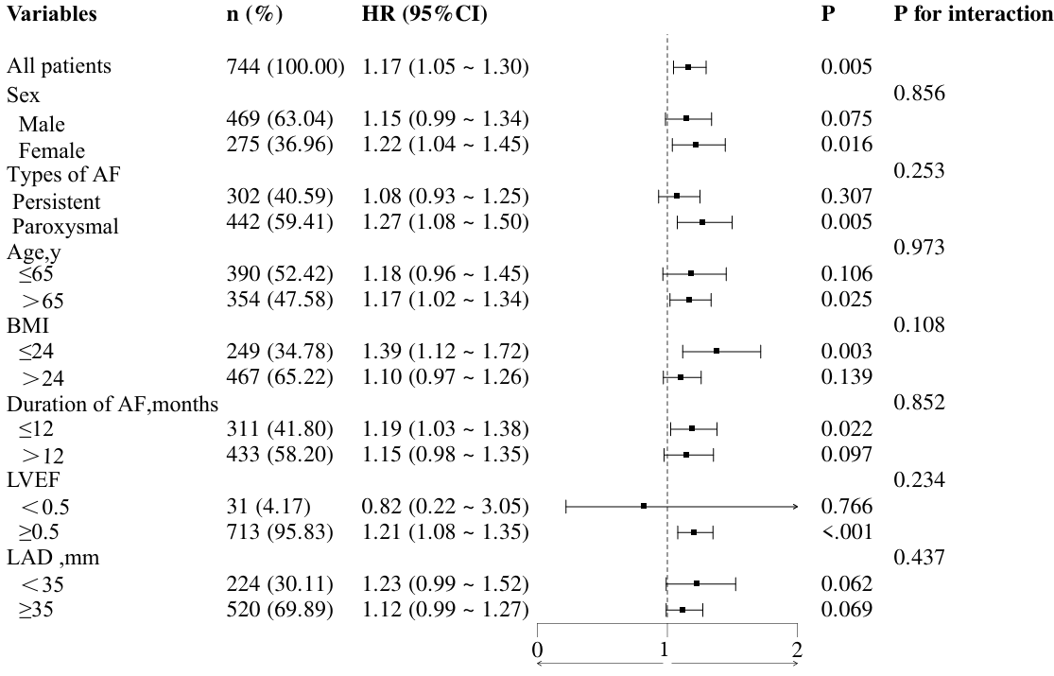

B
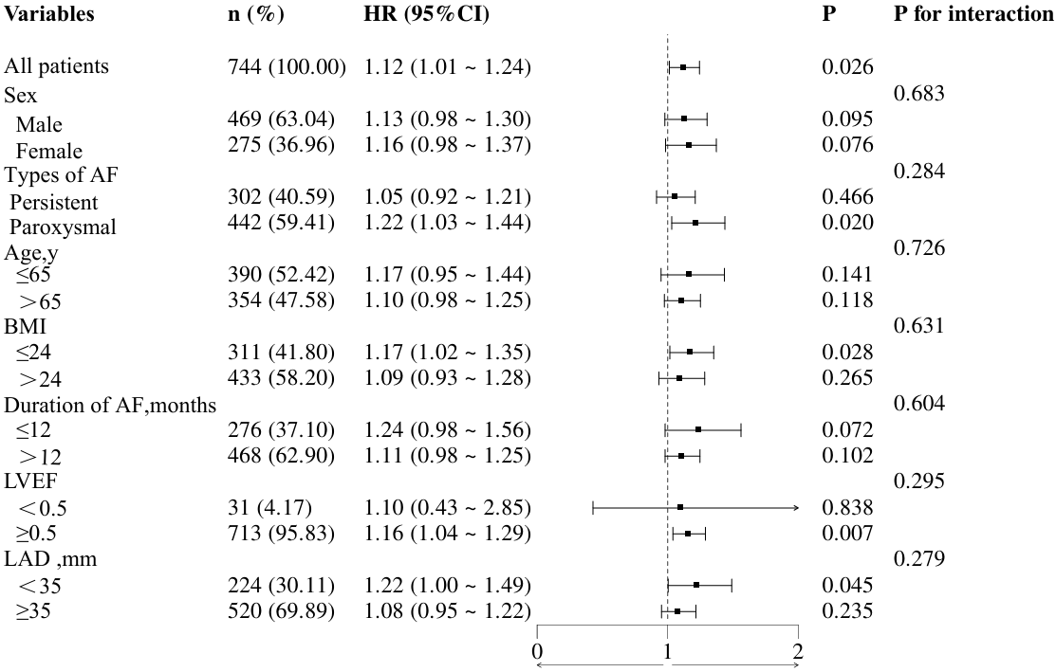

C
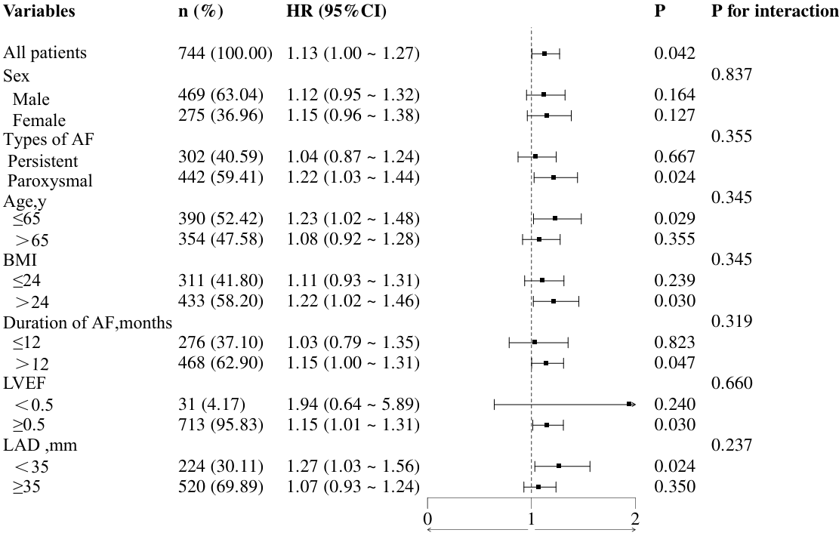

D
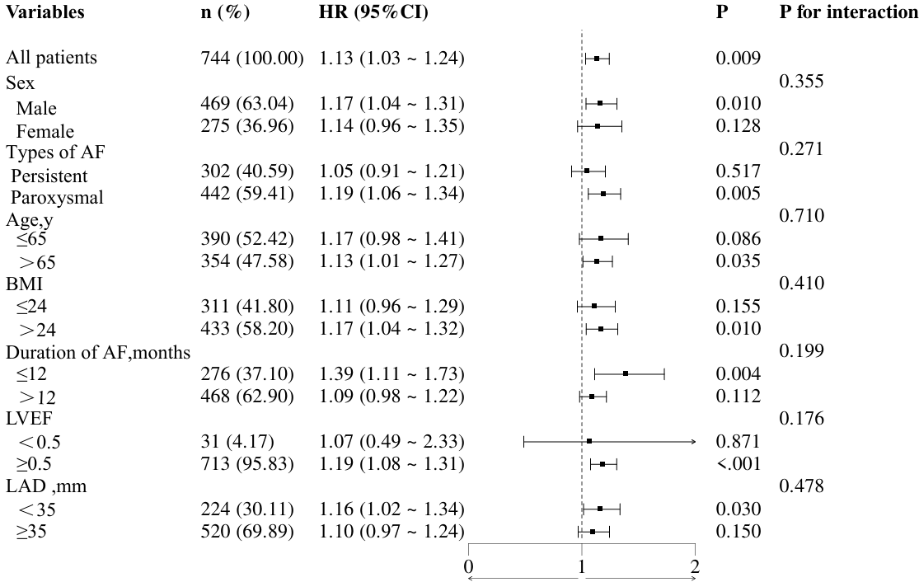

E
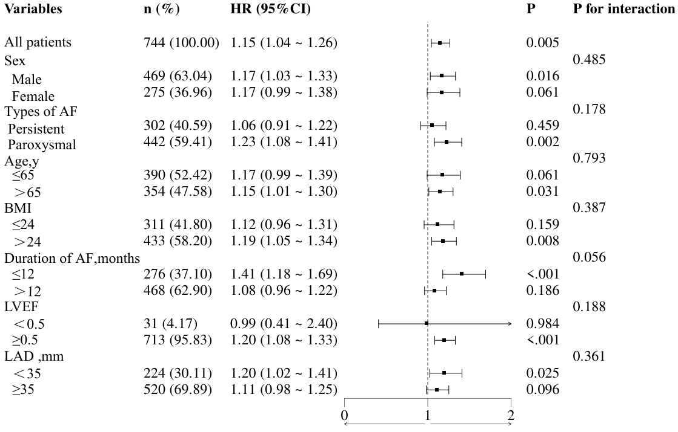
Supplementary Figure 1. Subgroup Analysis of the Association between the Composite Inflammatory Index and AF Recurrence
A: Subgroup Analysis of the Association between the SII and AF Recurrence; B: Subgroup Analysis of the Association between the NLR and AF Recurrence; C: Subgroup Analysis of the Association between the NPR and AF Recurrence; D: Subgroup Analysis of the Association between the SIRI and AF Recurrence; E: Subgroup Analysis of the Association between the PIV and AF Recurrence.
Adjusted for sex, type of atrial fibrillation, heart failure, age, BMI, AF duration, CHA2DS2-VAS-C score, triglycerides, high-density lipoprotein cholesterol , LVEF, and LAD.

Supplementary Table 3. Association between composite inflammatory markers and AF recurrence after missing data imputation.
Variables | Model1 |  | Model2 |  | Model3
Variables | HR (95%CI) | P | HR (95%CI) | P | HR (95%CI) | P
SII (per SD incresae) | 1.15 (1.06 ~ 1.26) | <0.001 | 1.11 (1.01 ~ 1.23) | 0.025 | 1.11 (1.01 ~ 1.22) | 0.033
SII quantile
1 | 1.00 (Reference) |  | 1.00 (Reference) |  | 1.00 (Reference)
2 | 1.45 (0.95 ~ 2.22) | 0.088 | 1.36 (0.88 ~ 2.08) | 0.166 | 1.36 (0.88 ~ 2.09) | 0.164
3 | 1.68 (1.10 ~ 2.55) | 0.015 | 1.61 (1.06 ~ 2.45) | 0.026 | 1.63 (1.07 ~ 2.49) | 0.024
4 | 2.10 (1.41 ~ 3.12) | <0.001 | 1.83 (1.21 ~ 2.76) | 0.004 | 1.79 (1.19 ~ 2.70) | 0.005
P for trend |  | <0.001 |  | 0.005 |  | 0.007
NLR (per SD incresae) | 1.17 (1.07 ~ 1.29) | <0.001 | 1.11 (1.01 ~ 1.23) | 0.046 | 1.10 (0.99 ~ 1.22) | 0.072
NLR quantile
1 | 1.00 (Reference) |  | 1.00 (Reference) |  | 1.00 (Reference)
2 | 1.27 (0.83 ~ 1.93) | 0.267 | 1.25 (0.82 ~ 1.90) | 0.299 | 1.21 (0.80 ~ 1.84) | 0.371
3 | 1.52 (1.01 ~ 2.27) | 0.043 | 1.41 (0.94 ~ 2.11) | 0.101 | 1.35 (0.90 ~ 2.03) | 0.149
4 | 1.86 (1.26 ~ 2.76) | 0.002 | 1.65 (1.11 ~ 2.47) | 0.014 | 1.54 (1.03 ~ 2.31) | 0.035
P for trend |  | 0.043 |  | 0.115 |  | 0.153
PLR (per SD incresae) | 1.15 (1.04 ~ 1.28) | 0.006 | 1.11 (1.00 ~ 1.24) | 0.056 | 1.11 (0.99 ~ 1.24) | 0.072
PLR quantile
1 | 1.00 (Reference) |  | 1.00 (Reference) |  | 1.00 (Reference)
2 | 0.75 (0.49 ~ 1.14) | 0.174 | 0.71 (0.47 ~ 1.09) | 0.116 | 0.70 (0.46 ~ 1.06) | 0.094
3 | 1.13 (0.77 ~ 1.66) | 0.522 | 1.04 (0.70 ~ 1.52) | 0.856 | 0.98 (0.67 ~ 1.45) | 0.929
4 | 1.40 (0.97 ~ 2.01) | 0.074 | 1.27 (0.87 ~ 1.84) | 0.212 | 1.19 (0.82 ~ 1.72) | 0.370
P for trend | 1.01 (1.01 ~ 1.01) | 0.011 | 1.01 (1.01 ~ 1.01) | 0.042 | 1.00 (1.00 ~ 1.01) | 0.091
LMR (per SD incresae) | 0.81 (0.70 ~ 0.94) | 0.005 | 0.86 (0.74 ~ 1.00) | 0.058 | 0.88 (0.76 ~ 1.03) | 0.104
LMR quantile
1 | 1.00 (Reference) |  | 1.00 (Reference) |  | 1.00 (Reference)
2 | 0.98 (0.68 ~ 1.41) | 0.911 | 1.07 (0.74 ~ 1.54) | 0.730 | 1.12 (0.77 ~ 1.62) | 0.543
3 | 0.83 (0.57 ~ 1.22) | 0.345 | 0.94 (0.64 ~ 1.37) | 0.740 | 0.98 (0.66 ~ 1.43) | 0.900
4 | 0.72 (0.49 ~ 1.08) | 0.110 | 0.88 (0.58 ~ 1.32) | 0.534 | 0.92 (0.61 ~ 1.39) | 0.694
P for trend | 0.91 (0.82 ~ 1.01) | 0.078 | 0.96 (0.86 ~ 1.06) | 0.425 | 0.97 (0.87 ~ 1.07) | 0.543
NPR (per SD incresae) | 1.18 (1.05 ~ 1.32) | 0.005 | 1.15 (1.02 ~ 1.29) | 0.022 | 1.13 (1.01 ~ 1.27) | 0.043
NPR quantile
1 | 1.00 (Reference) |  | 1.00 (Reference) |  | 1.00 (Reference)
2 | 0.74 (0.49 ~ 1.13) | 0.161 | 0.73 (0.48 ~ 1.10) | 0.132 | 0.74 (0.49 ~ 1.13) | 0.159
3 | 1.54 (1.07 ~ 2.23) | 0.021 | 1.49 (1.03 ~ 2.16) | 0.034 | 1.45 (1.01 ~ 2.10) | 0.049
4 | 1.27 (0.87 ~ 1.87) | 0.215 | 1.20 (0.82 ~ 1.77) | 0.353 | 1.18 (0.80 ~ 1.74) | 0.392
P for trend |  | 0.043 |  | 0.086 |  | 0.116
SIRI (per SD incresae) | 1.17 (1.08 ~ 1.28) | <0.001 | 1.14 (1.04 ~ 1.24) | 0.006 | 1.12 (1.02 ~ 1.23) | 0.018
SIRI quantile
1 | 1.00 (Reference) |  | 1.00 (Reference) |  | 1.00 (Reference)
2 | 1.49 (0.98 ~ 2.27) | 0.060 | 1.38 (0.91 ~ 2.11) | 0.130 | 1.40 (0.92 ~ 2.13) | 0.117
3 | 1.59 (1.04 ~ 2.41) | 0.031 | 1.39 (0.91 ~ 2.13) | 0.133 | 1.38 (0.90 ~ 2.13) | 0.139
4 | 2.03 (1.36 ~ 3.05) | <.001 | 1.79 (1.18 ~ 2.71) | 0.007 | 1.74 (1.14 ~ 2.64) | 0.009
P for trend | 1.40 (1.14 ~ 1.72) | 0.001 | 1.32 (1.07 ~ 1.63) | 0.011 | 1.29 (1.04 ~ 1.60) | 0.018
PAR (per SD incresae) | 1.06 (0.93 ~ 1.21) | 0.404 | 1.05 (0.92 ~ 1.20) | 0.493 | 1.08 (0.94 ~ 1.24) | 0.257
PAR quantile
1 | 1.00 (Reference) |  | 1.00 (Reference) |  | 1.00 (Reference)
2 | 0.83 (0.55 ~ 1.24) | 0.353 | 0.87 (0.58 ~ 1.31) | 0.508 | 0.87 (0.58 ~ 1.31) | 0.507
3 | 1.18 (0.81 ~ 1.70) | 0.390 | 1.20 (0.83 ~ 1.74) | 0.336 | 1.27 (0.87 ~ 1.84) | 0.216
4 | 1.01 (0.69 ~ 1.48) | 0.953 | 1.02 (0.69 ~ 1.49) | 0.932 | 1.09 (0.74 ~ 1.61) | 0.654
P for trend | 1.03 (0.91 ~ 1.17) | 0.618 | 1.03 (0.91 ~ 1.16) | 0.652 | 1.06 (0.93 ~ 1.19) | 0.391
PIV (per SD incresae) | 1.18 (1.08 ~ 1.30) | <0.001 | 1.16 (1.06 ~ 1.28) | 0.002 | 1.15 (1.05 ~ 1.26) | 0.004
PIV quantile
1 | 1.00 (Reference) |  | 1.00 (Reference) |  | 1.00 (Reference)
2 | 0.93 (0.61 ~ 1.43) | 0.746 | 0.87 (0.57 ~ 1.34) | 0.530 | 0.90 (0.58 ~ 1.38) | 0.624
3 | 1.45 (0.98 ~ 2.14) | 0.060 | 1.37 (0.93 ~ 2.04) | 0.114 | 1.39 (0.94 ~ 2.06) | 0.102
4 | 1.64 (1.13 ~ 2.40) | 0.010 | 1.50 (1.02 ~ 2.22) | 0.040 | 1.52 (1.03 ~ 2.24) | 0.037
P for trend | 1.01 (1.01 ~ 1.01) | 0.002 | 1.01 (1.01 ~ 1.01) | 0.008 | 1.01 (1.01 ~ 1.01) | 0.008
HALP (per SD incresae) | 0.95 (0.82 ~ 1.10) | 0.454 | 0.98 (0.85 ~ 1.13) | 0.762 | 0.99 (0.86 ~ 1.14) | 0.893
HALP quantile
1 | 1.00 (Reference) |  | 1.00 (Reference) |  | 1.00 (Reference)
2 | 0.84 (0.58 ~ 1.20) | 0.331 | 0.91 (0.63 ~ 1.31) | 0.595 | 0.89 (0.62 ~ 1.28) | 0.532
3 | 0.88 (0.60 ~ 1.27) | 0.488 | 0.97 (0.67 ~ 1.42) | 0.887 | 0.96 (0.66 ~ 1.40) | 0.824
4 | 0.93 (0.64 ~ 1.36) | 0.721 | 1.08 (0.73 ~ 1.58) | 0.700 | 1.13 (0.77 ~ 1.66) | 0.533
P for trend | 1.00 (0.99 ~ 1.01) | 0.728 | 1.00 (1.00 ~ 1.01) | 0.695 | 1.00 (1.00 ~ 1.01) | 0.553
Model 1: Adjusted for sex, age, and BMI.
Model 2: Adjusted for sex, type of atrial fibrillation, heart failure, age, BMI, AF duration, and CHA2DS2-VAS-C score.
Model 3: Adjusted for sex, type of atrial fibrillation, heart failure, age, BMI, AF duration, CHA2DS2-VAS-C score, triglycerides, high-density lipoprotein cholesterol , LVEF, and LAD.

