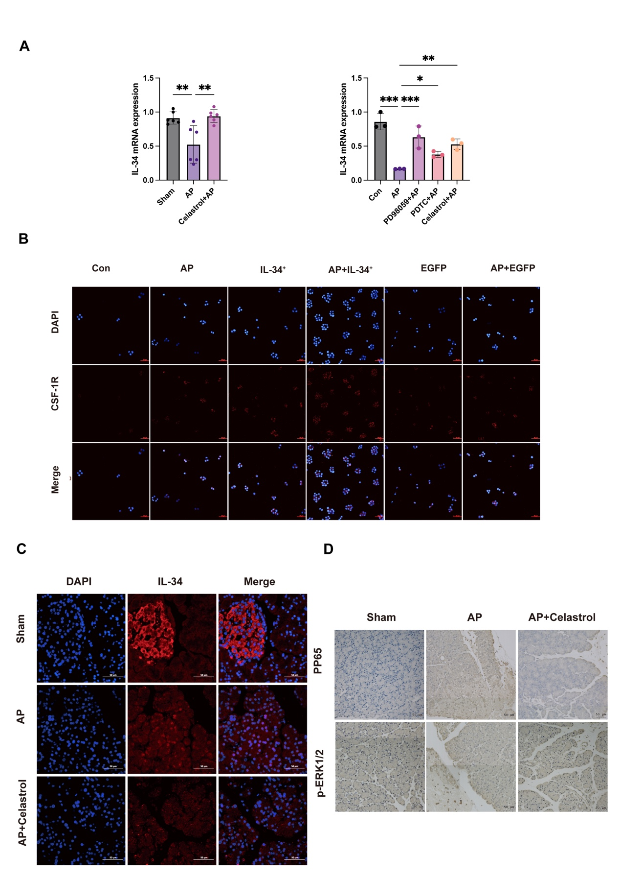
Supplementary Figure S1. Supportive validation and localization data. (A) IL-34 mRNA expression in pancreatic tissue (n = 6) and AR42J cells (n = 3). Data are presented as mean ± SD. Statistical analysis was performed using one-way ANOVA. *P < 0.05, **P < 0.01, ***P < 0.001 vs AP group. (B) Immunofluorescence staining of CSF-1R in AR42J cells (scale bar: 50 μm). (C) Immunofluorescence staining of IL-34 in pancreatic tissue (scale bar: 50 μm). (D) Representative immunohistochemistry of p-p65 and p-ERK1/2 in pancreatic tissue (scale bar: 50 μm).

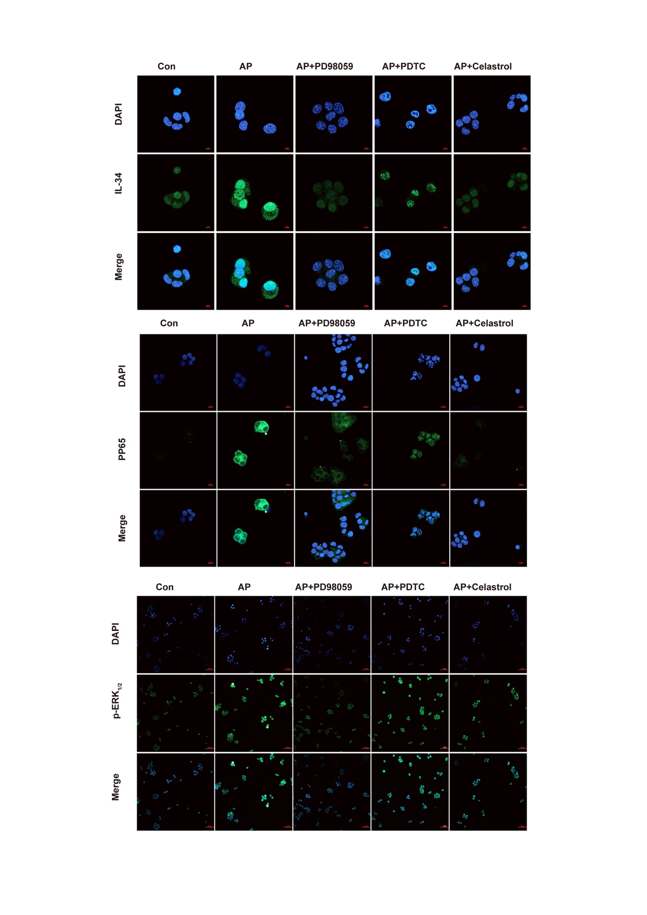
Supplementary Figure S2. Representative immunofluorescence images in AR42J cells under pathway inhibition and celastrol treatment (WT). Representative immunofluorescence images of IL-34, pp65, and p-ERK1/2 in AR42J cells under Con, AP, AP+PD98059, AP+PDTC, and AP+celastrol conditions. Scale bars: IL-34: 5 μm; p65: 10 μm; p-ERK1/2: 50 μm.

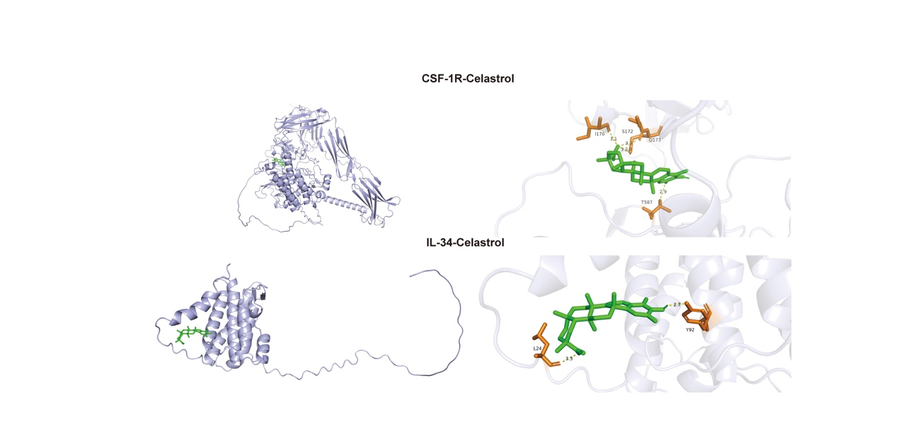
Supplementary Figure S3. Exploratory in silico docking of celastrol with IL-34 and CSF-1R. Representative docking poses showing predicted binding orientations with selected residues highlighted. Docking analysis was performed as an exploratory structural assessment and does not constitute proof of direct binding or active-site inhibition. Docking was performed to the reported ligand-binding pocket of CSF-1R (ATP/ligand-binding pocket) and a predicted interface region of IL-34; the poses suggest predominantly hydrophobic contacts with limited polar interactions; no covalent docking was modeled; MD simulations were not performed.

