Supplementary Table S1. B-cell lymphoma cell lines, subtypes, and culture conditions.
Cell Line | Subtype | Culture Conditions
ULA | Likely DLBCL | IMDM + Opti-MEM (1:1) + 20% (v/v) FBS
RI-1 | DLBCL, GCB | RPMI-1640 + 10% (v/v) FBS
Daudi | Burkitt lymphoma | RPMI-1640 + 10% (v/v) FBS
Raji | Burkitt lymphoma | RPMI-1640 + 10% (v/v) FBS
NU-DUL-1 | DLBCL, ABC | RPMI-1640 + 10% (v/v) FBS
OCI-LY18 | DLBCL, ABC | RPMI-1640 + 10% (v/v) FBS
OCI-LY19 | DLBCL, GCB | alpha-MEM (with nucleosides) + 10% (v/v) FBS
SU-DHL-6 | DLBCL, GCB | RPMI-1640 + 10% (v/v) FBS
SU-DHL-10 | DLBCL, ABC | RPMI-1640 + 20% (v/v) FBS

Abbreviation: DLBCL: Diffuse Large B-Cell Lymphoma; GCB: Germinal Center B-cell-like; ABC: Activated B-cell-like.

Supplementary Figure S1

A
Jurkat
Merge
DAPI
CD47
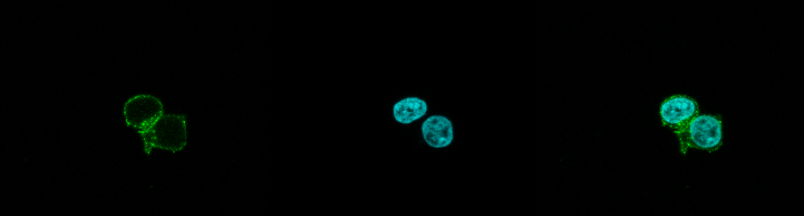
Ctrl

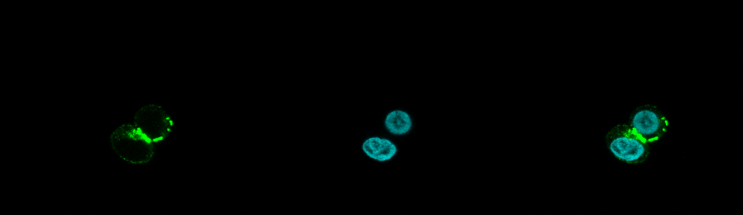
CO-005

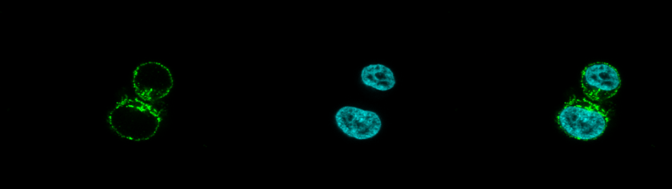
Magrolimab

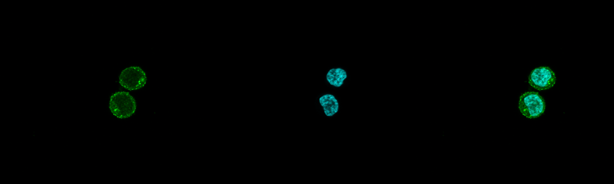
B6H12
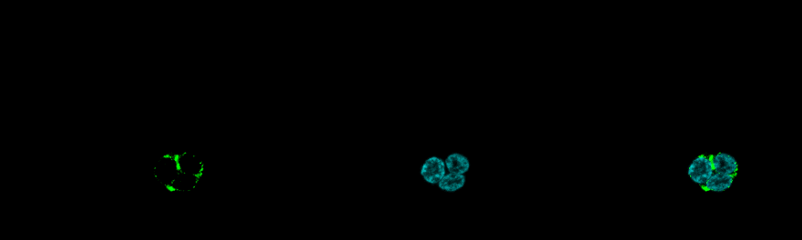
CO-004

B

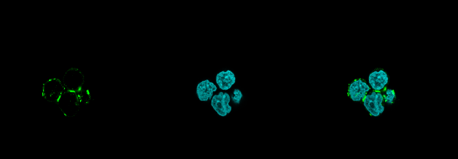
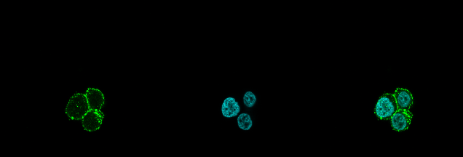
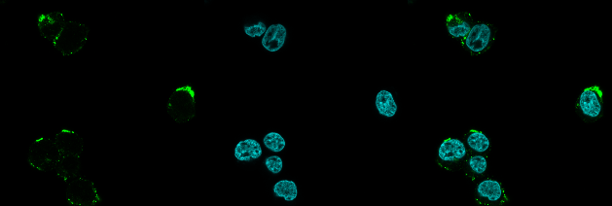
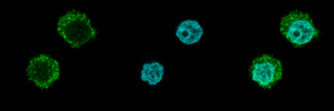
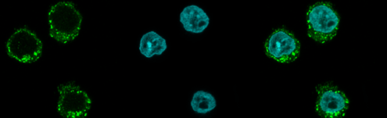
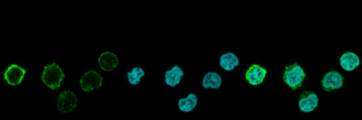
CD47
DAPI
Merge
MOLT-4
CD47
DAPI
Merge
KG-1a
CO-005
CO-005
CO-005
Ctrl
Ctrl
REH

Ctrl

CO-005 triggers CD47 receptor capping in (A) Jurkat cells were either treated with 1µg/ml of CO-005, Magrolimab, B6H12, or CO-004 for 3 hours or untreated (Ctrl). (B) MOLT-4, KG-1a, and REH cell lines were treated with 1µg/ml CO-005 for 3 hours or untreated. Receptor distribution was visualized by confocal microscopy following immunofluorescence staining.

