Structural Formula of Taurine-Modified Gossypol (Enol Form)

1. Synthesis Procedure

The synthesis method was referenced from ^{[1]}. In a 100 mL round-bottom flask, gossypol acetate (2.90 g, 5.0 mmol), taurine (1.25 g, 10 mmol), and sodium hydroxide (0.61 g, 15 mmol) were added separately, followed by 55 mL of 90% aqueous methanol. The mixture was stirred and heated under reflux for 4 hours, then cooled to room temperature and filtered. The precipitate was washed with 10 mL of anhydrous ethanol and 10 mL of diethyl ether sequentially to obtain 2.42 g of crude product. Further recrystallization from 90% aqueous methanol yielded sodium taurogossypolate as a pale yellow crystalline powder, which was then dried under vacuum. Finally, 1.95 g of the product was obtained with a yield of 64% (calculated based on gossypol acetate) and a purity of 95.5%.

- Spectroscopic Data
¹H NMR (400 MHz, d₆-DMSO): δ 13.17 – 12.85 (m, 2H), 9.71 (d, J = 13.2 Hz, 2H), 8.55 (s, 2H), 7.82 (s, 2H), 7.42 (s, 2H), 3.77 (m, 4H), 3.70 (m, 2H), 2.82 (t, J = 6.1 Hz, 4H), 1.92 (s, 6H), 1.55 – 1.34 (m, 12H).
¹³C NMR (101 MHz, d₆-DMSO): δ 172.06, 162.24, 149.97, 147.10, 131.51, 127.37, 126.99, 120.67, 116.58, 103.71, 51.29, 48.04, 26.98, 20.82, 20.68.
IR Data (KBr Pellet Method): The strong absorption band of aromatic aldehyde originally present in gossypol acetate (around 1711 cm⁻¹) disappeared, while characteristic absorption peaks of aliphatic sulfonate (1047 cm⁻¹ and 1212 cm⁻¹) appeared ^{[2].}
Molecular Formula: C₃₄H₃₈N₂Na₂O₁₂S₂
Molecular Weight: 776.1662 g/mol
HR-MS (TOF-MS, ES⁺): m/z calculated for [M+Na]⁺: 799.1559; found: 799.1589.

- References：

- Guo Z M, Zhu C Q, Bian J, Wu G P, Teng L, Cai S Y, Jiang J Y. Synthesis of sodium taurogossypolate and its antiviral activity [J]. Chinese Journal of Medicinal Chemistry, 1992(02): 36−38+44.
[2] Shi C Z, Zhou S Y, Wang Z Y, Ding W P. A new immunosuppressant: Synthesis of sodium taurogossypolate [J]. Acta Academiae Medicinae Wuhan, 1983(02): 184−187.
Appendices：

Table S1. Experimental Reagents and Materials
Name | Purity | Manufacturer
Gossypol Acetate | 97% | Aladdin Industrial Corporation
Taurine | 99% | Aladdin Industrial Corporation
NaOH | Analytical Grade | Sinopharm Chemical Reagent Co., Ltd.
Methanol | Analytical Grade | Sinopharm Chemical Reagent Co., Ltd.
Anhydrous Ethanol | Analytical Grade | Sinopharm Chemical Reagent Co., Ltd.
Diethyl Ether | Analytical Grade | Sinopharm Chemical Reagent Co., Ltd.

Figure S1. Photograph of Taurine-Modified Gossypol (GT) as a Crystalline Powder
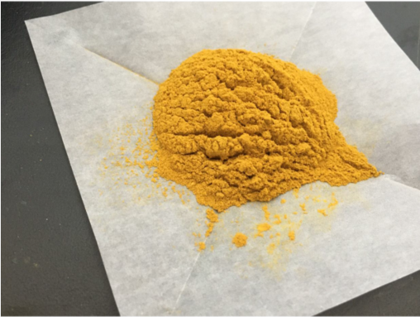

Figure S2. Microscopic Photograph of Taurine-Modified Gossypol (GT) as a Crystalline Powder (Magnification: 40×)
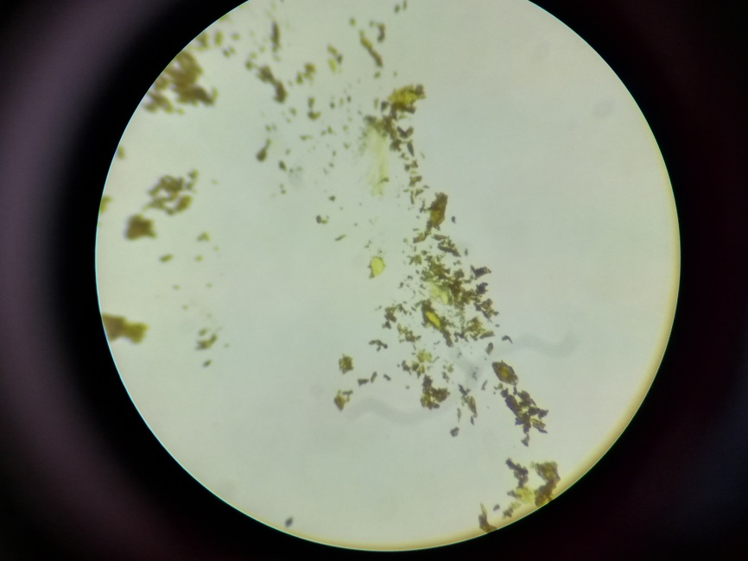
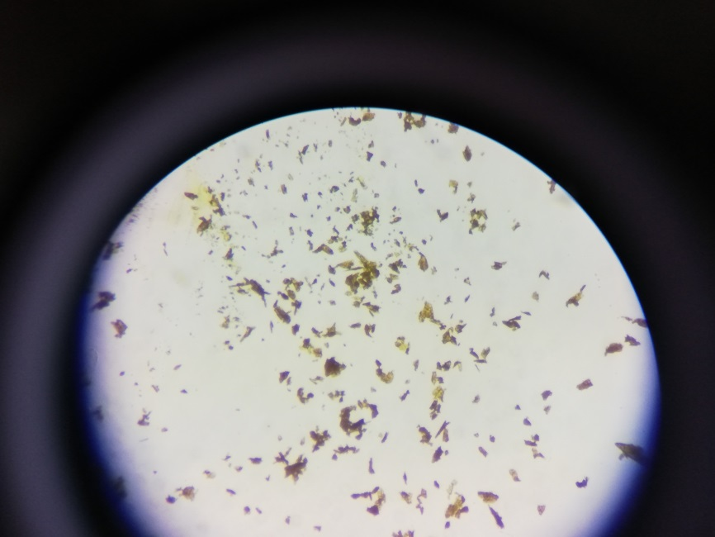

Figure S3. IR Spectrum of Taurine-Modified Gossypol (GT) (Instrument Model: Thermo Nicolet IS 10)
IR Spectrum of Taurine-Modified Gossypol (GT)
Figure S4. NMR Spectrum of Taurine-Modified Gossypol (GT) NMR Spectra (Instrument Model: Bruker Avance III 400)

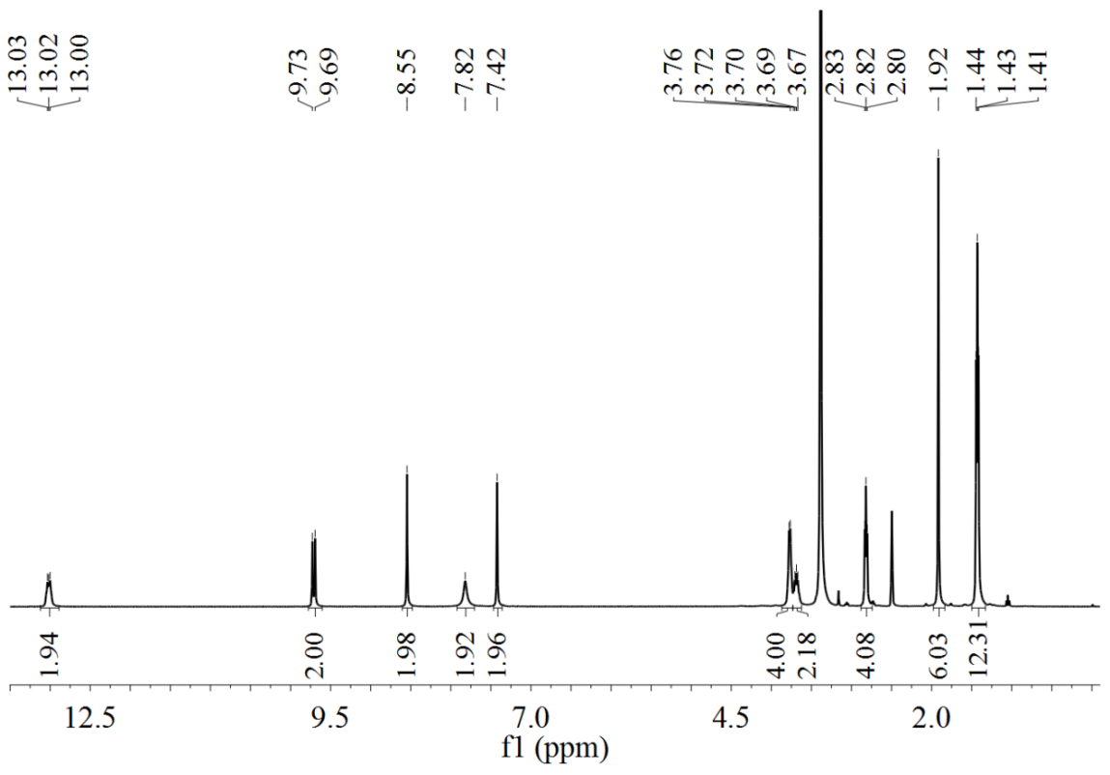
¹H NMR Spectrum of Taurine-Modified Gossypol (GT) (400 MHz, d₆-DMSO)

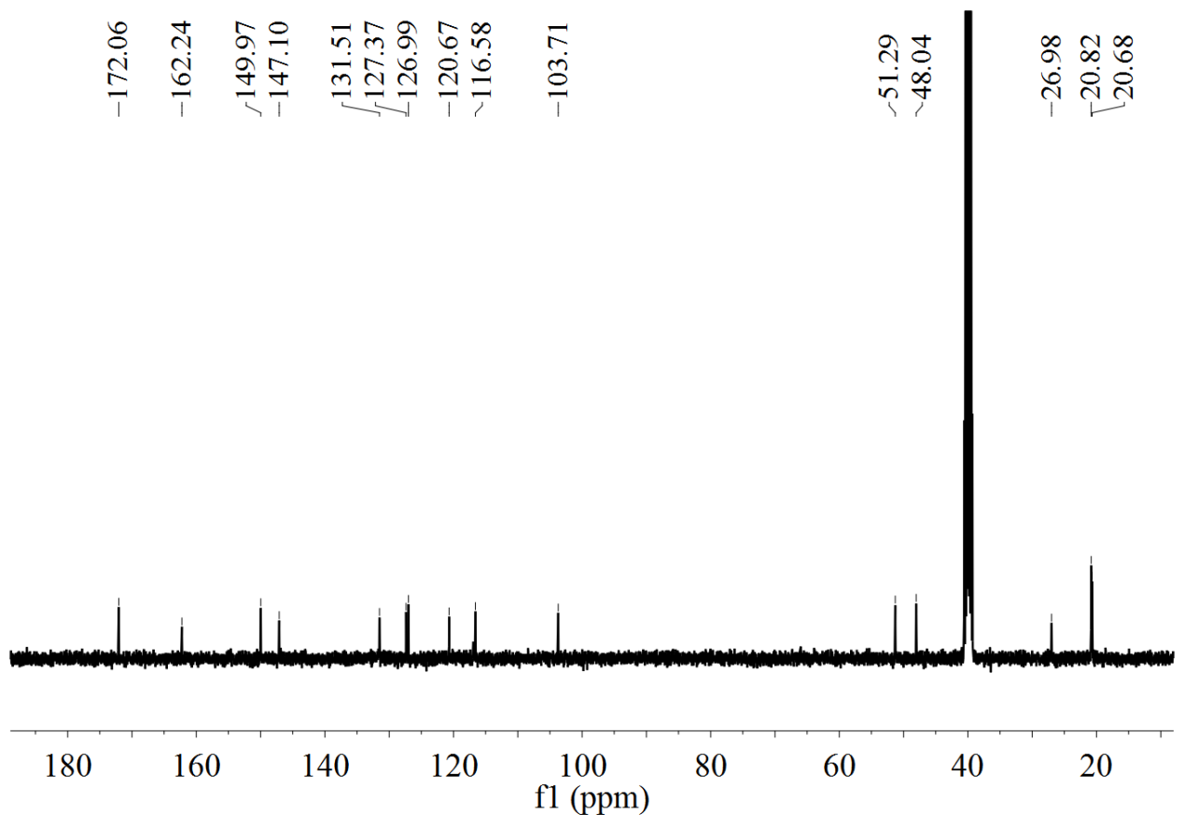
¹³C NMR Spectrum of Taurine-Modified Gossypol (GT) (101 MHz, d₆-DMSO)

