Supplementary Table 1 Baseline characteristics of participants
Variables | Total | No surgery | Surgery | P value
Variables | (n = 298) | (n = 59) | (n = 239) | P value
Age, (years) | 78.5 ± 7.5 | 80.0 ± 7.7 | 78.1 ± 7.5 | 0.081
Gender，n(%) |  |  |  | 0.681
Female | 185 (62.1) | 38 (64.4) | 147 (61.5)
Insurance，n(%)
Yes | 133 (44.6) | 18 (30.5) | 115 (48.1) | 0.015
Career，n(%) |  |  |  | 0.354
Farmer | 164 (55.0) | 34 (57.6) | 130 (54.4)
Worker | 6 (2.0) | 0 (0) | 6 (2.5)
Freelancer | 60 (20.1) | 15 (25.4) | 45 (18.8)
Retirement | 68 (22.8) | 10 (16.9) | 58 (24.3)
Injury. Reason，n(%) |  |  |  | 0.787
Fall | 275 (92.3) | 54 (91.5) | 221 (92.5)
Accidence | 23 (7.7) | 5 (8.5) | 18 (7.5)
Hip fracture，n(%) |  |  |  | < 0.001
Femoral neck fracture | 103 (34.6) | 13 (22) | 90 (37.7)
Per trochanteric fracture | 190 (63.8) | 42 (71.2) | 148 (61.9)
Subtrochanteric fracture | 5 (1.7) | 4 (6.8) | 1 (0.4)
Hypertension，n(%) |  |  |  | 0.773
Yes | 116 (38.9) | 22 (37.3) | 94 (39.3)
DM, n (%)
Yes | 32 (10.7) | 5 (8.5) | 27 (11.3)
Heart disease, n(%) |  |  |  | 0.030
Yes | 40 (13.4) | 13 (22) | 27 (11.3)
Chronic kidney disease, n(%) |  |  |  | 1.000
Yes | 9 (3.0) | 2 (3.4) | 7 (2.9)
Cerebral disease, n(%) |  |  |  | 0.402
Yes | 27 (9.1) | 7 (11.9) | 20 (8.4)
Pulmonary disease, n(%) |  |  |  | 0.007
Yes | 20 (6.7) | 9 (15.3) | 11 (4.6)
Liver disease, n(%) |  |  |  | 0.485
Yes | 3 (1.0) | 1 (1.7) | 2 (0.8)
Hospital costs (¥) | 21360.0  (15770.0, 26600.0) | 4747.0  (3301.0, 7544.0) | 23000.0  (19100.0, 27820.0) | < 0.001
LOS (days) | 14.5 (10.2, 18.8) | 7.0 (4.0, 12.0) | 16.0 (12.0, 19.0) | < 0.001
Notes: LOS: length of stay, DM,: diabetes mellifluous., (¥): yuan.

Supplementary Table 2 Multivariate analysis of risk association with mortality
Variable | Model 1 |  |  | Model 2 |  |  | Model 3 |  |  | Model 4
Variable | OR (95%CI) | P value |  | OR (95%CI) | P value |  | OR (95%CI) | P value |  | OR (95%CI) | P value
Surgery
No | Reference |  |  | Reference |  |  | Reference |  |  | Reference
Yes | 0.39 (0.19~0.79) | 0.009 |  | 0.42 (0.20~0.86) | 0.018 |  | 0.39 (0.19~0.82) | 0.012 |  | 0.43 (0.2~0.92) | 0.030
Model 1: did not adjust any con founders.
Model 2: adjusted for age and gender.
Model 3: additionally adjusted for injury reason and fracture type.
Model 4: additionally adjusted for hypertension, diabetes,insurance,and pulmonary disease .
Supplementary Table 3 Multivariate analysis of risk association with mortality
Variable | Model 1 |  |  | Model 2 |  |  | Model 3 |  |  | Model 4
Variable | OR (95%CI) | P value |  | OR (95%CI) | P value |  | OR (95%CI) | P value |  | OR (95%CI) | P value
Surgery
No | Reference |  |  | Reference |  |  | Reference |  |  | Reference
Yes | 0.39 (0.19~0.79) | 0.009 |  | 0.42 (0.20~0.86) | 0.018 |  | 0.39 (0.19~0.82) | 0.012 |  | 0.44  (0.21~0.96) | 0.038
Model 1: did not adjust any con founders.
Model 2: adjusted for age and gender.
Model 3: additionally adjusted for injury reason and fracture type.
Model 4: additionally adjusted for hypertension, diabetes, heart disease,,and pulmonary disease .

Supplemental Figure 1 Risk ration for exposure confounder relationship
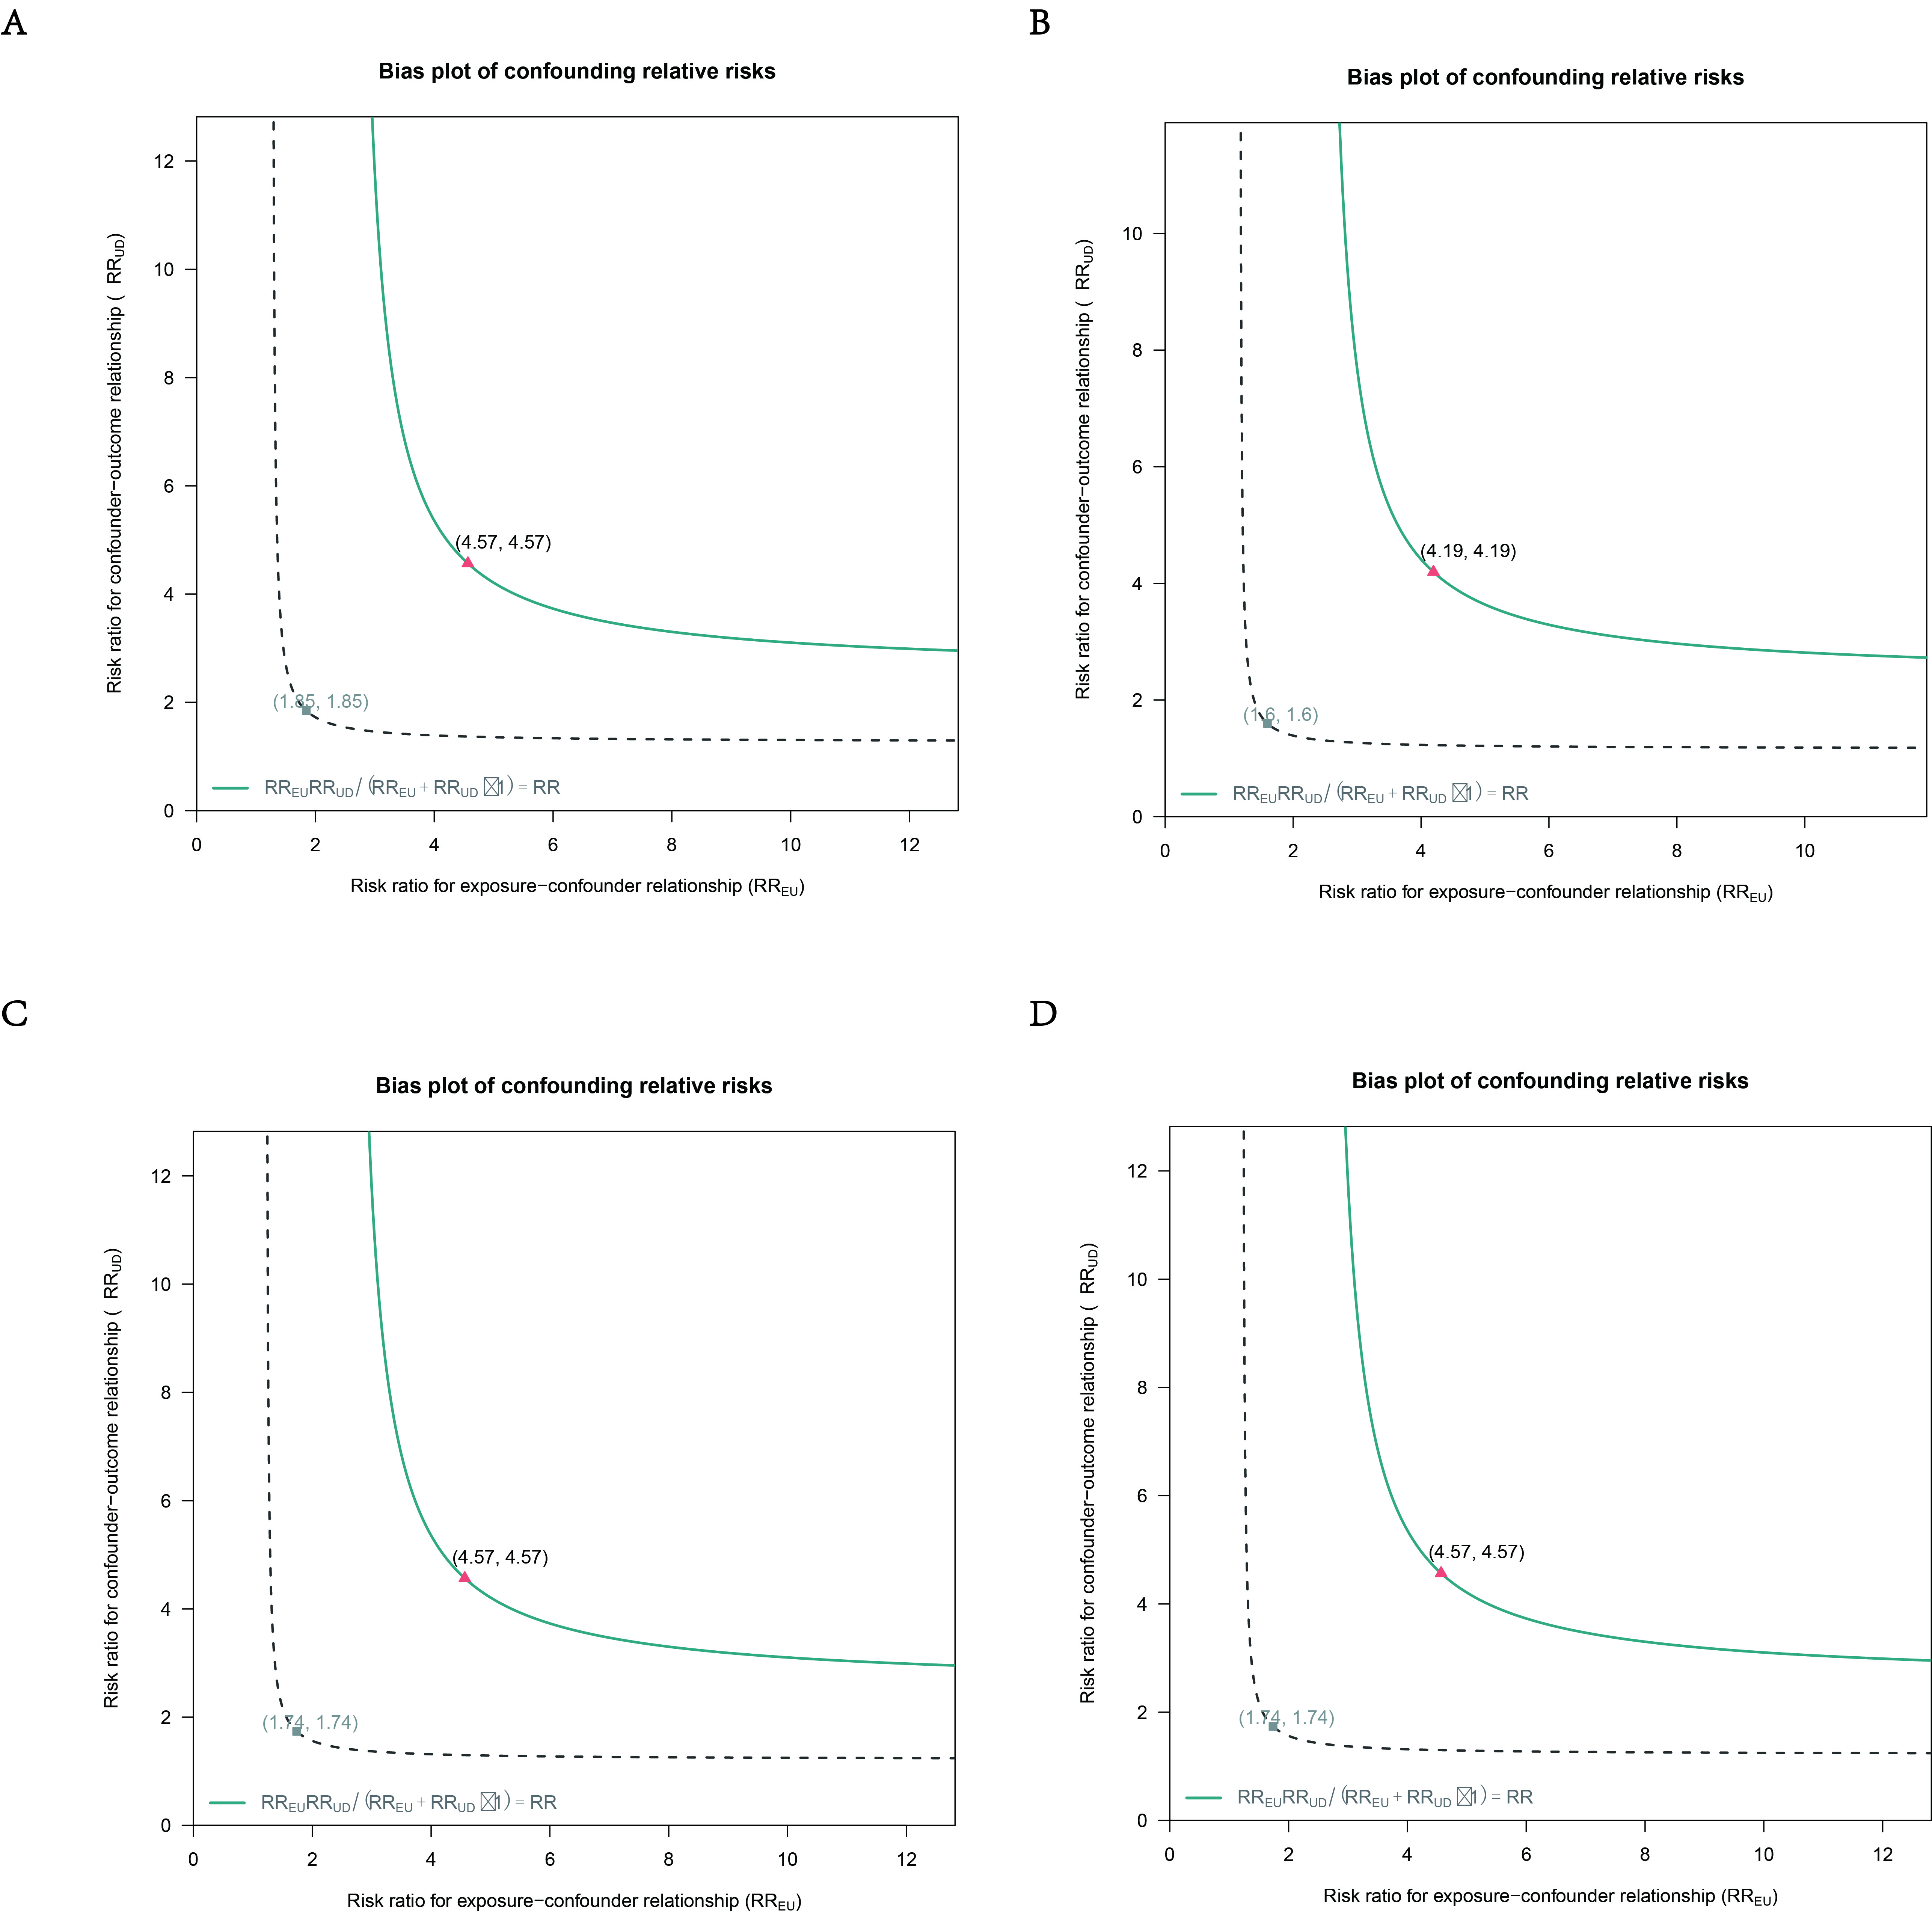
A: did not adjust any confounders.
B: adjusted for age and gender.
C: additionally adjusted for injury reason and fracture type.
D: additionally adjusted for hypertension, and DM.

