Supplementary Table S1: Diagnostic specificity and species identification results of the Nanopore tNGS DR-TB assay among non-tuberculous mycobacteria (NTM) and mycobacteria-negative clinical control samples.

Sample Category / Species | N | Reference Result  (Anyplex™ MTB/NTM) | tNGS Result | %Concordance
Non-tuberculous mycobacteria (NTM)
Mycobacterium abscessus | 2 | NTM positive, M. abscessus** | M. abscessus | 100%
Mycobacterium iranicum | 1 | NTM positive | M. iranicum | 100%
Unidentified NTM species | 7 | NTM positive  (Genus level) | Unidentified/  Low reads* | N/A***
Mycobacteria-negative controls  (true negative control) | 10 | Negative for MTB and NTM | Negative | 100%
Total | 20 |  |  | 100% Specificity
Notes: * indicates tNGS sequencing yielded insufficient data for identification due to low bacterial load (Ct values >35 or smear-negative). ** indicates the species-level was confirm using LPA. *** indicates concordance was not applicable (N/A). However, both methods agreed on the absence of M. tuberculosis.

Supplementary Table S2: Detailed genotypic (gDST) and phenotypic (pDST) drug susceptibility results for the 59 clinical isolates included in the diagnostic assessment.
Abbreviations: gDST, genotypic drug susceptibility testing; pDST, phenotypic drug susceptibility testing; RAVs, resistance-associated variants. Sample types: SPT, sputum sample; CLN, culture isolate. Patient Categories: PS, pan-susceptible; IR, isoniazid-resistant; RR, rifampicin-resistant; MDR, multidrug-resistant; pre-XDR, pre-extensively drug-resistant. Drugs & Phenotypes: INH, isoniazid; RIF, rifampicin; EMB, ethambutol; PZA, pyrazinamide; STM, streptomycin; AMK, amikacin; KAN, kanamycin; ETO, ethionamide; FQs, fluoroquinolones; -R, resistant (e.g., RIF-R); -S, susceptible; ND, not determined/done.
Supplementary Figure S1 Nanopore tNGS TB-DR Custom Panel results for the 59 samples. The reports were retrieved from the EPI2ME Lab software (wf-tb-amr workflow), showing species identification, spoligotyping, lineage, and drug resistance profiles for each sample.
TB-SPT
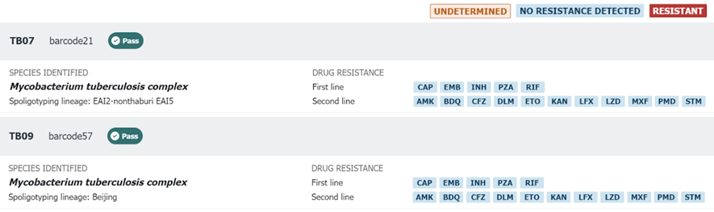
IR
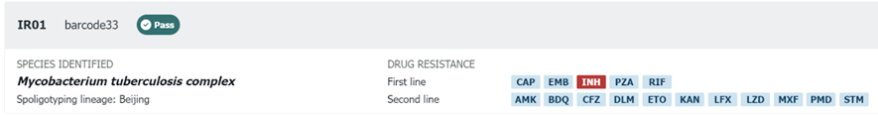
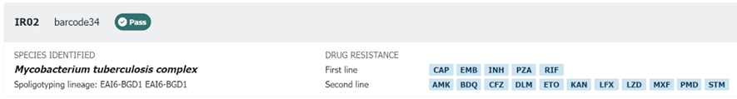
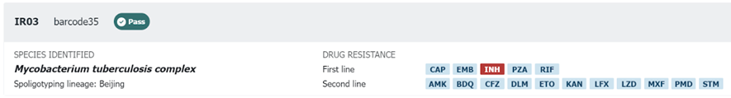
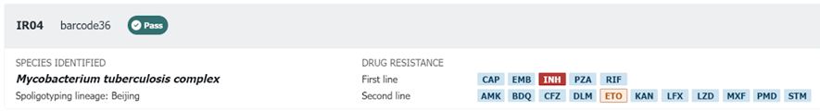
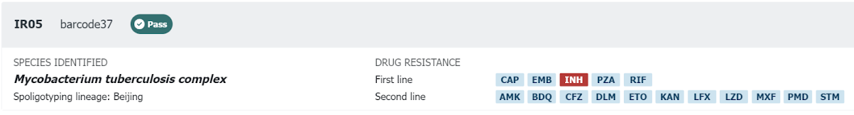
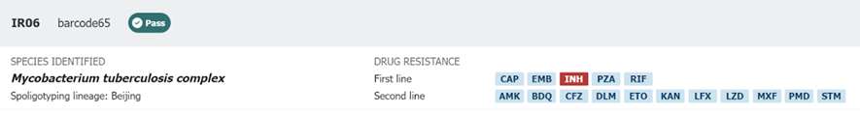
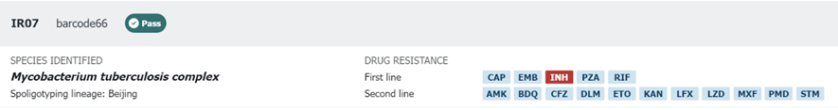
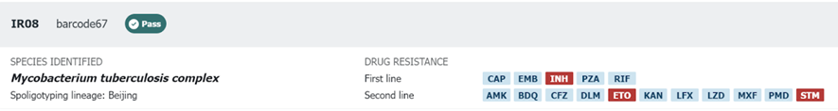
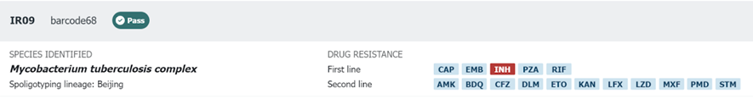
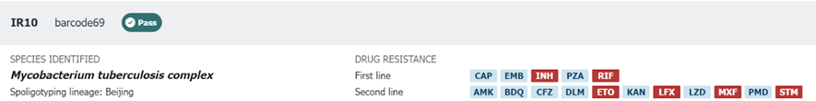
RR
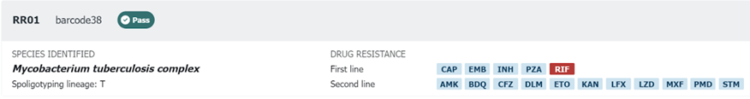
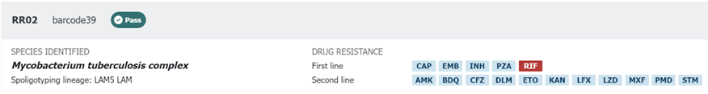
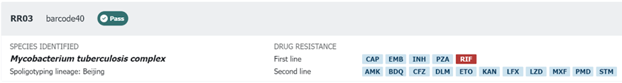
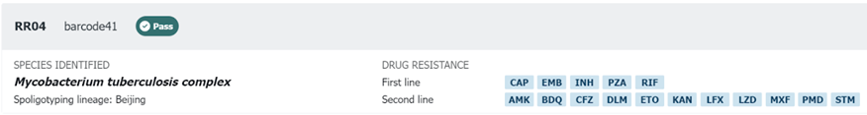
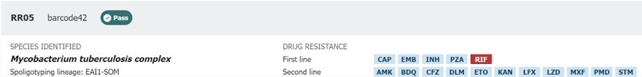
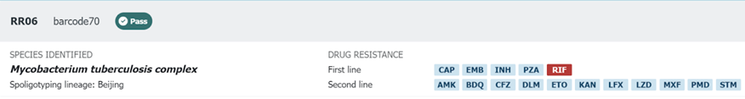
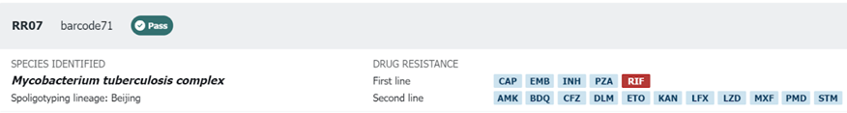
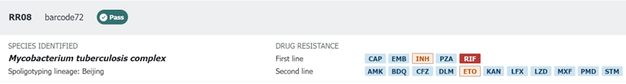
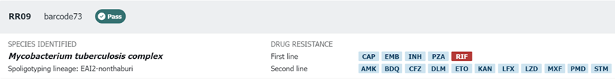
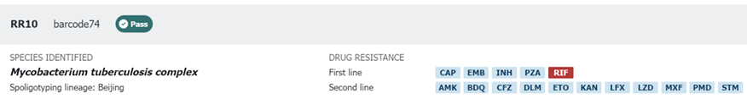
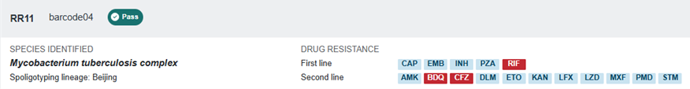
IRR/MDR
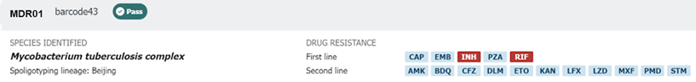
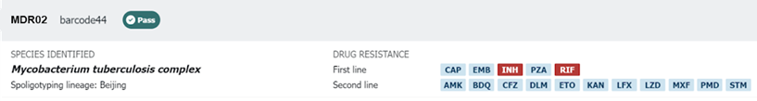
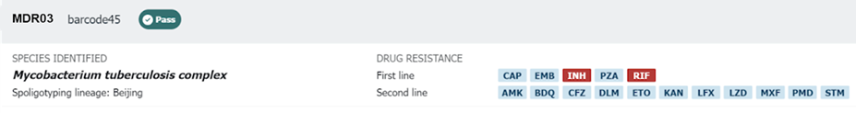
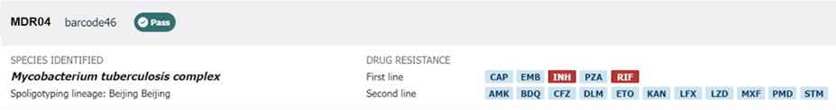
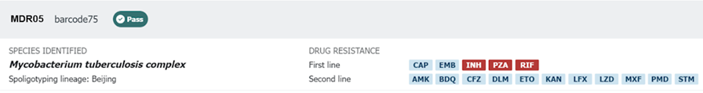
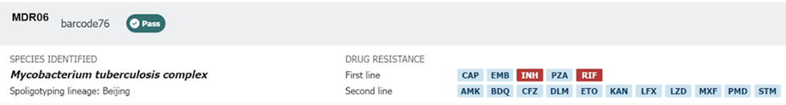
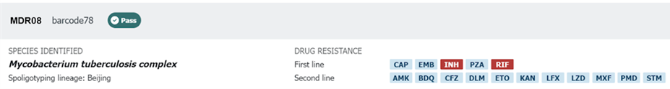
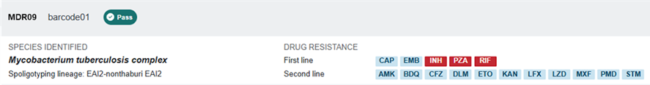
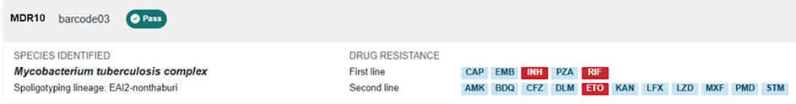
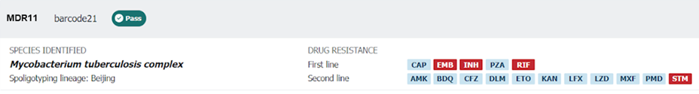
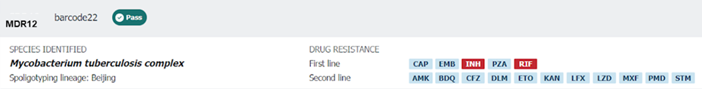
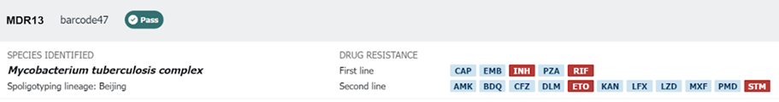
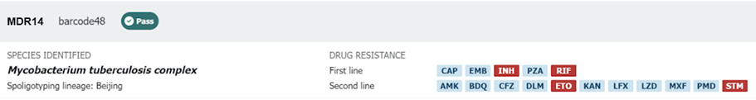
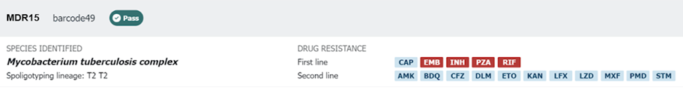
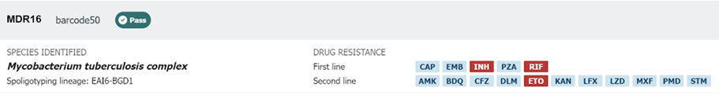
Pre-XDR
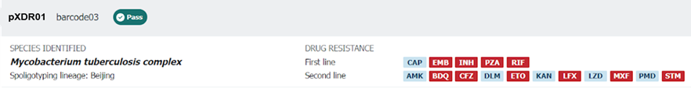
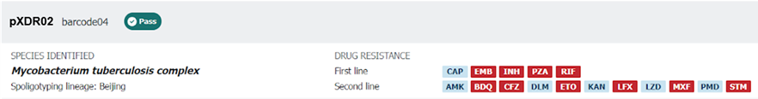
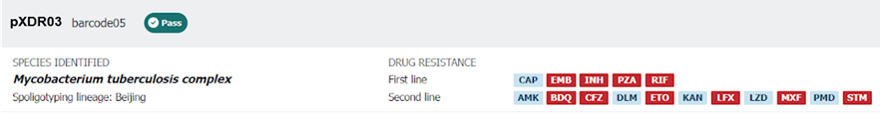
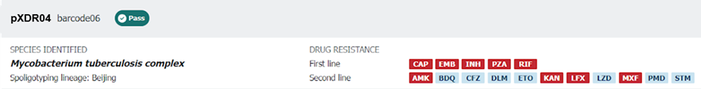
PS
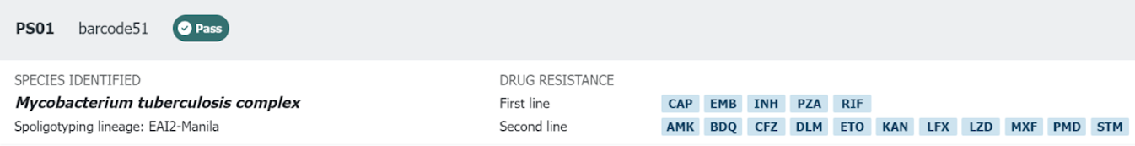
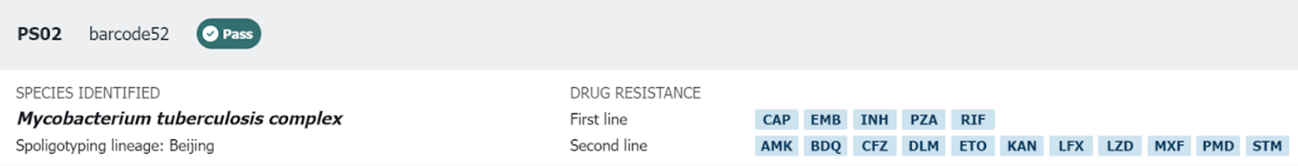
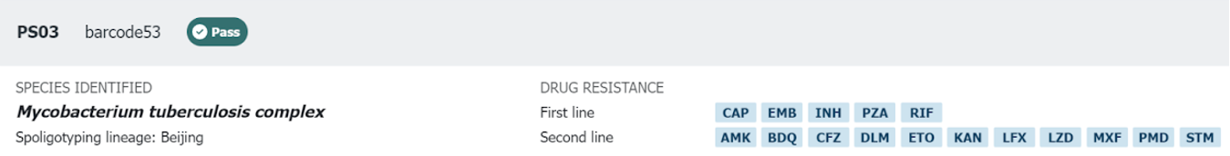
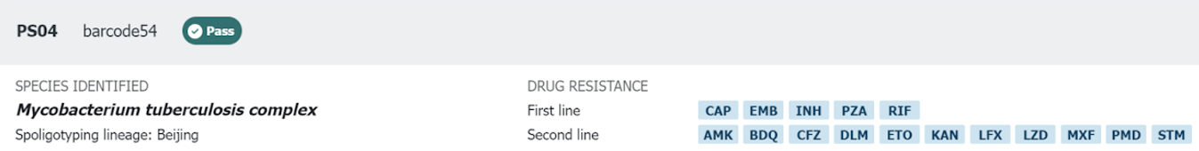
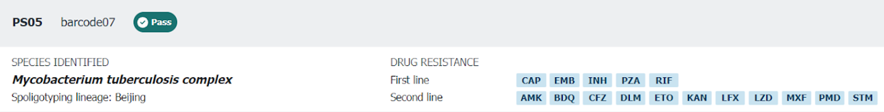
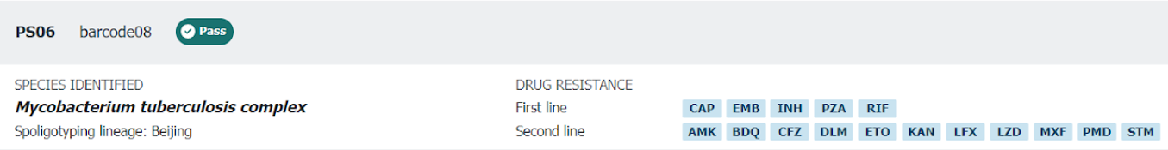
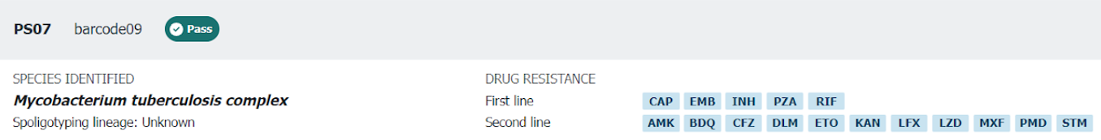
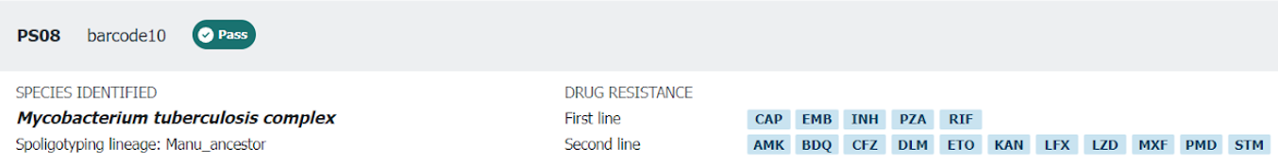
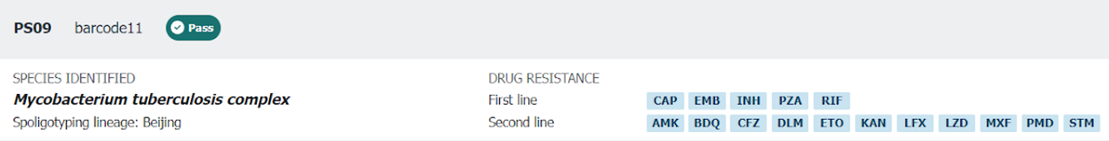
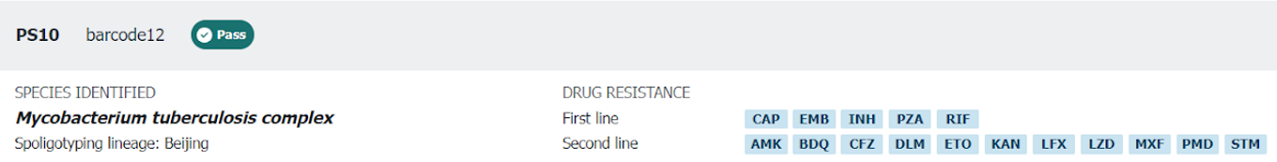
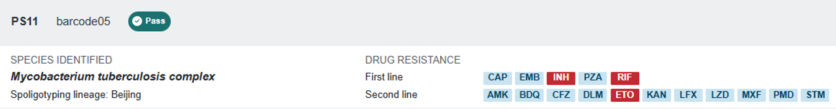
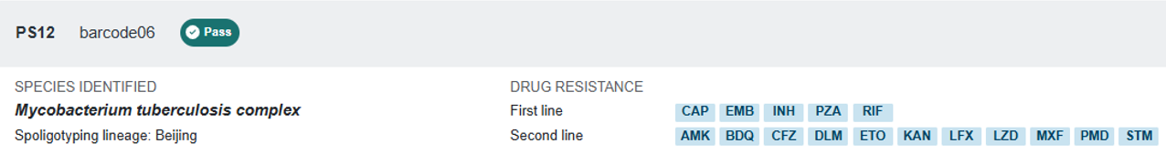
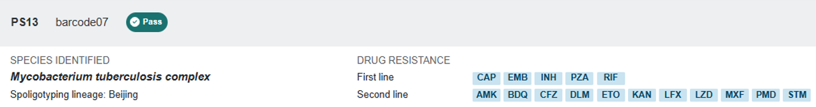
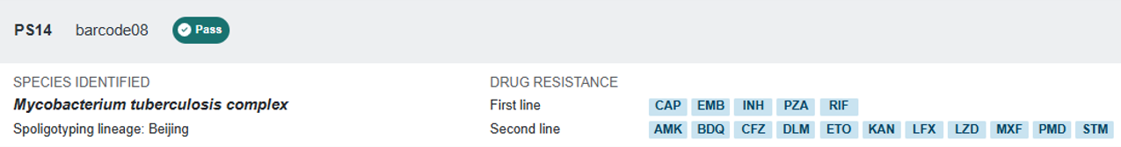
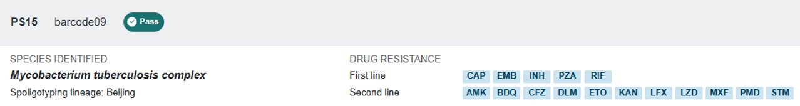
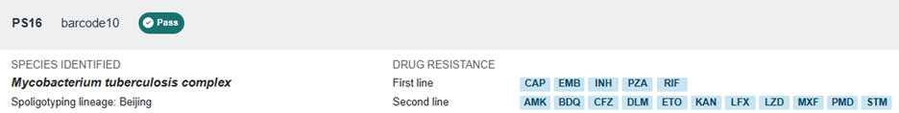
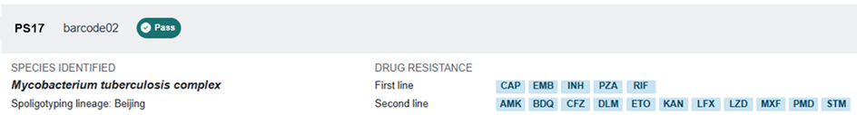

Abbreviations: PS, pan-susceptible; IR, isoniazid-resistant; RR, rifampicin-resistant; IRR, isoniazid- and rifampicin-resistant; MDR, multidrug-resistant; pre-XDR, pre-extensively drug-resistant; SPT, sputum sample; CLN, colony sample.

