Supplementary data
Bérard C. et al

Material and methods
- Materials
For nanodroplets synthesis and characterization, tributyl O-acetyl citrate (ATBC) 98% was purchased from Sigma-Aldrich (St. Quentin Fallavier, France) and Capryol® 90 (C-90) was graciously provided by GatteFossé SAS (Saint-Priest, France). Perfluorooctyl bromide (PFOB) 98% was purchased from Fluorochem (Hadfiel, United Kingdom), trehalose anhydrous (98%), paclitaxel (PTX) and docetaxel (DTX) were purchased from TCI Europe (Boereveldseweg, Belgium). 0.22 µm cellulose acetate (CA) filters were purchased from AIT France (Cormeilles-en-Parisis, France). Methyl tert-butyl ether (MTBE) and acetonitrile (ACN) of Ultra-High Performance Liquid Chromatography-Mass Spectrometry (UHPLC-MS) grade were purchased from Carlo Erba (Val de Reuil, France). Phosphate Buffer Saline (PBS) Tablets pH 7.4 were purchased from Panreac (Castellar del Vallès, Spain).
For cell culture, Eagle’s Minimum Essential Medium (EMEM) was obtained from Lonza (Verviers, Belgium) and fetal calf serum (FCS) from Eurobio (Les Ulis, France). Dulbecco’s Modified Eagle Medium (DMEM), L-Glutamine, penicillin/streptomycin, trypsin (0.05% Trypsin/Ethylene diamine tetraacetic acid (EDTA) 1X) and PBS or Dulbecco's Phosphate-Buffered Saline (DPBS) were purchased from Gibco (Paisley, United Kingdom). For animal studies, branded formulation of DTX (Docetaxel Accord® 20 mg mL⁻¹) was purchased from Accord Healthcare France.

- LC-MS analysis of DTX in blood and brain tissue
The system was controlled by MassLynx Version 4.2 (Waters, Milford, MA, USA). Three & five microliters of sample were injected to an Acquity UPLC® CSH C18 1.7 µm column (2.1 × 100 mm, Waters, Milford, MA, USA) kept at 45 °C, for the blood and brain samples, respectively. Chromatographic separation was achieved using mobile phases consisting of water (A) and ACN (B), both containing 0.01% formic acid with a flow rate of 0.4 mL min⁻¹. The elution gradient was from 30% B to 99% B in 4.5 minutes, maintained at this ratio for 2 minutes then back to initial conditions in 1.5 minutes and maintained at initial condition during 1 minute (total run time 7 minutes). Data acquisition and processing were performed using MassLynx version 4.2 and TargetLynx software (Waters, Milford, USA).
DTX and internal standard were injected to identify the multiple reactions monitoring (MRM) acquisition in positive electrospray ionization (ESI) mode. The capillary voltage was set to 3.2 kV and the source temperature to 150 °C. Nitrogen was used as drying and nebulizing gas at 150 L h⁻¹ for the gas flow and 1000 L h⁻¹ for the desolvation gas at 550 °C. MRM analysis was used to monitor the transitions from precursor ions to dominant product ions. Two specific optimized mass transitions ion-pair were used to determine DTX and internal standard, with the most intense transition used for the quantification (quantifier transition (QT)) and the second used for confirmation purposes (qualifier transition (QL)). The mass transition ion-pair were followed as m/z 830.4 → 304.2 (QT, Collision energy (CE)= 20 eV) and 830.40 → 248.10 (QL, CE= 40 eV) for DTX, and m/z 854.40 → 509.3 (QT, CE= 20 eV) and 854.40 → 286.20 (QL, CE= 30 eV) for internal standard.

Results
Figure S1. Assessment of the in vitro anti-glioma activity of docetaxel (DTX) using the MTT assay on U87-MG cells incubated for 72 h with DTX dissolved in DMSO, tributyl O-acetyl citrate (ATBC) or Capryol® 90 (C-90) oil (0.1, 1, 2.5, 5, 10, 50 nmol L⁻¹). The values are expressed as mean ± SD (n = 3). MTT, 3-(4,5-dimethylthiazol-2-yl)-2,5-diphenyltetrazolium bromide.

Figure S2. NDs size distribution of the TEM image using ImageJ software
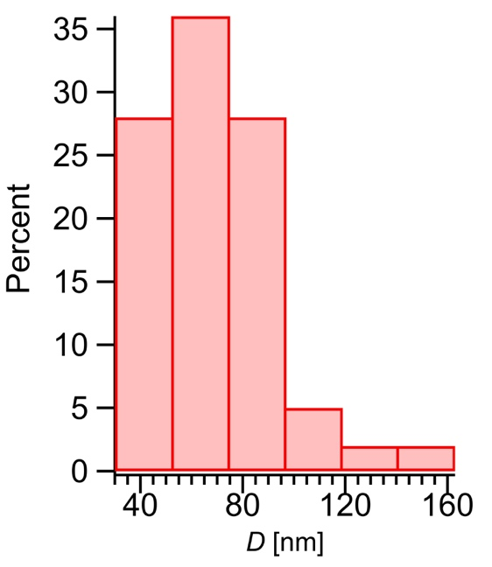

Table S1. Impact of trehalose concentration on nanodroplets size (D_{H}) before freeze-drying and after rehydration of the freeze-dried emulsion.
 | Before freeze-drying | After rehydration of the freeze-dried emulsion
% (w/v) of trehalose^{a)} |  | 0 | 5% | 10% | 15%
D_{H} [Z-av in nm] | 73 ± 8 | 211 ± 8 | 99 ± 21 | 82 ± 8 | 89 ± 13
S_{f}/S_{i}^{b)} |  | 2.90 | 1.36 | 1.13 | 1.23
^{a)}% of trehalose after rehydration of the freeze-dried emulsion; ^{b)}Si: initial size of the parent emulsion before freeze-drying, Sf: final size after rehydration of the freeze-dried emulsion.

