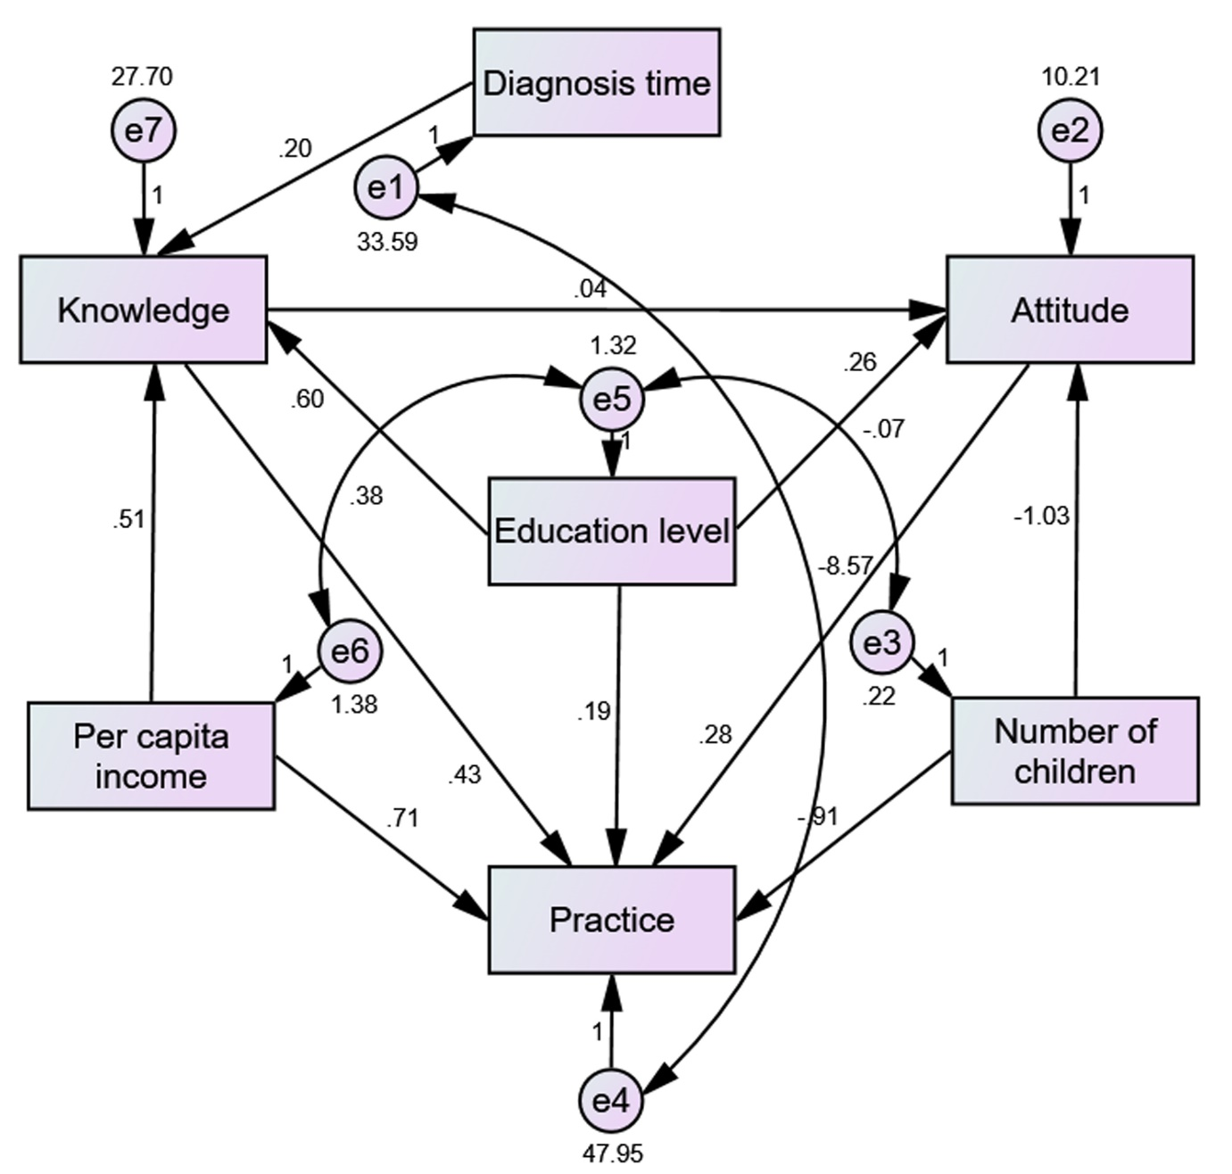

Figure S1 Structural equation modeling among parents of children under two years old.

Table S1 Univariate and multivariate logistic regression analysis associated with knowledge
Variables | Univariate regression analysis |  | Multivariate regression analysis
Variables | OR (95% CI) | P | OR (95% CI) | P
Gender
Male | 0.586(0.288 1.194) | 0.141
Female | ref
Age | 1.073(1.021 1.127) | 0.005 | 0.998(0.933 1.069) | 0.964
Child’s gender
Male | 1.069(0.651 1.755) | 0.791
Female | ref
Child’s age | 1.155(1.083 1.233) | <0.001 | 1.044(0.940 1.160) | 0.419
Residence
Rural | 0.408(0.194 0.857) | 0.018 | 0.868(0.379 1.991) | 0.739
Urban | ref |  | ref
Suburban | 0.916(0.421 1.991) | 0.824 | 1.380(0.588 3.237) | 0.459
Education
High school and below | ref |  | ref
College | 1.506(0.505 4.493) | 0.462 | 1.174(0.362 3.809) | 0.789
Bachelor’s degree | 2.851(1.079 7.533) | 0.035 | 1.753(0.578 5.320) | 0.322
Master’s degree and above | 4.291(1.461 12.603) | 0.008 | 1.782(0.489 6.489) | 0.381
Employment status
Employed | ref |  | ref
Unemployed | 1.934(1.040 3.597) | 0.037 | 0.753(0.360 1.575) | 0.451
Monthly income per capita
<5000 | ref |  | ref
5000-10000 | 3.076(0..689 13.719) | 0.141 | 2.683(0.575 12.515) | 0.209
10000-20000 | 6.941(1.586 30.381) | 0.010 | 4.739(1.015 22.124) | 0.048
>20000 | 6.031(1.371 26.521) | 0.017 | 4.155(0.868 19.875) | 0.075
Smoking status
Never smoked | ref |  | ref
Formerly smoked | 0.306(0.106 0.884) | 0.029 | 1.261(0.663 2.399) | 0.480
Currently smoke | 0.675(0.381 1.197) | 0.179 | 0.427(0.130 1.396) | 0.159
Number of children in the household
1 | ref
≥2 | 1.100(0.669 1.807) | 0.707
Mother's age at the birth of the affected child | 1.008(0.949 1.071) | 0.800
Pet keeping
Yes | 1.065(0.495 2.292) | 0.872
No | ref
Time since the child was diagnosed with atopic dermatitis | 1.021(1.013 1.029) | <0.001 | 1.017(1.006 1.028) | 0.002

Table S2 Univariate and multivariate logistic regression analysis associated with attitudes
Variables | Univariate regression analysis |  | Multivariate regression analysis
Variables | OR (95% CI) | P | OR (95% CI) | P
Knowledge | 1.048(1.008 1.090) | 0.018 | 1.047(1.006 1.089) | 0.024
Gender
Male | 0.752(0.402 1.406) | 0.371
Female | ref
Age | 1.004(0.958 1.053) | 0.857
Child’s gender
Male | 1.228(0.767 1.966) | 0.393
Female | ref
Child’s age | 0.989(0.923 1.061) | 0.764
Residence
Rural | 1.030(0.584 1.816) | 0.918
Urban | ref
Suburban | 1.043(0.493 2.208) | 0.912
Education
High school and below | ref
College | 1.244(0.500 3.097) | 0.638
Bachelor’s degree | 2.208(0.990 4.927) | 0.053
Master’s degree and above | 1.571(0.585 4.221) | 0.370
Employment status
Employed | ref
Unemployed | 0.642(0.368 1.118) | 0.117
Monthly income per capita
<5000 | ref
5000-10000 | 1.231(0.500 3.030) | 0.651
10000-20000 | 1.763(0.714 4.356) | 0.219
>20000 | 1.385(0.553 3.471) | 0.487
Smoking status
Never smoked | ref |  | ref
Formerly smoked | 0.927(0.460 1.868) | 0.833 | 0.991(0.489 2.009) | 0.980
Currently smoke | 0.473(0.260 0.859) | 0.014 | 0.488(0.268 0.889) | 0.019
Number of children in the household
1 | ref
≥2 | 0.675(0.416 1.095) | 0.111
Mother's age at the birth of the affected child | 0.986(0.931 1.045) | 0.645
Pet keeping
Yes | 1.154(0.566 2.351) | 0.694
No | ref
Time since the child was diagnosed with atopic dermatitis | 0.994(0.985 1.003) | 0.206

Table S3 Univariate and multivariate logistic regression analysis associated with practices
Variables | Univariate regression analysis |  | Multivariate regression analysis
Variables | OR (95% CI) | P | OR (95% CI) | P
Knowledge | 1.100(1.056 1.145) | <0.001 | 1.127(1.074 1.181) | <0.001
Attitudes | 1.081(1.011 1.155) | 0.022 | 1.057(0.982 1.138) | 0.142
Gender
Male | 0.572(0.344 0.953) | 0.032 | 0.743(0.418 1.320) | 0.311
Female | ref |  | ref
Age | 0.953(0.913 0.955) | 0.030 | 1.001(0.944 1.061) | 0.980
Child’s gender
Male | 0.588(0.378 0.916) | 0.019 | 0.528(0.323 0.863) | 0.011
Female | ref |  | ref
Child’s age | 0.897(0.845 0.952) | <0.001 | 0.841(0.774 0.914) | <0.001
Residence
Rural | 0.960(0.569 1.621) | 0.879
Urban | ref
Suburban | 0.899(0.453 1.783) | 0.760
Education
High school and below | ref |  | ref
College | 1.671(0.859 3.251) | 0.130 | 1.121(0.538 2.333) | 0.761
Bachelor’s degree | 2.484(1.355 4.552) | 0.003 | 1.559(0.775 3.134) | 0.213
Master’s degree and above | 1.800(0.831 3.899) | 0.136 | 1.039(0.417 2.590) | 0.935
Employment status
Employed | ref
Unemployed | 0.851(0.532 1.360) | 0.499
Monthly income per capita
<5000 | ref |  | ref
5000-10000 | 2.002(1.010 3.967) | 0.047 | 1.332(0.622 2.851) | 0.460
10000-20000 | 3.296(1.560 6.966) | 0.002 | 2.107(0.897 4.949) | 0.087
>20000 | 2.104(1.031 4.293) | 0.041 | 1.674(0..729 3.846) | 0.224
Smoking status
Never smoked | ref
Formerly smoked | 0.893(0.464 1.718) | 0.734
Currently smoke | 1.100(0.671 1.803) | 0.706
Number of children in the household
1 | ref |  | ref
≥2 | 0.460(0.297 0.711) | <0.001 | 0.791(0.465 1.344) | 0.385
Mother's age at the birth of the affected child | 0.988(0.937 1.041) | 0.654
Pet keeping
Yes | 0.748(0.392 1.425) | 0.377
No | ref
Time since the child was diagnosed with atopic dermatitis | 0.994(0.987 1.002) | 0.123

Table S4 Pearson correlation coefficients among knowledge, attitudes, and practices
 | Knowledge | Attitudes | Practices
Knowledge | 1
Attitudes | 0.056 (P=0.235) | 1
Practices | 0.328 (P<0.001) | 0.175 (P<0.001) | 1

Values represent Pearson correlation coefficients (r).
Table S5 Structural Equation Modeling
Dependent variable | Path | Independent variable | Estimate | P
Knowledge | <--- | Education | 0.820 | <0.001
Knowledge | <--- | Monthly per capita income | 0.596 | 0.009
Knowledge | <--- | Duration since child's diagnosis | 0.065 | <0.001
Attitudes | <--- | K | 0.019 | 0.470
Attitudes | <--- | Education | 0.209 | 0.127
Attitudes | <--- | Number of children in the household | -0.711 | 0.025
Practices | <--- | K | 0.407 | <0.001
Practices | <--- | A | 0.338 | 0.002
Practices | <--- | Monthly per capita income | 0.735 | 0.022
Practices | <--- | Number of children in the household | -2.857 | <0.001
Practices | <--- | Education | -0.041 | 0.902

Table S6 Goodness-of-fit indices for the structural equation model
Indicators | References standards | Observed results
CMIN/DF | 1-3 Excellent and 3-5 Good | 5.376
RMSEA | <0.08 Good | 0.099
IFI | >0.8 Good | 0.872
TLI | >0.8 Good | 0.648
CFI | >0.8 Good | 0.866
GFI | >0.8 Good | 0.975
CMIN/DF = Chi-square divided by degrees of freedom;
RMSEA = Root mean square error of approximation;
IFI = Incremental fit index;
TLI = Tucker–Lewis index;
CFI = Comparative fit index;
GFI = Goodness-of-fit index.
Table S7 Univariate and multivariate logistic regression analysis associated with knowledge for subgroup
Variables | Univariate regression analysis
Variables | OR (95% CI) | P
Gender
Male | 0.461(0.134 1.584) | 0.219
Female | ref
Age | 1.038(0.956 1.128) | 0.375
Child’s gender
Male | 1.174(0.553 2.490) | 0.676
Female | ref
Child’s age | 1.092(0.669 1.781) | 0.725
Residence
Rural | 1.015(0.418 2.462) | 0.974
Urban | ref
Suburban | 1.427(0.525 3.883) | 0.486
Education
High school and below | ref
College | 1.991(0.391 10.149) | 0.407
Bachelor’s degree | 2.573(0.565 11.720) | 0.222
Master’s degree and above | 3.414(0.639 18.248) | 0.151
Employment status
Employed | ref
Unemployed | 0.820(0.361 1.859) | 0.634
Monthly income per capita
<5000 | ref
5000-10000 | 2.237(0.267 18.705) | 0.458
10000-20000 | 6.377(0.791 51.426) | 0.082
>20000 | 4.561(0.555 37.522) | 0.158
Smoking status
Never smoked | ref
Formerly smoked | 0.390(0.087 1.747) | 0.218
Currently smoke | 0.565(0.231 1.383) | 0.211
Number of children in the household
1 | ref
≥2 | 1.166(0.534 2.546) | 0.701
Mother's age at the birth of the affected child | 1.060(0.970 1.158) | 0.199
Pet keeping
Yes | 0.985(0.322 3.013) | 0.979
No | ref
Time since the child was diagnosed with atopic dermatitis | 1.061(1.008 1.116) | 0.024

Table S8 Univariate and multivariate logistic regression analysis associated with attitudes for subgroup
Variables | Univariate regression analysis
Variables | OR (95% CI) | P
Knowledge | 1.062(1.007 1.120) | 0.028
Gender
Male | 0.645(0.271 1.535) | 0.321
Female | ref
Age | 1.007(0.941 1.078) | 0.830
Child’s gender
Male | 1.359(0.739 2.499) | 0.324
Female | ref
Child’s age | 1.144(0.772 1.695) | 0.503
Residence
Rural | 1.037(0.511 2.104) | 0.920
Urban | ref
Suburban | 1.429(0.628 3.251) | 0.395
Education
High school and below | ref
College | 0.964(0.296 3.137) | 0.952
Bachelor’s degree | 2.217(0.795 6.181) | 0.128
Master’s degree and above | 1.500(0.426 5.277) | 0.528
Employment status
Employed | ref
Unemployed | 0.678(0.346 1.328) | 0.257
Monthly income per capita
<5000 | ref
5000-10000 | 0.759(0.268 2.149) | 0.604
10000-20000 | 1.415(0.494 4.052) | 0.518
>20000 | 0.764(0.254 2.297) | 0.631
Smoking status
Never smoked | ref
Formerly smoked | 0.883(0.352 2.211) | 0.790
Currently smoke | 0.452(0.211 0.965) | 0.040
Number of children in the household
1 | ref
≥2 | 0.542(0.269 1.094) | 0.087
Mother's age at the birth of the affected child | 0.992(0.922 1.068) | 0.837
Pet keeping
Yes | 1.010(0.413 2.467) | 0.983
No | ref
Time since the child was diagnosed with atopic dermatitis | 1.039(0.993 1.088) | 0.101

Table S9 Univariate and multivariate logistic regression analysis associated with practice for subgroup
Variables | Univariate regression analysis |  | Multivariate regression analysis
Variables | OR (95%CI) | P | OR (95%CI) | P
Knowledge | 1.133(1.057 1.215) | <0.001 | 1.136(1.055 1.224) | 0.001
Attitudes | 1.088(0.981 1.207) | 0.109
Gender
Male | 0.747(0.330 1.692) | 0.485
Female | ref
Age | 1.001(0.928 1.079) | 0.980
Child’s gender
Male | 0.493(0.244 0.995) | 0.049 | 0.413(0.196 0.872) | 0.020
Female | ref |  | ref
Child’s age | 0.727(0.476 1.108) | 0.138
Residence
Rural | 0.772(0.358 1.666) | 0.510
Urban | ref
Suburban | 0.533(0.223 1.277) | 0.158
Education
High school and below | ref |  | ref
College | 2.024(0.783 5.233) | 0.146 | 1.546(0.573 4.176) | 0.390
Bachelor’s degree | 3.392(1.387 8.296) | 0.007 | 2.225(0.867 5.706) | 0.096
Master’s degree and above | 2.750(0.840 9.000) | 0.094 | 2.067(0.604 7.073) | 0.247
Employment status
Employed | ref
Unemployed | 0.664(0.338 1.306) | 0.235
Monthly income per capita
<5000 | ref
5000-10000 | 1.511(0.559 4.085) | 0.416
10000-20000 | 2.537(0.816 7.891) | 0.108
>20000 | 2.256(0.743 6.850) | 0.151
Smoking status
Never smoked | ref
Formerly smoked | 0.814(0.303 2.187) | 0.683
Currently smoke | 1.058(0.500 2.240) | 0.883
Number of children in the household
1 | ref
≥2 | 0.939(0.467 1.890) | 0.860
Mother's age at the birth of the affected child | 1.025(0.945 1.112) | 0.554
Pet keeping
Yes | 0.567(0.237 1.358) | 0.203
No | ref
Time since the child was diagnosed with atopic dermatitis | 0.971(0.923 1.021) | 0.250

Table S10 SEM results for subgroup
Dependent variable | Path | Independent variable | Estimate | P
Knowledge | <--- | Education | 0.599 | 0.043
Knowledge | <--- | Monthly per capita income | 0.514 | 0.076
Knowledge | <--- | Duration since diagnosis | 0.203 | <0.001
Attitudes | <--- | K | 0.043 | 0.243
Attitudes | <--- | Education | 0.262 | 0.137
Attitudes | <--- | Number of children in the household | -1.035 | 0.016
Practices | <--- | K | 0.433 | <0.001
Practices | <--- | A | 0.282 | 0.032
Practices | <--- | Monthly per capita income | 0.706 | 0.060
Practices | <--- | Number of children in the household | -0.913 | 0.322
Practices | <--- | Education | 0.192 | 0.621

Table S11 Goodness-of-fit indices for the subgroup structural equation model
Indicator | Reference standard | Observed results
CMIN/DF | 1-3 Excellent，3-5 Good | 1.979
RMSEA | <0.08 Good | 0.061
IFI | >0.8 Good | 0.942
TLI | >0.8 Good | 0804
CFI | >0.8 Good | 0.935
GFI | >0.8 Good | 0.985
CMIN/DF = Chi-square divided by degrees of freedom;
RMSEA = Root mean square error of approximation;
IFI = Incremental fit index;
TLI = Tucker–Lewis index;
CFI = Comparative fit index;
GFI = Goodness-of-fit index.

