Supplementary Tables
Supplementary Table S1: Preferred Reporting Items for Systematic Reviews and Meta-analyses (PRISMA) 2020 Checklist
Section and Topic | Item # | Checklist item | Location where item is reported
TITLE
Title | 1 | Identify the report as a systematic review. | Page 1
ABSTRACT
Abstract | 2 | See the PRISMA 2020 for Abstracts checklist. | Page 2
INTRODUCTION
Rationale | 3 | Describe the rationale for the review in the context of existing knowledge. | Pages 3-6
Objectives | 4 | Provide an explicit statement of the objective(s) or question(s) the review addresses. | Page 6
METHODS
Eligibility criteria | 5 | Specify the inclusion and exclusion criteria for the review and how studies were grouped for the syntheses. | Page 6
Information sources | 6 | Specify all databases, registers, websites, organisations, reference lists and other sources searched or consulted to identify studies. Specify the date when each source was last searched or consulted. | Page 7
Search strategy | 7 | Present the full search strategies for all databases, registers and websites, including any filters and limits used. | Pages 7-8
Selection process | 8 | Specify the methods used to decide whether a study met the inclusion criteria of the review, including how many reviewers screened each record and each report retrieved, whether they worked independently, and if applicable, details of automation tools used in the process. | Page 7
Data collection process | 9 | Specify the methods used to collect data from reports, including how many reviewers collected data from each report, whether they worked independently, any processes for obtaining or confirming data from study investigators, and if applicable, details of automation tools used in the process. | Page 7
Data items | 10a | List and define all outcomes for which data were sought. Specify whether all results that were compatible with each outcome domain in each study were sought (e.g. for all measures, time points, analyses), and if not, the methods used to decide which results to collect. | Pages 6-7
Data items | 10b | List and define all other variables for which data were sought (e.g. participant and intervention characteristics, funding sources). Describe any assumptions made about any missing or unclear information. | Pages 6-7
Study risk of bias assessment | 11 | Specify the methods used to assess risk of bias in the included studies, including details of the tool(s) used, how many reviewers assessed each study and whether they worked independently, and if applicable, details of automation tools used in the process. | Pages 7-8
Effect measures | 12 | Specify for each outcome the effect measure(s) (e.g. risk ratio, mean difference) used in the synthesis or presentation of results. | Page 10
Synthesis methods | 13a | Describe the processes used to decide which studies were eligible for each synthesis (e.g. tabulating the study intervention characteristics and comparing against the planned groups for each synthesis (item #5)). | Page 6,  table 1
Synthesis methods | 13b | Describe any methods required to prepare the data for presentation or synthesis, such as handling of missing summary statistics, or data conversions. | Page 6
Synthesis methods | 13c | Describe any methods used to tabulate or visually display results of individual studies and syntheses. | Pages 6-7
Synthesis methods | 13d | Describe any methods used to synthesize results and provide a rationale for the choice(s). If meta-analysis was performed, describe the model(s), method(s) to identify the presence and extent of statistical heterogeneity, and software package(s) used. | Page 7
Synthesis methods | 13e | Describe any methods used to explore possible causes of heterogeneity among study results (e.g. subgroup analysis, meta-regression). | ------
Synthesis methods | 13f | Describe any sensitivity analyses conducted to assess robustness of the synthesized results. | ------
Reporting bias assessment | 14 | Describe any methods used to assess risk of bias due to missing results in a synthesis (arising from reporting biases). | Pages 7-8
Certainty assessment | 15 | Describe any methods used to assess certainty (or confidence) in the body of evidence for an outcome. | Pages8-9
RESULTS
Study selection | 16a | Describe the results of the search and selection process, from the number of records identified in the search to the number of studies included in the review, ideally using a flow diagram. | Page 9,  Figure 1
Study selection | 16b | Cite studies that might appear to meet the inclusion criteria, but which were excluded, and explain why they were excluded. | Page 9
Study characteristics | 17 | Cite each included study and present its characteristics. | Page 10
Risk of bias in studies | 18 | Present assessments of risk of bias for each included study. | Page 10
Results of individual studies | 19 | For all outcomes, present, for each study: (a) summary statistics for each group (where appropriate) and (b) an effect estimate and its precision (e.g. confidence/credible interval), ideally using structured tables or plots. | Table 1,  Pages 10-12
Results of syntheses | 20a | For each synthesis, briefly summarise the characteristics and risk of bias among contributing studies. | Pages 10-12
Results of syntheses | 20b | Present results of all statistical syntheses conducted. If meta-analysis was done, present for each the summary estimate and its precision (e.g. confidence/credible interval) and measures of statistical heterogeneity. If comparing groups, describe the direction of the effect. | Pages 10-12
Results of syntheses | 20c | Present results of all investigations of possible causes of heterogeneity among study results. | -------
Results of syntheses | 20d | Present results of all sensitivity analyses conducted to assess the robustness of the synthesized results. | Pages 10-12
Reporting biases | 21 | Present assessments of risk of bias due to missing results (arising from reporting biases) for each synthesis assessed. | Pages 10-12
Certainty of evidence | 22 | Present assessments of certainty (or confidence) in the body of evidence for each outcome assessed. | Pages 10-12
DISCUSSION
Discussion | 23a | Provide a general interpretation of the results in the context of other evidence. | Pages 12-13
Discussion | 23b | Discuss any limitations of the evidence included in the review. | Page 13
Discussion | 23c | Discuss any limitations of the review processes used. | Page 13
Discussion | 23d | Discuss implications of the results for practice, policy, and future research. | Page 13
OTHER INFORMATION
Registration and protocol | 24a | Provide registration information for the review, including register name and registration number, or state that the review was not registered. | Page 6
Registration and protocol | 24b | Indicate where the review protocol can be accessed, or state that a protocol was not prepared.
Registration and protocol | 24c | Describe and explain any amendments to information provided at registration or in the protocol. | ------
Support | 25 | Describe sources of financial or non-financial support for the review, and the role of the funders or sponsors in the review. | No external fund was provided
Competing interests | 26 | Declare any competing interests of review authors. | Page 14
Availability of data, code and other materials | 27 | Report which of the following are publicly available and where they can be found: template data collection forms; data extracted from included studies; data used for all analyses; analytic code; any other materials used in the review. | Supplementary material
From: Page MJ, McKenzie JE, Bossuyt PM, Boutron I, Hoffmann TC, Mulrow CD, et al. The PRISMA 2020 statement: an updated guideline for reporting systematic reviews. BMJ 2021;372:n71. doi: 10.1136/bmj.n71. This work is licensed under CC BY 4.0. To view a copy of this license, visit https://creativecommons.org/licenses/by/4.0/

Supplementary Table S2: Search results from three electronic databases (n=68 studies)
Added to screening | References | Duplicates | Merged | Electronic databases
8 | 19 | 11 | 0 | MEDLINE
34 | 35 | 1 | 0 | PubMed
11 | 14 | 3 | 0 | Google Scholar

Supplementary Table S3: Quality assessment tool of review studies (n=13 studies)
No | C. Author and Year of Publication | Incomplete outcome data | Berksonian Bias | Non Response Bias | Sampling Bias | Recall Bias | Confounding Risk | Matching Criteria (matching criteria and the number of controls per case were given) | Methods of Case and Control Selection were identified
1 | Norzaee et al, 2024 ²⁴ | Low | High  Controls were randomly chosen and consisted of healthy children undergoing regular check-ups or visiting the pediatric clinic for non-blood-related issues such as fractures, osteoarticular disorders, trauma, injuries, gastrointestinal diseases, infections, and poisoning | Low | Low | Low | Low | High  The matching criteria were not identified | Low
2 | McKenzie et al, 2025 ¹¹ | Low | Low | Low | Low | Low | Low | Low | Low
3 | Kirkeleit et al, 2018²⁵ | Low |  | Low | Low |  | Low
4 | Yu et al, 2006 ²⁶ | Low | unsure | Low | unsure | unsure | unsure | Low | Low
5 | McKenzie et al, 2017 ²⁷ | Low | Low | Low | Low | Low | Low | Low | Low
6 | Heck et al, 2014 ²⁸ | Low | Low | Low | Low | Low | Low | Low | Low
7 | Lagorio et al, 2013²⁹ | Low | Low | High  Out of 108 cases and 194 controls eligible for inclusion, 46 cases and 60 controls (43% and 31%) agreed to take full part in the benzene side-stud | Low | Low | High  The authors neither identified nor control the confounders | Low | Low
8 | Harrison et al, 1999 ¹⁶ | Low | High  251 Controls were selected from solid cancer cases | Low | Unsure | Low | High  The authors neither identified nor control the confounders | High  The matching criteria were not identified | High  Methods of Case and Control Selection were not identified
9 | Brosselin et al, 2009 ³⁰ | Low | Low | Low | Low | Low | High  The authors neither identified nor control the confounders | Unsure | Low
10 | Tamayo-Uria et al, 2018 ³¹ | Low | Low | Low | Low | Low | Low | Low | Low
11 | Steffen et al, 2004¹³ | Low | High  Controls were recruited in the same hospitals as cases among children aged less than 15 years, living in the same area as cases, and hospitalized for acute pathologies, mainly traumatic (51%) and non-traumatic (34%) orthopaedic diseases | Low | Low | Low | Low | Low | Low
12 | Miligi et al, 2013³² | Low | Low | Low | Low | Low | Low | Low | Low
13 | Spycher et al, 2017 ³³ | Low |  | Low | Low |  | Low

Supplementary Figures
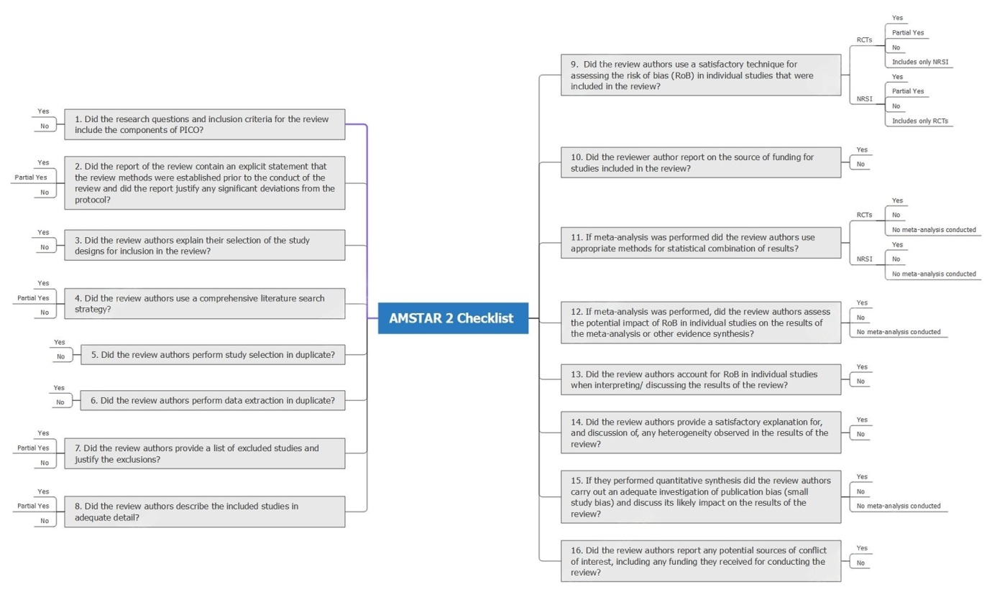

Supplementary Figure S1: AMSTAR 2: a critical appraisal tool for systematic reviews that include randomised or nonrandomized studies of healthcare interventions, or both

