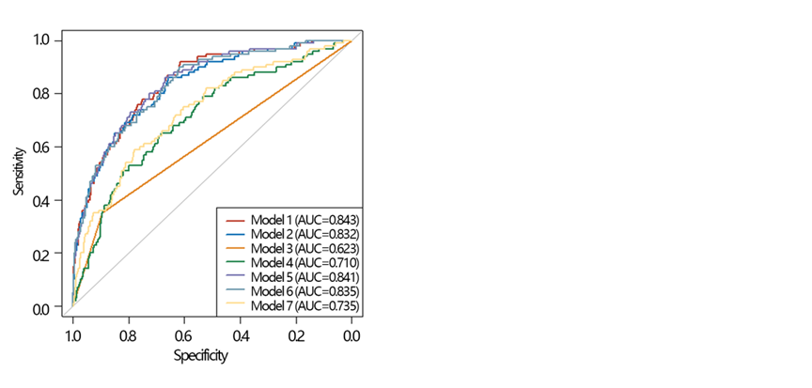

Supplementary Figure 1 ROC analysis of different models in the train set
Note: Model 1: age + weight + height +OP history of self-report + HGB + HDL-C
Model 2: age + weight + height
Model 3: OP history of self-report
Model 4: HGB+HDL-C
Model 5: age + weight + height + OP history of self-report
Model 6: age + weight + height + HGB + HDL-C
Model 7: OP history of self-report + HGB + HDL-C
Abbreviation: HGB: hemoglobin, HDL-C: high-density lipoprotein cholesterol, OP: osteoporosis, ROC: receiver operating characteristic curve, AUC: area under the curve

Supplementary Table 1 Missing variable statistics
Variables | Missing Count | Missing Percent
Gender | 0 | 0.00
Age | 0 | 0.00
Race | 0 | 0.00
Education level | 2 | 0.15
Marital status | 2 | 0.15
Smoking | 1 | 0.07
Drinking | 0 | 0.00
HEI-2015 | 177 | 13.1
PA | 270 | 19.99
Sleep duration | 0 | 0.00
Arthritis | 3 | 0.22
PIR | 98 | 7.25
BMI | 8 | 0.59
Weight | 6 | 0.44
Height | 7 | 0.52
WC | 18 | 1.33
diabetes | 0 | 0.00
Hypertension | 0 | 0.00
Cancer | 0 | 0.00
Glucocorticosteroid | 251 | 18.58
Milk | 4 | 0.30
OP history of self-report | 5 | 0.37
OP of parents | 89 | 6.59
Fracture history | 0 | 0.00
ALB | 68 | 5.03
ALP | 68 | 5.03
BUN | 68 | 5.03
Calcium | 69 | 5.11
TC | 68 | 5.03
CR | 68 | 5.03
GGT | 68 | 5.03
FPG | 68 | 5.03
Phosphorus | 68 | 5.03
TB | 68 | 5.03
TG | 68 | 5.03
UA | 68 | 5.03
Sodium | 68 | 5.03
Potassium | 68 | 5.03
Chloride | 68 | 5.03
WBC | 45 | 3.33
LC | 48 | 3.55
MC | 48 | 3.55
NC | 48 | 3.55
RBC | 45 | 3.33
HGB | 45 | 3.33
RDW | 45 | 3.33
PLT | 45 | 3.33
VD | 516 | 38.19
HDL-C | 62 | 4.59
Cadmium | 157 | 11.62
Lead | 157 | 11.62
Mercury | 157 | 11.62
OP | 0 | 0.00
Abbreviation: PIR: poverty income ratio, BMI: body mass index, WC: waist circumference, ALB: albumin, ALP: alkaline phosphatase, BUN: blood urea nitrogen, TC: total cholesterol, CR: creatinine, TG: triglyceride, TB: total bilirubin UA: uric acid, LC: lymphocyte count, MC: monocyte count, NC: neutrophils count, RBC: red blood cell count, HGB: Hemoglobin, FPG: fasting plasma glucose, GGT: gamma glutamyl transferase, RDW: red cell distribution width, PLT: platelet count, HDL-C: high-density lipoprotein Cholesterol, HEI-2015: health diet index-2015, PA: physical activity, OP: osteoporosis, VD: Vitamin D, WBC: white blood cell.

Supplementary Table 2 Collinearity analysis of variables in the train set
Variables | VIF
Gender | 1.750
Age | 1.366
Race | 1.113
Education level | 1.149
Marital status | 1.101
Drinking | 1.107
HEI-2015 | 1.151
PA | 1.086
Sleep duration | 1.076
PIR | 1.170
BMI | 10.111
Weight | 9.771
Height | 5.576
WC | 2.856
diabetes | 1.257
Hypertension | 1.242
Arthritis | 1.055
Cancer | 1.072
Glucocorticosteroid | 1.108
Milk | 1.065
OP history of self-report | 1.152
OP of parents | 1.178
Fracture history | 1.072
ALB | 1.411
ALP | 1.205
BUN | 1.500
Calcium | 1.365
TC | 1.261
CR | 1.307
GGT | 1.206
FPG | 1.201
Phosphorus | 1.177
TB | 1.168
TG | 1.321
UA | 1.233
Sodium | 1.450
Potassium | 1.155
Chloride | 1.461
WBC | 16.002
LC | 8.682
MC | 2.554
NC | 12.045
RBC | 1.832
HGB | 2.044
RDW | 1.355
PLT | 1.191
HDL-C | 1.361
Cadmium | 1.209
Lead | 1.202
Mercury | 1.104
Smoking | 1.188
Abbreviation: PIR: poverty income ratio, BMI: body mass index, WC: waist circumference, ALB: albumin, ALP: alkaline phosphatase, BUN: blood urea nitrogen, TC: total cholesterol, CR: creatinine, TG: triglyceride, TB: total bilirubin UA: uric acid, LC: lymphocyte count, MC: monocyte count, NC: neutrophils count, RBC: red blood cell count, HGB: Hemoglobin, FPG: fasting plasma glucose, GGT: gamma glutamyl transferase, RDW: red cell distribution width, PLT: platelet count, HDL-C: high-density lipoprotein Cholesterol, HEI-2015: health diet index-2015, PA: physical activity, WBC: white blood cell. VIF: variance inflation factor.
Supplementary Table 3 Collinearity analysis of variables after excluding variables with collinearity in the train set
Variables | VIF
Gender | 1.748
Age | 1.365
Race | 1.107
Education level | 1.151
Marital status | 1.099
Drinking | 1.108
HEI-2015 | 1.141
PA | 1.084
Sleep duration | 1.073
PIR | 1.170
Weight | 2.849
Height | 1.738
WC | 2.831
Diabetes | 1.253
Hypertension | 1.240
Arthritis | 1.053
Cancer | 1.072
Glucocorticosteroid | 1.104
Milk | 1.063
OP history of self-report | 1.146
OP of parents | 1.173
Fracture history | 1.072
ALB | 1.405
ALP | 1.203
BUN | 1.494
Calcium | 1.360
TC | 1.259
CR | 1.312
GGT | 1.203
FPG | 1.197
Phosphorus | 1.173
TB | 1.162
TG | 1.326
UA | 1.237
Sodium | 1.448
Potassium | 1.144
Chloride | 1.454
LC | 1.104
MC | 1.150
NC | 1.218
RBC | 1.830
HGB | 2.045
RDW | 1.338
PLT | 1.182
HDL-C | 1.366
Cadmium | 1.208
Lead | 1.199
Mercury | 1.101
Smoking | 1.183
Abbreviation: PIR: poverty income ratio, WC: waist circumference, ALB: albumin, ALP: alkaline phosphatase, BUN: blood urea nitrogen, TC: total cholesterol, CR: creatinine, TG: triglyceride, TB: total bilirubin UA: uric acid, LC: lymphocyte count, MC: monocyte count, NC: neutrophils count, RBC: red blood cell count, HGB: Hemoglobin, FPG: fasting plasma glucose, GGT: gamma glutamyl transferase, RDW: red cell distribution width, PLT: platelet count, HDL-C: high-density lipoprotein Cholesterol, HEI-2015: health diet index-2015, PA: physical activity, VIF: variance inflation factor.
Supplementary file 1

Supplementary specification about laboratory indicators
Among laboratory indicators, albumin (ALB, g/dL), alkaline phosphatase (ALP, U/L), blood urea nitrogen (BUN, mg/dL), calcium (mg/dL), creatinine (CR, mg/dL), phosphorus (mmol/L), total bilirubin (TB, mg/dL), triglyceride (TG, mg/dL), uric acid (UA, mg/dL), sodium (mmol/L), potassium (mmol/L), chloride (mmol/L), fasting plasma glucose (FPG, g/dL), and gamma glutamyl transferase (GGT, U/L) were collected from “Standard Biochemistry Profile” in NHANES. The detailed protocol for their detection method is described in https://wwwn.cdc.gov/Nchs/Data/Nhanes/Public/2007/DataFiles/BIOPRO_E.htm#Component_Description.
Among laboratory indicators, high-density lipoprotein cholesterol (HDL-C, mmol/L) and total cholesterol (TC, mg/dL) were collected from “Cholesterol – HDL” and “Cholesterol – Total” profiles, respectively, in NHANES. The detailed protocol for their detection method is described in
https://wwwn.cdc.gov/Nchs/Data/Nhanes/Public/2007/DataFiles/HDL_E.htm#LBDHDD and
https://wwwn.cdc.gov/Nchs/Data/Nhanes/Public/2007/DataFiles/TCHOL_E.htm#LBXTC, respectively.
Among laboratory indicators, white blood cell (WBC, 1000 cells/μL), lymphocyte count (LC, 1000 cells/μL), monocyte count (MC, 1000 cells/μL), neutrophils count (NC, 1000 cells/μL), red blood cell count, (RBC, million cells/μL), hemoglobin (HGB, g/dL), red cell distribution width (RDW, %), and platelet count (PLT, 1000 cells/μL) were collected from “Complete Blood Count with 5-Part Differential” in NHANES. The detailed protocol for their detection method is described in https://wwwn.cdc.gov/Nchs/Data/Nhanes/Public/2005/DataFiles/CBC_D.htm#LBXWBCSI.
Among laboratory indicators, mercury (nmol/L), cadmium (nmol/L), and lead (nmol/L) were collected from “Cadmium, Lead, & Total Mercury – Blood” profile. The detailed protocol for their detection method is described in https://wwwn.cdc.gov/Nchs/Data/Nhanes/Public/2005/DataFiles/PBCD_D.htm#LBDTHGSI.

