Supporting Information

List of Abbreviations

Abbreviation | Definition
ABTS | 2,2'-azino-bis(3-ethylbenzthiazoline-6-sulfonic acid)
ALT | alanine transaminase
ALP | alkaline phosphatase
AST | aspartate transaminase
AUC | area under the curve
BUN | urea nitrogen
C6 | Coumarin-6
C6-bNE | C6 loaded bNE
C_{max} | maximum drug concentration
CL | clearance
CRE | creatinine
DAS | Drug and Statistics
DCM | dichloromethane
DDS | drug delivery systems
DHE | dihydroethidium
DiR | DiIC18(7)
DiR-bNE | DiR-labeled bNE
DLE | drug loading efficiency
DLS | dynamic light scattering
DMY | dihydromyricetin
DMY-bNE | high DMY-loaded biomimetic nanoemulsion
EE | encapsulation efficiency
FA | formic acid
FDA | Food and Drug Administration
GMO | glyceryl monooleate
GMP | glycerol monopalmitate
GMS | glyceryl monostearate
GPX4 | glutathione peroxidase 4
GSH | reduced glutathione
HDL | high-density lipoprotein
H&E | hematoxylin and eosin
HFD | high fat diet
HO-1 | Heme Oxygenase 1
HPLC | high-performance liquid chromatography
LCN2 | lipocalin 2
LDH | lactate dehydrogenase
LDL | low-density lipoprotein
LPO | lipid peroxide
MAG | monoacylglyceride
MDA | malondialdehyde
MET | metformin hydrochloride
MRT | mean retention time
NAFLD | nonalcoholic fatty liver disease
NASH | nonalcoholic steatohepatitis
NCD | normal chow diet
NO | nitric oxide
Nrf2 | Nuclear factor erythroid 2-related factor 2
O.D. | optical density
ORO | Oil Red O
ROS | reactive oxygen species
SD | standard deviation
SPF | specific pathogen-free
t_{1/2} | half-life
TC | total cholesterol
TEM | transmission electron microscopy
TG | triglycerides
T_{max} | maximum drug concentration time
TRF | transferrin
V | apparent volume of distribution

Supplementary Figures and Tables

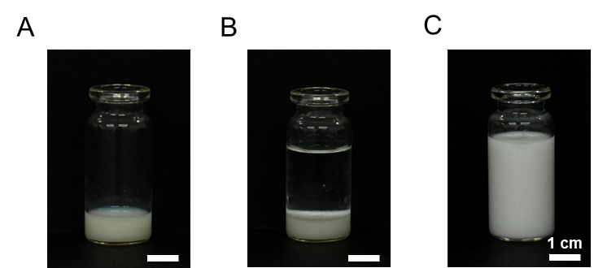
Figure S1. Images of DMY-bNE preparation process. (A) primary emulsion, (B) oil phase and water phase before secondary emulsification, and (C) secondary emulsion. Scale bars represent 1 cm (white).

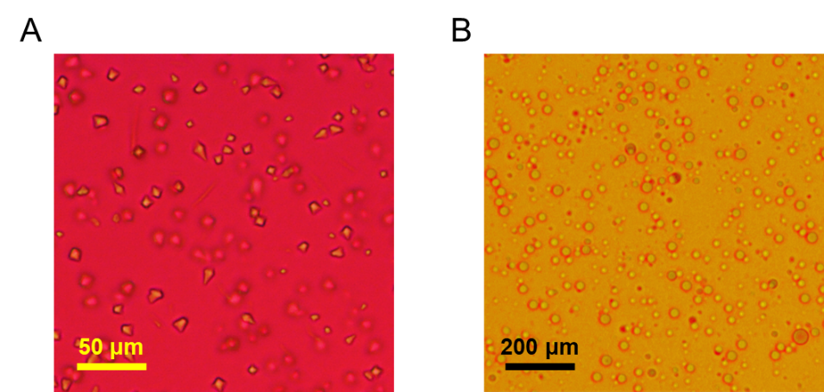
Figure S2. Representative Sudan III-stained images of (A) primary emulsion and (B) secondary emulsion. Scale bars represent 50 μm (yellow) and 200 μm (black).

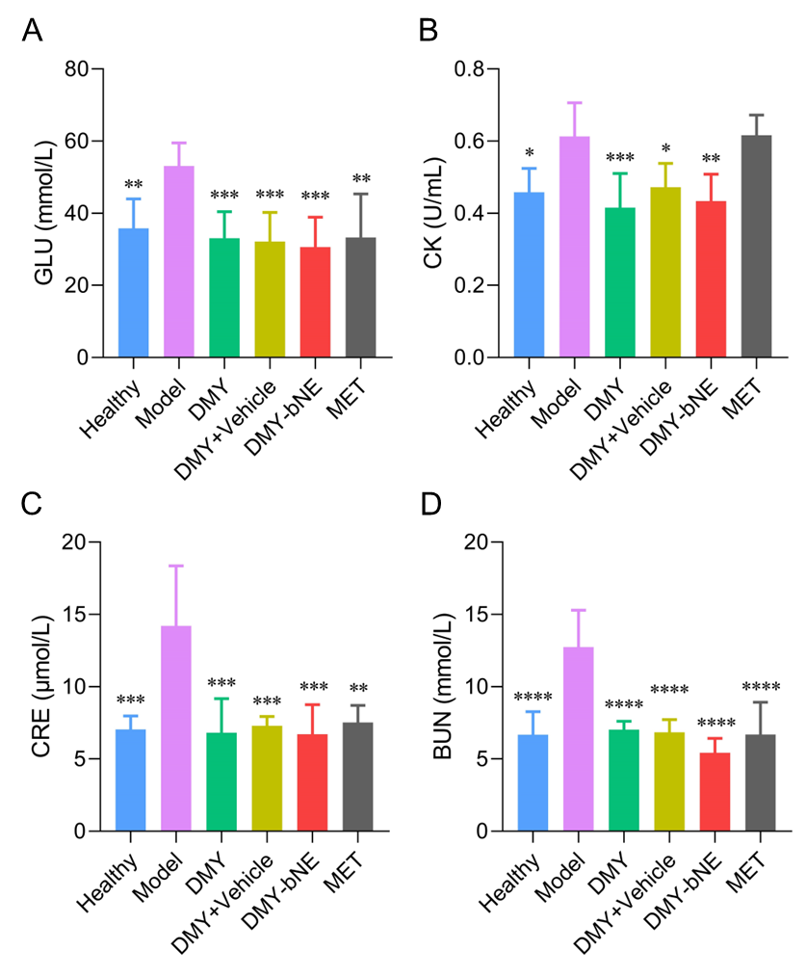
Figure S3. Plasma (A) glucose, (B) CK, (C) CRE and (D) BUN levels of healthy mice and NAFLD mice orally administrated with water (placebo), free DMY, DMY + vehicle, DMY-bNE and MET at the dose of 25 mg DMY/kg or 250 mg MET/kg for 6 weeks, respectively (n =8). Statistical analysis was performed using One-Way ANOVA. * p < 0.05, ** p < 0.01, *** p < 0.001, **** p < 0.0001, vs group Model.

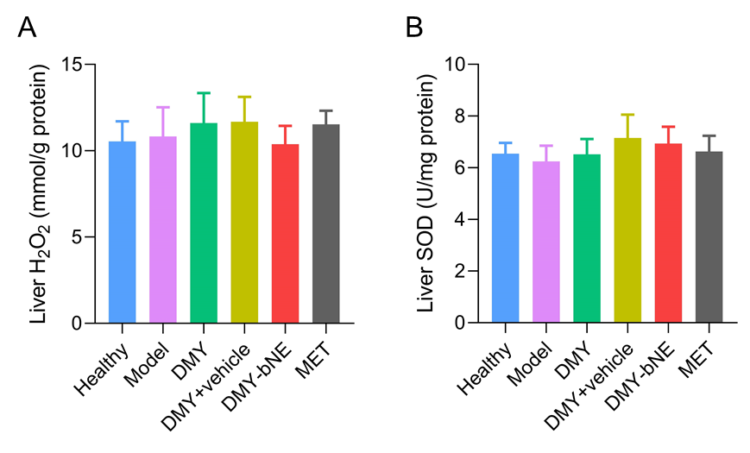
Figure S4. Liver (A) H₂O₂ and (B) SOD levels of healthy mice and NAFLD mice orally administrated with water (placebo), free DMY, DMY + vehicle, DMY-bNE and MET at the dose of 25 mg DMY/kg or 250 mg MET/kg for 6 weeks, respectively (n = 8).
Table S1. Preparation and characterization of DMY-bNE using different MAGs. The hydrodynamic diameters were measured using DLS (n = 5), and the EEs were determined by HPLC.
MAGs | DMY (mg) | Acetone (mL) | DCM (mL) | Primary emulsion W/O ratio | Water (mL) | Secondary emulsion O/W ratio | Diameter (nm) | EE (%)
100 mg GMO | 40 | 0.3 | 5 | 1:16.7 | 30 | 1:6 | 190.4 ± 3.3 | 99.5
100 mg GMS | 40 | 0.3 | 5 | 1:16.7 | 30 | 1:6 | 383.8 ± 4.1 | 85.2
100 mg GMP | 40 | 0.3 | 5 | 1:16.7 | 30 | 1:6 | 344.7 ± 2.5 | 88.9

Table S2. Fitting results of in vitro release profiles.
Models | Groups | Regression Equations | R²
Zero-order | DMY pH1.2 | y = 4.5x + 37.6 | 0.557
Zero-order | DMY pH6.8 | y = 4.0x + 43.7 | 0.478
Zero-order | DMY-bNE pH1.2 | y = 4.1x + 65.9 | 0.310
Zero-order | DMY-bNE pH6.8 | y = 4.1x + 67.2 | 0.311
First-order | DMY pH1.2 | y = 71.4 × (1 - e^{-1.26x}) | 0.972
First-order | DMY pH6.8 | y = 73.3 × (1 - e^{-1.55x}) | 0.970
First-order | DMY-bNE pH1.2 | y = 96.4 × (1 - e^{-2.37x}) | 0.990
First-order | DMY-bNE pH6.8 | y = 98.4 × (1 - e^{-2.32x}) | 0.984
Higuchi | DMY pH1.2 | y = 19.5x^{1/2} + 22.4 | 0.791
Higuchi | DMY pH6.8 | y = 17.7x^{1/2} + 29.6 | 0.721
Higuchi | DMY-bNE pH1.2 | y = 18.9x^{1/2} + 50.1 | 0.548
Higuchi | DMY-bNE pH6.8 | y = 19.2x^{1/2} + 51.1 | 0.551

Method Validation of DMY Quantification

DMY was quantitatively determined by HPLC (Waters e2695, USA) equipped with an ultraviolet detector and a reverse phase C₁₈ column (250×4.6 mm, 5 μm). The mobile phases consisted of (A) methanol and (B) 0.1% phosphoric acid in water (v/v) at the ratio of A:B = 32:68 (v/v). The flow rate, column temperature, injection volume and detection wavelength were 1 mL/min, 30℃, 10 μL and 290 nm, respectively. The analytical method was validated for system suitability, selectivity, linearity, range, sensitivity, accuracy, precision, solution stability, and robustness according to ICH Q2 guidelines.

System suitability and selectivity
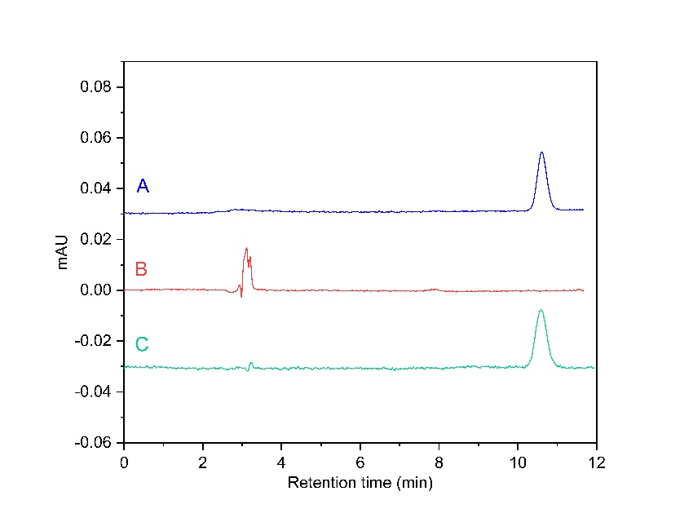
Figure S5. Representative HPLC chromatograms of specificity test of (A) DMY standard solution, (B) blank excipient solution and (C) matrix-matched sample solution.

Linearity, range and sensitivity
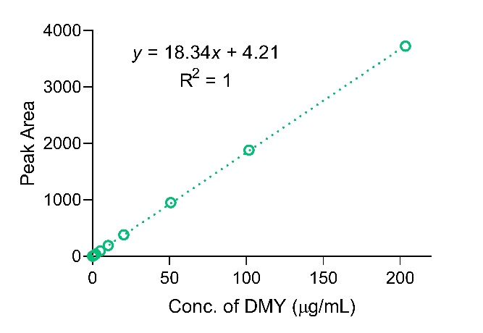
Figure S6. Standard curve of DMY.

Table S3. Linearity, range, LOD and LOQ of the analytical method.
Compound | Calibration range (μg/mL) | Linear regression equation | R² | LOD (μg/mL) | LOQ (μg/mL)
DMY | 0.1~203 | y = 18.34x + 4.21 | 1 | 0.01 | 0.02

Accuracy and precision

Table S4. Results of accuracy
Groups | Sample Conc. (μg/mL) | Determination Conc. (μg/mL) | Recovery (%) | RSD (%)
Low | 81.4 | 81.8 | 100.6 | 0.02
Low | 81.4 | 81.8 | 100.6 | 0.02
Low | 81.4 | 81.9 | 100.6 | 0.02
Middle | 101.7 | 102.3 | 100.6 | 0.02
Middle | 101.7 | 102.4 | 100.7 | 0.02
Middle | 101.7 | 102.4 | 100.7 | 0.02
High | 122.0 | 122.9 | 100.7 | 0.01
High | 122.0 | 122.9 | 100.7 | 0.01
High | 122.0 | 122.9 | 100.7 | 0.01

Table S5. Results of precision and intermediate precision
Sample Conc. (μg/mL) | Area₁ | RSD₁ (%) | Area₂ | RSD₂ (%)
101.7 | 1881.9 | 0.03 | 1876.1 | 0.03
101.7 | 1881.8 | 0.03 | 1877.2 | 0.03
101.7 | 1881.2 | 0.03 | 1876.6 | 0.03
101.7 | 1880.5 | 0.03 | 1877.7 | 0.03
101.7 | 1880.8 | 0.03 | 1876.0 | 0.03
101.7 | 1881.2 | 0.03 | 1877.3 | 0.03
RSD₁₂ (%) | 0.12

Solution stability

Table S6. Results of solution stability.
Time (h) | Area | RSD (%)
0 | 1881.9 | 0.02
2 | 1881.6 | 0.02
4 | 1881.5 | 0.02
8 | 1881.1 | 0.02
12 | 1880.7 | 0.02
24 | 1881.0 | 0.02

Robustness

Table S7. Results of robustness.
Variations |  | Area | RSD (%)
Component ratio of mobile phase (A:B, v:v) | 30:70 | 1881.2 | 0.01
Component ratio of mobile phase (A:B, v:v) | 32:68 | 1881.4 | 0.01
Component ratio of mobile phase (A:B, v:v) | 34:66 | 1881.8 | 0.01
Flow rate (mL/min) | 0.98 | 1881.9 | 0.01
Flow rate (mL/min) | 1.00 | 1881.4 | 0.01
Flow rate (mL/min) | 1.02 | 1881.8 | 0.01
Column temperature (℃) | 28 | 1881.0 | 0.02
Column temperature (℃) | 30 | 1881.4 | 0.02
Column temperature (℃) | 32 | 1880.5 | 0.02

