Supplementary Figure 1: The failure pattern of PMMA.
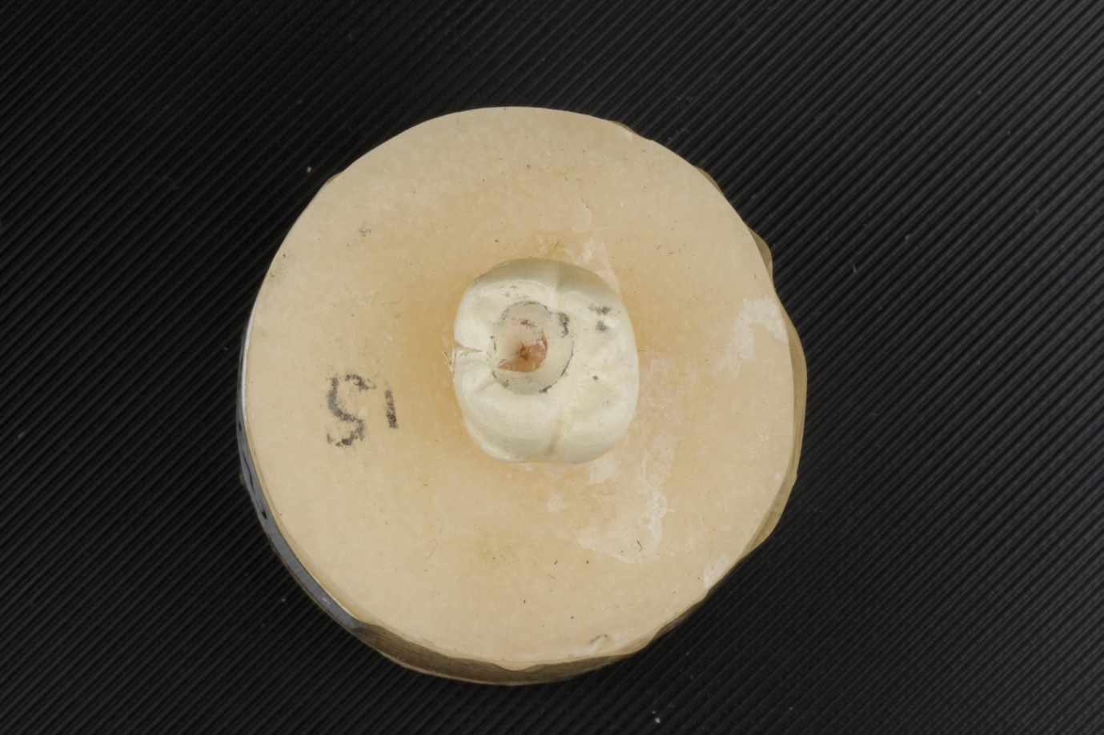

Supplementary Figure 2: The failure pattern of PEEK.
