Supplementary Fig. S1 Study flow diagram.
Sichuan provincial people’s hospital (n=369 individuals)

101 participants were excluded:
No T2DM diagnosis date (51 individuals),
Excluded participants with date mismatch (follow-up, DM diagnosis, deaths)=50 individuals

Sample size after quality control
(n=268 individuals)

48 participants were excluded due to no baseline information or based on inclusion criterion:
No NLR information: 16 individuals,
No HbA1c information:12 individuals,
No eGFR information: 9 individuals,
No Lipid information: 11 individuals,

Analysed cohort
(n=220 individuals)

Supplementary Fig. S2 Overall survival for the incidence of DN. Incident DN=268, Median survival time= 2.02 years (95% CI: 1.81 years, 2.25 years).

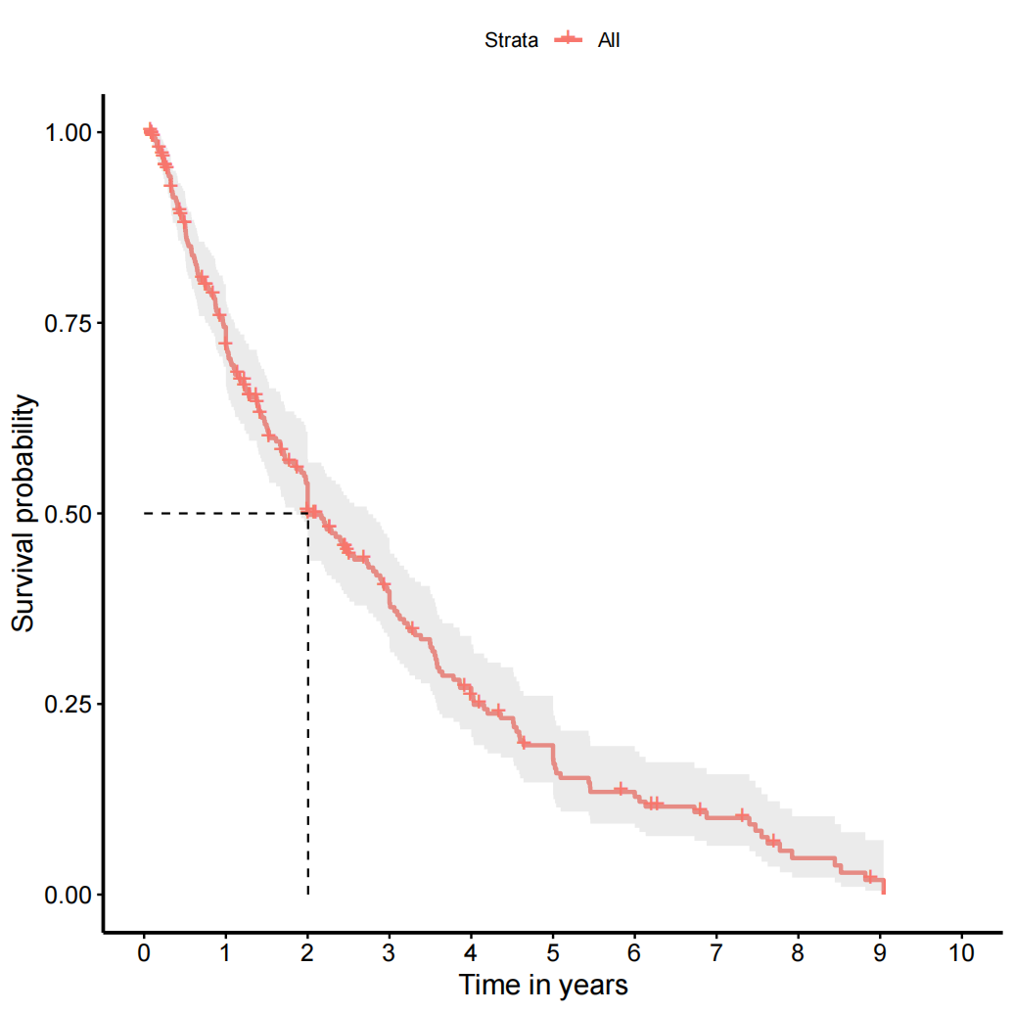

Supplementary Fig. S3 Survival for the incidence of DN for the analyzed cohort. Incident DN =220, Median survival time=1.85 years (95% CI: 1.66 years, 2.04 years years)
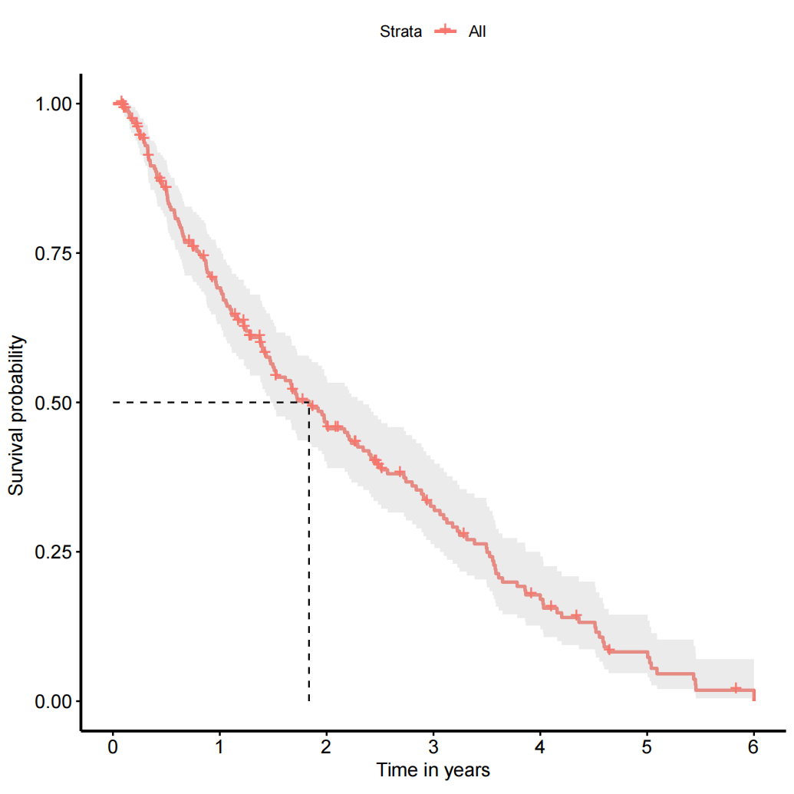

Supplementary Fig. S4 Time-dependent ROC chart of NLR for predicting DN.
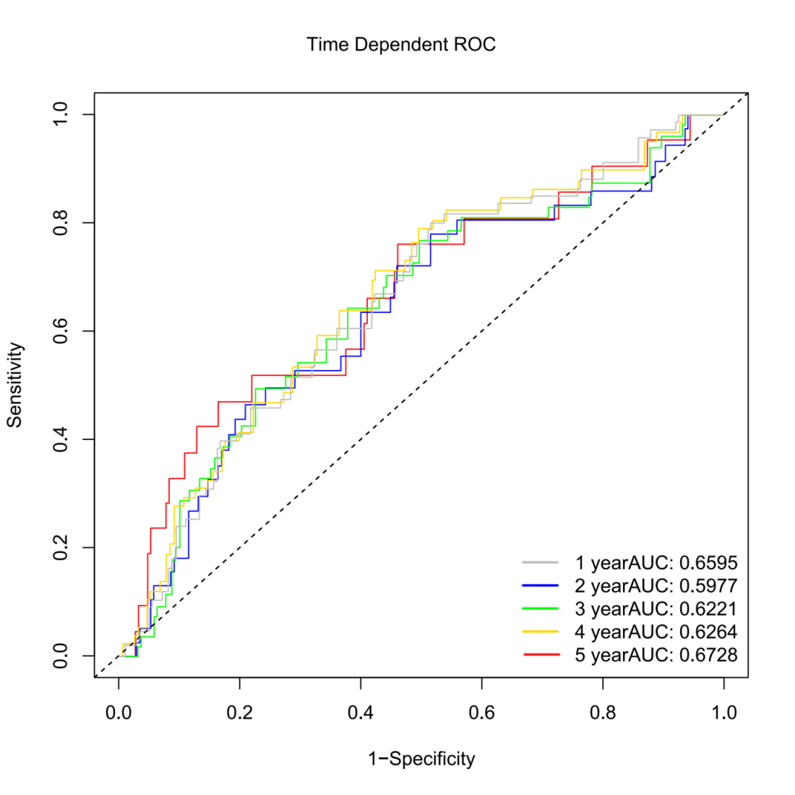

Supplementary Fig. S5 Event-free survival (EFS) plots showing the risk associated with demographic and clinical covariates for experiencing DN for a 6 year follow-up period (n=220).

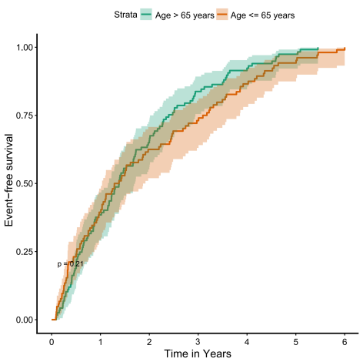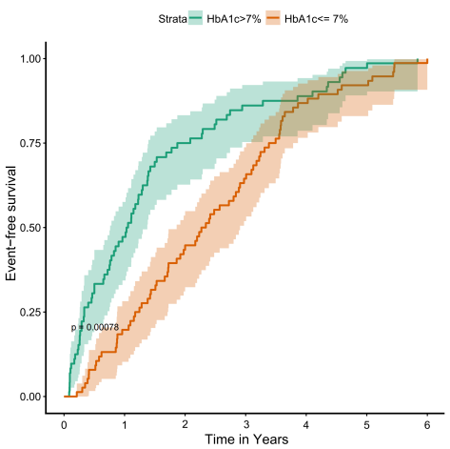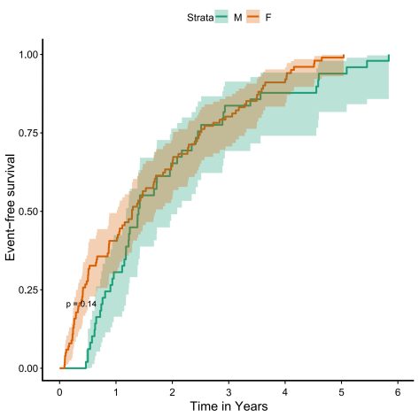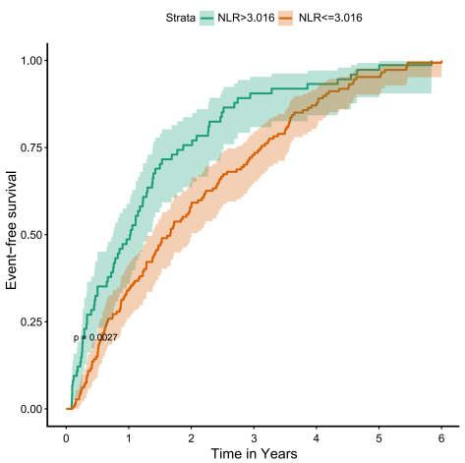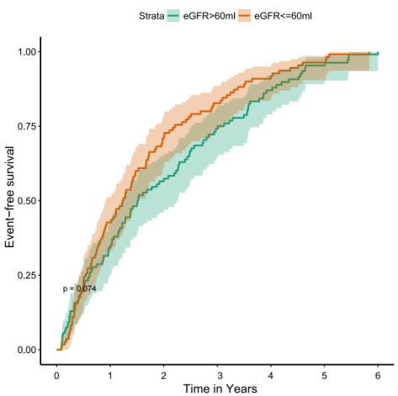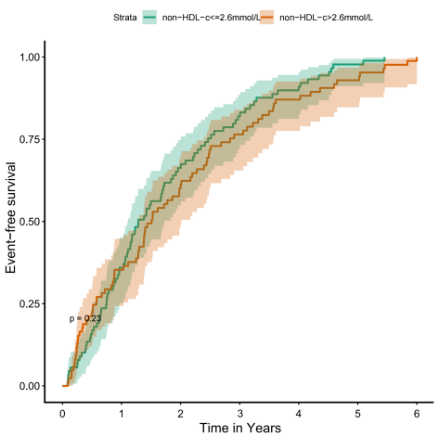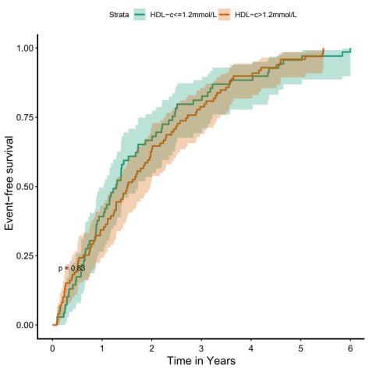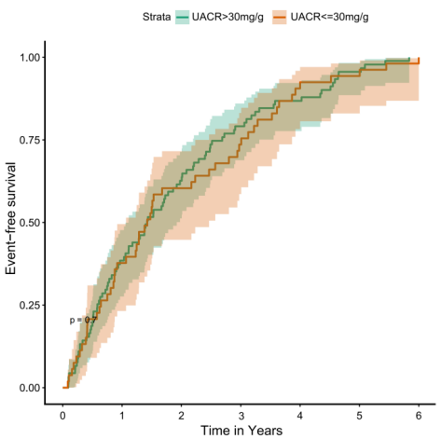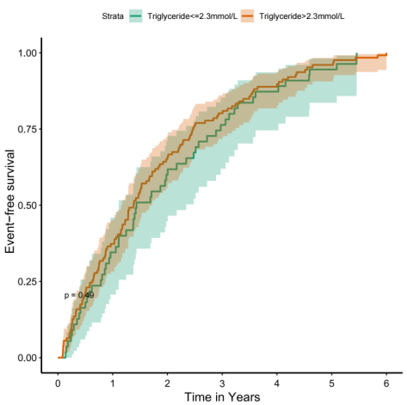

Supplementary Fig. S6 Cumulative Incidence Function (CIF) plots of covariates for experiencing DN for a 6 year follow-up period(n=220).
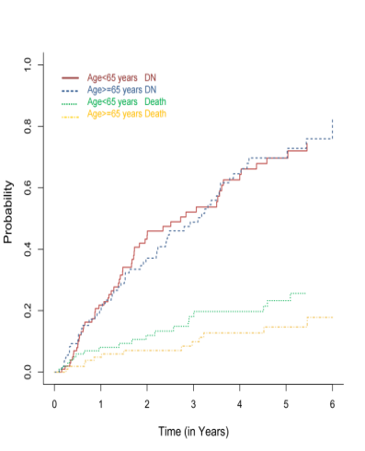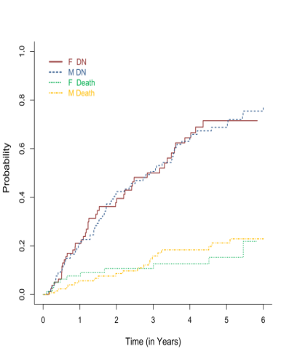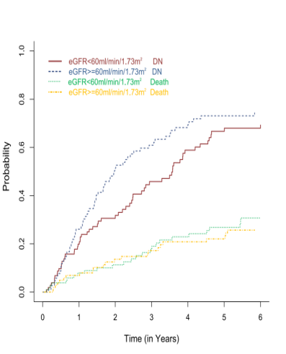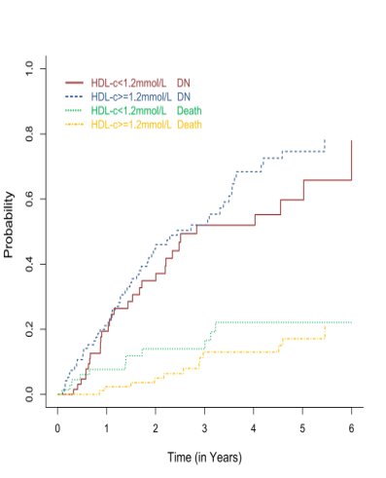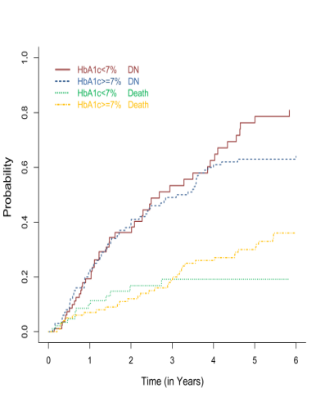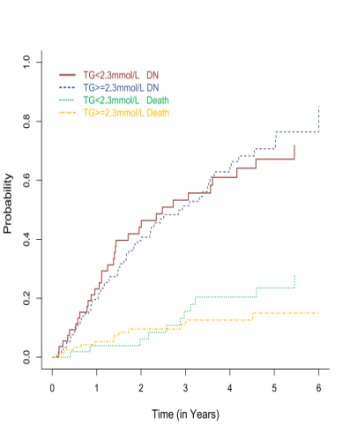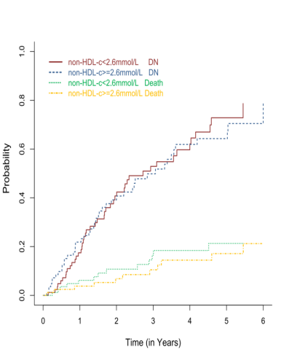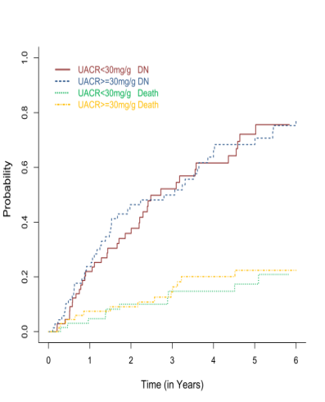
Supplementary Fig. S7 Bootstrap-derived NLR Sub-distribution Hazard Ratio (sHR).
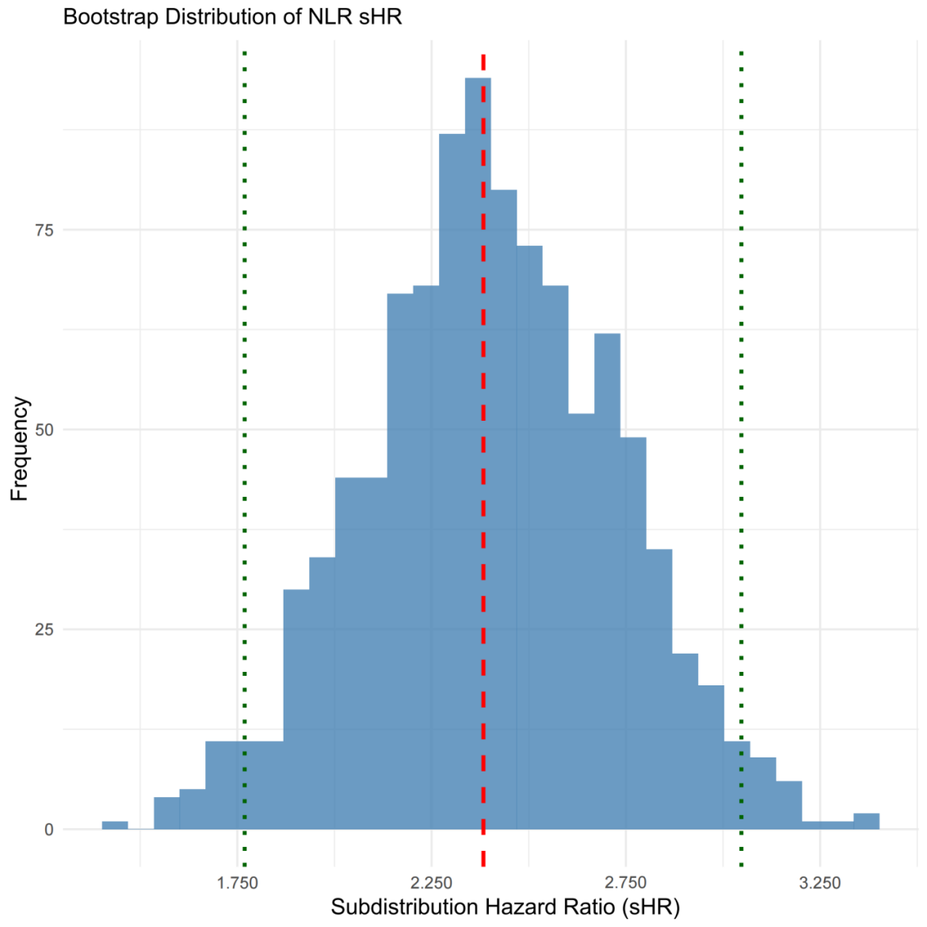

Supplementary Fig. S8 Risk for DN predicted by NLR stratified by quartiles of eGFR and UACR estimated from covariate-adjusted FGR model.
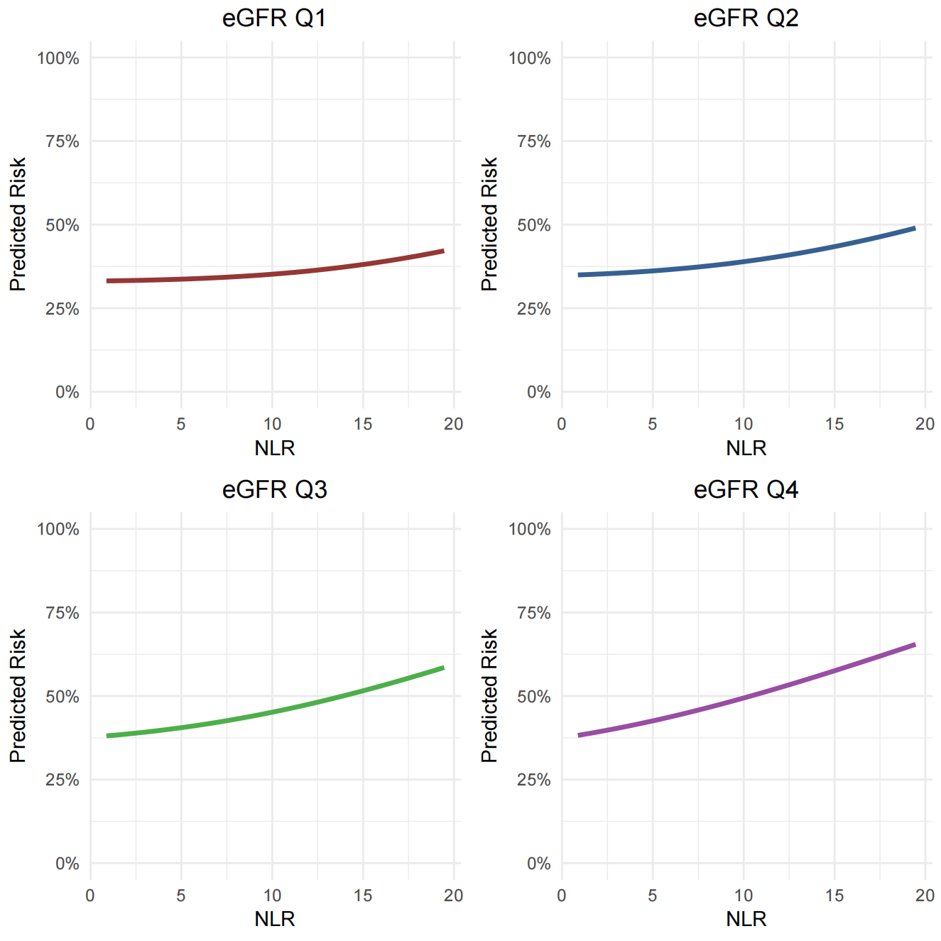
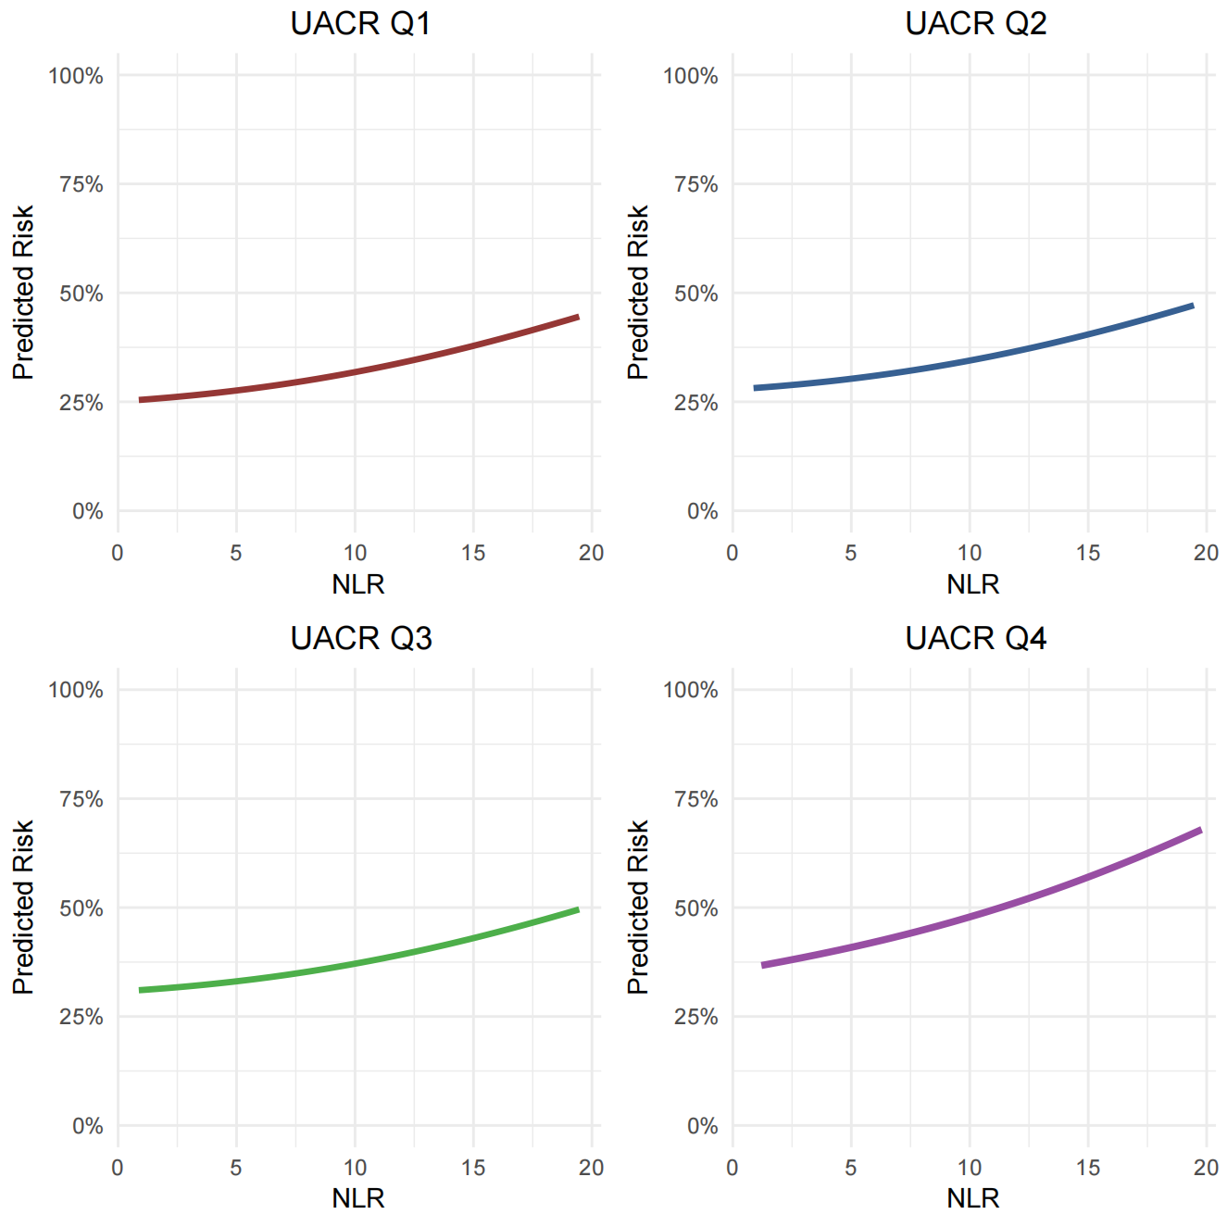
Supplementary Table. S1 The stratified analysis of baseline NLR by outcome status
Variable | Overall (n=220) | DN Progressors (n=133) | DN-Free (n=67) | Competing Events (n=20)
Age (years) | 64 (IQR:55-72) | 63 (IQR:54-72) | 66 (IQR:57-73) | 62 (IQR:52-71)
HbA1c (%) | 7.1(IQR:6.4-8.4) | 7.1 (IQR:6.6-8.0) | 7.1(IQR:6.3-8.1) | 7.2 (IQR:6.8-8.2)
NLR | 2.6(IQR: 1.8-4.0) | 2.7(IQR: 2.0-4.1) | 2.5 (IQR:1.7-3.8) | 2.6 (IQR:1.9-3.5)

