Exercise for anxiety: A systematic review and network meta-analysis of randomised controlled trials Supplementary Files

Table of Contents
P1 - Search Strategy 2
PubMed 2
Embase 2
WOS 3
Cochrane 3
P2 Characteristics of Included Studies 5
P3 Characteristics of treatments meeting participant threshold 12
P4 Risk of bias ratings for individual studies 14
P5 Sensitivity Analyses for Risk of Bias 17
P6 Forest plot of each data point informing each arm 18
P7 Summary table of credibility assessment 21
P8 Density plots for R2 from models with interactions between treatment and moderators 22
P9 Moderation by Comorbidities 23
P10 Prediction of outcomes by metabolic equivalent per minute 24
P11 Moderation for intervention effects by length of intervention in weeks 25
P12 Moderation by funded 26
P13 Moderation by reporter 27
P14 Moderation by group exercise 28
P15 Funnel plot for all exercise arms vs active control 29
P16 List of key excluded documents 30

Supporting Information P1 - Search Strategy

PubMed
#1 "Anxiety"[mh] OR "Anxiety Disorders"[mh] OR Anxiet*[tiab] OR Angst[tiab] OR Nervousness[tiab] OR Hypervigilance[tiab]
#2 "Qigong"[mh] OR Qigong[tiab] OR "Ch'i Kung”[tiab] OR “Tai Ji”[mh] OR “Tai ji”[tiab] OR “Taijiquan”[tiab] OR “Tai Chi”[tiab] OR "Yoga"[mh] OR Yoga[tiab] OR “yogic meditation”[tiab] OR Dancing[mh] OR Dancing[tiab] OR Dance[tiab]
#3 “Resistance Training”[mh] OR “Resistance Training*”[tiab] OR “Strength Training*”[tiab]
#4 "Jogging"[mh] OR Jogging*[tiab] OR "Walking"[mh] OR Walking[tiab] OR Ambulation[tiab]
#5 "Exercise"[mh] OR Exercise*[tiab] OR “Physical Activity*”[tiab] OR “Step aerobics”[tiab] OR Bicycling[mh] OR Bicycling[tiab] OR Swimming[mh] OR Swimming[tiab]
#6 “High intensity interval training”[mh] OR “High intensity interval training*”[tiab] OR “Sprint Interval Training*”[tiab] OR “HIIT”[tiab]
#7 #2 or #3 or #4 or #5
#8 "randomized controlled trial"[pt] OR "controlled clinical trial"[pt] OR "randomized controlled trials as topic"[mh] OR "clinical trials as topic"[mh] OR "controlled clinical trials as topic"[mh] OR "clinical trial"[pt] OR "random allocation"[mh] OR "double-blind method"[mh] OR randomized[tiab] OR randomised[tiab] OR randomization[tiab] OR randomly allocated[tiab] OR RCT[tiab] OR clinical trial*[tiab] OR clinical stud*[tiab] OR ((double[tiab] OR treble[tiab] OR triple[tiab]) AND (mask* [tiab] OR blind* [tiab]))
#9 #1 and #7 and #8 Result: 4608 Date: 2024/09/23

Embase
#1 "Anxiety"/exp OR "Anxiety Disorders"/exp OR Anxiet*:ab,ti OR Angst:ab,ti OR Nervousness:ab,ti OR Hypervigilance:ab,ti
#2 "Qigong"/exp OR Qigong:ab,ti OR "Chi Kung”:ab,ti OR “Tai Chi”/exp OR “Tai ji”:ab,ti OR “Taijiquan”:ab,ti OR “Tai Chi”:ab,ti OR "Yoga"/exp OR Yoga:ab,ti OR “yogic meditation”:ab,ti OR "Dancing"/exp OR Dancing:ab,ti OR Dance:ab,ti
#3 “Resistance Training”/exp OR “Resistance Training*”:ab,ti OR “Strength Training*”:ab,ti
#4 "Jogging"/exp OR Jogging*:ab, ti OR "Walking"/exp OR Walking:ab,ti OR Ambulation:ab,ti
#5 "Exercise"/exp OR Exercise*:ab,ti OR “Physical Activity*”:ab,ti OR “Step aerobics”:ab,ti OR Cycling/exp OR Swimming/exp OR Swimming:ab,ti or cycling:ab,ti
#6 “High intensity interval training”/exp OR “High intensity interval training*”:ab,ti OR “Sprint Interval Training*”:ab,ti OR “HIIT”:ab,ti
#7 #2 or #3 or #4 or #5
#8 "randomized controlled trial"/exp OR "controlled clinical trial"/exp OR "double-blind proceduer"/exp OR "triple blind proceduer"/exp or randomized:ab,ti OR randomised:ab,ti OR randomization:ab,ti OR "placebo"/exp or placebo:ab,ti OR "RCT":ab,ti OR ((double:ab,ti OR treble:ab,ti OR triple:ab,ti) AND (mask*:ab,ti OR blind*:ab,ti))
#9#1 AND #7 AND #8 AND ([article]/lim OR [article in press]/lim OR [review]/lim)

WOS
#1 TS=(Anxiety)) OR TS=( "Anxiety Disorders") OR TS=(Anxiet*) OR TS=(Angst) OR TS=(Nervousness) OR TS=(Hypervigilance)
#2 TS=(Qigong) OR TS=("Ch'i Kung”) OR TS=( “Tai Ji”) OR TS=(Taijiquan) OR TS=(“Tai Chi”) OR TS=(yoga) OR TS=(“yogic meditation”)) OR TS=(Dancing)) OR TS=(Dance)
#3 TS=(Exercise) OR TS=(“Physical Activity*”) OR TS=(“Step aerobics”) OR TS=(Bicycling) OR TS=(Swimming)
#4 TS=(“Strength Training*”) OR TS=( “Resistance Training*”)
#5 TS=(jogging) OR TS=(walking) OR TS=(Ambulation)
#6 TS=(“High intensity interval training*”) OR TS=( “Sprint Interval Training*”) OR TS=( “HIIT”)
#7 #2 OR #3 OR #4 OR #5 OR #6
#8 TS=("randomized controlled trial") OR TS=("controlled clinical trial") OR TS=("randomized controlled trials as topic") OR TS=("clinical trials as topic") OR TS=("controlled clinical trials as topic") OR TS=("clinical trial") OR TS=("random allocation") OR TS=("double-blind method") OR TS=(randomized) OR TS=(randomised) OR TS=(randomization) OR TS=( “randomly allocated”) OR TS=( “RCT”) OR TS=("clinical stud*")
#9 #1 AND #7 AND #8 Result:8843 Date:2024/09/23

Cochrane
#1 MeSH descriptor: [Anxiety] explode all trees 12937
#2 MeSH descriptor: [Anxiety Disorders] explode all trees 10404
#3 (“Anxiety” or “Anxirt” or “Angst” or “Nervousness” or “Hypervigilance” or “Anxiety Disorders”):ti,ab,kw (Word variations have been searched) 112284
#4 #1 or #2 or #3 114669
#5 MeSH descriptor: [Qigong] explode all trees 160
#6 (“Qigong” or “Chi Kung”):ti,ab,kw (Word variations have been searched) 805
#7 #5 or #6 805
#8 MeSH descriptor: [Tai Ji] explode all trees 591
#9 (“Tai Ji” or “taijiquan” or “Tai Chi Chuan”):ti,ab,kw (Word variations have been searched) 863
#10 #8 or #9 863
#11 MeSH descriptor: [Yoga] explode all trees 1240
#12 (“yoga” or “yogic meditation”):ti,ab,kw (Word variations have been searched) 6011
#13 #11 or #12 6011
#14 MeSH descriptor: [Dancing] explode all trees 294
#15 (“dancing” or “dance”):ti,ab,kw (Word variations have been searched) 1645
#16 #14 or #15 1645
#17 MeSH descriptor: [Resistance Training] explode all trees 5813
#18 (“Resistance Training” or “Strength Training”):ti,ab,kw (Word variations have been searched) 16923
#19 #17 or #18 16923
#20 MeSH descriptor: [Jogging] explode all trees 69
#21 MeSH descriptor: [Walking] explode all trees 8389
#22 (“jogging” or “walking” or “Ambulation”):ti,ab,kw (Word variations have been searched) 51547
#23 #20 or #21 or #22 52622
#24 MeSH descriptor: [Exercise] explode all trees 39380
#25 MeSH descriptor: [Swimming] explode all trees 658
#26 MeSH descriptor: [Bicycling] explode all trees 2157
#27 (“Exercise” OR “Physical Activity” OR “Step aerobics” OR “Bicycling” OR “Swimming”):ti,ab,kw (Word variations have been searched) 174373
#28 #24 or #25 or #26 or #27 178283
#29 MeSH descriptor: [High-Intensity Interval Training] explode all trees 1147
#30 (“high intensity interval training” or “Sprint Interval Training” or “HIIT”):ti,ab,kw (Word variations have been searched) 3794
#31 #29 or #30 3794
#32 #7 or #10 or #13 or #16 or #19 or #23 or #28 or #31 208095
#33 MeSH descriptor: [Randomized Controlled Trial] explode all trees 37
#34 (“randomized controlled trial” or “randomized”or“controlled” or “trial” or “RCT” or “placebo” or “Single blinded Method” or “Double blinded Method”):ti,ab,kw (Word variations have been searched) 1777397
#35 #33 or #34 1777397
#36 #4 and #32 and #35 6712

Supporting Information P2 Characteristics of Included Studies
Country | Funded | n | % Female | Mean Age (SD/Range) | Comorbidities | Baseline Depression | Treatment | Length (weeks) | Intensity prescribed (METs) | Exercise dose (METs/week) | Outcomes measured
Abedi, P. 2015[1]
Iran | Y | 53 | 100 | 52.4(3.8) | N | Moderate | Walking / Jogging | 12 | NA | NA | GHQ-28
Iran | Y | 53 | 100 | 53(4.1) | N | Moderate | Waitlist control | 12 | NA | NA | GHQ-28
Alex Molassiotis 2021[2]
China | N | 78 | 24 | 57.62(9.63) | Y | Moderate | Taiji/Qigong | 6 | 3 | 450 | DASS-21
China | N | 78 | 37 | 56.06(9.25) | Y | Moderate | Usual care | 6 | NA | NA | DASS-21
Alexandra G. Parker 2016[3]
Australia | Y | 40 | 60 | 17.75(2.58) | N | Moderate | Mixed aerobic exercises | 6 | 4 | 912 | BAI
Australia | Y | 40 | 62 | 17.44(2.29) | N | Moderate | Lifestyle psychoeducation | 6 | NA | NA | BAI
Ana M. Abrantes 2017[4]
USA | Y | 28 | 64 | 38(13) | Y | Moderate | Aerobic exercise | 12 | 6 | 825 | BAI
USA | Y | 28 | 64 | 38(13) | Y | Moderate | Health education | 12 | NA | NA | BAI
Anders Hovland 2012[5]
Norway | Y | 17 | 88 | 38.1(8.6) | Y | Moderate | Aerobic exercise | 12 | NA | 1190 | BAI
Norway | Y | 19 | 74 | 37.8(8.9) | Y | Moderate | Cognitive behavioral therapy | 12 | NA | NA | BAI
Andreas Broocks, M.D 1998[6]
Germany | Y | 16 | 62 | 31.8(9.5) | N | Severe | Walking / Jogging | 10 | NA | NA | BAI
Germany | Y | 15 | 27 | 33.9(9.2) | N | Severe | Clomipramine | 10 | NA | NA | BAI
Anna Ruiz-Comellas 2022 [7]
Spain | Y | 45 | 71 | 75(6.02) | N | Moderate | Walking / Jogging | 16 | 3 | NA | GAD-7
Spain | Y | 45 | 82 | 74(5.18) | N | Moderate | Usual care | 16 | NA | NA | GAD-7
Arcos-Carmona, I. M 2011[8]
Spain | N | 28 | 100 | 44.4(9.25) | Y | Moderate | Mixed aerobic exercises | 10 | NA | 396 | STAI-S
Spain | N | 28 | 100 | 44.4(9.25) | Y | Moderate | Sham treatment | 10 | NA | NA | STAI-S
Arnaud Philippot 2022[9]
Belgium | Y | 26 | 65 | 15.2(1.5) | N | Moderate | Aerobic exercise | 5 | NA | 600 | HADS-A
Belgium | Y | 26 | 60 | 15.5(1.8) | N | Moderate | Mixed aerobic exercises | 5 | NA | 915 | HADS-A
Azra Ahmadi 2013[10]
Iran | N | 10 | 100 | 36.8(9.17) | Y | Mild | Walking / Jogging | 8 | NA | 489 | BAI
Iran | N | 11 | 100 | 32.27(8.68) | Y | Mild | Yoga | 8 | 2 | 450 | BAI
Iran | N | 10 | 100 | 36.7(9.32) | Y | Mild | Waitlist control | 8 | NA | NA | BAI
Brett R Gordon 2020[11]
Ireland | Y | 21 | 64 | 25.29(5.7) | N | Moderate | Resistance exercise | 8 | 5 | 240 | STAI-Y2
Ireland | Y | 23 | 64 | 28.4(6.6) | N | Moderate | Waitlist control | 8 | NA | NA | STAI-Y2
Brett R. Gordon 2020[11]
Iran | Y | 18 | 67 | 26.5(5.8) | N | Moderate | Resistance exercise | 8 | 4 | 175 | STAI-Y2
Iran | Y | 31 | 67 | 26.7(4.9) | N | Moderate | Waitlist control | 8 | NA | NA | STAI-Y2
Broman-Fulks 2004[12]
USA | N | 29 | 79 | 20.76(3.16) | N | Severe | Aerobic exercise | 2 | 8 | 480 | STAI-S
USA | N | 25 | 72 | 21.64(6.75) | N | Severe | Walking / Jogging | 2 | 3 | 180 | STAI-S
Darragh O'Sullivan 2023[13]
USA | Y | 18 | 65 | 25.8(5.7) | N | Severe | Resistance exercise | 8 | 4 | 225 | QIDS
USA | Y | 33 | 62 | 27.5(5.7) | N | Severe | Waitlist control | 8 | NA | NA | QIDS
Duan Cheng 2021[14]
China | Y | 30 | 36 | 65.2(9.1) | Y | Moderate | Resistance exercise | 12 | NA | 519 | GAD-7
China | Y | 30 | 52 | 67.8(7.3) | Y | Moderate | Taiji/Qigong | 12 | NA | 339 | GAD-7
China | Y | 30 | 38 | 64.7(7.6) | Y | Moderate | Usual care | 12 | NA | NA | GAD-7
Falsafi 2016[15]
USA | Y | 30 | 86 | (18-50) | N | Moderate | Mindfulness | 8 | 2 | 210 | HAM-A
USA | Y | 30 | 86 | (18-50) | N | Moderate | Yoga | 8 | 2 | 350 | HAM-A
USA | Y | 30 | 86 | (18-50) | N | Moderate | Usual care | 8 | NA | NA | HAM-A
Farzane Shavaisi 2024[16]
Iran | Y | 30 | 100 | 21.27(2.5) | Y | Mild | Aerobic exercise | 8 | NA | 435 | DASS-21
Iran | Y | 30 | 100 | 21.63(1.73) | Y | Mild | Waitlist control | 8 | NA | NA | DASS-21
felipe J. aidar 2018[17]
Brasil | N | 22 | 47 | 51.8(8.5) | Y | Moderate | Mixed aerobic exercises | 12 | NA | 523 | STAI-S
Brasil | N | 21 | 47 | 52.7(6.7) | Y | Moderate | Waitlist control | 12 | NA | NA | STAI-S
Goran Kuvačić 2018[18]
Italy | N | 15 | 40 | 33.6(4.3) | Y | Moderate | Yoga | 8 | NA | 386 | SAS
Italy | N | 15 | 53 | 34.7(4.83) | Y | Moderate | Health education | 8 | NA | NA | SAS
H-M Chen 2014[19]
China | Y | 58 | 55 | 64.76(11.28) | Y | Mild | Walking / Jogging | 12 | 5 | 576 | HADS-A
China | Y | 58 | 52 | 63.57(10.54) | Y | Mild | Usual care | 12 | NA | NA | HADS-A
Hooria Jazaieri 2014[20]
USA | Y | 25 | 40 | 32.88(7.97) | N | Moderate | Aerobic exercise | 8 | NA | 750 | SIAS-S
USA | Y | 31 | 61 | 32.87(8.83) | N | Moderate | Mindfulness | 8 | 1 | 195 | SIAS-S
USA | N | 29 | 45 | 32.34(9.4) | N | Moderate | Waitlist control | 8 | NA | NA | SIAS-S
Jasper A J Smits 2008[21]
USA | N | 19 | 89 | 19.53(0.35) | N | Severe | Walking / Jogging | 2 | 8 | 320 | BAI
USA | N | 20 | 65 | 22.65(2.09) | N | Severe | Waitlist control | 2 | NA | NA | BAI
Jianwei Zhang 2023[22]
China | Y | 9 | 78 | 24.2(4.07) | N | Severe | Taiji/Qigong | 8 | NA | 550 | SAS
China | Y | 9 | 67 | 22.5(5.95) | N | Severe | Waitlist control | 8 | NA | NA | SAS
Jojo Y. Y. Kwok 2019[23]
China | Y | 67 | 58 | 63.5(9.3) | Y | Mild | Mixed aerobic exercises | 8 | NA | 742 | HADS-A
China | Y | 71 | 48 | 63.7(8.2) | Y | Mild | Yoga | 8 | 2 | 575 | HADS-A
Joshua J. Broman-Fulks 2015[24]
USA | N | 25 | 64 | 20.12(2.64) | N | Moderate | Aerobic exercise | 1 | 6 | 120 | STAI-S
USA | N | 26 | 62 | 19.19(2) | N | Moderate | Resistance exercise | 1 | 8 | 160 | STAI-S
USA | N | 26 | 54 | 19.74(1.72) | N | Moderate | Rest | 1 | NA | NA | STAI-S
Kah Poh Loh 2020[25]
USA | Y | 130 | 92 | 67.7(5.7) | Y | Mild | Mixed aerobic exercises | 6 | NA | NA | STAI
USA | Y | 122 | 91 | 65.5(4.8) | Y | Mild | Usual care | 6 | NA | NA | STAI
Karen L Caldwell 2016[26]
USA | Y | 56 | 74 | 21.2(3) | N | Moderate | Taiji/Qigong | 10 | 3 | 360 | STAI-S
USA | Y | 19 | 66 | 22.4(5.5) | N | Moderate | Handout on anxiety management | 10 | NA | NA | STAI-S
Katharina Gaudlitz 2014 [27]
Germany | Y | 27 | 50 | 35.4(12.6) | Y | Mild | Aerobic exercise | 8 | 8 | 720 | BAI
Germany | Y | 31 | 55 | 36.2(8.9) | Y | Mild | Stretching | 8 | NA | NA | BAI
Katrin Hardoerfer 2018[28]
Germany | Y | 37 | 87 | 59(12) | Y | Moderate | Yoga | 8 | 2 | 150 | GAD-7
Germany | Y | 33 | 91 | 56(14) | Y | Moderate | Waitlist control | 8 | NA | NA | GAD-7
Kevin M Crombie 2020[29]
USA | Y | 14 | 100 | 25.57(6.6) | Y | Moderate | Aerobic exercise | 1 | 8 | 498 | STAI-S
USA | Y | 14 | 100 | 26.57(7.6) | Y | Moderate | Sit quietly | 1 | NA | NA | STAI-S
Kyle Davis 2015[30]
USA | Y | 23 | 100 | 29.74(5.4) | N | Mild | Yoga | 8 | NA | 175 | STAI-S
USA | Y | 23 | 100 | 30.57(4.46) | N | Mild | Usual care | 8 | NA | NA | STAI-S
M Javnbakht 2009[31]
Iran | N | 34 | 100 | 31.44(9.1) | N | Moderate | Yoga | 8 | 3 | 594 | STAI-S
Iran | N | 31 | 100 | 31.31(10.5) | N | Moderate | Waitlist control | 8 | NA | NA | STAI-S
Marzieh Nazari 2020[32]
Iran | N | 22 | NA | 11.22(1.9) | Y | Moderate | Mixed aerobic exercises | 16 | NA | 1080 | RCMAS
Iran | N | 22 | NA | 11(2.67) | Y | Moderate | Usual care | 16 | NA | NA | RCMAS
Matthew P. Herring 2012[33]
USA | Y | 10 | 100 | 20.7(3) | N | Severe | Aerobic exercise | 6 | NA | 144 | PSWQ
USA | Y | 10 | 100 | 25.6(7.1) | N | Severe | Resistance exercise | 6 | NA | 116 | PSWQ
USA | Y | 10 | 100 | 24.2(6.3) | N | Severe | Waitlist control | 6 | NA | NA | PSWQ
Meghan K. Edwards, MS 2017[34]
USA | Y | 22 | 77 | 22.6(3.2) | N | Moderate | Mindfulness | 1 | 2 | 15 | STAI-Y2
USA | Y | 22 | 73 | 21.5(2.3) | N | Moderate | Walking / Jogging | 1 | 4 | 43 | STAI-Y2
USA | Y | 22 | 64 | 20.9(2.5) | N | Moderate | Sit quietly | 1 | NA | NA | STAI-Y2
Michael de Manincor 2016[35]
Australia | N | 47 | 87 | 39.5(11.3) | N | Moderate | Yoga | 6 | 3 | 792 | DASS-21
Australia | N | 54 | 74 | 38.2(11.2) | N | Moderate | Usual care | 6 | NA | NA | DASS-21
Mohammad Reza Armat 2022[36]
Iran | Y | 33 | 100 | 57.7(4.733) | N | Moderate | Yoga | 8 | 2 | 360 | BAI
Iran | Y | 30 | 100 | 58.97(5.368) | N | Moderate | Usual care | 8 | NA | NA | BAI
Posen Lee 2019[37]
China | Y | 15 | 59 | 80.65(4.36) | Y | Mild | Mixed aerobic exercises | 12 | NA | NA | DASS-A
China | Y | 15 | 76 | 79.67(6.55) | Y | Mild | Taiji/Qigong | 12 | 3 | NA | DASS-A
Renilson Moraes Ferreira1 2018[38]
Brasil | N | 18 | NA | 64.1(7) | Y | Moderate | Resistance exercise | 24 | 5 | 400 | BAI
Brasil | N | 17 | NA | 67.6(8.9) | Y | Moderate | Usual care | 24 | NA | NA | BAI
Rhiannon K. Patten 2023[39]
Australia | Y | 14 | 100 | 32.5(6.2) | Y | Moderate | Aerobic exercise | 12 | 4 | 530 | DASS-21
Australia | Y | 15 | 100 | 29.7(4.8) | Y | Moderate | Mixed aerobic exercises | 12 | NA | 530 | DASS-21
Rosenbaum 2014[40]
Australia | Y | 39 | 88 | 47.1(11.3) | Y | Moderate | Mixed aerobic exercises | 12 | NA | 1224 | DASS-21
Australia | Y | 42 | 89 | 50.2(12.7) | Y | Moderate | Usual care | 12 | NA | NA | DASS-21
Steptoe 1989[41]
U.K | Y | 24 | 82 | 35.4(8.3) | N | Severe | Aerobic exercise | 10 | 5 | 400 | STAI
U.K | Y | 23 | 88 | 38.7(10.3) | N | Severe | Mixed aerobic exercises | 10 | NA | 346 | STAI
Sunny H W Chan 2020[42]
China | Y | 62 | 68 | 50.7(10.6) | N | Moderate | Taiji/Qigong | 8 | 3 | 2880 | DASS-21
China | Y | 63 | 73 | 49.2(12.4) | N | Moderate | Usual care | 8 | NA | NA | DASS-21
China | Y | 62 | 71 | 51.6(9.5) | N | Moderate | Cognitive behavioral therapy | 8 | NA | NA | DASS-21
Tiffany Field 2012[43]
USA | Y | 46 | 100 | 24.4(4.7) | Y | Severe | Taiji/Qigong | 12 | 4 | 80 | STAI
USA | Y | 46 | 100 | 26(5.6) | Y | Severe | Waitlist control | 12 | NA | NA | STAI
Whitworth, J. W 2019[44]
USA | N | 15 | 73 | 27.67(5.95) | Y | Moderate | Resistance exercise | 3 | 5 | 450 | STAI
USA | N | 15 | 73 | 30.53(8.66) | Y | Moderate | Waitlist control | 3 | NA | NA | STAI

Supporting Information P3 Characteristics of treatments meeting participant threshold
 |  |  |  | Percent of studies with |  |  |  |  | Mean (SD)
Treatment | k | n | Countries | Participants with comorbidities | Group exercise prescriptions | Mild baseline anxiety | Moderate baseline anxiety | Severe baseline anxiety | Age | Percent Female | Intensity (METs) | Duration (mins/week)
Active control | 23 | 741 | Australia, Brasil, China, Germany, Iran, Italy, Spain, USA | 52.17 | NA | 17 | 78 | 4 | 41.13 (18.64) | 69.86 (22.42) | NA | NA
Aerobic exercise | 12 | 242 | Australia, Belgium, Germany, Iran, Norway, U.K, USA | 50.00 | 58.33 | 17 | 58 | 25 | 27.99 (8.19) | 77.74 (20.98) | 6.39 (1.73) | 85.13 (45.35)
Cognitive behavioral therapy | 2 | 80 | China, Norway | 50.00 | NA | 0 | 100 | 0 | 44.7 (9.76) | 72.35 (1.91) | NA | NA
Mindfulnes | 3 | 59 | USA | 0.00 | 100.00 | 0 | 100 | 0 | 25.86 (6.08) | 75 (12.71) | 1.43 (0.12) | 100 (78.1)
Mixed aerobic exercises | 11 | 354 | Australia, Belgium, Brasil, China, Iran, Spain, U.K, USA | 72.73 | 54.55 | 27 | 64 | 9 | 42.55 (22.67) | 75.26 (20.05) | 3.8 (NA) | 240 (NA)
Resistance exercise | 8 | 129 | Brasil, China, Iran, Ireland, USA | 37.50 | 50.00 | 0 | 75 | 25 | 34.91 (18.53) | 66.77 (18.82) | 5.17 (1.51) | 56.33 (25.15)
Taiji/Qigong | 7 | 231 | China, USA | 57.14 | 85.71 | 14 | 57 | 29 | 46.51 (23.53) | 67.36 (23.71) | 3.2 (0.45) | 312.5 (435.23)
Waitlist control | 15 | 329 | Brasil, China, Germany, Iran, Ireland, USA | 40.00 | NA | 13 | 53 | 33 | 32.81 (11.66) | 78.71 (20.73) | NA | NA
Walking / Jogging | 8 | 216 | China, Germany, Iran, Spain, USA | 25.00 | 37.50 | 25 | 38 | 38 | 40.43 (21.27) | 77.91 (16.76) | 4.62 (2.05) | 57.5 (46.46)
Yoga | 9 | 262 | Australia, China, Germany, Iran, Italy, USA | 44.44 | 88.89 | 33 | 67 | 0 | 41.01 (15.11) | 83.17 (23.14) | 2.66 (0.48) | 172.86 (60.2)

Supporting Information P4 Risk of bias ratings for individual studies
Author, Year | Sequence generation | Allocation concealment | Blinding participants | Blinding personnel | Blinding outcome assessment | Incomplete outcome | Selective reporting | Other bias | Overall bias
Abedi, P. 2015[1] | Low | Unclear | High | Unclear | Unclear | Low | Low | Low | High
Alex Molassiotis 2021[2] | Low | Low | High | Low | Low | Low | Low | Low | High
Alexandra G. Parker 2016[3] | Low | Low | High | Low | Low | High | Low | Low | Unclear
Ana M. Abrantes 2017[4] | Low | Low | High | Unclear | Unclear | Low | Low | Low | Unclear
Anders Hovland 2012[5] | Low | Low | High | Low | Low | Low | Low | Low | Unclear
Andreas Broocks, M.D 1998[6] | Low | Low | High | Low | Low | Low | Low | Low | Unclear
Anna Ruiz-Comellas 2022 [7] | Low | Low | High | Unclear | Unclear | High | Low | Low | Unclear
Arcos-Carmona, I. M 2011[8] | Unclear | Unclear | High | High | Unclear | Unclear | Low | Low | High
Arnaud Philippot 2022[9] | Low | Low | High | Low | Low | Low | Low | Low | Unclear
Azra Ahmadi 2013[10] | Unclear | Unclear | High | High | Unclear | Unclear | Low | Low | High
Brett R Gordon 2020[11] | Low | Low | High | Low | Low | Low | Low | Low | Unclear
Brett R. Gordon 2020[11] | Unclear | Unclear | High | High | Unclear | Low | Low | Low | High
Broman-Fulks 2004[12] | Unclear | Unclear | High | High | Unclear | Low | Low | Unclear | High
Darragh O'Sullivan 2023[13] | Low | Low | High | Low | Low | Low | Low | Low | Unclear
Duan Cheng 2021[14] | Low | Low | High | Unclear | Unclear | Low | Low | Low | High
Falsafi 2016[15] | Low | Unclear | High | High | High | Unclear | Low | Unclear | High
Farzane Shavaisi 2024[16] | Low | Low | High | Low | Low | Low | Low | Low | Unclear
felipe J. aidar 2018[17] | Unclear | Unclear | High | High | Unclear | Low | Low | Low | High
Goran Kuvačić 2018[18] | Unclear | Unclear | High | High | Unclear | Unclear | Low | Low | High
H-M Chen 2014[19] | Low | Low | High | Unclear | Unclear | Low | Low | Low | High
Hooria Jazaieri 2014[20] | Unclear | Unclear | High | Unclear | Unclear | Low | Low | Unclear | High
Jasper A J Smits 2008[21] | Low | Low | High | High | High | Unclear | Low | Low | High
Jianwei Zhang 2023[22] | Low | Low | High | Unclear | Low | Low | Unclear | Unclear | High
Jojo Y. Y. Kwok 2019[23] | Low | Low | High | Low | Low | Low | Low | Low | Unclear
Joshua J. Broman-Fulks 2015[24] | Unclear | Unclear | High | High | Unclear | Low | Low | Low | High
Kah Poh Loh 2020[25] | Low | Low | High | Unclear | Unclear | Unclear | Low | Low | High
Karen L Caldwell 2016[26] | Low | Low | High | Low | Low | Low | Unclear | Unclear | Unclear
Katharina Gaudlitz 2014 [27] | Low | Low | Low | Low | Low | Low | Low | Low | Low
Katrin Hardoerfer 2018[28] | Unclear | Unclear | High | High | Unclear | Low | Unclear | Low | High
Kevin M Crombie 2020[29] | Unclear | Unclear | High | High | Unclear | Unclear | Low | Low | High
Kyle Davis 2015[30] | Unclear | Low | High | Low | Unclear | Unclear | Low | Low | Unclear
M Javnbakht 2009[31] | Unclear | Unclear | High | High | Unclear | Unclear | Low | Unclear | High
Marzieh Nazari 2020[32] | Unclear | Unclear | High | High | Unclear | Low | Low | Low | High
Matthew P. Herring 2012[33] | Low | Low | High | Low | Low | Low | Low | Low | Unclear
Meghan K. Edwards, MS 2017[34] | Unclear | Unclear | High | Unclear | Low | Low | Low | Low | High
Michael de Manincor 2016[35] | Low | Low | Low | Low | Low | Unclear | Low | Low | Low
Mohammad Reza Armat 2022[36] | Low | Low | High | Unclear | Unclear | Low | Low | Unclear | Unclear
Posen Lee 2019[37] | Low | Low | High | Unclear | Unclear | Low | Unclear | Unclear | High
Renilson Moraes Ferreira1 2018[38] | Low | Low | High | Low | Low | Low | Low | Low | Unclear
Rhiannon K. Patten 2023[39] | Low | Low | High | Unclear | Unclear | Low | Low | Low | High
Rosenbaum 2014[40] | Low | Low | High | Low | Low | Unclear | Low | Low | Unclear
Steptoe 1989[41] | Unclear | Unclear | High | High | Unclear | Unclear | Low | Low | High
Sunny H W Chan 2020[42] | Low | Low | High | Low | Unclear | Low | Low | Low | Unclear
Tiffany Field 2012[43] | Unclear | Unclear | High | Unclear | Low | Low | Low | Unclear | High
Whitworth, J. W 2019[44] | Low | Low | High | Low | Unclear | Low | Low | Low | Unclear

Supporting Information P5 Sensitivity Analyses for Risk of Bias
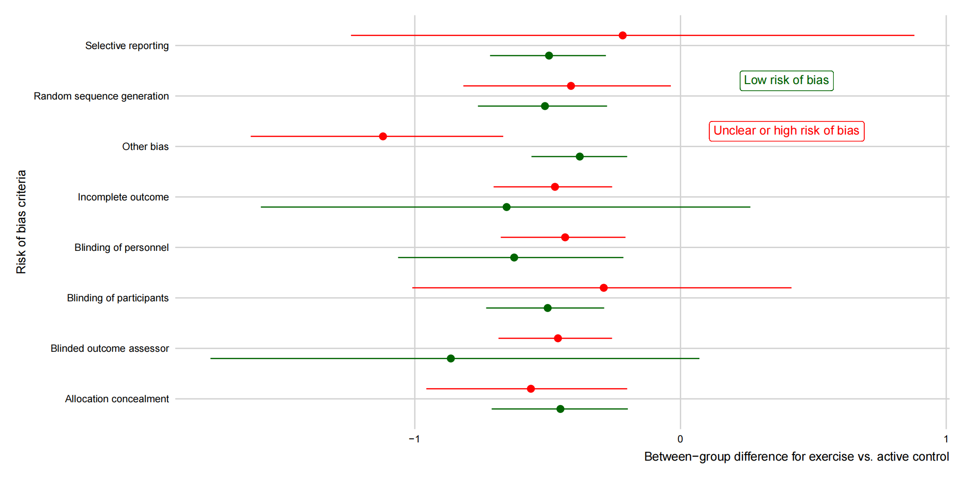

Supporting Information P6 Forest plot of each data point informing each arm

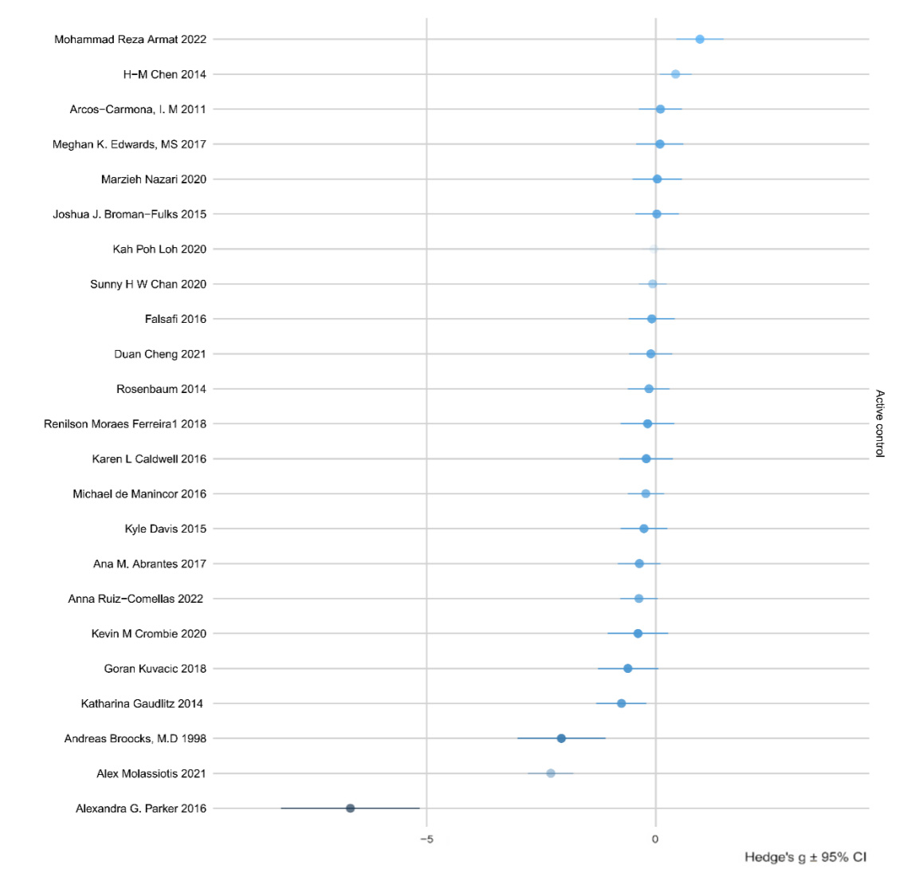

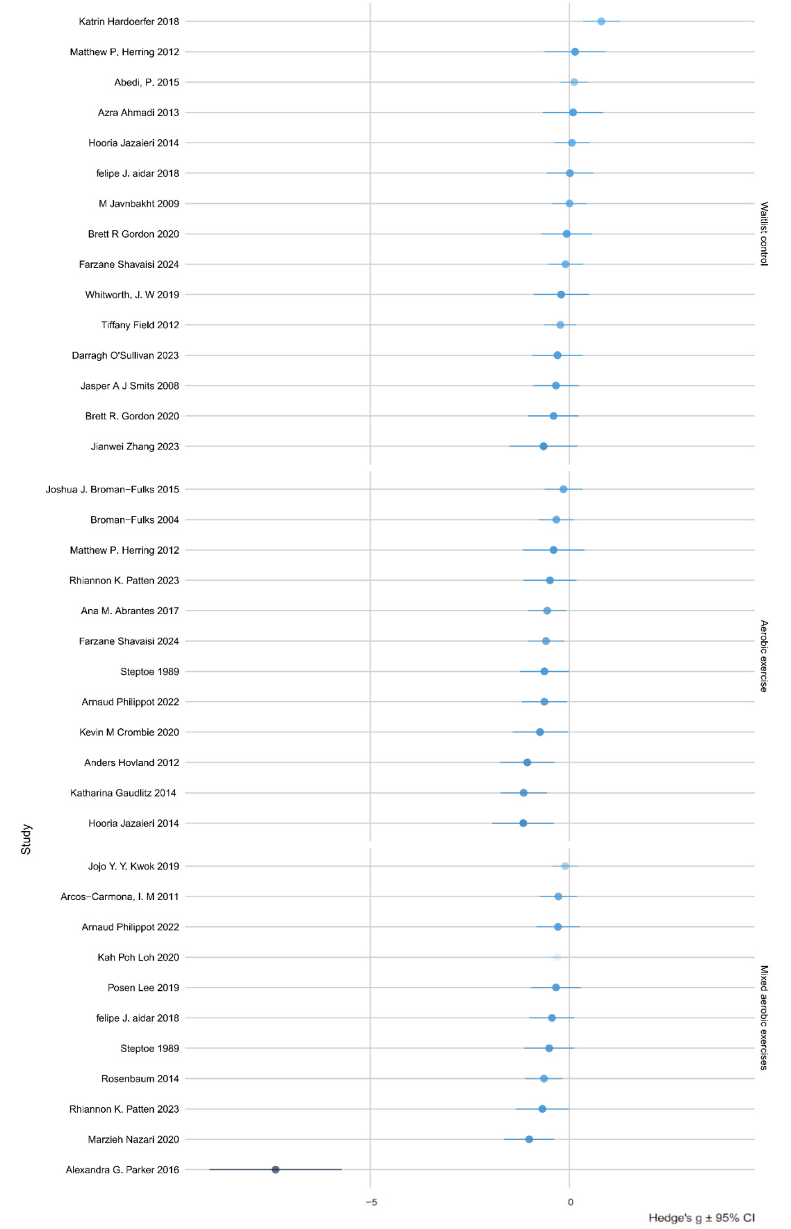
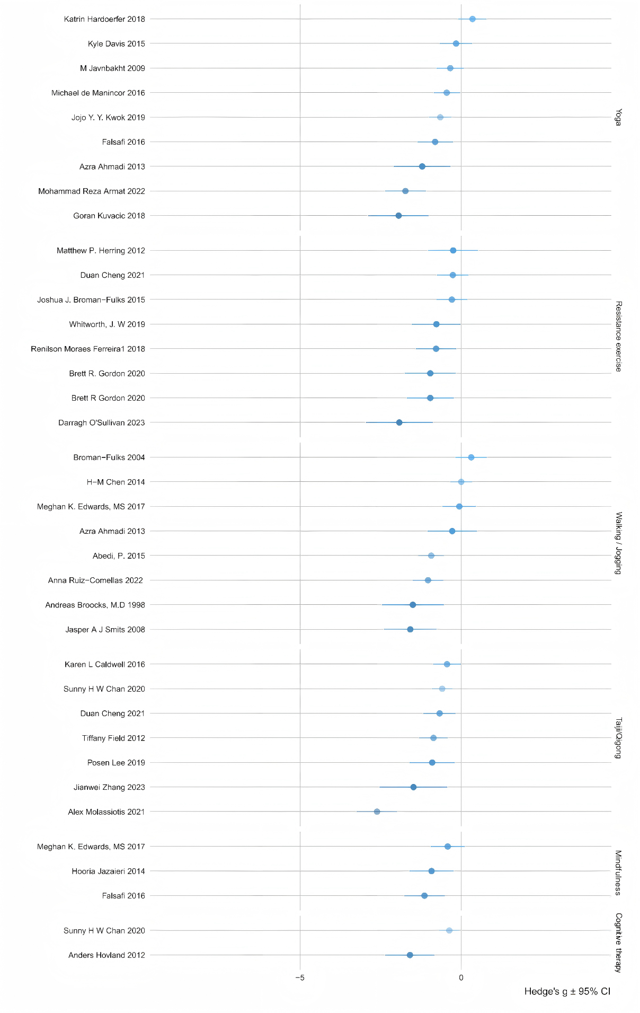

Supporting Information P7 Summary table of credibility assessment

Active control versus | Direct comparisons(k) | Within study bias | Reporting bias | Indirectness | Imprecision | Heterogeneity | Incoherence | Confidence rating
Aerobic exercise | 4 | ● | ● | ● | ● | ● | ● | low
Cognitive behavioral therapy | 1 | ● | ● | ● | ● | ● | ● | low
Mindfulness | 2 | ● | ● | ● | ● | ● | ● | low
Mixed aerobic exercises | 5 | ● | ● | ● | ● | ● | ● | low
Resistance exercise | 3 | ● | ● | ● | ● | ● | ● | low
Taiji/Qigong | 4 | ● | ● | ● | ● | ● | ● | low
Walking/Jogging | 4 | ● | ● | ● | ● | ● | ● | low
Yoga | 5 | ● | ● | ● | ● | ● | ● | low
Risk of bias
●Major concerns or high ●Some concerns or unclear ●No concerns or low

Supporting Information P8 Density plots for R2 from models with interactions between treatment and moderators

Supporting Information P9 Moderation by Comorbidities

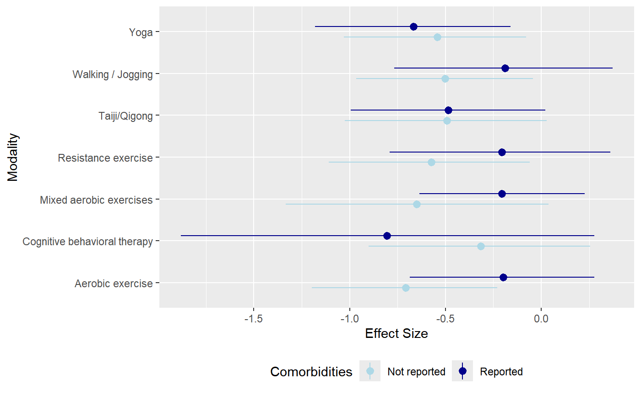

Supporting Information P10 Prediction of outcomes by metabolic equivalent per minute

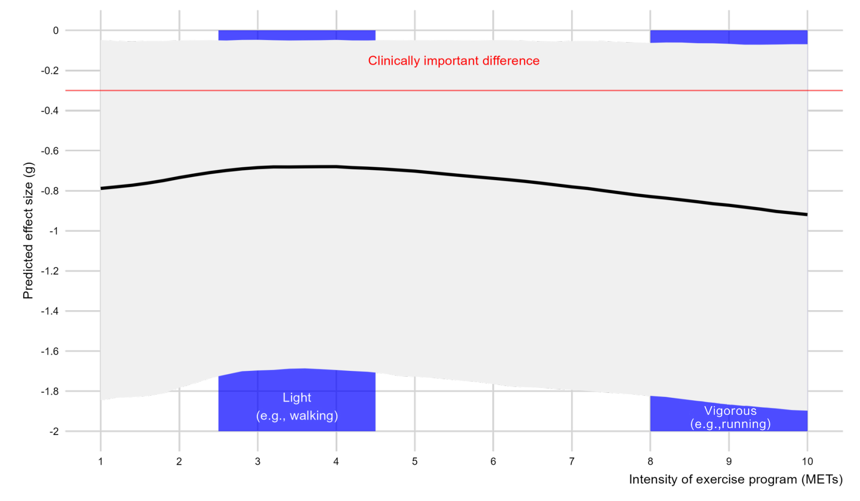

Supporting Information P11 Moderation for intervention effects by length of intervention in weeks

Supporting Information P12 Moderation by funded
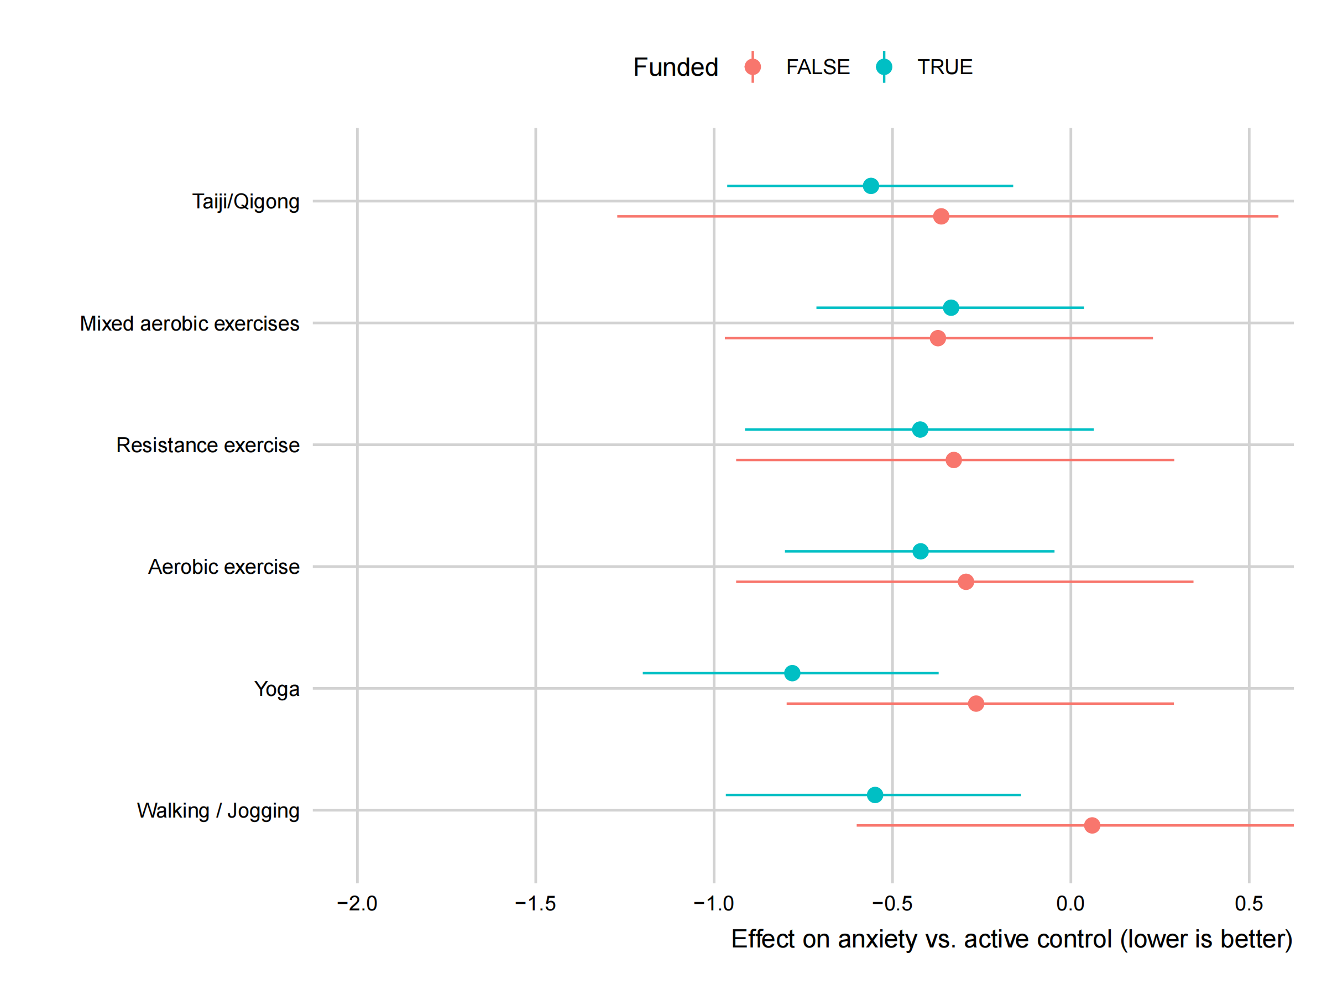

Supporting Information P13 Moderation by reporter
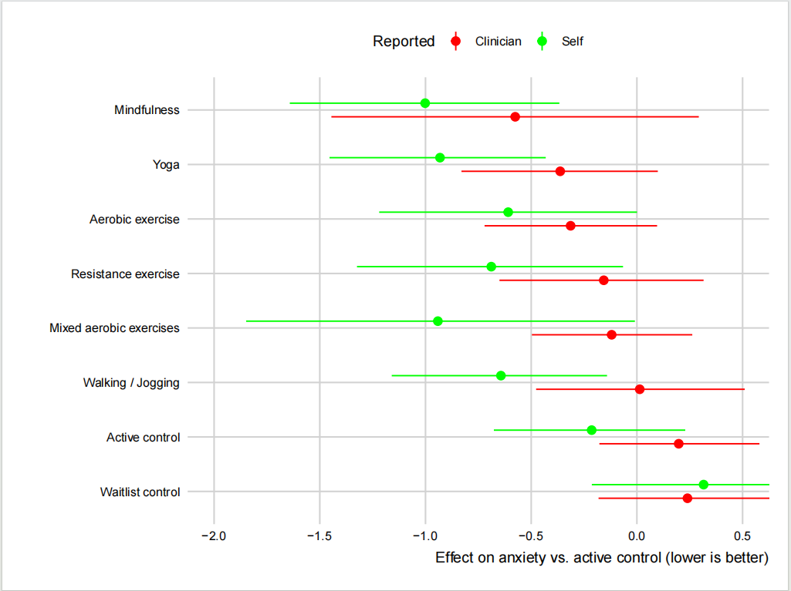

Supporting Information P14 Moderation by group exercise
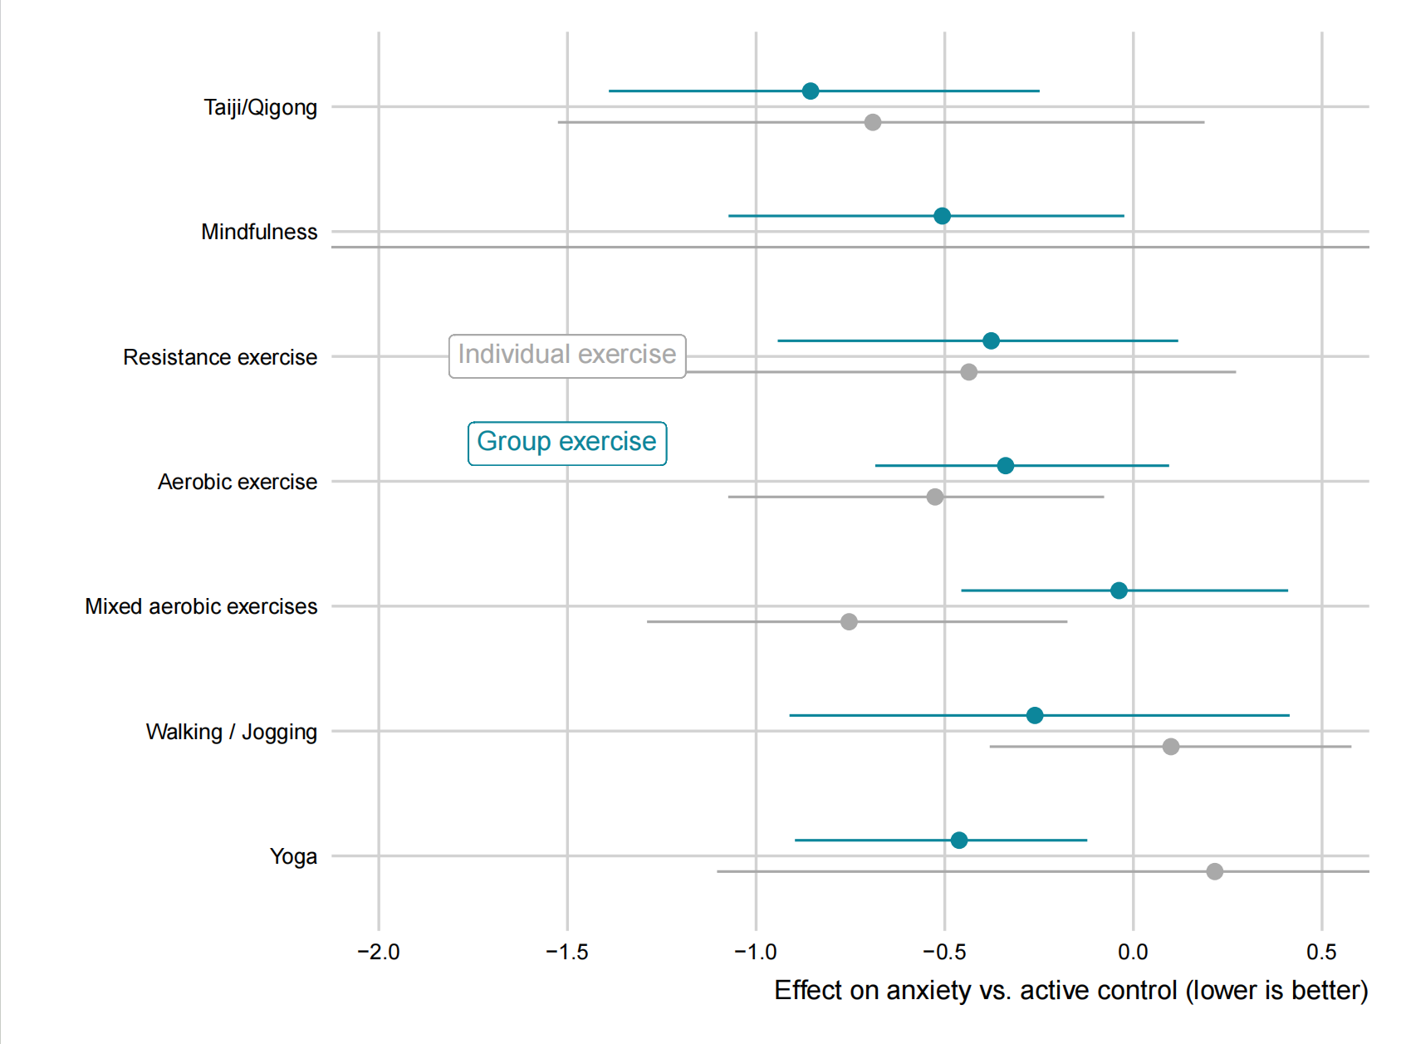

Supporting Information P15 Funnel plot for all exercise arms vs active control

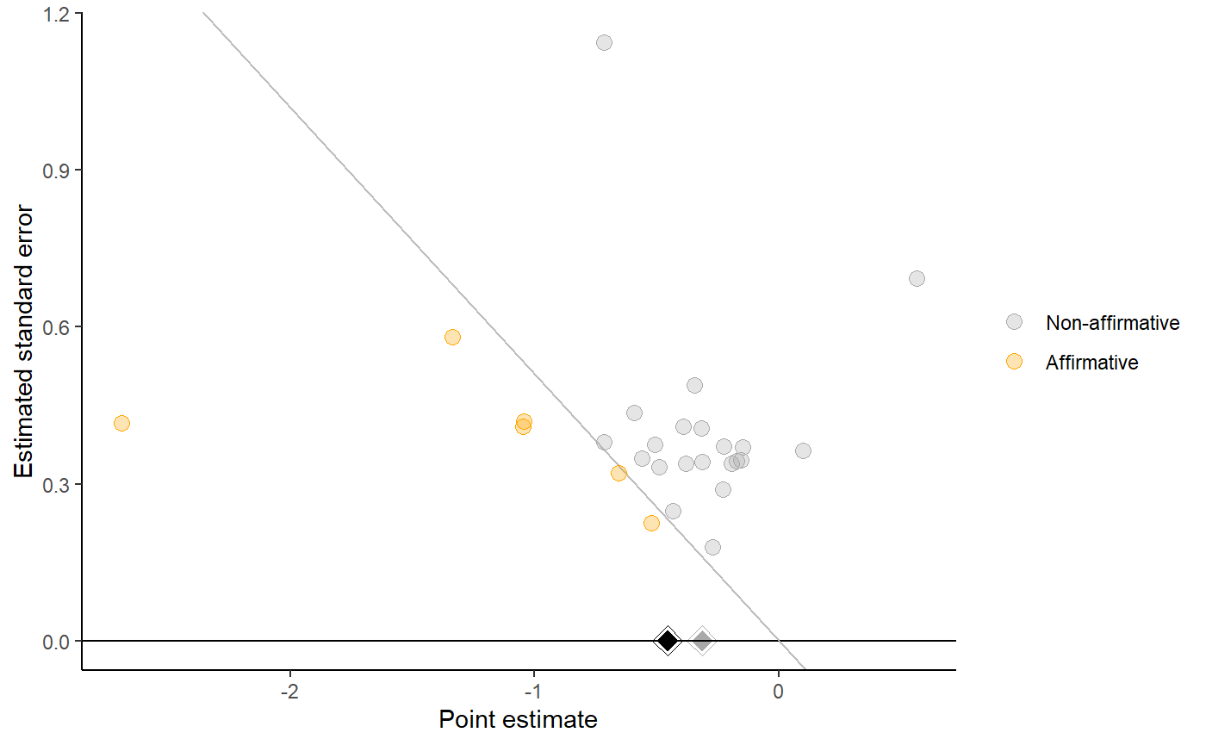

Supporting Information P16 List of key excluded documents
Ando, M., T. Morita, T. Akechi, S. Ito, M. Tanaka, Y. Ifuku, and T. Nakayama. "The Efficacy of Mindfulness-Based Meditation Therapy on Anxiety, Depression, and Spirituality in Japanese Patients with Cancer." [In eng]. J Palliat Med 12, no. 12 (Dec 2009): 1091-4. https://doi.org/10.1089/jpm.2009.0143.
Antunes, H. K., S. G. Stella, R. F. Santos, O. F. Bueno, and M. T. de Mello. "Depression, Anxiety and Quality of Life Scores in Seniors after an Endurance Exercise Program." [In eng]. Braz J Psychiatry 27, no. 4 (Dec 2005): 266-71. https://doi.org/10.1590/s1516-44462005000400003.
Aouani, H., S. Amara, F. Sahli, T. M. Barbosa, N. Souissi, and R. van den Tillaar. "Effect of Intensity Training Block on Anxiety State and Performance in Competitive Swimmers." [In eng]. PeerJ 12 (2024): e17708. https://doi.org/10.7717/peerj.17708.
Beck, E. N., M. T. Y. Wang, B. N. Intzandt, Q. J. Almeida, and K. A. Ehgoetz Martens. "Sensory Focused Exercise Improves Anxiety in Parkinson's Disease: A Randomized Controlled Trial." [In eng]. PLoS One 15, no. 4 (2020): e0230803. https://doi.org/10.1371/journal.pone.0230803.
Borrega-Mouquinho, Y., J. Sánchez-Gómez, J. P. Fuentes-García, D. Collado-Mateo, and S. Villafaina. "Effects of High-Intensity Interval Training and Moderate-Intensity Training on Stress, Depression, Anxiety, and Resilience in Healthy Adults During Coronavirus Disease 2019 Confinement: A Randomized Controlled Trial." [In eng]. Front Psychol 12 (2021): 643069. https://doi.org/10.3389/fpsyg.2021.643069.
Brenes, G. A., J. Divers, M. E. Miller, A. Anderson, G. Hargis, and S. C. Danhauer. "Comparison of Cognitive-Behavioral Therapy and Yoga for the Treatment of Late-Life Worry: A Randomized Preference Trial." [In eng]. Depress Anxiety 37, no. 12 (Dec 2020): 1194-207. https://doi.org/10.1002/da.23107.
Broman-Fulks, J. J., K. Kelso, and L. Zawilinski. "Effects of a Single Bout of Aerobic Exercise Versus Resistance Training on Cognitive Vulnerabilities for Anxiety Disorders." [In eng]. Cogn Behav Ther 44, no. 4 (2015): 240-51. https://doi.org/10.1080/16506073.2015.1020448.
Carcelén-Fraile, M. D. C., A. Aibar-Almazán, A. Martínez-Amat, J. D. Jiménez-García, V. Brandão-Loureiro, P. A. García-Garro, R. Fábrega-Cuadros, Y. Rivas-Campo, and F. Hita-Contreras. "Qigong for Mental Health and Sleep Quality in Postmenopausal Women: A Randomized Controlled Trial." [In eng]. Medicine (Baltimore) 101, no. 39 (Sep 30 2022): e30897. https://doi.org/10.1097/md.0000000000030897.
Castellote-Caballero, Y., M. D. C. Carcelén-Fraile, A. Aibar-Almazán, Y. Rivas-Campo, and A. M. González-Martín. "Yoga as a Therapeutic Approach to Mental Health in University Students: A Randomized Controlled Trial." [In eng]. Front Public Health 12 (2024): 1406937. https://doi.org/10.3389/fpubh.2024.1406937.
Charati, F. G., L. Shojaee, S. Haghighat, R. Esmaeili, Z. Madani, J. Y. Charati, S. H. Hosseini, and V. Shafipour. "Motor Exercises Effect on Improving Shoulders Functioning, Functional Ability, Quality of Life, Depression and Anxiety for Women with Breast Cancer." [In eng]. Clin Breast Cancer 22, no. 7 (Oct 2022): 666-73. https://doi.org/10.1016/j.clbc.2022.07.009.
Christensen, S. B., C. H. Dall, E. Prescott, S. S. Pedersen, and F. Gustafsson. "A High-Intensity Exercise Program Improves Exercise Capacity, Self-Perceived Health, Anxiety and Depression in Heart Transplant Recipients: A Randomized, Controlled Trial." [In eng]. J Heart Lung Transplant 31, no. 1 (Jan 2012): 106-7. https://doi.org/10.1016/j.healun.2011.10.014.
Courneya, K. S., D. C. McKenzie, K. Gelmon, J. R. Mackey, R. D. Reid, Y. Yasui, C. M. Friedenreich, et al. "A Multicenter Randomized Trial of the Effects of Exercise Dose and Type on Psychosocial Distress in Breast Cancer Patients Undergoing Chemotherapy." [In eng]. Cancer Epidemiol Biomarkers Prev 23, no. 5 (May 2014): 857-64. https://doi.org/10.1158/1055-9965.Epi-13-1163.
Dougherty, C. M., R. L. Burr, P. J. Kudenchuk, and R. W. Glenny. "Aerobic Exercise Effects on Quality of Life and Psychological Distress after an Implantable Cardioverter Defibrillator." [In eng]. J Cardiopulm Rehabil Prev 40, no. 2 (Mar 2020): 94-101. https://doi.org/10.1097/hcr.0000000000000444.
Dziubek, W., J. Kowalska, M. Kusztal, Ł Rogowski, T. Gołębiowski, M. Nikifur, J. Szczepańska-Gieracha, et al. "The Level of Anxiety and Depression in Dialysis Patients Undertaking Regular Physical Exercise Training--a Preliminary Study." [In eng]. Kidney Blood Press Res 41, no. 1 (2016): 86-98. https://doi.org/10.1159/000368548.
Edwards, M. K., R. E. Rhodes, and P. D. Loprinzi. "A Randomized Control Intervention Investigating the Effects of Acute Exercise on Emotional Regulation." [In eng]. Am J Health Behav 41, no. 5 (Sep 1 2017): 534-43. https://doi.org/10.5993/ajhb.41.5.2.
Eisenhut, L., D. Sadeghi-Bahmani, M. Gerber, A. Saemann, L. Staub, S. Brand, and D. Cordier. "Effects of Two Types of Exercise Training on Psychological Well-Being, Sleep and Physical Fitness in Patients with High-Grade Glioma (Who Iii and Iv)." [In eng]. J Psychiatr Res 151 (Jul 2022): 354-64. https://doi.org/10.1016/j.jpsychires.2022.03.058.
Esmail, A., T. Vrinceanu, M. Lussier, D. Predovan, N. Berryman, J. Houle, A. Karelis, et al. "Effects of Dance/Movement Training Vs. Aerobic Exercise Training on Cognition, Physical Fitness and Quality of Life in Older Adults: A randomized Controlled Trial." [In eng]. J Bodyw Mov Ther 24, no. 1 (Jan 2020): 212-20. https://doi.org/10.1016/j.jbmt.2019.05.004.
Gallego, J., J. M. Aguilar-Parra, A. J. Cangas, I. Langer Á, and I. Mañas. "Effect of a Mindfulness Program on Stress, Anxiety and Depression in University Students." [In eng]. Span J Psychol 17 (Jan 13 2015): E109. https://doi.org/10.1017/sjp.2014.102.
Garvin, A. W., K. F. Koltyn, and W. P. Morgan. "Influence of Acute Physical Activity and Relaxation on State Anxiety and Blood Lactate in Untrained College Males." [In eng]. Int J Sports Med 18, no. 6 (Aug 1997): 470-6. https://doi.org/10.1055/s-2007-972666.
Ho, R. T., T. C. Fong, I. K. Cheung, P. S. Yip, and M. Y. Luk. "Effects of a Short-Term Dance Movement Therapy Program on Symptoms and Stress in Patients with Breast Cancer Undergoing Radiotherapy: A Randomized, Controlled, Single-Blind Trial." [In eng]. J Pain Symptom Manage 51, no. 5 (May 2016): 824-31. https://doi.org/10.1016/j.jpainsymman.2015.12.332.
Jalal Jumaah, T., S. Faal Siahkal, Z. Behboodi Moghadam, and E. Ebrahimi. "The Effect of Yoga on Maternal Anxiety in Women with Excessive Gestational Weight Gain: A Randomized Controlled Trial." [In eng]. Complement Med Res 30, no. 6 (2023): 517-24. https://doi.org/10.1159/000534776. Auswirkung von Yoga auf Angst bei Schwangeren mit exzessiver Gewichtszunahme: Eine randomisierte kontrollierte Studie.
Khalsa, S. B., L. Hickey-Schultz, D. Cohen, N. Steiner, and S. Cope. "Evaluation of the Mental Health Benefits of Yoga in a Secondary School: A Preliminary Randomized Controlled Trial." [In eng]. J Behav Health Serv Res 39, no. 1 (Jan 2012): 80-90. https://doi.org/10.1007/s11414-011-9249-8.
Li, K., T. Walczak-Kozłowska, M. Lipowski, J. Li, D. Krokosz, Y. Su, H. Yu, and H. Fan. "The Effect of the Baduanjin Exercise on Covid-19-Related Anxiety, Psychological Well-Being and Lower Back Pain of College Students During the Pandemic." [In eng]. BMC Sports Sci Med Rehabil 14, no. 1 (Jun 8 2022): 102. https://doi.org/10.1186/s13102-022-00493-3.
Luo, L., N. Song, H. Yang, J. Huang, L. Zhou, and L. Zhang. "Intervention Effect of Long-Term Aerobic Training on Anxiety, Depression, and Sleep Quality of Middle School Students with Depression after Covid-19." [In eng]. Front Psychiatry 12 (2021): 720833. https://doi.org/10.3389/fpsyt.2021.720833.
Mikkelsen, M. K., C. M. Lund, A. Vinther, A. Tolver, J. S. Johansen, I. Chen, A. M. Ragle, et al. "Effects of a 12-Week Multimodal Exercise Intervention among Older Patients with Advanced Cancer: Results from a Randomized Controlled Trial." [In eng]. Oncologist 27, no. 1 (Feb 3 2022): 67-78. https://doi.org/10.1002/onco.13970.
Noggle, J. J., N. J. Steiner, T. Minami, and S. B. Khalsa. "Benefits of Yoga for Psychosocial Well-Being in a Us High School Curriculum: A Preliminary Randomized Controlled Trial." [In eng]. J Dev Behav Pediatr 33, no. 3 (Apr 2012): 193-201. https://doi.org/10.1097/DBP.0b013e31824afdc4.
Noreau, L., H. Martineau, L. Roy, and M. Belzile. "Effects of a Modified Dance-Based Exercise on Cardiorespiratory Fitness, Psychological State and Health Status of Persons with Rheumatoid Arthritis." [In eng]. Am J Phys Med Rehabil 74, no. 1 (Jan-Feb 1995): 19-27. https://doi.org/10.1097/00002060-199501000-00004.
Papp, M. E., M. Nygren-Bonnier, L. Gullstrand, P. E. Wändell, and P. Lindfors. "A Randomized Controlled Pilot Study of the Effects of 6-Week High Intensity Hatha Yoga Protocol on Health-Related Outcomes among Students." [In eng]. J Bodyw Mov Ther 23, no. 4 (Oct 2019): 766-72. https://doi.org/10.1016/j.jbmt.2019.05.013.
Santos, I. K., G. S. Pichini, D. Ferreira C. Daniel, P. B. Dantas, R. A. V. Browne, V. de Queiros, G. M. Soares, et al. "Effects of High-Intensity Interval Training in Combination with Detraining on Mental Health in Women with Polycystic Ovary Syndrome: A Randomized Controlled Trial." [In eng]. Front Physiol 13 (2022): 948414. https://doi.org/10.3389/fphys.2022.948414.
Silva, L. A. D., R. Doyenart, P. Henrique Salvan, W. Rodrigues, J. Felipe Lopes, K. Gomes, A. Thirupathi, R. A. Pinho, and P. C. Silveira. "Swimming Training Improves Mental Health Parameters, Cognition and Motor Coordination in Children with Attention Deficit Hyperactivity Disorder." [In eng]. Int J Environ Health Res 30, no. 5 (Oct 2020): 584-92. https://doi.org/10.1080/09603123.2019.1612041.
Streeter, C. C., T. H. Whitfield, L. Owen, T. Rein, S. K. Karri, A. Yakhkind, R. Perlmutter, et al. "Effects of Yoga Versus Walking on Mood, Anxiety, and Brain Gaba Levels: A Randomized Controlled Mrs Study." [In eng]. J Altern Complement Med 16, no. 11 (Nov 2010): 1145-52. https://doi.org/10.1089/acm.2010.0007.
Szaszkó, B., R. R. Schmid, U. Pomper, M. Maiworm, S. Laiber, H. Tschenett, U. M. Nater, and U. Ansorge. "The Influence of Hatha Yoga on Stress, Anxiety, and Suppression: A Randomized Controlled Trial." [In eng]. Acta Psychol (Amst) 241 (Nov 2023): 104075. https://doi.org/10.1016/j.actpsy.2023.104075.
Teng, H. C., M. L. Yeh, and M. H. Wang. "Walking with Controlled Breathing Improves Exercise Tolerance, Anxiety, and Quality of Life in Heart Failure Patients: A Randomized Controlled Trial." [In eng]. Eur J Cardiovasc Nurs 17, no. 8 (Dec 2018): 717-27. https://doi.org/10.1177/1474515118778453.
Vancini, R. L., A. B. R. Rayes, C. A. B. Lira, K. J. Sarro, and M. S. Andrade. "Pilates and Aerobic Training Improve Levels of Depression, Anxiety and Quality of Life in Overweight and Obese Individuals." [In eng]. Arq Neuropsiquiatr 75, no. 12 (Dec 2017): 850-57. https://doi.org/10.1590/0004-282x20170149.
Vizza, L., C. A. Smith, S. Swaraj, K. Agho, and B. S. Cheema. "The Feasibility of Progressive Resistance Training in Women with Polycystic Ovary Syndrome: A Pilot Randomized Controlled Trial." [In eng]. BMC Sports Sci Med Rehabil 8 (2016): 14. https://doi.org/10.1186/s13102-016-0039-8.
Wagener, T. L., D. A. Fedele, M. R. Mignogna, C. N. Hester, and S. R. Gillaspy. "Psychological Effects of Dance-Based Group Exergaming in Obese Adolescents." [In eng]. Pediatr Obes 7, no. 5 (Oct 2012): e68-74. https://doi.org/10.1111/j.2047-6310.2012.00065.x.
Wang, X., X. Yin, P. Liu, A. Wang, W. Mu, J. Xu, W. Lu, et al. "The Effect of Baduanjin Qigong Combined with Five-Elements Music on Anxiety and Quality of Sleep in Asymptomatic Patients with Covid-19 Infection: A Randomised Controlled Trial." [In eng]. Heliyon 9, no. 8 (Aug 2023): e18962. https://doi.org/10.1016/j.heliyon.2023.e18962.
Zheng, S., C. Kim, S. Lal, P. Meier, D. Sibbritt, and C. Zaslawski. "The Effects of Twelve Weeks of Tai Chi Practice on Anxiety in Stressed but Healthy People Compared to Exercise and Wait-List Groups-a Randomized Controlled Trial." [In eng]. J Clin Psychol 74, no. 1 (Jan 2018): 83-92. https://doi.org/10.1002/jclp.22482.

Reference
1. Abedi, P., P. Nikkhah, and S. Najar, Effect of pedometer-based walking on depression, anxiety and insomnia among postmenopausal women. Climacteric, 2015. 18(6): p. 841-5.
2. Molassiotis, A., D.V. Vu, and S.S.Y. Ching, The Effectiveness of Qigong in Managing a Cluster of Symptoms (Breathlessness-Fatigue-Anxiety) in Patients with Lung Cancer: A Randomized Controlled Trial. Integrative Cancer Therapies, 2021. 20: p. 15347354211008253.
3. Parker, A.G., et al., The effectiveness of simple psychological and physical activity interventions for high prevalence mental health problems in young people: A factorial randomised controlled trial. J Affect Disord, 2016. 196: p. 200-9.
4. Abrantes, A.M., et al., A pilot randomized controlled trial of aerobic exercise as an adjunct to OCD treatment. Gen Hosp Psychiatry, 2017. 49: p. 51-55.
5. Hovland, A., et al., Comparing physical exercise in groups to group cognitive behaviour therapy for the treatment of panic disorder in a randomized controlled trial. Behav Cogn Psychother, 2013. 41(4): p. 408-32.
6. Broocks, A., et al., Comparison of aerobic exercise, clomipramine, and placebo in the treatment of panic disorder. Am J Psychiatry, 1998. 155(5): p. 603-9.
7. Ruiz-Comellas, A., et al., Effects of Physical Activity Interventions in the Elderly with Anxiety, Depression, and Low Social Support: A Clinical Multicentre Randomised Trial. Healthcare (Basel), 2022. 10(11).
8. Arcos-Carmona, I.M., et al., [Effects of aerobic exercise program and relaxation techniques on anxiety, quality of sleep, depression, and quality of life in patients with fibromyalgia: a randomized controlled trial]. Med Clin (Barc), 2011. 137(9): p. 398-401.
9. Philippot, A., et al., Impact of physical exercise on depression and anxiety in adolescent inpatients: A randomized controlled trial. J Affect Disord, 2022. 301: p. 145-153.
10. Ahmadi, A., et al., Comparison of the Effect of 8 weeks Aerobic and Yoga Training on Ambulatory Function, Fatigue and Mood Status in MS Patients. Iran Red Crescent Med J, 2013. 15(6): p. 449-54.
11. Gordon, B.R., et al., Resistance exercise training for anxiety and worry symptoms among young adults: a randomized controlled trial. Sci Rep, 2020. 10(1): p. 17548.
12. Broman-Fulks, J.J., et al., Effects of aerobic exercise on anxiety sensitivity. Behav Res Ther, 2004. 42(2): p. 125-36.
13. O'Sullivan, D., et al., Effects of resistance exercise training on depressive symptoms among young adults: A randomized controlled trial. Psychiatry Res, 2023. 326: p. 115322.
14. Cheng, D., et al., Effect of Tai Chi and Resistance Training on Cancer-Related Fatigue and Quality of Life in Middle-Aged and Elderly Cancer Patients. Chin J Integr Med, 2021. 27(4): p. 265-272.
15. Falsafi, N., A Randomized Controlled Trial of Mindfulness Versus Yoga: Effects on Depression and/or Anxiety in College Students. J Am Psychiatr Nurses Assoc, 2016. 22(6): p. 483-497.
16. Shavaisi, F., et al., The effects of positive psychology and physical activity on depression, anxiety, and stress among students with premenstrual syndrome: a single-blind, randomized controlled trial. BMC Womens Health, 2024. 24(1): p. 499.
17. Aidar, F.J., et al., A randomized trial of the effects of an aquatic exercise program on depression, anxiety levels, and functional capacity of people who suffered an ischemic stroke. J Sports Med Phys Fitness, 2018. 58(7-8): p. 1171-1177.
18. Kuvacic, G., et al., Effectiveness of yoga and educational intervention on disability, anxiety, depression, and pain in people with CLBP: A randomized controlled trial. Complement Ther Clin Pract, 2018. 31: p. 262-267.
19. Chen, H.M., et al., Randomised controlled trial on the effectiveness of home-based walking exercise on anxiety, depression and cancer-related symptoms in patients with lung cancer. Br J Cancer, 2015. 112(3): p. 438-45.
20. Jazaieri, H., et al., A randomized trial of MBSR versus aerobic exercise for social anxiety disorder. J Clin Psychol, 2012. 68(7): p. 715-31.
21. Smits, J.A., et al., Reducing anxiety sensitivity with exercise. Depress Anxiety, 2008. 25(8): p. 689-99.
22. Zhang, J., et al., The effect of Bafa Wubu of Tai Chi on college students' anxiety and depression: A randomized, controlled pilot study. Front Physiol, 2023. 14: p. 1036010.
23. Kwok, J.Y.Y., et al., Effects of Mindfulness Yoga vs Stretching and Resistance Training Exercises on Anxiety and Depression for People With Parkinson Disease: A Randomized Clinical Trial. JAMA Neurol, 2019. 76(7): p. 755-763.
24. Broman-Fulks, J.J., K. Kelso, and L. Zawilinski, Effects of a Single Bout of Aerobic Exercise Versus Resistance Training on Cognitive Vulnerabilities for Anxiety Disorders. Cogn Behav Ther, 2015. 44(4): p. 240-51.
25. Loh, K.P., et al., Effects of a Home-based Exercise Program on Anxiety and Mood Disturbances in Older Adults with Cancer Receiving Chemotherapy. J Am Geriatr Soc, 2019. 67(5): p. 1005-1011.
26. Caldwell, K.L., et al., Effects of tai chi chuan on anxiety and sleep quality in young adults: lessons from a randomized controlled feasibility study. Nat Sci Sleep, 2016. 8: p. 305-314.
27. Gaudlitz, K., et al., Aerobic exercise training facilitates the effectiveness of cognitive behavioral therapy in panic disorder. Depress Anxiety, 2015. 32(3): p. 221-8.
28. Hardoerfer, K. and E. Jentschke, Effect of Yoga Therapy on Symptoms of Anxiety in Cancer Patients. Oncol Res Treat, 2018. 41(9): p. 526-532.
29. Crombie, K.M., et al., Aerobic exercise reduces anxiety and fear ratings to threat and increases circulating endocannabinoids in women with and without PTSD. Ment Health Phys Act, 2021. 20.
30. Davis, K., et al., A randomized controlled trial of yoga for pregnant women with symptoms of depression and anxiety. Complement Ther Clin Pract, 2015. 21(3): p. 166-72.
31. Javnbakht, M., R. Hejazi Kenari, and M. Ghasemi, Effects of yoga on depression and anxiety of women. Complement Ther Clin Pract, 2009. 15(2): p. 102-4.
32. Nazari, M., R. Shabani, and S. Dalili, The effect of concurrent resistance-aerobic training on serum cortisol level, anxiety, and quality of life in pediatric type 1 diabetes. J Pediatr Endocrinol Metab, 2020. 33(5): p. 599-604.
33. Herring, M.P., et al., Feasibility of exercise training for the short-term treatment of generalized anxiety disorder: a randomized controlled trial. Psychother Psychosom, 2012. 81(1): p. 21-8.
34. Edwards, M.K., S. Rosenbaum, and P.D. Loprinzi, Differential Experimental Effects of a Short Bout of Walking, Meditation, or Combination of Walking and Meditation on State Anxiety Among Young Adults. Am J Health Promot, 2018. 32(4): p. 949-958.
35. de Manincor, M., et al., INDIVIDUALIZED YOGA FOR REDUCING DEPRESSION AND ANXIETY, AND IMPROVING WELL-BEING: A RANDOMIZED CONTROLLED TRIAL. Depress Anxiety, 2016. 33(9): p. 816-28.
36. Armat, M.R., et al., The impact of laughter yoga on depression and anxiety among retired women: a randomized controlled clinical trial. J Women Aging, 2022. 34(1): p. 31-42.
37. Lee, P., et al., Qigong Reduces Depressive Symptoms of Taiwanese Elderly with Chronic Physical Illness: A Randomized Controlled Trial. J Altern Complement Med, 2020. 26(1): p. 76-78.
38. Ferreira, R.M., et al., The effect of resistance training on the anxiety symptoms and quality of life in elderly people with Parkinson's disease: a randomized controlled trial. Arq Neuropsiquiatr, 2018. 76(8): p. 499-506.
39. Patten, R.K., et al., Longitudinal affective response to high-intensity interval training and moderate-intensity continuous training in overweight women with polycystic ovary syndrome: A randomised trial. Psychol Sport Exerc, 2023. 64: p. 102325.
40. Rosenbaum, S., C. Sherrington, and A. Tiedemann, Exercise augmentation compared with usual care for post-traumatic stress disorder: a randomized controlled trial. Acta Psychiatr Scand, 2015. 131(5): p. 350-9.
41. Steptoe, A., et al., The effects of exercise training on mood and perceived coping ability in anxious adults from the general population. J Psychosom Res, 1989. 33(5): p. 537-47.
42. Chan, S.H.W., et al., A randomized controlled trial on the comparative effectiveness of mindfulness-based cognitive therapy and health qigong-based cognitive therapy among Chinese people with depression and anxiety disorders. BMC Psychiatry, 2020. 20(1): p. 590.
43. Field, T., et al., Tai chi/yoga reduces prenatal depression, anxiety and sleep disturbances. Complement Ther Clin Pract, 2013. 19(1): p. 6-10.
44. Whitworth, J.W., et al., Feasibility of Resistance Exercise for Posttraumatic Stress and Anxiety Symptoms: A Randomized Controlled Pilot Study. J Trauma Stress, 2019. 32(6): p. 977-984.

