Supplementary Online Contents
Journal of Blood Medicine

Supplemental Table 1 Types of Thrombosis and Department Distribution
Thrombotic Events | Medical Departments | Patient Distribution
Lower extremity Deep vein thrombosis（DVT ） | Department of Pulmonary and Critical Care Medicine | 5
Lower extremity Deep vein thrombosis（DVT ） | Department of Emergency Medicine | 4
Lower extremity Deep vein thrombosis（DVT ） | Department of Rheumatology | 3
Lower extremity Deep vein thrombosis（DVT ） | Department of Nephrology | 3
Lower extremity Deep vein thrombosis（DVT ） | Department of Cardiology | 3
Lower extremity Deep vein thrombosis（DVT ） | Department of Orthopedic | 2
Lower extremity Deep vein thrombosis（DVT ） | Department of Neurology | 2
Lower extremity Deep vein thrombosis（DVT ） | Department of Critical Care Medicine | 2
Lower extremity Deep vein thrombosis（DVT ） | Department of Rehabilitation Medicine​ | 1
Lower extremity Deep vein thrombosis（DVT ） | Department of General Surgery | 1
Lower extremity Deep vein thrombosis（DVT ） | Department of General Practice | 1
Lower extremity Deep vein thrombosis（DVT ） | Department of Cardiovascular Surgery | 1
Lower extremity Deep vein thrombosis（DVT ） | Department of Vascular Surgery | 1
Lower extremity Deep vein thrombosis（DVT ） | Department of Hematology | 1
Cerebral infarction | Department of Rheumatology | 10
Cerebral infarction | Department of Neurology | 9
Cerebral infarction | Department of Hematology | 3
Cerebral infarction | Department of Infectious Diseases | 1
Cerebral infarction | Department of Geriatric Medicine | 1
Cerebral infarction | Department of Cardiology | 1
Cerebral infarction | Department of Critical Care Medicine | 1
Lower extremity DVT and pulmonary embolism（PE） | Department of Pulmonary and Critical Care Medicine | 4
Lower extremity DVT and pulmonary embolism（PE） | Department of Rheumatology | 2
Lower extremity DVT and pulmonary embolism（PE） | Department of Interventional Radiology | 2
Lower extremity DVT and pulmonary embolism（PE） | Department of Infectious Diseases | 1
Lower extremity DVT and pulmonary embolism（PE） | Department of Emergency Medicine | 1
Lower extremity DVT and pulmonary embolism（PE） | Department of Hematology | 1
Lower extremity DVT and cerebral infarction | Department of Neurology | 3
Lower extremity DVT and cerebral infarction | Department of Rheumatology | 2
Lower extremity DVT and cerebral infarction | Department of Neurosurgery | 2
Lower extremity DVT and cerebral infarction | Department of Emergency Medicine | 1
Lower extremity DVT and cerebral infarction | Department of Traditional Chinese Medicine | 1
Lower extremity DVT and cerebral infarction | Department of Critical Care Medicine | 1
​Peripherally Inserted Central Catheter-related thrombosis | Department of Nephrology | 1
​Peripherally Inserted Central Catheter-related thrombosis | Department of Rheumatology | 1
Acute coronary syndrome（ACS） | Department of Hematology | 1
Acute coronary syndrome（ACS） | Department of Cardiology | 1
​Splanchnic vein thrombosis | Department of Gastroenterology | 1
​Splanchnic vein thrombosis | Department of Emergency Medicine | 1
​Upper Extremity and Lower extremity DVT | Department of Rheumatology | 1
​Upper Extremity and Lower extremity DVT | Department of Infectious Diseases | 1
Lower extremity DVT and Superficial Vein Thrombosis | Department of Rheumatology | 1
Lower extremity DVT and Superficial Vein Thrombosis | Department of General Surgery | 1
PE | Department of Rheumatology | 1
​Arteriovenous fistula thrombosis​ | Department of Nephrology | 1
Hepatic hemangioma with thrombosis in the right anterior lobe | Department of Rheumatology | 1
Cardiac Thrombus and ACS | Department of Cardiology | 1
Cerebral venous sinus thrombosis（CVST） | Department of Neurosurgery | 1
CVST and ACS | Department of Emergency Medicine | 1
Cerebral infarction and ​Lower extremity arterial thrombosis | Department of Neurology | 1
​Upper extremity arterial thrombosis | Department of Nephrology | 1
​Renal infarction | Department of Gastroenterology | 1
Lower extremity DVT and PE and Cerebral infarction | Department of Emergency Medicine | 1
Lower extremity DVT and ACS | Department of Critical Care Medicine | 1
Lower extremity DVT and Cerebral infarction and Atrial thrombus | Department of Neurology | 1
Lower extremity arterial thrombosis and Lower extremity DVT | Department of Emergency Medicine | 1
Lower extremity arterial thrombosis | Department of Vascular Surgery | 1

Supplemental Table 2 Clinical characteristics
Characteristics | TE（n=101） | No TE (n=795) | Z/X² | P
Sex, male/female, n | 40/61 | 184/611 | 12.948 | < 0.001
Age (y) median (IQR） | 69.00 (57.00, 76.00) | 50.00 (34.00, 60.00) | 8.739 | 0.000
BMI (kg/m²) median (IQR） | 22.31 (20.17, 25.11) | 22.43 (20.12, 25.07) | -0.220 | 0.826
Smoking History, n (%) | 16 (16) | 29 (4) | 27.934 | < 0.001
Comorbidities, n (%)
Hypertension | 49 (49) | 172 (22) | 34.846 | < 0.001
Diabetes Mellitus | 31 (31) | 93 (12) | 27.117 | < 0.001
Renal Insufficiency | 25 (25) | 41 (5) | 50.428 | < 0.001
dialysis | 8 (8) | 2 (0) |  | < 0.001
Liver Disease
Fatty Liver | 14 (14) | 87 (11) | 0.763 | 0.382
Diffuse Liver Lesions | 1 (1) | 7 (1) |  | 1.000
Atrial Fibrillation | 22 (22) | 17 (2) |  | < 0.001
Venous Thromboembolism History | 7 (7) | 7 (1) |  | < 0.001
Cardiovascular Events
Myocardial Infarction History | 3 (3) | 0 (0) |  | 0.001
Cardiac Dysfunction | 33 (33) | 30 (4) | 114.498 | < 0.001
Coronary Artery Disease | 19 (19) | 19 (2) |  | < 0.001
Cerebrovascular Event History
Cerebral hemorrhage | 4 (4) | 9 (1) |  | 0.049
Cerebral infarction | 39 (39) | 57 (7) | 92.622 | < 0.001
Peripheral Vascular Disease | 39 (39) | 17 (2) | 203.485 | < 0.001
Central Venous Catheter ＜1 month | 14 (14) | 31 (4) | 18.644 | < 0.001
Surgery History < 6 months | 15 (15) | 42 (5) | 13.774 | < 0.001
Fracture History < 6 months | 3 (3) | 6 (1) |  | 0.070
Sepsis < 1 month | 6 (6) | 8 (1) |  | 0.003
Pneumonia < 1 month | 73 (72) | 233 (29) | 73.576 | < 0.001
Autoimmune disorder (n, %)
Evans Syndrome | 4 (4) | 39 (5) |  | 1.000
Antiphospholipid Syndrome | 10 (10) | 46 (6) | 2.590 | 0.108
Systemic Lupus Erythematosus | 20 (20) | 192 (24) | 0.938 | 0.333
Sjögren’s Syndrome | 7 (7) | 118 (15) | 4.673 | 0.031
HBV/HCV | 0 (0) | 26 (3) |  | 0.105
HIV | 2 (2) | 2 (0) |  | 0.065

Notes:
Abbreviations: BMI, body mass index; TE, thromboembolism; IQR, interquartile range; HBV, hepatitis b virus; HCV, hepatitis c virus; HIV, human immunodeficiency virus

Supplemental Table 3 Comparison of Laboratory Results

 | TE (n=101) | No TE (n=795) | Z/X² | P | Reference value
RBC (10⁹/L) median (IQR) | 3.67 (2.88, 4.24) | 3.74 (3.13, 4.20) | -0.161 | 0.872 | 4.3-5.8 10⁹/L
WBC (10⁹/L) median (IQR） | 7.21 (5.49, 11.04) | 6.38 (4.31, 9.63) | 2.079 | 0.038 | 3.5-9.5 10⁹/L
PLT (10⁹/L) median (IQR） | 31.00 (15.00, 62.50) | 19.00 (6.00, 44.00) | 3.993 | < 0.001 | 125-350 10⁹/L
HGB (g/L) median(IQR) | 106.00 (90.00, 127.00) | 109.00 (92.00, 124.00) | 0.340 | 0.734 | 130-175 g/L (male)  115-150g/L (female）
Neutrophil count (10⁹/L) median (IQR） | 5.38 (3.76, 9.29) | 4.83 (2.91, 7.80) | 1.960 | 0.050 | 1.8-6.3 10⁹/L
Lymphocyte count (10⁹/L) median (IQR） | 0.94 (0.53, 1.45) | 1.01 (0.64, 1.45) | -1.455 | 0.146 | 1.1-3.2 10⁹/L
D-D (ug/ml) median (IQR) | 3.67 (1.22, 8.51) | 0.44 (0.26, 0.96) | 11.061 | 0.000 | 0-0.5 ug/ml
FIB (g/L) median (IQR) | 3.21 (2.51, 4.37) | 2.85 (2.31, 3.49) | 3.656 | < 0.001 | 2-4 g/L
PT (s) median (IQR) | 13.10 (12.05, 14.45) | 12.50 (11.60, 13.40) | 4.126 | < 0.001 | 10.5-16 s
APTT (s) median (IQR) | 34.20 (29.00, 39.60) | 32.60 (28.40, 37.30) | 2.049 | 0.040 | 25-45 s
TT (s) median (IQR) | 17.00 (15.65, 18.60) | 17.30 (16.20, 18.30) | -1.157 | 0.247 | 11-20 s
ALT (IU/L) median (IQR) | 26.00 (15.50, 45.55) | 19.00 (13.00, 33.00) | 2.729 | 0.006 | 9-50 IU/L
TBIL (umol/L) median (IQR) | 14.00 (9.15, 20.50) | 9.90 (7.30, 13.70) | 5.543 | < 0.001 | 3.4-21.0 umol/L
DBIL (umol/L) median (IQR) | 4.80 (3.30, 8.55) | 2.90 (1.90, 4.40) | 7.498 | < 0.001 | 0-5 umol/L
IBIL (umol/L) median (IQR) | 8.60 (5.35, 12.00) | 6.70 (4.50, 9.50) | 2.961 | 0.003 | 0-13.66 umol/L
Cr (umol/L) median (IQR) | 70.00 (48.00, 99.00) | 52.50 (44.00, 66.00) | 5.052 | < 0.001 | 57-111 umol/L
ALB (g/L) median (IQR) | 34.00 (30.30, 38.15) | 38.30 (33.30, 41.80) | -5.046 | < 0.001 | 40-55 g/L
*SLEDAI | 14/28 | 115/538 | 67.302 | < 0.001 | AnuA 0-20 RU/ml  Anti-C1q 0-16 AU/ml  Anti-dsDNA 0-100 IU/ml
*ACA | 5/43 | 74/577 | 37.883 | < 0.001 | 0-20 CU
*Aβ2-GP1 | 7/37 | 81/372 | 3.861 | 0.145 | 0-20 CU
*ANA | 45/68 | 518/677 | 23.299 | < 0.001 | negative
Notes:
Abbreviations: TE, thromboembolism; IQR, interquartile range; RBC, red blood cells; WBC, white blood cells; PLT, platelet; HGB, hemoglobin; D-D, d-dimer; FIB, fibrinogen; PT, prothrombin time; APTT, activated partial thromboplastin time; TT, thrombin time; ALT, alanine aminotransferase; TBIL, total bilirubin; DBIL, direct bilirubin; IBIL, indirect bilirubin; Cr, creatinine; ALB, albumin; SLEDAI, systemic lupus erythematosus disease activity index; ACA, anticardiolipin antibody; Aβ2-GP1, Anti-β2-glycoproteiIantibody; ANA, antinuclear antibody; AnuA, Anti-Nucleosome Antibody; Anti-C1q, Anti-Complement 1q Antibody; Anti-dsDNA, Anti-Double-Stranded DNA Antibody
* refers to laboratory parameters not included in subsequent studies

Supplemental Table 4 Comparison of data before and after imputation
 | Pre-imputation (n=896) | Post-imputation (n=896) | P
BMI (kg/m2) median (IQR） | 22.46 (20.18, 25.10) | 22.43 (20.13, 25.08) | 0.847
RBC (10⁹/L) median (IQR) | 3.74 (3.12, 4.21) | 3.73 (3.12, 4.21) | 0.929
WBC (10⁹/L) median (IQR） | 6.50 (4.39, 9.78) | 6.50 (4.40, 9.76) | 0.995
PLT (10⁹/L) median (IQR） | 21.00 (7.00, 45.00) | 21.00 (7.00, 45.00) | 0.972
HGB (g/L) median(IQR) | 109.00 (92.00, 124.00) | 109.00 (92.00, 124.00) | 0.946
Neutrophil count (10⁹/L) median (IQR） | 4.91 (3.05, 7.95) | 4.91 (3.06, 7.95) | 0.997
Lymphocyte count (10⁹/L) median (IQR） | 1.00 (0.64, 1.45) | 1.00 (0.64, 1.45) | 0.978
D-D (ug/ml) median (IQR) | 0.51 (0.29, 1.47) | 0.49 (0.28, 1.36) | 0.567
FIB (g/L) median (IQR) | 2.89 (2.32, 3.55) | 2.90 (2.32, 3.55) | 0.928
PT (s) median (IQR) | 12.60 (11.60, 13.40) | 12.60 (11.63, 13.40) | 0.911
APTT (s) median (IQR) | 32.80 (28.50, 37.50) | 32.80 (28.50, 37.50) | 0.996
TT (s) median (IQR) | 17.20 (16.10, 18.30) | 17.20 (16.10, 18.30) | 0.929
ALT (IU/L) median (IQR) | 19.90 (13.00, 34.75) | 20.0 (13.05, 35.00) | 0.877
TBIL (umol/L) median (IQR) | 10.10 (7.40, 14.43) | 10.15 (7.40, 14.40) | 0.980
DBIL (umol/L) median (IQR) | 3.10 (2.00, 4.70) | 3.10 (2.00, 4.70) | 0.981
IBIL (umol/L) median (IQR) | 6.90 (4.50, 10.13) | 6.90 (4.50, 10.10) | 0.997
Cr (umol/L) median (IQR) | 54.00 (44.00, 68.00) | 53.70 (44.00, 68.00) | 0.949
ALB (g/L) median (IQR) | 37.80 (32.78, 41.50) | 37.80 (32.63, 41.50) | 0.966
Notes:
Abbreviations: IQR, interquartile range; BMI, body mass index; RBC, red blood cells; WBC, white blood cells; PLT, Platelet; HGB, hemoglobin; D-D, d-dimer; FIB, fibrinogen; PT, prothrombin time; APTT, activated partial thromboplastin time; TT, Thrombin time; ALT, alanine aminotransferase; TBIL, total bilirubin; DBIL, direct bilirubin; IBIL, indirect bilirubin; Cr, creatinine; ALB, albumin

Supplemental Table 5 Association strength and effect size analysis of variables between training and validation sets
Type | Variables | Statistical measure | Value | Effect size interpretation
Categorical | Diabetes Mellitus | Cramer's V | 0.114 | Moderate association
Categorical | Central Venous Catheter ＜1month | Cramer's V | 0.072 | Weak association
Categorical | dialysis | Cramer's V | 0.069 | Weak association
Continuous | FIB | Cohen's d | 0.12 | Small effect sizes
Notes:
Abbreviations: FIB, fibrinogen

Supplemental Table 6 Factors associated with venous thrombosis in patients with immune thrombocytopenia.
Variables | VTE patients (n=52) | Other patients​(n=844) | P | Logistic regression analysis
 |  |  |  | OR | 95%CI | P
Sex, male/female, n | 23/29 | 201/643 | < 0.001 | 1.018 | 0.392~2.642 | 0.971
Age (y) median (IQR） | 72.00 (57.00, 77.00) | 50.00 (35.00, 62.00) | < 0.001 | 1.021 | 0.993~1.049 | 0.144
BMI (kg/m²) median (IQR） | 21.62 (19.65, 25.49) | 22.46 (20.17, 25.04) | 0.661
Smoking History, n (%) | 8 (15) | 37 (4) | 0.003 | 0.638 | 0.145~2.812 | 0.553
Comorbidities, n (%)
Hypertension | 20 (38) | 201 (24) | 0.017 | 0.581 | 0.223~1.511 | 0.265
Diabetes Mellitus | 9 (17) | 115 (14) | 0.455
Renal Insufficiency | 12 (23) | 54 (6) | < 0.001 | 1.114 | 0.261~4.743 | 0.884
Liver Disease | 7 (13) | 102 (12) | 0.768
Atrial Fibrillation | 15 (29) | 24 (3) | < 0.001 | 6.870 | 2.373~19.886 | < 0.001
Venous Thromboembolism History | 4 (8) | 10 (1) | 0.007 | 11.021 | 1.995~60.873 | 0.006
Cardiovascular Events | 22 (42) | 64 (8) | < 0.001 | 1.411 | 0.516~3.857 | 0.502
Cerebrovascular Event History | 15 (29) | 89 (11) | < 0.001 | 1.247 | 0.434~3.585 | 0.682
Peripheral Vascular Disease | 21 (40) | 35 (4) | < 0.001 | 4.700 | 1.723~12.824 | 0.003
Central Venous Catheter ＜1 month | 10 (19) | 35 (4) | < 0.001 | 3.591 | 1.018~12.670 | 0.047
Surgery History < 6 months | 9 (17) | 48 (6) | 0.004 | 1.466 | 0.445~4.826 | 0.530
Fracture History < 6 months | 2 (4) | 7 (1) | 0.092
Sepsis < 1 month | 3 (6) | 11 (1) | 0.043 | 0.470 | 0.054~4.082 | 0.494
Pneumonia < 1 month | 41 (79) | 265 (31) | < 0.001 | 3.552 | 1.338~9.431 | 0.011
Autoimmune disorder (n, %)
Evans Syndrome | 1 (2) | 42 (5) | 0.507
Antiphospholipid Syndrome | 4 (8) | 52 (6) | 0.559
Systemic Lupus Erythematosus | 9 (17) | 203 (24) | 0.267
Sjögren’s Syndrome | 2 (4) | 123 (15) | 0.030 | 0.256 | 0.049~1.325 | 0.104
HBV/HCV | 0 (0) | 26 (3) | 0.394
HIV | 1 (2) | 3 (0) | 0.213
Laboratory Indices
RBC (10⁹/L) median (IQR) | 3.64 (2.88, 4.26) | 3.74 (3.13, 4.20) | 0.855
WBC (10⁹/L) median (IQR） | 7.16 (5.55, 11.67) | 6.47 (4.34, 9.70) | 0.163
PLT (10⁹/L) median (IQR） | 37.50 (15.00, 66.00) | 20.00 (6.00, 44.00) | < 0.001 | 1.003 | 0.999~1.007 | 0.130
HGB (g/L) median(IQR) | 110.00 (90.75, 127.75) | 109.00 (92.00, 124.00) | 0.404
Neutrophil count (10⁹/L) median (IQR） | 5.34 (3.74, 9.00) | 4.87 (2.95, 7.90) | 0.187
Lymphocyte count (10⁹/L) median (IQR） | 0.80 (0.60 1.55) | 1.00 (0.64, 1.44) | 0.470
D-D (ug/ml) median (IQR) | 5.97 (2.07, 16.75) | 0.44 (0.27, 1.06) | < 0.001 | 1.152 | 1.085~1.224 | < 0.001
FIB (g/L) median (IQR) | 3.38 (2.47, 4.50) | 2.89 (2.32, 3.53) | 0.007 | 1.169 | 0.862~1.586 | 0.314
PT (s) median (IQR) | 13.30 (12.23, 14.93) | 12.60 (11.60, 13.40) | < 0.001 | 0.971 | 0.885~1.065 | 0.528
APTT (s) median (IQR) | 34.85 (29.30, 40.48) | 32.70 (28.40, 37.40) | 0.071
TT (s) median (IQR) | 16.90 (15.63, 18.48) | 17.20 (16.10, 18.30) | 0.258
ALT (IU/L) median (IQR) | 26.50 (13.25, 41.43) | 19.65 (13.05, 34.53) | 0.229
TBIL (umol/L) median (IQR) | 14.30 (8.95, 20.43) | 10.00 (7.30, 14.10) | < 0.001 | 0.990 | 0.880~1.113 | 0.862
DBIL (umol/L) median (IQR) | 5.15 (3.15, 8.58) | 3.00 (1.93,4.50) | < 0.001 | 1.059 | 0.927~1.209 | 0.402
IBIL (umol/L) median (IQR) | 9.20 (4.53, 14.20) | 6.80 (4.50, 9.68) | 0.032 | 1.000 | 0.897~1.115 | 0.998
Cr (umol/L) median (IQR) | 68.00 (50.23, 94.78) | 53.00 (44.00, 67.00) | < 0.001 | 1.001 | 0.996~1.007 | 0.704
ALB (g/L) median (IQR) | 32.95 (29.38, 37.73) | 38.05 (33.10, 41.68) | < 0.001 | 1.003 | 0.936~1.076 | 0.926

Notes:
Abbreviations: VTE, venous thromboembolism; IQR, interquartile range; BMI, body mass index;HBV, hepatitis b virus; HCV, hepatitis c virus; HIV, human immunodeficiency virus; RBC, red blood cells; WBC, white blood cells; PLT, Platelet; HGB, hemoglobin; D-D, d-dimer; FIB, fibrinogen; PT, prothrombin time; APTT, activated partial thromboplastin time; TT, Thrombin time; ALT, alanine aminotransferase; TBIL, total bilirubin; DBIL, direct bilirubin; IBIL, indirect bilirubin; Cr, creatinine; ALB, albumin

Supplemental Table 7 Factors associated with arterial thrombosis in patients with immune thrombocytopenia.
Variables | ATE patients (n=34) | Other patients​  (n=862) | P | Logistic regression analysis
 |  |  |  | OR | 95%CI | P
Sex, male/female, n | 11/23 | 213/649 | 0.313
Age (y) median (IQR） | 63.50 (54.00, 73.25) | 50.50 (35.75, 64.00) | < 0.001 | 1.003 | 0.976~1.032 | 0.816
BMI (kg/m²) median (IQR） | 23.30 (21.02, 25.27) | 22.40 (20.09, 25.07) | 0.180
Smoking History, n (%) | 5 (15) | 40 (5) | 0.024 | 3.238 | 0.974~10.762 | 0.055
Comorbidities, n (%)
Hypertension | 24 (71) | 197 (23) | < 0.001 | 3.315 | 1.322~8.308 | 0.011
Diabetes Mellitus | 14 (41) | 110 (13) | < 0.001 | 1.364 | 0.549~3.387 | 0.504
Renal Insufficiency | 10 (29) | 56 (6) | < 0.001 | 3.663 | 1.112~12.070 | 0.033
Liver Disease | 7 (21) | 102 (12) | 0.173
Atrial Fibrillation | 5 (15) | 34 (4) | 0.013 | 1.109 | 0.319~3.862 | 0.870
Venous Thromboembolism History | 1 (3) | 13 (2) | 0.421
Cardiovascular Events | 10 (29) | 76 (9) | < 0.001 | 0.784 | 0.259~2.369 | 0.666
Cerebrovascular Event History | 17 (50) | 87 (10) | < 0.001 | 3.259 | 1.334~7.961 | 0.010
Peripheral Vascular Disease | 12 (35) | 44 (5) | < 0.001 | 5.374 | 1.977~14.609 | < 0.001
Central Venous Catheter ＜1 month | 2 (6) | 43 (5) | 0.686
Surgery History < 6 months | 1 (3) | 56 (6) | 0.718
Fracture History < 6 months | 0 (0) | 9 (1) | 1.000
Sepsis < 1 month | 1 (3) | 13 (2) | 0.421
Pneumonia < 1 month | 17 (50) | 289 (34) | 0.047 | 0.764 | 0.320~1.822 | 0.544
Autoimmune disorder (n, %)
Evans Syndrome | 2 (6) | 41 (5) | 0.676
Antiphospholipid Syndrome | 5 (15) | 51 (6) | 0.055
Systemic Lupus Erythematosus | 9 (26) | 203 (24) | 0.694
Sjögren’s Syndrome | 4 (12) | 121 (14) | 1.000
HBV/HCV | 0 (0) | 26 (3) | 0.619
HIV | 1 (3) | 3 (0) | 0.144
Laboratory Indices
RBC (10⁹/L) median (IQR) | 3.81 (2.79, 4.45) | 3.73 (3.13, 4.20) | 0.610
WBC (10⁹/L) median (IQR） | 7.16 (5.59, 10.28) | 6.44 (4.37, 9.71) | 0.324
PLT (10⁹/L) median (IQR） | 30.00 (10.75, 56.50) | 20.00 (7.00, 45.00) | 0.168
HGB (g/L) median(IQR) | 111.50 (89.75, 130.00) | 109.00 (92.00, 124.00) | 0.686
Neutrophil count (10⁹/L) median (IQR） | 5.35 (4.03, 8.04) | 4.88 (3.06, 7.94) | 0.477
Lymphocyte count (10⁹/L) median (IQR） | 0.98 (0.53 1.51) | 1.00 (0.64, 1.44) | 0.866
D-D (ug/ml) median (IQR) | 1.15 (0.40, 2.19) | 0.48 (0.28, 1.35) | 0.003 | 0.987 | 0.926~1.051 | 0.676
FIB (g/L) median (IQR) | 3.07 (2.38, 3.65) | 2.89 (2.32, 3.55) | 0.320
PT (s) median (IQR) | 12.95 (11.18, 13.93) | 12.60 (11.70, 13.40) | 0.562
APTT (s) median (IQR) | 30.60 (28.08, 38.63) | 32.80 (28.50, 37.43) | 0.777
TT (s) median (IQR) | 17.20 (16.08, 18.70) | 17.20 (16.10, 18.30) | 0.902
ALT (IU/L) median (IQR) | 23.50 (16.00, 61.25) | 20.00 (13.00, 34.70) | 0.111
TBIL (umol/L) median (IQR) | 13.25 (8.68, 19.35) | 10.10 (7.40, 14.30) | 0.021 | 1.015 | 0.985~1.047 | 0.336
DBIL (umol/L) median (IQR) | 4.25 (3.15, 6.63) | 3.10 (2.00, 4.60) | 0.002 | 0.987 | 0.947~1.029 | 0.548
IBIL (umol/L) median (IQR) | 8.05 (4.95, 11.23) | 6.85 (4.50, 9.90) | 0.172
Cr (umol/L) median (IQR) | 71.00 (51.00, 104.25) | 53.00 (44.00, 68.00) | < 0.001 | 1.000 | 0.997~1.004 | 0.828
ALB (g/L) median (IQR) | 37.15 (33.70, 39.90) | 37.85 (32.50, 41.53) | 0.579

Notes:
Abbreviations: ATE, arterial thromboembolism; IQR, interquartile range; BMI, body mass index;HBV, hepatitis b virus; HCV, hepatitis c virus; HIV, human immunodeficiency virus; RBC, red blood cells; WBC, white blood cells; PLT, Platelet; HGB, hemoglobin; D-D, d-dimer; FIB, fibrinogen; PT, prothrombin time; APTT, activated partial thromboplastin time; TT, Thrombin time; ALT, alanine aminotransferase; TBIL, total bilirubin; DBIL, direct bilirubin; IBIL, indirect bilirubin; Cr, creatinine; ALB, albumin

Supplemental Table 8 Factors associated with combined venous & arterial thrombosis in patients with immune thrombocytopenia.
Variables | ATE+VTE patients (n=15) | Other patients​  (n=881) | P | Logistic regression analysis
 |  |  |  | OR | 95%CI | P
Sex, male/female, n | 6/9 | 218/663 | 0.225
Age (y) median (IQR） | 70.00 (64.00, 77.00) | 51.00 (36.00, 64.00) | < 0.001 | 1.065 | 1.000~1.135 | 0.051
BMI (kg/m²) median (IQR） | 20.31 (19.59, 23.44) | 22.46 (20.17, 25.09) | 0.082
Smoking History, n (%) | 3 (20) | 42 (5) | 0.035 | 1.192 | 0.174~8.173 | 0.858
Comorbidities, n (%)
Hypertension | 5 (33) | 216 (25) | 0.544
Diabetes Mellitus | 8 (53) | 116 (13) | < 0.001 | 6.880 | 1.535~30.842 | 0.012
Renal Insufficiency | 3 (20) | 63 (7) | 0.092
Liver Disease | 1 (7) | 108 (12) | 1.000
Atrial Fibrillation | 2 (13) | 37 (4) | 0.136
Venous Thromboembolism History | 2 (13) | 12 (1) | 0.021 | 73.554 | 4.379~1235.360 | 0.003
Cardiovascular Events | 8 (53) | 78 (9) | < 0.001 | 1.488 | 0.351~6.311 | 0.590
Cerebrovascular Event History | 7 (47) | 97 (11) | < 0.001 | 1.431 | 0.325~6.307 | 0.636
Peripheral Vascular Disease | 6 (40) | 50 (6) | < 0.001 | 4.229 | 0.881~20.300 | 0.072
Central Venous Catheter ＜1 month | 2 (13) | 43 (5) | 0.171
Surgery History < 6 months | 5 (33) | 52 (6) | 0.002 | 8.429 | 1.920~37.010 | 0.005
Fracture History < 6 months | 1 (7) | 8 (1) | 0.142
Sepsis < 1 month | 2 (13) | 12 (1) | 0.021 | 0.905 | 0.086~9.539 | 0.934
Pneumonia < 1 month | 15 (100) | 291 (33) | < 0.001 |  |  | 0.990
Autoimmune disorder (n, %)
Evans Syndrome | 1 (7) | 42 (5) | 0.525
Antiphospholipid Syndrome | 1 (7) | 55 (6) | 1.000
Systemic Lupus Erythematosus | 2 (13) | 210 (24) | 0.541
Sjögren’s Syndrome | 1 (7) | 124 (14) | 0.708
HBV/HCV | 0 (0) | 26 (3) | 1.000
HIV | 0 (0) | 4 (0) | 1.000
Laboratory Indices
RBC (10⁹/L) median (IQR) | 3.59 (2.90, 3.97) | 3.74 (3.12, 4.21) | 0.400
WBC (10⁹/L) median (IQR） | 7.90 (4.60, 13.69) | 6.47 (4.39, 9.71) | 0.266
PLT (10⁹/L) median (IQR） | 31.00 (23.00, 42.00) | 20.00 (7.00, 45.00) | 0.133
HGB (g/L) median(IQR) | 103.00 (87.00, 114.00) | 109.00 (92.00, 124.00) | 0.198
Neutrophil count (10⁹/L) median (IQR） | 6.87 (3.39, 11.72) | 4.89 (3.06, 7.90) | 0.172
Lymphocyte count (10⁹/L) median (IQR） | 0.75 (0.27 1.08) | 1.00 (0.64, 1.45) | 0.043 | 0.654 | 0.216~1.981 | 0.452
D-D (ug/ml) median (IQR) | 4.27 (1.66, 11.12) | 0.47 (0.28, 1.35) | < 0.001 | 1.013 | 0.921~1.114 | 0.796
FIB (g/L) median (IQR) | 4.06 (3.13, 4.51) | 2.89 (2.32, 3.54) | 0.009 | 1.822 | 1.048~3.167 | 0.034
PT (s) median (IQR) | 13.40 (12.50, 15.40) | 12.60 (11.60, 13.40) | 0.007 | 0.901 | 0.769~1.054 | 0.192
APTT (s) median (IQR) | 36.10 (33.30, 38.70) | 32.70 (28.40, 37.40) | 0.029 | 1.017 | 0.919~1.126 | 0.739
TT (s) median (IQR) | 16.50 (15.40, 18.00) | 17.20 (16.10, 18.30) | 0.329
ALT (IU/L) median (IQR) | 30.50 (19.00, 75.40) | 19.90 (13.00, 34.90) | 0.031 | 1.011 | 1.002~1.020 | 0.015
TBIL (umol/L) median (IQR) | 15.70 (10.40, 22.70) | 10.10 (7.35, 14.30) | 0.004 | 0.948 | 0.863~1.042 | 0.271
DBIL (umol/L) median (IQR) | 7.50 (4.20, 11.90) | 3.10 (2.00, 4.60) | < 0.001 | 1.060 | 0.946~1.187 | 0.315
IBIL (umol/L) median (IQR) | 7.30 (6.00, 11.10) | 6.90 (4.50,10.00) | 0.175
Cr (umol/L) median (IQR) | 58.00 (34.20, 102.00) | 53.60 (44.00, 68.00) | 0.416
ALB (g/L) median (IQR) | 31.80 (29.10, 36.80) | 38.00 (32.85, 41.50) | 0.001 | 1.035 | 0.913~1.175 | 0.588

Notes:
Abbreviations: ATE, arterial thromboembolism; VTE, venous thromboembolism; IQR, interquartile range; BMI, body mass index;HBV, hepatitis b virus; HCV, hepatitis c virus; HIV, human immunodeficiency virus; RBC, red blood cells; WBC, white blood cells; PLT, Platelet; HGB, hemoglobin; D-D, d-dimer; FIB, fibrinogen; PT, prothrombin time; APTT, activated partial thromboplastin time; TT, Thrombin time; ALT, alanine aminotransferase; TBIL, total bilirubin; DBIL, direct bilirubin; IBIL, indirect bilirubin; Cr, creatinine; ALB, albumin

Supplemental Table 9 Variables associated in patients with primary immune thrombocytopenia.
Variables | TE patients (n=68) | No TE patients​  (n=402) | P | Logistic regression analysis
 |  |  |  | OR | 95%CI | P
Sex, male/female, n | 32/36 | 134/268 | 0.029 | 4.340 | 1.081~17.430 | 0.039
Age (y) median (IQR） | 73.00 (64.00, 77.00) | 51.00 (36.00, 64.00) | < 0.001 | 1.041 | 0.997~1.086 | 0.071
BMI (kg/m²) median (IQR） | 21.76 (20.11, 25.11) | 23.19 (20.50, 25.81) | 0.163
Smoking History, n (%) | 11 (16) | 19 (5) | 0.001 | 10.423 | 1.349~80.528 | 0.025
Comorbidities, n (%)
Hypertension | 35 (51) | 88 (22) | <0.001 | 0.894 | 0.225~3.552 | 0.873
Diabetes Mellitus | 25 (37) | 51 (13) | < 0.001 | 1.533 | 0.383~6.134 | 0.546
Renal Insufficiency | 19 (28) | 10 (2) | < 0.001 | 2.295 | 0.182~28.932 | 0.520
Liver Disease | 11 (16) | 45 (11) | 0.241
Atrial Fibrillation | 18 (26) | 10 (2) | < 0.001 | 3.465 | 0.670~17.929 | 0.138
Venous Thromboembolism History | 5 (7) | 2 (0) | < 0.001 | 10.236 | 0.614~170.748 | 0.105
Cardiovascular Events | 32 (47) | 18 (4) | < 0.001 | 0.809 | 0.163~4.013 | 0.795
Cerebrovascular Event History | 30 (44) | 29 (7) | < 0.001 | 5.628 | 1.287~24.618 | 0.022
Peripheral Vascular Disease | 31 (46) | 4 (1) | < 0.001 | 110.038 | 17.248~702.005 | <0.001
Central Venous Catheter ＜1 month | 12 (18) | 9 (2) | < 0.001 | 8.459 | 0.874~81.839 | 0.065
Surgery History < 6 months | 12 (18) | 25 (6) | 0.001 | 7.039 | 1.194~41.487 | 0.031
Fracture History < 6 months | 3 (4) | 3 (1) | 0.042 | 0.514 | 0.024~11.219 | 0.673
Sepsis < 1 month | 5 (7) | 2 (0) | < 0.001 | 1.593 | 0.005~553.385 | 0.876
Pneumonia < 1 month | 47 (69) | 76 (19) | < 0.001 | 4.252 | 1.216~14.869 | 0.023
Autoimmune disorder (n, %)
Evans Syndrome | 1 (1) | 11 (3) | 1.000
Antiphospholipid Syndrome | 1 (1) | 10 (2) | 1.000
Systemic Lupus Erythematosus | 1 (1) | 9 (2) | 1.000
Sjögren’s Syndrome | 0 (0) | 5 (1) | 1.000
HBV/HCV | 0 (0) | 13 (3) | 0.231
HIV | 0 (0) | 0 (0)
Laboratory Indices
RBC (10⁹/L) median (IQR) | 3.76 (3.18, 4.26) | 3.90 (3.38, 4.28) | 0.486
WBC (10⁹/L) median (IQR） | 7.28 (5.69, 12.07) | 7.36 (5.29, 10.62) | 0.611
PLT (10⁹/L) median (IQR） | 33.00 (15.75, 62.75) | 13.00 (5.00, 30.00) | < 0.001 | 1.000 | 0.995~1.006 | 0.881
HGB (g/L) median(IQR) | 111.50 (95.25, 127.00) | 115.00 (99.00, 127.00) | 0.635
Neutrophil count (10⁹/L) median (IQR） | 5.84 (4.11, 9.85) | 5.84 (3.74, 8.93) | 0.672
Lymphocyte count (10⁹/L) median (IQR） | 0.96 (0.53, 1.44) | 1.05 (0.70, 1.46) | 0.058
D-D (ug/ml) median (IQR) | 3.90 (1.38, 10.22) | 0.39 (0.25, 0.77) | < 0.001 | 1.298 | 1.143~1.475 | < 0.001
FIB (g/L) median (IQR) | 3.43 (2.81, 4.56) | 2.92 (2.35, 3.56) | < 0.001 | 1.400 | 0.871~2.252 | 0.165
PT (s) median (IQR) | 13.35 (12.30, 14.93) | 12.70 (11.88, 13.40) | < 0.001 | 1.574 | 1.122~2.210 | 0.009
APTT (s) median (IQR) | 33.95 (28.78, 38.93) | 32.50 (28.70, 36.33) | 0.065
TT (s) median (IQR) | 16.90 (15.63, 18.08) | 17.20 (16.18, 18.30) | 0.300
ALT (IU/L) median (IQR) | 23.65 (14.00, 42.83) | 19.00 (13.00, 35.00) | 0.230
TBIL (umol/L) median (IQR) | 14.85 (10.40, 20.73) | 9.90 (7.40, 13.01) | < 0.001 | 0.657 | 0.447~0.966 | 0.033
DBIL (umol/L) median (IQR) | 5.00 (3.60, 8.68) | 2.97 (2.00, 4.40) | < 0.001 | 1.841 | 1.050~3.226 | 0.033
IBIL (umol/L) median (IQR) | 9.30 (6.00, 12.40) | 6.60 (4.68, 9.20) | < 0.001 | 1.481 | 1.055~2.079 | 0.023
Cr (umol/L) median (IQR) | 70.00 (52.93, 112.75) | 54.00 (44.00, 64.93) | < 0.001 | 1.010 | 1.001~1.019 | 0.036
ALB (g/L) median (IQR) | 34.10 (30.50, 38.30) | 39.40 (34.90, 42.33) | < 0.001 | 1.044 | 0.933~1.169 | 0.451

Notes:
Abbreviations:TE, thromboembolism; IQR, interquartile range; BMI, body mass index;HBV, hepatitis b virus; HCV, hepatitis c virus; HIV, human immunodeficiency virus; RBC, red blood cells; WBC, white blood cells; PLT, Platelet; HGB, hemoglobin; D-D, d-dimer; FIB, fibrinogen; PT, prothrombin time; APTT, activated partial thromboplastin time; TT, Thrombin time; ALT, alanine aminotransferase; TBIL, total bilirubin; DBIL, direct bilirubin; IBIL, indirect bilirubin; Cr, creatinine; ALB, albumin

Supplemental Table 10 Variables associated in patients with secondary immune thrombocytopenia.
Variables | TE patients (n=33) | No TE patients​  (n=393) | P | Logistic regression analysis
 |  |  |  | OR | 95%CI | P
Sex, male/female, n | 8/25 | 50/343 | 0.106
Age (y) median (IQR） | 58.00 (44.50, 64.00) | 48.00 (32.00, 58.00) | 0.002 | 1.013 | 0.979~1.047 | 0.462
BMI (kg/m²) median (IQR） | 23.24 (20.19, 24.85) | 21.86 (19.72, 24.16) | 0.292
Smoking History, n (%) | 5 (15) | 10 (3) | 0.004 | 2.643 | 0.357~19.593 | 0.342
Comorbidities, n (%)
Hypertension | 14 (42) | 84 (21) | 0.006 | 1.596 | 0.570~4.472 | 0.374
Diabetes Mellitus | 6 (18) | 42 (11) | 0.244
Renal Insufficiency | 6 (18) | 31 (8) | 0.055
Liver Disease | 4 (12) | 49 (12) | 1.000
Atrial Fibrillation | 4 (12) | 7 (2) | 0.007 | 2.207 | 0.347~14.020 | 0.401
Venous Thromboembolism History | 2 (6) | 5 (1) | 0.096
Cardiovascular Events | 8 (24) | 28 (7) | 0.004 | 1.440 | 0.403~5.139 | 0.574
Cerebrovascular Event History | 9 (27) | 36 (9) | 0.004 | 1.498 | 0.480~4.676 | 0.486
Peripheral Vascular Disease | 8 (24) | 13 (3) | < 0.001 | 4.721 | 1.351~16.495 | 0.015
Central Venous Catheter ＜1 month | 2 (6) | 22 (6) | 0.708
Surgery History < 6 months | 3 (9) | 17 (4) | 0.195
Fracture History < 6 months | 0 (0) | 3 (1) | 1.000
Sepsis < 1 month | 1 (3) | 6 (2) | 0.434
Pneumonia < 1 month | 26 (79) | 157 (40) | < 0.001 | 2.405 | 0.851~6.795 | 0.098
Autoimmune disorder (n, %)
Evans Syndrome | 3 (9) | 28 (7) | 0.723
Antiphospholipid Syndrome | 9 (27) | 36 (9) | 0.004 | 4.708 | 1.621~13.672 | 0.004
Systemic Lupus Erythematosus | 19 (58) | 183 (47) | 0.224
Sjögren’s Syndrome | 7 (21) | 113 (29) | 0.355
HBV/HCV | 0 (0) | 13 (3) | 0.611
HIV | 2 (6) | 2 (1) | 0.032 | 11.346 | 0.925~139.206 | 0.058
Laboratory Indices
RBC (10⁹/L) median (IQR) | 3.30 (2.71, 4.23) | 3.56 (3.00, 4.03) | 0.564
WBC (10⁹/L) median (IQR） | 6.68 (3.76, 10.26) | 5.37 (3.79, 8.17) | 0.316
PLT (10⁹/L) median (IQR） | 30.00 (14.00, 60.50) | 28.00 (9.00, 62.00) | 0.621
HGB (g/L) median(IQR) | 97.00 (85.00, 125.50) | 103.00 (87.00, 118.00) | 0.935
Neutrophil count (10⁹/L) median (IQR） | 5.34 (2.12, 7.74) | 3.92 (2.33, 6.66) | 0.393
Lymphocyte count (10⁹/L) median (IQR） | 0.89 (0.53, 1.52) | 0.92 (0.60, 1.43) | 0.895
D-D (ug/ml) median (IQR) | 2.16 (0.66, 8.46) | 0.51 (0.28, 1.37) | < 0.001 | 1.205 | 1.073~1.354 | 0.002
FIB (g/L) median (IQR) | 2.87 (2.35, 3.73) | 2.78 (2.28, 3.38) | 0.318
PT (s) median (IQR) | 12.90 (11.05, 13.95) | 12.30 (11.40, 13.20) | 0.267
APTT (s) median (IQR) | 34.30 (29.70, 42.65) | 32.80 (28.25, 38.35) | 0.249
TT (s) median (IQR) | 17.00 (15.70, 18.75) | 17.30 (16.15, 18.30) | 0.717
ALT (IU/L) median (IQR) | 32.00 (18.85, 59.70) | 20.00 (13.00, 31.65) | 0.002 | 1.004 | 0.995~1.014 | 0.383
TBIL (umol/L) median (IQR) | 11.60 (8.25, 20.05) | 9.80 (7.10, 14.85) | 0.109
DBIL (umol/L) median (IQR) | 4.80 (3.00, 8.25) | 2.90 (1.80, 4.55) | < 0.001 | 1.012 | 0.959~1.068 | 0.666
IBIL (umol/L) median (IQR) | 7.10 (4.25, 11.00) | 6.80 (4.25,10.20) | 0.641
Cr (umol/L) median (IQR) | 65.00 (42.30, 81.50) | 51.60 (43.35, 66.40) | 0.098
ALB (g/L) median (IQR) | 34.00 (29.15, 37.50) | 37.20 (31.90, 40.75) | 0.028 | 1.022 | 0.956~1.094 | 0.520

Notes:
Abbreviations:TE, thromboembolism; IQR, interquartile range; BMI, body mass index;HBV, hepatitis b virus; HCV, hepatitis c virus; HIV, human immunodeficiency virus; RBC, red blood cells; WBC, white blood cells; PLT, Platelet; HGB, hemoglobin; D-D, d-dimer; FIB, fibrinogen; PT, prothrombin time; APTT, activated partial thromboplastin time; TT, Thrombin time; ALT, alanine aminotransferase; TBIL, total bilirubin; DBIL, direct bilirubin; IBIL, indirect bilirubin; Cr, creatinine; ALB, albumin

Supplemental Figure 1 Feature selection was performed using LASSO regression

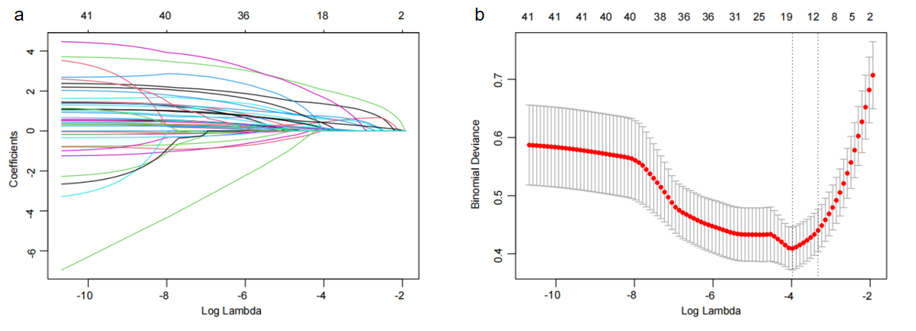
Feature selection was performed using LASSO regression. Figure a displays the coefficient profiles of 41 features plotted against the log(λ) sequence. Figure b illustrates the 10-fold cross-validation results with vertical dashed lines marking two critical λ values: The left dashed line corresponds to lambda.min (λ=0.01872102), where the mean cross-validation error is minimized, yielding a model with 16 non-zero coefficients. The right dashed line represents lambda.1se (0.03590524), the largest λ value within one standard error of the minimum error, resulting in a sparser model with 12 non-zero coefficients.

Supplemental Figure 2 Univariate logistic regression analysis to assess the association between medication use and thrombotic events

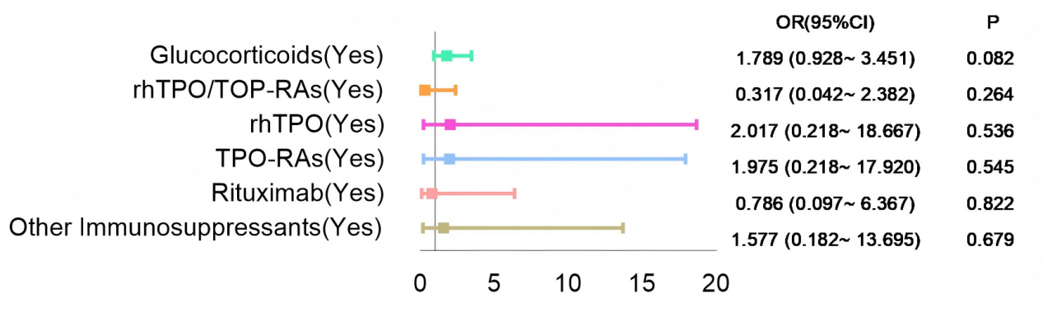

Supplemental Figure 3 Predictive performance comparison of individual risk factors

a b
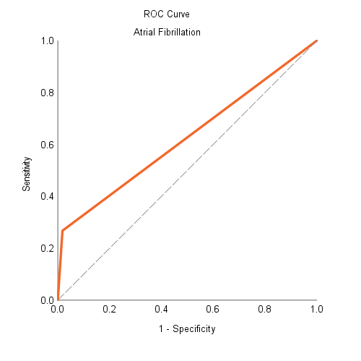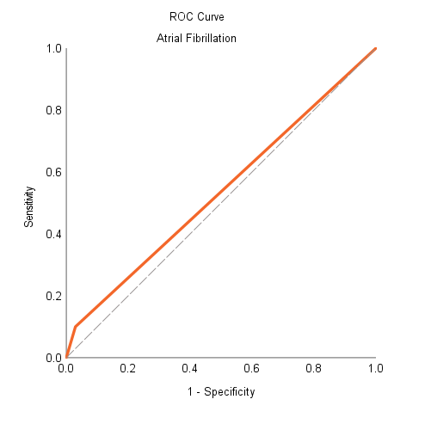

c d
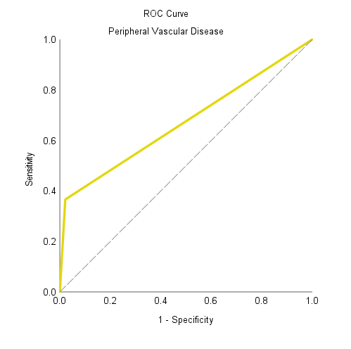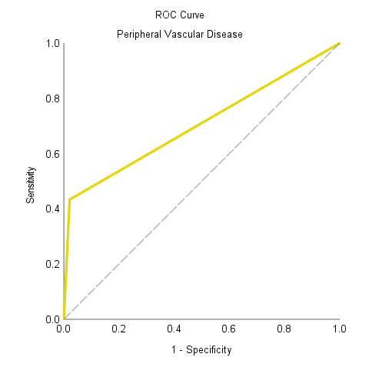

e f
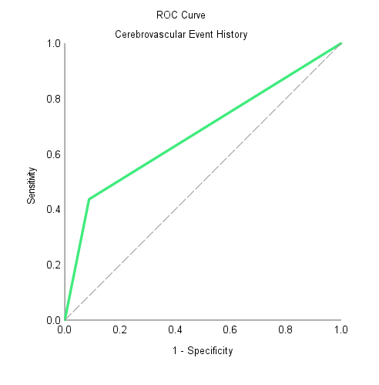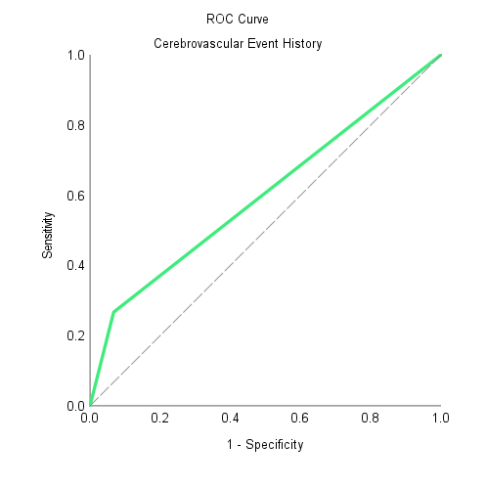

g h
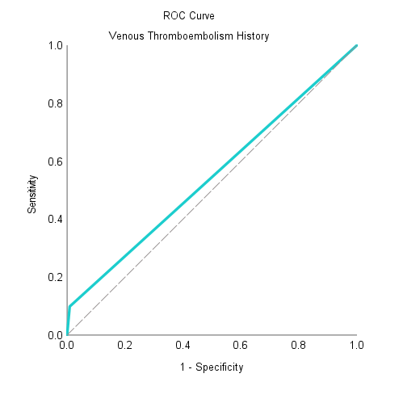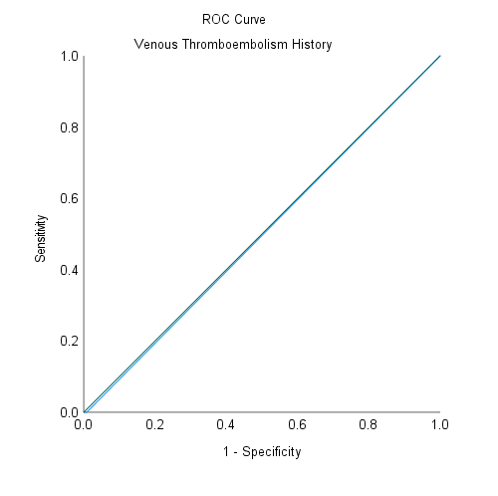

i j
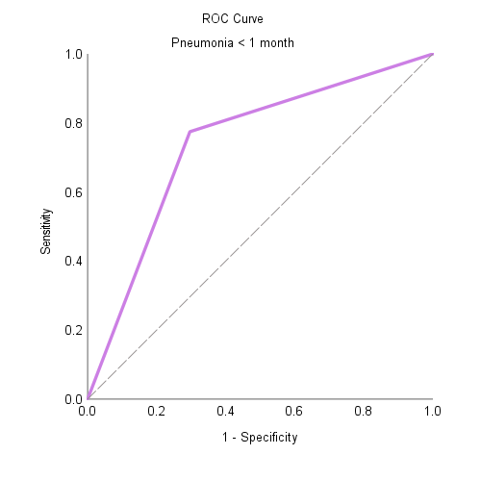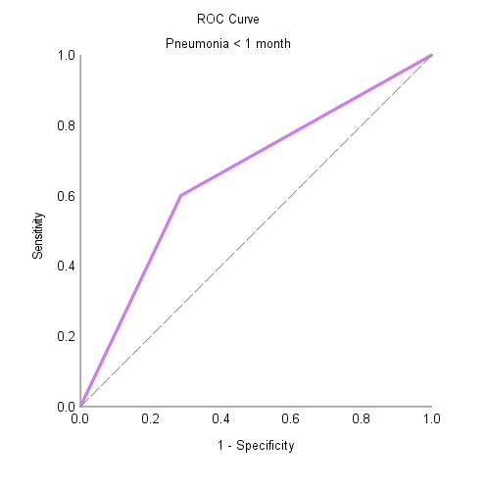

k l
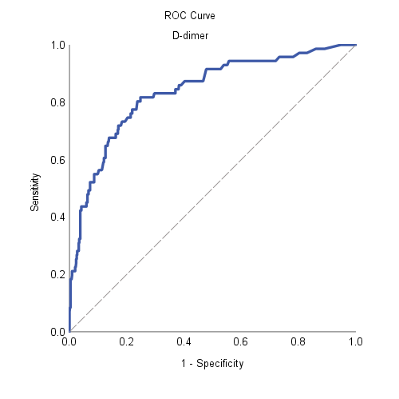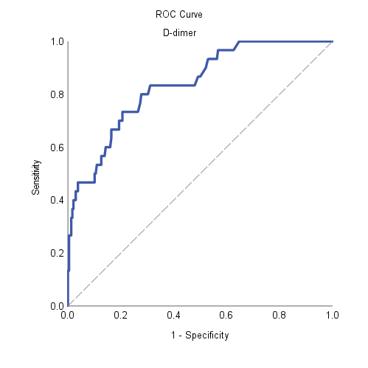
(a、c、e、g、i、k) ROC curves in the training set.
(b、d、f、h、j、l) ROC curves in the validation set.

