On-line Supplementary Material
Contents
Appendix Table | Page
- Definition of postoperative complications | 1
- Supplemental Table 1. Surgery information. | 2-3
- Supplemental Table 2. Generalized estimating equation model for assessing | 4
- Supplemental Figure 1. Vital sign parameters between groups. | 5

Definition of postoperative complications
1. Postoperative pneumonia: meets the following criteria:
1) Sputum culture positive.
2) Respiratory infection. Patient has received antibiotics for a suspected respiratory infection and met one or more of the following criteria: new or changed sputum, new or changed lung opacities, fever, white blood cell count > 12×10⁹ l⁻¹.
2. Postoperative pleural effusion
Chest radiograph demonstrating blunting of the costophrenic angle, loss of sharp silhouette of the ipsilateral hemidiaphragm in upright position, evidence of displacement of adjacent anatomical structures or (in supine position) a hazy opacity in one hemithorax with preserved vascular shadows.
3. Postoperative acute kidney injury (AKI): Defined using the creatinine component of the kidney disease: Improving Global Outcomes (KDIGO) criteria. Meets any of the following:
1) Increase in serum creatinine by ≥ 0.3 mg/dl (≥ 26.5 µmol/l) within 48 hours.
2) Increase in serum creatinine to ≥ 1.5 times baseline, which is known or presumed to have occurred within the prior 7 days.
3) Urine volume <0.5 ml/kg/h for 6 hours.

Supplemental Table 1. Surgery information.
Variables | Zero-balanced ultrafiltration  (n=53) | Conventional ultrafiltration  (n=53) | P
Type of cardiac surgery*, n (%) |  |  | 0.167
Isolated valve replacement | 16 (30.19) | 19 (35.85)
Multi-valve replacement | 19 (35.85) | 8 (15.09)
Multi-valve replacement and tricuspid valve repair | 3 (5.66) | 9 (16.98)
CABG | 4 (7.55) | 5 (9.43)
CABG and valve replacement | 5 (9.43) | 4 (7.55)
CHD | 4 (7.55) | 7 (13.20)
Bentall | 2 (3.77) | 1 (1.89)
Operation duration, min, median (IQR) | 260.00 (225.00, 300.00) | 250.00 (205.00, 290.00) | 0.363
Operation duration group, n (%) |  |  | 0.548
< 4 hours | 18 (33.96) | 22 (41.51)
≥ 4 hours | 35 (66.04) | 31 (58.49)
CPB duration, min, mean (SD) | 143.43 (45.53) | 137.19 (50.84) | 0.507
CPB duration group, n (%) |  |  | 0.835
< 2 hours | 16 (30.19) | 18 (33.96)
≥ 2 hours | 37 (69.81) | 35 (66.04)
Ultrafiltration capacity, ml, mean (SD) | 2158.49 (912.40) | 1122.64 (541.95) | <0.001
Crystalloid during CBP#, ml, median (IQR) | 3200.00 (2900.00,  3500.00) | 2200.00 (2000.00,  3300.00) | 0.002
Hct (%) during CBP, mean (SD) | 24.95 (2.15) | 25.61 (2.42) | 0.197
Red blood cell, n (%) | 18 (33.96) | 20 (37.74) | 0.112
Plasma, n (%) | 22 (41.51) | 20 (37.74) | 0.691
Cryoprecipitate, n (%) | 3 (5.66) | 1 (1.89) | 0.610
Platelet, n (%) | 3 (5.66) | 1 (1.89) | 0.610
Autologous blood, ml, median (IQR) | 900.00 (800.00, 1000.00) | 1000.00 (800.00, 1000.00) | 0.216
Bleeding volume, ml, median (IQR) | 380.00 (350.00, 400.00) | 380.00 (300.00, 400.00) | 0.344
Urine, ml, median (IQR) | 1200.00 (700.00, 1700.00) | 1000.00 (700.00, 1600.00) | 0.839
Net volume, ml, median (IQR) | 1400.00 (700.00, 2050.00) | 1150.00 (600.00, 1850.00) | 0.495
Net volume during CBP, ml, median (IQR) | 600.00 (0.00, 960.00) | 500.00 (100.00, 790.00) | 0.934
Dexmedetomidine dosage, μg, median (IQR) | 100.00 (84.00, 120.00) | 99.33(80.00, 120.00) | 0.942
Heart recovery, n (%) |  |  | 0.922
Automatic re-beat | 21 (39.62) | 19 (35.85)
Defibrillation once | 18 (33.96) | 19 (35.85)
Defibrillation multiple | 14 (26.42) | 19 (35.85)
Summary statistics presented as No. (%) of patients, mean ± SD, or median (quartile 1–quartile 3) for factors, symmetric continuous variables, and skewed continuous variables.
* This included coronary artery bypass grafting surgery conducted on its own or together with other types of surgery, such as the valve replacement.
# All patients received crystalloid.
Abbreviation: CHD, Congenital heart disease; CABG, Coronary artery bypass grafting; CPB, cardiopulmonary bypass; Hct, Hematocrit; IQR, Inter quartile range; SD, standard deviations.

Supplemental Table 2. Generalized estimating equation model for assessing intervention effect on postoperative MMSE score.
Mini-Mental State Examination score | Zero-balanced ultrafiltration  (n=53) | Conventional  ultrafiltration  (n=53) | Treatment differences between groups  (95% CI) | P
Model effect *
Overall effect, marginal mean | 27.56 ± 3.13 | 26.63 ± 4.41 | 0.79 (-0.14, 1.71) | 0.096
Time |  |  |  | 0.001
Baseline Mini-Mental State Examination score, mean ± SD | 29.21 ± 1.26 | 29.08 ± 1.34 | 0.20 (-0.63, 0.37) | 0.600
Time × intervention interaction |  |  |  | 0.661
1 month, mean ± SD | 26.79 ± 3.76 | 25.66 ± 5.09 | 0.99 (-0.57, 2.56) | 0.214
3 months, mean ± SD | 28.32 ± 2.11 | 27.60 ± 3.38 | 0.57 (-4.03, 1.56) | 0.248
*A generalized estimating equations model was run to compare Mini-Mental State Examination score between groups, with patients treated by zero-balanced ultrafiltration (intervention) group, time (1 and 3 months after surgery), treatment group × time interaction, and baseline Mini-Mental State Examination score as fixed effects and participant as a clustering variable.
Abbreviations: SD, standard deviations; CI, confidence interval.

Supplemental Figure 1. Vital sign parameters between groups.
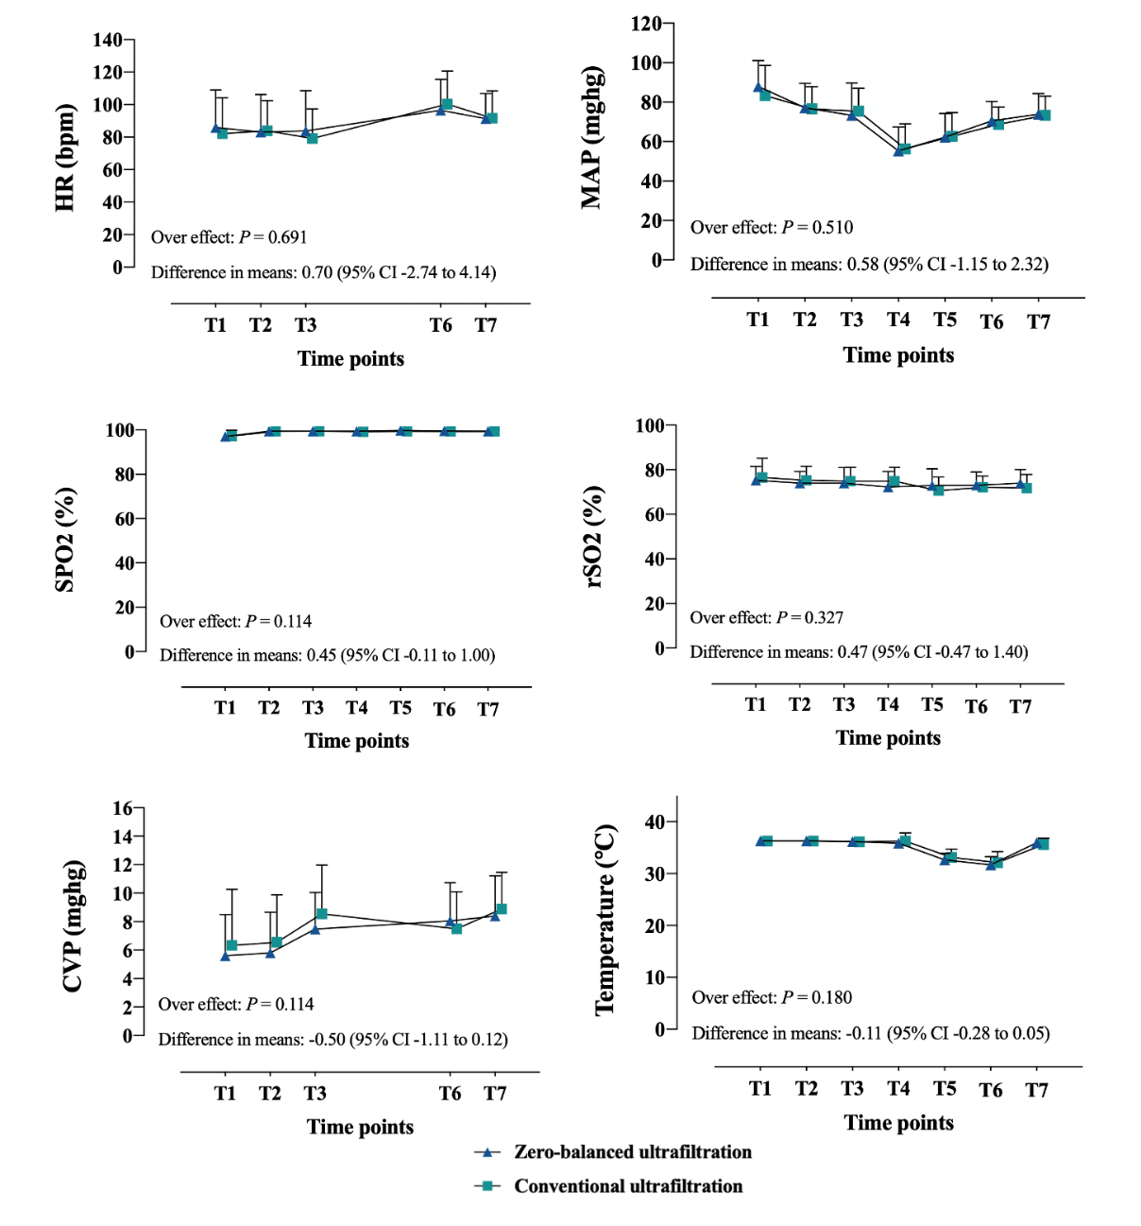

Time point: T1, entered the operating room for 5 min; T2, 1 min after tracheal intubation; T3, at skin incision; T4, CPB 10 min; T5, CPB 40 min; T6, 10 min after separation from CPB; T7, during skin closing.
Abbreviations: HR; heart rate; MAP, mean arterial pressure; SPO2, pulse oxygen saturation; rSO2, cerebral oxygen saturation; CVP, Central venous pressure; CI, confidence interval.

