Supplemental Table S1 Overview of 9 TNBC samples selected for study with IMC summarizing clinicopathologic and immunohistochemical data. BR: Deidentified slide number; GR: Glucocorticoid receptor; H-score: Weighted histological (H) score for GR-expression; Regions of interest per slide: Number of analyzed regions per slide.

Low GR Samples  (n=4) (H<100) | BR03 | BR19 | BR40 | BR42
Age | 54 | 34 | 45 | 73
Race | Black | White | White | Black
GR H-score | 100 | 20 | 65 | 100
Regions of interest per slide | 3 | 3 | 5 | 5
High GR Samples  (n=5) (H>200) | BR07 | BR12 | BR15 | BR26 | BR35
Age | 59 | 78 | 51 | 52 | 60
Race | Black | Black | Black | Black | Black
GR H-score | 280 | 290 | 290 | 240 | 290
Regions of interest per slide | 5 | 3 | 5 | 5 | 5

Supplemental Table S2 GR status, deidentified patient ID, ROI area, and number of cells counted per ROI. All ROIs were obtained from a single slide derived from the same biopsy specimen per patient and represent technical sampling units rather than independent biological replicates; ROI number and size were comparable between GR-high and GR-low groups.

GR | Patient | Region | Acquisition area mm² | Number of cells
Low | Br_03 | Br_03_001 | 0.511602 | 3199
Low | Br_03 | Br_03_002 | 0.46563 | 4137
Low | Br_03 | Br_03_003 | 0.839938 | 6676
Low | Br_19 | Br_19_001 | 0.631411 | 3787
Low | Br_19 | Br_19_002 | 0.701932 | 4946
Low | Br_19 | Br_19_003 | 0.782308 | 7589
Low | Br_40 | Br_40_004 | 0.70152 | 4344
Low | Br_40 | Br_40_005 | 0.670005 | 5059
Low | Br_40 | Br_40_006 | 0.698985 | 4333
Low | Br_40 | Br_40_007 | 0.71175 | 4974
Low | Br_40 | Br_40_008 | 0.713135 | 5075
Low | Br_42 | Br_42_001 | 0.915607 | 4842
Low | Br_42 | Br_42_002 | 0.841825 | 4354
Low | Br_42 | Br_42_003 | 0.90963 | 3578
Low | Br_42 | Br_42_004 | 0.947477 | 6688
Low | Br_42 | Br_42_005 | 0.911071 | 7700
High | Br_07 | Br_07_001 | 0.781023 | 6556
High | Br_07 | Br_07_002 | 0.756899 | 6745
High | Br_07 | Br_07_003 | 0.823064 | 7832
High | Br_07 | Br_07_004 | 0.819408 | 8370
High | Br_07 | Br_07_005 | 0.751325 | 6358
High | Br_12 | Br_12_001 | 0.752103 | 5351
High | Br_12 | Br_12_002 | 0.771228 | 7261
High | Br_12 | Br_12_003 | 0.789127 | 7499
High | Br_15 | Br_15_001 | 0.703696 | 5930
High | Br_15 | Br_15_002 | 0.714918 | 6107
High | Br_15 | Br_15_003 | 0.701486 | 6127
High | Br_15 | Br_15_004 | 0.715164 | 7468
High | Br_15 | Br_15_005 | 0.7047 | 6347
High | Br_26 | Br_26_001 | 0.782668 | 5936
High | Br_26 | Br_26_002 | 0.723884 | 7300
High | Br_26 | Br_26_003 | 0.774084 | 7009
High | Br_26 | Br_26_004 | 0.7676 | 8510
High | Br_26 | Br_26_005 | 0.686736 | 6568
High | Br_35 | Br_35_001 | 0.75184 | 9503
High | Br_35 | Br_35_002 | 0.745107 | 8559
High | Br_35 | Br_35_003 | 0.754952 | 7763
High | Br_35 | Br_35_004 | 0.751646 | 7545
High | Br_35 | Br_35_005 | 0.756711 | 7549

Abbreviations: Br: Deidentified slide number; GR: Glucocorticoid receptor.

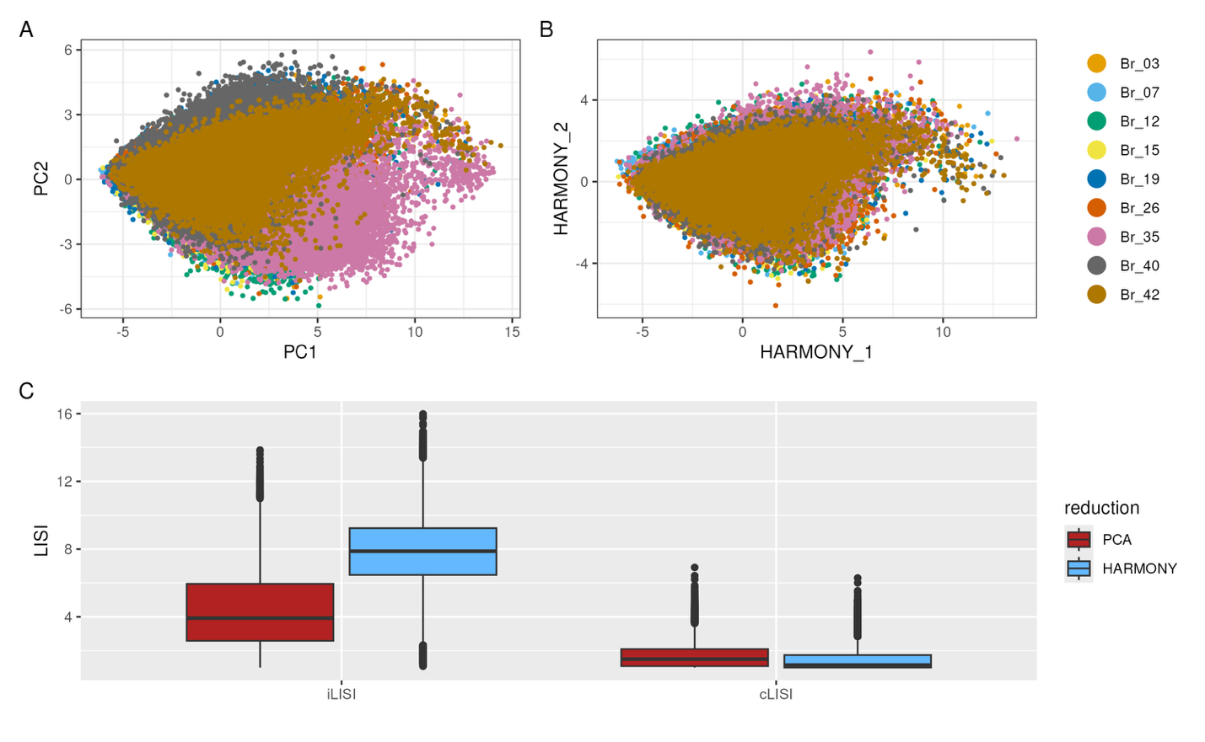
Supplemental Figure S1 Evaluation of effectiveness of batch correction. (A): PCA plot of uncorrected embeddings. (B): Harmony plot of corrected embeddings. (C): iLISI (integration inverse local Simpson’s index) and cLISI (cell type inverse local Simpson’s index) shown before (PCA) and after (HARMONY) batch correction.

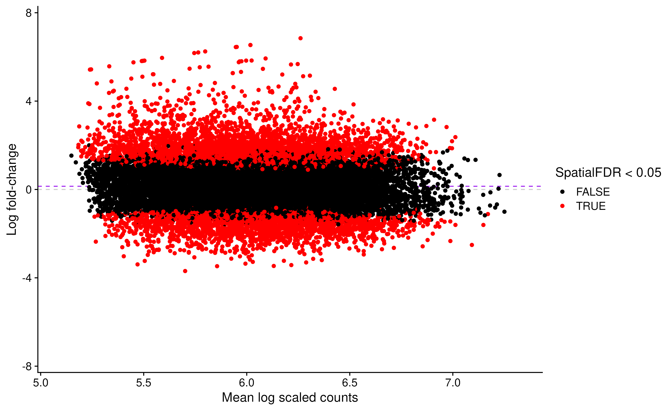
Supplemental Figure S2 MA plot of miloR neighborhoods. Horizontal, centered distribution indicates effective control of class imbalance. Gray dashed lined: expected null log fold-change. Purple dashed line: observed log fold change for non-differentially abundant (SpatialFDR > 0.05) neighborhoods. If class imbalance is effectively controlled by the model, the distribution of neighborhoods will be roughly horizontal and centered near 0 on the y-axis.

Phenotype | Key Markers | Citations
Cancer cells | AE1/AE3+, EGFR+ | 1,2
Proliferating cancer cells | AE1/AE3+, EGFR+, Ki-67+ | 3,4
HLA-ABC+ cancer cells | AE1/AE3+, HLA-ABC+ | 5,6
Early-activated dendritic/natural killer cells | CD69, CD11c+, CD56+, PD-L1+, Perforin+ | 7,8
NK cells | CD56(bright), Granzyme B+, Perforin+ | 9, 10
Exhausted/Immature NK cells | CD56(dim), CCR7(reduced), Granzyme B-, Perforin+ | 11,12
Activated CD8+ T cells | CD45RO+, CD8+, Perforin+, HLA-DR+ | 13
Activated effector memory CD4+ T cells | CD45RO+, CD4+, Granzyme B+, Perforin + | 14,15
Activated cytotoxic CD4+ T cells | CD4+, CCR7+, Granzyme B+, Perforin + | 14,15
T-regulatory cells | CD45RO+, CD4+ CD25+ | 16,17
Proliferating cells | Ki-67+ | 18
Other cells | none | none

Supplemental Table S3 Cell phenotype definitions, key markers, and references used to classify tumor and immune-cell subsets in TNBC. See supplementary citations for further biological rationale.

References:
- Moll R, Franke WW, Schiller DL, Geiger B, Krepler R. The catalog of human cytokeratins: Patterns of expression in normal epithelia, tumors and cultured cells. Cell. 1982;31(1):11–24.
- Hynes NE, Lane HA. ERBB receptors and cancer: the complexity of targeted inhibitors. Nature Reviews Cancer. 2005;5(5):341–54.
- Scholzen T, Gerdes J. The Ki-67 protein: from the known to the unknown. Journal of Cellular Physiology. 2000;182(3):311–22.
- Dowsett M, Nielsen TO, A'Hern R, Bartlett J, Coombes RC, Cuzick J. Assessment of Ki67 in breast cancer: recommendations from the International Ki67 in Breast Cancer Working Group. Journal of the National Cancer Institute. 2011;103(22):1656–64.
- Garrido F, Aptsiauri N, Doorduijn EM, Lora AM, van Hall T. The urgent need to recover MHC class I in cancers for effective immunotherapy. Nature Reviews Cancer. 2016;16(12):767–81.
- McGranahan N, Rosenthal R, Hiley CT, Rowan AJ, Watkins TBK, Wilson GA. Allele-specific HLA loss and immune escape in lung cancer evolution. Cell. 2017;171(6):1259–71.e11.
- Cibrián D, Sánchez-Madrid F. CD69: from activation marker to metabolic gatekeeper. Eur J Immunol. 2017;47(6):946–53.
- Voskoboinik I, Whisstock JC, Trapani JA. Perforin and granzymes: function, dysfunction and human pathology. Nat Rev Immunol. 2015;15(6):388–400.
- Caligiuri MA. Human natural killer cells. Blood. 2008;112(3):461–9.
- Campbell JJ, Qin S, Unutmaz D, Soler D, Murphy KE, Hodge MR, et al. Unique subpopulations of CD56+ NK and NK-T peripheral blood lymphocytes identified by chemokine receptor expression repertoire. J Immunol. 2001;166(11):6477–82.
- Bi J, Tian Z. NK Cell Exhaustion. Front Immunol. 2017;8:760.
- Shi Y, Hao D, Qian H, Tao Z. Natural killer cell-based cancer immunotherapy: from basics to clinical trials. Exp Hematol Oncol. 2024;13(1):101.
- Gonzalez SM, Taborda NA, Rugeles MT. Role of Different Subpopulations of CD8(+) T Cells during HIV Exposure and Infection. Front Immunol. 2017;8:936.
- Takeuchi A, Saito T. CD4 CTL, a Cytotoxic Subset of CD4(+) T Cells, Their Differentiation and Function. Front Immunol. 2017;8:194.
- Oja AE, Vieira Braga FA, Remmerswaal EB, Kragten NA, Hertoghs KM, Zuo J, et al. The Transcription Factor Hobit Identifies Human Cytotoxic CD4(+) T Cells. Front Immunol. 2017;8:325.
- Plitas G, Konopacki C, Wu K, Bos PD, Morrow M, Putintseva EV, et al. Regulatory T Cells Exhibit Distinct Features in Human Breast Cancer. Immunity. 2016;45(5):1122–34.
- Kotsakis A, Koinis F, Katsarou A, Gioulbasani M, Aggouraki D, Kentepozidis N, et al. Prognostic value of circulating regulatory T cell subsets in untreated non-small cell lung cancer patients. Sci Rep. 2016;6:39247.
- Gerdes J, Schwab U, Lemke H, Stein H. Production of a mouse monoclonal antibody reactive with a human nuclear antigen associated with cell proliferation. Int J Cancer. 1983;31(1):13–20.

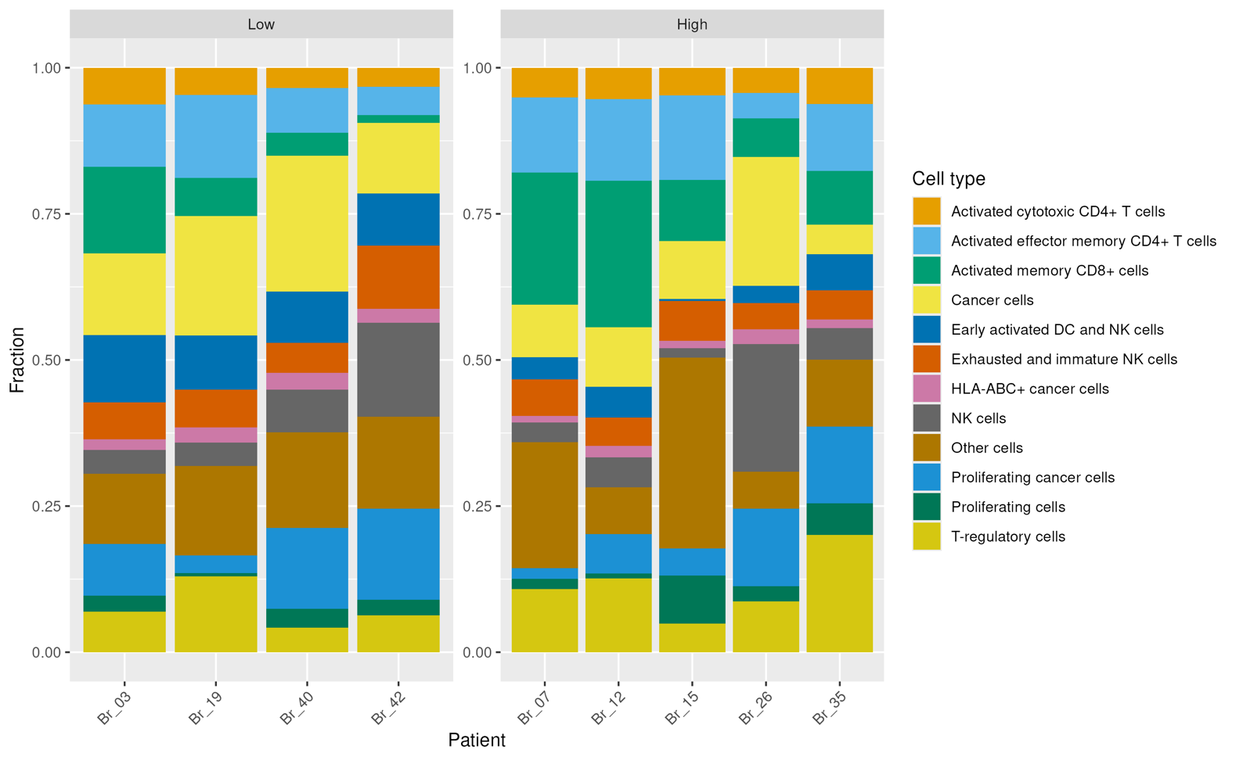
Supplemental Figure S3 Fractional composition plot showing fraction of each cell type per deidentified patient sample (Br).

