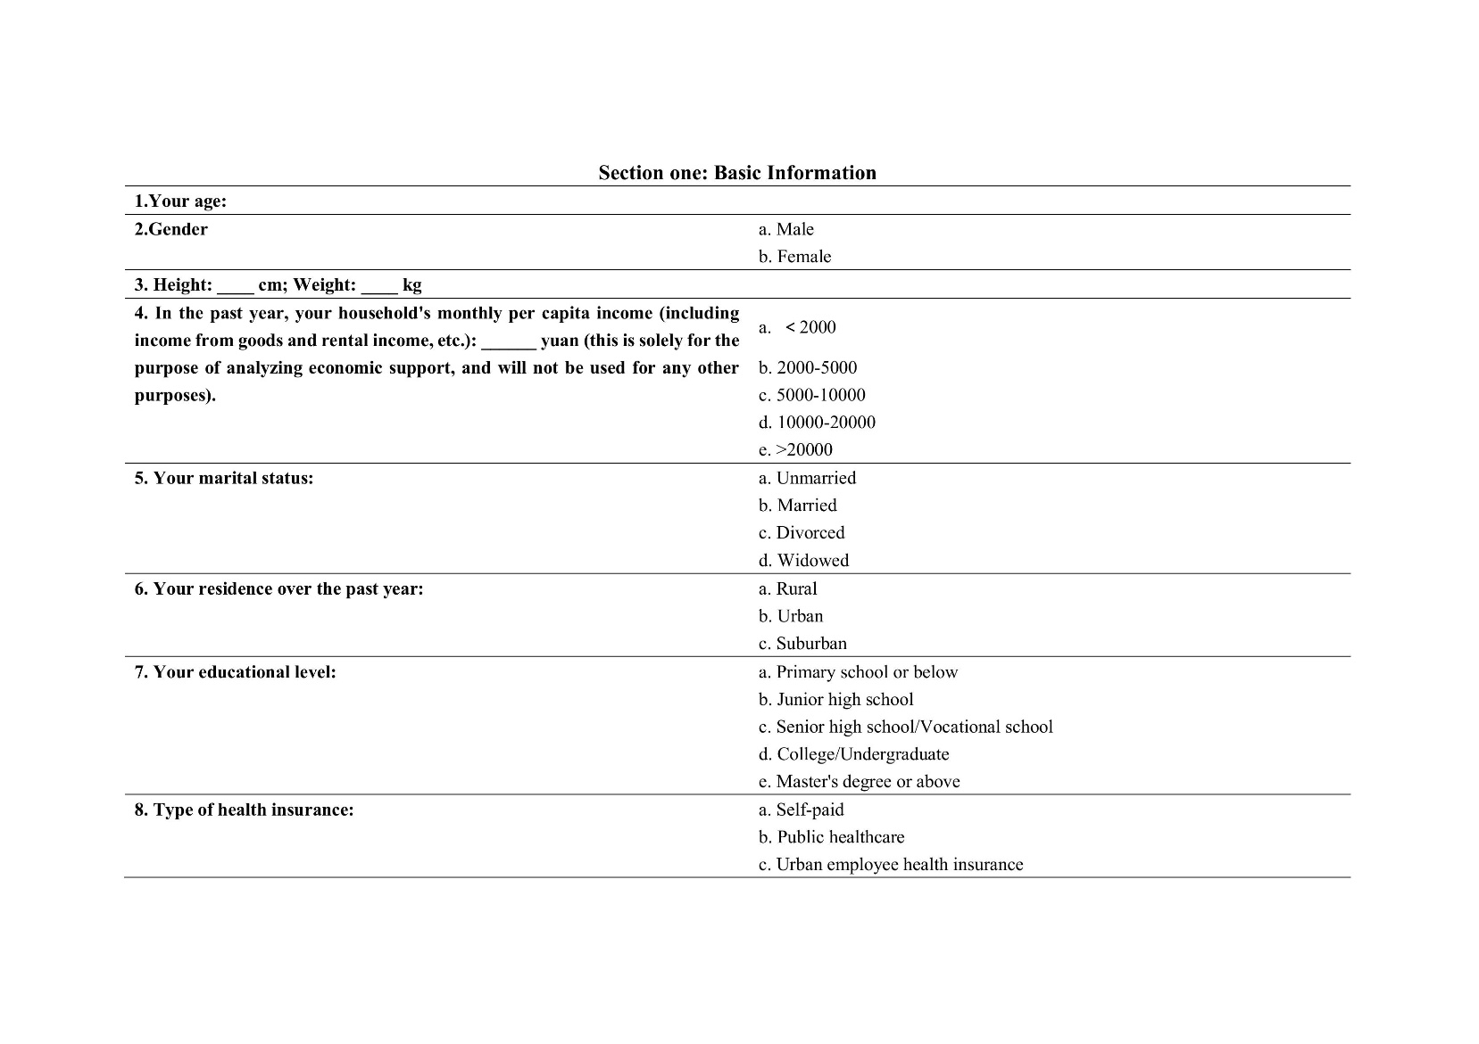
Supplementary Figure 1. Blank questionnaire (Page 1)
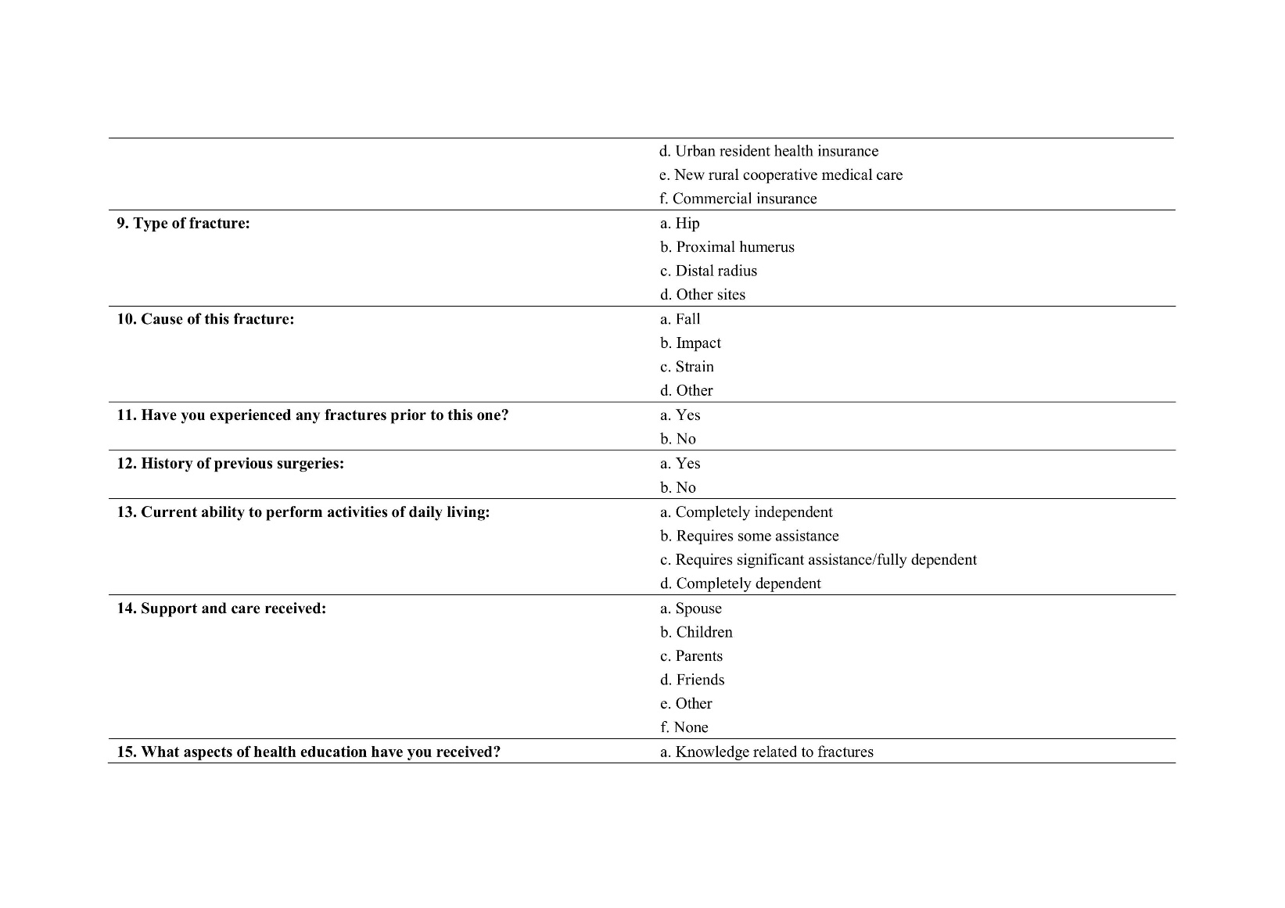
Supplementary Figure 2. Blank questionnaire (Page 2)
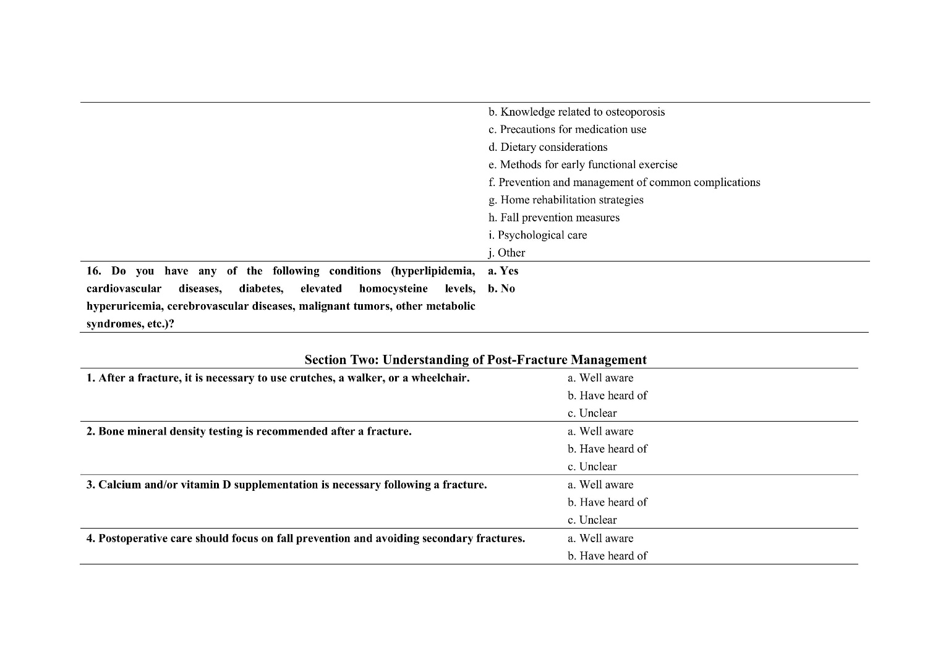
Supplementary Figure 3. Blank questionnaire (Page 3)
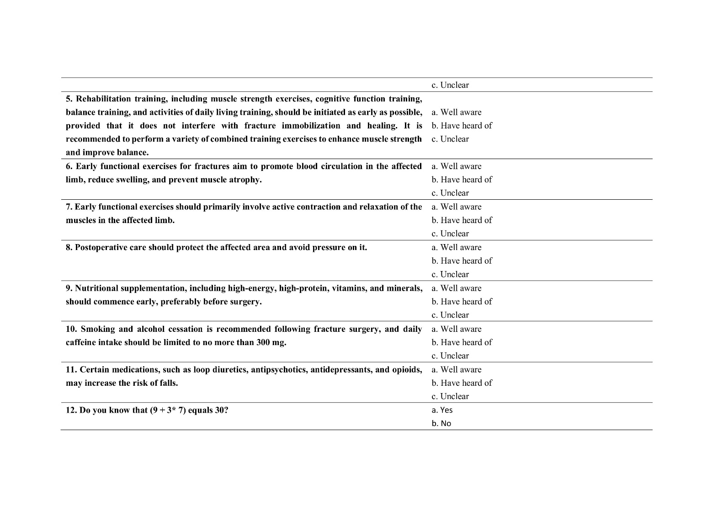
Supplementary Figure 4. Blank questionnaire (Page 4)
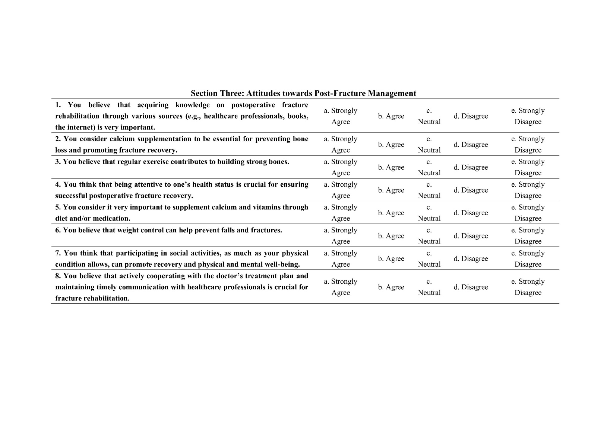
Supplementary Figure 5. Blank questionnaire (Page 5)
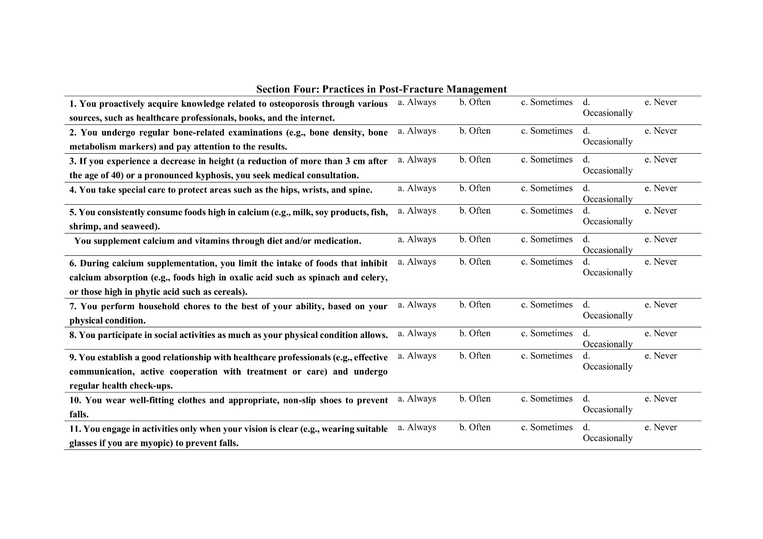
Supplementary Figure 6. Blank questionnaire (Page 6)
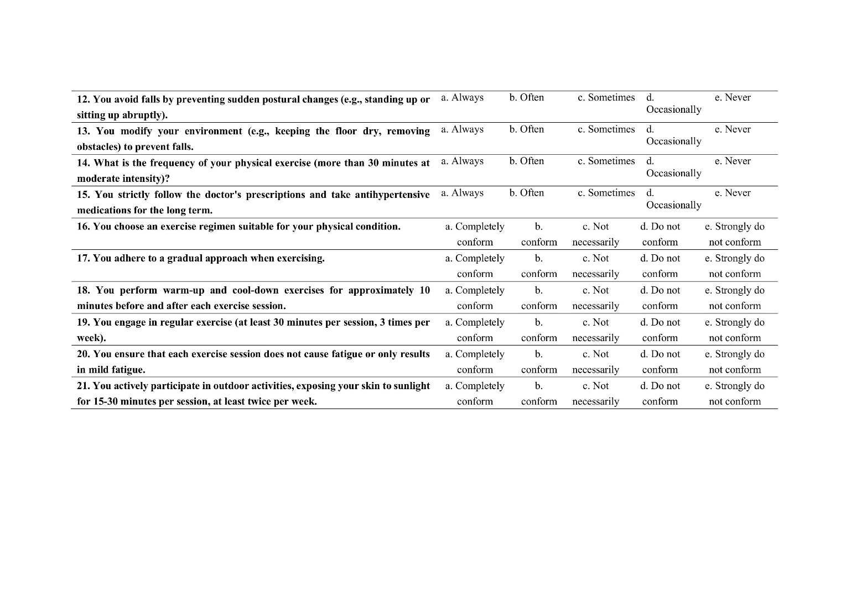
Supplementary Figure 7. Blank questionnaire (Page 7)

Supplementary Figure 8. Health Education received.

Supplement Table 1. Comparison of baseline demographic and clinical characteristics between online and offline (telephone) respondents
 | Total (n=556) | Online group (n=501) | Telephone group (n=55) | P
Age (years) | 53.56±15.49 | 53.73 (15.52) | 52.93 (15.36)
≤30 | 46 (8.27) | 42 (8.4) | 4 (7.3) | 0.958
31–40 | 78 (14.03) | 68 (13.6) | 10 (18.2)
41–50 | 94 (16.91) | 86 (17.2) | 8 (14.5)
51–60 | 142 (25.54) | 128 (25.5) | 14 (25.5)
61–70 | 110 (19.78) | 99 (19.8) | 11 (20.0)
>70 | 86 (15.47) | 78 (15.6) | 8 (14.5)
Sex
Male | 277 (49.82) | 248 (49.5) | 29 (52.7) | 0.755
Female | 279 (50.18) | 253 (50.5) | 26 (47.3)
BMI
<18.5 | 39 (7.01) | 36 (7.2) | 3 (5.5) | 0.609
18.5-23.9 | 278 (50.00) | 253 (50.5) | 25 (45.5)
>24.0 | 239 (42.99) | 212 (42.3) | 27 (49.1)
Monthly per capita income (CNY)
＜2,000 | 73 (13.13) | 63 (12.6) | 10 (18.2) | <0.001
2,000-5,000 | 183 (32.91) | 153 (30.5) | 30 (54.5)
5,000-10,000 | 223 (40.11) | 208 (41.5) | 15 (27.3)
10,000-20,000 | 63 (11.33) | 63 (12.6) | 0 (0.0)
>20,000 | 14 (2.52) | 14 (2.8) | 0 (0.0)
Marital status
Unmarried/Divorced/Widowed | 45 (8.09) | 41 (8.2) | 4 (7.3) | 0.999
Married | 511 (91.91) | 460 (91.8) | 51 (92.7)
Place of residence
Rural | 182 (32.73) | 147 (29.3) | 35 (63.6) | <0.001
Urban | 199 (35.79) | 193 (38.5) | 6 (10.9)
Suburban | 175 (31.47) | 161 (32.1) | 14 (25.5)
Educational level
Primary school or below | 286 (51.44) | 255 (50.9) | 31 (56.4) | 0.491
Junior high school | 125 (22.48) | 111 (22.2) | 14 (25.5)
Senior high school/Vocational secondary school | 70 (12.59) | 64 (12.8) | 6 (10.9)
Junior college/Bachelor’s degree or above | 75 (13.49) | 71 (14.2) | 4 (7.3)
Medical insurance type
Self-paid | 156 (28.06) | 140 (27.9) | 16 (29.1) | 0.983
Insurance reimbursement | 400 (71.94) | 361 (72.1) | 39 (70.9)
Fracture type
Hip | 112 (20.14) | 100 (20.0) | 12 (21.8) | 0.602
Proximal humerus | 54 (9.71) | 47 (9.4) | 7 (12.7)
Distal radius | 63 (11.33) | 55 (11.0) | 8 (14.5)
Other sites | 327 (58.81) | 299 (59.7) | 28 (50.9)
Cause of fracture
Fall | 380 (68.35) | 342 (68.3) | 38 (69.1) | 0.925
Impact injury | 121 (21.76) | 110 (22.0) | 11 (20.0)
Other | 55 (9.89) | 49 (9.8) | 6 (10.9)
Have you ever sustained a fracture before this fracture?
Yes | 46 (8.27) | 41 (8.2) | 5 (9.1) | 0.999
No | 510 (91.73) | 460 (91.8) | 50 (90.9)
History of surgery
Yes | 146 (26.26) | 130 (25.9) | 16 (29.1) | 0.733
No | 410 (73.74) | 371 (74.1) | 39 (70.9)
Current ability to perform activities of daily living
Completely independent | 280 (50.36) | 265 (52.9) | 15 (27.3) | <0.001
Requires partial assistance | 229 (41.19) | 192 (38.3) | 37 (67.3)
Requires extensive assistance/Completely dependent | 47 (8.45) | 44 (8.8) | 3 (5.5)
Complications
Yes | 216 (38.85) | 200 (39.9) | 16 (29.1) | 0.156
No | 340 (61.15) | 301 (60.1) | 39 (70.9)

Supplement Table 2. Univariable and multivariable regression analyses of factors associated with knowledge scores among patients with fractures
Knowledge | Univariable analysis |  | Multivariable analysis
Knowledge | β(95%CI) | P | β(95%CI) | P
Age (years)
≤30
31–40 | 1.204 (-0.093,2.500) | 0.069 | 1.244 (-0.045,2.532) | 0.059
41–50 | 1.705 (0.451,2.960) | 0.008 | 1.748 (0.501,2.995) | 0.006
51–60 | 1.321 (0.138,2.504) | 0.029 | 1.368 (0.192,2.544) | 0.023
61–70 | 2.043 (0.819,3.268) | 0.001 | 2.186 (0.965,3.408) | <0.001
>70 | 0.722 (-0.552,1.996) | 0.266 | 0.913 (-0.361,2.188) | 0.161
Sex
Male
Female | 0.215 (-0.382,0.812) | 0.480
BMI
18.5-23.9
<18.5 | -0.202 (-1.407,1.002) | 0.742
>24.0 | 0.050 (-0.572,0.671) | 0.875
Monthly per capita income (CNY)
＜2,000
2,000-5,000 | 0.465 (-0.510,1.439) | 0.349
5,000-10,000 | 0.271 (-0.679,1.220) | 0.576
10,000-20,000 | 0.066 (-1.144,1.277) | 0.914
>20,000 | -1.132 (-3.186,0.921) | 0.279
Marital status
Married
Unmarried/Divorced/Widowed | -0.801 (-1.894,0.292) | 0.151
Place of residence
Rural
Urban | -0.412 (-1.133,0.309) | 0.262
Suburban | 0.221 (-0.523,0.965) | 0.560
Educational level
Primary school or below
Junior high school | -0.279 (-1.033,0.476) | 0.468
Senior high school/Vocational secondary school | 0.324 (-0.614,1.262) | 0.498
Junior college/Bachelor’s degree or above | 0.455 (-0.458,1.367) | 0.329
Medical insurance type
Self-paid
Insurance reimbursement | -0.119 (-0.783,0.546) | 0.726
Have you ever sustained a fracture before this fracture?
No
Yes | -1.263 (-2.341,-0.184) | 0.022 | -1.357 (-2.439,-0.275) | 0.014
History of surgery
No
Yes | -0.410 (-1.087,0.268) | 0.236
Current ability to perform activities of daily living
Requires extensive assistance/Completely dependent
Completely independent | -0.063 (-1.174,1.048) | 0.911
Requires partial assistance | 0.048 (-1.080,1.176) | 0.933
Complications
No
Yes | 0.233 (-0.379,0.846) | 0.455

Supplement Table 3. Univariable and multivariable regression analyses of factors associated with attitude scores among patients with fractures
Attitude | Univariable analysis |  | Multivariable analysis
Attitude | β(95%CI) | P |  | β(95%CI) | P
Knowledge | 1.346 (1.248,1.444) | <0.001 | 1.355 (1.258,1.451) |  | <0.001
Age (years)
≤30
31–40 | -0.704 (-3.050,1.643) | 0.556
41–50 | -0.578 (-2.849,1.693) | 0.618
51–60 | -1.068 (-3.209,1.073) | 0.328
61–70 | -0.489 (-2.705,1.728) | 0.665
>70 | -1.036 (-3.341,1.270) | 0.378
Sex
Male
Female | 0.519 (-0.549,1.586) | 0.340
BMI
18.5-23.9
<18.5 | -0.428 (-2.582,1.726) | 0.696
>24.0 | -0.353 (-1.464,0.759) | 0.533
Monthly per capita income (CNY)
＜2,000
2,000-5,000 | 0.912 (-0.829,2.653) | 0.304
5,000-10,000 | 0.059 (-1.637,1.756) | 0.945
10,000-20,000 | -0.478 (-2.641,1.686) | 0.665
>20,000 | -1.406 (-5.076,2.264) | 0.452
Marital status
Married
Unmarried/Divorced/Widowed | 1.978 (0.028,3.929) | 0.047 | 3.578 (2.234,4.922) |  | <0.001
Place of residence
Rural
Urban | -1.502 (-2.783,-0.221) | 0.022 | -0.858 (-1.730,0.014) |  | 0.054
Suburban | 0.461 (-0.861,1.784) | 0.494 | 0.052 (-0.820,0.924) |  | 0.907
Educational level
Primary school or below
Junior high school | -1.346 (-2.693,0.001) | 0.050 | -0.955 (-1.824,-0.087) |  | 0.031
Senior high school/Vocational secondary school | 0.233 (-1.442,1.907) | 0.785 | -0.246 (-1.349,0.858) |  | 0.662
Junior college/Bachelor’s degree or above | 0.132 (-1.498,1.761) | 0.874 | -1.222 (-2.384,-0.059) |  | 0.040
Medical insurance type
Self-paid
Insurance reimbursement | -0.557 (-1.745,0.631) | 0.357
Have you ever sustained a fracture before this fracture?
No
Yes | -0.583 (-2.521,1.355) | 0.555
History of surgery
No
Yes | -0.699 (-1.911,0.513) | 0.258
Current ability to perform activities of daily living
Requires extensive assistance/Completely dependent
Completely independent | -0.970 (-2.946,1.007) | 0.336
Requires partial assistance | 0.361 (-1.647,2.369) | 0.724
Complications
No
Yes | -0.447 (-1.542,0.648) | 0.423

Supplement Table 4. Univariable and multivariable regression analyses of factors associated with practice scores among patients with fractures
Practice | Univariable analysis |  | Multivariable analysis
Practice | β(95%CI) | P | β(95%CI) | P
Knowledge | 3.904 (3.669,4.139) | <0.001 | 2.056 (1.747,2.365) | <0.001
Attitude | 2.165 (2.032,2.299) | <0.001 | 1.332 (1.161,1.503) | <0.001
Age (years)
≤30
31–40 | 7.596 (1.363,13.830) | 0.017 | 5.803 (2.694,8.912) | <0.001
41–50 | 9.445 (3.411,15.478) | 0.002 | 7.116 (4.082,10.151) | <0.001
51–60 | 6.307 (0.618,11.996) | 0.030 | 7.097 (4.088,10.107) | <0.001
61–70 | 7.191 (1.304,13.079) | 0.017 | 6.899 (3.543,10.255) | <0.001
>70 | 1.694 (-4.432,7.819) | 0.587 | 5.210 (1.536,8.884) | 0.006
Sex
Male
Female | 0.989 (-1.886,3.863) | 0.500
BMI
18.5-23.9
<18.5 | -3.592 (-9.384,2.201) | 0.224
>24.0 | 0.498 (-2.490,3.486) | 0.743
Monthly per capita income (CNY)
＜2,000
2,000-5,000 | 2.886 (-1.799,7.570) | 0.227 | -0.167 (-2.797,2.463) | 0.901
5,000-10,000 | 3.953 (-0.611,8.516) | 0.089 | 3.333 (0.376,6.290) | 0.028
10,000-20,000 | 5.729 (-0.091,11.548) | 0.054 | 6.531 (2.922,10.141) | <0.001
>20,000 | -0.319 (-10.193,9.555) | 0.949 | 3.386 (-1.710,8.482) | 0.193
Marital status
Married
Unmarried/Divorced/Widowed | -3.337 (-8.601,1.928) | 0.214
Place of residence
Rural
Urban | -1.367 (-4.836,2.103) | 0.439
Suburban | 1.958 (-1.624,5.539) | 0.283
Educational level
Primary school or below
Junior high school | -1.649 (-5.285,1.987) | 0.373
Senior high school/Vocational secondary school | 1.674 (-2.847,6.196) | 0.467
Junior college/Bachelor’s degree or above | -0.524 (-4.923,3.875) | 0.815
Medical insurance type
Self-paid
Insurance reimbursement | -1.342 (-4.540,1.856) | 0.410
Have you ever sustained a fracture before this fracture?
No
Yes | -2.300 (-7.516,2.915) | 0.387
History of surgery
No
Yes | -2.357 (-5.618,0.905) | 0.156
Current ability to perform activities of daily living
Requires extensive assistance/Completely dependent
Completely independent | -0.677 (-6.023,4.669) | 0.804
Requires partial assistance | 0.473 (-4.958,5.904) | 0.864
Complications
No
Yes | 0.179 (-2.771,3.129) | 0.905

Supplement Table 5. Model fitting index of CFA
Indicators | Reference | Actual
RMSEA | <0.080 | 0.056
SRMR | <0.080 | 0.058
TLI | >0.800 | 0.867
CFI | >0.800 | 0.874

Supplement Table 6. Total, direct, and indirect effects among knowledge, attitude, and practice in the structural equation model
Model paths |  | Total effects |  | Direct Effect |  | Indirect effect
 |  | β(95%CI) | P | β(95%CI) | P | β(95%CI) | P
Attitude
 | Knowledge | 0.913 (0.877, 0.949) | <0.001 | 0.913 (0.877, 0.949) | <0.001
Practice
 | Knowledge | 0.946 (0.919, 0.972) | <0.001 | 0.710 (0.495, 0.925) | <0.001 | 0.235 (0.041, 0.430) | 0.018
 | Attitude | 0.258 (0.040, 0.475) | 0.021 | 0.258 (0.040, 0.475) | 0.021

Supplement Table 7. SEM model fit
Indicators | Reference | Actual
RMSEA | <0.080 | 0.056
SRMR | <0.080 | 0.058
TLI | >0.800 | 0.867
CFI | >0.800 | 0.874

