Supplementary

Supplementary Figure 1. Interview Guide
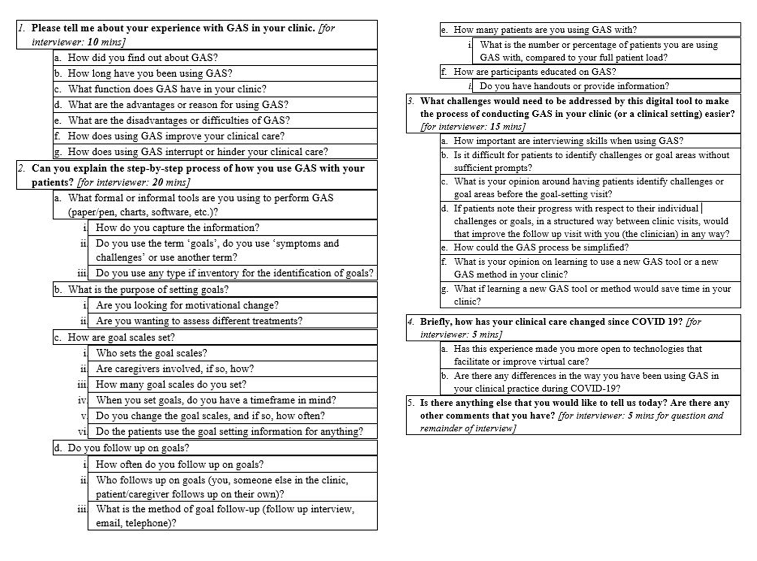

Supplementary Table 1. Coding Tree for Analysis of GAS Data
Category | Descriptor/project objectives | CODE:
- Clinician Introduction and Current Usage of GAS | How Clinician-Investigators are currently using Goal Attainment Scaling (GAS) in their clinics. | - Personal Experience Using GAS  - How Clinician is Currently Using GAS
- Process of GAS | What is the current process when using GAS with patients? | - GAS Implementation  - How Patients are Involved  - GAS Interviewers  - Training GAS Interviewers  - Menu-Based GAS
- Why the Clinician is Using GAS | What are the benefits of GAS usage? | - Patient Centered Care  - Benefits of Using GAS  - Challenges with Other Outcome Measures  - GAS Reliability
- Challenges of GAS | What are the current challenges in using GAS? | - Challenges of Using GAS  - Barriers with the Healthcare System
- Simplifying and Endorsing the GAS Process | What is needed to make the process of conducting GAS in a clinical setting easier? | - Tool Development  - Practice Affecting Changes  - Barriers with the Health Care System

