Supplementary Figure 1 The flow chart of the study.

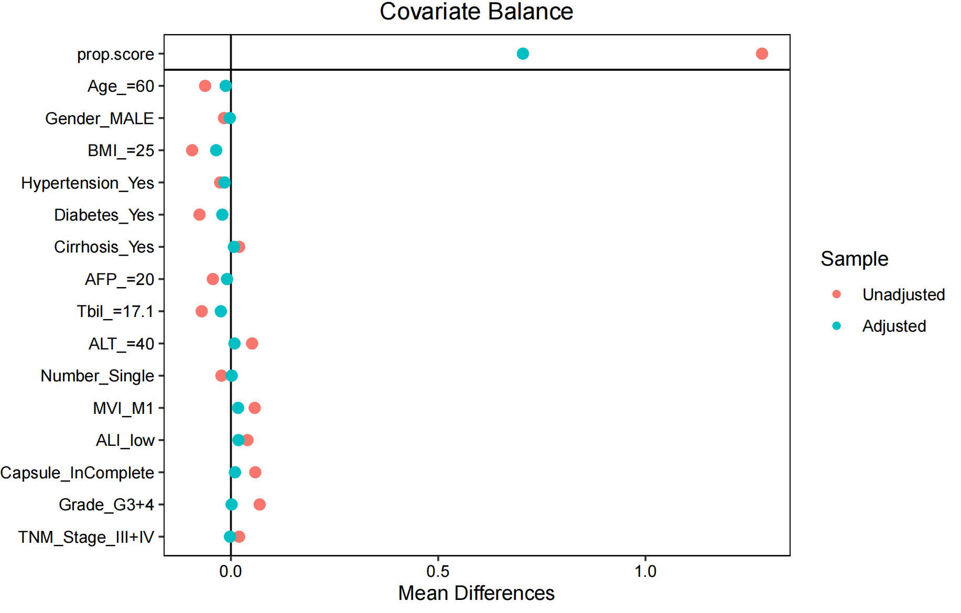

Supplementary Figure 2 Covariate balance plot before and after PSM analysis.

Supplementary Table 1 Baseline characteristics of included training and testing cohort.
Characteristics | level | Test (N=131) | Train (N=308) | p
Age (mean (SD)) (Years) | >60 | 63 (48.1%) | 141 (45.8%) | 0.734
 | ≤60 | 68 (51.9%) | 167 (54.2%)
Gender | FEMALE | 16 (12.2%) | 33 (10.7%) | 0.771
 | MALE | 115 (87.8%) | 275 (89.3%)
BMI (Kg/m2) | <25 | 102 (77.9%) | 249 (80.8%) | 0.559
 | ≥25 | 29 (22.1%) | 59 (19.2%)
Hypertension (%) | No | 106 (80.9%) | 248 (80.5%) | 1.000
 | Yes | 25 (19.1%) | 60 (19.5%)
Diabetes(%) | No | 109 (83.2%) | 258 (83.8%) | 0.997
 | Yes | 22 (16.8%) | 50 (16.2%)
HBsAg(%) | Negative | 27 (20.6%) | 50 (16.2%) | 0.334
 | Positive | 104 (79.4%) | 258 (83.8%)
Cirrhosis(%) | No | 39 (29.8%) | 93 (30.2%) | 1.000
 | Yes | 92 (70.2%) | 215 (69.8%)
Portal_hypertension(%) | No | 99 (75.6%) | 245 (79.5%) | 0.425
 | Yes | 32 (24.4%) | 63 (20.5%)
Child-Pugh score (%) | 5 | 86 (65.6%) | 215 (69.8%) | 0.456
 | 6 | 45 (34.4%) | 93 (30.2%)
AFP (ng/ml) | >20 | 67 (51.1%) | 174 (56.5%) | 0.355
 | ≤20 | 64 (48.9%) | 134 (43.5%)
ALB (g/L) | <35 | 17 (13%) | 45 (14.6%) | 0.764
 | ≥35 | 114 (87%) | 263 (85.4%)
Tbil (umol/L) | >17.1 | 46 (35.1%) | 119 (38.6%) | 0.556
 | ≤17.1 | 85 (64.9%) | 189 (61.4%)
GGT (U/L) | >60 | 63 (48.1%) | 143 (46.4%) | 0.830
 | ≤60 | 68 (51.9%) | 165 (53.6%)
ALT (U/L) | >40 | 50 (38.2%) | 136 (44.2%) | 0.291
 | ≤40 | 81 (61.8%) | 172 (55.8%)
Tumor size (cm) | <5 | 67 (51.1%) | 143 (46.4%) | 0.423
 | ≥5 | 64 (48.9%) | 165 (53.6%)
Tumor number (%) | Multiple | 29 (22.1%) | 67 (21.8%) | 1.000
 | Single | 102 (77.9%) | 241 (78.2%)
Tumor Capsule (%) | complete | 115 (87.8%) | 267 (86.7%) | 0.874
 | InComplete | 16 (12.2%) | 41 (13.3%)
Vascular invasion (%) | No | 104 (79.4%) | 234 (76%) | 0.513
 | Yes | 27 (20.6%) | 74 (24%)
MVI (%) | M0 | 90 (68.7%) | 190 (61.7%) | 0.197
 | M1 | 41 (31.3%) | 118 (38.3%)
Tumor Grade (%) | G1+2 | 96 (73.3%) | 217 (70.5%) | 0.628
 | G3+4 | 35 (26.7%) | 91 (29.5%)
Major resection (%) | No | 92 (70.2%) | 217 (70.5%) | 1.000
 | Yes | 39 (29.8%) | 91 (29.5%)
Anatomical resection (%) | No | 64 (48.9%) | 131 (42.5%) | 0.265
 | Yes | 67 (51.1%) | 177 (57.5%)
Surgical approach (%) | Lapro | 68 (51.9%) | 182 (59.1%) | 0.199
 | Open | 63 (48.1%) | 126 (40.9%)
Intraoperative_bleeding (ml) | >400 | 23 (17.6%) | 71 (23.1%) | 0.247
 | ≤400 | 108 (82.4%) | 237 (76.9%)
ALI | high | 98 (74.8%) | 210 (68.2%) | 0.202
 | low | 33 (25.2%) | 98 (31.8%)
RC2 (Mean ± SD) (mmol/L) |  | 0.8 ± 1.1 | 0.8 ± 0.5 | 0.423
TNM stage (%) | I+II | 103 (78.6%) | 230 (74.7%) | 0.445
 | III+IV | 28 (21.4%) | 78 (25.3%)
Abbreviations: ALB, albumin; ALT, alanine aminotransferase; AFP: alpha fetoprotein; BMI: body mass index; HDL-c, high-density lipoprotein cholesterol; LDL-c, low-density lipoprotein cholesterol; remnant cholesterol; TBIL, total bilirubin; TC, total cholesterol; TG, triglycerides; GGT, glutamyl transpeptidase; HBsAg: hepatitis B surface antigen; MVI: microvascular invasion; TNM: tumor node metastasis classification.

