Supplementary Table 1: Univariable Cox regression analysis of RFS.
Characteristics | B | SE | HR | 95%CI | Z | P value
Age, years | -0.013 | 0.006 | 0.988 | 0.975-1.000 | -1.982 | 0.047
Sex, Male | 0.002 | 0.192 | 1.002 | 0.688-1.459 | 0.009 | 0.993
BMI, kg/m² | -0.008 | 0.021 | 0.992 | 0.953-1.033 | -0.401 | 0.689
Hypertension, Yes | 0.143 | 0.150 | 1.154 | 0.860-1.547 | 0.955 | 0.340
Diabetes, Yes | -0.022 | 0.189 | 0.979 | 0.675-1.418 | -0.115 | 0.909
TBIL, μmol/L | -0.001 | 0.004 | 0.999 | 0.992-1.006 | -0.241 | 0.810
DBIL, μmol/L | -0.001 | 0.004 | 0.999 | 0.990-1.008 | -0.273 | 0.785
IBIL, μmol/L | -0.001 | 0.014 | 0.999 | 0.973-1.026 | -0.068 | 0.946
TBA, μmol/L | 0.001 | 0.004 | 1.001 | 0.993-1.010 | 0.282 | 0.778
TP, g/L | -0.004 | 0.011 | 0.996 | 0.974-1.019 | -0.327 | 0.744
ALB, g/L | -0.028 | 0.017 | 0.973 | 0.940-1.006 | -1.603 | 0.109
GLB, g/L | 0.012 | 0.014 | 1.012 | 0.985-1.039 | 0.876 | 0.381
PA, mg/L | -0.003 | 0.001 | 0.997 | 0.995-0.999 | -2.974 | 0.003
ALT, U/L | 0.001 | 0.001 | 1.001 | 0.999-1.004 | 1.152 | 0.249
AST, U/L | 0.003 | 0.001 | 1.003 | 1.000-1.006 | 2.298 | 0.022
ASTm, U/L | 0.040 | 0.011 | 1.041 | 1.018-1.064 | 3.609 | <0.001
GGT, U/L | 0.001 | 0.000 | 1.001 | 1.000-1.001 | 2.058 | 0.040
ALP, U/L | 0.001 | 0.000 | 1.001 | 1.000-1.002 | 1.922 | 0.055
LDH, U/L | 0.006 | 0.001 | 1.006 | 1.004-1.008 | 5.663 | <0.001
SCR, μmol/L | 0.002 | 0.004 | 1.002 | 0.993-1.010 | 0.434 | 0.664
WBC, 10⁹/L | 0.062 | 0.035 | 1.064 | 0.993-1.140 | 1.758 | 0.079
NEUT, 10⁹/L | 0.141 | 0.044 | 1.151 | 1.057-1.254 | 3.230 | 0.001
LYM, 10⁹/L | -0.279 | 0.113 | 0.756 | 0.606-0.943 | -2.480 | 0.013
MONO, 10⁹/L | 0.373 | 0.312 | 1.452 | 0.788-2.675 | 1.195 | 0.232
EOS, 10⁹/L | 0.069 | 0.345 | 1.072 | 0.545-2.109 | 0.201 | 0.841
BASO, 10⁹/L | -3.449 | 4.456 | 0.032 | 0.000-197.273 | -0.774 | 0.439
RBC, 10¹²/L | 0.051 | 0.120 | 1.052 | 0.831-1.333 | 0.424 | 0.671
PLT, 10⁹/L | 0.001 | 0.001 | 1.001 | 0.999-1.003 | 0.905 | 0.365
INR | 1.040 | 0.713 | 2.830 | 0.700-11.441 | 1.459 | 0.144
PT, s | 0.098 | 0.056 | 1.103 | 0.988-1.232 | 1.740 | 0.082
AFP, μg/L | 0.000 | 0.000 | 1.000 | 1.000-1.001 | 2.274 | 0.023
CEA, μg/L | 0.003 | 0.007 | 1.003 | 0.989-1.016 | 0.399 | 0.690
CA199, U/mL | 0.001 | 0.000 | 1.001 | 1.000-1.002 | 2.659 | 0.008
HBsAg, Positive | 0.182 | 0.171 | 1.200 | 0.859-1.676 | 1.069 | 0.285
HBsAb, Positive | -0.227 | 0.207 | 0.797 | 0.531-1.195 | -1.098 | 0.272
HBeAg, Positive | 0.051 | 0.148 | 1.053 | 0.788-1.406 | 0.347 | 0.728
HBeAb, Positive | -0.175 | 0.132 | 0.839 | 0.648-1.087 | -1.327 | 0.185
HBcAb, Positive | 0.372 | 0.413 | 1.451 | 0.646-3.263 | 0.901 | 0.368
HBV DNA load, >1×10³IU/mL | -0.022 | 0.130 | 0.978 | 0.758-1.262 | -0.168 | 0.867
HCV, Positive | -0.010 | 0.452 | 0.990 | 0.408-2.402 | -0.022 | 0.982
Ascites, Positive | 0.424 | 0.215 | 1.529 | 1.003-2.331 | 1.972 | 0.049
Macrovascular invasion, Positive | 1.002 | 0.149 | 2.724 | 2.034-3.649 | 6.720 | <0.001
Large bile duct invasion, Positive | 0.536 | 0.286 | 1.709 | 0.975-2.996 | 1.871 | 0.061
Pringle maneuver, Yes | 0.417 | 0.173 | 1.517 | 1.082-2.128 | 2.416 | 0.016
Transfusion, Yes | 0.292 | 0.179 | 1.339 | 0.943-1.901 | 1.632 | 0.103
Surgery, Non-anatomic | -0.248 | 0.145 | 0.780 | 0.587-1.036 | -1.714 | 0.086
Surgical margin, ≤0.1cm | 0.271 | 0.127 | 1.311 | 1.023-1.681 | 2.143 | 0.032
Tumor diameter, cm | 0.105 | 0.015 | 1.110 | 1.078-1.144 | 6.871 | <0.001
Tumor number, Multiple | 0.797 | 0.134 | 2.219 | 1.707-2.883 | 5.957 | <0.001
Lymph node metastasis, Positive | 0.765 | 0.205 | 2.148 | 1.438-3.210 | 3.731 | <0.001
Distant metastasis, Positive | 1.223 | 0.457 | 3.398 | 1.388-8.317 | 2.678 | 0.007
Tumor differentiation, Poor | 0.263 | 0.131 | 1.301 | 1.006-1.682 | 2.005 | 0.045
MVI, Positive | 0.704 | 0.129 | 2.021 | 1.568-2.605 | 5.435 | <0.001
PNI, Positive | 0.710 | 0.164 | 2.033 | 1.474-2.804 | 4.327 | <0.001
Capsule, Positive | -0.144 | 0.156 | 0.865 | 0.638-1.174 | -0.928 | 0.353
TLS, Positive | -0.386 | 0.136 | 0.680 | 0.521-0.888 | -2.828 | 0.005
Mature TLS, Positive | -0.481 | 0.169 | 0.618 | 0.444-0.862 | -2.840 | 0.005
TLS grading system, TLS 1 | -0.280 | 0.143 | 0.756 | 0.572-0.999 | -1.966 | 0.049
TLS grading system, TLS 2a | -0.406 | 0.268 | 0.666 | 0.394-1.127 | -1.515 | 0.130
TLS grading system, TLS 2b | -0.814 | 0.231 | 0.443 | 0.282-0.696 | -3.529 | <0.001
Cirrhosis, Positive | 0.153 | 0.126 | 1.165 | 0.911-1.491 | 1.219 | 0.223
TNM, III-IV | 0.624 | 0.145 | 1.867 | 1.404-2.482 | 4.295 | <0.001
PA-TACE, Yes | -0.253 | 0.136 | 0.776 | 0.595-1.014 | -1.860 | 0.063
RFS: recurrence-free survival; BMI: body mass index; TBIL: total bilirubin; DBIL: direct bilirubin; IBIL: indirect bilirubin; TBA: total biliary acid; TP: total protein; ALB: albumin; GLB: globulin; PA: prealbumin; ALT: alanine amino transferase; AST: aspartate amino transferase; ASTm: aspartate transaminase mitochondrial; GGT: γ-glutamyl transpeptidase; ALP: alkaline phosphatase; LDH: lactate dehydrogenase; SCR: serum creatinine; WBC: white blood cell; NEUT: neutrophil; LYM: lymphocyte; MONO: monocyte; EOS: eosinophil; BASO: basophil; RBC: red blood cell; PLT: platelet; INR: international normalized ratio; PT: prothrombin time; AFP: alpha fetoprotein; CEA: carcinoembryonic antigen; CA199: carbohydrate antigen 19-9; HBsAg: hepatitis B surface antigen; HBsAb: hepatitis B surface antibody; HBeAg: hepatitis B e antigen; HBeAb: hepatitis B e antibody; HBcAb: hepatitis B core antibody; HBV DNA: hepatitis B virus deoxyribonucleic acid; HCV: hepatitis C virus; MVI: microvascular invasion; PNI: perineural invasion; TLS: tertiary lymphoid structure; TNM: tumor-node-metastasis; PA-TACE: postoperative adjuvant transarterial chemoembolization; SE: standard error; HR: hazard ratio; CI: confidence interval.

Supplementary Table 2: Univariable Cox regression analysis of OS.
Characteristics | B | SE | HR | 95%CI | Z | P value
Age, years | 0.006 | 0.007 | 1.006 | 0.992-1.019 | 0.832 | 0.405
Sex, Male | 0.075 | 0.213 | 1.078 | 0.710-1.636 | 0.351 | 0.725
BMI, kg/m² | -0.009 | 0.021 | 0.991 | 0.951-1.033 | -0.426 | 0.670
Hypertension, Yes | 0.195 | 0.154 | 1.216 | 0.899-1.644 | 1.271 | 0.204
Diabetes, Yes | 0.076 | 0.197 | 1.079 | 0.734-1.588 | 0.387 | 0.699
TBIL, μmol/L | 0.003 | 0.003 | 1.003 | 0.997-1.008 | 0.831 | 0.406
DBIL, μmol/L | 0.003 | 0.004 | 1.003 | 0.996-1.010 | 0.851 | 0.395
IBIL, μmol/L | 0.008 | 0.014 | 1.008 | 0.980-1.037 | 0.542 | 0.588
TBA, μmol/L | 0.000 | 0.005 | 1.000 | 0.991-1.009 | -0.028 | 0.978
TP, g/L | 0.009 | 0.013 | 1.009 | 0.984-1.034 | 0.715 | 0.475
ALB, g/L | -0.031 | 0.019 | 0.969 | 0.934-1.006 | -1.664 | 0.096
GLB, g/L | 0.031 | 0.014 | 1.032 | 1.003-1.061 | 2.196 | 0.028
PA, mg/L | -0.003 | 0.001 | 0.997 | 0.994-0.999 | -3.159 | 0.002
ALT, U/L | 0.000 | 0.001 | 1.000 | 0.997-1.002 | -0.305 | 0.760
AST, U/L | 0.000 | 0.002 | 1.000 | 0.997-1.003 | -0.075 | 0.940
ASTm, U/L | 0.007 | 0.012 | 1.007 | 0.985-1.031 | 0.633 | 0.527
GGT, U/L | 0.000 | 0.000 | 1.000 | 1.000-1.001 | 1.323 | 0.186
ALP, U/L | 0.001 | 0.001 | 1.001 | 1.000-1.002 | 2.208 | 0.027
LDH, U/L | 0.005 | 0.001 | 1.005 | 1.003-1.007 | 4.091 | <0.001
SCR, μmol/L | -0.001 | 0.005 | 0.999 | 0.990-1.008 | -0.300 | 0.764
WBC, 10⁹/L | 0.068 | 0.040 | 1.071 | 0.990-1.158 | 1.718 | 0.086
NEUT, 10⁹/L | 0.147 | 0.049 | 1.159 | 1.054-1.275 | 3.036 | 0.002
LYM, 10⁹/L | -0.287 | 0.128 | 0.751 | 0.584-0.965 | -2.236 | 0.025
MONO, 10⁹/L | 0.474 | 0.349 | 1.607 | 0.811-3.185 | 1.359 | 0.174
EOS, 10⁹/L | -0.020 | 0.262 | 0.980 | 0.586-1.638 | -0.078 | 0.938
BASO, 10⁹/L | -4.914 | 4.612 | 0.007 | 0.000-61.866 | -1.065 | 0.287
RBC, 10¹²/L | -0.056 | 0.130 | 0.946 | 0.733-1.221 | -0.427 | 0.669
PLT, 10⁹/L | 0.001 | 0.001 | 1.001 | 0.999-1.003 | 0.665 | 0.506
INR | 0.812 | 0.788 | 2.252 | 0.480-10.558 | 1.030 | 0.303
PT, s | 0.046 | 0.064 | 1.048 | 0.925-1.187 | 0.731 | 0.465
AFP, μg/L | 0.000 | 0.000 | 1.000 | 1.000-1.001 | 1.413 | 0.158
CEA, μg/L | 0.009 | 0.006 | 1.010 | 0.997-1.022 | 1.483 | 0.138
CA199, U/mL | 0.001 | 0.000 | 1.001 | 1.001-1.002 | 3.360 | 0.001
HBsAg, Positive | 0.051 | 0.181 | 1.052 | 0.738-1.499 | 0.280 | 0.779
HBsAb, Positive | -0.113 | 0.221 | 0.893 | 0.580-1.377 | -0.510 | 0.610
HBeAg, Positive | 0.013 | 0.162 | 1.013 | 0.738-1.390 | 0.080 | 0.936
HBeAb, Positive | -0.055 | 0.145 | 0.946 | 0.712-1.258 | -0.382 | 0.703
HBcAb, Positive | 0.163 | 0.453 | 1.177 | 0.485-2.859 | 0.360 | 0.718
HBV DNA load, >1×10³IU/mL | 0.097 | 0.140 | 1.102 | 0.837-1.451 | 0.692 | 0.489
HCV, Positive | -0.080 | 0.505 | 0.923 | 0.343-2.484 | -0.158 | 0.874
Ascites, Positive | 0.396 | 0.241 | 1.485 | 0.926-2.382 | 1.643 | 0.100
Macrovascular invasion, Positive | 1.109 | 0.154 | 3.030 | 2.240-4.099 | 7.189 | <0.001
Large bile duct invasion, Positive | 0.118 | 0.324 | 1.125 | 0.596-2.124 | 0.363 | 0.717
Pringle maneuver, Yes | 0.493 | 0.194 | 1.637 | 1.118-2.396 | 2.534 | 0.011
Transfusion, Yes | 0.542 | 0.179 | 1.719 | 1.210-2.442 | 3.024 | 0.002
Surgery, Non-anatomic | -0.151 | 0.158 | 0.860 | 0.630-1.173 | -0.953 | 0.340
Surgical margin, ≤0.1cm | 0.442 | 0.140 | 1.556 | 1.184-2.045 | 3.169 | 0.002
Tumor diameter, cm | 0.119 | 0.017 | 1.127 | 1.089-1.165 | 6.957 | <0.001
Tumor number, Multiple | 0.675 | 0.142 | 1.965 | 1.488-2.595 | 4.759 | <0.001
Lymph node metastasis, Positive | 1.089 | 0.210 | 2.970 | 1.967-4.484 | 5.179 | <0.001
Distant metastasis, Positive | 1.705 | 0.516 | 5.504 | 2.002-15.132 | 3.305 | 0.001
Tumor differentiation, Poor | 0.285 | 0.143 | 1.330 | 1.004-1.762 | 1.987 | 0.047
MVI, Positive | 0.877 | 0.144 | 2.404 | 1.813-3.189 | 6.089 | <0.001
PNI, Positive | 0.815 | 0.172 | 2.258 | 1.612-3.163 | 4.739 | <0.001
Capsule, Positive | 0.149 | 0.176 | 1.161 | 0.823-1.637 | 0.850 | 0.395
TLS, Positive | -0.503 | 0.145 | 0.605 | 0.455-0.804 | -3.466 | 0.001
Mature TLS, Positive | -0.520 | 0.187 | 0.594 | 0.412-0.858 | -2.775 | 0.006
TLS grading system, TLS 1 | -0.400 | 0.152 | 0.670 | 0.497-0.903 | -2.628 | 0.009
TLS grading system, TLS 2a | -0.485 | 0.284 | 0.616 | 0.353-1.076 | -1.704 | 0.088
TLS grading system, TLS 2b | -0.967 | 0.259 | 0.380 | 0.229-0.632 | -3.734 | <0.001
Cirrhosis, Positive | 0.308 | 0.137 | 1.361 | 1.041-1.779 | 2.252 | 0.024
TNM, III-IV | 0.703 | 0.153 | 2.020 | 1.498-2.725 | 4.606 | <0.001
PA-TACE, Yes | -0.086 | 0.149 | 0.917 | 0.685-1.229 | -0.578 | 0.563
OS: overall survival; BMI: body mass index; TBIL: total bilirubin; DBIL: direct bilirubin; IBIL: indirect bilirubin; TBA: total biliary acid; TP: total protein; ALB: albumin; GLB: globulin; PA: prealbumin; ALT: alanine amino transferase; AST: aspartate amino transferase; ASTm: aspartate transaminase mitochondrial; GGT: γ-glutamyl transpeptidase; ALP: alkaline phosphatase; LDH: lactate dehydrogenase; SCR: serum creatinine; WBC: white blood cell; NEUT: neutrophil; LYM: lymphocyte; MONO: monocyte; EOS: eosinophil; BASO: basophil; RBC: red blood cell; PLT: platelet; INR: international normalized ratio; PT: prothrombin time; AFP: alpha fetoprotein; CEA: carcinoembryonic antigen; CA199: carbohydrate antigen 19-9; HBsAg: hepatitis B surface antigen; HBsAb: hepatitis B surface antibody; HBeAg: hepatitis B e antigen; HBeAb: hepatitis B e antibody; HBcAb: hepatitis B core antibody; HBV DNA: hepatitis B virus deoxyribonucleic acid; HCV: hepatitis C virus; MVI: microvascular invasion; PNI: perineural invasion; TLS: tertiary lymphoid structure; TNM: tumor-node-metastasis; PA-TACE: postoperative adjuvant transarterial chemoembolization; SE: standard error; HR: hazard ratio; CI: confidence interval.

Supplementary Table 3: Univariable Cox regression analysis of early RFS.
Characteristics | B | SE | HR | 95%CI | Z | P value
Age, years | -0.017 | 0.007 | 0.984 | 0.970-0.998 | -2.273 | 0.023
Sex, Male | -0.199 | 0.205 | 0.820 | 0.549-1.224 | -0.971 | 0.332
BMI, kg/m² | -0.033 | 0.024 | 0.967 | 0.922-1.014 | -1.378 | 0.168
Hypertension, Yes | 0.106 | 0.172 | 1.112 | 0.794-1.557 | 0.620 | 0.535
Diabetes, Yes | -0.197 | 0.236 | 0.821 | 0.517-1.304 | -0.835 | 0.404
TBIL, μmol/L | -0.001 | 0.004 | 0.999 | 0.991-1.008 | -0.136 | 0.892
DBIL, μmol/L | 0.000 | 0.005 | 1.000 | 0.990-1.009 | -0.096 | 0.923
IBIL, μmol/L | -0.004 | 0.016 | 0.996 | 0.965-1.028 | -0.231 | 0.817
TBA, μmol/L | -0.004 | 0.006 | 0.996 | 0.985-1.008 | -0.666 | 0.505
TP, g/L | -0.001 | 0.013 | 0.999 | 0.973-1.025 | -0.094 | 0.925
ALB, g/L | -0.013 | 0.020 | 0.987 | 0.949-1.027 | -0.639 | 0.523
GLB, g/L | 0.006 | 0.016 | 1.006 | 0.976-1.037 | 0.383 | 0.702
PA, mg/L | -0.003 | 0.001 | 0.997 | 0.995-0.999 | -2.601 | 0.009
ALT, U/L | 0.000 | 0.002 | 1.000 | 0.997-1.003 | -0.039 | 0.969
AST, U/L | 0.002 | 0.002 | 1.002 | 0.999-1.006 | 1.283 | 0.199
ASTm, U/L | 0.037 | 0.013 | 1.038 | 1.012-1.064 | 2.902 | 0.004
GGT, U/L | 0.000 | 0.000 | 1.000 | 1.000-1.001 | 0.939 | 0.348
ALP, U/L | 0.001 | 0.001 | 1.001 | 1.000-1.002 | 1.433 | 0.152
LDH, U/L | 0.006 | 0.001 | 1.006 | 1.004-1.008 | 6.179 | <0.001
SCR, μmol/L | 0.000 | 0.005 | 1.000 | 0.990-1.009 | -0.084 | 0.933
WBC, 10⁹/L | 0.087 | 0.040 | 1.091 | 1.008-1.181 | 2.159 | 0.031
NEUT, 10⁹/L | 0.184 | 0.049 | 1.202 | 1.092-1.322 | 3.773 | <0.001
LYM, 10⁹/L | -0.357 | 0.134 | 0.700 | 0.538-0.910 | -2.665 | 0.008
MONO, 10⁹/L | 0.463 | 0.347 | 1.589 | 0.804-3.138 | 1.333 | 0.183
EOS, 10⁹/L | 0.088 | 0.348 | 1.092 | 0.552-2.160 | 0.253 | 0.800
BASO, 10⁹/L | 0.185 | 4.873 | 1.203 | 0.000-16919.836 | 0.038 | 0.970
RBC, 10¹²/L | 0.107 | 0.138 | 1.113 | 0.849-1.458 | 0.775 | 0.438
PLT, 10⁹/L | 0.002 | 0.001 | 1.002 | 0.999-1.004 | 1.472 | 0.141
INR | 0.913 | 0.828 | 2.493 | 0.492-12.624 | 1.104 | 0.270
PT, s | 0.071 | 0.065 | 1.074 | 0.945-1.220 | 1.089 | 0.276
AFP, μg/L | 0.000 | 0.000 | 1.000 | 1.000-1.001 | 2.938 | 0.003
CEA, μg/L | 0.009 | 0.007 | 1.009 | 0.995-1.023 | 1.221 | 0.222
CA199, U/mL | 0.001 | 0.000 | 1.001 | 1.000-1.002 | 3.188 | 0.001
HBsAg, Positive | 0.111 | 0.194 | 1.118 | 0.765-1.634 | 0.574 | 0.566
HBsAb, Positive | -0.226 | 0.242 | 0.798 | 0.497-1.281 | -0.935 | 0.350
HBeAg, Positive | -0.046 | 0.175 | 0.955 | 0.678-1.345 | -0.264 | 0.792
HBeAb, Positive | -0.116 | 0.152 | 0.891 | 0.661-1.200 | -0.763 | 0.446
HBcAb, Positive | 0.407 | 0.505 | 1.502 | 0.558-4.044 | 0.805 | 0.421
HBV DNA load, >1×10³IU/mL | -0.116 | 0.151 | 0.890 | 0.663-1.196 | -0.773 | 0.439
HCV, Positive | -0.606 | 0.711 | 0.545 | 0.135-2.197 | -0.853 | 0.394
Ascites, Positive | 0.459 | 0.237 | 1.583 | 0.995-2.518 | 1.940 | 0.052
Macrovascular invasion, Positive | 1.073 | 0.160 | 2.924 | 2.139-3.998 | 6.722 | <0.001
Large bile duct invasion, Positive | 0.342 | 0.325 | 1.408 | 0.745-2.663 | 1.054 | 0.292
Pringle maneuver, Yes | 0.647 | 0.223 | 1.910 | 1.235-2.955 | 2.909 | 0.004
Transfusion, Yes | 0.146 | 0.208 | 1.157 | 0.770-1.738 | 0.703 | 0.482
Surgery, Non-anatomic | -0.267 | 0.163 | 0.766 | 0.557-1.053 | -1.643 | 0.100
Surgical margin, ≤0.1cm | 0.306 | 0.146 | 1.358 | 1.019-1.810 | 2.090 | 0.037
Tumor diameter, cm | 0.115 | 0.016 | 1.122 | 1.087-1.159 | 7.087 | <0.001
Tumor number, Multiple | 0.818 | 0.148 | 2.266 | 1.695-3.029 | 5.523 | <0.001
Lymph node metastasis, Positive | 0.967 | 0.213 | 2.629 | 1.733-3.989 | 4.546 | <0.001
Distant metastasis, Positive | 1.223 | 0.457 | 3.398 | 1.388-8.317 | 2.678 | 0.007
Tumor differentiation, Poor | 0.392 | 0.155 | 1.480 | 1.091-2.006 | 2.524 | 0.012
MVI, Positive | 0.847 | 0.154 | 2.334 | 1.724-3.158 | 5.490 | <0.001
PNI, Positive | 0.585 | 0.179 | 1.795 | 1.265-2.546 | 3.275 | 0.001
Capsule, Positive | -0.144 | 0.176 | 0.866 | 0.613-1.223 | -0.816 | 0.415
TLS, Positive | -0.538 | 0.152 | 0.584 | 0.434-0.787 | -3.538 | <0.001
Mature TLS, Positive | -0.680 | 0.215 | 0.507 | 0.333-0.772 | -3.168 | 0.002
TLS grading system, TLS 1 | -0.405 | 0.158 | 0.667 | 0.489-0.909 | -2.561 | 0.010
TLS grading system, TLS 2a | -0.790 | 0.339 | 0.454 | 0.233-0.882 | -2.329 | 0.020
TLS grading system, TLS 2b | -1.034 | 0.286 | 0.356 | 0.203-0.623 | -3.613 | <0.001
Cirrhosis, Positive | 0.134 | 0.145 | 1.144 | 0.861-1.519 | 0.927 | 0.354
TNM, III-IV | 0.697 | 0.159 | 2.008 | 1.470-2.741 | 4.387 | <0.001
PA-TACE, Yes | -0.345 | 0.160 | 0.709 | 0.518-0.969 | -2.155 | 0.031
RFS: recurrence-free survival; BMI: body mass index; TBIL: total bilirubin; DBIL: direct bilirubin; IBIL: indirect bilirubin; TBA: total biliary acid; TP: total protein; ALB: albumin; GLB: globulin; PA: prealbumin; ALT: alanine amino transferase; AST: aspartate amino transferase; ASTm: aspartate transaminase mitochondrial; GGT: γ-glutamyl transpeptidase; ALP: alkaline phosphatase; LDH: lactate dehydrogenase; SCR: serum creatinine; WBC: white blood cell; NEUT: neutrophil; LYM: lymphocyte; MONO: monocyte; EOS: eosinophil; BASO: basophil; RBC: red blood cell; PLT: platelet; INR: international normalized ratio; PT: prothrombin time; AFP: alpha fetoprotein; CEA: carcinoembryonic antigen; CA199: carbohydrate antigen 19-9; HBsAg: hepatitis B surface antigen; HBsAb: hepatitis B surface antibody; HBeAg: hepatitis B e antigen; HBeAb: hepatitis B e antibody; HBcAb: hepatitis B core antibody; HBV DNA: hepatitis B virus deoxyribonucleic acid; HCV: hepatitis C virus; MVI: microvascular invasion; PNI: perineural invasion; TLS: tertiary lymphoid structure; TNM: tumor-node-metastasis; PA-TACE: postoperative adjuvant transarterial chemoembolization; SE: standard error; HR: hazard ratio; CI: confidence interval.

Supplementary Table 4: Univariable Cox regression analysis of late RFS.
Characteristics | B | SE | HR | 95%CI | Z | P value
Age, years | 0.000 | 0.013 | 1.000 | 0.975-1.026 | 0.006 | 0.996
Sex, Male | 0.993 | 0.592 | 2.699 | 0.845-8.618 | 1.676 | 0.094
BMI, kg/m² | 0.060 | 0.037 | 1.062 | 0.987-1.142 | 1.605 | 0.109
Hypertension, Yes | 0.262 | 0.304 | 1.300 | 0.716-2.359 | 0.861 | 0.389
Diabetes, Yes | 0.375 | 0.322 | 1.455 | 0.774-2.735 | 1.164 | 0.244
TBIL, μmol/L | -0.002 | 0.007 | 0.998 | 0.984-1.013 | -0.233 | 0.816
DBIL, μmol/L | -0.004 | 0.010 | 0.996 | 0.977-1.017 | -0.350 | 0.726
IBIL, μmol/L | 0.006 | 0.025 | 1.006 | 0.958-1.057 | 0.257 | 0.797
TBA, μmol/L | 0.010 | 0.006 | 1.010 | 0.998-1.022 | 1.568 | 0.117
TP, g/L | -0.012 | 0.023 | 0.988 | 0.944-1.035 | -0.498 | 0.618
ALB, g/L | -0.069 | 0.034 | 0.933 | 0.874-0.997 | -2.052 | 0.040
GLB, g/L | 0.031 | 0.028 | 1.031 | 0.977-1.089 | 1.118 | 0.264
PA, mg/L | -0.003 | 0.002 | 0.997 | 0.993-1.001 | -1.447 | 0.148
ALT, U/L | 0.004 | 0.002 | 1.004 | 1.000-1.007 | 2.253 | 0.024
AST, U/L | 0.007 | 0.003 | 1.007 | 1.001-1.013 | 2.387 | 0.017
ASTm, U/L | 0.053 | 0.025 | 1.055 | 1.005-1.107 | 2.177 | 0.029
GGT, U/L | 0.002 | 0.001 | 1.002 | 1.001-1.003 | 3.417 | 0.001
ALP, U/L | 0.001 | 0.001 | 1.001 | 0.999-1.003 | 1.397 | 0.162
LDH, U/L | -0.001 | 0.004 | 0.999 | 0.990-1.007 | -0.317 | 0.751
SCR, μmol/L | 0.011 | 0.009 | 1.011 | 0.992-1.030 | 1.122 | 0.262
WBC, 10⁹/L | -0.013 | 0.071 | 0.987 | 0.859-1.135 | -0.179 | 0.858
NEUT, 10⁹/L | -0.003 | 0.095 | 0.997 | 0.828-1.201 | -0.031 | 0.975
LYM, 10⁹/L | -0.087 | 0.207 | 0.917 | 0.611-1.377 | -0.419 | 0.675
MONO, 10⁹/L | 0.052 | 0.676 | 1.053 | 0.280-3.963 | 0.077 | 0.939
EOS, 10⁹/L | -0.191 | 1.324 | 0.826 | 0.062-11.062 | -0.144 | 0.885
BASO, 10⁹/L | -17.139 | 10.084 | 0.000 | 0.000-13.813 | -1.700 | 0.089
RBC, 10¹²/L | -0.127 | 0.245 | 0.881 | 0.545-1.425 | -0.517 | 0.605
PLT, 10⁹/L | -0.002 | 0.002 | 0.998 | 0.994-1.002 | -0.803 | 0.422
INR | 1.414 | 1.407 | 4.110 | 0.261-64.855 | 1.004 | 0.315
PT, s | 0.184 | 0.113 | 1.202 | 0.962-1.500 | 1.620 | 0.105
AFP, μg/L | 0.000 | 0.000 | 1.000 | 0.999-1.000 | -0.641 | 0.522
CEA, μg/L | -0.026 | 0.031 | 0.975 | 0.917-1.036 | -0.826 | 0.409
CA199, U/mL | 0.000 | 0.001 | 1.000 | 0.997-1.002 | -0.334 | 0.739
HBsAg, Positive | 0.404 | 0.360 | 1.497 | 0.739-3.033 | 1.121 | 0.262
HBsAb, Positive | -0.231 | 0.401 | 0.793 | 0.361-1.742 | -0.577 | 0.564
HBeAg, Positive | 0.324 | 0.280 | 1.383 | 0.800-2.392 | 1.160 | 0.246
HBeAb, Positive | -0.364 | 0.266 | 0.695 | 0.413-1.170 | -1.368 | 0.171
HBcAb, Positive | 0.299 | 0.719 | 1.349 | 0.329-5.522 | 0.416 | 0.677
HBV DNA load, >1×10³IU/mL | 0.268 | 0.260 | 1.307 | 0.785-2.175 | 1.029 | 0.303
HCV, Positive | 0.788 | 0.597 | 2.199 | 0.682-7.089 | 1.320 | 0.187
Ascites, Positive | 0.270 | 0.518 | 1.310 | 0.474-3.616 | 0.520 | 0.603
Macrovascular invasion, Positive | 0.509 | 0.469 | 1.664 | 0.664-4.168 | 1.087 | 0.277
Large bile duct invasion, Positive | 1.727 | 0.619 | 5.624 | 1.672-18.917 | 2.791 | 0.005
Pringle maneuver, Yes | -0.042 | 0.284 | 0.959 | 0.550-1.672 | -0.148 | 0.883
Transfusion, Yes | 0.817 | 0.353 | 2.265 | 1.133-4.525 | 2.314 | 0.021
Surgery, Non-anatomic | -0.177 | 0.321 | 0.837 | 0.446-1.571 | -0.553 | 0.581
Surgical margin, ≤0.1cm | 0.167 | 0.252 | 1.182 | 0.721-1.936 | 0.664 | 0.507
Tumor diameter, cm | 0.042 | 0.044 | 1.043 | 0.956-1.137 | 0.938 | 0.348
Tumor number, Multiple | 0.703 | 0.317 | 2.019 | 1.085-3.757 | 2.217 | 0.027
Lymph node metastasis, Positive | -0.948 | 1.008 | 0.388 | 0.054-2.797 | -0.940 | 0.347
Distant metastasis, Positive | NA | NA | NA | NA | NA | NA
Tumor differentiation, Poor | -0.092 | 0.251 | 0.912 | 0.557-1.493 | -0.367 | 0.714
MVI, Positive | 0.309 | 0.257 | 1.362 | 0.823-2.253 | 1.203 | 0.229
PNI, Positive | 1.526 | 0.390 | 4.601 | 2.141-9.887 | 3.911 | <0.001
Capsule, Positive | -0.147 | 0.333 | 0.863 | 0.450-1.656 | -0.443 | 0.658
TLS, Positive | 0.207 | 0.332 | 1.230 | 0.642-2.358 | 0.624 | 0.533
Mature TLS, Positive | -0.063 | 0.284 | 0.939 | 0.538-1.639 | -0.222 | 0.824
TLS grading system, TLS 1 | 0.252 | 0.346 | 1.287 | 0.653-2.535 | 0.729 | 0.466
TLS grading system, TLS 2a | 0.684 | 0.485 | 1.981 | 0.766-5.126 | 1.409 | 0.159
TLS grading system, TLS 2b | -0.140 | 0.437 | 0.869 | 0.369-2.047 | -0.321 | 0.748
Cirrhosis, Positive | 0.210 | 0.252 | 1.234 | 0.753-2.022 | 0.835 | 0.404
TNM, III-IV | 0.265 | 0.380 | 1.303 | 0.619-2.744 | 0.698 | 0.485
PA-TACE, Yes | 0.007 | 0.262 | 1.007 | 0.603-1.683 | 0.028 | 0.978
RFS: recurrence-free survival; BMI: body mass index; TBIL: total bilirubin; DBIL: direct bilirubin; IBIL: indirect bilirubin; TBA: total biliary acid; TP: total protein; ALB: albumin; GLB: globulin; PA: prealbumin; ALT: alanine amino transferase; AST: aspartate amino transferase; ASTm: aspartate transaminase mitochondrial; GGT: γ-glutamyl transpeptidase; ALP: alkaline phosphatase; LDH: lactate dehydrogenase; SCR: serum creatinine; WBC: white blood cell; NEUT: neutrophil; LYM: lymphocyte; MONO: monocyte; EOS: eosinophil; BASO: basophil; RBC: red blood cell; PLT: platelet; INR: international normalized ratio; PT: prothrombin time; AFP: alpha fetoprotein; CEA: carcinoembryonic antigen; CA199: carbohydrate antigen 19-9; HBsAg: hepatitis B surface antigen; HBsAb: hepatitis B surface antibody; HBeAg: hepatitis B e antigen; HBeAb: hepatitis B e antibody; HBcAb: hepatitis B core antibody; HBV DNA: hepatitis B virus deoxyribonucleic acid; HCV: hepatitis C virus; MVI: microvascular invasion; PNI: perineural invasion; TLS: tertiary lymphoid structure; TNM: tumor-node-metastasis; PA-TACE: postoperative adjuvant transarterial chemoembolization; SE: standard error; HR: hazard ratio; CI: confidence interval; NA: not applicable.

Supplementary Table 5: Univariable logistic analysis of the predictive factors of TLS.
Characteristics | B | SE | OR (95%CI) | Z | P value
Age, years | 0.002 | 0.012 | 1.002 (0.978-1.026) | 0.144 | 0.886
Sex, Male | -0.369 | 0.402 | 0.691 (0.298-1.468) | -0.917 | 0.359
BMI, kg/m² | 0.022 | 0.040 | 1.023 (0.946-1.107) | 0.561 | 0.575
Hypertension, Yes | -0.075 | 0.293 | 0.928 (0.527-1.670) | -0.255 | 0.798
Diabetes, Yes | -0.897 | 0.353 | 0.408 (0.204-0.819) | -2.546 | 0.011
TBIL, μmol/L | -0.005 | 0.006 | 0.995 (0.983-1.008) | -0.771 | 0.441
DBIL, μmol/L | -0.005 | 0.007 | 0.995 (0.979-1.010) | -0.750 | 0.453
IBIL, μmol/L | -0.018 | 0.026 | 0.983 (0.934-1.036) | -0.679 | 0.497
TBA, μmol/L | 0.008 | 0.010 | 1.008 (0.990-1.031) | 0.797 | 0.425
TP, g/L | 0.041 | 0.023 | 1.042 (0.996-1.091) | 1.759 | 0.079
ALB, g/L | 0.074 | 0.034 | 1.077 (1.009-1.152) | 2.214 | 0.027
GLB, g/L | 0.008 | 0.027 | 1.008 (0.957-1.064) | 0.295 | 0.768
PA, mg/L | 0.005 | 0.002 | 1.005 (1.001-1.009) | 2.479 | 0.013
ALT, U/L | 0.001 | 0.003 | 1.001 (0.996-1.007) | 0.248 | 0.804
AST, U/L | -0.002 | 0.003 | 0.998 (0.991-1.005) | -0.666 | 0.506
ASTm, U/L | -0.022 | 0.023 | 0.978 (0.934-1.026) | -0.942 | 0.346
GGT, U/L | -0.001 | 0.001 | 0.999 (0.997-1.000) | -1.778 | 0.075
ALP, U/L | -0.002 | 0.002 | 0.998 (0.994-1.001) | -1.118 | 0.263
LDH, U/L | -0.006 | 0.002 | 0.994 (0.990-0.998) | -2.612 | 0.009
SCR, μmol/L | -0.004 | 0.008 | 0.996 (0.980-1.013) | -0.455 | 0.649
WBC, 10⁹/L | -0.051 | 0.069 | 0.951 (0.830-1.090) | -0.733 | 0.463
NEUT, 10⁹/L | -0.167 | 0.087 | 0.846 (0.711-1.003) | -1.923 | 0.054
LYM, 10⁹/L | 0.670 | 0.250 | 1.954 (1.212-3.233) | 2.685 | 0.007
MONO, 10⁹/L | -0.751 | 0.654 | 0.472 (0.129-1.734) | -1.148 | 0.251
EOS, 10⁹/L | 0.456 | 0.716 | 1.578 (0.574-11.14) | 0.637 | 0.524
BASO, 10⁹/L | -8.307 | 7.532 | 0.000 (0.000-880.100) | -1.103 | 0.270
RBC, 10¹²/L | 0.497 | 0.241 | 1.644 (1.031-2.658) | 2.063 | 0.039
PLT, 10⁹/L | 0.000 | 0.002 | 1.000 (0.997-1.004) | 0.044 | 0.965
INR | -4.064 | 1.494 | 0.017 (0.001-0.311) | -2.720 | 0.007
PT, s | -0.355 | 0.118 | 0.701 (0.554-0.882) | -3.007 | 0.003
AFP, μg/L | 0.000 | 0.000 | 1.000 (0.999-1.000) | -1.176 | 0.240
CEA, μg/L | -0.010 | 0.013 | 0.990 (0.965-1.018) | -0.761 | 0.446
CA199, U/mL | -0.002 | 0.001 | 0.998 (0.997-1.000) | -2.225 | 0.026
HBsAg, Positive | 0.155 | 0.325 | 1.168 (0.606-2.181) | 0.477 | 0.633
HBsAb, Positive | -0.359 | 0.386 | 0.698 (0.332-1.527) | -0.932 | 0.352
HBeAg, Positive | -0.040 | 0.297 | 0.961 (0.542-1.745) | -0.135 | 0.893
HBeAb, Positive | 0.067 | 0.266 | 1.069 (0.630-1.793) | 0.251 | 0.802
HBcAb, Positive | 0.378 | 0.741 | 1.459 (0.294-6.075) | 0.510 | 0.610
HBV DNA load, >1×10³IU/mL | 0.477 | 0.269 | 1.612 (0.959-2.755) | 1.777 | 0.076
HCV, Positive | -0.481 | 0.922 | 0.618 (0.101-4.752) | -0.522 | 0.602
Ascites, Positive | -0.799 | 0.415 | 0.450 (0.199-1.029) | -1.926 | 0.054
Macrovascular invasion, Positive | -0.382 | 0.288 | 0.683 (0.390-1.212) | -1.324 | 0.186
Large bile duct invasion, Positive | 0.040 | 0.605 | 1.041 (0.338-3.875) | 0.066 | 0.947
Pringle maneuver, Yes | -0.653 | 0.377 | 0.520 (0.237-1.050) | -1.735 | 0.083
Transfusion, Yes | -0.520 | 0.332 | 0.595 (0.312-1.155) | -1.566 | 0.117
Surgery, Non-anatomic | -0.125 | 0.298 | 0.882 (0.483-1.564) | -0.420 | 0.675
Surgical margin, ≤0.1cm | -0.223 | 0.253 | 0.801 (0.485-1.310) | -0.880 | 0.379
Tumor diameter, cm | -0.143 | 0.034 | 0.866 (0.809-0.925) | -4.216 | <0.001
Tumor number, Multiple | -0.552 | 0.259 | 0.576 (0.346-0.960) | -2.128 | 0.033
Lymph node metastasis, Positive | -0.708 | 0.381 | 0.493 (0.234-1.054) | -1.860 | 0.063
Distant metastasis, Positive | 0.515 | 1.125 | 1.674 (0.244-32.990) | 0.458 | 0.647
Tumor differentiation, Poor | -0.031 | 0.259 | 0.969 (0.580-1.605) | -0.120 | 0.904
MVI, Positive | -0.416 | 0.255 | 0.660 (0.397-1.084) | -1.629 | 0.103
PNI, Positive | 0.741 | 0.392 | 2.099 (1.015-4.790) | 1.893 | 0.058
Capsule, Positive | 0.106 | 0.310 | 1.112 (0.596-2.019) | 0.343 | 0.732
Cirrhosis, Positive | 0.106 | 0.251 | 1.112 (0.681-1.823) | 0.421 | 0.673
TNM, III-IV | -0.593 | 0.280 | 0.553 (0.320-0.963) | -2.114 | 0.035
PA-TACE, Yes | -0.169 | 0.270 | 0.844 (0.499-1.445) | -0.626 | 0.531
TLS: tertiary lymphoid structure; BMI: body mass index; TBIL: total bilirubin; DBIL: direct bilirubin; IBIL: indirect bilirubin; TBA: total biliary acid; TP: total protein; ALB: albumin; GLB: globulin; PA: prealbumin; ALT: alanine amino transferase; AST: aspartate amino transferase; ASTm: aspartate transaminase mitochondrial; GGT: γ-glutamyl transpeptidase; ALP: alkaline phosphatase; LDH: lactate dehydrogenase; SCR: serum creatinine; WBC: white blood cell; NEUT: neutrophil; LYM: lymphocyte; MONO: monocyte; EOS: eosinophil; BASO: basophil; RBC: red blood cell; PLT: platelet; INR: international normalized ratio; PT: prothrombin time; AFP: alpha fetoprotein; CEA: carcinoembryonic antigen; CA199: carbohydrate antigen 19-9; HBsAg: hepatitis B surface antigen; HBsAb: hepatitis B surface antibody; HBeAg: hepatitis B e antigen; HBeAb: hepatitis B e antibody; HBcAb: hepatitis B core antibody; HBV DNA: hepatitis B virus deoxyribonucleic acid; HCV: hepatitis C virus; MVI: microvascular invasion; PNI: perineural invasion; TNM: tumor-node-metastasis; PA-TACE: postoperative adjuvant transarterial chemoembolization; SE: standard error; OR: odds ratio; CI: confidence interval.

Supplementary Table 6: Univariable logistic analysis of the predictive factors of mTLS.
Characteristics | B | SE | OR (95%CI) | Z | P value
Age, years | 0.006 | 0.014 | 1.006 (0.979-1.035) | 0.451 | 0.652
Sex, Male | -0.602 | 0.390 | 0.548 (0.261-1.218) | -1.544 | 0.123
BMI, kg/m² | 0.024 | 0.045 | 1.025 (0.936-1.120) | 0.535 | 0.593
Hypertension, Yes | 0.366 | 0.325 | 1.442 (0.748-2.696) | 1.126 | 0.260
Diabetes, Yes | -0.255 | 0.470 | 0.775 (0.280-1.829) | -0.542 | 0.588
TBIL, μmol/L | -0.021 | 0.020 | 0.980 (0.933-1.005) | -1.008 | 0.313
DBIL, μmol/L | -0.041 | 0.044 | 0.960 (0.861-1.005) | -0.930 | 0.352
IBIL, μmol/L | -0.030 | 0.036 | 0.970 (0.898-1.034) | -0.833 | 0.405
TBA, μmol/L | -0.004 | 0.012 | 0.996 (0.970-1.016) | -0.375 | 0.707
TP, g/L | 0.010 | 0.026 | 1.010 (0.959-1.063) | 0.375 | 0.708
ALB, g/L | 0.059 | 0.040 | 1.061 (0.982-1.151) | 1.462 | 0.144
GLB, g/L | -0.023 | 0.032 | 0.977 (0.916-1.038) | -0.730 | 0.465
PA, mg/L | 0.002 | 0.002 | 1.002 (0.997-1.006) | 0.778 | 0.437
ALT, U/L | 0.000 | 0.003 | 1.000 (0.993-1.005) | -0.004 | 0.997
AST, U/L | -0.002 | 0.005 | 0.998 (0.985-1.005) | -0.437 | 0.662
ASTm, U/L | -0.023 | 0.034 | 0.977 (0.906-1.035) | -0.685 | 0.493
GGT, U/L | -0.002 | 0.001 | 0.998 (0.995-1.001) | -1.174 | 0.240
ALP, U/L | -0.002 | 0.003 | 0.998 (0.991-1.002) | -0.704 | 0.481
LDH, U/L | -0.006 | 0.004 | 0.994 (0.986-1.000) | -1.676 | 0.094
SCR, μmol/L | 0.001 | 0.010 | 1.001 (0.981-1.020) | 0.075 | 0.940
WBC, 10⁹/L | -0.164 | 0.088 | 0.849 (0.710-1.003) | -1.868 | 0.062
NEUT, 10⁹/L | -0.337 | 0.123 | 0.714 (0.555-0.900) | -2.735 | 0.006
LYM, 10⁹/L | 0.150 | 0.264 | 1.162 (0.687-1.941) | 0.569 | 0.569
MONO, 10⁹/L | -2.316 | 0.992 | 0.099 (0.013-0.620) | -2.334 | 0.020
EOS, 10⁹/L | 1.106 | 0.741 | 3.023 (1.045-18.980) | 1.493 | 0.135
BASO, 10⁹/L | 1.227 | 8.973 | 3.410 (0.000-69471.000) | 0.137 | 0.891
RBC, 10¹²/L | 0.148 | 0.271 | 1.159 (0.680-1.976) | 0.544 | 0.586
PLT, 10⁹/L | -0.005 | 0.002 | 0.995 (0.990-0.999) | -2.203 | 0.028
INR | -1.226 | 1.786 | 0.293 (0.008-8.816) | -0.687 | 0.492
PT, s | -0.151 | 0.144 | 0.860 (0.641-1.131) | -1.044 | 0.296
AFP, μg/L | -0.001 | 0.000 | 0.999 (0.999-1.000) | -1.731 | 0.084
CEA, μg/L | -0.143 | 0.080 | 0.867 (0.727-0.977) | -1.794 | 0.073
CA199, U/mL | -0.004 | 0.002 | 0.996 (0.991-1.000) | -1.587 | 0.112
HBsAg, Positive | 0.166 | 0.398 | 1.181 (0.562-2.725) | 0.417 | 0.676
HBsAb, Positive | -0.305 | 0.509 | 0.737 (0.242-1.850) | -0.599 | 0.549
HBeAg, Positive | 0.080 | 0.342 | 1.083 (0.539-2.074) | 0.234 | 0.815
HBeAb, Positive | -0.015 | 0.310 | 0.985 (0.542-1.838) | -0.049 | 0.961
HBcAb, Positive | 0.509 | 1.079 | 1.664 (0.288-31.410) | 0.472 | 0.637
HBV DNA load, >1×10³IU/mL | 0.157 | 0.293 | 1.170 (0.654-2.075) | 0.534 | 0.593
HCV, Positive | 0.063 | 1.128 | 1.065 (0.054-7.363) | 0.056 | 0.956
Ascites, Positive | -0.633 | 0.632 | 0.531 (0.123-1.596) | -1.002 | 0.316
Macrovascular invasion, Positive | -1.106 | 0.454 | 0.331 (0.123-0.751) | -2.434 | 0.015
Large bile duct invasion, Positive | 0.156 | 0.668 | 1.169 (0.258-3.891) | 0.234 | 0.815
Pringle maneuver, Yes | -0.799 | 0.344 | 0.450 (0.232-0.899) | -2.323 | 0.020
Transfusion, Yes | -0.312 | 0.439 | 0.732 (0.286-1.639) | -0.712 | 0.477
Surgery, Non-anatomic | -0.236 | 0.329 | 0.790 (0.420-1.539) | -0.717 | 0.473
Surgical margin, ≤0.1cm | -0.483 | 0.291 | 0.617 (0.347-1.089) | -1.661 | 0.097
Tumor diameter, cm | -0.314 | 0.075 | 0.730 (0.623-0.835) | -4.213 | <0.001
Tumor number, Multiple | -0.442 | 0.327 | 0.643 (0.329-1.197) | -1.352 | 0.176
Lymph node metastasis, Positive | -1.353 | 0.745 | 0.258 (0.041-0.891) | -1.815 | 0.069
Distant metastasis, Positive | -14.138 | 650.874 | 0.000 (NA-1.610) | -0.022 | 0.983
Tumor differentiation, Poor | -0.464 | 0.293 | 0.629 (0.354-1.122) | -1.584 | 0.113
MVI, Positive | -0.654 | 0.293 | 0.520 (0.291-0.920) | -2.231 | 0.026
PNI, Positive | 0.358 | 0.368 | 1.431 (0.672-2.88) | 0.973 | 0.330
Capsule, Positive | 0.082 | 0.370 | 1.085 (0.542-2.336) | 0.222 | 0.824
Cirrhosis, Positive | 0.082 | 0.290 | 1.085 (0.613-1.917) | 0.283 | 0.777
TNM, III-IV | -1.410 | 0.488 | 0.244 (0.082-0.582) | -2.886 | 0.004
PA-TACE, Yes | -0.032 | 0.319 | 0.968 (0.507-1.784) | -0.101 | 0.919
mTLS: mature tertiary lymphoid structure; BMI: body mass index; TBIL: total bilirubin; DBIL: direct bilirubin; IBIL: indirect bilirubin; TBA: total biliary acid; TP: total protein; ALB: albumin; GLB: globulin; PA: prealbumin; ALT: alanine amino transferase; AST: aspartate amino transferase; ASTm: aspartate transaminase mitochondrial; GGT: γ-glutamyl transpeptidase; ALP: alkaline phosphatase; LDH: lactate dehydrogenase; SCR: serum creatinine; WBC: white blood cell; NEUT: neutrophil; LYM: lymphocyte; MONO: monocyte; EOS: eosinophil; BASO: basophil; RBC: red blood cell; PLT: platelet; INR: international normalized ratio; PT: prothrombin time; AFP: alpha fetoprotein; CEA: carcinoembryonic antigen; CA199: carbohydrate antigen 19-9; HBsAg: hepatitis B surface antigen; HBsAb: hepatitis B surface antibody; HBeAg: hepatitis B e antigen; HBeAb: hepatitis B e antibody; HBcAb: hepatitis B core antibody; HBV DNA: hepatitis B virus deoxyribonucleic acid; HCV: hepatitis C virus; MVI: microvascular invasion; PNI: perineural invasion; TNM: tumor-node-metastasis; PA-TACE: postoperative adjuvant transarterial chemoembolization; SE: standard error; OR: odds ratio; CI: confidence interval; NA: not applicable.

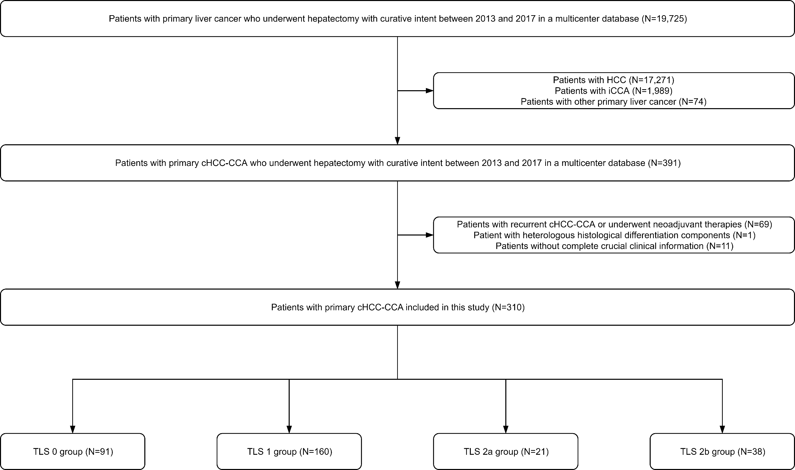
Supplementary Figure 1: Selection of the study cohort. HCC: hepatocellular carcinoma; iCCA: intrahepatic cholangiocarcinoma; cHCC-CCA: combined hepatocellular-cholangiocarcinoma; TLS: tertiary lymphoid structure.
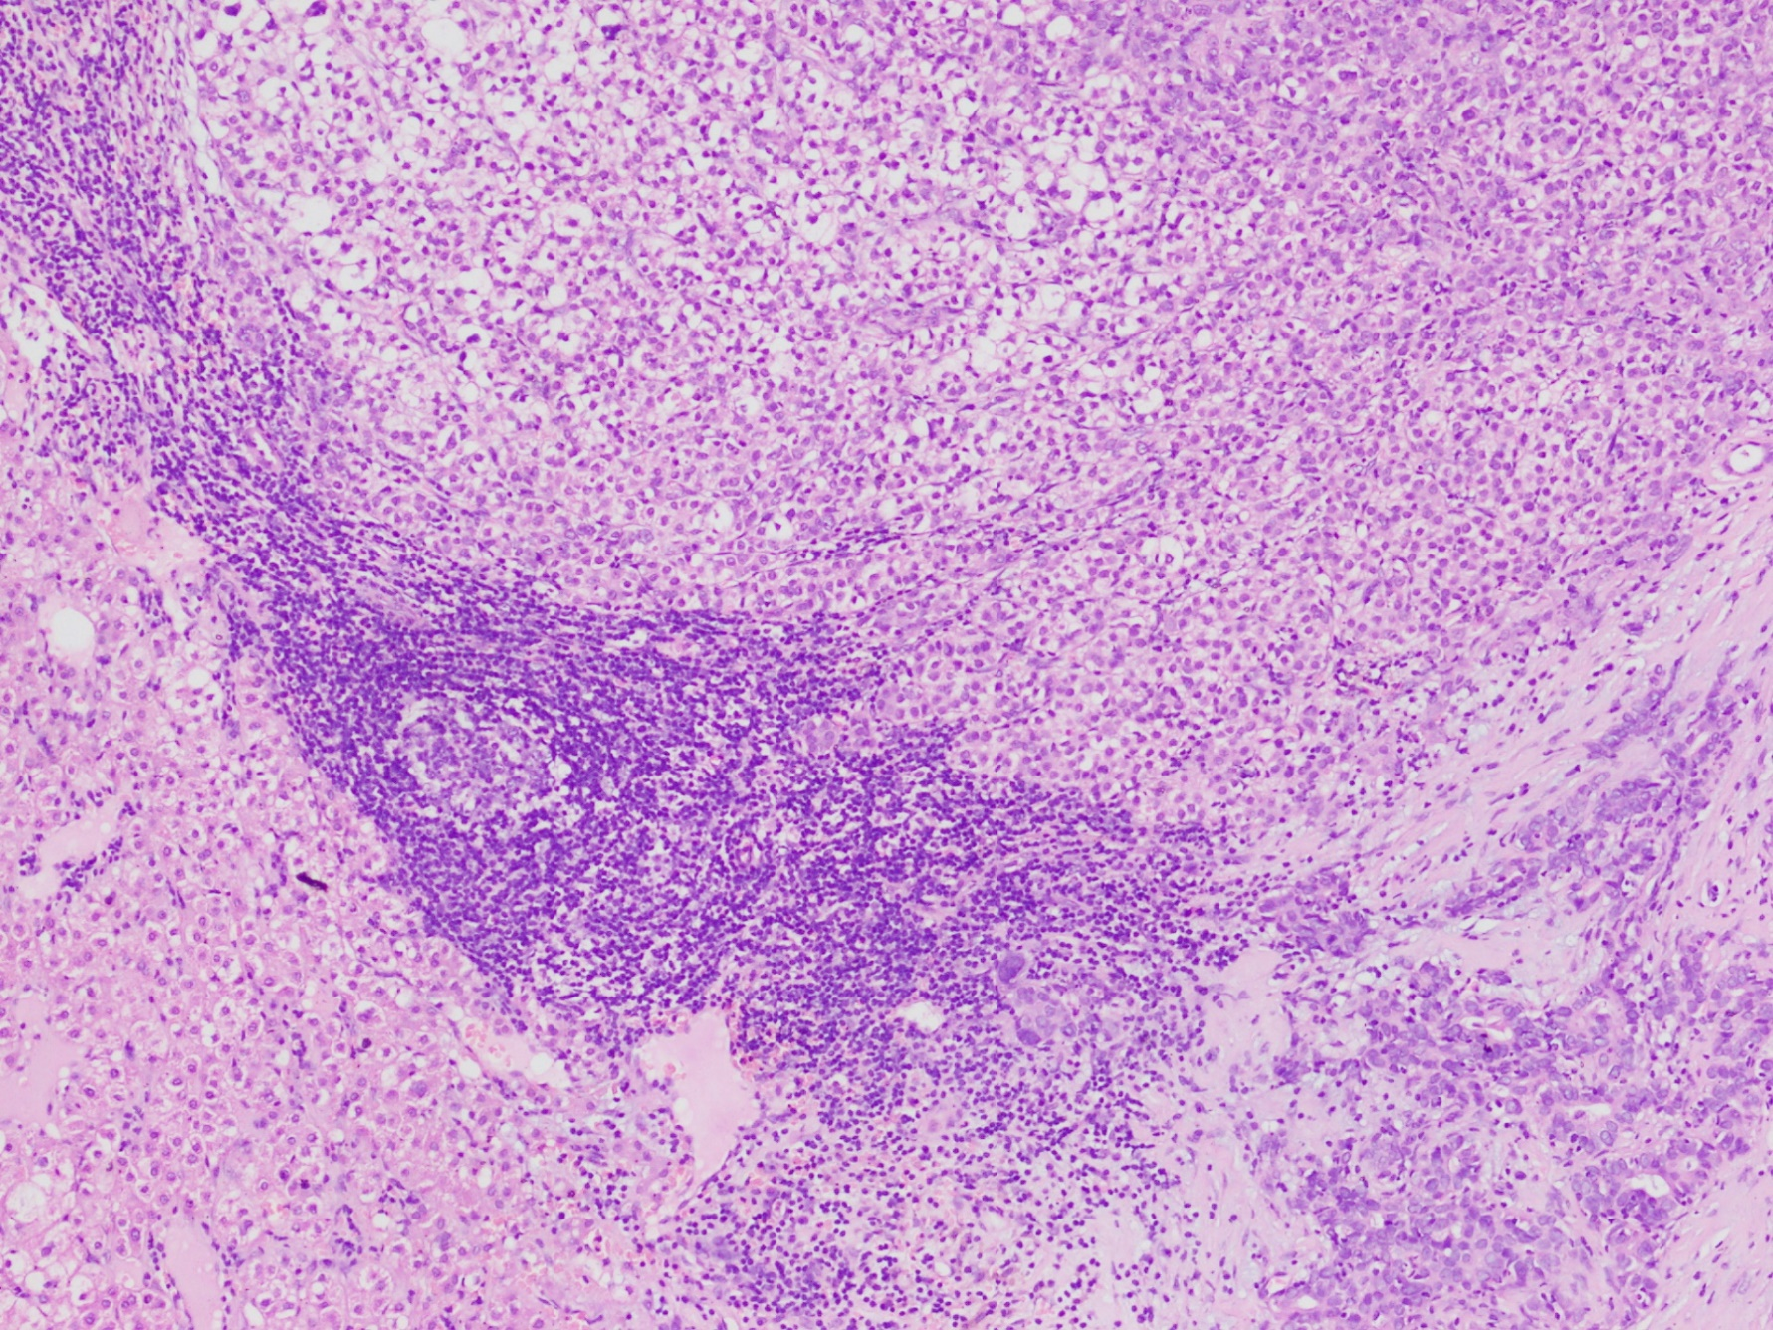
Supplementary Figure 2: Representative histopathological images of peritumoral mTLS in cHCC-CCA (100× magnification). mTLS: mature tertiary lymphoid structure; cHCC-CCA: combined hepatocellular-cholangiocarcinoma.
Supplementary Figure 3: Representative immunohistochemical images of mTLS in cHCC-CCA (100× magnification). A. CD20; B. CD3; C. CD21; D. CD23; E. CD35. mTLS: mature tertiary lymphoid structure; cHCC-CCA: combined hepatocellular-cholangiocarcinoma.
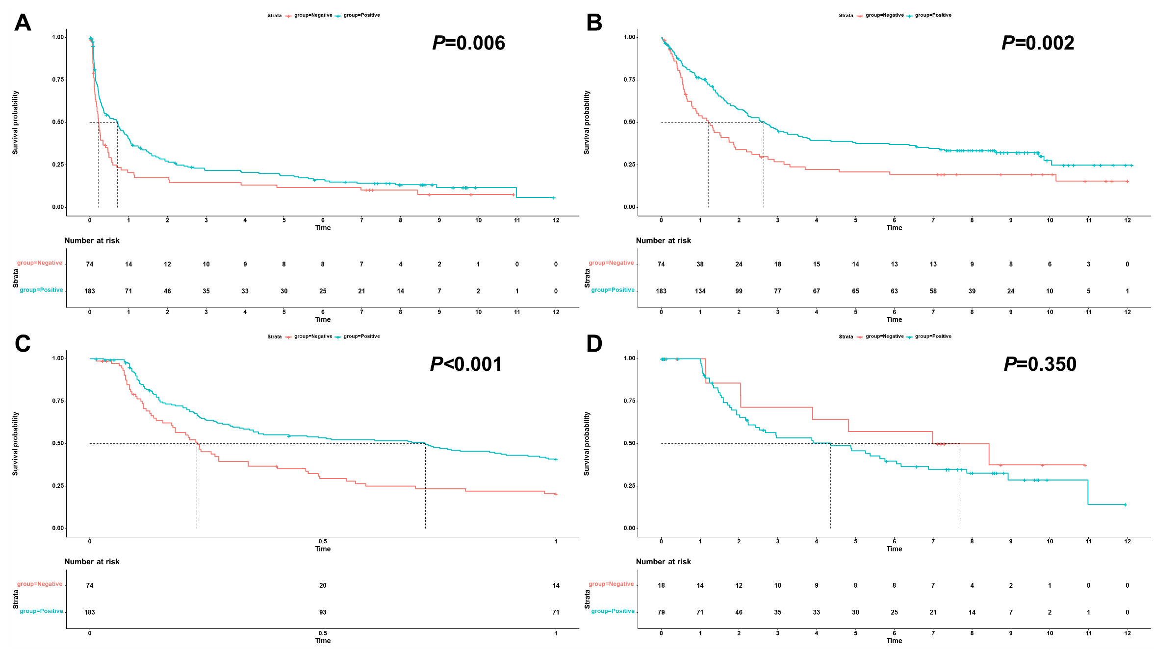
Supplementary Figure 4: Impact of TLS on the prognosis of HBsAg-positive cHCC-CCA. A. RFS; B. OS; C. early RFS; D. late RFS. TLS: tertiary lymphoid structure; HBsAg: hepatitis B surface antigen; cHCC-CCA: combined hepatocellular-cholangiocarcinoma; RFS: recurrence-free survival; OS: overall survival.

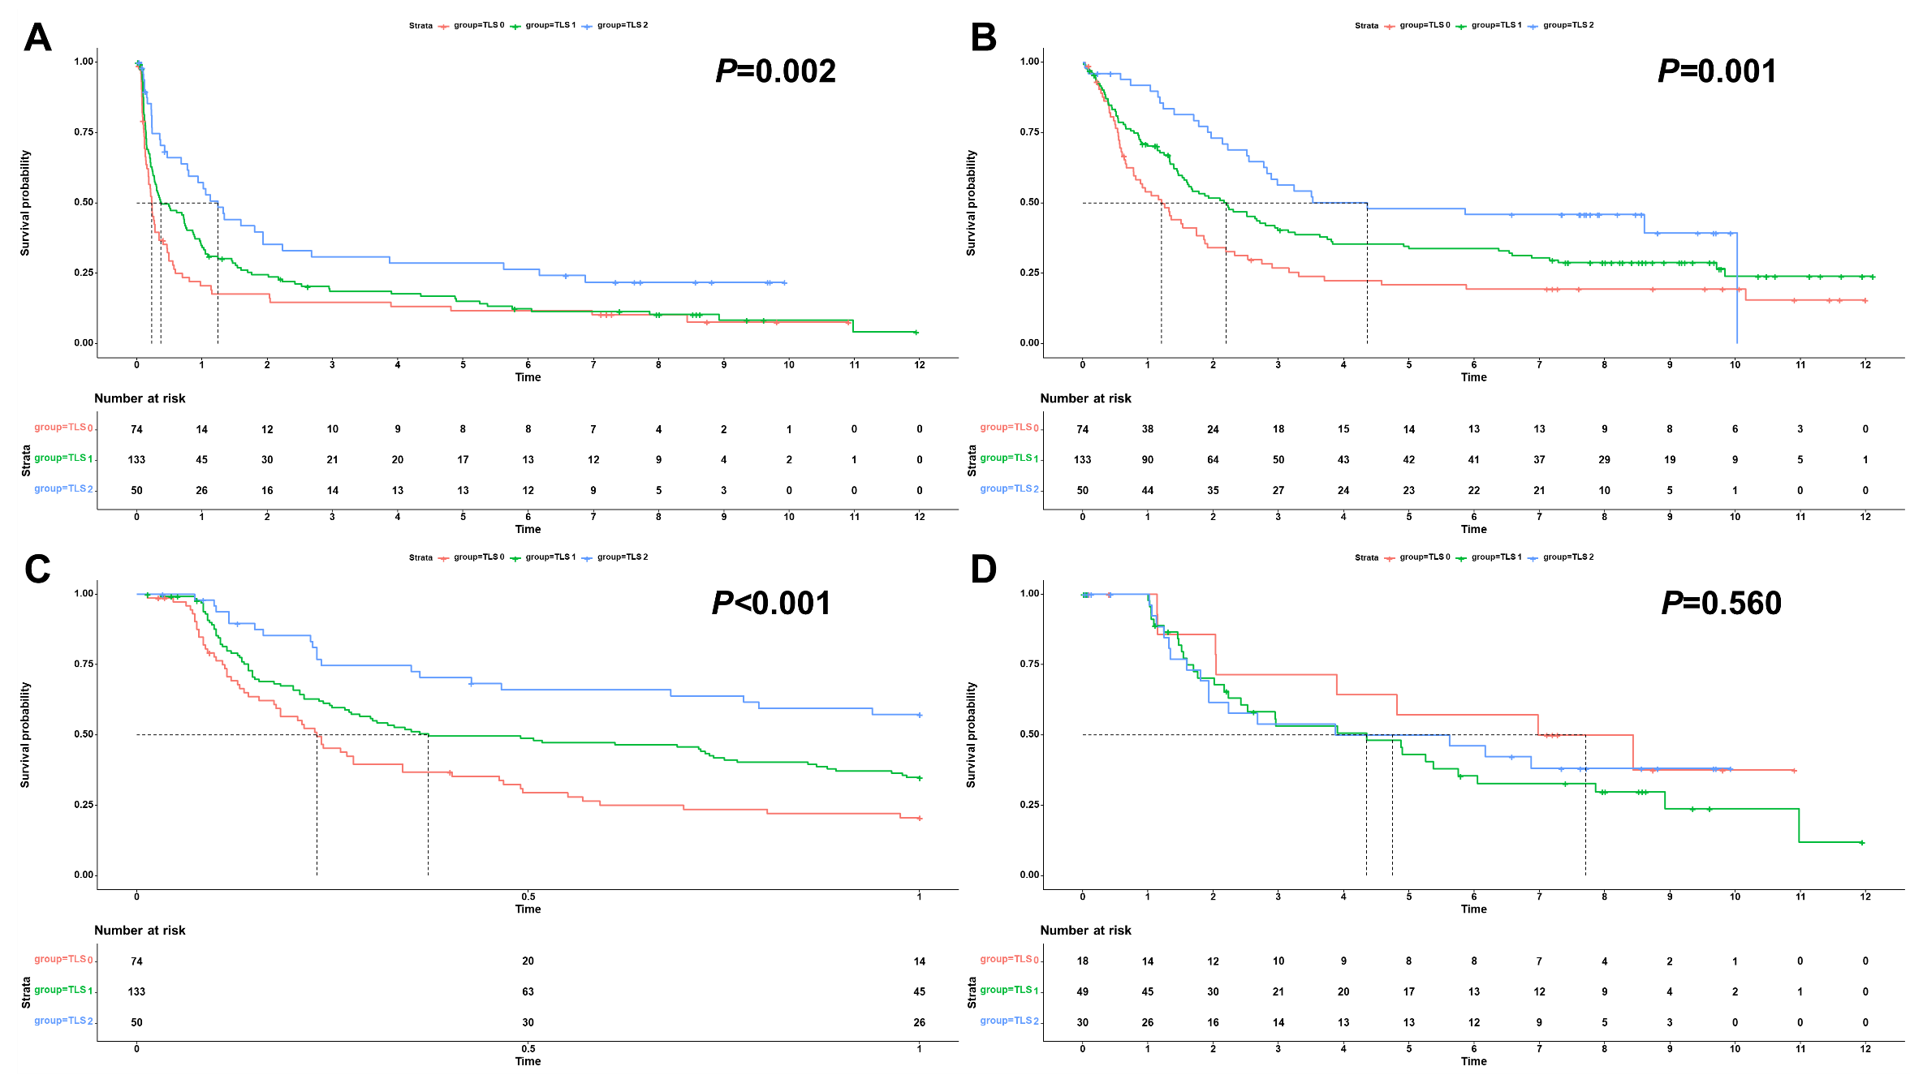
Supplementary Figure 5: Impact of iTLS and mTLS on the prognosis of HBsAg-positive cHCC-CCA. A. RFS; B. OS; C. early RFS; D. late RFS. iTLS: immature tertiary lymphoid structure; mature tertiary lymphoid structure; HBsAg: hepatitis B surface antigen; cHCC-CCA: combined hepatocellular-cholangiocarcinoma; RFS: recurrence-free survival; OS: overall survival.
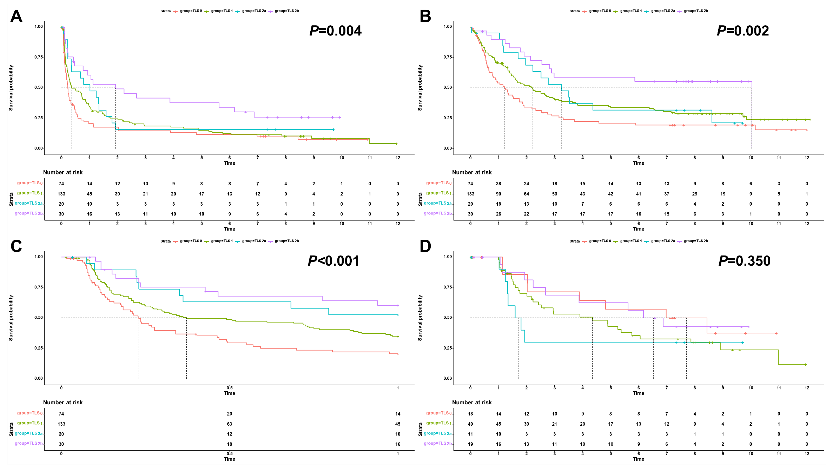
Supplementary Figure 6: Impact of TLS grading system on the prognosis of HBsAg-positive cHCC-CCA. A. RFS; B. OS; C. early RFS; D. late RFS. TLS: tertiary lymphoid structure; HBsAg: hepatitis B surface antigen; cHCC-CCA: combined hepatocellular-cholangiocarcinoma; RFS: recurrence-free survival; OS: overall survival.

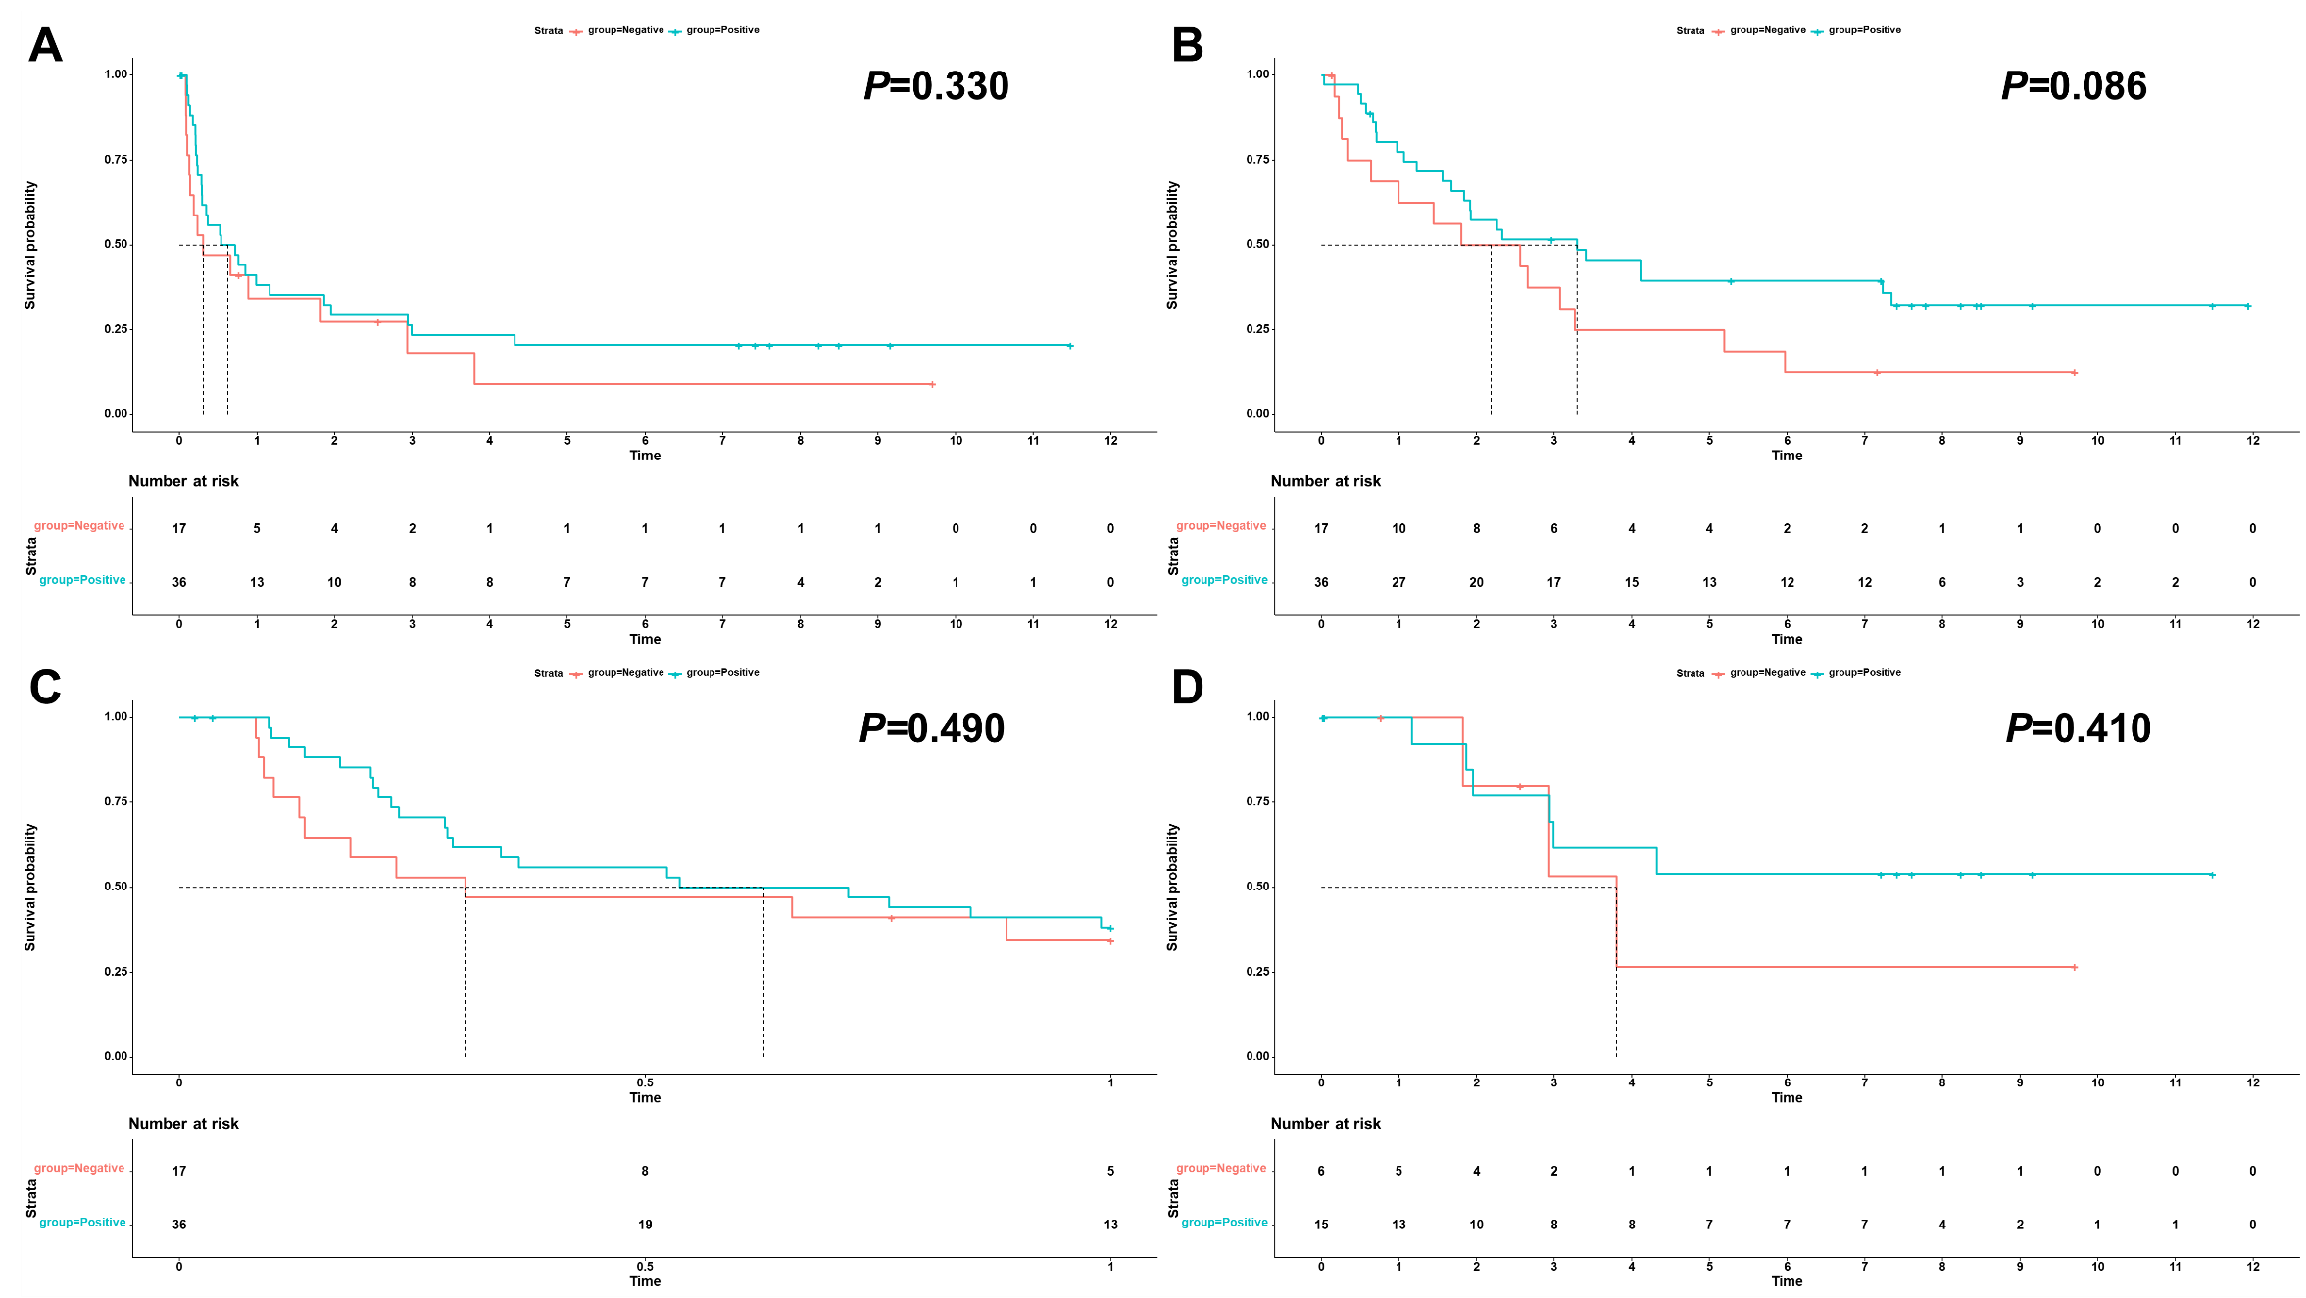
Supplementary Figure 7: Impact of TLS on the prognosis of HBsAg-negative cHCC-CCA. A. RFS; B. OS; C. early RFS; D. late RFS. TLS: tertiary lymphoid structure; HBsAg: hepatitis B surface antigen; cHCC-CCA: combined hepatocellular-cholangiocarcinoma; RFS: recurrence-free survival; OS: overall survival.

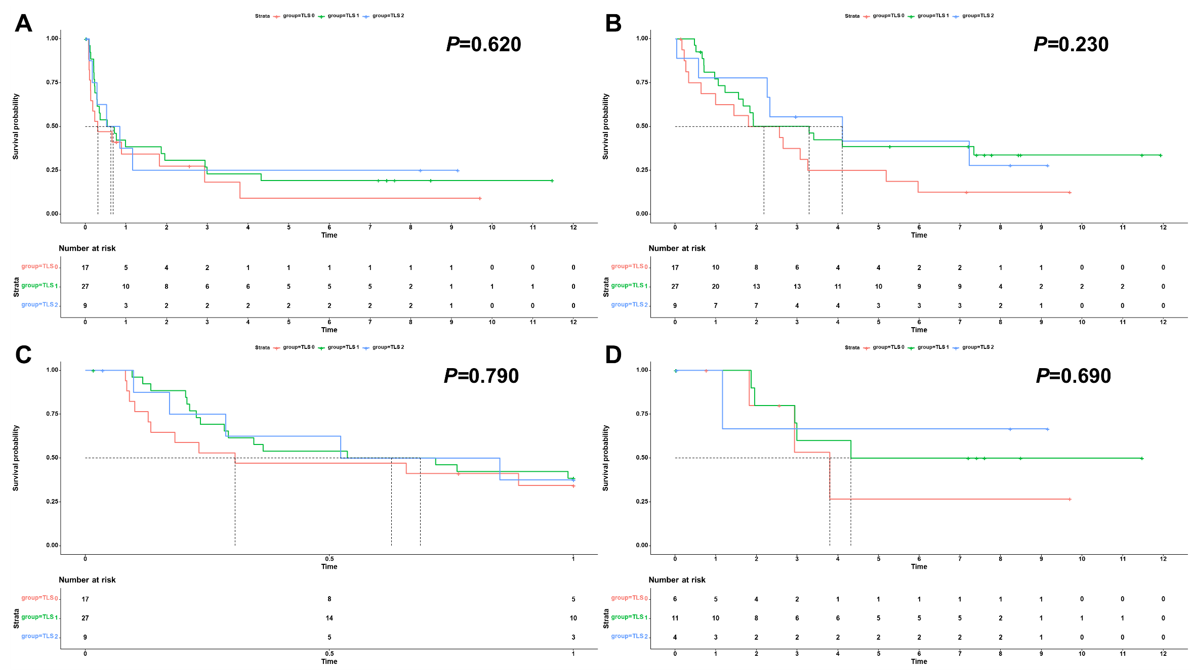
Supplementary Figure 8: Impact of iTLS and mTLS on the prognosis of HBsAg-negative cHCC-CCA. A. RFS; B. OS; C. early RFS; D. late RFS. iTLS: immature tertiary lymphoid structure; mature tertiary lymphoid structure; HBsAg: hepatitis B surface antigen; cHCC-CCA: combined hepatocellular-cholangiocarcinoma; RFS: recurrence-free survival; OS: overall survival.

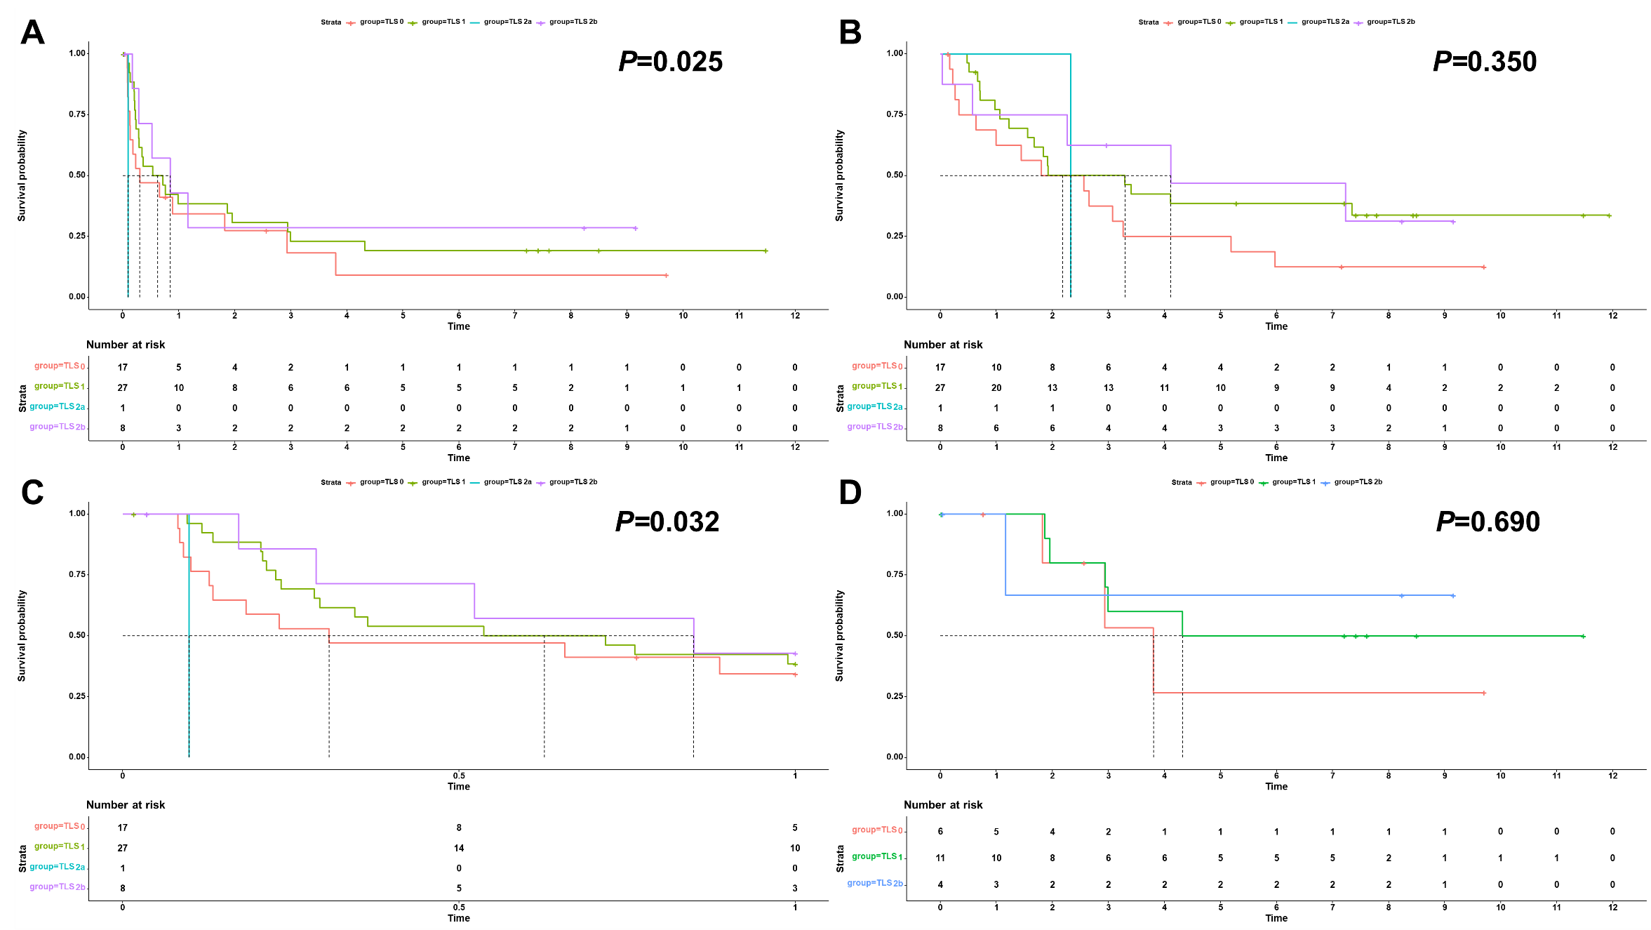
Supplementary Figure 9: Impact of TLS grading system on the prognosis of HBsAg-negative cHCC-CCA. A. RFS; B. OS; C. early RFS; D. late RFS. TLS: tertiary lymphoid structure; HBsAg: hepatitis B surface antigen; cHCC-CCA: combined hepatocellular-cholangiocarcinoma; RFS: recurrence-free survival; OS: overall survival.

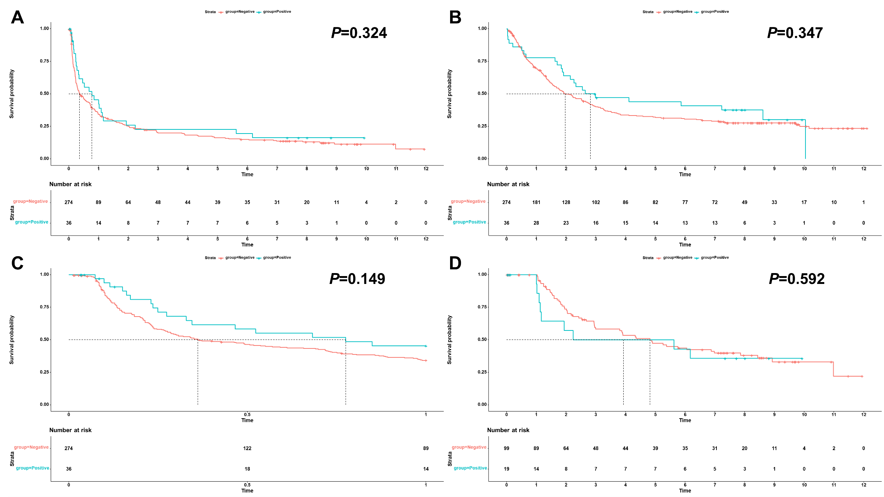
Supplementary Figure 10: Impact of peritumoral mTLS on the prognosis of cHCC-CCA. A. RFS; B. OS; C. early RFS; D. late RFS. mTLS: mature tertiary lymphoid structure; cHCC-CCA: combined hepatocellular-cholangiocarcinoma; RFS: recurrence-free survival; OS: overall survival.

