Supplementary Material
Table of contents
1. Supplementary Methods 2
1.1. Pseudo-individuals 2
1.2. Variance estimation for confidence intervals 2
2. Supplementary Tables 3
Supplementary Table 1. 3
Supplementary Table 2. 5
Supplementary Table 3. 6
3. Supplementary Figures 7
Supplementary Figure 1. 7
Supplementary Figure 2. 8
Supplementary Figure 3. 9
Supplementary Figure 4. 10
Supplementary Figure 5. 11
4. References 12

Supplementary Methods

Pseudo-individuals
Demographic data to define the study cohort was obtained from the Total Population Register that contains dates of migrations into and out of Sweden and The Cause of Death Register. The study used an open cohort design¹ with inclusion between January 1, 2003, and December 31, 2022. All adults (at least 18 years old) that had been residing in Sweden for at least one year on January 1, 2003, were included. Then on January 1 each following year until 2022 new individuals reaching the age of 18 having resided in Sweden for at least one year were added to the cohort, and individuals that had migrated to Sweden after January 1, 2003, were ≥18 years old, and had resided in Sweden for at least one year. Each individual was consequently assigned a first date of inclusion.
Since individuals could be included at many potential dates and to obtain an even distribution of index dates across calendar time, we generated a sequence of inclusion dates called index dates for everyone in each year and quarter (January 1-March 31, April 1-June 30, July 1-September 30, October 1-December 31) following the first date of inclusion. This sequence of dates was generated independently across individuals and did not depend on any data other than the first date of inclusion (January 1). The index dates of one individual were created by
- sampling an index date (uniformly at random) in the quarter corresponding to the first date of inclusion, and
- each subsequent index date was generated deterministically in the next quarter at approximately the same relative position within the quarter.
Each individual could consequently have up to 80 different index dates 90-92 days apart. We considered each combination of an index date and individual a pseudo-individual. A pseudo-individual was only included in the analyses if it was alive, resided in Sweden at its index date and had resided in Sweden for at least one year prior to the index date. Variance estimation was performed by accounting for this dependence between pseudo-individuals as described below.

Variance estimation for confidence intervals
For computational reasons (large sample size of 6 billion rows) the data set was randomly split into 64 parts of approximately equal size where all pseudo-individuals corresponding to one individual were allocated to the same part. Point estimates and variance estimates were obtained separately for each of the 64 parts in parallel using the parallel R-package. These were subsequently pooled based on standard pooling rules for independent normally distributed random variables motivated by the asymptotic normality of the estimators. Point estimates (e.g. c-indices and survival proportions) and confidence intervals were obtained from the corresponding pooled normal distributions as detailed below.
Point estimate: weighted average of the 64 estimates where the weights were equal to the proportion of pseudo-individuals in the part out of all pseudo-individuals (≈1/64).
Variance estimate: pooled variance equal to a weighted average of the 64 variance estimates where the weights were equal to the squared proportion of pseudo-individuals in the part out of all pseudo-individuals. Within each data part we used a robust variance estimator (infinitesimal Jackknife) to account for the use of multiple pseudo-individuals for each individual using the cluster argument of the functions used in the survival R-package.² A 95% confidence interval was obtained the usual way by using the weighted average pointe estimate, quantile of the normal distribution, and the square root of the pooled variance.

Supplementary Tables
Supplementary Table 1. TRIPOD checklist.

Section/Topic | Item |  | Checklist Item | Page
Title and abstract
Title | 1 | D;V | Identify the study as developing and/or validating a multivariable prediction model, the target population, and the outcome to be predicted. | 1
Abstract | 2 | D;V | Provide a summary of objectives, study design, setting, participants, sample size, predictors, outcome, statistical analysis, results, and conclusions. | 2
Introduction
Background and objectives | 3a | D;V | Explain the medical context (including whether diagnostic or prognostic) and rationale for developing or validating the multivariable prediction model, including references to existing models. | 4
Background and objectives | 3b | D;V | Specify the objectives, including whether the study describes the development or validation of the model or both. | 4
Methods
Source of data | 4a | D;V | Describe the study design or source of data (e.g., randomized trial, cohort, or registry data), separately for the development and validation data sets, if applicable. | 5
Source of data | 4b | D;V | Specify the key study dates, including start of accrual; end of accrual; and, if applicable, end of follow-up. | 5
Participants | 5a | D;V | Specify key elements of the study setting (e.g., primary care, secondary care, general population) including number and location of centres. | 5
Participants | 5b | D;V | Describe eligibility criteria for participants. | 5
Participants | 5c | D;V | Give details of treatments received, if relevant. | NA
Outcome | 6a | D;V | Clearly define the outcome that is predicted by the prediction model, including how and when assessed. | 6
Outcome | 6b | D;V | Report any actions to blind assessment of the outcome to be predicted. | NA
Predictors | 7a | D;V | Clearly define all predictors used in developing or validating the multivariable prediction model, including how and when they were measured. | 6
Predictors | 7b | D;V | Report any actions to blind assessment of predictors for the outcome and other predictors. | NA
Sample size | 8 | D;V | Explain how the study size was arrived at. | 5
Missing data | 9 | D;V | Describe how missing data were handled (e.g., complete-case analysis, single imputation, multiple imputation) with details of any imputation method. | NA
Statistical analysis methods | 10a | D | Describe how predictors were handled in the analyses. | 6
Statistical analysis methods | 10b | D | Specify type of model, all model-building procedures (including any predictor selection), and method for internal validation. | 6
Statistical analysis methods | 10c | V | For validation, describe how the predictions were calculated. | 6
Statistical analysis methods | 10d | D;V | Specify all measures used to assess model performance and, if relevant, to compare multiple models. | 6
Statistical analysis methods | 10e | V | Describe any model updating (e.g., recalibration) arising from the validation, if done. | NA
Risk groups | 11 | D;V | Provide details on how risk groups were created, if done. | NA
Development vs. validation | 12 | V | For validation, identify any differences from the development data in setting, eligibility criteria, outcome, and predictors. | NA
Results
Participants | 13a | D;V | Describe the flow of participants through the study, including the number of participants with and without the outcome and, if applicable, a summary of the follow-up time. A diagram may be helpful. | 8
Participants | 13b | D;V | Describe the characteristics of the participants (basic demographics, clinical features, available predictors), including the number of participants with missing data for predictors and outcome. | 8
Participants | 13c | V | For validation, show a comparison with the development data of the distribution of important variables (demographics, predictors and outcome). | NA
Model development | 14a | D | Specify the number of participants and outcome events in each analysis. | 8
Model development | 14b | D | If done, report the unadjusted association between each candidate predictor and outcome. | NA
Model specification | 15a | D | Present the full prediction model to allow predictions for individuals (i.e., all regression coefficients, and model intercept or baseline survival at a given time point). | 9-10
Model specification | 15b | D | Explain how to the use the prediction model. | 11-13
Model performance | 16 | D;V | Report performance measures (with CIs) for the prediction model. | 9-10
Model-updating | 17 | V | If done, report the results from any model updating (i.e., model specification, model performance). | NA
Discussion
Limitations | 18 | D;V | Discuss any limitations of the study (such as nonrepresentative sample, few events per predictor, missing data). | 13
Interpretation | 19a | V | For validation, discuss the results with reference to performance in the development data, and any other validation data. | NA
Interpretation | 19b | D;V | Give an overall interpretation of the results, considering objectives, limitations, results from similar studies, and other relevant evidence. | 12-13
Implications | 20 | D;V | Discuss the potential clinical use of the model and implications for future research. | 11-12
Other information
Supplementary information | 21 | D;V | Provide information about the availability of supplementary resources, such as study protocol, Web calculator, and data sets. | 15
Funding | 22 | D;V | Give the source of funding and the role of the funders for the present study. | 15

*Items relevant only to the development of a prediction model are denoted by D, items relating solely to a validation of a prediction model are denoted by V, and items relating to both are denoted D;V. We recommend using the TRIPOD Checklist in conjunction with the TRIPOD Explanation and Elaboration document.

Supplementary Table 2. Baseline characteristics for pseudo-individuals according to sex.
 | Men |  | Women
 | N | (%) | N | (%)
Pseudo-individuals (N x100 000) | 2969 | (100) | 3028 | (100)
Age (years)
Median (interquartile range; IQR) | 48 (33 – 63) |  | 50 (35 – 66)
18-49 | 1570 | (52.9) | 1500 | (49.5)
50-69 | 932 | (31.4) | 926 | (30.6)
70-79 | 306 | (10.3) | 340 | (11.2)
≥80 | 162 | (5.5) | 261 | (8.6)
Number of healthcare encounters* during
the previous year
0 | 1888 | (63.6) | 1614 | (53.3)
1-3 | 792 | (26.7) | 1006 | (33.2)
≥4 | 289 | (9.7) | 407 | (13.4)
Number of healthcare encounters* during
the previous 10 years
0 | 913 | (30.8) | 583 | (19.3)
1-3 | 950 | (32) | 916 | (30.3)
≥4 | 1106 | (37.2) | 1528 | (50.5)
Charlson comorbidity index (1-year look-back period)
0 | 2741 | (92.3) | 2812 | (92.9)
1 | 93 | (3.1) | 110 | (3.6)
2 | 91 | (3.1) | 72 | (2.4)
3 | 19 | (0.6) | 14 | (0.5)
≥4 | 25 | (0.8) | 19 | (0.6)
Charlson comorbidity index (10-year look-back period)
0 | 2085 | (70.2) | 2121 | (70.1)
1 | 201 | (6.8) | 224 | (7.4)
2 | 140 | (4.7) | 143 | (4.7)
3 | 48 | (1.6) | 42 | (1.4)
≥4 | 56 | (1.9) | 48 | (1.6)
Occurrence of ICD-10 code chapter during
the previous 10 years
A or B (infectious and parasitic diseases) | 267 | (9) | 351 | (11.6)
C or D (neoplasms and diseases of the blood  and blood-forming organs) | 423 | (14.3) | 669 | (22.1)
E (endocrine, nutritional, and metabolic diseases) | 294 | (9.9) | 403 | (13.3)
F (mental and behavioral disorders) | 308 | (10.4) | 370 | (12.2)
G (diseases of the nervous system) | 272 | (9.2) | 321 | (10.6)
H (ear, nose, or throat diseases) | 599 | (20.2) | 767 | (25.3)
I (diseases of the circulatory system) | 554 | (18.7) | 558 | (18.4)
J (diseases of the respiratory system) | 366 | (12.3) | 411 | (13.6)
K (diseases of the digestive system) | 536 | (18.1) | 592 | (19.6)
L (diseases of the skin and subcutaneous tissue) | 391 | (13.2) | 543 | (18)
M (diseases of the musculoskeletal system and  connective tissue) | 702 | (23.7) | 839 | (27.7)
N (diseases of the genitourinary system) | 417 | (14) | 1022 | (33.8)
R (symptoms, signs, and abnormal clinical and  laboratory findings, not elsewhere classified) | 909 | (30.7) | 1134 | (37.5)
S or T (injury, poisoning and certain other  consequences of external causes) | 975 | (32.9) | 866 | (28.6)
Z (factors influencing health status and  contact with health services) | 1083 | (36.5) | 1661 | (54.9)
O, P, Q, U or Y (miscellaneous) | 73 | (2.5) | 633 | (20.9)

*Defined as a unique date of an inpatient or a specialist out-patient visit registered in The National Patient Registry.

Supplementary Table 3. Follow-up and number of deaths for pseudo-individuals.

 | All ages |  | 18-49 years |  | 50-69 years |  | 70+ years
 | N | (%) | N | (%) | N | (%) | N | (%)
Pseudo-individuals (N 100 000) | 5994 | (100) | 3068 | (100) | 1858 | (100) | 1068 | (100)
Follow-up* (years)
Median (interquartile range; IQR) | 10.2 (5.4 – 15.4) |  | 10.2 (5.3 – 15.4) |  | 10.5 (5.7 – 15.6) |  | 9.6 (5.1 – 14.9)
Observed time to event or censoring (years)
≤1 year | 99 | (1.6) | 24 | (0.8) | 15 | (0.8) | 60 | (5.6)
1-5 years | 1563 | (26.1) | 703 | (22.9) | 438 | (23.6) | 421 | (39.4)
5-10 years | 1656 | (27.6) | 797 | (25.9) | 513 | (27.6) | 346 | (32.3)
>10 years | 2680 | (44.7) | 1546 | (50.4) | 892 | (48) | 242 | (22.6)
Deaths
Yes | 797 | (13.3) | 42 | (1.4) | 217 | (11.7) | 538 | (50.3)
No | 5200 | (86.7) | 3028 | (98.6) | 1641 | (88.3) | 531 | (49.7)

*The length of follow-up was calculated using the reverse Kaplan-Meier method.³

Supplementary Figures
Supplementary Figure 1. C-index of the Charlson Comorbidity Index (CCI) using 1 year of follow-up a according to source of information and number of times diagnoses had to appear during the 10-year look-back period by source and or as main vs secondary diagnosis. Pseudo-individuals aged <30 years were analyzed as one group since there were few events in this age span. 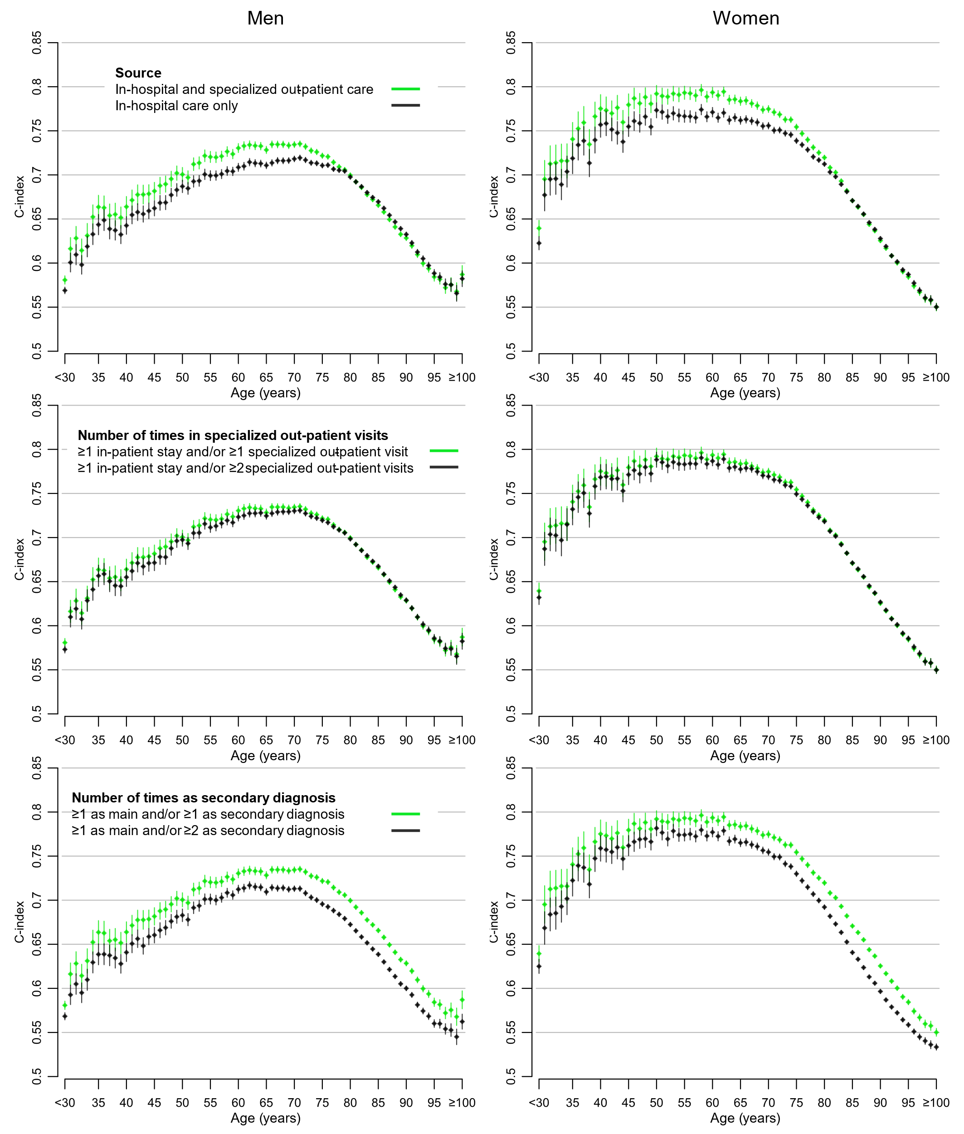

Supplementary Figure 2. C-index of the Charlson Comorbidity Index (CCI) using 5 years of follow-up for mortality. Pseudo-individuals aged <30 years were analyzed as one group since there were few events in this age span. 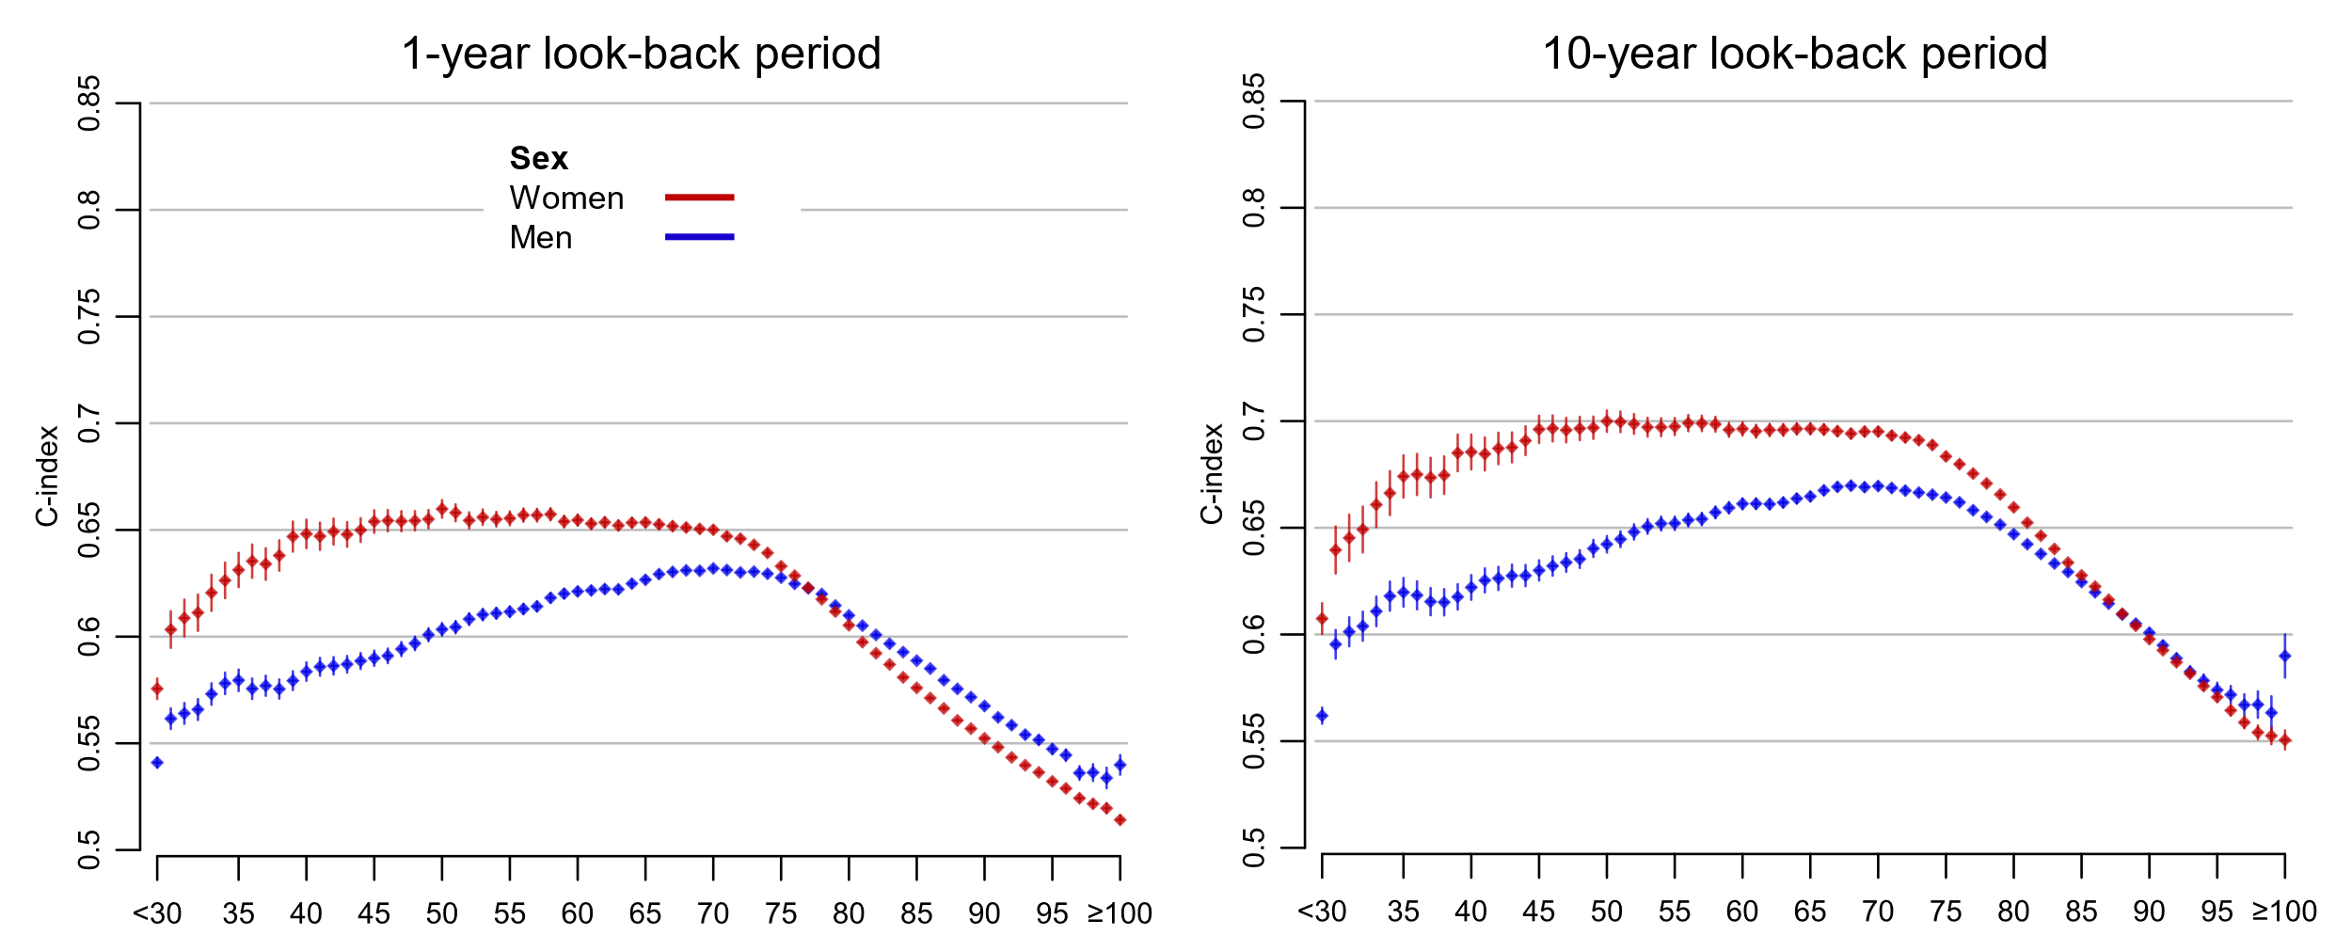

Supplementary Figure 3. Risk of death within 10 years according to Charlson Comorbidity Index (CCI) and age. Pseudo-individuals aged <30 and ≥90 years were analyzed as one group since there were few events and/or pseudo-individuals in some categories of CCI and age in this age span. 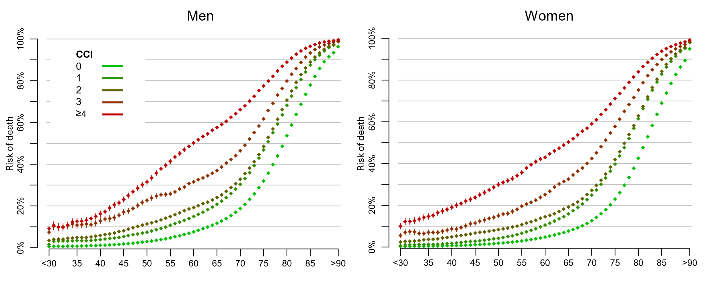
Supplementary Figure 4. Risk of death according to age and the Charlson Comorbidity Index (CCI), using a 10-year look-back period (CCI_{10years}), in men. The 5-year estimates are provided with confidence intervals (CIs). Numbers at risk are provided for each level of CCI per 100 000 pseudo-individuals.
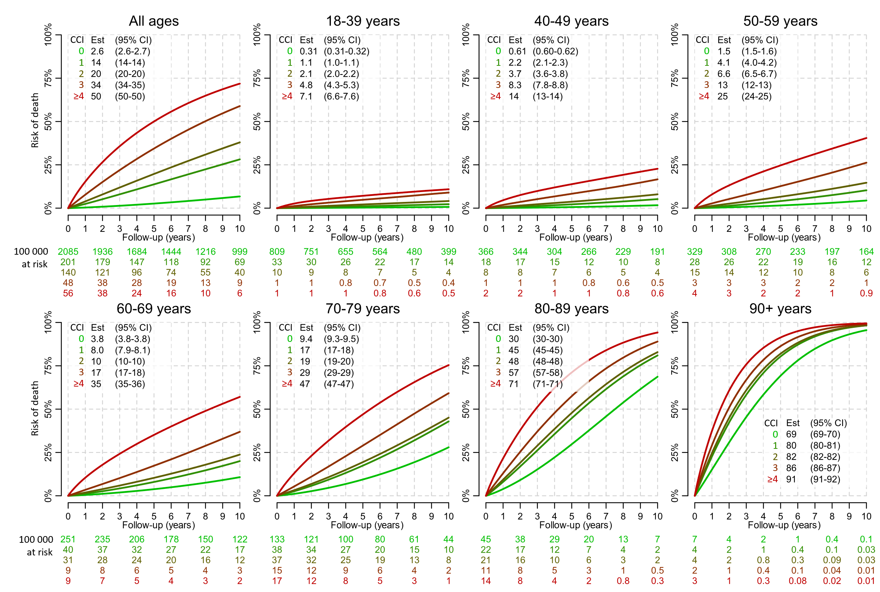

Supplementary Figure 5. Risk of death according to age and the Charlson Comorbidity Index (CCI), using a 10-year look-back period (CCI_{10years}), in women. The 5-year estimates are provided with confidence intervals (CIs). Numbers at risk are provided for each level of CCI per 100 000 pseudo-individuals.
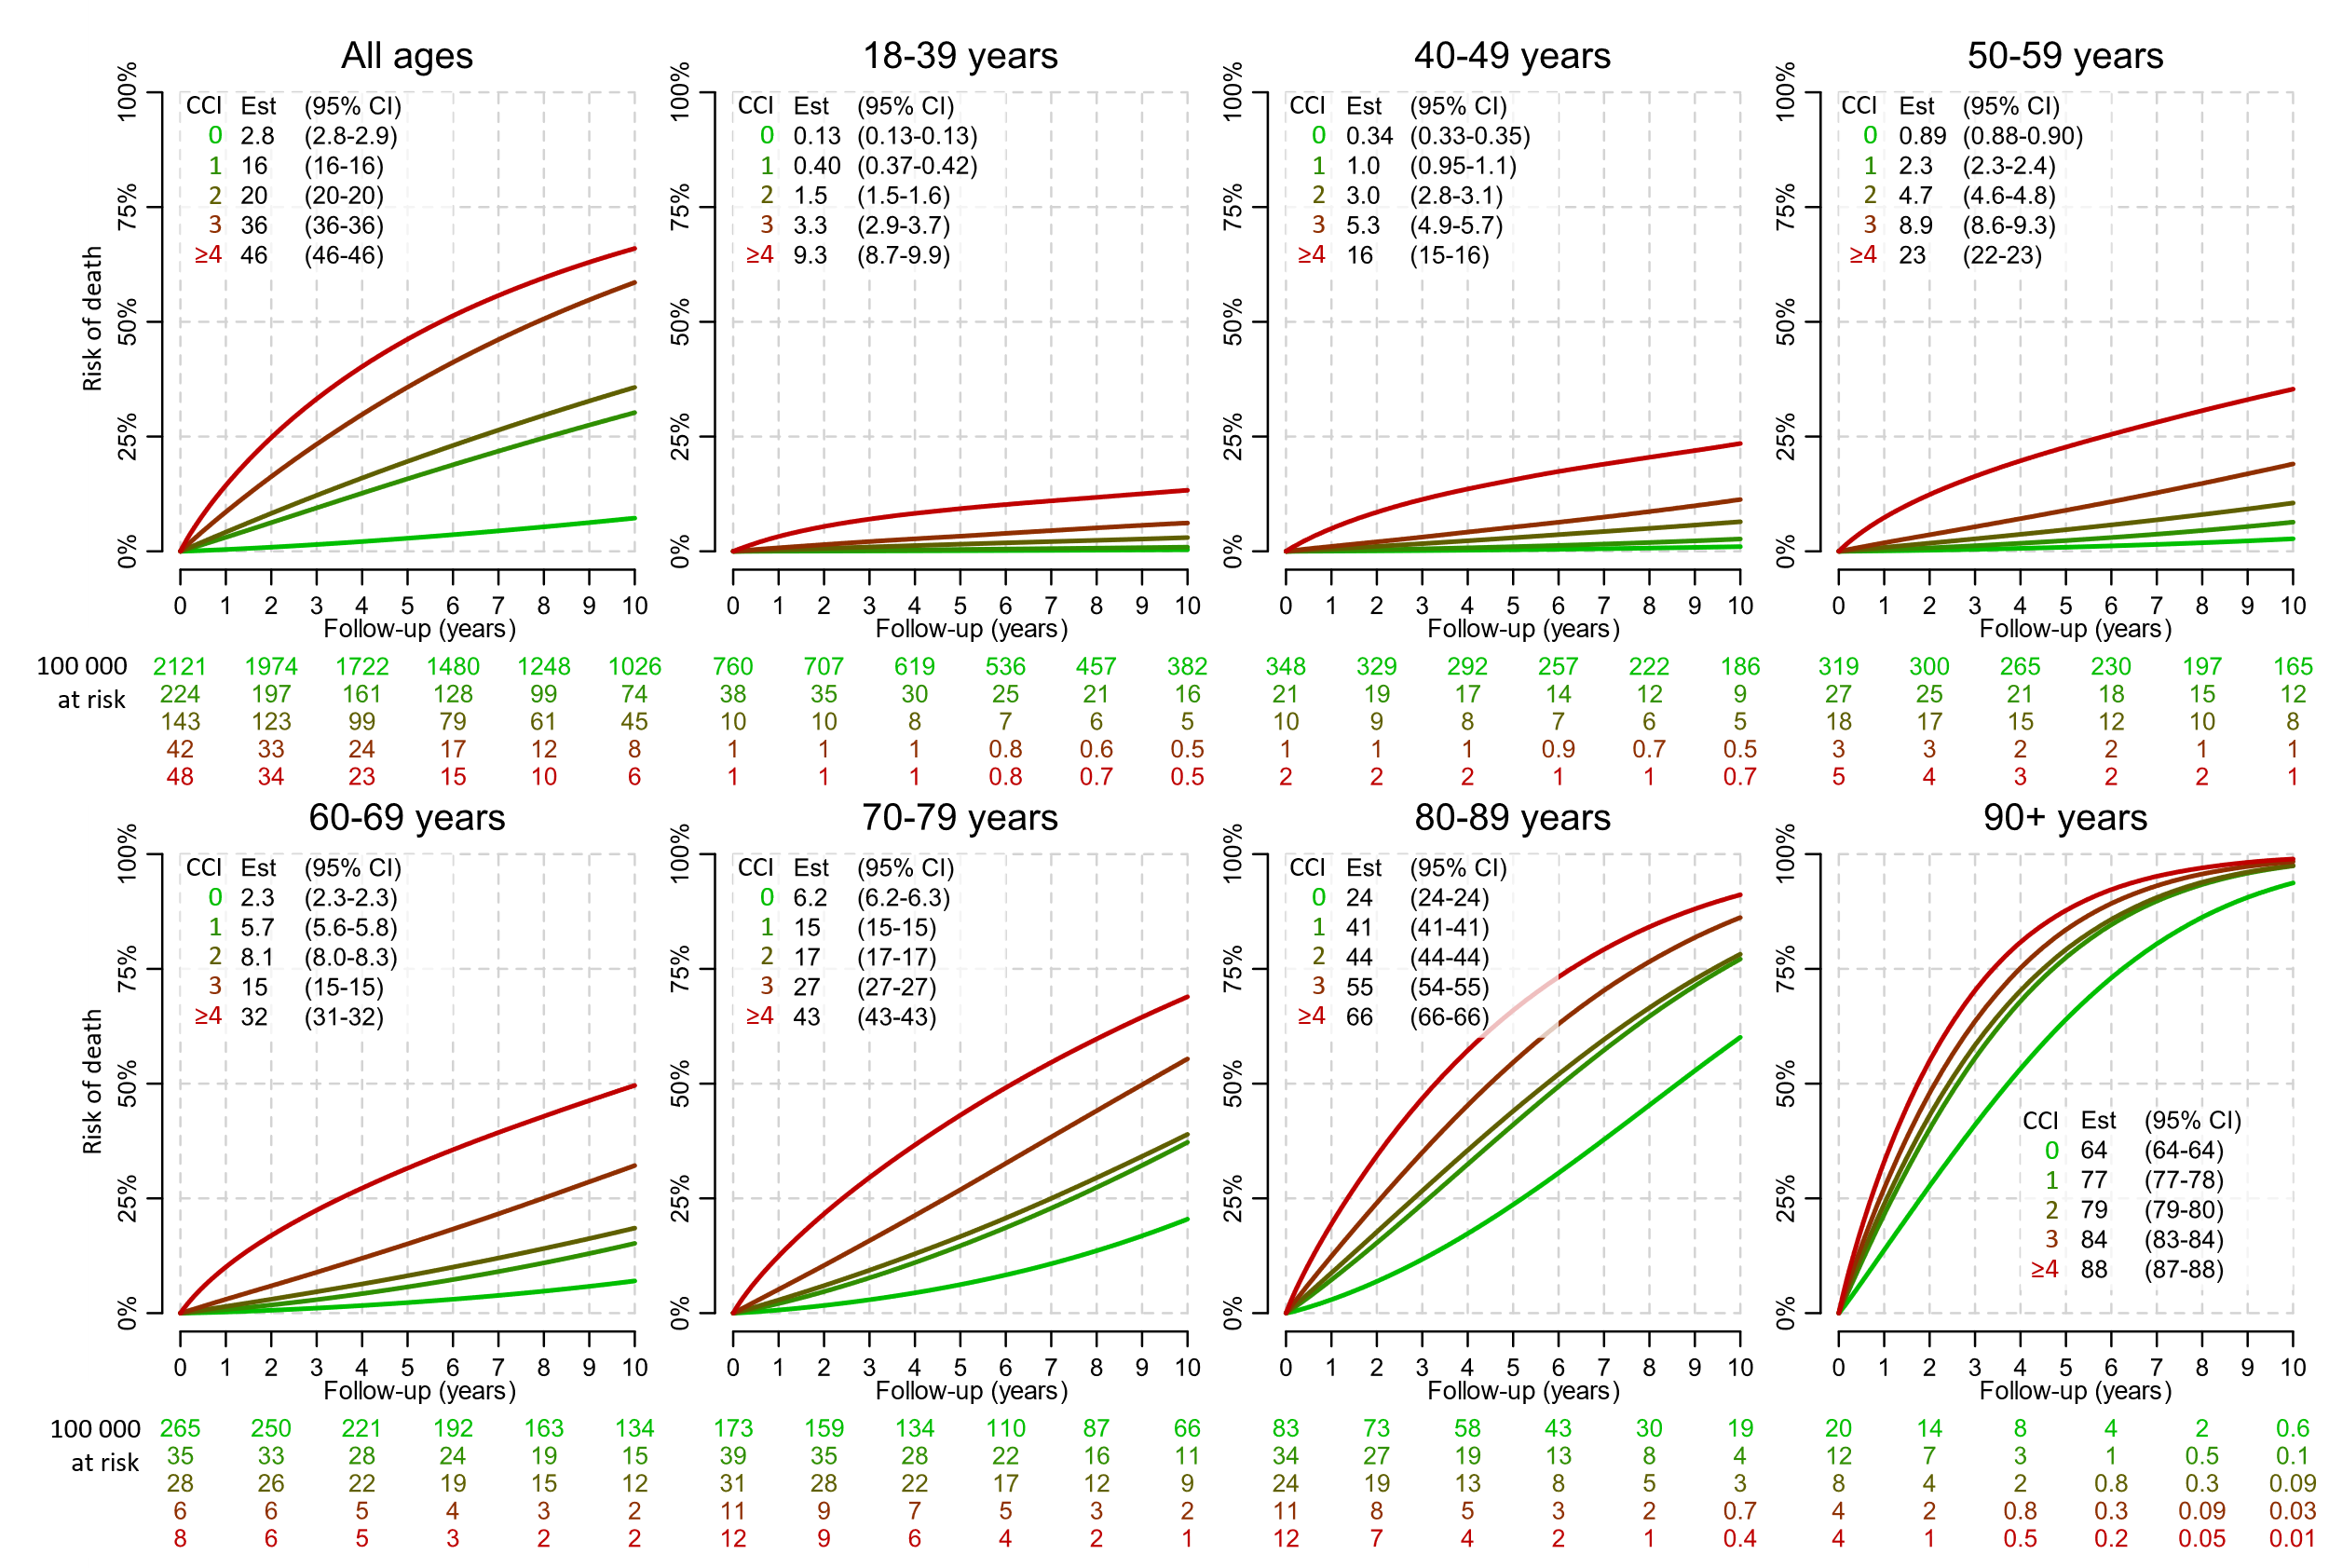

References
1. Rothman KJ, Huybrechts KF, Murray EJ. Epidemiology: an introduction: Oxford university press, 2024.
2. Therneau T. A package for survival analysis in S. R package version 2015;2(7).
3. Schemper M, Smith TL. A note on quantifying follow-up in studies of failure time. Controlled clinical trials 1996;17(4):343-346.

