Appendix 1: Search Strings
Appendix Table 1 The Search Strategy
Databases | Search Strings | Timeframe | Outcomes
PubMed | "social capital"[Title/Abstract] AND ("definition"[Title/Abstract] OR "concept"[Title/Abstract] OR "framework"[Title/Abstract] OR "conceptual framework"[Title/Abstract] OR "theory"[Title/Abstract] OR "dimension"[Title/Abstract]) | 20220223 | 992
Web of Science Core Collection | (TI=("social capital ")) AND TI=(definition OR concept OR framework OR "conceptual framework" OR theory OR dimension OR model) | 20220223 | 545
Medline | (TI=("social capital ")) AND TI=(definition OR concept OR framework OR "conceptual framework" OR theory OR dimension OR model) | 20220223 | 104
Embase | Embase <1974 to 2022 February 22>  4 social capital/ 3398  5 (definition or concept* or framework or theory or dimension or model).mp. [mp=title, abstract, heading word, drug trade name, original title, device manufacturer, drug manufacturer, device trade name, keyword heading word, floating subheading word, candidate term word] 6018414  6 4 and 5 1497  7 limit 6 to (full text and english language) 506 | 20220224 | 506
Note:The search syntax for Embase is presented in its native format as exported from the database. *No special symbols (e.g., , †) requiring explanation are used within this table.
TI = Title (field tag used in Web of Science and Medline)

Appendix2: The Original Health-Related Social Capital Scale Items Pool
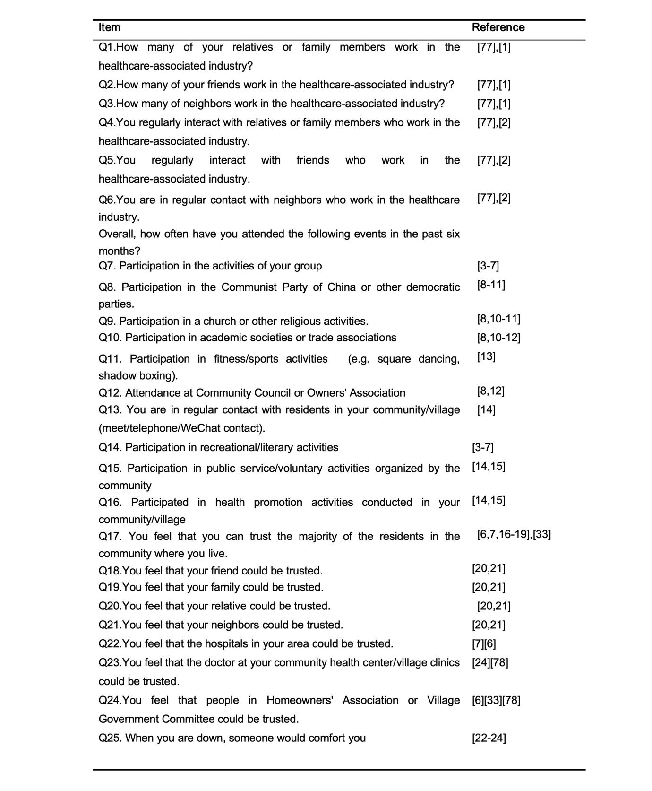
Appendix Figure1a The Original Health-Related Social Capital Scale Items Pool

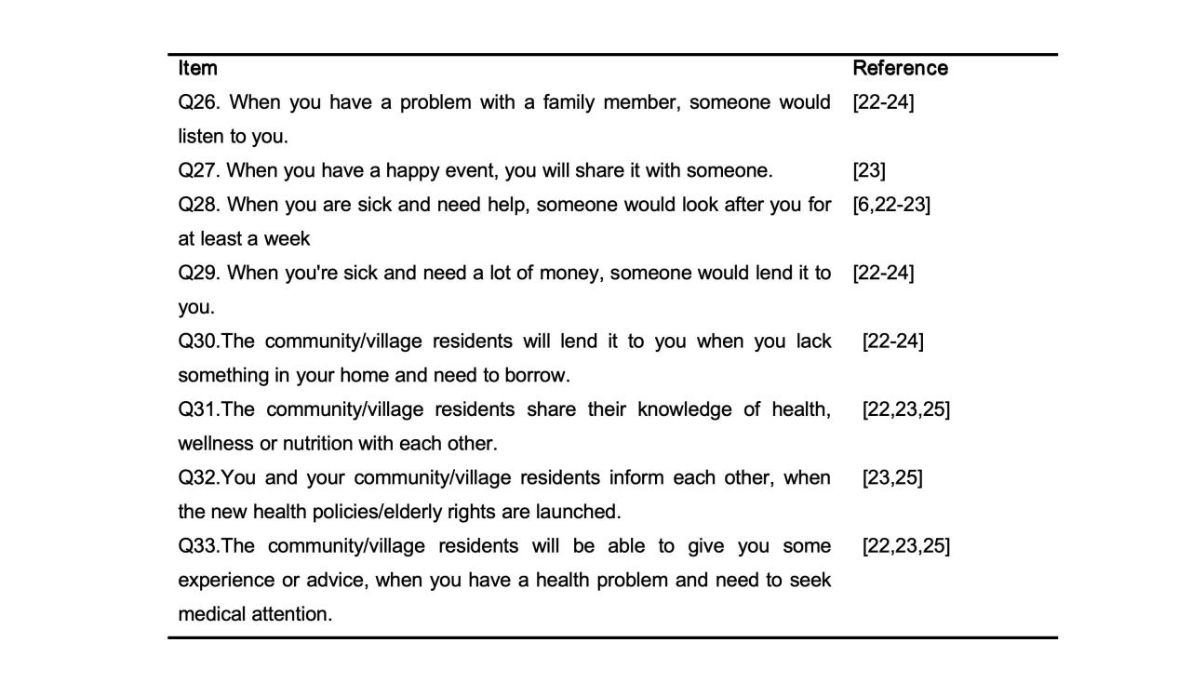
Appendix Figure1b The Original Health-Related Social Capital Scale Items Pool
Reference
1.Only in the appendix
[1]M. Van Der Gaag, T.A.B. Snijders, The Resource Generator: social capital quantification with concrete items, Social Networks 27 (2005) 1–29. https://doi.org/10.1016/j.socnet.2004.10.001.
[2]J. Lubben, E. Blozik, G. Gillmann, S. Iliffe, W. von Renteln Kruse, J.C. Beck, A.E. Stuck, Performance of an abbreviated version of the Lubben Social Network Scale among three European community-dwelling older adult populations, Gerontologist 46 (2006) 503–513. https://doi.org/10.1093/geront/46.4.503.
[3]C. Grootaert, Measuring social capital: An integrated questionnaire, World Bank Publications, 2004.
[4] C. Grootaert, T. Van Bastelaer, others, Understanding and measuring social capital: A multidisciplinary tool for practitioners, World Bank Publications, 2002.
[5] Yang J., Hu R., Social capital and mental health of urban and rural residents, Social Sciences in Yunnan (2016) 131–136.
[6] Yang S., Gao B., Han J., Yu B., Yang S., Reliability and validity evaluation of social capital scale for middle-aged and olopeople with different health status, Modern Preventive Medicine 47 (2020) 4484–4487.
[7] Zhang J., Xu S., The Influence of Social Capital Factors on Life Satisfaction among Chinese Rural Older Adults, Population Journal 43 (2021) 74–85. https://doi.org/10.16405/j.cnki.1004-129X.2021.02.006.
[8] R. Fang, MEASURING SOCIAL SAPITAL IN CHINA:AN RESEARCH ON PERSPECTIVE OF POLITICAL SCIENCE INDIGENIZATION, SOCIALSCIENCES ACADEMIC PRESS(CHINA), Beijing, 2014.
9.luo
- Xu X., Zhou L., Multi-level Social Capital and Health Status of the Rural Elderly, Journal of Yunnan Minzu University(Philosophy and Social Sciences Edition) 39 (2022) 112–121. https://doi.org/10.13727/j.cnki.53-1191/c.20220107.010.
- [11]Yue Z., Liang H., The Impact of Social Capital on Individual Health of the Rural Elderly, Journal of South China Agricultural University(Social Science Edition) 19 (2020) 34–45.
[12]Ma W., An Empirical Study on the Internal Mechanism of Social Capitals Afecting Residents’Happines, Journal of Social Sciences (2018) 62–72. https://doi.org/10.13644/j.cnki.cn31-1112.2018.02.006.
[13] Meng H., Guo J., Social Capital and Life Satisfaction Among Older Adults Living in Urban China: An Empirical Study in Shanghai, SOCIAL CONSTRUCTION 9 (2022) 60–71.
[14] L. Guillen, L. Coromina, W.E. Saris, Measurement of Social Participation and its Place in Social Capital Theory, Soc Indic Res 100 (2011) 331–350. https://doi.org/10.1007/s11205-010-9631-6.
[15] Yang T., Zhang C., Public Health Research from a Social Capital Perspective, Chinese Journal of Preventive Medicine 44 (2010) 188–190.
[16] Gui Y., Huang R., Measuring Community Social Capital : An empirical study, Sociological Studies (2008) 122-142+244-245. https://doi.org/10.19934/j.cnki.shxyj.2008.03.006.
[17] Lv N., A study of the relationship between community social capital, community environment and cognitive function in old age in rural areas of northeast China, Social Construction 8 (2021) 75–82.
[18] W. Poortinga, Social relations or social capital? Individual and community health effects of bonding social capital, Soc Sci Med 63 (2006) 255–270. https://doi.org/10.1016/j.socscimed.2005.11.039.
[19] Zhang W., Zhang J., Influence of Community Social Capital on Satisfaction of Residents, The Journal of Jiangsu Administration Institute (2019) 70–77.
[20] T.A. Engbers, M.F. Thompson, T.F. Slaper, Theory and Measurement in Social Capital Research, Soc Indic Res 132 (2017) 537–558. https://doi.org/10.1007/s11205-016-1299-0.
[21] Hu F., Prevention and Control at the individual leveStudy on Social Capital and Chronic Diseases, Doctor, Anhui Medical University, 2015. https://kns.cnki.net/kcms2/article/abstract?v=lD5CuVSaeOvph8SCoLe5TT76DRzHnC5C-nkQhEL8DGzzihFH94RAvwplIJ--PNmpDBZkmhavfqhNv9TYwL69AmFr1y_Gr2P7scLyeW2TNzOKbJO2M8XKeciZzdHwcXUAzIz3L9Kkxi2gcE6WJUS1zg==&uniplatform=NZKPT&language=CHS (accessed October 15, 2023).
[22] Liu K., Zhang N., Li Y., Sun X., Revision and evaluation of the rural elderly resource generator scale, Journal of Shandong University(Health Sciences) 53 (2015) 87–91.
[23] M. Rostila, A resource-based theory of social capital for health research: Can it help us bridge the individual and collective facets of the concept?, Soc Theory Health 9 (2011) 109–129. https://doi.org/10.1057/sth.2011.4.
[24] Zhu W., Social Capital and the Elderly Health--Based on the Comprehensive lnvestigation of Communities in Shanghai, Journal of Social Sciences (2015) 69–80. https://doi.org/10.13644/j.cnki.cn31-1112.2015.05.009.
[25] Luo J., Fang Z., Measurement of Community Social Capital - A Measurement Approach Introducing a Social Network Perspective, Jiangsu Social Sciences (2014) 114–124. https://doi.org/10.13858/j.cnki.cn32-1312/c.2014.01.028.
2. Both in the manuscript and appendix
[33]X. Ma, X. Piao, T. Oshio, Impact of social participation on health among middle-aged and elderly adults: evidence from longitudinal survey data in China, BMC Public Health 20 (2020) 502. https://doi.org/10.1186/s12889-020-08650-4.
[77] Guo K., Li Y., Yu X., Meng J., Yan C., Paths for Family Social Capital Affecting Health Status Mediated by Health Literacy, Chinese General Practice 24 (2021) 1249–1253.
[78] Wang H., Study of Indicators on social capital for community older people, Master, ANHUI MEDICAL UNIVERSITY, 2013. https://kns.cnki.net/kcms2/article/abstract?v=3uoqIhG8C475KOm_zrgu4lQARvep2SAk8URRK9V8kZLG_vkiPpTeIZd9UxCt1Mcwey4E5t2SGQ_2VhBJ_0qD-IhRju9YQjeq&uniplatform=NZKPT (accessed September 11, 2023).

Appendix3: A Summary Table of Backgrounds of the 14 Experts
Appendix Table 2 The Backgrounds of the 14 Experts
ID | Gender | Age | Education Level | Affiliation | Displine/Main Expertise | Professional Qualification | Working Years | Delphi Round 1 | Delphi Round 2
1 | Male | 31 | Doctor | School of Medicine and Health Management, Tongji Medical College, Huazhong University of Science and Technology | Health Policy | Intermediate | 4 | √ | √
2 | Male | 34 | Doctor | School of Medicine and Health Management, Tongji Medical College, Huazhong University of Science and Technology | Health Policy | Intermediate | 2 | √ | √
3 | Male | 60 | Doctor | School of Medicine and Health Management, Tongji Medical College, Huazhong University of Science and Technology | Health Policy | Senior | 22 | √ | √
4 | Male | 37 | Doctor | School of Medicine and Health Management, Tongji Medical College, Huazhong University of Science and Technology | Health Policy | Intermediate | 6 | √ | √
5 | Male | 45 | Doctor | School of Sociology, Huazhong University of Science and Technology | Population Sociology | Senior | 20 | √ | √
6 | Male | 43 | Doctor | School of public health, SHANDONG University | Social Determinants Of Health | Senior | 14 | √ | √
7 | Female | 53 | Doctor | School of Health Management，Anhui Medical University | Health Policy | Senior | 30 | √ | √
8 | Female | 34 | Doctor | School of Pharmacy, Tongji Medical College, Huazhong University of Science and Technology | Health Policy | Senior Vice | 5 | √ | √
9 | Male | 48 | Doctor | College of public health, ZHENGZHOU University | Health Behavior | Senior | 20 | √ | √
10 | Female | 37 | Doctor | School of public health, Peking University | Health Policy | Senior | 15 | √ | √
11 | Male | 41 | Doctor | School of public health, SHANDONG University | Chronic Disease Management | Senior Vice | 9 | √ | √
12 | Female | 50 | Master | Hainan Medical University | Health Management | Senior | 28 | √ | √
13 | Male | 35 | Doctor | School of public health, Sun Yat-Sen University | Health Management &Health Policy | Senior Vice | 8 | √ | √
14 | Male | 49 | Doctor | School of public health, Sun Yat-Sen University | Health Management& Health Policy | Senior | 25 | √ | √

Appendix4: The First Expert Consultation
1.Questionnaire
Distinguished Professor:

Thank you for taking the time to participate in this expert consultation. We are most grateful for your support! Please check (√) in the box that corresponds to your answer.

First part:
1. Gender: ☐Male ☐Female
2. Age (in years): _____________
3. What is your highest level of education?
☐Doctor ☐Master
4. Working years: _____________
5. What is your Profession title?
☐ Senior ☐ Vice-high ☐ Intermediate
6. Which statement best describes your familiarity with the social capital theory?
☐Very familiar ☐More familiar ☐Average ☐Less familiar ☐Very unfamiliar
7. Which statement best describes your familiarity with the measurements of social capital?
☐Very familiar ☐More familiar ☐Average ☐Less familiar ☐Very unfamiliar
8. Which statement best describes your familiarity with the research on healthy aging?
☐Very familiar ☐More familiar ☐Average ☐Less familiar ☐Very unfamiliar
9. Which statement best describes your judgment origins?
9.1 Theoretical analysis：
☐Very small ☐Small ☐Medium ☐Big ☐Very big
9.2 Practical experience：
☐Very small ☐Small ☐Medium ☐Big ☐Very big
9.3Domestic and international peers understand：
☐Very small ☐Small ☐Medium ☐Big ☐Very big
9.4 intuitive judgment：
☐Very small ☐Small ☐Medium ☐Big ☐Very big

Second Part: The Health-Related Social Capital for Older People Scale Items Pool
Instructions for completing the form:
Relevance or not: “Not relevant = 1,” “Somewhat relevant = 2”, “Quite relevant = 3”, and “Highly relevant = 4”.
Opinions and Suggestions: If you have any opinion or suggestion on a dimension or a specific entry, or if you think that a new indicator should be added, please fill in the "Opinions or Suggestions" in the last column of the form.

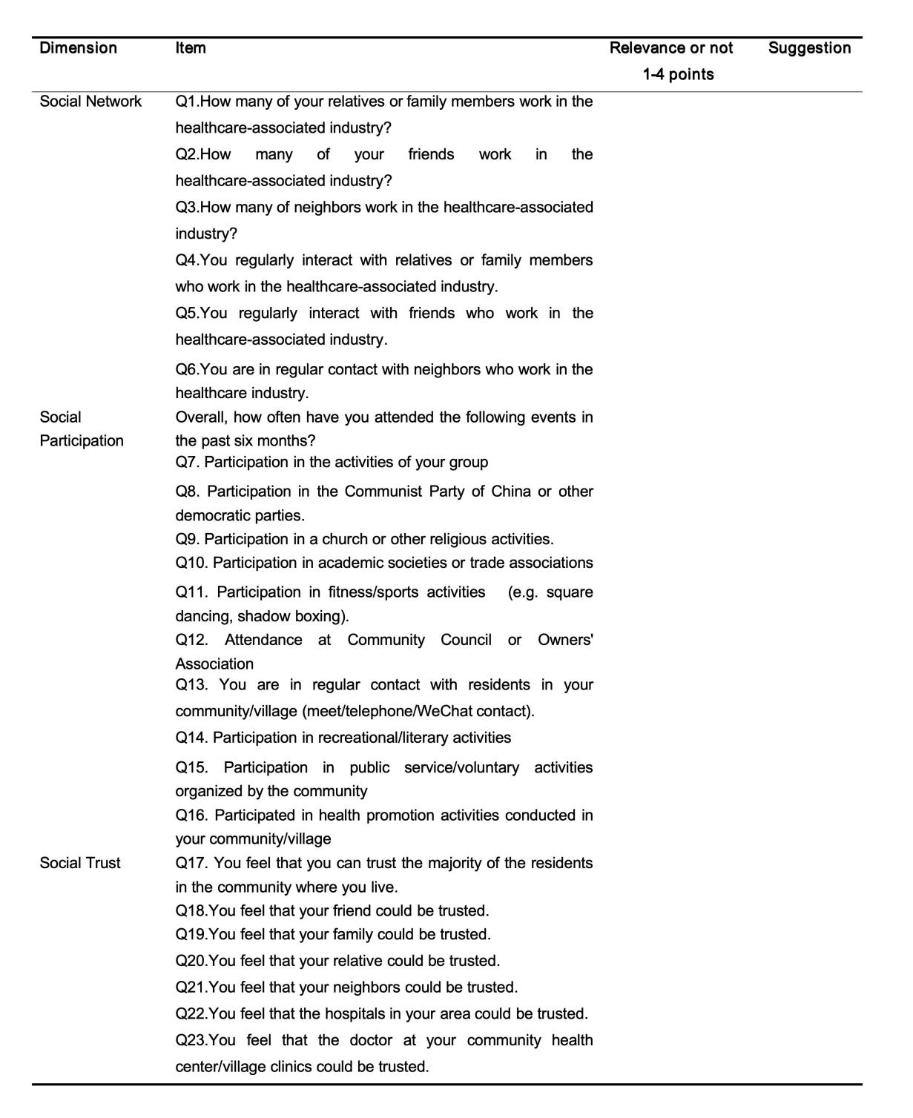
Appendix Figure2a Second Part: The Health-Related Social Capital for Older People Scale Items Pool(The First Expert Consultation )
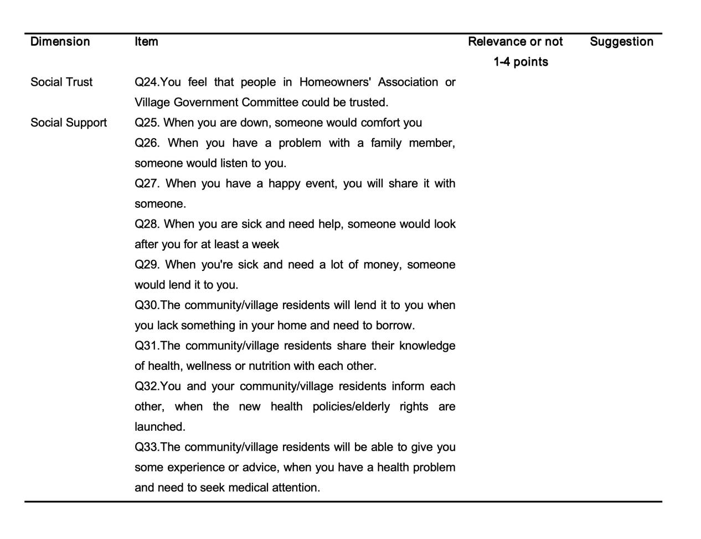
Appendix Figure2b Second Part: The Health-Related Social Capital for Older People Scale Items Pool(The First Expert Consultation )

2. The Results of the First Expert Consultation
Appendix Table 3 The Results of the First Expert Consultation
Item | Number/Count of Experts in Agreement | Whether  Retain  Yes(Y)/No(N) | Modification Result
Q1.How many of your relatives or family members work in the healthcare-associated industry? | 13 | Y
Q2.How many of your friends work in the healthcare-associated industry? | 13 | Y
Q3.How many of neighbors work in the healthcare-associated industry? | 13 | Y
Q4.You regularly interact with relatives or family members who work in the healthcare-associated industry. | 13 | Y | You regularly interact with relatives or family members who work in the healthcare-associated industry. (e.g., doctors, nurses, pharmacists, etc.)
Q5.You regularly interact with friends who work in the healthcare-associated industry. | 12 | Y | You regularly interact with friends who work in the healthcare-associated industry. (e.g., doctors, nurses, pharmacists, etc.)
Q6.You are in regular contact with neighbors who work in the healthcare industry.  Overall, how often have you attended the following events in the past six months? | 14 | Y | You are in regular contact with neighbors who work in the healthcare industry. (e.g., doctors, nurses, pharmacists, etc.)
Q7. Participation in the activities of your group | 14 | Y
Q8. Participation in the Communist Party of China or other democratic parties. | 9 | N
Q9. Participation in a church or other religious activities. | 11 | Y
Q10. Participation in academic societies or trade associations | 13 | Y
Q11. Participation in fitness/sports activities (e.g. square dancing, shadow boxing). | 14 | Y
Q12. Attendance at Community Council or Owners' Association | 13 | Y
Q13. You are in regular contact with residents in your community/village (meet/telephone/WeChat contact). | 14 | Y | Participation in classmate/hometown association activities.
Q14. Participation in recreational/literary activities | 13 | Y
Q15. Participation in public service/voluntary activities organized by the community | 14 | Y | Participation in public service/voluntary activities organized by the community
Q16. Participated in health promotion activities conducted in your community/village | 9 | N
Q17. You feel that you can trust the majority of the residents in the community where you live. | 12 | Y
Q18.You feel that your friend could be trusted. | 14 | Y
Q19.You feel that your family could be trusted. | 14 | Y | You feel that your family or relatives could be trusted.
Q20.You feel that your relative could be trusted. | 10 | N
Q21.You feel that your neighbors could be trusted. | 14 | Y
Q22.You feel that the hospitals in your area could be trusted. | 14 | Y
Q23.You feel that the doctor at your community health center/village clinics could be trusted. | 14 | Y
Q24.You feel that people in Homeowners' Association or Village Government Committee could be trusted. | 13 | Y | You feel that the competence of the community council/village health coach could be trusted.
Q25. When you are down, someone would comfort you | 13 | Y
Q26. When you have a problem with a family member, someone would listen to you. | 13 | Y
Q27. When you have a happy event, you will share it with someone. | 12 | Y
Q28. When you are sick and need help, someone would look after you for at least a week | 14 | Y
Q29. When you're sick and need a lot of money, someone would lend it to you. | 12 | Y
Q30.The community/village residents will lend it to you when you lack something in your home and need to borrow. | 14 | Y | When there is a temporary shortage of medicines and masks in your home, someone will provide them to you.
Q31.The community/village residents share their knowledge of health, wellness or nutrition with each other. | 14 | Y
Q32.You and your community/village residents inform each other, when the new health policies/elderly rights are launched. | 14 | Y
Q33.The community/village residents will be able to give you some experience or advice, when you have a health problem and need to seek medical attention. | 14 | Y

Appendix5: The Second Expert Consultation
1.Questionnaire
Distinguished Professor:

Thank you for taking the time to participate in this expert consultation. We are most grateful for your support! Please check (√) in the box that corresponds to your answer.

First part:
1. Gender: ☐Male ☐Female
2. Age (in years): _____________
3. What is your highest level of education?
☐Doctor ☐Master
4. Working years: _____________
5. What is your Profession title?
☐ Senior ☐ Vice-high ☐ Intermediate
6. Which statement best describes your familiarity with the social capital theory?
☐Very familiar ☐More familiar ☐Average ☐Less familiar ☐Very unfamiliar
7. Which statement best describes your familiarity with the measurements of social capital?
☐Very familiar ☐More familiar ☐Average ☐Less familiar ☐Very unfamiliar
8. Which statement best describes your familiarity with the research on healthy aging?
☐Very familiar ☐More familiar ☐Average ☐Less familiar ☐Very unfamiliar
9. Which statement best describes your judgment origins?
9.1 Theoretical analysis：
☐Very small ☐Small ☐Medium ☐Big ☐Very big
9.2 Practical experience：
☐Very small ☐Small ☐Medium ☐Big ☐Very big
9.3Domestic and international peers understand：
☐Very small ☐Small ☐Medium ☐Big ☐Very big
9.4 intuitive judgment：
☐Very small ☐Small ☐Medium ☐Big ☐Very big

Second Part: The Health-Related Social Capital for Older People Scale Items Pool
Instructions for completing the form:
Relevance or not: “Not relevant = 1,” “Somewhat relevant = 2”, “Quite relevant = 3”, and “Highly relevant = 4”.
Opinions and Suggestions: If you have any opinion or suggestion on a dimension or a specific entry, or if you think that a new indicator should be added, please fill in the "Opinions or Suggestions" in the last column of the form.

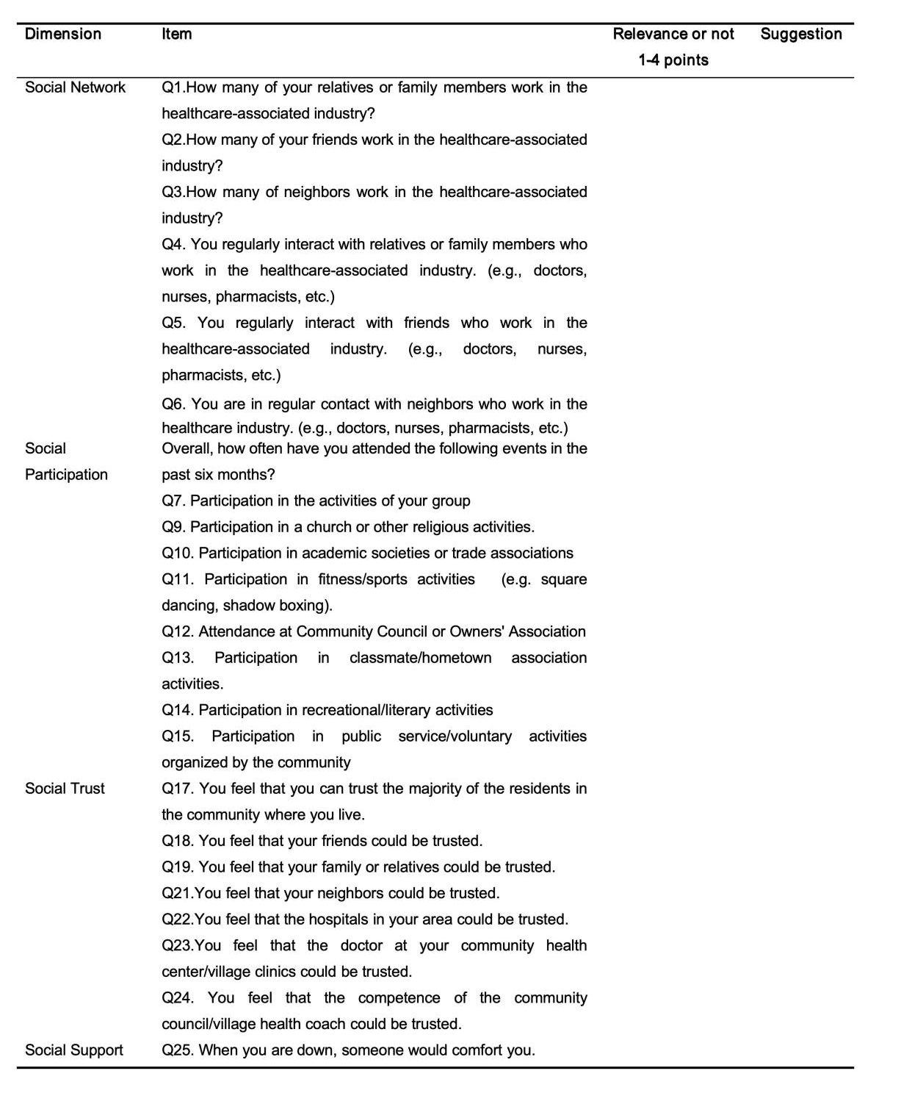
Appendix Figure3a Second Part: The Health-Related Social Capital for Older People Scale Items Pool(The Second Expert Consultation )
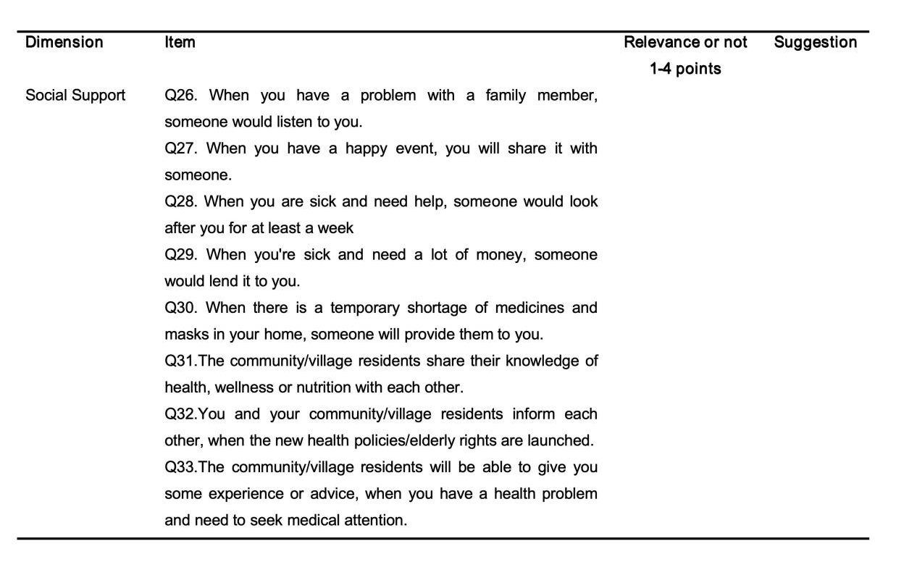
Appendix Figure3b Second Part: The Health-Related Social Capital for Older People Scale Items Pool(The Second Expert Consultation )

2. The Results of the Second Expert Consultation
Appendix Table 4 The Results of the Second Expert Consultation
Item | Number/Count of Experts in Agreement | Whether Retain  Yes(Y)/No(N)
Q1.How many of your relatives or family members work in the healthcare-associated industry? | 14 | Y
Q2.How many of your friends work in the healthcare-associated industry? | 14 | Y
Q3.How many of neighbors work in the healthcare-associated industry? | 14 | Y
Q4. You regularly interact with relatives or family members who work in the healthcare-associated industry. (e.g., doctors, nurses, pharmacists, etc.) | 14 | Y
Q5. You regularly interact with friends who work in the healthcare-associated industry. (e.g., doctors, nurses, pharmacists, etc.) | 14 | Y
Q6. You are in regular contact with neighbors who work in the healthcare industry. (e.g., doctors, nurses, pharmacists, etc.)  Overall, how often have you attended the following events in the past six months? | 14 | Y
Q7. Participation in the activities of your group | 11 | Y
Q9. Participation in a church or other religious activities. | 8 | N
Q10. Participation in academic societies or trade associations | 8 | N
Q11. Participation in fitness/sports activities (e.g. square dancing, shadow boxing). | 14 | Y
Q12. Attendance at Community Council or Owners' Association | 9 | N
Q13. Participation in classmate/hometown association activities. | 12 | Y
Q14. Participation in recreational/literary activities | 13 | Y
Q15. Participation in public service/voluntary activities organized by the community | 13 | Y
Q17. You feel that you can trust the majority of the residents in the community where you live. | 14 | Y
Q18. You feel that your friends could be trusted. | 14 | Y
Q19. You feel that your family or relatives could be trusted. | 14 | Y
Q21.You feel that your neighbors could be trusted. | 14 | Y
Q22.You feel that the hospitals in your area could be trusted. | 14 | Y
Q23.You feel that the doctor at your community health center/village clinics could be trusted. | 14 | Y
Q24. You feel that the competence of the community council/village health coach could be trusted. | 14 | Y
Q25. When you are down, someone would comfort you | 14 | Y
Q26. When you have a problem with a family member, someone would listen to you. | 8 | N
Q27. When you have a happy event, you will share it with someone. | 14 | Y
Q28. When you are sick and need help, someone would look after you for at least a week | 14 | Y
Q29. When you're sick and need a lot of money, someone would lend it to you. | 14 | Y
Q30. When there is a temporary shortage of medicines and masks in your home, someone will provide them to you. | 14 | Y
Q31.The community/village residents share their knowledge of health, wellness or nutrition with each other. | 14 | Y
Q32.You and your community/village residents inform each other, when the new health policies/elderly rights are launched. | 14 | Y
Q33.The community/village residents will be able to give you some experience or advice, when you have a health problem and need to seek medical attention. | 14 | Y

Appendix6: The 26-Item Health-Related Social Capital Scale after the Two Rounds Expert Consultations
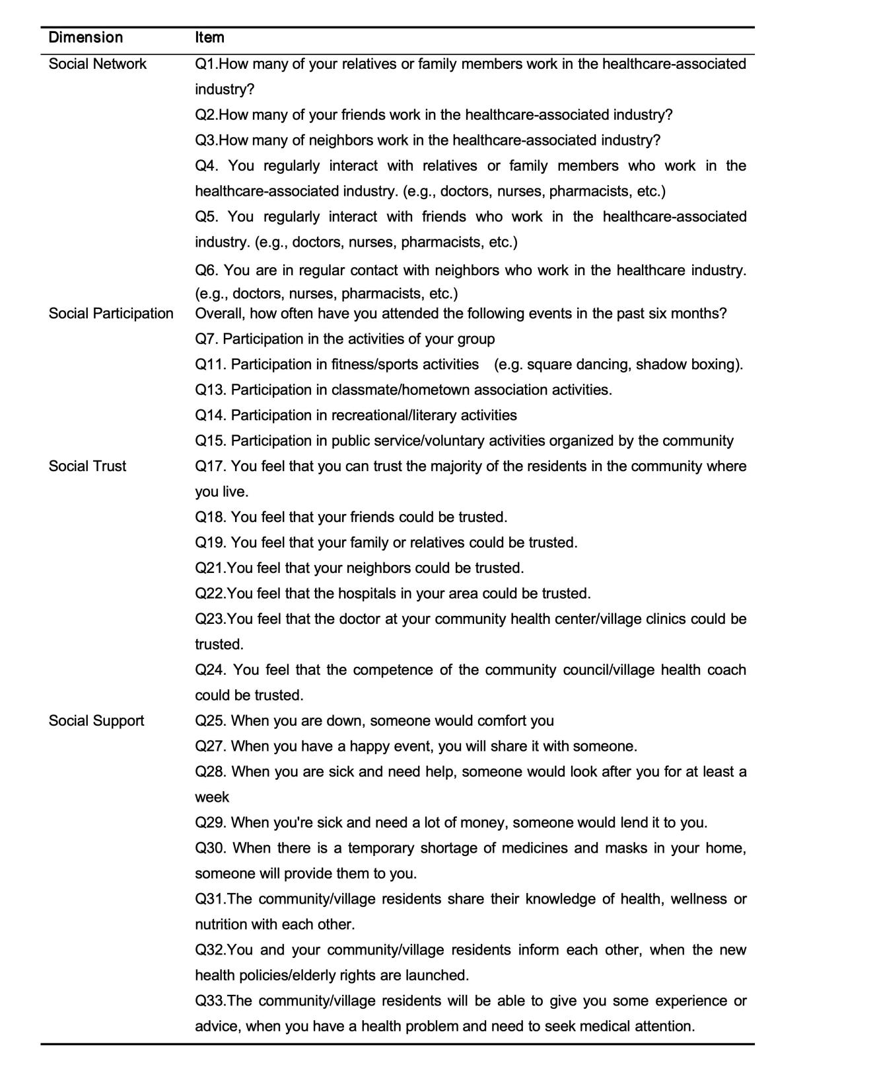
Appendix Figure4 The 26-Item Health-Related Social Capital Scale after the Two Rounds Expert Consultations

Appendix7: The Content Validity of the 26-item Health-Related Social Capital Scale
Appendix Table5 The Content Validity of the 26-item Health-Related Social Capital Scale
Item | Experts in Agreement (N) | I-CVI
Q1 | 14 | 1
Q2 | 14 | 1
Q3 | 14 | 1
Q4 | 14 | 1
Q5 | 14 | 1
Q6 | 14 | 1
Q7 | 11 | 0.786
Q11 | 14 | 1
Q13 | 12 | 0.857
Q14 | 13 | 0.929
Q15 | 13 | 0.929
Q17 | 14 | 1
Q18 | 14 | 1
Q19 | 14 | 1
Q21 | 14 | 1
Q22 | 14 | 1
Q23 | 14 | 1
Q24 | 14 | 1
Q25 | 14 | 1
Q27 | 14 | 1
Q28 | 14 | 1
Q29 | 14 | 1
Q30 | 14 | 1
Q31 | 14 | 1
Q32 | 14 | 1
Q33 | 14 | 1
S-CVI/Ave |  | 0.981
S-CVI/UA |  | 0.846
Abbreviations: I-CVI = Item-level Content Validity Index; S-CVI/Ave = Scale-level Content Validity Index based on the averaging method; S-CVI/UA = Scale-level Content Validity Index based on Universal Agreement. Common acceptability criteria are: I-CVI ≥ 0.78, S-CVI/Ave ≥ 0.90, S-CVI/UA ≥ 0.80.
Appendix8:The Final Health-related Social Capital Scale Items Pool
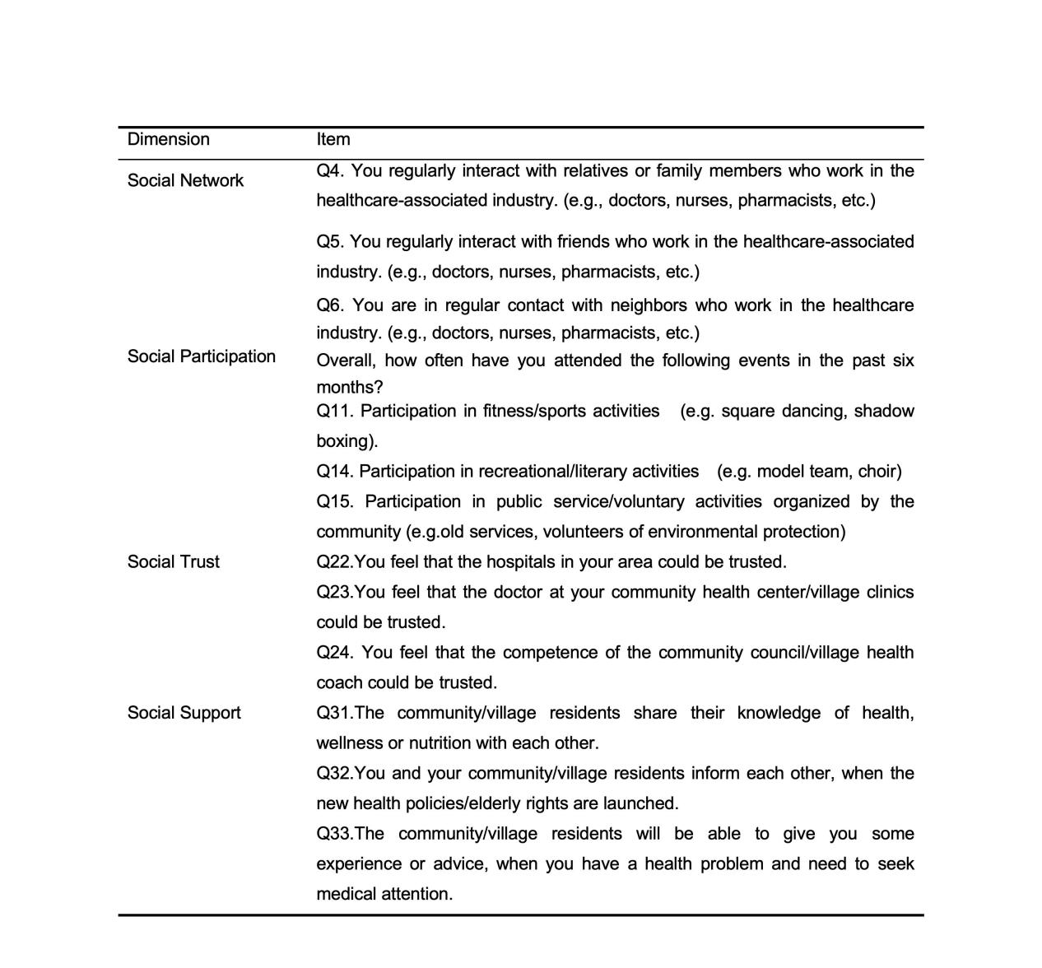
Appendix Figure 5 The Final Health-related Social Capital Scale Items Pool
Appendix9:The EFA of Final Health-Related Social Capital Scale
Appendix Table6 The EFA of Final Health-Related Social Capital Scale (KMO=0.767, χ2 = 2169.45, df = 66, p < 0.001)
Item | Communalities | Factor 1 | Factor 2 | Factor 3 | Factor 4
Q4 | 0.449 | 0.688 | -0.158 | 0.193 | 0.368
Q5 | 0.585 | 0.928 | -0.195 | 0.332 | 0.266
Q6 | 0.459 | 0.710 | -0.160 | 0.300 | 0.260
Q11 | 0.301 | 0.253 | -0.141 | 0.616 | 0.148
Q14 | 0.420 | 0.237 | -0.182 | 0.751 | 0.127
Q15 | 0.447 | 0.273 | -0.225 | 0.800 | 0.091
Q22 | 0.504 | 0.135 | -0.788 | 0.179 | 0.267
Q23 | 0.536 | 0.151 | -0.850 | 0.188 | 0.230
Q24 | 0.456 | 0.226 | -0.734 | 0.217 | 0.264
Q31 | 0.452 | 0.268 | -0.26 | 0.102 | 0.740
Q32 | 0.520 | 0.357 | -0.273 | 0.105 | 0.790
Q33 | 0.527 | 0.296 | -0.246 | 0.209 | 0.829
Rotation Sums of Squared Loading |  | 2.412 | 2.275 | 2.000 | 2.373
% of variance |  | 28.264 | 12.505 | 11.641 | 7.805
Note: Principal axis factoring with Oblique rotation was conducted.
Factor loadings with an absolute value >=0.40 are in bold.
Factor labels were assigned based on item content and theoretical alignment: Factor 1 = Social Network, Factor 2 = Social Trust, Factor 3 =Social Participation, Factor 4 = Social Support.
Communalities represent the proportion of each item's variance explained by the common factors.

Appendix10: External Validity of the Final Scale
Appendix Table7 The Associations between the Four Dimension and Total Scale and Key Available Attributes and Self-Rated Health Status
Variable | Social Networks | Social Participation | Social Trust | Social Support | Total scale
Variable | β | β | β | β | β
Gender | 0.411 | -0.483 | -0.107 | -0.072 | -0.252
Age | -0.017 | 0.044 | -0.026 | -0.027 | -0.026
Education level | 0.070 | 0.174 | -0.061 | 0.096 | 0.279
Monthly income | 0.334* | 0.353** | -0.007 | 0.192 | 0.872*.
Residence( Urban(reference))
Town | 0.642 | 0.731. | 0.656. | 0.464 | 2.492*
Rural | 0.808. | 1.037* | 0.481 | 0.456 | 2.782*
Living arrangement
(Living alone(reference))
Living with partner only | -0.260 | -0.646 | -1.504** | -0.934. | -3.344*
Living with children's family only | -0.594 | -1.011 | -1.331* | -0.718 | -3.655*
Living with partner and children's family | 0.639 | -0.310 | -1.555** | -0.579 | -1.804
Other | 0.867 | 1.058 | -0.740 | 0.359 | 1.544
Health status
(Very poor(reference))
Poor | 1.003 | 0.717 | 1.882* | 0.172 | 3.773
Fair | 0.781 | 0.817 | 1.187 | -0.188 | 2.597
Good | -0.085 | 0.250 | 1.289 | -0.537 | 0.917
Excellent good | 1.029 | 1.422 | 2.528** | -0.843 | 4.136.
Note:. p<0.1;* p<0.05,** p<0.01
Figure Legends
Appendix Figure1a The Original Health-Related Social Capital Scale Items Pool
Appendix Figure1b The Original Health-Related Social Capital Scale Items Pool
Appendix Figure2a Second Part: The Health-Related Social Capital for Older People Scale Items Pool(The First Expert Consultation )
Appendix Figure2b Second Part: The Health-Related Social Capital for Older People Scale Items Pool(The First Expert Consultation )

Appendix Figure3a Second Part: The Health-Related Social Capital for Older People Scale Items Pool(The Second Expert Consultation )
Appendix Figure3b Second Part: The Health-Related Social Capital for Older People Scale Items Pool(The Second Expert Consultation )
Appendix Figure4 The 26-Item Health-Related Social Capital Scale after the Two Rounds Expert Consultations
Appendix Figure 5 The Final Health-related Social Capital Scale Items Pool

