Supplemental tables and figures for “Hyperbaric oxygen treatment as a novel add-on in selected patients with infective endocarditis – a safety and feasibility trial”:
Table of Content | Page
Analysis of serum cytokines and by flow cytometry | 2
Supplementary Tables
Table S1 – Side-effects of HBO₂ treatment | 4
Table S2 – Echocardiographic parameters before and after HBO₂ treatment | 5
Table S3 – Standard biochemistry at inclusion | 6
Supplementary Figures
Figure S1 – HBO₂ treatment table Rigshospitalet 14 (RH14) | 7
Figure S2 – Changes in biomarker levels pre- and post-HBO₂ treatment | 8
Figure S3 – Serum cytokine and adhesion molecule levels pre- and post-HBO₂ treatment | 9
Figure S4 – Changes in serum biomarker levels pre- and post-HBO₂ treatment | 10
Figure S5 – Flow cytometry analysis of whole blood pre- and post-HBO₂ treatment | 11
Figure S6 – Flow cytometry analysis of whole blood pre- and post-HBO₂ treatment | 12

Serum cytokines
For multiplex analysis, a human cytokine assay (Bio-Rad, Hercules, CA) was used on a LUMINEX® 200TM platform (Luminex Corporation, Austin, TX). Granulocyte–colony stimulating factor (G-CSF),¹⁵ urokinase plasminogen activator surface receptor (uPAR, CD87)¹⁶, interleukin (IL)-1β and IL-8^{15,17}, vascular endothelial growth factor (VEGF)¹⁸, intercellular adhesion molecule 1 (ICAM-1)¹⁹, vascular cell adhesion protein 1 (VCAM-1)²⁰ and E-selectin²⁰ were measured (purchased from R&D systems, Abingdon, UK). Missing samples and sample outliers with values beyond ±2 standard deviations were excluded for analysis.

Flow cytometry
To measure total leukocyte count (data not shown) and neutrophils (Panel 1), 50 µl of citrate whole blood were added to a counting tubes (BD Trucount™ tube, 340334) placed on ice followed by addition of 10 µl each of the following antibodies: CD11b Monoclonal Antibody (M1/70), APC, eBioscience™, CD15 Monoclonal Antibody (HI98), FITC, eBioscience, and CD45 Monoclonal Antibody (HI30), eFluor 450,eBioscience. The samples were incubated in the dark for 30 min and added 1 ml FACS lysing solution (BD FACS™ lysing Solution) dilute 1:10 in MilliQH2O for simultaneous lysing of erythrocytes and fixation. After incubation for 10 minutes, the samples were analyzed by flow cytometry.
For estimating platelet-neutrophil-complexes (Panel 2), 100 µl of citrate whole blood were added to a 5 mL falcon tube (Corning Science México S.A. de C.V. Ref 352054) placed on ice followed by addition of 10 µl each of the following antibodies: CD11b Monoclonal Antibody (ICRF44), Super Bright 600, eBioscience, CD15 Monoclonal Antibody (HI98), eFluor 450, eBioscience, CD42b Monoclonal Antibody (HIP1), FITC, eBioscience, and CD62P (P-Selectin) Monoclonal Antibody (Psel.KO2.3), APC, eBioscience. The samples were incubated in the dark for 30 min and diluted 1000 times in cold PBS filtered through a 0.22 µm filter before flow cytometrical analysis on an Attune NxT flow cytometer (Thermo Fisher Scientific, Waltham, MA, USA).
Samples from panel 1 were recorded using standard filter settings and samples from panel 2 were recorded using the Attune NxT No-Wash No-Lyse Filter Kit (Thermo Fisher Scientific)²¹. Missing and failed samples and outliers with values beyond ±2 standard deviations were excluded from the analysis.

SUPPLEMENTARY TABLES

Supplementary table 1:
Side-effects of HBO₂ treatment
Registered side-effects of HBO₂ treatment | Number of patients/Total HBO₂ sessions  (n=13/ n=62)
Any side-effect | 3/4
Ear barotrauma | 0/0
Claustrophobia | 2/3
Arrythmia | 0/0
Oxygen seizures | 0/0
Hypoglycemia | 0/0
Other | 2/2

Supplementary table 2:
Echocardiographic parameters
ECHO measurements | ECHO prior to diagnosis of IE  n = 8 | ECHO before HBO₂ treatment  n =10 | ECHO after HBO₂  treatment  n =10
LVEF
Normal (55-60%) | 6 (75%) | 6 (60%) | 6 (60%)
Mildly impaired (45-55%) | 1 (13%) | 2 (20%) | 3 (30%)
Moderately impaired (35-45%) | 1 (13%) | 2 (20%) | 1 (10%)
Vegetations max. length
0-5 mm |  | 5 (50%) | 6 (60%)
5-10 mm |  | 5 (50%) | 4 (40%)
> 10 mm |  | 0 (0%) | 0 (0%)
Moderate to severe aortic stenosis | 2 (25%) | 3 (30%) | 3 (30%)
Moderate to severe mitral stenosis | 2 (25%) | 2 (20%) | 2 (20%)
Moderate to severe aortic regurgitation | 0 (0%) | 1 (10%) | 1 (10%)
Moderate to severe mitral regurgitation | 0 (0%) | 1 (10%) | 1 (10%)

Supplementary table 3:
Standard biochemistry at inclusion
Biochemistry | Median (IQR)
CRP – mg/L | 26.0 (15.0, 57.5)
Leukocytes - x 10⁹/L | 8.6 (7.4, 10.8)
Neutrofilic leuc. | 6.3 (4.6, 7.9)
Lymphocytes | 1.3 (1.2, 2.3)
Eosinfilic leuc. | 0.2 (0.1, 0.4)
Monocytic leuc. | 0.7 (0.5, 0.8)
Thrombocytes - x 10⁹/L | 295.5 (232.5, 353.5)
Procalcitonin – ng/mL | 0.3 (0.1, 0.6)
Potassium (K⁺) – mmol/L | 3.8 (3.6, 3.9)
Sodium (Na⁺) – mmol/L | 138.5 (135.5, 141.8)
Calcium (Ca²⁺) – mmol/L | 1.3 (1.3, 1.3)
Glucose – mmol/L | 6.6 (6.6, 8.4)
Creatinine - μmol/L | 83.0 (61.0, 98.0)
Hemoglobin – mmol/L | 6.2 (5.8, 7.3)
INR | 1.2 (1.1, 1.2)
D-dimer - mg/L (FEU) | 0.5 (0.5, 0.5)
ALAT – U/L | 25.0 (22.5, 30.5)
Bilirubin - μmol/L | 9.0 (5.8, 12.2)
Alkaline phosphate – U/L | 89.5 (74.0, 109.8)

SUPPLEMENTAL FIGURES:

Figure S1
Time, minutes
Pressure/
MSW
Table RH 14
10
5
27
14
0

AIR

OXYGEN
5
5
27
26
Figure S1: HBO₂ treatment table Rigshospitalet 14 (RH14). A total of 90 minutes oxygen breathing at 14 msw overpressure (240 kPa) using two air brakes. Patients continue oxygen breathing during decompression phase. MSW = meters sea water pressure.

Figure S2
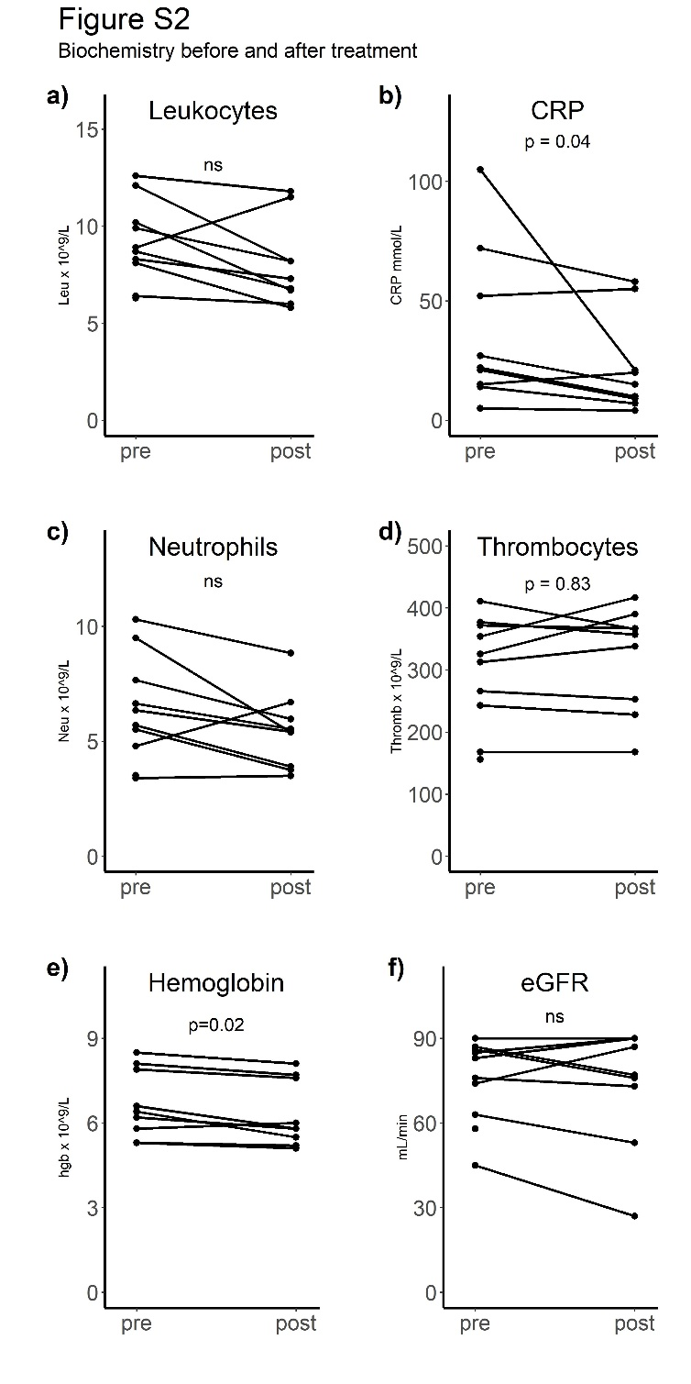
Figure S2. Changes in biomarker levels pre- and post-HBO₂ treatment. Blood levels of leucocytes (a), plasma levels of C-reactive protein (CRP) (b) blood levels of neutrophilic leucocytes (c) blood levels of thrombocytes (d), plasma hemoglobin levels (e) and estimated glomerular filtration rate (eGFR) (f) were measured before (pre) and after (post) each hyperbaric oxygen (HBO₂) treatment. Statistical analysis was performed using the Wilcoxon matched pairs signed rank test. ns = non-significant (p >0.05).

Figure S3
Figure S3. Serum cytokine and adhesion molecule levels pre- and post-HBO₂ treatment. Serum levels of interleukin 8 (a), urokinase plasminogen activator surface receptor (uPAR) (b), intercellular adhesion molecule 1 (ICAM-1) (c), and vascular endothelial growth factor (VEGF) (d) was measured before (pre) and after (post) each hyperbaric oxygen (HBO₂) treatment. Concentrations are presented in pg/mL. The number of patients included in the analysis for each HBO₂ session was as follows: session 1 (n=9), session 2 (n=7), session 3 (n=8), session 4 (n=9), session 5 (n=9), and session 6 (n=7). Missing samples and outliers beyond ± standard deviations were excluded. Statistical analysis was not performed.

Figure S4

Figure S4. Changes in serum biomarker levels pre- and post-HBO₂ treatment. Serum levels of granulocyte colony-stimulating factor (G-CSF) (a), vascular cell adhesion protein 1 (VCAM-1) (b) and E-selectin (c) were measured before (pre) and after (post) each hyperbaric oxygen (HBO₂) treatment. Pooled data pre and post hyperbaric oxygen (HBO₂) treatment showed a significant increase of VCAM-1 and E-selectin and a significant decrease of granulocyte colony-stimulating factor (G-CSF). Values presented in pg/mL. Statistical analysis was performed using the Wilcoxon matched pairs signed rank test (*P ≤ 0.05).

Figure S5
Figure S5. Flow cytometry analysis of whole blood pre- and post-HBO₂ treatment. Flow cytometry was used to analyze whole blood samples collected pre and post HBO₂ treatment, at session 1, 3 and 5. Neutrophils (a) and activated neutrophils (b) we quantified. A paired t-test was used to compare pre- and post-HBO₂ measurements. Abbreviations: MFI, mean fluorescent index; ns, non-significant; n=samples for analysis.

Figure S6

Figure S6. Flow cytometry analysis of whole blood pre- and post-HBO₂ treatment. Flow cytometry was performed on whole blood samples collected before pre and post HBO₂ treatment. Statistical analysis was conducted using the Wilcoxon matched pairs signed rank test for non-parametric data (a, b) and a paired t-test for parametric data (c, d). Abbreviations: MFI, mean fluorescent index; ns, non-significant. Significant decreases are indicated by asterisks (*P ≤ 0.05; **P ≤ 0.001).

