Supporting Information

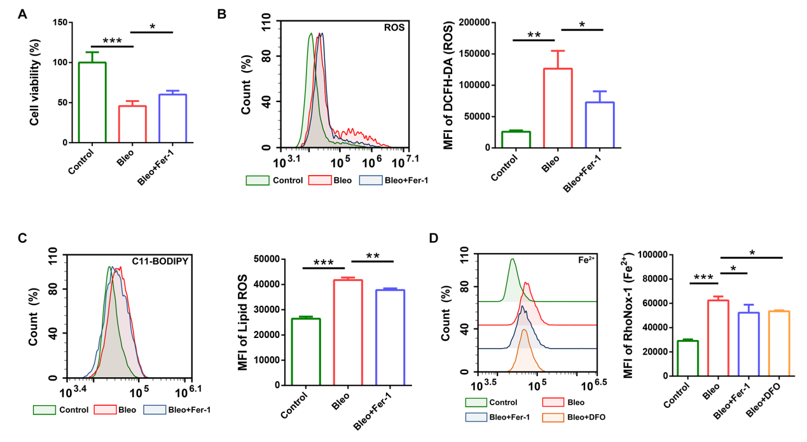
Figure S1. Bleomycin induces ferroptosis in MLE-12 cells in vitro.
(A) Cell viability of MLE-12 cells following treatment with bleomycin or bleomycin + Fer-1, as assessed by CCK-8 assay. (B) Intracellular ROS levels measured by flow cytometry using DCFH-DA probe after bleomycin or bleomycin + Fer-1 treatment. (C) Lipid peroxidation levels detected by flow cytometry using the C11-BODIPY probe following bleomycin or bleomycin + Fer-1 treatment. (D) Intracellular Fe²⁺ levels assessed by flow cytometry after treatment with bleomycin, bleomycin + Fer-1, or DFO. Data are presented as the mean ± SD. *P < 0.05, **P < 0.01, ***P < 0.001

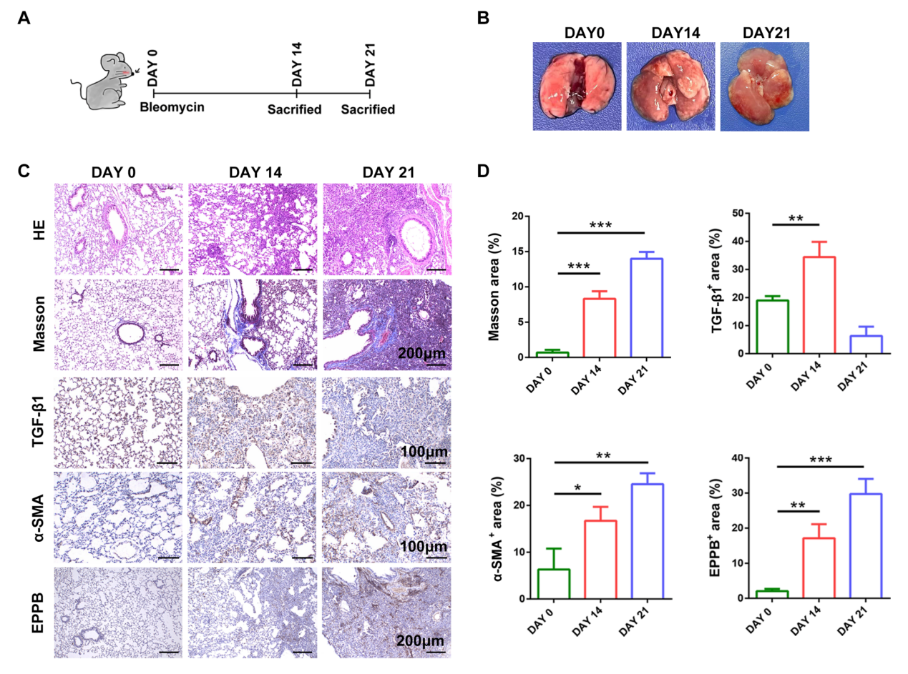
Figure S2. Establishment of a bleomycin-induced pulmonary fibrosis model via intratracheal instillation in mice.
(A) Schematic diagram of the experimental design. (B) Representative gross images of mouse lungs on Day 0, Day 14, and Day 21 post-bleomycin instillation. (C) Histological analyses of lung tissues by HE and Masson's trichrome staining; immunohistochemical staining for TGF-β1 and α-SMA; and enhanced Prussian blue (EPPB) staining for iron deposition. (D) Quantitative analysis of histological and immunohistochemical staining results. Data are presented as the mean ± SD. *P < 0.05, **P < 0.01, ***P < 0.001
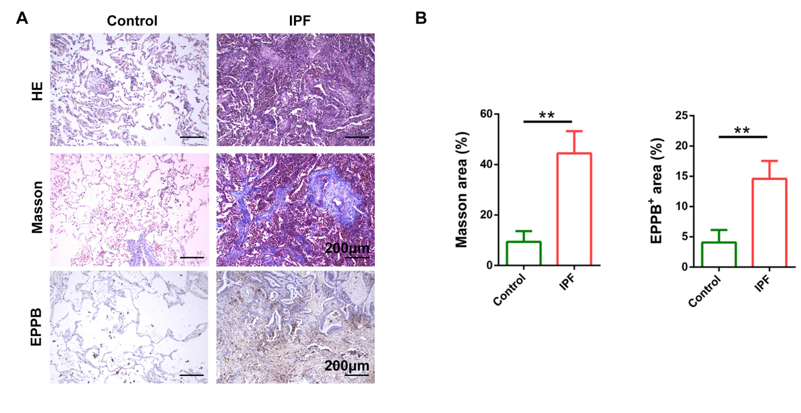
Figure S3. Histopathological analysis of lung tissue sections from IPF patients.
- Representative images of HE staining, Masson's trichrome staining and EPPB staining. (B) Quantitative analysis of histological and IHC staining results. Data are presented as the mean ± SD. ns P > 0.05, **P < 0.01

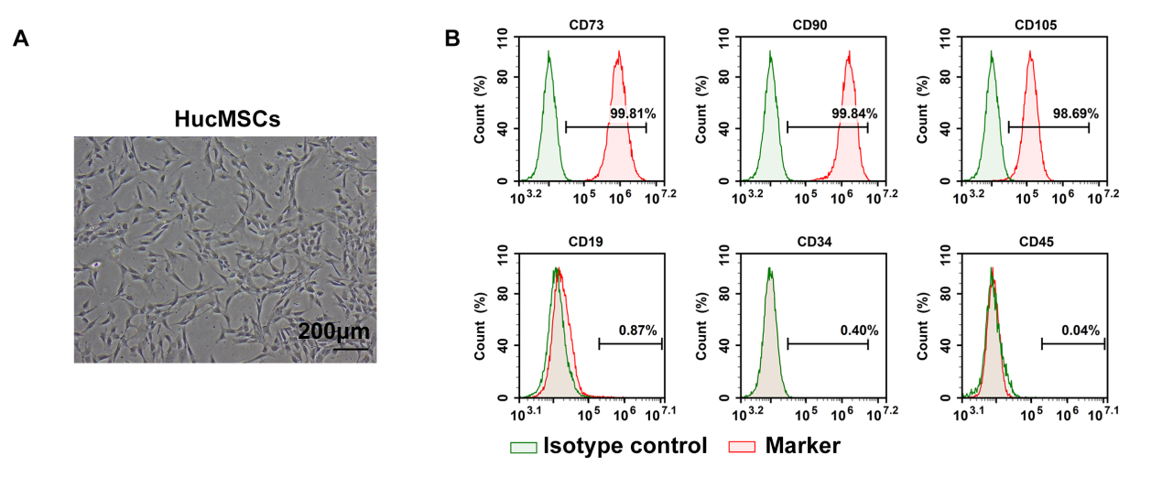
Figure S4. Culture and characterization of HucMSCs.
- Morphology of HucMSCs observed under a light microscope. (B) Flow cytometric analysis of surface marker expression.

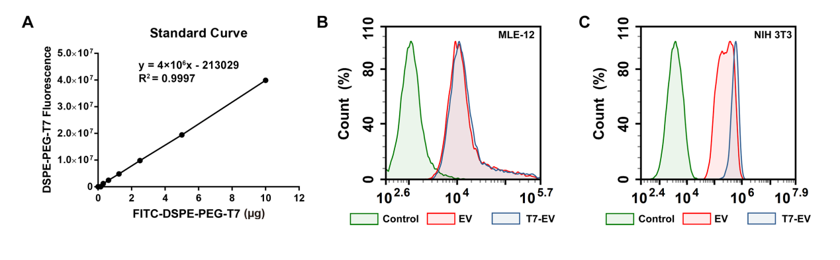
Figure S5. Preparation and cellular uptake of T7-EV
(A) Standard curve of FITC-DSPE-PEG-T7. (B) Flow cytometric analysis of EV and T7-EV uptake by MLE-12 cells. (C) Flow cytometric analysis of EV and T7-EV uptake by NIH 3T3 cells.
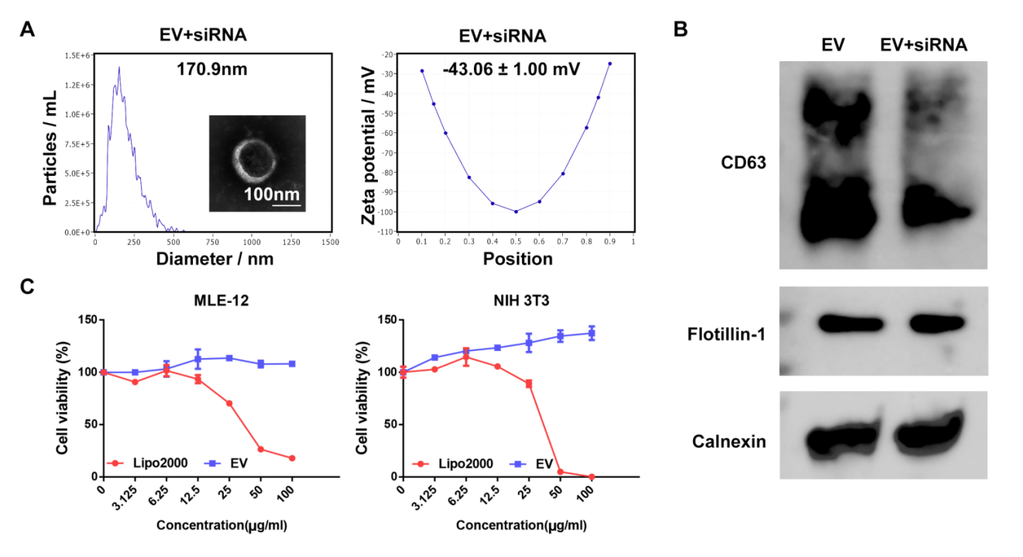
Figure S6. Preparation and characterization of EV+siRNA complexes
(A) Transmission electron microscopy, particle size, and zeta potential characterization of EV+siRNA complexes. (B) Western blot analysis of CD63, Flotillin-1, and Calnexin expression in EVs and EV+siRNA complexes. (C) CCK-8 assay to evaluate the cytotoxicity of Lipo2000 and EVs on MLE-12 and NIH 3T3 cells.
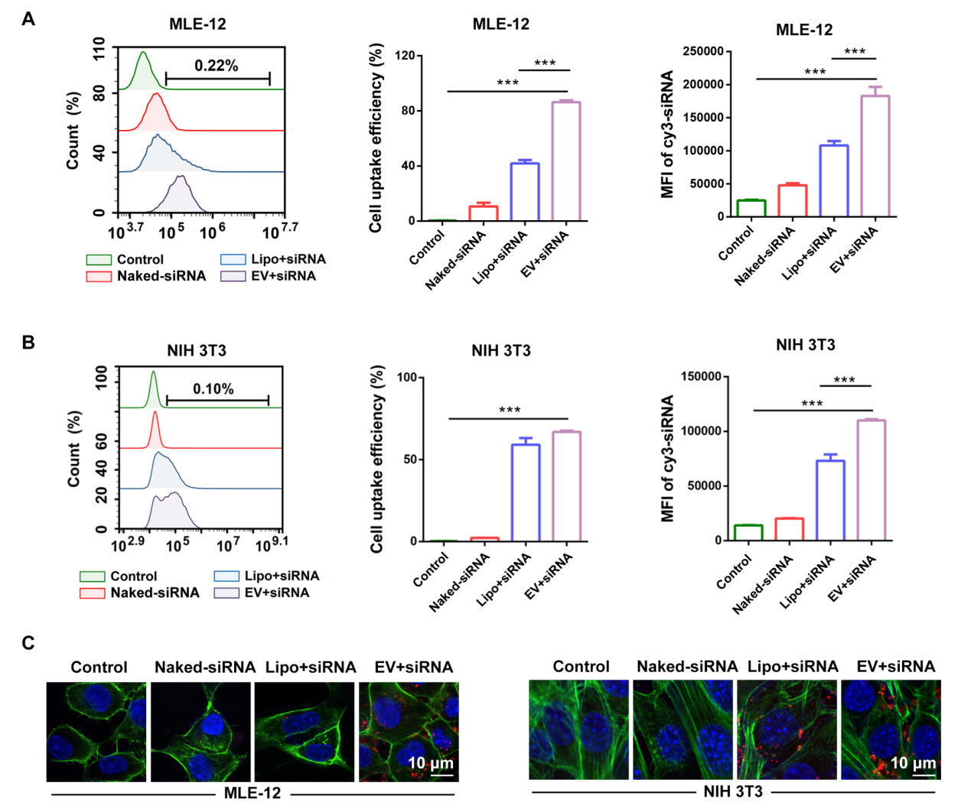
Figure S7. Validation of siRNA delivery efficiency by EV+siRNA complexes
(A) Flow cytometry analysis of uptake efficiency of Naked-siRNA, Lipo+siRNA, and EV+siRNA by MLE-12 and (B) NIH 3T3 cells. (C) Representative confocal microscopy images showing the uptake of Naked-siRNA, Lipo+siRNA and EV+siRNA by MLE-12 and NIH 3T3 cells after 24 h of incubation. Data are presented as the mean ± SD. ***P < 0.001
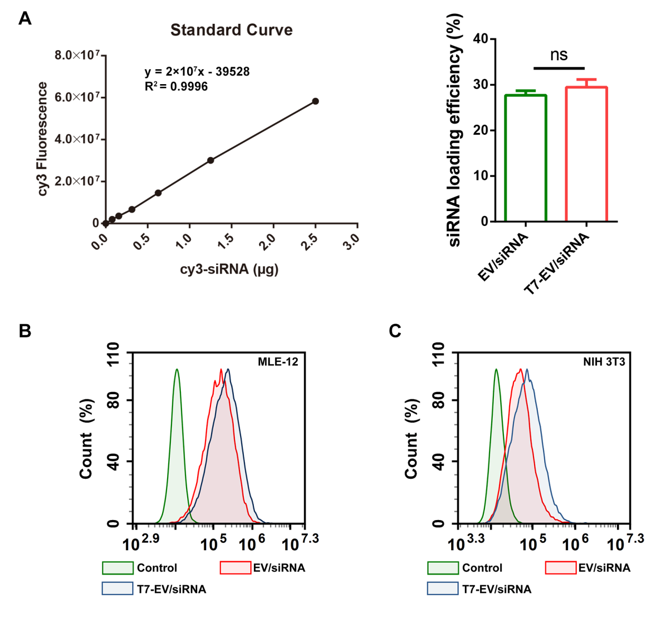
Figure S8. Loading efficiency and delivery capability of T7-EV/siRNA
- siRNA loading efficiency in EV/siRNA and T7-EV/siRNA complexes. B) Flow cytometry analysis of uptake efficiency of EV/siRNA and T7-EV/siRNA by MLE-12 and (C) NIH 3T3 cells.

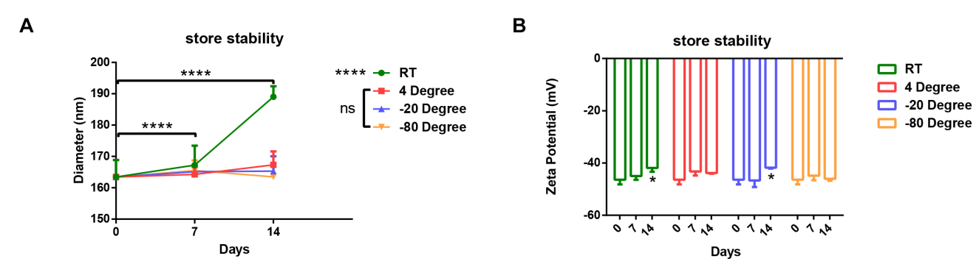
Figure S9. Storage conditions of T7-EV/siTGF-β1
(A) Particle size measured by NTA after storage at room temperature, 4 °C, −20 °C, and −80 °C for 0, 7, and 14 days. (B) Zeta potential measured by NTA after storage at room temperature, 4 °C, −20 °C, and −80 °C for 0, 7, and 14 days. Data are presented as the mean ± SD. *P < 0.05, ****P < 0.0001

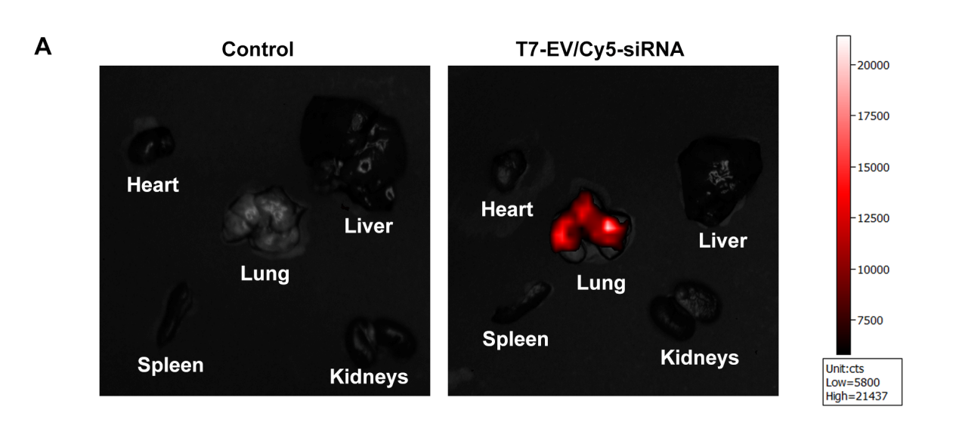
Figure S10. Biodistribution of T7-EV/Cy5-siRNA following nebulized inhalation
(A) Ex vivo imaging showing the distribution of T7-EV/Cy5-siRNA in major organs after nebulized administration.

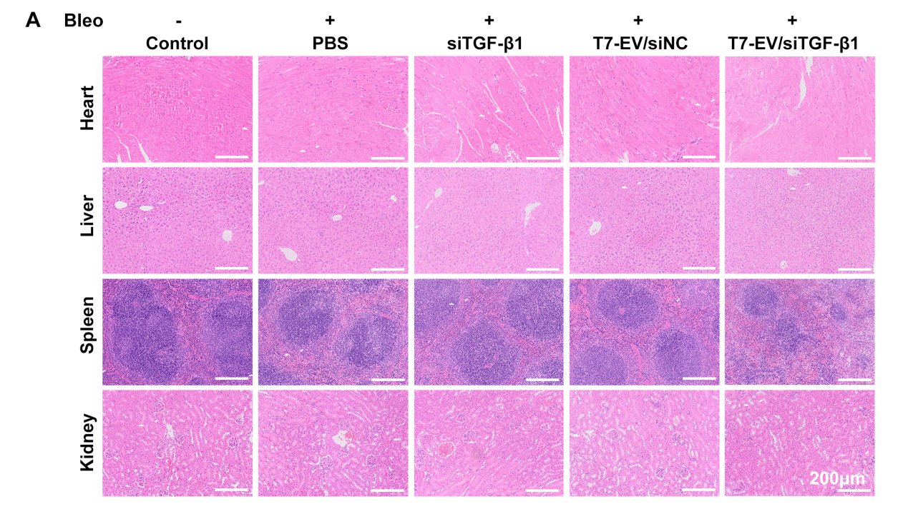
Figure S11. Preliminary safety evaluation of T7-EV/siTGF-β1
(A) HE staining of major organs.

