Supplementary Files
Index of supplementary materials
Supplementary 1. Detailed Search Strategy
Supplementary 2. Data synthesis and integration
Supplementary 3. Methodological quality
3.1 Quality Assessment of Qualitative research
3.2 Quality Assessment of Quantitative research

Supplementary 1. Detailed Search Strategy
PubMed 353
#1 | "Acupuncture Therapy"[Mesh] OR "Moxibustion"[Mesh] OR "Cupping Therapy"[Mesh] OR "Acupressure"[Mesh] OR "Tai Ji"[Mesh] | 34682
#2 | "Acupuncture"[TIAB] OR "Electroacupuncture"[TIAB] OR "Moxibustion"[TIAB] OR "Moxa"[TIAB] OR "Cupping"[TIAB] OR "Tui Na"[TIAB] OR "Qigong"[TIAB] OR "Tai Chi"[TIAB] OR "Acupressure"[TIAB] OR "Auriculotherapy"[TIAB] OR ("dietary therapy"[TIAB] AND ("chinese medicine"[TIAB] OR "TCM"[TIAB])) | 44672
#3 | Search: #1 OR #2 | 50647
#4 | "Patient Preference"[Mesh] OR "Decision Making"[Mesh] | 260362
#5 | "preference*"[TIAB] OR "choice*"[TIAB] OR "attitude*"[TIAB] OR "perception*"[TIAB] OR "belief*"[TIAB] OR "motivation*"[TIAB] OR "barrier*"[TIAB] OR "willingness"[TIAB] OR "acceptability"[TIAB] OR "decision making"[TIAB] OR "reason* for use"[TIAB] | 2059162
#6 | Search: #4 OR #5 | 2204874
#7 | "Neoplasms"[MeSH Terms] | 4151857
#8 | "Neoplasm*"[TIAB] OR "Tumor*"[TIAB] OR "Cancer*"[TIAB] OR "Malignan*"[TIAB] | 4105896
#9 | Search: #7 OR #8 | 5476868
#10 | Search:(#1 OR #2) AND (#4 OR #5) AND (#7 OR #8) | 353
CINAHL 253
#1 | S1=(MH "Acupuncture+") OR (MH "Acupressure") OR (MH "Moxibustion") OR (MH "Massage") OR (MH "Qigong") OR (MH "Tai Chi") | 38086
#2 | S2=TI ( Acupuncture OR Electroacupuncture OR Moxibustion OR Moxa OR Cupping OR "Tui Na" OR Qigong OR "Tai Chi" OR Acupressure OR Auriculotherapy ) OR AB ( Acupuncture OR Electroacupuncture OR Moxibustion OR Moxa OR Cupping OR "Tui Na" OR Qigong OR "Tai Chi" OR Acupressure OR Auriculotherapy ) | 20050
#3 | S1 OR S2 | 42622
#4 | S4=(MH "Patient Preferences") OR (MH "Attitudes+") OR (MH "Decision Making+") | 166894
#5 | S5= TI ( preference* OR choice* OR attitude* OR perception* OR belief* OR motivation* OR barrier* OR willingness OR acceptability OR "decision making" OR "reasons for use" ) OR AB ( preference* OR choice* OR attitude* OR perception* OR belief* OR motivation* OR barrier* OR willingness OR acceptability OR "decision making" OR "reasons for use" ) | 638928
#6 | S4 OR S5 | 741904
#7 | (MH "Neoplasms+") | 674922
#8 | TI ( Neoplasm* OR Tumor* OR Cancer* OR Malignan* ) OR AB ( Neoplasm* OR Tumor* OR Cancer* OR Malignan* ) | 693412
#9 | S7 OR S8 | 926631
#10 | S3 AND S6 AND S9 | 253
Embase 1319
#1 | 'acupuncture'/exp OR 'moxibustion'/exp OR 'qigong'/exp OR 'tai chi'/exp OR 'acupressure'/exp OR 'massage'/exp | 92983
#2 | ('acupuncture' OR 'electroacupuncture' OR 'moxibustion' OR 'moxa' OR 'cupping' OR 'tui na' OR 'qigong' OR 'tai chi' OR 'acupressure' OR 'auriculotherapy'):ti,ab,kw | 63984
#3 | #1 OR #2 | 100672
#4 | 'patient preference'/exp OR 'health attitude'/exp OR 'decision making'/exp | 700890
#5 | (preference* OR choice* OR attitude* OR perception* OR belief* OR motivation* OR barrier* OR willingness OR acceptability OR 'decision making' OR 'reasons for use'):ti,ab,kw | 2654922
#6 | #4 OR #5 | 2990725
#7 | 'neoplasm'/exp | 6867129
#8 | (neoplasm* OR tumor* OR cancer* OR malignan*):ti,ab,kw | 5797562
#9 | #7 OR #8 | 7989059
#10 | #3 AND #6 AND #9 | 1319
Proquest 66
abstract("Acupuncture" OR "Electroacupuncture" OR "Moxibustion" OR "Moxa" OR "Cupping" OR "Tui Na" OR "Qigong" OR "Tai Chi" OR "Acupressure" OR "Auriculotherapy") AND abstract(preference* OR choice* OR attitude* OR perception* OR belief* OR motivation* OR barrier* OR willingness OR acceptability OR "decision making" OR "reasons for use") AND abstract(Neoplasm* OR Tumor* OR Cancer* OR Malignan*) | 66
Psyclnfo 12
S1 | MeSH "Acupuncture" OR DE "Qigong" OR DE "Tai Chi" OR DE "Massage" | 8
S2 | AB ( Acupuncture OR Electroacupuncture OR Moxibustion OR Moxa OR Cupping OR "Tui Na" OR Qigong OR "Tai Chi" OR Acupressure OR Auriculotherapy ) | 408
S3 | S1 OR S2 | 408
S4 | MeSH "Treatment Preferences" OR DE "Attitudes" OR DE "Decision Making" OR DE "Motivation" OR DE "Beliefs" | 6966
S5 | AB ( preference* OR choice* OR attitude* OR perception* OR belief* OR motivation* OR barrier* OR willingness OR acceptability OR "decision making" OR "reasons for use" ) | 52071
S6 | S4 OR S5 | 55344
S7 | MeSH "Neoplasms" | 690
S8 | AB ( Neoplasm* OR Tumor* OR Cancer* OR Malignan* ) | 1495
S9 | S7 OR S8 | 1578
S10 | S3 AND S6 AND S9 | 12
Web of Science 201
"Acupuncture" OR "Electroacupuncture" OR "Moxibustion" OR "Moxa" OR "Cupping" OR "Tui Na" OR "Qigong" OR "Tai Chi" OR "Acupressure" OR "Auriculotherapy" (Abstract) and preference* OR choice* OR attitude* OR perception* OR belief* OR motivation* OR barrier* OR willingness OR acceptability OR "decision making" OR "reasons for use" (Abstract) and Neoplasm* OR Tumor* OR Cancer* OR Malignan* (Abstract) | 201
WAN FANG DATA 412
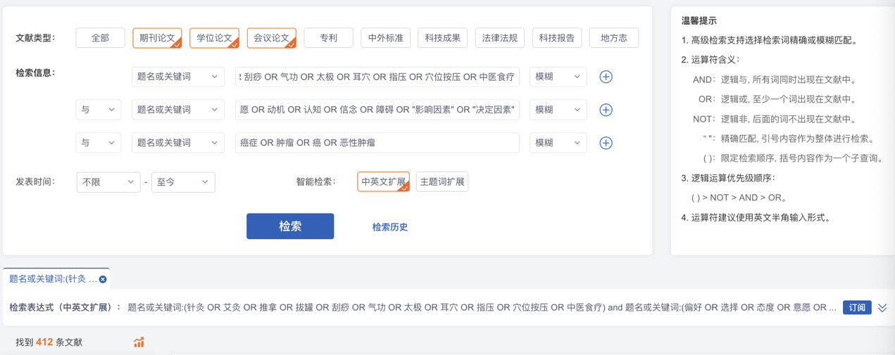
China National Knowledge Infrastructure 410
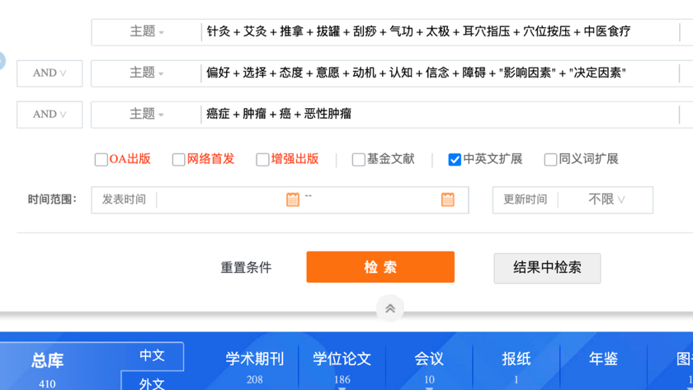

Supplementary 2. Data synthesis and integration
Convergent integrated approach
Findings | Categories | Integrated Findings
1. age: patients aged ≥60 years were more likely to use TCM appropriate technology.  2. Gender: Female patients are more likely to choose acupuncture.  3. Educational level: Patients with an educational level below high school have a lower willingness to use TCM appropriate technology.  4. Individual cultural background: In Taiwanese culture, TCM is regarded as a traditional and safe therapy, which influences patients' trust and preference for TCM. | Demographic Characteristics | Individual  Factors
1. Disease stage: Early-stage patients hope to prevent recurrence or metastasis through TCM. Late-stage patients are more concerned about strengthening their health through TCM to "coexist peacefully" with cancer.  2. Symptom experience  (1) Patients want to improve chemotherapy side effects  (2) The patient's desire to improve the discomfort caused by the disease itself  (3) Patients with good sleep quality have a relatively low need and desire for the application of appropriate Chinese medicine techniques.  (4) Patients who are more tolerant of pain tend to take other treatments or just tolerate the pain. | Disease-Related Factors | Individual  Factors
1. Psychological status: patients considering acupuncture had significantly higher levels of stress, anxiety, and depression  2. Demand for a sense of control: patients want to actively participate in the treatment through Chinese medicine to reduce the sense of dependence on Western medicine | Psychological and Emotional Factors | Individual  Factors
1. Knowledge of Chinese medicine  (1) Awareness of TCM health care:Patients with low awareness of TCM health care have lower willingness to use TCM appropriate technology.  (2) Knowledge and Understanding of Appropriate Chinese Medicine Technology: The low level of knowledge and understanding of appropriate Chinese medicine technology leads to skepticism about efficacy and safety.  (3) Openness to integrative therapies  2. Perception of Western medicine  (1) Concerns about the side effects of Western medical treatment  (2) Perception of the limitations of Western medicine  3. Expectations and perceptions  (1) Expected benefits: the more patients expect benefits from acupuncture the more they tend to choose acupuncture.  (2) Perceived security  (3) Perceived usefulness  (4) Perceived ease of use  (5) Sense of Benefit from Appropriate Chinese Medicine Technology | Cognitions, Beliefs, and Attitudes | Individual  Factors
1. Some patients may have previous experience of using TCM with good results. Personal or family experience of previous use of TCM.  2. Lack of knowledge: Patients did not choose acupuncture because they "did not understand that acupuncture can treat insomnia". | Experience and Knowledge | Individual  Factors
1. The patient wishes to improve the side effects of chemotherapy and enhance the quality of life.  2. The frequency and intensity of hot flashes and night sweats prompts patients to seek treatment.  3. The need for improvement of other accompanying symptoms.  4. Physical improvement needs  5. Hope of preventing recurrence or metastasis: Early-stage patients hope to prevent tumor recurrence or metastasis by TCM. | Needs and Motivations | Individual  Factors
1. Patients preferred acupuncture treatments that were less painful and less stimulating.  2. Patients receive treatment frequency of 2 to 3 times per week. Some patients are reluctant to take additional medications.  3. Fear of pain: Patients refuse acupuncture because they are "afraid of pain". | Treatment Preferences and Fears | Individual  Factors
1. Doctor-patient communication: quality and modality, information provision  2. Doctor-patient relationship: quality of doctor-patient relationship  3. Attitude of the medical team: positive attitude, negative attitude, recommendation of a few nurses or hospital physicians | Healthcare Professionals' Influence | Interpersonal  Relationships
1. Family support  2. Family recommendations and traditions  3. Family participation | Family Influence | Interpersonal  Relationships
1. Suggestions from friends  2. Views of other cancer patients  3. Social support | Influence from Friends and Other Patients | Interpersonal  Relationships
1. Time accessibility, economic accessibility, geographic accessibility  2. Services  3. Service model  4. Quality of service  5. Therapeutic environment | Healthcare Organization Service Provision | Health system factors
1. Integration of clinical practice  2. Physician collaboration | Healthcare Organization Integration and Collaboration | Health system factors
1. Whether hospitals have put in place publicity and education on Chinese medicine technology.  2. Professional development and implementation | Healthcare Organization Promotion and Education | Health system factors
1. Cultural roots of Chinese medicine  2. Community acceptance of Chinese medicine  3. Community support for Chinese medicine practitioners  4. Cultural atmosphere of Chinese medicine  5. Community norms | Culture and Social Norms | Social factors
1. Accessibility of Chinese medicine services  2. Accessibility of information | Community Resources and Accessibility | Social factors
Information Sharing and Recommendations | Community Support Networks | Social factors
1. Coverage: Does it cover Chinese medicine outpatient services, does it cover Chinese medicine inpatient services, does it cover specific Chinese medicine therapies (e.g. acupuncture), and what is the percentage and amount of coverage?  2. Types of health insurance: National Health Insurance (NHI) coverage, complementary role of commercial insurance  3. Geographical differences: differences in health insurance policies in different countries or regions | Medical insurance coverage | Policy level
1. Service standardization: Are the operation standards of TCM treatment clear? Is the qualification system for practitioners such as acupuncturists sound?  2. Adverse reaction monitoring: whether there is a monitoring and reporting system for adverse reactions to Chinese medicine treatment | Industry Regulation and Supervision | Policy level
1. Research funding: the amount and direction of government or charitable organizations' funding for Chinese medicine research  2. Promotion of results: publication and dissemination of research results, public popularization of Chinese medicine knowledge, the status of Chinese medicine in medical education | Research Funding and Promotion | Policy level
1. System integration: Is TCM integrated into the public healthcare system? Are western hospitals allowed to set up TCM departments? To what extent is integrated Chinese and Western medicine promoted?  2. Policy support: How strong is the government's policy support for TCM treatment? Is TCM included in the standard treatment guidelines for cancer? Does the planning of the National Health Commission support medical specialty care?  3. Cooperation between Chinese and Western medicines: Is cooperation and exchange between Chinese and Western medicines encouraged? Are there any models of joint consultation and treatment between Chinese and Western medicines? | Health system integration and policy support | Policy level

Supplementary 3. Methodological quality
3.1 Quality Assessment of Qualitative research

No. | Author, Year, Country | S2 | 1.1 | 1.2 | 1.3 | 1.4 | 1.5
1 | Chen et al.2023 | Yes | Yes | Yes | Yes | Yes | Yes
2 | Porter et al.2017 | Yes | Yes | Yes | Yes | Yes | Yes
3 | Ee et al. 2022 | Yes | Yes | Yes | Yes | Yes | Yes
4 | Mackereth et al. 2014 | Yes | Yes | Yes | Yes | Yes | Yes
5 | Chan et al. 2014 | Yes | Yes | Yes | Yes | Yes | Yes
6 | BA et al. 2024 | Yes | Yes | Yes | Yes | No | No
7 | Liu et al. 2011 | Yes | Yes | Yes | Yes | Yes | Yes
8 | Oberoi et al. 2022. | Yes | Yes | Yes | Yes | Yes | Yes
9 | Yin et al. 2017 | Yes | Yes | Yes | Yes | Yes | Yes
10 | Shen et al. 2024 | Yes | Yes | Yes | Yes | Yes | Yes
11 | Li et al. 2023 | Yes | Yes | Yes | Yes | Yes | Yes
12 | Walker et al. 2007 | Yes | Yes | Yes | Yes | Yes | Yes
13 | Hung et al.2023 | Yes | Yes | Yes | Yes | Yes | Yes
14 | Garland et al. 2018 | Yes | Yes | Yes | Yes | Yes | Yes

S1: Are there clear research questions?
S2: Do the collected data allow to address the research questions?
1.1 Is the qualitative approach appropriate?
1.2 Are the data collection methods adequate?
1.3 Is the data analysis adequate?
1.4 Is the interpretation of results supported by the data?
1.5 Is there coherence between data, analysis, and results?

3.2 Quality Assessment of Quantitative research
No. | Author, Year, Country | S1 | S2 | 3.1 | 3.2 | 3.3 | 3.4 | 3.5
1 | Lee et al. 2017 | Yes | Yes | No | Yes | Yes | Yes | unclear
2 | Bao et al. 2018 | Yes | Yes | No | Yes | Yes | Yes | unclear
3 | Tack et al. 2021 | Yes | Yes | Yes | Yes | Yes | Yes | Yes
4 | Bao et al.²³ 2017 | Yes | Yes | No | Yes | Yes | Yes | unclear
5 | Sun et al. 2018 | Yes | Yes | No | Yes | Yes | Yes | unclear
6 | Sun et al. 2017 | Yes | Yes | No | Yes | Yes | Yes | unclear
7 | Teng et al. 2023 | Yes | Yes | Yes | unclear | Yes | unclear | Yes
8 | Liou et al. 2021 | Yes | Yes | No | Yes | Yes | Yes | unclear
9 | Oh et al. 2017 | Yes | Yes | No | Yes | Yes | No | unclear
10 | Enblom et al. 2017 | Yes | Yes | Yes | Yes | Yes | Yes | Yes
11 | Widgren et al.2022 | Yes | Yes | Yes | Yes | Yes | Yes | Yes
12 | Liu et al. 2022 | Yes | Yes | No | Yes | Yes | Yes | unclear
13 | Zhang et al.2024 | Yes | Yes | unclear | unclear | No | unclear | Yes
S1:Are there clear research questions?
S2:Do the collected data allow to address the research questions?
3.1Are the participants representative of the target population?
3.2Are the measurements appropriate?
3.3Is there complete outcome data?
3.4 Are the confounders accounted for in the design and analysis?
3.5Was the intervention administered as intended?

