Figure S1 Stability of PFCDs: Representative TEM image of PFCDs in deionized water after 5 days of storage (scale bar: 50 nm).
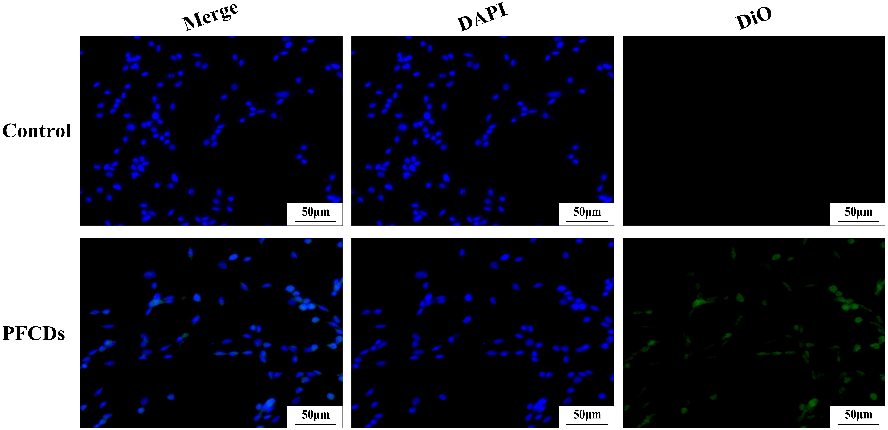
Figure S2 Representative confocal microscopy images (DiO channel) showing the cellular uptake of PFCDs by PC12 cells. Nuclei were stained with DAPI (scale bar: 50 μm).
Figure S3 (A) Representative confocal microscopy images (DiO channel) showing PFCD fluorescence in rat brain tissue across experimental groups. Nuclei were stained with DAPI (scale bar: 50 μm). (B) Percentage of DiO⁺ cells in rat brain tissue across experimental groups, expressed as a percentage of DAPI⁺ cells (mean ± SD, n=3). Statistical significance: **P < 0.01 vs. Sham + PFCDs group.

