Supplementary Files
Supplementary Table 1: Standards for Reporting Qualitative Research (SRQR) checklist
SRQR Item | Description | How Addressed in This Study
Title | Concise description with qualitative focus | Study title reflects qualitative design (student experiences of empathy)
Abstract | Structured summary | Provided with background, methods, results, and conclusion
Problem formulation | Problem and rationale | Background section outlines limited exploration of empathy in non-clinical settings, esp. in MENA region
Purpose/Research questions | Clear aims | To explore how students perceive and experience faculty empathy
Qualitative approach & research paradigm | Paradigm, guiding theory | Qualitative descriptive design, constructivist epistemology
Researcher characteristics & reflexivity | Researcher position and influence | Researcher positionality and reflexivity explicitly reported
Context | Study setting | Conducted at University of Hail, Saudi Arabia
Sampling strategy | Participant selection | Purposive maximum variation sampling of 16 undergraduates
Ethical issues | Informed consent, approval | Institutional approval and student consent obtained
Data collection methods | Procedures, instruments | Reflective essay protocol with open-ended prompts
Data collection instruments | Tools, adaptation | Essay prompts piloted and reviewed by experts for cultural appropriateness
Units of study | Sample description | 16 students, equal gender/program representation
Data processing | Anonymization, management | Essays anonymized, translated, stored securely
Data analysis | Analytic process | Braun & Clarke thematic analysis, iterative coding
Techniques to enhance trustworthiness | Strategies for rigor | Reflexive journaling, peer debriefing, independent coding
Findings/results | Main results | Four major themes with supporting quotations
Integration with prior work | Consistency/variation | Discussed alongside regional and international literature
Limitations | Study weaknesses | Acknowledged small sample, single-institution context, translation issues
Transferability | Relevance to other contexts | Sampling ensured diversity across programs/levels
Implications | Contribution | Calls for embedding empathy into faculty development

Supplementary Table 2: Process of the research work
Stage | Detailed Procedure | Safeguards / Quality Checks | Examples
1. Submission | Students submitted essays electronically via secure university platform or official university email accounts. | Essays required word range (400–600 words). Participants were reminded submissions would remain anonymous and not affect grades. | Essay uploaded via Blackboard system; student informed consent implied by submission.
2. Initial Screening | Principal investigator confirmed eligibility (undergraduate student, enrolled in one of four programs, voluntary participation). | Excluded essays from students directly taught or supervised by the PI to reduce bias. | A 2nd-year HIIM student in PI’s course excluded from dataset.
3. Translation | 8/16 essays written in Arabic translated into English by two independent bilingual translators with graduate-level health sciences training. | Discrepancies resolved through consensus meetings; fidelity of meaning prioritized over literal translation. | Arabic phrase “الصمت أشبه بالتجاهل” translated consistently as “silence felt like rejection.”
4. Back-Translation | 25% of translated essays back-translated into Arabic by an independent bilingual reviewer. | Compared with original Arabic to confirm semantic accuracy; adjustments made as necessary. | Word “support” corrected from “assistance” to “empathy” for closer cultural meaning.
5. Anonymization | All identifiers removed (names, IDs, faculty names, course titles). Each essay assigned a numerical ID (e.g., Student 1, Student 2). | Faculty names replaced with neutral codes (e.g., “Professor X”); cross-check of all files to ensure identifiers were removed. | “Dr. Ahmed X” replaced with “Professor X.”
6. Data Storage | Both original Arabic and translated English essays stored on a secure, password-protected institutional server accessible only to the PI and research assistant. | Server compliant with institutional ethical guidelines; files encrypted; no copies saved on personal devices. | PI’s server log monitored for access.
7. Analysis Corpus | The English-language versions of all essays (including translations) used for thematic analysis to ensure comparability across the dataset. | Reflexive memos recorded where cultural nuance may have been lost; this limitation acknowledged in the discussion. | Arabic metaphor about “light in darkness” noted in reflexive memo.
8. Data Use | Essays coded using Braun & Clarke’s six-phase thematic analysis. Themes supported by verbatim quotes (with anonymized student IDs). | Quotes verified against original text for accuracy; cross-checks done by co-analyst. | “I believe in you” quote double-checked in both English and Arabic versions.
9. Data Retention | Data retained securely for the duration required by institutional IRB policy; planned destruction after retention period. | Compliance with IRB (Approval No: H-2024-360); retention limited to secure institutional storage only. | All anonymized essays archived until 2029.

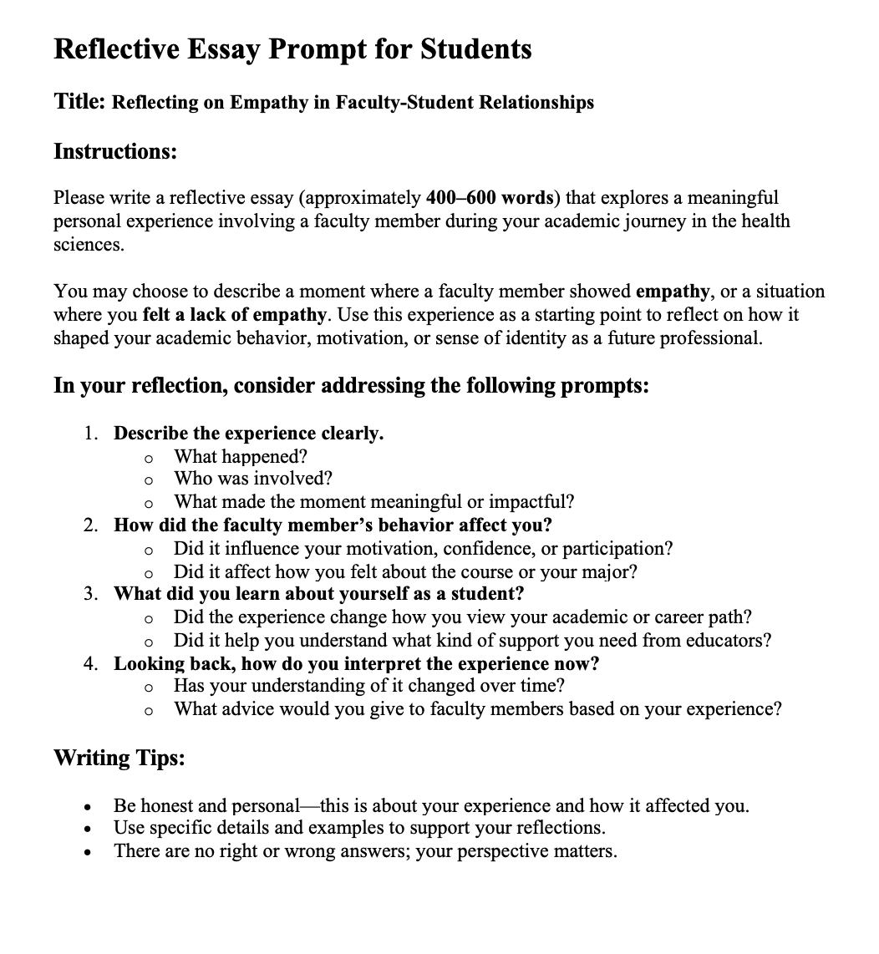
Supplementary Figure 1: Reflective Essay Prompt for Students

Supplementary Figure 2: The consent form
