 | STUDY PERIOD
 | Enrolment | Baseline | Pre-pain threshold test | Pain threshold test | Post-test
TIMEPOINT | Enrolment | Baseline | Sleep-related data collection | Pain threshold test | Post-test
ENROLMENT:
Eligibility screen
Informed consent
General information
ASSESSMENTS:
Pittsburgh Sleep Quality Index (PSQI)
Self-Rating Anxiety Scale (SAS)
Self-Rating Depression Scale (SDS)
Polysomnography (PSG)*
Heart rate variability (HRV)*
Pain threshold test
Adverse events
Reasons for drop-out and withdrawals
Supplementary Table 1: Schedule of enrolment, pain threshold test, and assessments.
Note: *: In the patient group, PSG and HRV will be implemented as far as practical.
indicates Conducting a process or collecting an indicator; indicates ongoing processes.
Supplementary Figure 1: The test acupoints that will be used in the study.

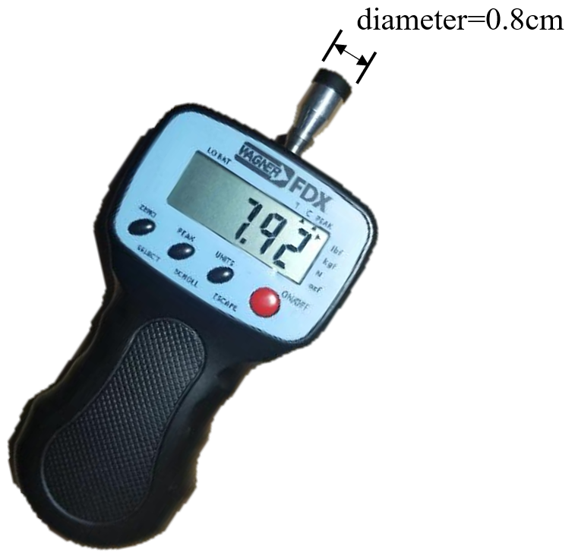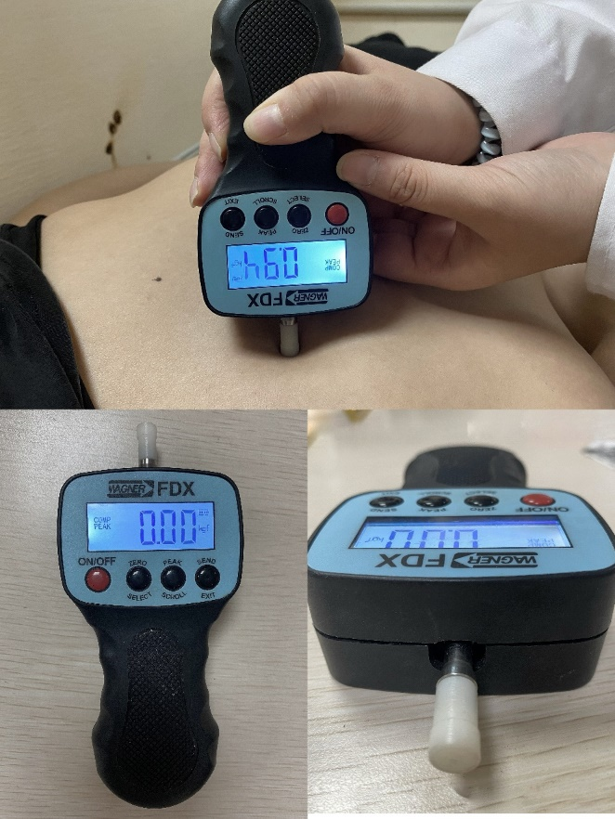
Supplementary Figure 2: Force One FDIX and PPT measurement illustration.
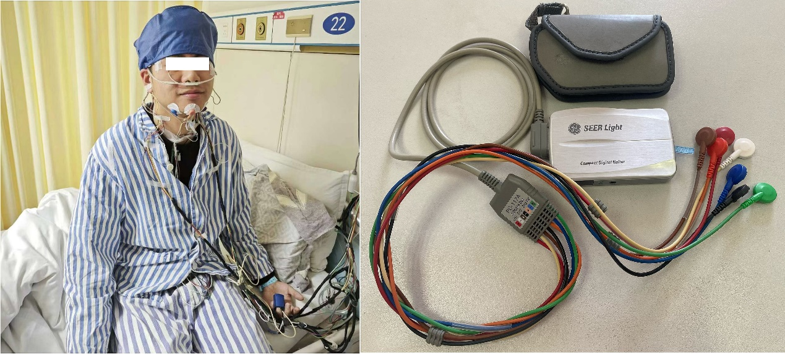
Supplementary Figure 3: PSG and HRV device.

Supplementary Table 2: Acupoints selected for use in the study
Acupoints | Location
Baihui (GV20) | On the head, 5 cun straight up from the center of the front hairline
Yintang (EX-HN3) | On the head, in the depression midway between the medial ends of the two eyebrows
Taiyang (EX-HN5) | On the head, between the tip of the eyebrow and the outer canthus of the eye, in the depression about one horizontal finger backward
Anmian (EX-HN0) | On the neck, at the midpoint of the line connecting Yifeng and Fengchi. Yifeng is in the depression behind the ear; Fengchi is below the occipital bone, in the depression between the upper end of the sternocleidomastoid muscle and the upper end of the trapezius muscle.
Fengchi (GB20) | On the neck, below the occipital bone, in the depression between the upper end of the sternocleidomastoid muscle and the upper end of the trapezius muscle
Shenmen (HT7) | In the anteromedial aspect of the anterior wrist, at the ulnar end of the distal transverse line of the palmar side of the wrist, at the radial edge of the ulnar wrist flexor tendon
Neiguan (PC6) | On the anterior side of the forearm, 2 cun above the transverse stripe on the distal part of the palmar side of the wrist, between the tendon of the palmaris longus and the tendon of the flexor carpi radialis muscle
Sanyinjiao (SP6) | On the medial side of the lower leg, 3 cun above the tip of the inner ankle, posterior to the medial border of the tibia bone.
Juque (RN14) | In the upper abdomen, 6 cun above the umbilicus, on the anterior midline
Xinshu (BL15) | On the back, below the spinous process of the 5th thoracic vertebra, 1.5 cun from the posterior midline.

Supplementary Table 3: PSG and HRV operation procedures
PSG operation procedures
1 | Subjects were prepared, washed, and wired.
2 | Localization and interpretation followed the AASM Manual for the Interpretation of Sleep and Related Events, version 2.6. Brain regions were identified using the International 10-20 system, and leads (e.g., electrooculogram, mandibular electromyogram) were established according to the manual for preselection and localization.
3 | Cleanse the skin with an abrasive cream that.
4 | The wires are fixed with conductive paste and the head is fixed with an elastic mesh cap.
5 | The cardiac leads were connected with splinter electrodes and chest and abdominal tethers.
6 | Nasal catheters, snore detectors and oxygen clamps were placed.
7 | The operator opens the SleepwareG3 software, enters the subject's personal information, calibrates it, and begins data logging.
HRV operation procedures
1 | Subjects were asked to refrain from strenuous activity for 1 hour prior to the test and to refrain from consuming alcohol, caffeine, or strong tea for 24 hours.
2 | After resting on your back for 10 minutes, wash the skin area with alcohol and gently rub to minimize impedance.
3 | A standard 12-lead electrode was used, secured with tape and an elastic bandage, and the device activated. The recordings were then analyzed and

Supplementary Table 4: The relationship between types of insomnia and acupoint pressure pain thresholds (Mean± SD, gf)
 | Difficulty falling asleep | Difficulty staying asleep | Early riser |  |  | Hybrid type | F | p Value
GV20 | 1162.74±282.61 | 1271.25±310.64 | 1176.33±284.52 | 1266.58±233.26 |  |  | 0.776 | 0.512
EX-HN3 | 1210.16±390.72 | 1198.13±177.32 | 1210.00±342.37 | 1372.89±333.51 |  |  | 1.039 | 0.381
EX-HN5 | 1222.98±252.60 | 1340.31±256.86 | 1225.33±435.38 | 1287.76±286.78 |  |  | 0.537 | 0.662
EX-HN0 | 1260.32±255.52 | 1341.25±171.17 | 1292.67±281.98 | 1290.26±173.43 |  |  | 0.274 | 0.844
GB20 | 1370.57±258.99 | 1481.88±149.40 | 1296.83±277.52 | 1433.03±256.01 |  |  | 1.257 | 0.296
HT7 | 1334.76±260.40 | 1335.31±180.51 | 1361.17±273.45 | 1460.00±188.72 |  |  | 1.180 | 0.324
PC6 | 1346.21±257.73 | 1345.63±137.62 | 1372.50±378.59 | 1443.29±209.09 |  |  | 0.566 | 0.639
SP6 | 1339.27±247.10 | 1492.19±175.05 | 1415.50±223.41 | 1428.55±198.08 |  |  | 1.330 | 0.272
RN14 | 1795.89±380.07 | 1896.25±110.93 | 1815.67±335.54 | 1804.74±292.18 |  |  | 0.201 | 0.895
BL15 | 1278.55±284.73 | 1486.25±237.96 | 1294.33±275.19 | 1415.79±225.39 |  |  | 1.947 | 0.130

Supplementary Table 5: The relationship between types of insomnia and acupoint pain sensitization rate (n(%))
 | Difficulty falling asleep | Difficulty staying asleep | Early riser |  | Hybrid type | χ² | p Value
GV20 | 20(64.5%) | 5(62.5%) | 12(80.0%) |  | 10(52.6%) | 2.752 | 0.431
EX-HN3 | 17(54.8%) | 5(62.5%) | 7(46.7%) |  | 6(31.6%) | 3.380 | 0.337
EX-HN5 | 17(54.8%) | 4(50.0%) | 8(53.3%) |  | 8(42.1%) | 0.819 | 0.845
EX-HN0 | 24(77.4%) | 6(75.0%) | 10(66.7%) |  | 14(73.7%) | 0.597 | 0.897
GB20 | 27(87.1%) | 7(87.5%) | 13(86.7%) |  | 14(73.7%) | 1.692 | 0.639
HT7 | 25(80.6%) | 6(75.0%) | 11(73.3%) |  | 9(47.4%) | 6.211 | 0.102
PC6 | 20(64.5%) | 6(75.0%) | 8(53.3%) |  | 9(47.4%) | 2.536 | 0.469
SP6 | 27(87.1%) | 6(75.0%) | 12(80.0%) |  | 16(84.2%) | 0.817 | 0.845
RN14 | 26(83.9%) | 8(100.0%) | 12(80.0%) |  | 15(78.9%) | 3.282 | 0.350
BL15 | 30(96.8%) | 17(87.5%) | 14(93.3%) |  | 16(84.2%) | 2.691 | 0.442

Supplementary Table 6: The relationship between disease duration and acupoint pressure pain thresholds (Mean±SD, gf)
 | 3-6 months | 6-12 months | 12-36 months | >36 mouths | F | p Value
GV20 | 1192.73±304.17 | 1094.44±176.15 | 1224.44±279.69 | 1226.73±284.08 | 0.590 | 0.623
EX-HN3 | 1013.64±301.87 | 1248.89±200.59 | 1232.59±354.40 | 1371.73±364.31 | 2.966 | 0.038*
EX-HN5 | 965.68±344.72 | 1240.56±217.54 | 1293.98±286.96 | 1336.83±267.44 | 4.760 | 0.004*
EX-HN0 | 1131.36±230.51 | 1384.44±286.37 | 1276.85±198.42 | 1320.19±225.42 | 2.527 | 0.065
GB20 | 1163.18±242.52 | 1422.22±258.84 | 1408.70±248.40 | 1438.17±227.82 | 3.669 | 0.016*
HT7 | 1250.46±233.30 | 1358.33±205.15 | 1390.28±254.70 | 1411.54±234.21 | 1.248 | 0.299
PC6 | 1172.50±348.03 | 1428.33±214.69 | 1422.22±240.18 | 1398.27±237.44 | 2.822 | 0.045*
SP6 | 1249.55±294.98 | 1482.78±130.17 | 1456.57±192.66 | 1362.02±223.37 | 3.093 | 0.033*
RN14 | 1631.14±413.38 | 1816.11±364.64 | 1828.89±237.78 | 1873.08±340.09 | 1.498 | 0.223
BL15 | 1200.45±355.74 | 1441.11±221.67 | 1410.56±273.82 | 1291.54±235.10 | 2.312 | 0.084
Note: * indicates P<0.05; the difference is statistically significant.
Supplementary Table 7: The relationship between disease duration and acupoint pain sensitization rate (n(%))
 | 3-6 months | 6-12 months | 12-36 months | >36 mouths | χ² | p Value
GV20 | 7(63.6%) | 7(77.8%) | 18(66.7%) | 15(57.7%) | 1.319 | 0.725
EX-HN3 | 8(72.7%) | 3(33.3%) | 15(55.6%) | 9(34.6%) | 6.090 | 0.107
EX-HN5 | 9(81.8%) | 4(44.4%) | 12(44.4%) | 12(46.2%) | 5.404 | 0.145
EX-HN0 | 10(90.9%) | 7(77.8%) | 21(77.8%) | 16(61.5%) | 4.221 | 0.239
GB20 | 11(100.0%) | 7(77.8%) | 21(77.8%) | 22(84.6%) | 4.779 | 0.189
HT7 | 11(100.0%) | 7(77.8%) | 18(66.7%) | 15(57.7%) | 10.023 | 0.018*
PC6 | 10(90.9%) | 4(44.4%) | 15(55.6%) | 14(53.8%) | 6.819 | 0.078
SP6 | 11(100.0%) | 7(77.8%) | 21(77.8%) | 22(84.6%) | 4.779 | 0.189
RN14 | 10(90.9%) | 7(77.8%) | 24(88.9%) | 20(76.9%) | 2.078 | 0.556
BL15 | 10(90.9%) | 9(100.0%) | 23(85.2%) | 25(96.2%) | 3.646 | 0.302
Note: * indicates P<0.05; the difference is statistically significant.
Supplementary Table 8: Relationship between frequency of attacks and acupoint pressure pain thresholds (Mean±SD, gf)
 | 3 times a week | 4-5 times a week | ＞5 times a week | F | p Value
GV20 | 1226.67±368.39 | 1254.79±254.85 | 1159.12±235.31 | 0.926 | 0.401
EX-HN3 | 1284.67±323.55 | 1214.38±398.15 | 1262.35±333.01 | 0.214 | 0.808
EX-HN5 | 1182.83±265.69 | 1266.77±332.69 | 1274.63±301.77 | 0.505 | 0.606
EX-HN0 | 1349.00±339.75 | 1269.38±230.71 | 1264.85±169.01 | 0.749 | 0.477
GB20 | 1373.00±298.47 | 1343.02±287.44 | 1417.50±208.93 | 0.612 | 0.545
HT7 | 1401.00±222.04 | 1397.50±175.29 | 1343.02±285.99 | 0.485 | 0.618
PC6 | 1344.50±249.35 | 1423.85±212.35 | 1357.87±304.08 | 0.572 | 0.567
SP6 | 1414.33±232.36 | 1423.33±187.15 | 1366.32±248.42 | 0.514 | 0.600
RN14 | 1651.50±361.35 | 1772.29±312.93 | 1913.53±288.35 | 3.973 | 0.023*
BL15 | 1397.00±308.81 | 1305.63±272.17 | 1339.71±268.30 | 0.498 | 0.610
Note: * indicates P<0.05; the difference is statistically significant.
Supplementary Table 9: Relationship between the frequency of attacks and acupoint pain sensitization rate (n(%))
 | 3 times a week | 4-5 times a week | ＞5 times a week | χ² | P
GV20 | 11(73.3%) | 12(50.0%) | 24(70.6%) | 3.260 | 0.196
EX-HN3 | 7(46.7%) | 11(45.8%) | 17(50.0%) | 0.110 | 0.946
EX-HN5 | 9(60.0%) | 11(45.8%) | 17(50.0%) | 0.757 | 0.685
EX-HN0 | 10(66.7%) | 16(66.7%) | 28(82.4%) | 2.321 | 0.313
GB20 | 12(80.0%) | 19(79.2%) | 30(88.2%) | 1.037 | 0.595
HT7 | 11(73.3%) | 16(66.7%) | 24(70.6%) | 0.211 | 0.900
PC6 | 10(66.7%) | 12(50.0%) | 21(61.8%) | 1.272 | 0.529
SP6 | 13(86.7%) | 19(79.2%) | 29(85.3%) | 0.504 | 0.777
RN14 | 13(86.7%) | 20(83.3%) | 28(82.4%) | 0.148 | 0.929
BL15 | 14(93.3%) | 22(91.7%) | 31(91.2%) | 0.067 | 0.967

Supplementary Table 10: Correlation of acupoint pressure pain thresholds with sleep continuity parameters
 | Sleep latency (s) |  | Sleep efficiency (%) |  | Wake-up time after sleep (times)
 | r | P | r | P |  | r | P
GV20 | -0.233 | 0.274 | 0.111 | 0.642 |  | 0.012 | 0.957
EX-HN3 | -0.468 | 0.021* | 0.330 | 0.156 |  | 0.013 | 0.951
EX-HN5 | -0.129 | 0.547 | 0.104 | 0.664 |  | 0.154 | 0.473
EX-HN0 | 0.198 | 0.353 | -0.170 | 0.474 |  | 0.108 | 0.616
GB20 | -0.221 | 0.298 | 0.047 | 0.845 |  | 0.022 | 0.918
HT7 | 0.061 | 0.776 | -0.209 | 0.376 |  | 0.214 | 0.315
PC6 | 0.001 | 0.995 | -0.214 | 0.364 |  | 0.333 | 0.112
SP6 | -0.140 | 0.515 | -0.099 | 0.679 |  | 0.032 | 0.881
RN14 | -0.157 | 0.463 | 0.076 | 0.749 |  | -0.038 | 0.860
BL15 | -0.249 | 0.241 | -0.110 | 0.644 |  | -0.074 | 0.732
Note: * indicates P<0.05; the difference is statistically significant.

Supplementary Table 11: Single-factor logistic regression of acupoint sensitivity and sleep continuity parameters
 | Sleep latency (s) |  |  |  |  |  | Sleep efficiency (%) |  |  |  |  |  | Wake-up time after sleep (times)
 | B | SE | Wald | P | OR | 95%CI  (lower bound- upper bound) | B | SE | Wald | P | OR | 95%CI  (lower bound- upper bound) | B | SE | Wald | P | OR | 95%CI  (lower bound- upper bound)
GV20 | 0.010 | 0.018 | 0.332 | 0.571 | 1.010 | (0.975 -1.047) | -0.002 | 0.019 | 0.014 | 0.906 | 0.998 | (0.961 -1.035) | -0.007 | 0.008 | 0.897 | 0.344 | 0.993 | (0.977 -1.008)
EX-HN3 | 0.073 | 0.034 | 4.472 | 0.054 | 1.075 | (1.005 -1.150) | 0.005 | 0.019 | 0.059 | 0.808 | 1.005 | (0.968 -1.043) | 0.007 | 0.006 | 1.087 | 0.297 | 1.007 | (0.994 -1.020)
EX-HN5 | 0.007 | 0.018 | 0.168 | 0.682 | 1.007 | (0.973 -1.043) | -1.827 | 3.255 | 0.315 | 0.575 | 0.161 | (0.000 -9.489) | 0.005 | 0.006 | 0.818 | 0.366 | 1.005 | (0.994 -1.017)
EX-HN0 | -0.001 | 0.021 | 0.004 | 0.952 | 0.999 | (0.958 -1.042) | 0.407 | 3.580 | 0.013 | 0.909 | 1.503 | (0.001 -1.673) | 0.003 | 0.007 | 0.129 | 0.719 | 1.003 | (0.988 -1.018)
GB20 | 0.028 | 0.032 | 0.776 | 0.378 | 1.029 | (0.966 -1.096) | 0.072 | 0.271 | 0.071 | 0.791 | 1.075 | (0.632 -1.828) | 0.003 | 0.008 | 0.139 | 0.710 | 1.003 | (0.988 -1.018)
HT7 | 0.009 | 0.020 | 0.217 | 0.642 | 1.009 | (0.970 -1.050) | -0.012 | 0.019 | 0.401 | 0.526 | 0.988 | (0.952 -1.026) | 0.004 | 0.007 | 0.369 | 0.544 | 1.004 | (0.990 -1.018)
PC6 | 0.022 | 0.021 | 1.121 | 0.290 | 1.022 | (0.982 -1.064) | 2.122 | 3.398 | 0.390 | 0.523 | 8.345 | (0.011 -6.508) | -0.005 | 0.006 | 0.675 | 0.411 | 0.995 | (0.984 -1.007)
SP6 | 0.017 | 0.023 | 0.538 | 0.463 | 1.017 | (0.972 -1.065) | 1.778 | 3.201 | 0.309 | 0.579 | 5.921 | (0.011 -3.142) | -0.005 | 0.005 | 0.962 | 0.327 | 0.995 | (0.985 -1.005)
RN14 | 0.011 | 0.038 | 0.081 | 0.776 | 1.011 | (0.939 -1.088) | 0.070 | 0.429 | 0.027 | 0.871 | 1.072 | (0.463 -2.486) | 0.003 | 0.011 | 0.048 | 0.826 | 1.003 | (0.980 -1.025)
BL15 | 0.435 | 0.452 | 0.927 | 0.336 | 1.545 | (0.637 -3.747) | 0.057 | 0.263 | 0.047 | 0.828 | 1.059 | (0.632 -1.772) | 0.019 | 0.027 | 0.471 | 0.492 | 1.019 | (0.966 -1.074)
Note: B indicates regression coefficient, SE indicates standard error, Wald indicates statistical value. OR indicates odds ratios, 95%CI indicates 95% confidence intervals.

Supplementary Table 12: Correlation between acupoint pressure pain thresholds and sleep depth parameters
 | N3 duration (s) |  | N3 percentage (%)
 | r | P | r | P
GV20 | 0.357 | 0.086 | 0.448 | 0.047*
EX-HN3 | 0.249 | 0.240 | 0.104 | 0.663
EX-HN5 | -0.031 | 0.887 | -0.208 | 0.378
EX-HN0 | -0.085 | 0.692 | -0.209 | 0.376
GB20 | -0.063 | 0.770 | -0.080 | 0.738
HT7 | 0.068 | 0.753 | -0.027 | 0.910
PC6 | -0.026 | 0.905 | 0.041 | 0.862
SP6 | -0.139 | 0.517 | -0.044 | 0.853
RN14 | 0.095 | 0.660 | 0.021 | 0.931
BL15 | -0.032 | 0.883 | -0.107 | 0.653
Note: * indicates P<0.05; the difference is statistically significant.

Supplementary 13: Single-factor logistic regression of acupoint sensitivity and sleep depth parameters
 | N3 duration(s) |  |  |  |  |  | N3 percentage (%)
 | B | SE | Wald | P | OR | 95%CI  (lower bound- upper bound) | B | SE | Wald | P | OR | 95%CI  (lower bound- upper bound)
GV20 | -0.035 | 0.018 | 3.765 | 0.052 | 0.966 | (0.933 -1.000) | 0.373 | 0.556 | 0.451 | 0.502 | 1.452 | (0.489 -4.316)
EX-HN3 | -0.021 | 0.015 | 1.850 | 0.175 | 0.980 | (0.951 -1.009) | 0.677 | 1.244 | 0.296 | 0.586 | 1.969 | (0.172 -2.253)
EX-HN5 | 0.002 | 0.014 | 0.025 | 0.874 | 1.002 | (0.975 -1.030) | -0.469 | 0.899 | 0.271 | 0.602 | 0.626 | (0.107 -3.648)
EX-HN0 | -0.009 | 0.018 | 0.273 | 0.601 | 0.991 | (0.957 -1.026) | 0.591 | 2.199 | 0.072 | 0.788 | 1.806 | (0.024 -1.345)
GB20 | -0.024 | 0.021 | 1.319 | 0.251 | 0.977 | (0.938 -1.017) | 0.390 | 1.100 | 0.126 | 0.723 | 1.477 | (0.171 -1.275)
HT7 | -0.005 | 0.015 | 0.129 | 0.720 | 0.995 | (0.966 -1.024) | 0.737 | 2.563 | 0.083 | 0.774 | 2.089 | (0.014 -3.175)
PC6 | -0.007 | 0.014 | 0.233 | 0.629 | 0.993 | (0.966 -1.021) | 0.470 | 0.833 | 0.318 | 0.573 | 1.599 | (0.313 -8.185)
SP6 | -0.011 | 0.016 | 0.479 | 0.489 | 0.989 | (0.958 -1.021) | 0.343 | 0.754 | 0.207 | 0.649 | 1.410 | (0.322 -6.179)
RN14 | -0.032 | 0.034 | 0.876 | 0.349 | 0.968 | (0.906 -1.036) | 0.457 | 2.340 | 0.038 | 0.845 | 1.579 | (0.016 -1.548)
BL15 | -0.034 | 0.035 | 0.936 | 0.333 | 0.967 | (0.903 -1.035) | 0.406 | 1.960 | 0.043 | 0.836 | 1.501 | (0.032 -6.921)
Note: B indicates regression coefficient, SE indicates standard error, Wald indicates statistical value. OR indicates odds ratios, 95%CI indicates 95% confidence intervals.

Supplementary Table 14: Correlation between REM parameters and acupoint pressure pain thresholds
 | REM latency period (s) |  | REM percentage (%)
 | r | P | r | P
GV20 | 0.131 | 0.542 | 0.035 | 0.885
EX-HN3 | -0.244 | 0.250 | -0.090 | 0.707
EX-HN5 | -0.212 | 0.320 | 0.015 | 0.948
EX-HN0 | -0.046 | 0.831 | 0.015 | 0.950
GB20 | 0.030 | 0.891 | 0.119 | 0.618
HT7 | -0.163 | 0.448 | -0.053 | 0.823
PC6 | -0.068 | 0.753 | 0.093 | 0.698
SP6 | -0.173 | 0.419 | -0.106 | 0.656
RN14 | 0.221 | 0.298 | -0.147 | 0.536
BL15 | -0.093 | 0.665 | 0.354 | 0.125

Note: abbreviation: REM indicates Rapid Eye Movement.

Supplementary Table 15: Single-factor logistic regression analysis of acupoint sensitivity and REM parameters
 | REM latency period (s) |  |  |  |  |  | REM percentage (%)
 | B | SE | Wald | P | OR | 95%CI  (lower bound- upper bound) | B | SE | Wald | P | OR | 95%CI  (lower bound-  upper bound)
GV20 | -0.002 | 0.004 | 0.366 | 0.545 | 0.998 | (0.990 -1.005) | 2.322 | 7.037 | 0.109 | 0.741 | 1.193 | (0.001 -9.949)
EX-HN3 | 0.008 | 0.005 | 2.386 | 0.122 | 1.088 | (0.998 -1.019) | 1.218 | 8.513 | 2.048 | 0.152 | 1.950 | (0.011 -3.437)
EX-HN5 | 0.007 | 0.005 | 1.878 | 0.171 | 1.007 | (0.997 -1.017) | -0.502 | 1.185 | 0.179 | 0.672 | 0.605 | (0.059 -6.178)
EX-HN0 | 0.005 | 0.007 | 0.541 | 0.462 | 1.005 | (0.992 -1.018) | 0.785 | 5.362 | 0.021 | 0.884 | 2.192 | (0.001 -8.027)
GB20 | 0.004 | 0.006 | 0.486 | 0.486 | 1.004 | (0.992 -1.017) | 2.691 | 8.466 | 0.101 | 0.751 | 1.474 | (0.001 -2.368)
HT7 | 0.007 | 0.006 | 1.290 | 0.256 | 1.007 | (0.995 -1.020) | 6.591 | 7.583 | 0.755 | 0.385 | 7.282 | (0.001 -2.073)
PC6 | 0.000 | 0.004 | 0.017 | 0.897 | 1.000 | (0.993 -1.006) | 6.789 | 7.316 | 0.861 | 0.353 | 8.878 | (0.001 -1.498)
SP6 | -0.002 | 0.004 | 0.445 | 0.505 | 0.998 | (0.990 -1.005) | 1.212 | 8.485 | 2.042 | 0.153 | 1.845 | (0.011 -3.082)
RN14 | 0.000 | 0.006 | 0.003 | 0.958 | 1.000 | (0.988 -1.012) | 3.822 | 1.235 | 0.096 | 0.757 | 4.569 | (0.001 -1.500)
BL15 | -0.001 | 0.006 | 0.040 | 0.841 | 0.999 | (0.988 -1.010) | 1.062 | 1.296 | 0.672 | 0.412 | 4.133 | (0.001 -4.466)
Note: B indicates regression coefficient, SE indicates standard error, Wald indicates statistical value. REM indicates Rapid Eye Movement, OR indicates odds ratios, 95%CI indicates 95% confidence intervals.

Supplementary Table 16: Correlation between acupoint pressure pain thresholds and HRV parameters (ms²)
 | VLF(0.000-0.040Hz) |  | LF(0.040-0.150Hz) |  |  |  |  |  | HF(0.150-0.400Hz) |  |  | LF/HF
 | r | P | r |  | P |  | r |  |  | P |  | r |  |  | P
GV20 | -0.256 | 0.218 | -0.214 |  | 0.304 |  | -0.125 |  |  | 0.553 |  | -0.476 |  |  | 0.016*
EX-HN3 | -0.378 | 0.063 | -0.187 |  | 0.372 |  | 0.085 |  |  | 0.686 |  | -0.316 |  |  | 0.124
EX-HN5 | -0.274 | 0.186 | -0.124 |  | 0.556 |  | -0.016 |  |  | 0.940 |  | -0.008 |  |  | 0.968
EX-HN0 | 0.256 | 0.216 | -0.013 |  | 0.949 |  | -0.033 |  |  | 0.875 |  | 0.099 |  |  | 0.637
GB20 | 0.037 | 0.859 | -0.196 |  | 0.348 |  | 0.072 |  |  | 0.731 |  | -0.019 |  |  | 0.927
HT7 | -0.169 | 0.420 | -0.176 |  | 0.399 |  | 0.116 |  |  | 0.581 |  | -0.334 |  |  | 0.103
PC6 | -0.268 | 0.196 |  | -0.303 |  | 0.141 |  | 0.019 |  |  | 0.929 |  | -0.173 | 0.408
SP6 | -0.391 | 0.053 |  | -0.397 |  | 0.049* |  | 0.035 |  |  | 0.868 |  | -0.227 | 0.275
RN14 | -0.259 | 0.212 |  | -0.360 |  | 0.077 |  | -0.340 |  |  | 0.096 |  | 0.226 | 0.277
BL15 | -0.183 | 0.382 |  | -0.262 |  | 0.205 |  | 0.045 |  |  | 0.830 |  | -0.118 | 0.575
Note: * indicates P<0.05; the difference is statistically significant.
Abbreviation: HRV: Heart rate variability; VLF: Very Low Frequency; LF: Low Frequency; HF: High Frequency;

