Supplementary Information
The diagnosis of Seasonal Allergic Rhinitis (SAR) in this study was based on the ARIA guidelines¹ with the following criteria:
- Symptoms: Patients exhibited at least two of the following symptoms: rhinorrhea, nasal congestion, nasal itching, sneezing, with a total duration of more than 1 hour per day. Eye symptoms such as ocular itching/grittiness/redness, and watery eyes were also commonly associated.
- Signs: Typical nasal findings included pale, edematous nasal mucosa and watery nasal discharge.
- Allergen Testing: At least one positive result for allergen-specific skin prick test (SPT) and/or serum specific IgE (sIgE) for the relevant allergens, such as Artemisia pollen, was required to confirm the allergic nature of the symptoms.

Total Nasal Symptom Score (TNSS) Definition
The TNSS is a composite score used to assess the severity of nasal symptoms in patients with allergic rhinitis. During the peak pollen period (PPP), patients’ nasal symptoms, including rhinorrhea, nasal congestion, nasal itching, sneezing, are assessed daily. Each symptom is scored on a scale from 0 to 3:
- 0 = No symptoms
- 1 = Mild symptoms
- 2 = Moderate symptoms
- 3 = Severe symptoms
The total score is the sum of the individual symptom scores, with a maximum possible score of 12. A score of 6 or more during the last PPP is required for study inclusion, indicating a clinically significant level of nasal symptoms.

1.Brożek JL, Bousquet J, Agache I, et al. Allergic Rhinitis and its Impact on Asthma (ARIA) guidelines-2016 revision. J Allergy Clin Immunol. Oct 2017;140(4):950-958.

Supplementary Table S1. Allergen Concentration of Sublingual Drops and Dosage Regimen
Treatment Time |  |  | Artemisia annua Drops |  | Major allergen content (BU/mL) |  | Day 1 (drops) |  | Day 2 (drops) |  | Day 3 (drops) |  | Day 4 (drops) |  | Day 5 (drops) |  | Day 6 (drops) |  | Day 7 (drops)
Escalation phase | Week 1 | No. 1 |  | 25 |  | 1 |  | 2 |  | 3 |  | 4 |  | 5 |  | 5 |  | 5
Escalation phase | Week 2 | No. 2 |  | 128 |  | 1 |  | 2 |  | 3 |  | 4 |  | 5 |  | 5 |  | 5
Escalation phase | Week 3 | No. 3 |  | 640 |  | 1 |  | 2 |  | 3 |  | 4 |  | 5 |  | 5 |  | 5
Escalation phase | Week 4 | No. 4 |  | 3200 |  | 1 |  | 2 |  | 3 |  | 4 |  | 5 |  | 5 |  | 5
Escalation phase | Week 5 | No. 5 |  | 16000 |  | 1 |  | 2 |  | 3 |  | 4 |  | 5 |  | 5 |  | 5
Maintenance phase | Week 6 and later | No. 6 |  | 16000 |  | 3 |  | 3 |  | 3 |  | 3 |  | 3 |  | 3 |  | 3
BU, biologic units.
Supplementary Table S2. Impacts of pollen concentration on various symptom scores in SLIT and control groups from GAM analysis
Group | Response Variable | Adjusted R² | EDF | F value | P value
SLIT | CSMS | 0.718 | 2.896 | 119.9 | <0.001
SLIT | TNSS | 0.721 | 2.913 | 121.7 | <0.001
SLIT | TOSS | 0.737 | 2.863 | 132.2 | <0.001
SLIT | DMS | 0.696 | 2.850 | 108.6 | <0.001
SLIT | Nasal itching | 0.705 | 2.882 | 112.6 | <0.001
SLIT | Sneezing | 0.708 | 2.929 | 113.8 | <0.001
SLIT | Rhinorrhea | 0.725 | 2.935 | 124.2 | <0.001
SLIT | Nasal congestion | 0.692 | 2.845 | 106.4 | <0.001
SLIT | Ocular itching/  grittiness/redness | 0.720 | 2.902 | 121.2 | <0.001
SLIT | Watery eyes | 0.727 | 2.705 | 128.0 | <0.001
Control | CSMS | 0.702 | 6.644 | 42.64 | <0.001
Control | TNSS | 0.666 | 6.695 | 35.87 | <0.001
Control | TOSS | 0.570 | 5.726 | 27.13 | <0.001
Control | DMS | 0.599 | 5.598 | 31.12 | <0.001
Control | Nasal itching | 0.581 | 4.489 | 39.84 | <0.001
Control | Sneezing | 0.553 | 3.795 | 43.59 | <0.001
Control | Rhinorrhea | 0.537 | 6.451 | 21.63 | <0.001
Control | Nasal congestion | 0.592 | 4.421 | 42.01 | <0.001
Control | Ocular itching/  grittiness/redness | 0.592 | 5.684 | 29.84 | <0.001
Control | Watery eyes | 0.471 | 5.383 | 19.31 | <0.001
CSMS, combined symptom and medication score; DMS, daily medication score; EDF, effective degrees of freedom; GAM, generalized additive model; SLIT, sublingual immunotherapy; TNSS, total nasal symptom scores; TOSS, total ocular symptom scores.

Supplementary Table S3 Linear Mixed Effects on Clinical Outcomes for Year-Specific and Combined Data: Analysis Based on Artemisia Pollen Concentration
 |  | Model 1 | Model 2 | Model 3
CSMS | Group2 | -0.66* (0.25) | -1.08*** (0.23) | -0.85*** (0.22)
 | Time | 0.29*** (0.06) | 0.12* (0.05) | 0.07* (0.04)
 | Pollen | 0.28*** (0.02) | 0.11*** (0.02) | 0.22*** (0.02)
 | Group2 × time | -0.39*** (0.06) | -0.12* (0.05) | -0.34*** (0.04)
 | Group1 × time × pollen | 0.25** (0.09) | 0.04 (0.06) | 0.11* (0.05)
 | Group2 × time × pollen | 0.14*** (0.04) | 0.03 (0.03) | 0.02 (0.03)
TNSS | Group2 | -0.67 (0.65) | -2.19*** (0.57) | -1.27* (0.50)
 | Time | 0.70*** (0.14) | 0.34** (0.11) | 0.38*** (0.09)
 | Pollen | 0.63*** (0.05) | 0.18*** (0.05) | 0.49*** (0.06)
 | Group2 × time | -0.95*** (0.15) | -0.41*** (0.12) | -1.02*** (0.09)
 | Group1 × time × pollen | 0.66** (0.21) | 0.13 (0.13) | 0.20# (0.11)
 | Group2 × time × pollen | 0.37*** (0.10) | -0.02 (0.06) | 0.04 (0.07)
TOSS | Group2 | -0.32 (0.40) | -1.07** (0.34) | -0.61# (0.34)
 | Time | 0.19** (0.06) | 0.25*** (0.05) | 0.18*** (0.04)
 | Pollen | 0.30*** (0.02) | 0.14*** (0.02) | 0.25*** (0.03)
 | Group2 × time | -0.33*** (0.07) | -0.18*** (0.05) | -0.42*** (0.04)
 | Group1 × time × pollen | 0.41*** (0.10) | 0.15* (0.06) | 0.15** (0.06)
 | Group2 × time × pollen | 0.26*** (0.04) | -0.01 (0.03) | 0.03 (0.03)
DMS | Group2 | -0.49* (0.19) | -0.53** (0.17) | -0.53** (0.17)
 | Time | 0.12** (0.04) | 0.03 (0.03) | -0.02 (0.02)
 | Pollen | 0.12*** (0.01) | 0.06*** (0.01) | 0.10*** (0.02)
 | Group2 × time | -0.15*** (0.04) | -0.01 (0.03) | -0.08*** (0.02)
 | Group1 × time × pollen | 0.09 (0.05) | 0.004 (0.04) | 0.06* (0.03)
 | Group2 × time × pollen | 0.05* (0.02) | 0.04* (0.02) | 0.01 (0.02)
Model 1, Model 2, and Model 3 were based on data from the 2022 pollen season, the 2023 pollen season, and the combined data from both years, respectively. Group 1 and Group 2 represent the control group and the SLIT group, respectively. The values indicated the coefficients of the fixed effects (β) with standard errors (SE) shown in parentheses. # P < 0.1, * P < 0.05, ** P < 0.01, and *** P < 0.001.
CSMS, combined symptom and medication score; DMS, daily medication score; TNSS, total nasal symptom scores; TOSS, total ocular symptom scores.

Supplementary Figures
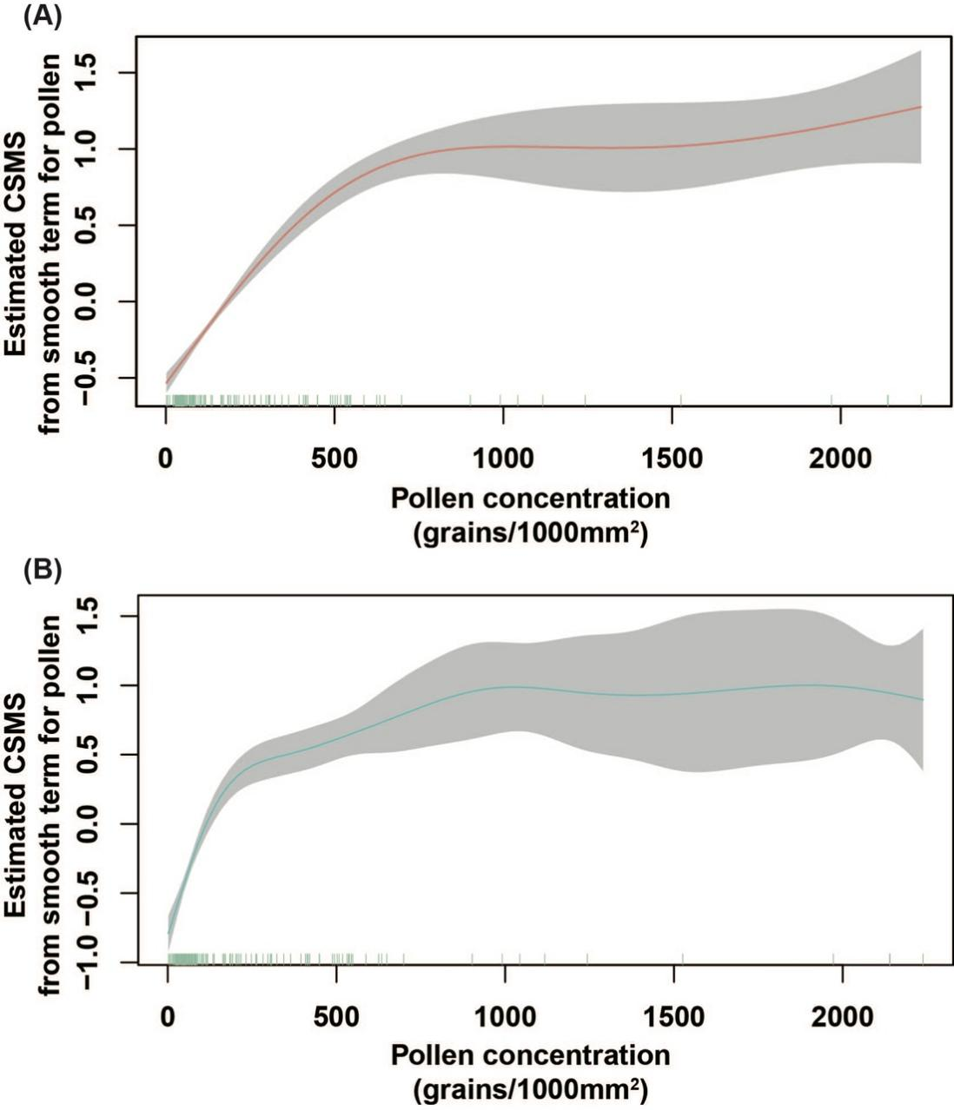
Figure S1. The relationship between pollen concentration and CSMS for patients in SLIT group (A) and control group (B), as estimated by a generalized additive model.
The solid line depicts the smooth function of pollen concentration, while the shaded area represents the 95% confidence interval of the estimate.
CSMS, combined symptom and medication score.

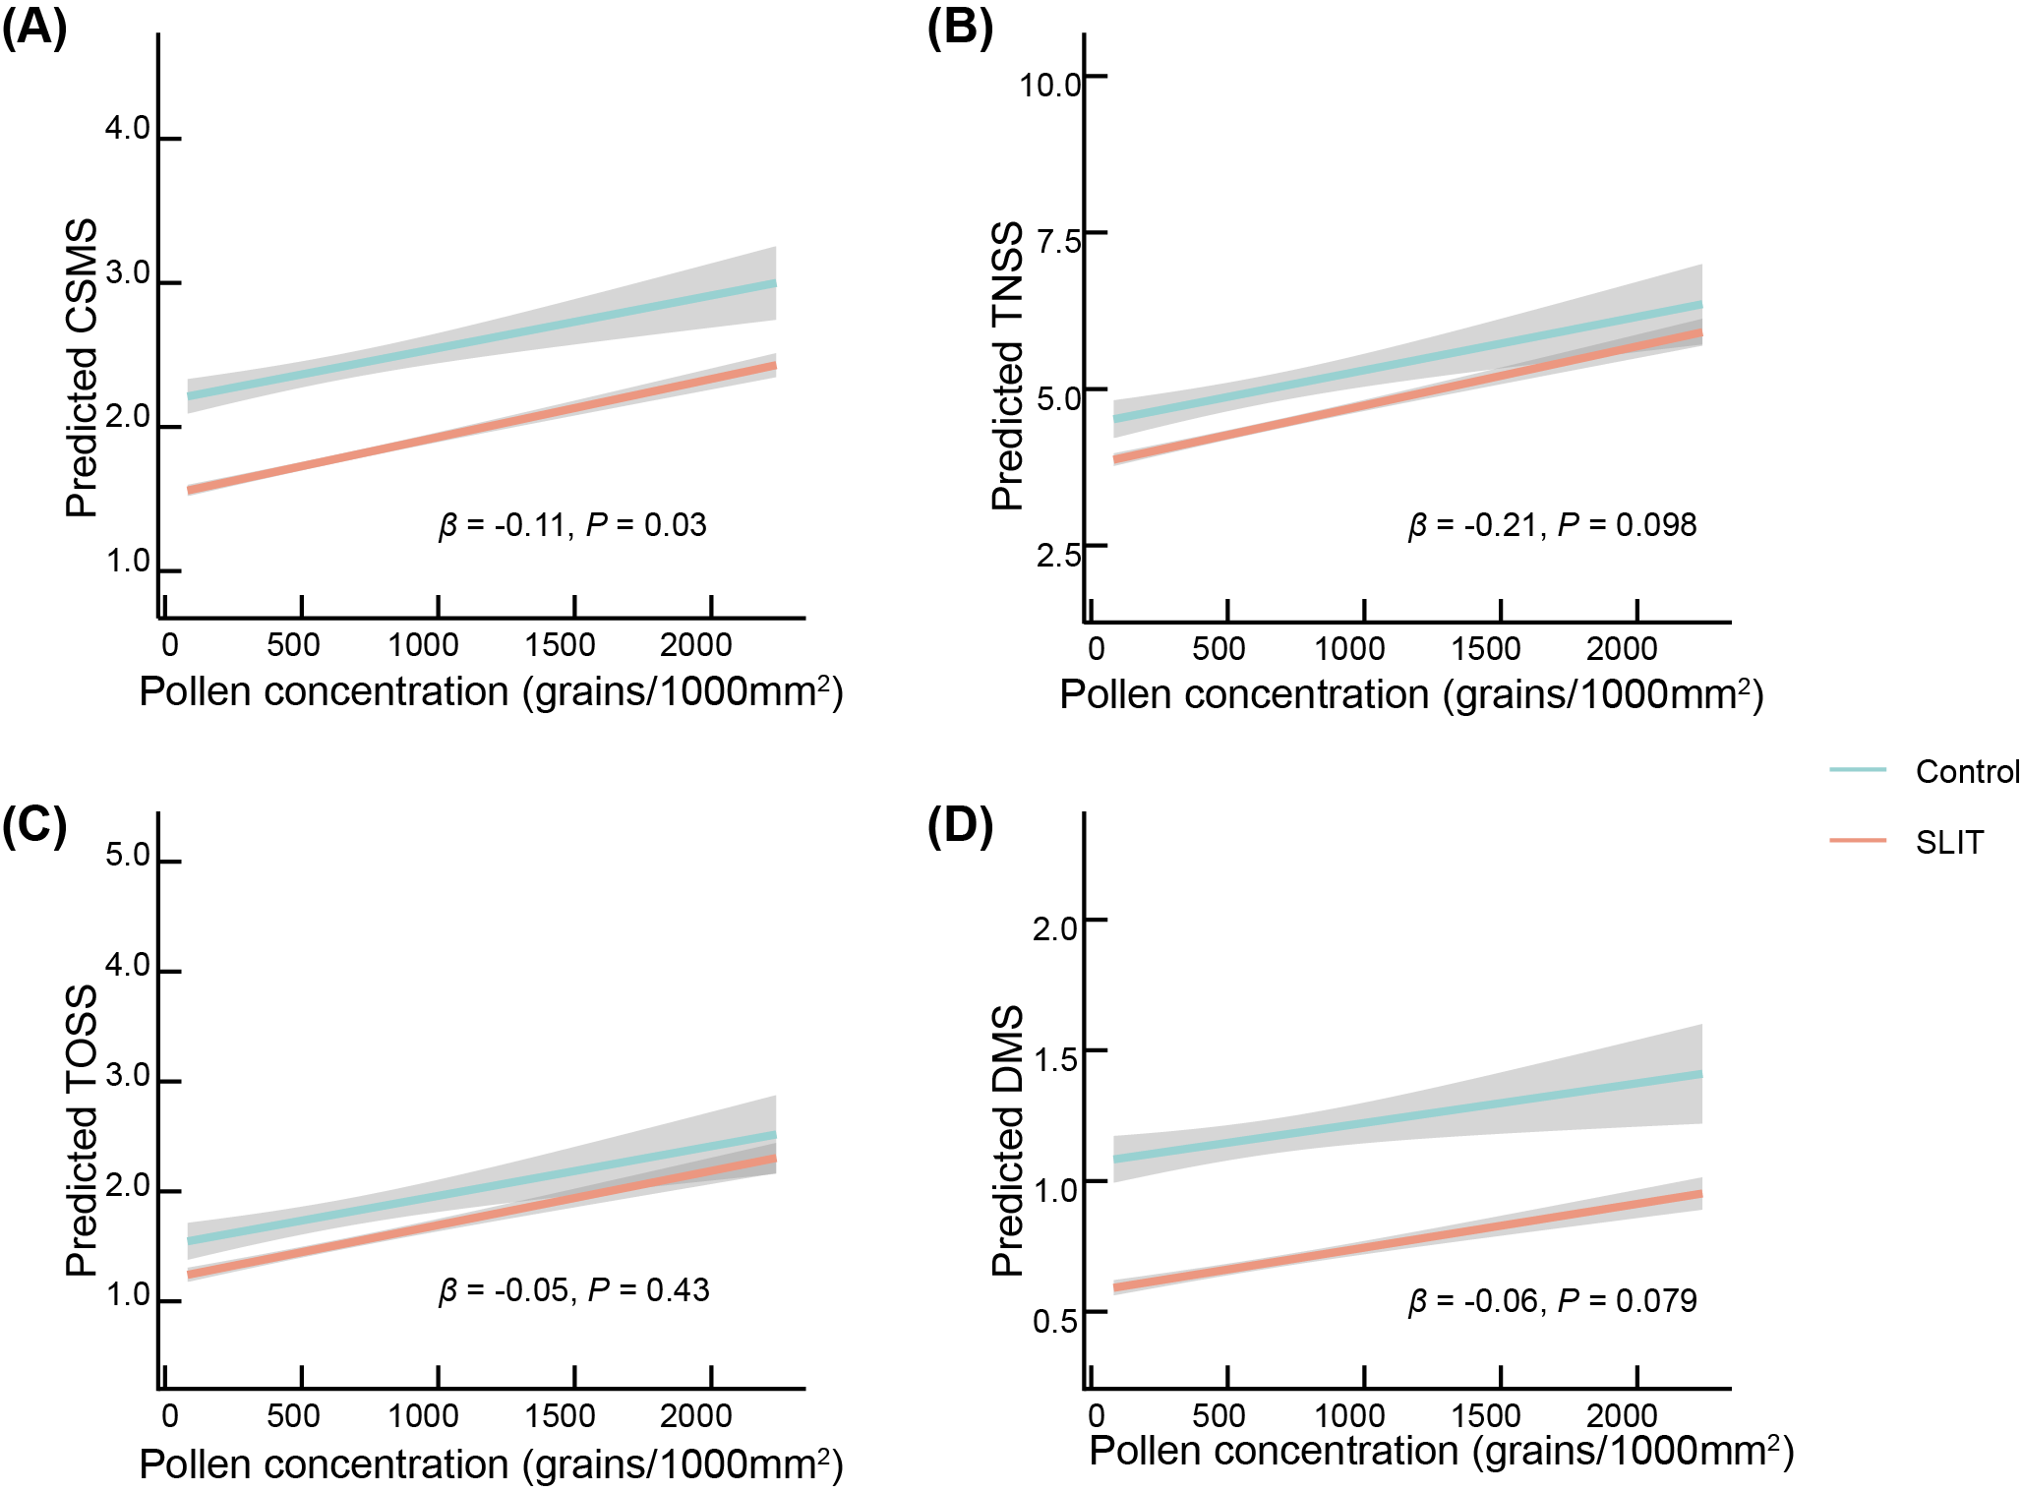
Figure S2. LMM-Predicted CSMS (A), TNSS (B), TOSS (C), and DMS (D) with Pollen Concentration Changes in SLIT and Control Groups.
The fitted line was shown with the shaded area representing the 95% confidence interval, based on the LMM for the initial pollen season. β represented the coefficient of the group2 × time × pollen interaction term.
CSMS, combined symptom and medication score; DMS, daily medication score; LMM, linear mixed model; SLIT, sublingual immunotherapy; TNSS, total nasal symptom scores; TOSS, total ocular symptom scores.

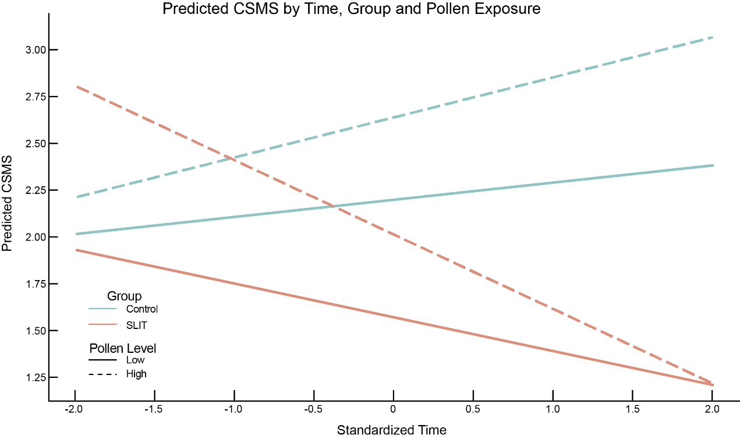
Figure S3. Interaction Effects of Treatment Group, Time, and Pollen Exposure on Daily CSMS
This schematic illustration visualized the estimated fixed effects from the linear mixed-effects model examining daily CSMS. Lines represented two treatment groups: SLIT and control, plotted at two pollen concentration levels (low and high). The negative slope of the SLIT group under high pollen exposure illustrates the significant group × time × pollen interaction effect (β = –0.11, P = 0.03), indicating enhanced SLIT efficacy with increasing pollen levels during the first pollen season.
CSMS, combined symptom and medication score; SLIT, sublingual immunotherapy.
Figure S4. Correlations between changes in CSMS and allergen-specific IgG4 and IgA levels in the SLIT group
Spearman correlation analyses were performed between CSMS changes and immunoglobulin levels. (A) serum sIgG4, (B) serum sIgA, (C) nasal secretion sIgG4, and (D) nasal secretion sIgA.
Art-sIgG4, Artemisia-specific Immunoglobulin G subclass 4; CSMS, combined symptom and medication score; PPP, peak pollen period.

