Supplementary Figure 1 The DSA imaging of HAPVF.
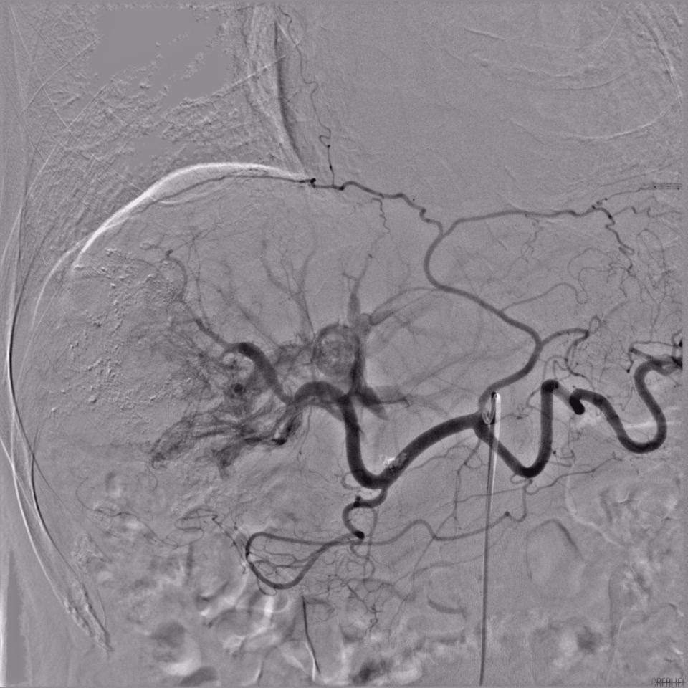
DSA, digital subtraction angiography; HAPVF, hepatic artery-portal vein fistula.

Supplementary Figure 2 The DSA imaging of HAHVF.
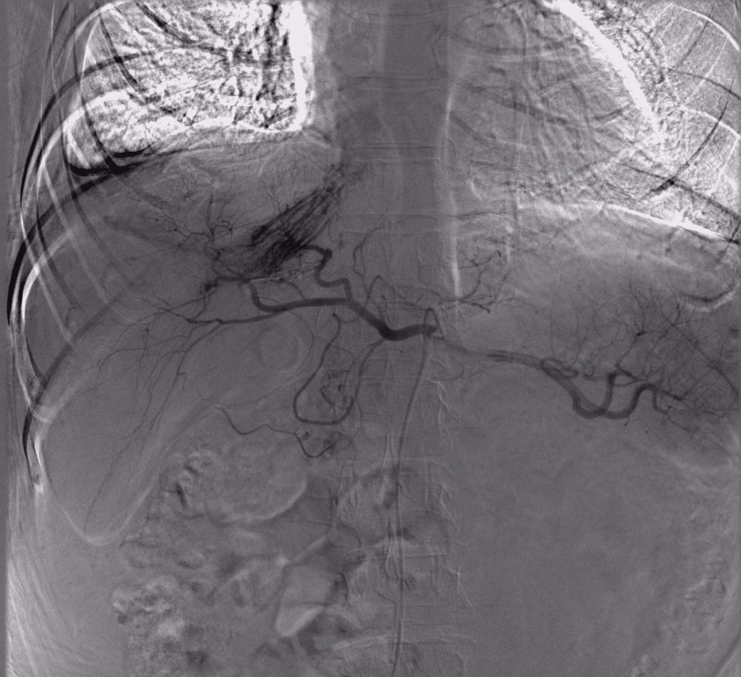
DSA, digital subtraction angiography; HAHVF, hepatic artery-hepatic vein fistula.

Supplementary Figure 3 The DSA imaging of mixed-type fistula.
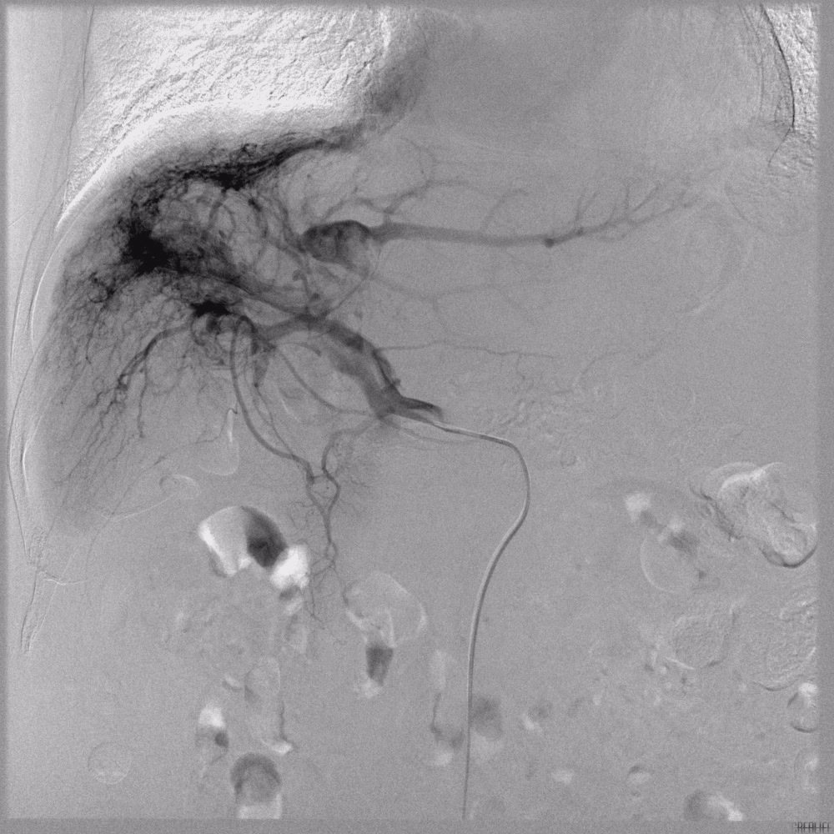
DSA, digital subtraction angiography.

Supplementary Figure 4 The standardized mean difference plot of baseline characteristics before and after propensity score matching.
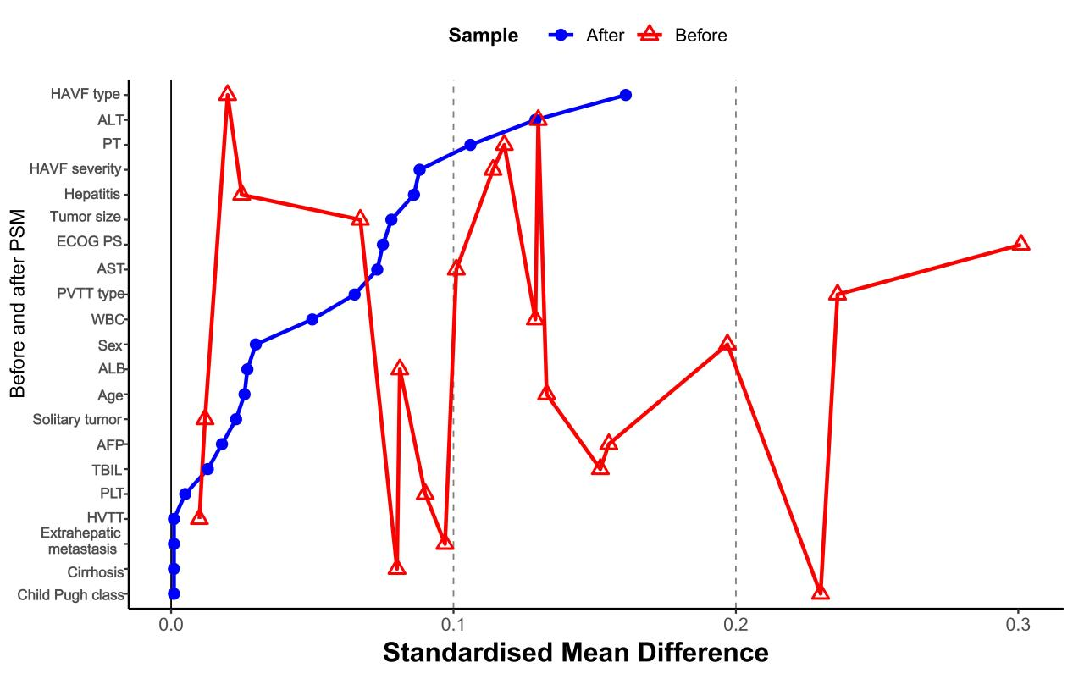
HAVF, hepatic arteriovenous fistula; ALT, alanine aminotransferase; PT, prothrombin time; ECOG PS, Eastern Cooperative Oncology Group performance status; AST, aspartate aminotransferase; PVTT, portal vein tumor thrombus; WBC, white blood cell; ALB, albumin; AFP, alpha-fetoprotein; TBIL, total bilirubin; PLT, platelet; HVTT, hepatic vein tumor thrombus.

