Supplementary material
Supplementary Table 1 Feature Encoding and Definitions
Feature | Encoding | Definition / Measurement
Age | — | Actual age in years at the time of admission
Gender | 1 = Male; 2 = Female | Biological sex at birth
Education Level | 1 = Primary school or below; 2 = Junior high school; 3 = Senior high school or above | The highest level of formal education attained
Smoking History | 0 = No; 1 = Yes | Current tobacco use at the time of admission
Drinking History | 0 = No; 1 = Yes | Current alcohol consumption at the time of admission
BMI | — | Body Mass Index, calculated from height and weight measured at admission (BMI = weight [kg] / height [m]²)
Number of Comorbidities | 0 = 0; 1 = 1; 2 = 2; 3 = ≥3 | Number of chronic diseases already had by the patient before admission.
Hypertension | 0 = No; 1 = Yes | Physician-diagnosed hypertension prior to admission
Diabetes | 0 = No; 1 = Yes | Physician-diagnosed diabetes mellitus prior to admission
Hyperlipidemia | 0 = No; 1 = Yes | Physician-diagnosed hyperlipidemia prior to admission
Coronary Heart Disease | 0 = No; 1 = Yes | Physician-diagnosed coronary heart disease prior to admission
Atrial Fibrillation | 0 = No; 1 = Yes | Physician-diagnosed atrial fibrillation prior to admission
History of Stroke | 0 = No; 1 = Yes | Physician-diagnosed history of stroke (ischemic or hemorrhagic) prior to the current admission
ADL Grade | 1 = Independence (BI=100); 2 = Mild Dependence (BI=61-99); 3 = Moderate Dependence (BI=41-60); 4 = Severe Dependence (BI≤40) | Level of dependence in Activities of Daily Living, assessed at admission using the Barthel Index (BI)
Hypoalbuminemia | 0 = No; 1 = Yes | Laboratory result at admission: serum total protein < 60 g/L and/or serum albumin < 30 g/L
NIHSS Score | — | National Institutes of Health Stroke Scale score, assessed at admission. Scores range from 0 to 42, with higher scores indicating more severe neurological impairment.
pre-mRS Grade | 1 = 0-2(Favorable Outcome); 2 = 3-5(Poor Outcome) | Pre-stroke modified Rankin Scale score, assessing functional status prior to the current stroke event.
Lesion Hemisphere | 1 = Left; 2 = Right; 3 = Bilateral | The cerebral hemisphere(s) affected by the acute ischemic lesion, as determined by CT imaging.
Multifocal Lesions | 0 = No; 1 = Yes | Presence of two or more distinct acute ischemic lesions, as identified on DWI and/or MRA sequences.
Treatment Methods | 1 = Conservative Treatment; 2 =Thrombolysis/Thrombectomy | Primary treatment strategy determined by neurologists based on individual patient condition and clinical guidelines.
Abbreviations：BI, Barthel Index; NIHSS, National Institutes of Health Stroke Scale; pre-mRS, pre-stroke modified Rankin Scale; DWI, Diffusion-Weighted Imaging; MRA, Magnetic Resonance Angiography.

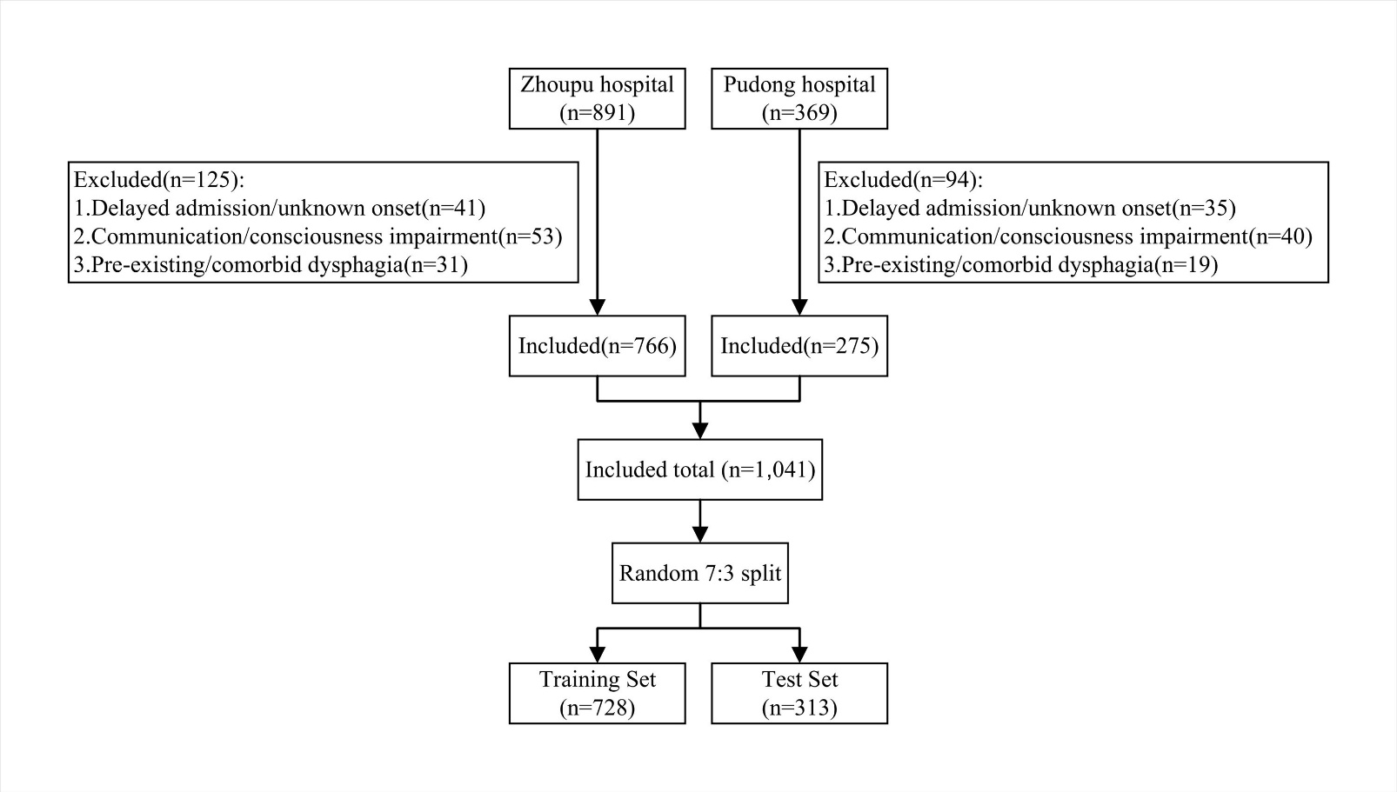
Supplementary Figure 1 Participant recruitment flowchart
Supplementary Table 2 FOIS scores of 305 patients with dysphagia
FOIS score | Description | n(%)
1 | Nothing by mouth | 111(36.4)
2 | Tube dependent with minimal oral intake | 77(25.2)
3 | Tube dependent with consistent oral intake | 69(22.6)
4 | Total oral diet of a single consistency | 39(12.8)
5 | Total oral diet with multiple consistencies, but requiring special preparation | 3(1.0)
6 | Total oral diet with multiple consistencies without special preparation, but with specific food limitations | 6(2.0)
7 | Total oral diet with no restrictions | 0(0.0)
Abbreviations：FOIS, Functional Oral Intake Scale; PSD, Post-stroke dysphagia.

Supplementary Table 3 Comparison of Characteristics Between Training and Test Sets
Characteristic | Training Set (n=728) | Test Set (n=313) | Z/χ² | P-value
Dysphagia, n (%) |  |  | 0.037 | 0.848
No | 516(70.9) | 220(70.3)
Yes | 212(29.1) | 93(29.7)
Age(years) | 70（63,78） | 70(61,77) | -0.785 | 0.433
Gender, n (%) |  |  | 0.144 | 0.704
Male | 451(62.0) | 190(60.7)
Female | 277(38.0) | 123(39.3)
Education Level, n (%) |  |  | 0.669 | 0.716
Primary School or Below | 340(46.7) | 138(44.1)
Junior High School | 279(38.3) | 124(39.6)
Senior High School or Above | 109(15.0) | 51(16.3)
Smoking, n (%) |  |  | 0.059 | 0.808
No | 579(79.5) | 251(80.2)
Yes | 149(20.5) | 62(19.8)
Drinking, n(%) |  |  | 0.021 | 0.885
No | 658(90.4) | 282(90.1)
Yes | 70(9.6) | 31(9.9)
BMI, Kg/m² | 24.34(22.22,26.57) | 24.34(22.31,26.57) | -0.468 | 0.640
Number of Chronic Conditions, n (%) |  |  | 4.942 | 0.176
0 | 110(15.1) | 52(16.6)
1 | 279(38.3) | 99(31.6)
2 | 224(30.8) | 101(32.3)
≥3 | 115(15.8) | 61(19.5)
Hypertension, n(%) |  |  | 0.238 | 0.625
No | 194(26.6) | 88(28.1)
Yes | 534(73.4) | 225(71.9)
Diabetes, n(%) |  |  | 0.914 | 0.339
No | 492(67.6) | 202(64.5)
Yes | 236(32.4) | 111(35.5)
Hyperlipidemia, n(%) |  |  | 2.475 | 0.116
No | 709(97.4) | 299(95.5)
Yes | 19(2.6) | 14(4.5)
Coronary Heart Disease, n(%) |  |  | 1.230 | 0.267
No | 650(89.3) | 272(86.9)
Yes | 78(10.7) | 41(13.1)
Atrial Fibrillation, n(%) |  |  | 0.481 | 0.488
No | 702(96.4) | 299(95.5)
Yes | 26(3.6) | 14(4.5)
History of Stroke, n(%) |  |  | 0.433 | 0.511
No | 549(75.4) | 230(73.5)
Yes | 179(24.6) | 83(26.5)
ADL Grade, n (%) |  |  | 0.764 | 0.858
Independence | 152(20.9) | 65(20.8)
Mild Dependence | 183(25.1) | 85(27.2)
Moderate Dependence | 236(32.4) | 94(30.0)
Severe Dependence | 157(21.6) | 69(22.0)
Hypoalbuminemia, n(%) |  |  | 0.327 | 0.568
No | 635(87.2) | 277(88.5)
Yes | 93(12.8) | 36(11.5)
NIHSS Score | 2(0,6) | 2(0,7) | -1.000 | 0.317
mRS Grade, n (%) |  |  | 0.329 | 0.566
0-2 | 421(57.8) | 175(55.9)
3-5 | 307(42.2) | 138(44.1)
Lesion Hemisphere, n(%) |  |  | 2.347 | 0.309
Left | 376(51.6) | 146(46.6)
Right | 330(45.3) | 158(50.5)
Bilateral | 22(3.0) | 9(2.9)
Multifocal Lesions, n(%) |  |  | 4.983 | 0.026
No | 540(74.2) | 211(67.4)
Yes | 188(25.8) | 102(32.6)
Treatment Methods, n (%) |  |  | 0.182 | 0.670
Conservative Treatment | 662(90.9) | 282(90.1)
Thrombolysis/Thrombectomy | 66(9.1) | 31(9.9)
Note：Continuous values were presented as median (IQR). Categorical values were presented as n (%).Bold implies that the p-value is statistically significant.
Abbreviations：BMI, Body Mass Index；ADL, Activities of Daily Living；NIHSS, National Institutes of Health Stroke Scale；mRS, Modified Rankin Scale.

Supplementary Table 4 Spearman Correlation Analysis of the Features
 | Coronary heart disease | ADL grade | Hypoalbuminemia | NIHSS score | Lesion hemisphere | Multifocal Lesions
Coronary heart disease | 1.000 | 0.101** | 0.057 | 0.046 | 0.017 | 0.120**
ADL grade | 0.101** | 1.000 | 0.335** | 0.589** | 0.141** | 0.490**
Hypoalbuminemia | 0.101 | 0.335** | 1.000 | 0.333** | 0.109** | 0.267**
NIHSS score | 0.057 | 0.589** | 0.333** | 1.000 | 0.110** | 0.511**
Lesion hemisphere | 0.017 | 0.141** | 0.109** | 0.110** | 1.000 | 0.132**
Multifocal Lesions | 0.120** | 0.490** | 0.267** | 0.511** | 0.132** | 1.000
Note: **,p < 0.01 (two-tailed tests).
Abbreviations：ADL, Activities of Daily Living；NIHSS, National Institutes of Health Stroke Scale.

Supplementary Table 5 Variance Inflation Factor Analysis of the Features
Features | Tolerance | VIF
Coronary heart disease | 0.982 | 1.018
ADL grade | 0.630 | 1.588
Hypoalbuminemia | 0.851 | 1.176
NIHSS score | 0.640 | 1.562
Lesion hemisphere | 0.955 | 1.047
Multifocal lesions | 0.688 | 1.455
Abbreviations：VIF, variance inflation factor ;ADL, Activities of Daily Living ;NIHSS, National Institutes of Health Stroke Scale.

Supplementary Table 6 DeLong’s Test for Pairwise Comparison of ROC Curves
Dataset | Model1 | Model2 | AUC1 | AUC2 | p-value
Train set | RF | SVM | 0.959 | 0.942 | 0.188
 | RF | LR | 0.959 | 0.949 | 0.362
 | RF | KNN | 0.959 | 0.953 | 0.554
 | RF | Lasso | 0.959 | 0.951 | 0.454
 | RF | ANN | 0.959 | 0.944 | 0.180
 | SVM | LR | 0.942 | 0.949 | 0.622
 | SVM | KNN | 0.942 | 0.953 | 0.436
 | SVM | Lasso | 0.942 | 0.951 | 0.512
 | SVM | ANN | 0.942 | 0.944 | 0.886
 | LR | KNN | 0.949 | 0.953 | 0.754
 | LR | Lasso | 0.949 | 0.951 | 0.863
 | LR | ANN | 0.949 | 0.944 | 0.693
 | KNN | Lasso | 0.953 | 0.951 | 0.885
 | KNN | ANN | 0.953 | 0.944 | 0.473
 | Lasso | ANN | 0.951 | 0.944 | 0.564
Test set | RF | SVM | 0.952 | 0.946 | 0.522
 | RF | LR | 0.952 | 0.950 | 0.850
 | RF | KNN | 0.952 | 0.958 | 0.397
 | RF | Lasso | 0.952 | 0.950 | 0.857
 | RF | ANN | 0.952 | 0.962 | 0.110
 | SVM | LR | 0.946 | 0.950 | 0.308
 | SVM | KNN | 0.946 | 0.958 | 0.295
 | SVM | Lasso | 0.946 | 0.950 | 0.290
 | SVM | ANN | 0.946 | 0.962 | 0.020
 | LR | KNN | 0.950 | 0.958 | 0.434
 | LR | Lasso | 0.950 | 0.950 | 0.887
 | LR | ANN | 0.950 | 0.962 | 0.036
 | KNN | Lasso | 0.958 | 0.950 | 0.439
 | KNN | ANN | 0.958 | 0.962 | 0.602
 | Lasso | ANN | 0.950 | 0.962 | 0.037
Note:Bold implies that the p-value is statistically significant.
Abbreviations：AUC, Area Under the Curve. RF, Random Forest；SVM，Support Vector Machine；LR, Logistic Regression；KNN, K- Nearest Neighbors；Lasso, Least Absolute Shrinkage and Selection Operator；ANN, Artificial Neural Network.

Supplementary Table 7 Hyperparameter settings for six models
Model | Parameter | Tuning scope | Optimal hyperparameter
RF | mtry | （2, 4, 6, 8, 10） | 2
SVM | sigma | （0.01, 0.1, 1） | 0.1
SVM | C | (0.25, 0.5, 1, 2) | 0.5
LR | none | none | none
KNN | k | （3, 5, 7, 9, 11, 13, 15） | 7
Lasso | alpha | （0, 0.5, 1） | 0.5
Lasso | lambda | （0.001, 0.01, 0.1, 1） | 0.001
ANN | size | （3, 5, 7） | 7
 | decay | （0, 0.001, 0.01） | 0.01
Abbreviations：RF, Random Forest；SVM，Support Vector Machine；LR, Logistic Regression；KNN, K-Nearest Neighbors；Lasso, Least Absolute Shrinkage and Selection Operator；ANN, Artificial Neural Network.

