Supplementary Materials

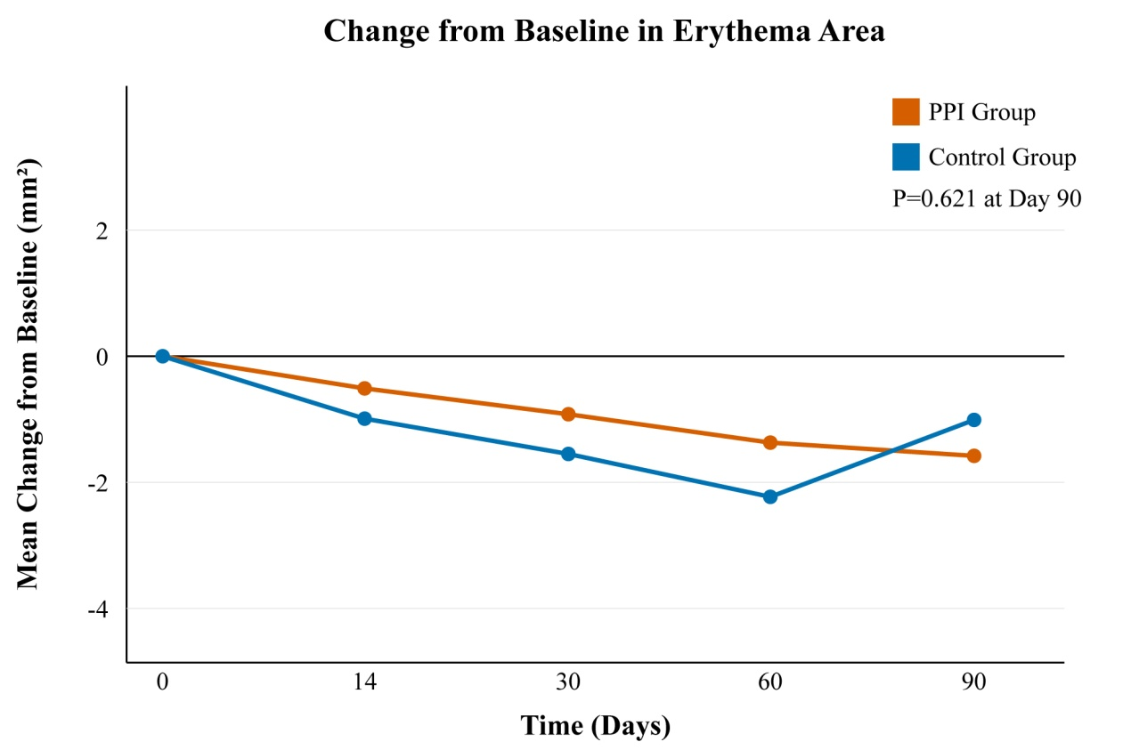

Supplementary Figure S1. Change from Baseline in Facial Erythema Area.

Mean change from baseline in facial erythema area (mm²) over the 90-day study period. Data points represent the mean for the Placental Polypeptide Injection (PPI) and Control groups. No statistically significant difference was observed between the groups at Day 90 (P = 0.621, independent t-test).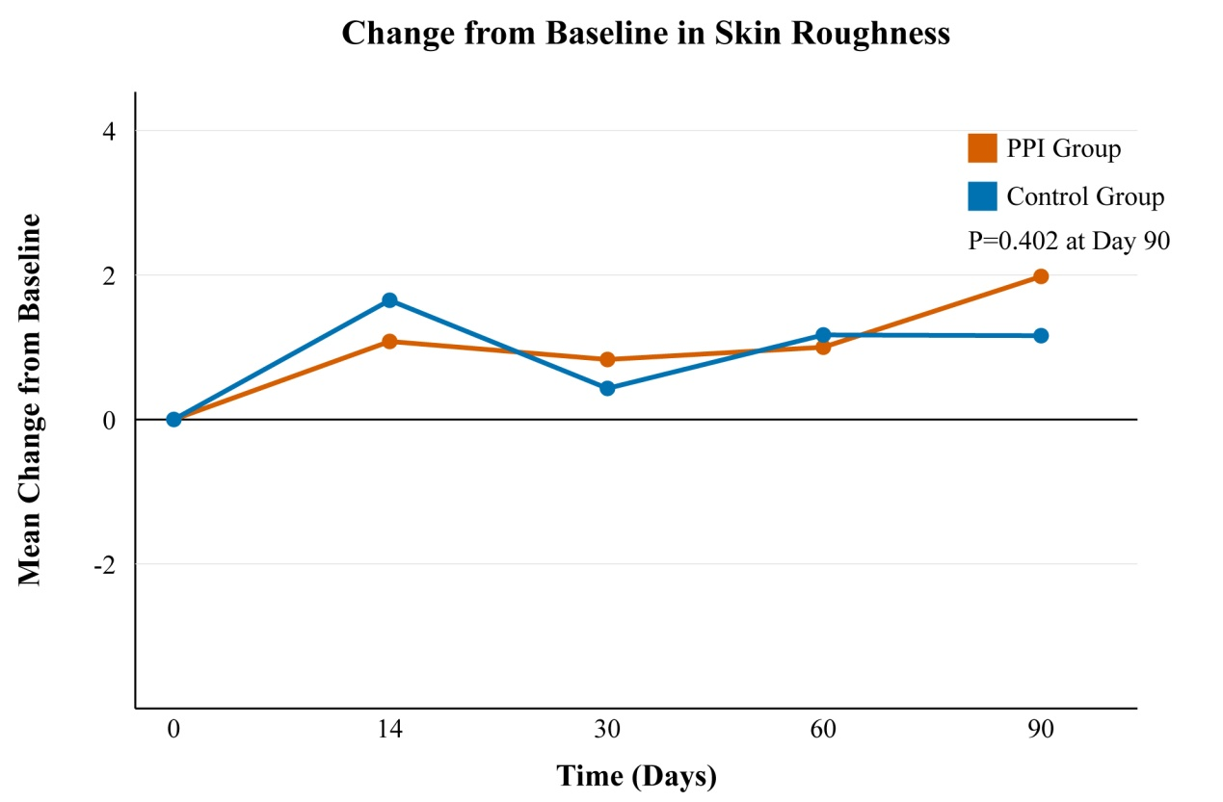

Supplementary Figure S2. Change from Baseline in Skin Roughness. Mean change from baseline in the total facial skin roughness score over 90 days. Data points represent the mean for the Placental Polypeptide Injection (PPI) and Control groups. No statistically significant difference was observed between the groups at Day 90 (P = 0.402, independent t-test).

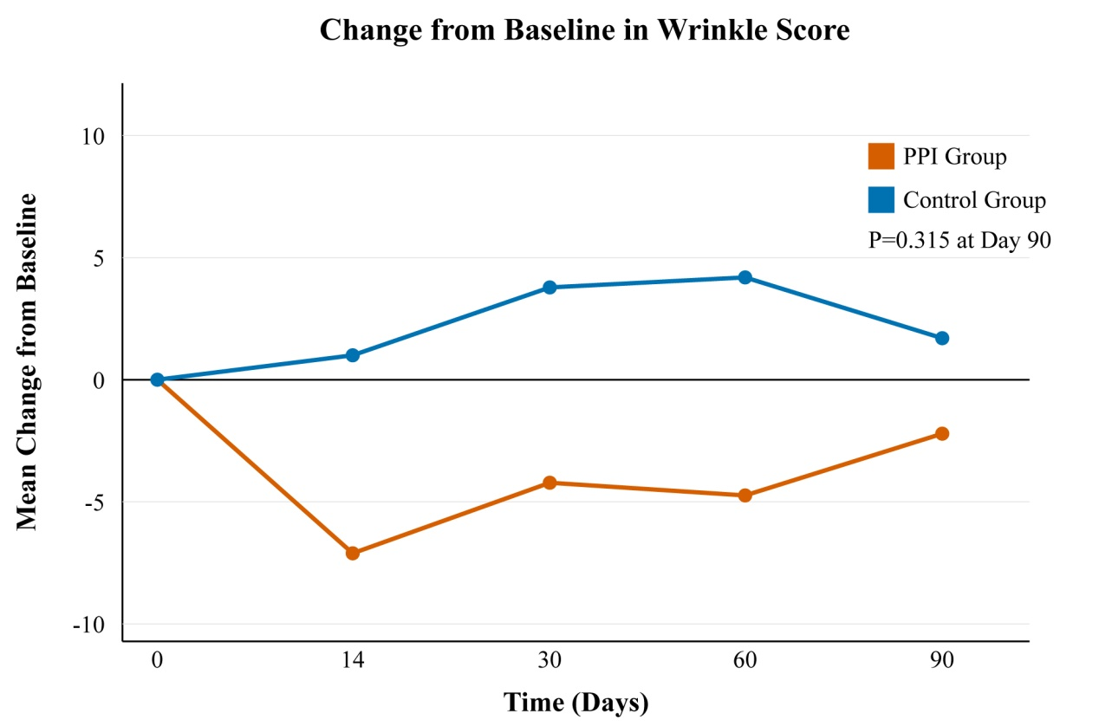

Supplementary Figure S3. Change from Baseline in Wrinkle Score. Mean change from baseline in the facial wrinkle score over 90 days. Data points represent the mean for the Placental Polypeptide Injection (PPI) and Control groups. No statistically significant difference was observed between the groups at Day 90 (P = 0.315, independent t-test).

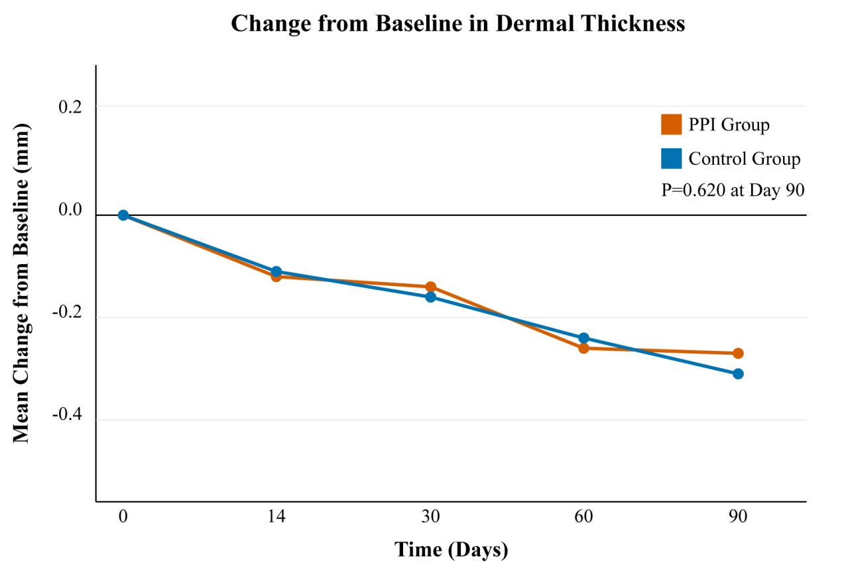

Supplementary Figure S4. Change from Baseline in Dermal Thickness. Mean change from baseline in dermal thickness (mm) over 90 days. Data points represent the mean for the Placental Polypeptide Injection (PPI) and Control groups. No statistically significant difference was observed between the groups at Day 90 (P = 0.620, independent t-test).

Supplementary Table S1. Primary Efficacy Endpoint at Day 90
Endpoint | PPI Group (n=95) | Control Group (n=51) | P-value
Change from Baseline in Hemoglobin Content, mean ± SD | -1788.61 ± 1843.93 | -756.65 ± 1493.17 | 0.001
PPI, Placental Polypeptide Injection; SD, Standard Deviation. Bold P-value indicates statistical significance (P < 0.05).

Supplementary Table S2. Detailed List of All Adverse Events
System Organ Class | Adverse Event Term | PPI Group (n=104) | Control Group (n=52)
Skin and Subcutaneous Tissue Disorders | Pigmentation disorder | 1 (Mild, Unrelated) | 0
 | Facial peeling | 1 (Moderate, Possibly Related) | 0
 | Facial pigmentation | 1 (Moderate, Possibly Related) | 0
 | Facial erythema | 1 (Moderate, Possibly Related) | 0
 | Folliculitis | 0 | 1 (Mild, Unrelated)
Respiratory, Thoracic and Mediastinal Disorders | Cough | 0 | 1 (Mild, Unrelated)
 | Rhinitis | 0 | 1 (Mild, Unrelated)
Eye Disorders | Conjunctivitis | 0 | 1 (Mild, Unrelated)
Gastrointestinal Disorders | Abdominal discomfort | 0 | 1 (Mild, Unrelated)

Supplementary Table S3. Concomitant Medications
ATC Code | Medication Name | PPI Group (n=103) | Control Group (n=51)
Total Participants with Concomitant Medication: 8 (7.8%) in PPI Group, 5 (9.8%) in Control Group
R01AD | Beclometasone nasal spray | 1 | 1
N02BE01 | Paracetamol | 2 | 1
M01AE01 | Ibuprofen | 1 | 1
A02BC01 | Omeprazole | 1 | 0
R06AX13 | Loratadine | 3 | 2
ATC, Anatomical Therapeutic Chemical Classification System. Data represent the number of participants using the medication.

