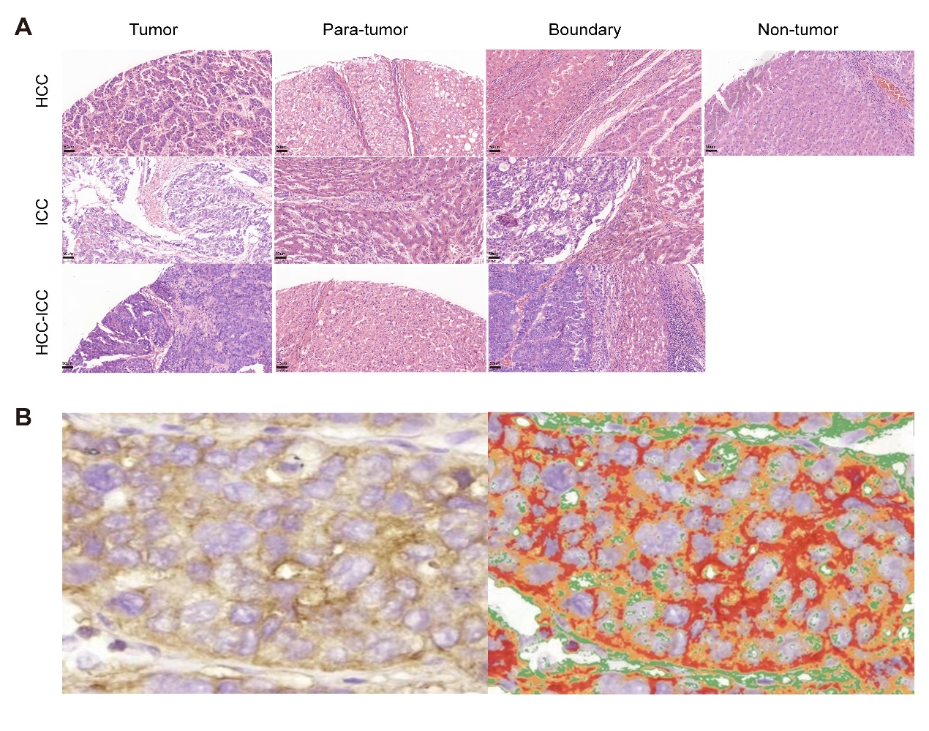
Fig. S1：Basic information of sections and schematic diagram of the score.
(A) Histological assessment in different regions of sections and different pathologic types. Scale bars, 50 μm.
(B) Schematic diagram of the score. QuantCenter software can quantify the area size of each color region in an image but cannot automatically distinguish between different colors. Therefore, during scoring, we manually selected areas corresponding to strong positive (brown-yellow), moderate positive (dark yellow), and weak positive (light yellow) staining using a color picker tool capable of differentiating colors. To aid visualization, these areas were marked in red, orange, and green, respectively, while negative (unstained) regions were excluded. After accurately outlining each relevant area, the software calculated the proportion of each color within the field of view. These values were then used to compute the H-score according to the standard formula.

