Supplementary Information

- Figure S1. Definitions of persistence, discontinuation and bio-switch.
- Figure S2. Kaplan-Meier curves for biologic persistence in the balanced populations. a. Population after PS-IPTW; b. Population after PS-matching
- Figure S3. Kaplan-Meier curves for biologic persistence (sensitivity analysis 1: prescription gap = days of supply plus 2 dosing intervals). a. Original population; b. Population after PS-IPTW; c. Population after PS-matching
- Figure S4. Kaplan-Meier curves for biologic persistence (sensitivity analysis 2: prescription gap = days of supply plus 90 days). a. Original population; b. Population after PS-IPTW; c. Population after PS-matching
- Figure S5. Kaplan-Meier curves for treatment-free status in the balanced population. a. Population after PS-IPTW; b. Population after PS-matching

- Table S1. Patient characteristics for the persistence analysis after propensity score methods of inverse probability of treatment weighting (IPTW) and matching
- Table S2. Patient characteristics for the treatment-free analysis after propensity score methods of inverse probability of treatment weighting (IPTW) and matching
Figure S1. Definitions of persistence, discontinuation and bio-switch.
a. Persistence was defined as the duration of continuous exposure to a biologic from initiation to discontinuation. Discontinuation was identified if a prescription gap for the index biologic was greater than its days of supply, which was equal to its maintenance dosing interval, plus a predefined time window. The discontinuation date was defined as the last day of the index biologic’s supply.
b. Bio-switch was defined as initiating a subsequent biologic before the end of the prescription gap.

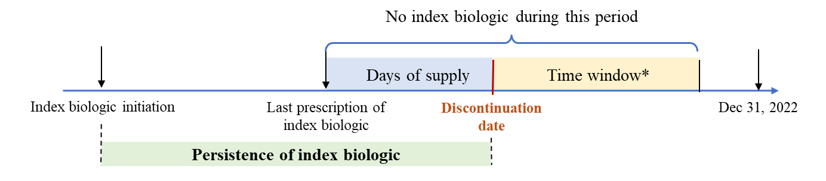
a.

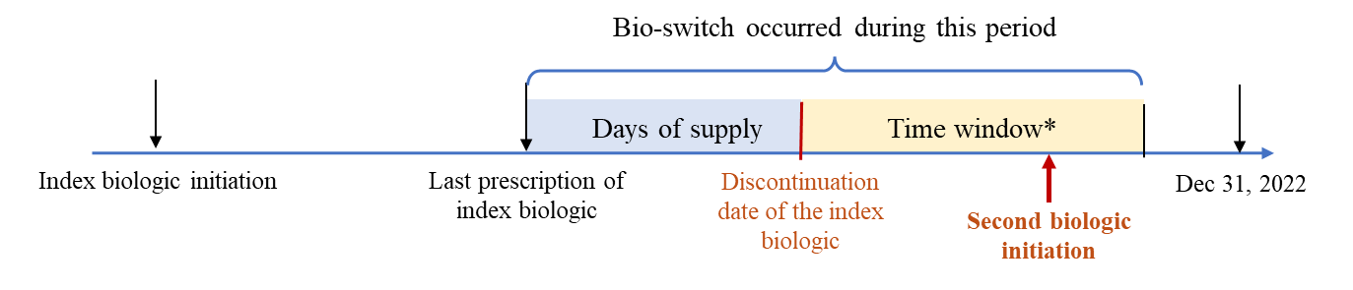
b.

*: in the main analysis, the time window = one maintenance dosing interval for each biologic (2 weeks for BRO, 4 weeks for SEC, IXE and BIM, 8 weeks for GUS, and 12 weeks for RIS and TIL); in sensitivity analyses, alternative definitions of the time window were employed: two maintenance dosing intervals for each biologic and fixed 90 days for all biologics.

Figure S2. Kaplan-Meier curves for biologic persistence in the balanced populations.
a. Population after PS-IPTW.
b. Population after PS-matching.

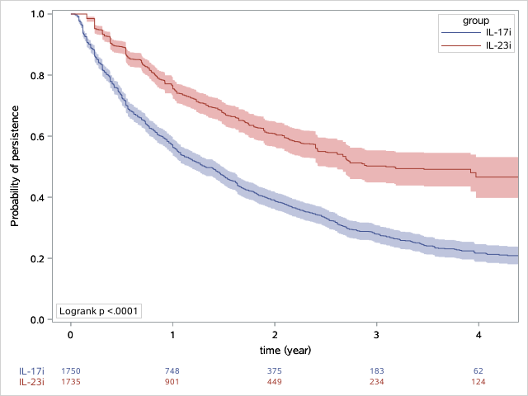
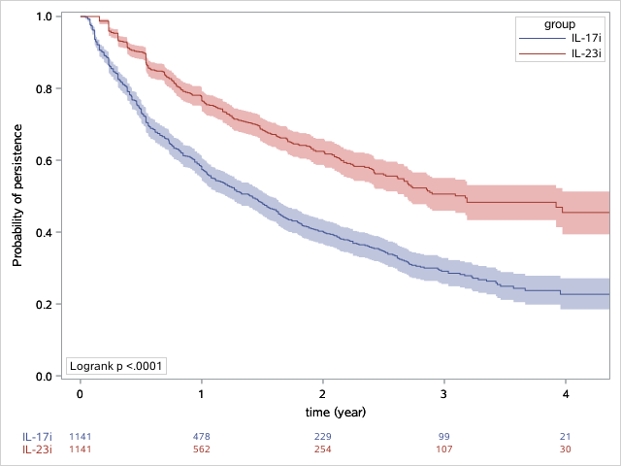
a. b.

Figure S3. Kaplan-Meier curves for biologic persistence (sensitivity analysis 1: prescription gap = days of supply plus two maintenance dosing intervals).
a. Original population.
b. Population after PS-IPTW.
c. Population after PS-matching.

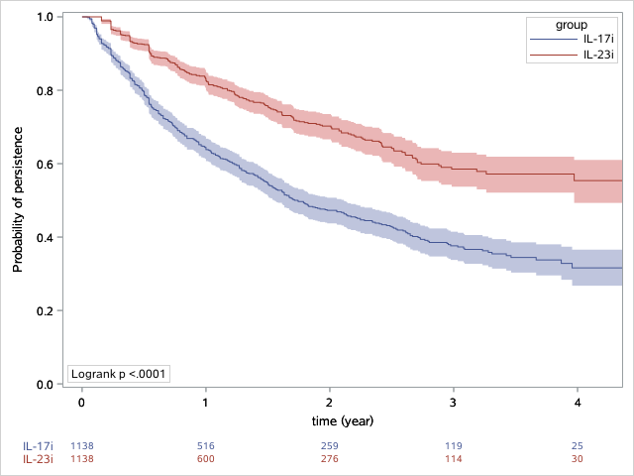
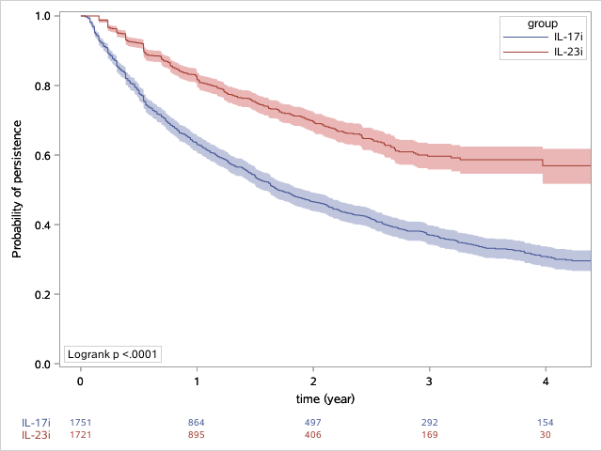
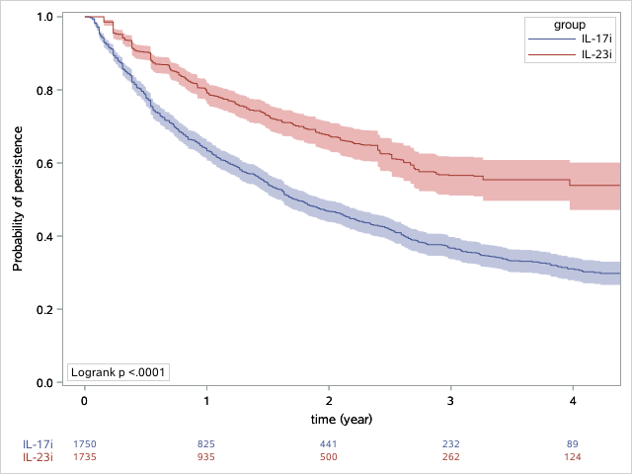
a. b. c.

Figure S4. Kaplan-Meier curves for biologic persistence (sensitivity analysis 2: prescription gap = days of supply plus 90 days).
a. Original population.
b. Population after PS-IPTW.
c. Population after PS-matching.

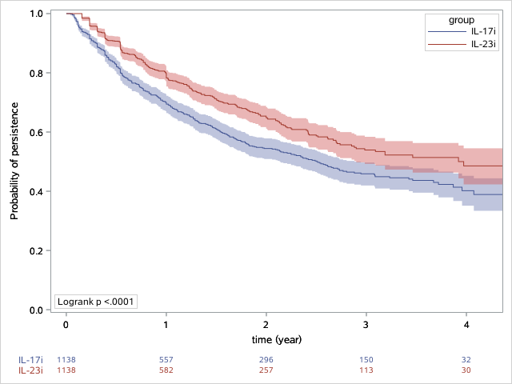
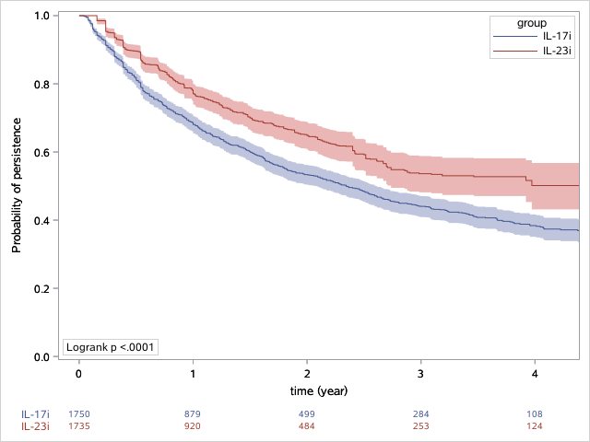
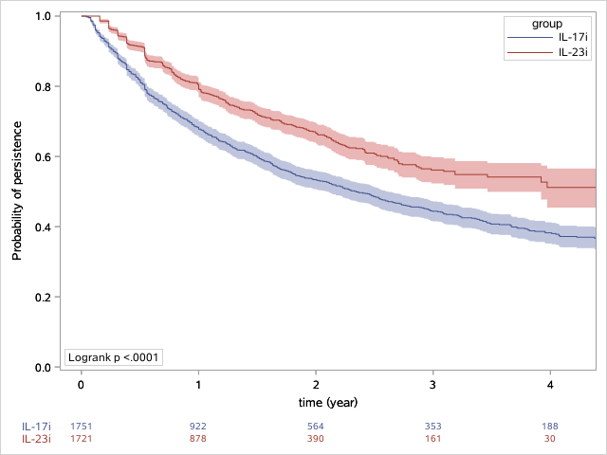
a. b. c.

Figure S5. Kaplan-Meier curves for treatment-free status in the balanced populations.
a. Population after PS-IPTW.
b. Population after PS-matching.

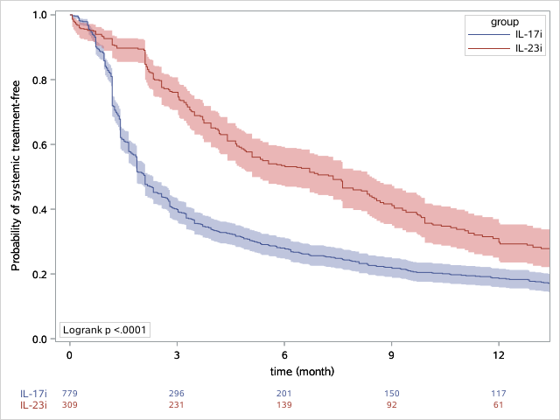
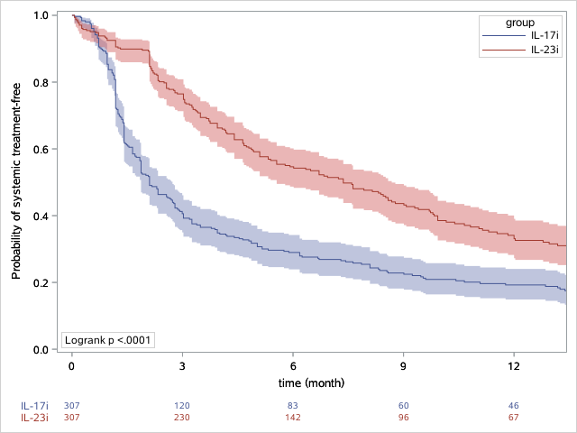
a. b.

Table S1. Patient characteristics for the persistence analysis after propensity score methods of inverse probability of treatment weighting (IPTW) and matching
 | Weighted cohorts |  |  |  |  |  | Matched cohorts
 | IL-17i |  | IL-23i |  | SMD |  | IL-17i |  | IL-23i |  | SMD
Total number, n | 1750 |  | 1735 |  |  |  | 1141 |  | 1141
Sex, n (%) |  |  |  |  | 0.00 |  |  |  |  |  | 0.00
Male | 1160 | 66.3% | 1149 | 66.2% |  |  | 762 | 66.8% | 762 | 66.8%
Female | 590 | 33.7% | 586 | 33.8% |  |  | 379 | 33.2% | 379 | 33.2%
Age at index, years |  |  |  |  | 0.00 |  |  |  |  |  | 0.02
Means | 56.6 |  | 56.6 |  |  |  | 55.4 |  | 55.6
SD | 14.9 |  | 15.7 |  |  |  | 15.1 |  | 15.6
Median | 57.0 |  | 56.0 |  |  |  | 55.0 |  | 55.0
Q1-Q3 | 46-69 |  | 46-70 |  |  |  | 45-68 |  | 45-69
Time of biologic therapy initiation, n (%) |  |  |  |  | 0.02 |  |  |  |  |  | 0.00
2015-2018 | 364 | 20.8% | 371 | 21.4% |  |  | 90 | 7.9% | 90 | 7.9%
2019-2022 | 1387 | 79.2% | 1364 | 78.6% |  |  | 1051 | 92.1% | 1051 | 92.1%
Any systemic therapy during baseline, n (%) |  |  |  |  | 0.01 |  |  |  |  |  | 0.01
Yes | 789 | 45.1% | 792 | 45.7% |  |  | 504 | 44.2% | 509 | 44.6%
No | 962 | 55.0% | 942 | 54.3% |  |  | 637 | 55.8% | 632 | 55.4%
Any topical therapy during baseline, n (%) |  |  |  |  | 0.01 |  |  |  |  |  | 0.02
Yes | 1370 | 78.3% | 1362 | 78.6% |  |  | 872 | 76.4% | 861 | 75.5%
No | 380 | 21.7% | 372 | 21.5% |  |  | 269 | 23.6% | 280 | 24.5%
Charlson comorbidity index (CCI) during baseline |  |  |  |  | 0.01 |  |  |  |  |  | 0.01
Means | 0.8 |  | 0.8 |  |  |  | 0.74 |  | 0.73
SD | 1.5 |  | 1.6 |  |  |  | 1.5 |  | 1.53
Median | 0 |  | 0 |  |  |  | 0 |  | 0
Q1-Q3 | 0-1 |  | 0-1 |  |  |  | 0-1 |  | 0-1
Other comorbid conditions during baseline
PsA, n (%) | 289 | 16.5% | 316 | 18.2% | 0.05 |  | 202 | 17.7% | 192 | 16.8% | 0.02
Depression, n (%) | 32 | 1.9% | 34 | 2.0% | 0.01 |  | 20 | 1.8% | 21 | 1.8% | 0.01
Hospital size classification, n (%) |  |  |  |  | 0.09 |  |  |  |  |  | 0.08
199 beds or less | 25 | 1.4% | 27 | 1.5% |  |  | 14 | 1.2% | 18 | 1.6%
200 to -499 beds | 585 | 33.4% | 582 | 33.6% |  |  | 372 | 32.6% | 365 | 32.0%
500 beds or more | 1140 | 65.1% | 1126 | 64.9% |  |  | 755 | 66.2% | 758 | 66.4%
All-cause hospitalization during baseline, n (%) |  |  |  |  | 0.03 |  |  |  |  |  | 0.00
Yes | 187 | 10.7% | 202 | 11.7% |  |  | 124 | 10.9% | 123 | 10.8%
No | 1563 | 89.3% | 1532 | 88.3% |  |  | 1017 | 89.1% | 1018 | 89.2%
Duration from first observed psoriasis-related claim to the index date, months |  |  |  |  | 0.01 |  |  |  |  |  | 0.02
Means | 14.9 |  | 15.2 |  |  |  | 13.7 |  | 14.0
SD | 22.1 |  | 21.4 |  |  |  | 21.4 |  | 20.7
Median | 2.8 |  | 4.0 |  |  |  | 2.4 |  | 3.3
Q1-Q3 | 0.9-21.8 |  | 1.0-21.0 |  |  |  | 0.9-17.9 |  | 1.0-18.9

Table S2. Patient characteristics for the treatment-free analysis after propensity score methods of inverse probability of treatment weighting (IPTW) and matching
 | Weighted cohorts |  |  |  |  |  | Matched cohorts
 | IL-17i |  | IL-23i |  | SMD |  | IL-17i |  | IL-23i |  | SMD
Patient number, n | 779 |  | 309 |  |  |  | 307 |  | 307
Sex, n (%) |  |  |  |  | 0.01 |  |  |  |  |  | 0.05
Male | 532 | 68.30% | 213 | 68.90% |  |  | 186 | 60.60% | 194 | 63.20%
Female | 247 | 31.70% | 96 | 31.10% |  |  | 121 | 39.40% | 113 | 36.80%
Age at index, years |  |  |  |  | 0 |  |  |  |  |  | 0.05
Means | 57.4 |  | 57.4 |  |  |  | 61 |  | 60.2
SD | 15.7 |  | 16.3 |  |  |  | 16.3 |  | 15.8
Median | 58 |  | 58 |  |  |  | 63 |  | 61
Q1-Q3 | 46-71 |  | 46-72 |  |  |  | 51-74 |  | 49-73
Any systemic therapy during baseline, n (%) |  |  |  |  | 0.02 |  |  |  |  |  | 0.04
Yes | 233 | 29.90% | 95 | 30.60% |  |  | 100 | 32.60% | 94 | 30.60%
No | 546 | 70.10% | 215 | 69.40% |  |  | 207 | 67.40% | 213 | 69.40%
Any topical therapy during baseline, n (%) |  |  |  |  | 0.06 |  |  |  |  |  | 0.08
Yes | 610 | 78.30% | 235 | 76.00% |  |  | 256 | 83.40% | 247 | 80.50%
No | 169 | 21.70% | 74 | 24.00% |  |  | 51 | 16.60% | 60 | 19.50%
Charlson comorbidity index (CCI) during baseline |  |  |  |  | 0.01 |  |  |  |  |  | 0.05
Means | 1.1 |  | 1 |  |  |  | 1.2 |  | 1.1
SD | 1.8 |  | 1.9 |  |  |  | 2 |  | 2
Median | 0 |  | 0 |  |  |  | 0 |  | 0
Q1-Q3 | 0-1 |  | 0-1 |  |  |  | 0-2 |  | 0-1
Other comorbid conditions during baseline
PsA, n (%) | 148 | 19.00% | 57 | 18.50% | 0.01 |  | 43 | 14.00% | 33 | 10.80% | 0.10
Depression, n (%) | 22 | 2.90% | 8 | 2.70% | 0.01 |  | 13 | 4.20% | 10 | 3.30% | 0.05
Hospital size classification, n (%) |  |  |  |  | 0.08
199 beds or less | 8 | 1.00% | 5 | 1.50% |  |  | 4 | 1.30% | 5 | 1.60% | 0.10
200 to -499 beds | 295 | 37.90% | 114 | 36.90% |  |  | 122 | 39.70% | 114 | 37.10%
500 beds or more | 475 | 61.10% | 191 | 61.60% |  |  | 181 | 59.00% | 188 | 61.20%
All-cause hospitalization during baseline, n (%) |  |  |  |  | 0.02 |  |  |  |  |  | 0.07
Yes | 122 | 15.70% | 51 | 16.40% |  |  | 64 | 20.80% | 55 | 17.90%
No | 656 | 84.30% | 259 | 83.60% |  |  | 243 | 79.20% | 252 | 82.10%
Duration from first observed psoriasis-related claim to the discontinuation date, months |  |  |  |  | 0 |  |  |  |  |  | 0.05
Means | 23.9 |  | 23.8 |  |  |  | 26 |  | 25
SD | 21.5 |  | 19.4 |  |  |  | 22.8 |  | 20.4
Median | 17.5 |  | 16.6 |  |  |  | 18.6 |  | 17.5
Q1-Q3 | 6.5-36.5 |  | 9.5-34.6 |  |  |  | 6.6-38.5 |  | 9.5-36.5

