Supporting Information

Tyrosinase-Responsive Activated Nano-Coated Sensor for Sensitive Detection of Melanoma Biomarkers

Fig S1. Particle size distribution image of Au nanoparticles.
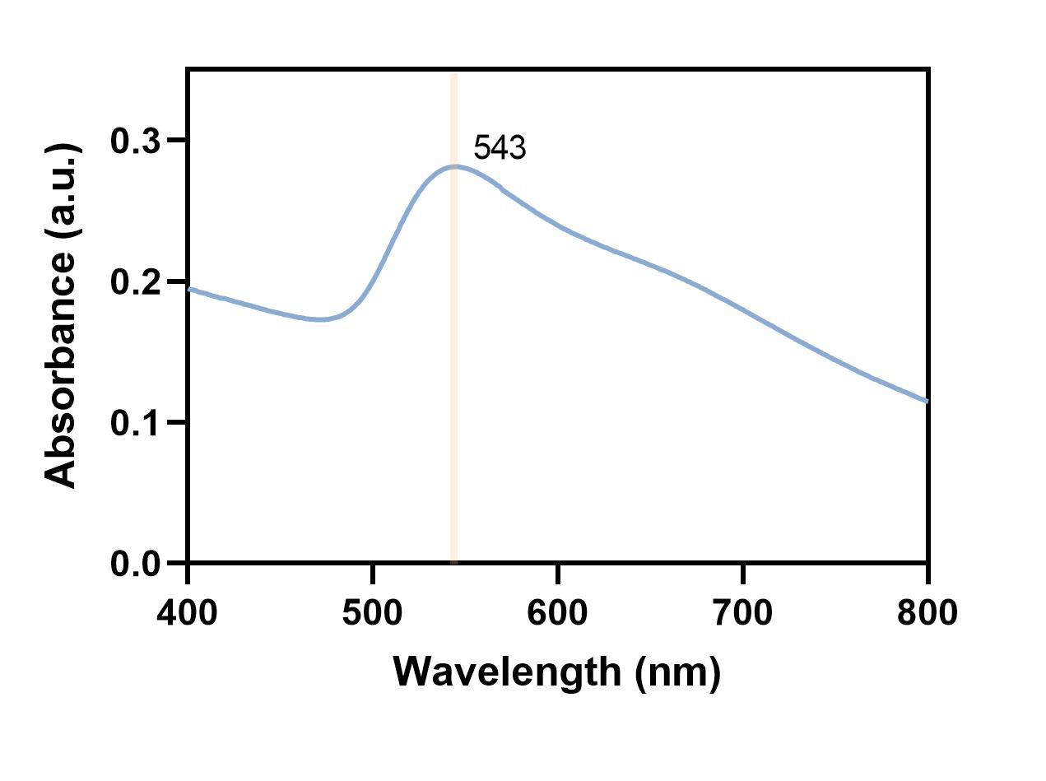
Fig S2. UV absorption image of Au nanoparticles.
Fig S3. Zeta potential of MWCNTs, MWCNTs-COOH and MWCNTs-tyr.

Fig S4. SEM image of SPE.
Fig S5. SEM image of MWCNTs-tyr/Au/PEDOT/SPE.
Fig S6. Representative SEM/EDS images from two random locations on the same electrode, demonstrating a consistent distribution profile of the target element.

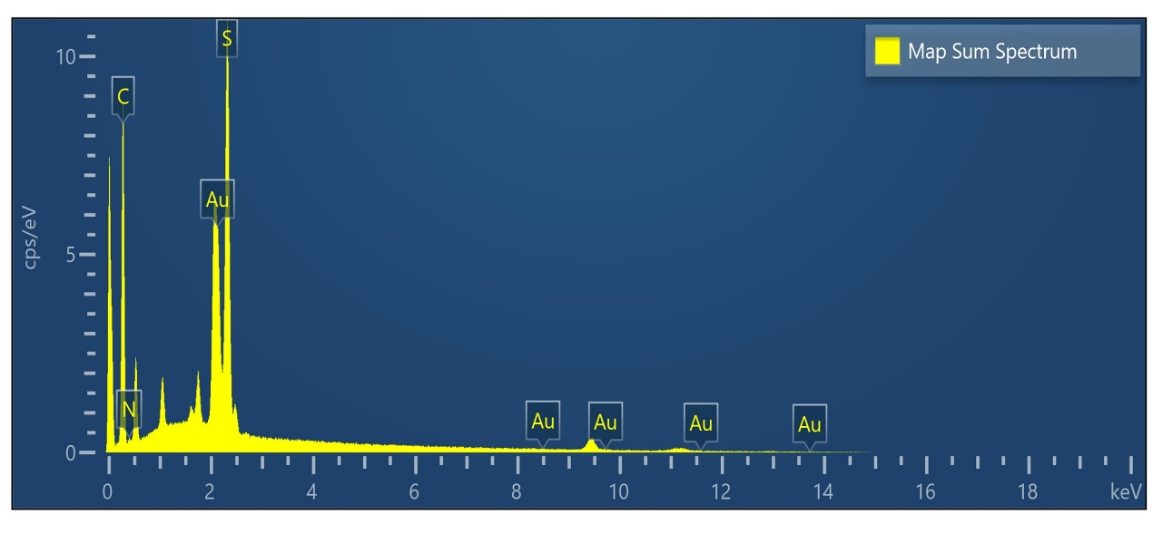
Fig S7. EDS spectrum of MWCNTs-tyr/Au/PEDOT/SPE by SEM.
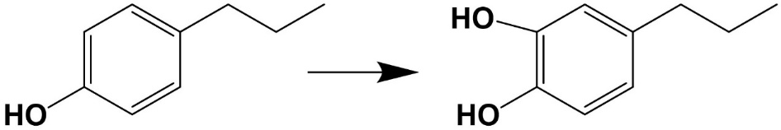
Fig S8. Tyrosinase catalyzes the conversion of monophenol to diphenol in tyramine. (a) Extracted ion chromatogram (EIC) of dopamine at m/z 154.09 (precursor ion) in tyramine and tyrosinase reaction solution. (b) Full scan MS¹ spectrum of dopamine in positive electrospray ionization (ESI⁺) mode, showing the protonated molecular ion [M+H]⁺ at m/z 154.09 and the chemical structure. (c) Product ion spectrum of dopamine (precursor ion m/z 137.06) and proposed fragment.
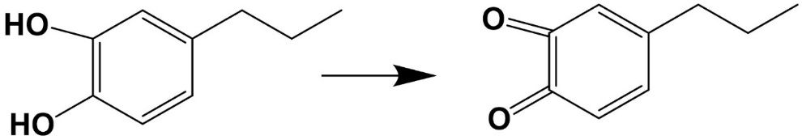
Fig S9. The conversion of Catechol to quinone in electrochemical oxidation. (a) Extracted ion chromatogram (EIC) of dopamine quinone at m/z 152.07 (precursor ion) in Dopamine Electrochemical Oxidation Solution. (b) Full scan MS¹ spectrum of dopamine quinone in positive electrospray ionization (ESI⁺) mode, showing the protonated molecular ion [M+H]⁺ at m/z 152.07 and the chemical structure. (c) Product ion spectrum of dopamine quinone (precursor ion m/z 122.06) and proposed fragment.
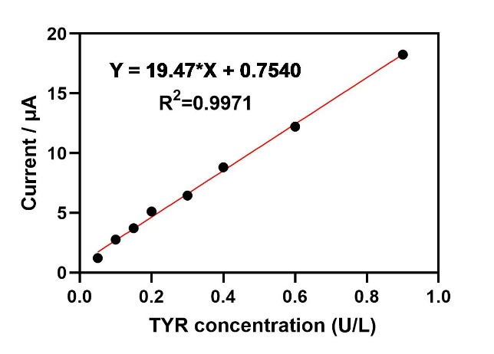
Fig S10. Linear relationship between tyrosinase concentration in serum matrix and current.

Table S1. Recoveries of TYR in serum based on the MWCNTs-tyr/Au/PEDOT/SPE.
Background (U/L) | Spiked (U/L) | Measured (U/L) | Recovery (%)
0.00 | 0.10 | 0.096 | 96.0
0.00 | 0.40 | 0.415 | 103.7
0.00 | 0.80 | 0.792 | 99.0

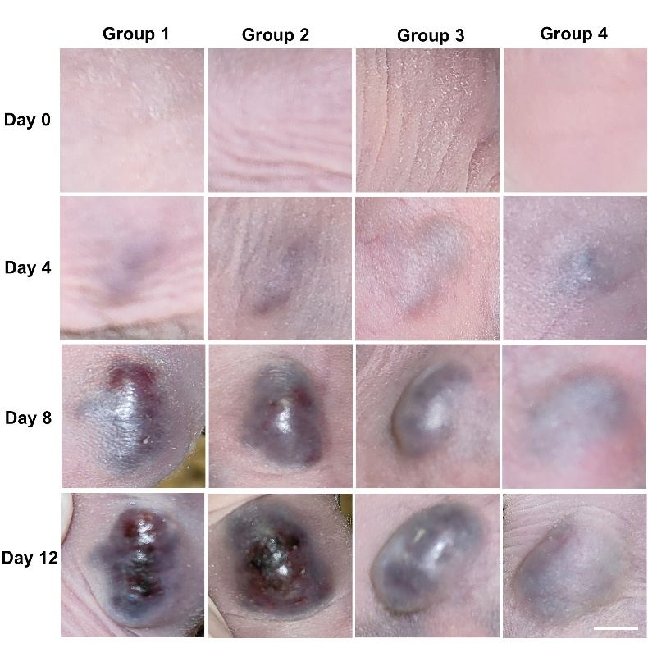
Fig S11. Growth status of cutaneous melanoma in the additional four groups of mice. scale bar= 500 μm.

Fig S12. Dynamic Changes in Serum TYR Concentrations in Melanoma Mice.
Fig S13. ELISA was used to determine the statistical concentration values of tyrosinase in serum samples from tumor-bearing mice.

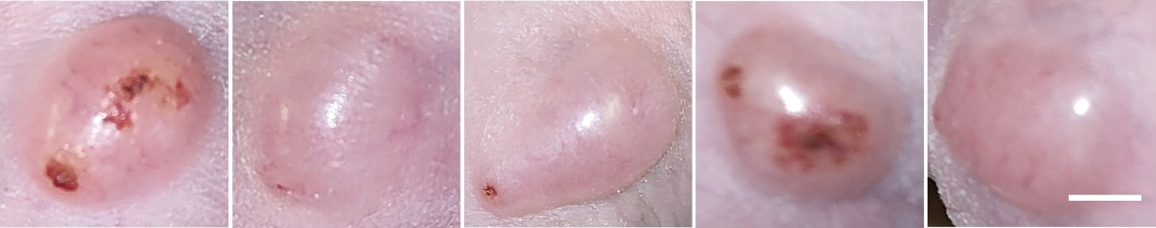
Fig S14. Growth Status of Skin Tumors in 4T1 Tumor-Bearing Mice (Non-Melanoma), n =5, scale bar= 500 μm.

