Supplementary Figure 1. Excerpts from biologic patient decision aid.
Panel A: Participants are asked to indicate which, if any, biologics have been recommended to them by their rheumatologist. | Panel C: Participants are invited to consider whether they feel they have enough knowledge and support to make a decision about taking a biologic.
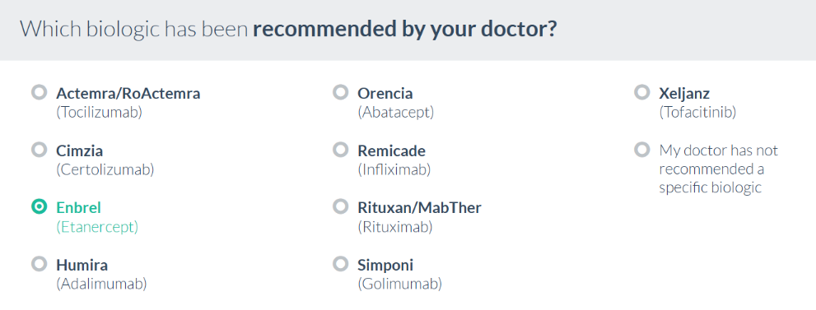 | 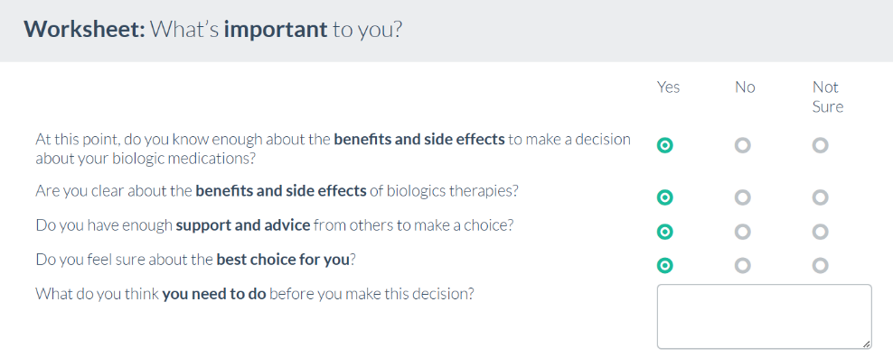
Panel B: Participants may compare how important the different features of biologic medications are to them. The decision aid summarizes the relative weight of each dimension in a pie chart. | Panel D: Participants are provided with recommendations based on their responses to the earlier exercises. The rheumatologist’s recommendation is also highlighted in the summary table for reference.
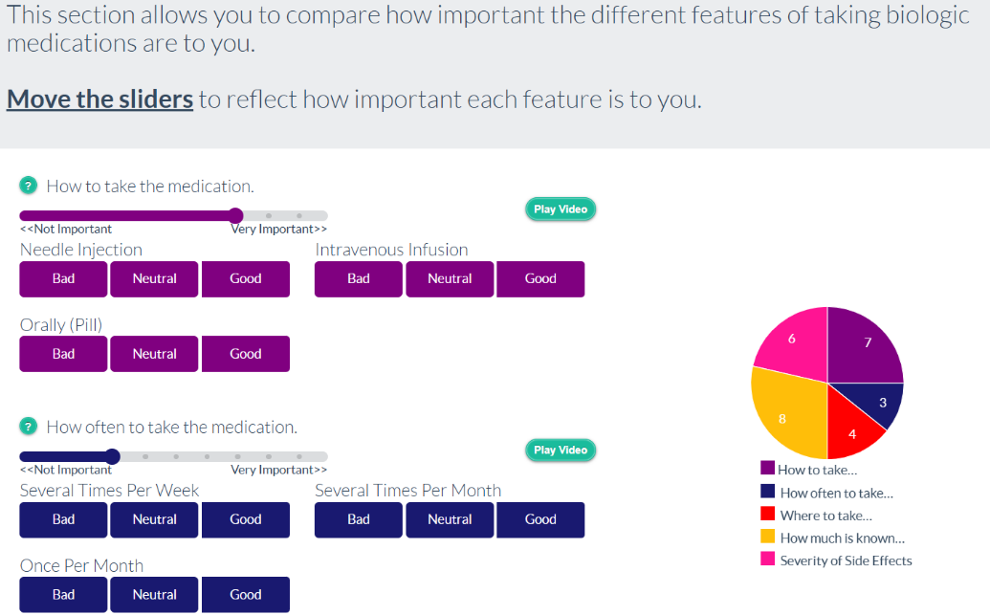 | 