Supporting Information

Supplementary Figures:

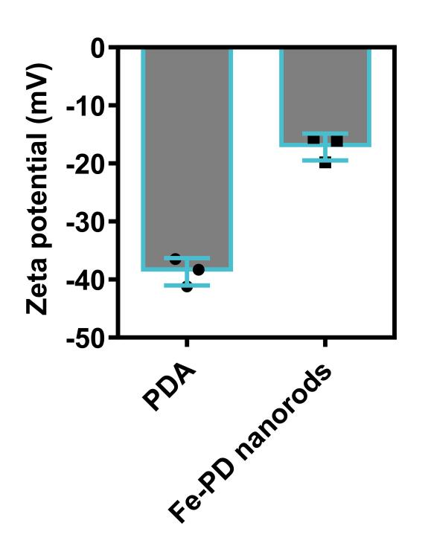
Figure S1. The zeta potential of PDA and Fe-PD nanorods.
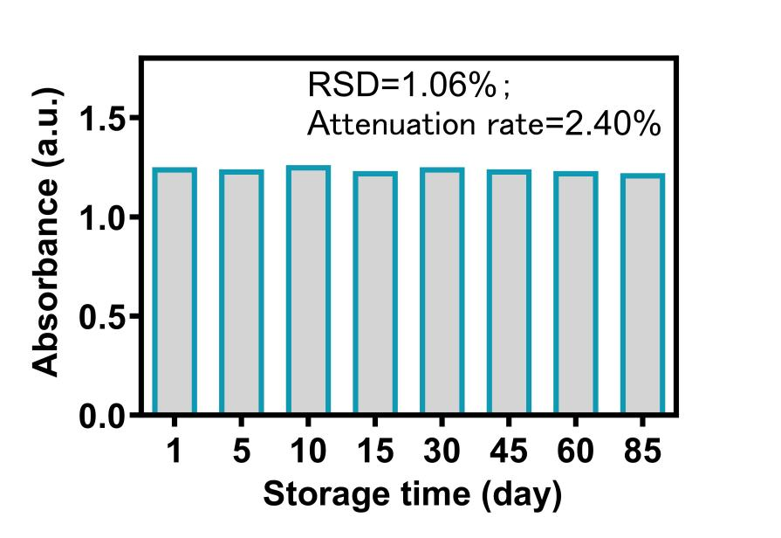
Figure S2. The long term catalytic stability of Fe-PD nanorods over time for 85 days.

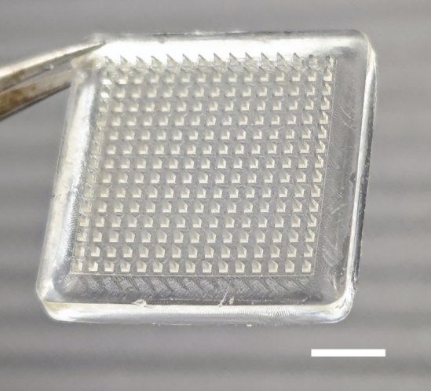

Figure S3. Photograph of the actual microneedle patch demolded for the PDMS mold. Scale bar, 3 mm.

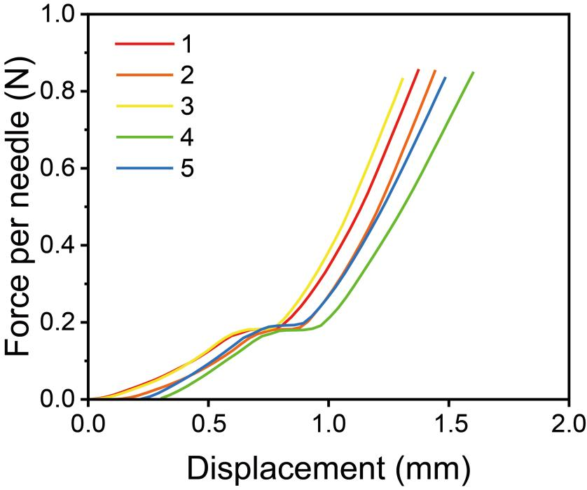

Figure S4. Curves of the loading fracture force versus displacement when 5 tests of compression experiments.

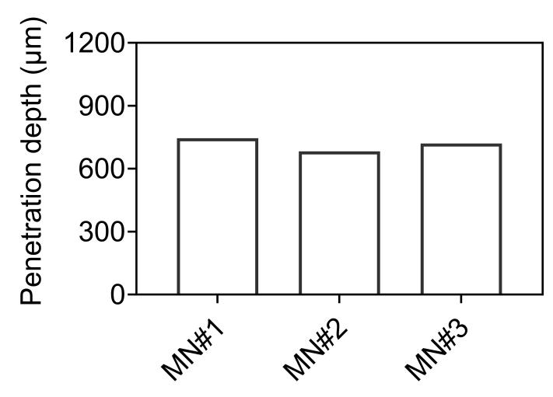

Figure S5. Penetration depths of three microneedle patches for pig skin. MN#1, MN#2, and MN#3 represent three repetitive tests of the MN patch.

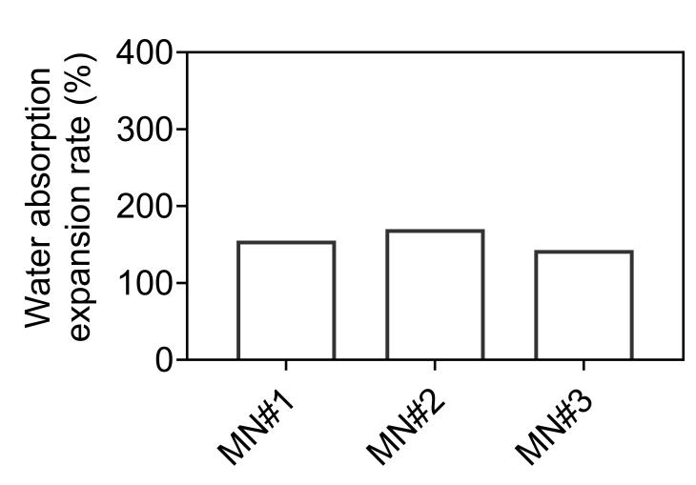

Figure S6. Water absorption expansion rate of three microneedle patches immersed in phosphate buffer solution (PBS, 10 mM, pH 7.4). MN#1, MN#2, and MN#3 represent three repetitive tests of the MN patch.

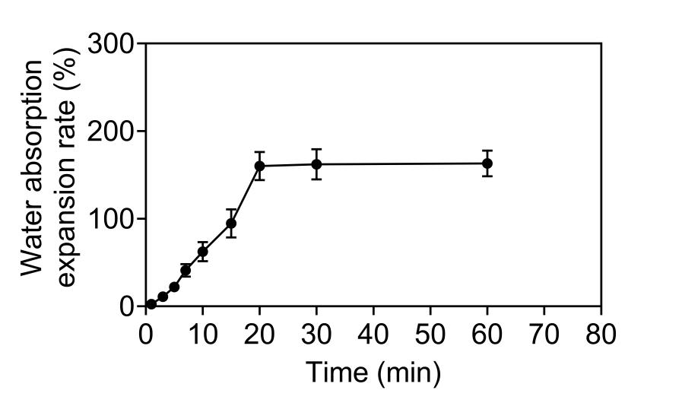

Figure S7. Water absorption expansion rate of the microneedle patch over time immersed in artificial interstitial fluid (AISF).

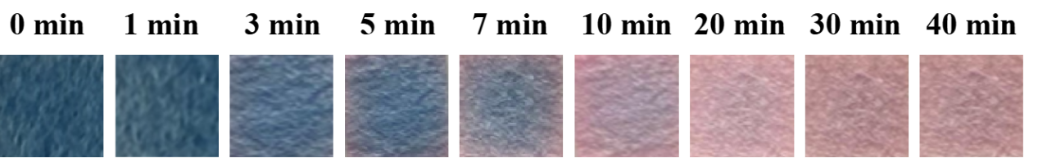

Figure S8. Photographs of color changes of the microneedle patches containing a colorimetric indicator (CoCl₂) upon interaction with the extracted AISF from pig skin.
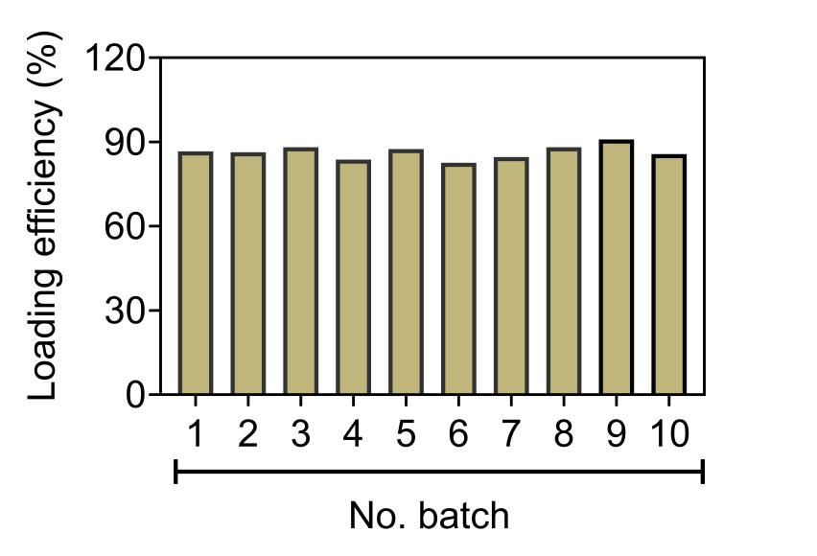

Figure S9. The nanozyme loading efficicency of MN-based Colorisensors for each bath. n=10.
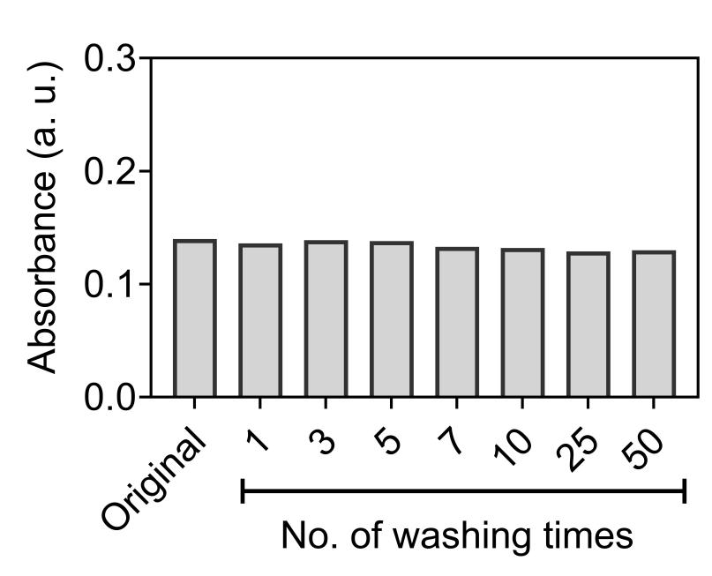

Figure S10. Absorbance values at 652 nm after continuous washing tests of the developed Colorisensor. Original represents a control testing with no washing treatment.

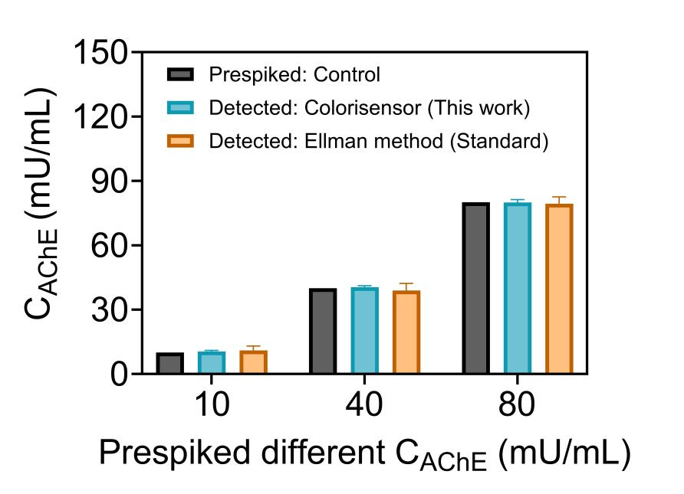

Figure S11. AChE concentrations (C_{AChE}) in AISF prespiked by Control (as added original concentrations) and detected by the developed Colorisensor (This work) and the Ellman method as the standard method.

Supplementary Tables:
Table S1. EDS characterization of the Fe-PD nanoenzyme for element analysis
Element | Wt%
C | 77.9
N | 3.6
O | 12.5
Fe | 6.0

Table S2. Comparison of the apparent Michaelis-Menten constant (K_{m}) and maximum reaction rate (V_{max}) of Fe-PD with those of previously reported nanozymes using TMB as the substrate.
Nanozymes | K_{m} (mM) | V_{max} (10⁻⁸ M S⁻¹) | Ref.
Fe-NDs | 0.76 | 2.27 | [1]
KFePW₁₂O₄₀ | 0.35 | 3.70 | [2]
CF@CuAl-LDH | 4.40 | 0.59 | [3]
CB-CQDs | 0.83 | 5.13 | [4]
Zn-CuO | 10.0 | 2.88 | [5]
ZIF-67 | 13.69 | 0.35 | [6]
Fe-PD | 0.85 | 15.38 | This work
Fe-PD nanozymes present Iron (III)-polydopamine nanorods prepared in this work.
0.85 presents Michaelis constant (K_{m}, mM) of Fe-PD nanozymes prepared in the steady-state kinetic parameter analysis when using TMB as the substrate.
15.38 presents maximum reaction rate (V_{max}, 10⁻⁸ M S⁻¹) of Fe-PD nanozymes prepared in the steady-state kinetic parameter analysis when using TMB as the substrate.

Table S3. Comparison of the apparent Michaelis-Menten constant (K_{m}) and maximum reaction rate (V_{max}) of PFe-PD with those of previously reported nanozymes using H₂O₂ as the substrate.
Nanozymes | K_{m} (mM) | V_{max} (10⁻⁸ M S⁻¹) | Ref.
Fe-NDs | 0.87 | 3.76 | [1]
KFePW₁₂O₄₀ | 165 | 6.90 | [2]
CF@CuAl-LDH | 1.48 | 0.29 | [3]
CB-CQDs | 0.70 | 4.69 | [4]
Zn-CuO | 71 | 0.30 | [5]
ZIF-67 | 3.52 | 0.28 | [6]
Fe-PD | 0.24 | 9.16 | This work
Fe-PD nanozymes present Iron (III)-polydopamine nanorods prepared in this work.
0.24 presents Michaelis constant (Km) of Fe-PD nanozymes prepared in the steady-state kinetic parameter analysis when using H₂O₂ as the substrate.
9.16 presents maximum reaction rate (V_{max}) of Fe-PD nanozymes prepared in the steady-state kinetic parameter analysis when using H₂O₂ as the substrate.

Table S4. Comparison of performance parameters of the conventional and developed detection methods for AChE determination.
Detection methods | Detection Range (mU/mL) | LOD (mU/mL) | Ref.
Ellman assay | 0-83 | / | [7]
Colorimetric assay | 200-1500 | 200 | [8]
Fluorescence assay | 0-30 | 0.03 | [9]
Colorimetric assay | 0.54-3.93 | 0.029 | [10]
Multicolor assay | 0.01–500 | 0.0074 | [11]
Colorimetric assay | 0.1-30 | 0.066 | [12]
Colorisensor | 0.01-1000 | 0.007 | This work

References:

1. Li, C.; Zeng, J.; Guo, D.; Liu, L.; Xiong, L.; Luo, X.; Hu, Z.; Wu, F., Cobalt-doped carbon quantum dots with peroxidase-mimetic activity for ascorbic acid detection through both fluorometric and colorimetric methods. ACS Appl. Mater. Interfaces 2021, 13, 49453-49461.

2. Liu, X.; Wang, X.; Qi, C.; Han, Q.; Xiao, W.; Cai, S.; Wang, C.; Yang, R., Sensitive colorimetric detection of ascorbic acid using Pt/CeO2 nanocomposites as peroxidase mimics. Appl. Surf. Sci. 2019, 479, 532-539.

3. Chen, S.; Chi, M.; Yang, Z.; Gao, M.; Wang, C.; Lu, X., Carbon dots/Fe3O4 hybrid nanofibers as efficient peroxidase mimics for sensitive detection of H2O2 and ascorbic acid. Inorg. Chem. Front. 2017, 4, 1621-1627.

4. Yadav, P. K.; Singh, V. K.; Chandra, S.; Bano, D.; Kumar, V.; Talat, M.; Hasan, S. H., Green synthesis of fluorescent carbon quantum dots from Azadirachta indica leaves and their peroxidase-mimetic activity for the detection of H2O2 and ascorbic acid in common fresh fruits. ACS Biomater. Sci. Eng. 2019, 5, 623-632.

5. Isho, R. D.; Mohammad, N. S. M.; Omer, K. M., Synthesis of MnO2 sub-microspheres with effective oxidase-mimicking nanozymes for the colorimetric assay of ascorbic acid in orange fruits and juice. New J. Chem. 2023, 47, 7800-7809.

6. Dadakhani, S.; Dehghan, G.; Khataee, A., A robust and facile label-free method for highly sensitive colorimetric detection of ascorbic acid in fresh fruits based on peroxidase-like activity of modified FeCo-LDH@WO3 nanocomposite. Spectrochim. Acta, Part A 2023, 302, 123016.

7. Ellman, G. L.; Courtney, K. D.; Andres, V., Jr.; Feather-Stone, R. M., A new and rapid colorimetric determination of acetylcholinesterase activity. Biochem. Pharmacol. 1961, 7, 88-95.

8. Li, Y.; Bai, H.; Li, C.; Shi, G., Colorimetric assays for acetylcholinesterase activity and inhibitor screening based on the disassembly-assembly of a water-soluble polythiophene derivative. ACS Appl. Mater. Interfaces 2011, 3, 1306-10.

9. Zhang, R.-L.; Liang, S.-S.; Jin, M.; He, T.; Zhang, Z.-Q., Simple and sensitive fluorescence assay for acetylcholinesterase activity detection and inhibitor screening based on glutathione-capped gold nanoclusters. Sens. Actuators, B 2017, 253, 196-202.

10. Wang, Y.; Xue, Y.; Zhao, Q.; Wang, S.; Sun, J.; Yang, X., Colorimetric Assay for Acetylcholinesterase Activity and Inhibitor Screening Based on Metal-Organic Framework Nanosheets. Anal. Chem. 2022, 94, 16345-16352.

11. Li, Y.; Chen, L.; Li, C. Y.; Zhang, J.; Zhao, Y.; Yang, Y. H.; Yang, T., Nanoplasmonic biosensors for multicolor visual analysis of acetylcholinesterase activity and drug inhibitor screening in point-of-care testing. Biosens. Bioelectron. 2024, 247, 115912.

12. Mao, Y. W.; Zhang, J.; Zhang, R.; Li, J. Q.; Wang, A. J.; Zhou, X. C.; Feng, J. J., N-Doped Carbon Nanotubes Supported Fe-Mn Dual-Single-Atoms Nanozyme with Synergistically Enhanced Peroxidase Activity for Sensitive Colorimetric Detection of Acetylcholinesterase and Its Inhibitor. Anal. Chem. 2023, 95, 8640-8648.

